Shopdev Pvt. Ltd is an **e-commerce** **company** focused on providing **technology, design, and consultancy services**. It also develops and delivers **innovative products** that disrupt the current e-commerce sphere to give the ultimate competitive edge. Shopistan was incorporated in **2012** and raised its seed round from **Kima Ventures** in 2013.

Shopistan is run by **Ali Aziz**, an **ecommerce veteran** with experience working at Amazon.com and eBay. We are a team of over 60 professionals with a heavy focus on technology.

Shopistan is a **leader in Pakistan's ecommerce space**. We are going after a market that is projected to be over USD 2B by 2020. Shopistan offers managed ecommerce services to retailers and technology and design outsourcing services for **product development to clients globally**. Shopistan runs a **product accelerator** that helps startups accelerate their product to market. We provide **UI/UX design** and technology expertise to build products in exchange for equity. We consider our resource investment as a first round of investment since first rounds are typically raised to fast track products. We limit our focus to startups doing **e-commerce in the edtech, fintench, healthtech and other "virtual products"** verticals - where the product or service can be delivered electronically.

**Nearpeer** is a massively open online course (MOOC) platform which connects teachers and students. It caters to students of O/A Levels, CA, LUMS, LSE etc and gives them easy access to various class lectures, class notes and quizzes at very affordable prices. We have launched a one of a kind **Omnichannel** enabling middleware, a self-service ecommerce platform, an innovative digital wallet and a machine learning based conversational commerce bot (shopify, daraz.pk, meganto, clicky.pk). **Shopdesk** is a POS and e-commerce platform for MAC, PC & iPad which helps you sell in stores and online by managing inventory and books, all in one place on the cloud.

Ecommerce Products

Managed ecommerce services

Startup Acceleration

Managed Services

Social Media & Online Marketing

Technology & Design Services

System administration services

Uptime monitoring

Hacking prevention

Bug Fixing

Daily Updates

Location-wise inventory management

Real time logistics management

Real time order tracking and order file generation

Customer service

SMS and email notifications of order status.

User journey flowcharts

High fidelity wireframes

UX based on proven data and research

Modern Interaction Design

* HMO stands for health maintenance organization.
* POS stands for point of service.
* PPO stands for preferred provider organization.
* PFFS stands for private fee for service.

**Senior Year Project: Call Center Simulation in Network Simulator-3 and Node.js**

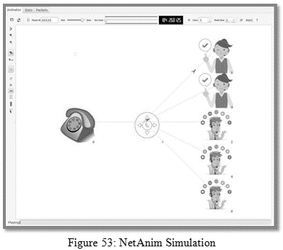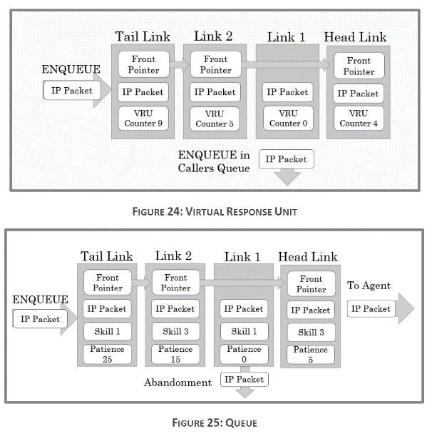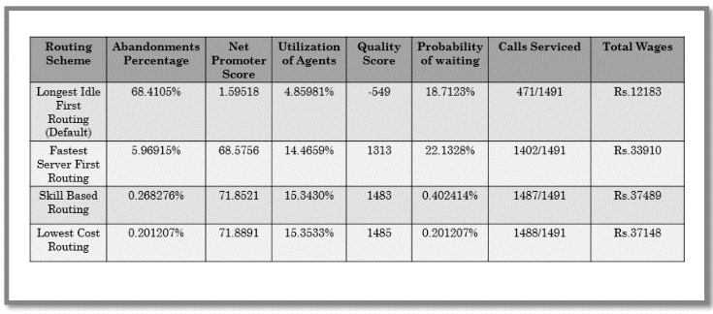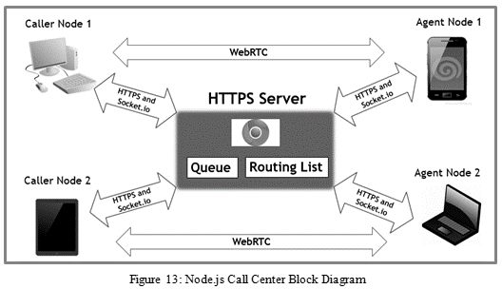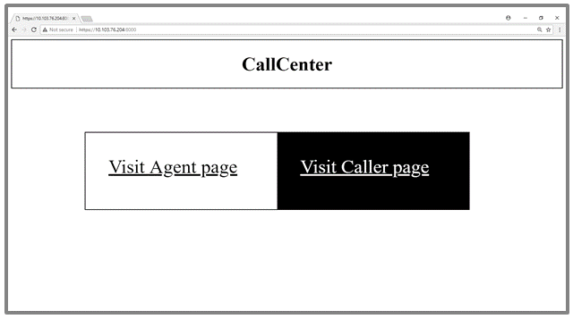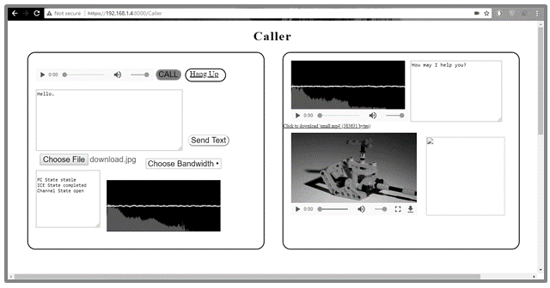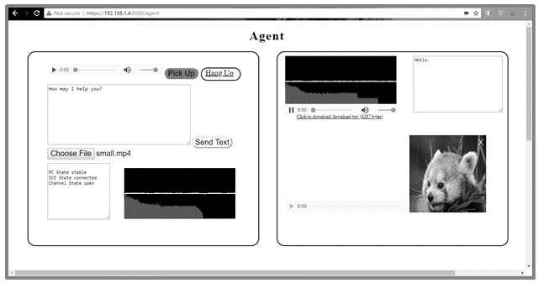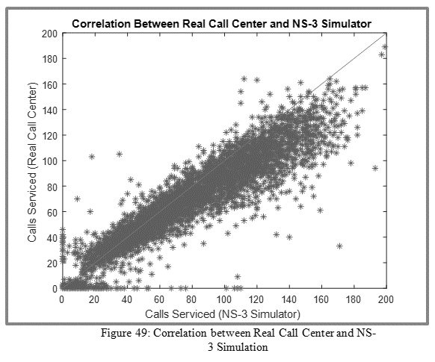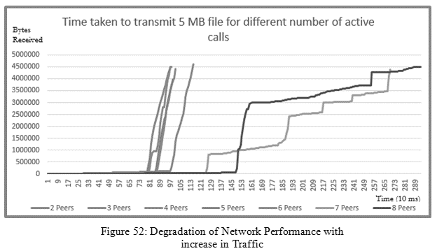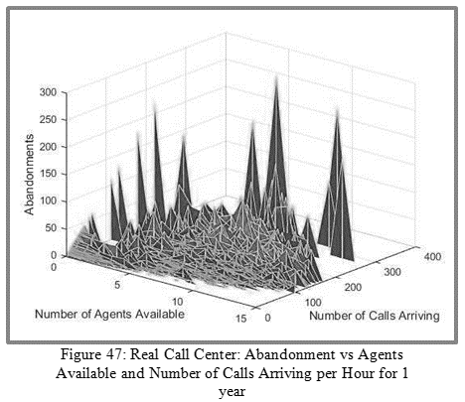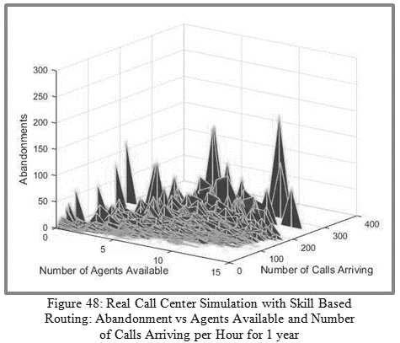

**Research Project (3-3.5GHz Local Oscillator Bank)**

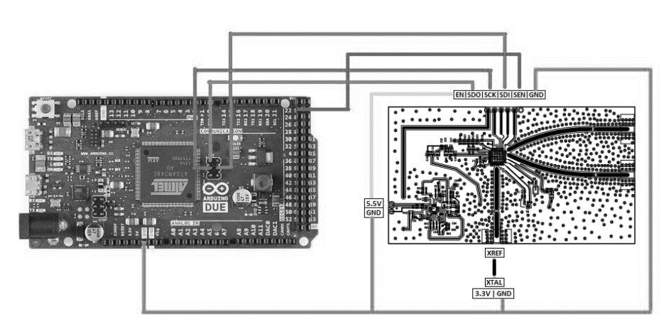

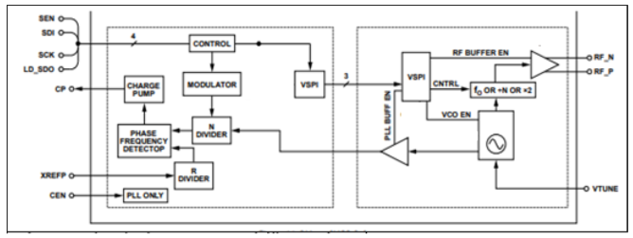

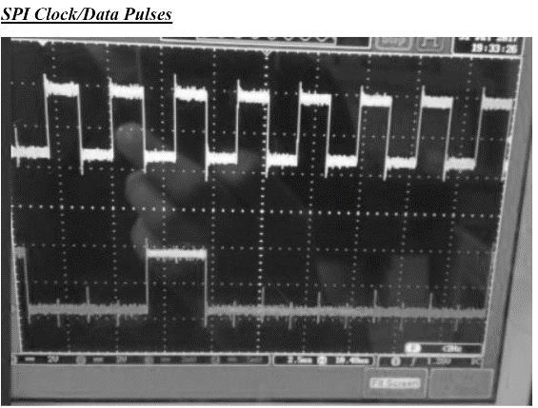

**Simulations in Java**

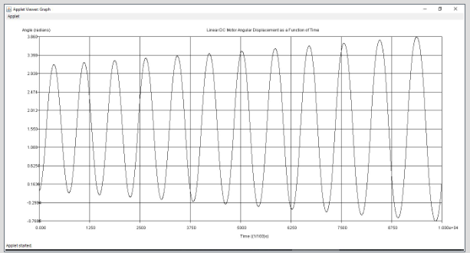

Figure : DC Motor Simulation

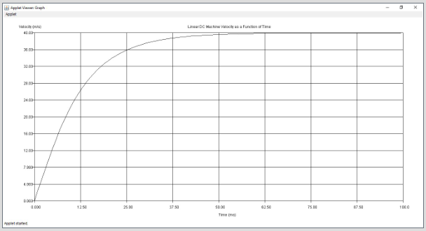

Figure : Linear DC Machine Simulation