Ferromagnetic Resonance of Magnetic Transmission Line Parameters of Saturated Ferrite Film

**Muhammad Shamaas1, Muhammad Asghar Saqib2, Syed Abdul Rahman Kashif3 and Syed Shah Irfan Hussain4**

1, 2, 3, 4Department of Electrical Engineering, University of Engineering and Technology, Lahore 54890, Pakistan

12018msee004@student.uet.edu.pk, 2saqib@uet.edu.pk, 3abdulrahaman@uet.edu.pk, 4ssirfanhussain@uet.edu.pk,

**Abstract** –*A*

**Keywords:**T

# Introduction

Gyromagnetic materials are widely used in high frequency applications like microwave devices and radar communication because of their directional and non-reciprocal properties. Ferromagnetic materials change their electromagnetic properties when magnetic bias field is applied [10]. The bias field produces Zeeman splitting in energy levels, and the saturated magnetic dipoles can transition between the energy levels by absorbing high frequency fields. These materials exhibit Ferromagnetic resonance, in the micro and mm-wave region, under the influence of external magnetostatic bias fields. During ferromagnetic resonance, their affinity for magnetic flux increases greatly, enabling them to conduct magnetic information efficiently using spin waves. The heightened permeability and high resistivity makes them extremely useful for microwave devices, isolators, circulators and absorbers. Unfortunately, the non-linear and anisotropic nature of magnetized ferrites greatly complicates their analysis and design. The magnetic properties of microwave ferrites vary widely with chemical composition, crystal structure and bias field. Realistic system level models for the analysis of Ferromagnetic materials must account for this information delay, distortion and attenuation.

Many researchers have attempted to explain non-reciprocal properties of magnetized ferromagnets using the electromagnetic transmission line model [1], [10], [11]. An analysis of the propagation of UHF electromagnetic fields in a waveguide filled with anisotropic, magnetized ferrite was given in [1]. Experimental results for calculating frequency dependent behavior of complex permeability and permittivity of a ferromagnetic transmission line was presented in [1] and [10], where the measured intrinsic impedance and propagation constant were used to determine the per unit length transmission line parameters. In [11], an estimate for the parasitic capacitance of a ferromagnetic core was presented, which stores electric energy in the gradient electric field developed inside the core and is responsible for the high frequency self-resonance and frequency limitation of the magnetic core. The frequency independent Ohmic losses were also considered in an equivalent core impedance.

The transcendental electrodynamic equations for propagation of fields in gyromagnetic media do not have a close form solution so they can only be solved via electromagnetic simulations [10]. The propagation of UHF signals in dispersive, anisotropic, conductive ferromagnetic transformer cores has been widely studied using FDTD simulations [11], [8], [1]. The micro-magnetic FDTD simulations accurately modeled the precessional magnetization dynamics, and the results were comparable to analytical results [1].

Many researchers have tried to translate the results into an Electromagnetic Transmission Line system level design which can explain the flow of magnetic flux as the effective magnetic charge due to the application of Magnetomotive force. Unlike Electric Transmission Lines, these magnetic circuits are not designed to conduct electric charge upon application of electromotive force. In [4], a Magnetic Transmission Line model was developed, which was based on the conventional Electric Transmission Line model. For magnetic transmission lines, transverse impedance and the longitudinal admittance determine the propagation constants for the wave modes. The Magnetic Transmission Line exhibited the behavior of a high pass filter. Simulations showed that they exhibit super-luminal phase velocity and almost zero attenuation dispersion in the microwave frequency range [5].

The Magnetic Transmission Line Model explains the flow of magnetic flux in ferromagnetic materials as the effective magnetic charge. It provides a system level circuit for relating Magnetomotive force to Magnetic flux rate. Analogous to the scalar Electric Potential in Electric Transmission Lines, scalar magnetic potential is defined as

The Magnetic Displacement Current is defined as the rate of change of magnetic flux :

The Magnetic Transmission Line Equations can be written as

where the per unit length transverse magnetic inductance represents a magnetic Energy storage element storing magnetic flux; the per unit length longitudinal capacitance represents an Electric Energy storage element resulting from the dielectric nature of the ferromagnet; and the per unit length Magnetic conductance dissipates energy due to Hysteresis, Eddy currents, Skin effect, Proximity effect, Magnetoresistance and other residual losses.

The characteristic impedance and propagation constant are calculated by the following relations:

where is the Transverse Magnetic Impedance and is the Longitudinal Magnetic Admittance.

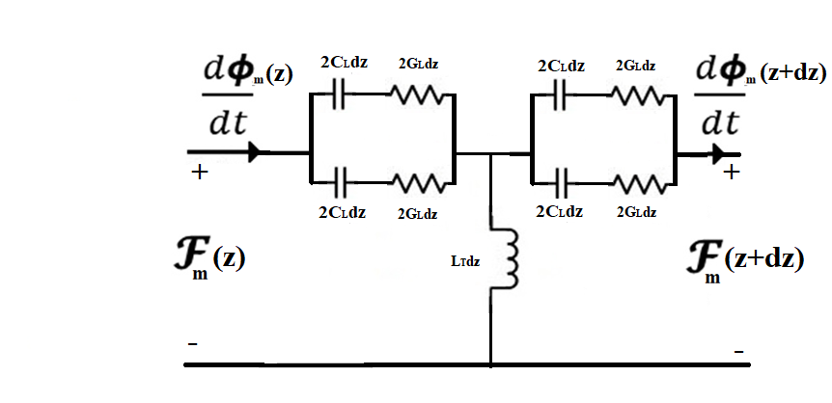

Figure : Magnetic Transmission Line Circuit Model

This research attempts to extend the Magnetic Transmission Line model for the modeling saturated ferromagnetic materials, and studying the effects of ferromagnetic resonance on the per unit length magnetic transmission line transverse impedance and longitudinal admittance.

# Finite Difference Time Domain Electromagnetic Simulation

MEEP software was used for the electromagnetic simulation of the Gyrotropic, Dispersive, Ferromagnetic Transmission Lines using the Finite Difference Time Domain method which discretizes Maxwell’s Equations using central difference approximations for space and time partial derivatives. The different field components at a grid location are stored in the edges and faces of a cubic element called Yee’s Cell. The electromagnetic fields are evolved in discrete time steps using leap frog method.

Landau-Lifshitz-Gilbert model describes the precessional motion of saturated magnetic dipoles in a magnetic field.

wheredescribes the linear deviation of magnetization from its static equilibrium value. **M** precesses around the effective Magnetic Field Intensity . represents gyromagnetic ratio, and is the phenomenological Gilbert damping factor.

For ferromagnetic media biased in the z-direction (**b =** 1 , a non-diagonal susceptibility tensor is used to relate Magnetization and Field intensity **M**= **H**.

where == , == and =



Figure : 300 GHz Ferromagnetic Resonance of Susceptibility Tensor Element

The Hx and Hy fields are coupled due to the off-diagonal terms in the susceptibility tensor. The resulting equations for the evolution of magnetic field components are:

The equations can be solved by taking the inverse Fourier Transform and discretizing the resulting equations.

Finite Difference Time Domain simulator MEEP solves these equations by the modified Yee’s Algorithm.

# Simulation Results

A Magnetic Gaussian Current Pulse with a bandwidth of 450 GHz was applied at the input side of the magnetized ferrite. The Fourier Transform of the pulse is shown in Fig. 3.

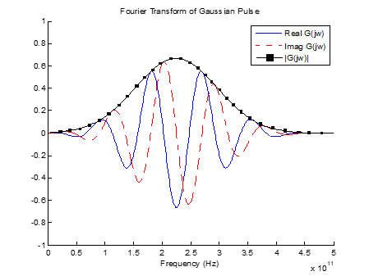

Figure : Fourier Transform of Input Gaussian Magnetic Current Pulse

Different frequencies faced different degrees of rotation per unit of propagation distance:

The resultant polarization changes continuously as the different frequency components experience different rates of rotation per unit distance of propagation. The polarization of each frequency changed from linear polarization as it moved in the direction of propagation. Hence, the Gaussian pulse was heavily deformed as it reached the output end. The resultant polarization was a combination of all the polarizations of the different frequencies.



Figure : The Gyromagnetic Precession of Magnetic Field during Ferromagnetic Resonance

The 300 GHz harmonic of the incident Gaussian wave matched the Larmor frequency, and gave rise to Gyromagnetic resonance. The wave impedance shown in Figure 5 was calculated using the Fourier Transform of a small window of input and output signals, during steady state of gyromagnetic resonance. The intrinsic wave impedance spikes during gyromagnetic resonance as seen in Figure 5. This is due to the huge spike in magnetic susceptibility and magnetic permeability during the 300 GHz gyromagnetic resonance. The huge value of intrinsic wave impedance increases the electromagnetic power losses across the saturated ferrite. It absorbs a lot of electromagnetic energy from the Transverse Field, and starts to heat up.



Figure : Plot of Intrinsic Wave Impedance vs. Frequency

The calculated wave propagation constant is shown in Figure 6. The phase constant and attenuation constant was calculated for Hx component. The attenuation constant was calculated by comparing the magnetic field strength at input and output sides. The output signal was heavily amplified compared to the input signal hence the attenuation constant was negative during gyromagnetic resonance.

As seen in Figure 6, the 300 GHz harmonic experiences no net rotation along the direction of propagation, because the observation points were 1 millimeter apart and the 300 GHz harmonic completes one complete rotational cycle after every millimeter.



Figure : Plot of Attenuation Constant and Phase Constant vs. Frequency

During Gyromagnetic Resonance, the per unit length Longitudinal Admittance spikes as shown in Figure 7. This leads to a severe increase in the power dissipation in the Ferrite sample. The Longitudinal Magnetic Capacitance and Magnetic Conductance drops, as shown in Figure 7. The excessive drop in Magnetic conductance makes the magnetic reluctance very small. This makes the saturated ferrite sample highly conductive to electromagnetic flux. The saturated ferrite sample absorbs a lot of electromagnetic energy and starts to heat up. Eventually, the resonating sample will get damaged due to overheating.



Figure : Plot of Longitudinal Admittance vs. Frequency

During Gyromagnetic Resonance, the per unit length Transverse Impedance spikes as shown in Figure 8. This leads to a severe increase in the power dissipation in the Ferrite sample. The magnetic flux leakage drops heavily and this makes the saturated ferrite sample highly conductive to electromagnetic flux. Ultimately, the saturated ferrite sample absorbs a lot of electromagnetic energy.



Figure : Plot of Transverse Impedance vs. Frequency

w

# Conclusion

A Finite Difference Time Domain EHF simulation of saturated MnZn ferrite is presented for studying the effects of gyromagnetic resonance on longitudinal magnetic admittance and transverse magnetic impedance. The gyromagnetic precession of saturated magnetic dipoles was modeled using linearized Landau-Lifshitz-Gilbert model in MEEP simulator. It is shown that gyromagnetic resonance can be observed when the frequency spectrum of the input EHF signal overlaps sufficiently with the Larmor precession frequency band. Discrete Fourier Analysis of electromagnetic fields was used to estimate the frequency dependent behavior of per unit length longitudinal magnetic admittance and transverse magnetic impedance. It is shown that gyromagnetic resonance leads to a drastic increase in the electromagnetic energy losses of transverse magnetic conductance. The nonreciprocal propagation properties of Magnetized Ferromagnets make them highly useful in Microwave Applications for directional control of Electromagnetic waves. This property is often used in ferrite loaded microstrip patch antennas to amplify incoming UHF signals. The gyromagnetic saturated ferrite sample is tuned by a variable magnetic bias to resonate in the desired frequency band. This increases its radiation resistance and it ultimately absorbs a huge amount of incoming radiation. This property is often used in ferrite loaded microstrip patch antennas to amplify incoming EHF signals. The gyromagnetic saturated ferrite sample is tuned by a variable magnetic bias to resonate in the desired frequency band. Ultimately, it absorbs a huge amount of incoming radiation and behaves as a very efficient antenna. This property is useful in modern technical applications in spintronic devices, space navigation, wireless communication, maritime and geophysical prospecting instruments.

# References

[1] H. Al-Barqawi, N. Dib and M. Khodier, “A Full-Wave Two-Dimensional Finite-Difference Frequency-Domain Analysis of Ferrite-Loaded Structures”. Mosharaka International Conference on Communications, Propagation and Electronics, 2008.

[2] L. Chao, A. Sharma and M. N. Afsar, “Microwave and Millimeter Wave Ferromagnetic Absorption of Nanoferrites,” *IEEE Transactions on Magnetics*, vol.48, no. 11, pp. 2773–2776, Nov. 2012.

[3] S. Blundell, *Magnetism in condensed matter*. Oxford: Oxford University Press, 2014.

[4] J. Faria and M. Pires, “Theory of Magnetic Transmission Lines,” *IEEE Transactions on Microwave Theory and Techniques*, vol. 60, no. 10, pp. 2941–2949, 2012.

[5] J. Faria, “Formulation of Multiwire Magnetic Transmission-Line Theory”, *Progress in Electromagnetics Research B*, Vol. 49, 2013.

[6] N. Adachi et al., “Far-Infrared Ferromagnetic Resonance of Magnetic Garnet for High Frequency Electromagnetic Sensor,” *IEEE Transactions on Magnetics*, vol.46, no. 6, pp. 1986–1989, Jun. 2010.

[7] A. Oskooi, D. Roundy, M. Ibanescu, P. Bermel, J. Joannopoulos, and S. Johnson, “MEEP: A flexible free-software package for electromagnetic simulations by the FDTD method”, *Computer Physics Communications*, Vol. 181, pp. 687-702, 2010.

[8] N. Shirdel, A. Akbari, H. Mirzaei, and M. Abrishamian, “Three-dimensional simulation of UHF signal propagation in transformer using FDTD method,” *2011 International Conference on Power Engineering, Energy and Electrical Drives*, 2011.

[9] A. Taflove and S. Hagness, *Computational Electrodynamics: The Finite-Difference Time-Domain Method*, 3rd ed. Boston: Artech House, 2005.

[10] J. Xu, M. Koledintseva, Y. Zhang, Y. He, B. Matlin, R. Dubroff, J. Drewniak, and J. Zhang, “Complex Permittivity and Permeability Measurements and Finite-Difference Time-Domain Simulation of Ferrite Materials,” *IEEE Transactions on Electromagnetic Compatibility*, vol. 52, no. 4, 2010.

[11] H. Zhao, Y. Li, Q. Lin, and S. Wang, “The Parasitic Capacitance of Magnetic Components with Ferrite Cores Due to Time-Varying Electromagnetic (EM) Field,” *2018 IEEE Energy Conversion Congress and Exposition (ECCE)*, 2018.