Power System Planning Assignment 3
Earthing, Ground and Neutral.
Muhammad Shamaas
2018-MS-EE-4
University of Engineering and Technology G.T. Road Lahore Punjab Pakistan
2018msee004@student.uet.edu.pk

Abstract: Proper Earthing is pivotal for the design of distribution system, as it protects the substation operation and maintenance personnel from electrocution and fire hazards. During insulation failures, handling of high voltage equipment and faults, it must be ensured that consumers are protected from fatal currents by contact with exposed metal surfaces of faulty devices. In this paper, some important techniques for Medium Voltage Substation Earthing are discussed that focus on controlling the fault loop impedance and current. This is integral for the operation of Residual Current Devices and Circuit Breakers. A discussion of IEEE Standards for Low Voltage Earthing Networks compares these techniques based on their cost, and the effectiveness to ensure continuity of service, and the safety of consumers.

Index Terms—Residual Current Device, Equipotential Bonding, Earthing Rods, Fault Loop Impedance, Isolation Failure.

INTRODUCTION

Ground or Earth in an Electrical Power Network is the reference potential for measurements of all potential differences. The potential of Earth surface is taken to be equal to zero because it is a very large conductor and has a very large radius. It is considered electrically neutral of charge from inside, hence the surface potential of earth is very close to zero at all times. It is the preferred reference because it is accessible all over the Power Network and adding charge to it does not change its potential significantly [1].
The neutral is the circuit conductor that normally carries current back to the source (generator or transformer). The neutrals of different circuits do not have the same potential unlike the ground which has common voltage for the entire power system. The neutral does not always have a potential of zero volts due to voltage drops in transmission lines and distribution cables. Single phase systems have a neutral wire to carry return current to source [4]. In the case of three-phase networks, neutral is the conductor that connects to the star point and carries current back to source. The same concept applies in the case of poly-phase circuits. Neutral is usually connected to Earth at the main electrical panels, street drops and step-down distribution transformers [3]. Neutral wires are usually connected at a neutral bus within panel boards or switchboards, and are bonded to Earth ground at either the electrical service entrance, or at transformers within the system. Some arrangements of polyphase transformers may result in no neutral point, and no neutral conductors [1].
Under normal conditions, the grounding conductor does not carry any current because it is not designed to be part of the circuit. The Earthing of Network Plant and Consumer Electronics is used to ensure safety and reduce possibilities of damage in case of failure. It prevents long term over voltages; and minimizes risk of electric shock hazards; if the live conductor comes in contact with metal casing. If the Earth wire is absent, the metal case attains a very high voltage; causing lethal current to flow through the operator (100-200mA) [3]. The high resistance path through the body makes the current small; hence most protective devices are not triggered [3]. This results in serious damage to the operator and the equipment. The Earth wire provides a preferable low impedance path for the current to flow as shown in Fig. 1. 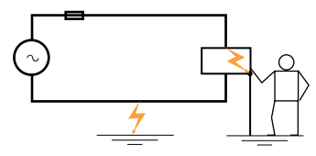
Fig. 1: Earth wire conducting during Insulation Failure [2]
The high Earth wire leakage current triggers the protective devices; like fuses; to disconnect the faulty plant or circuit. In the case of poly-phase circuits, if a high voltage conductor experiences a fault and its voltage becomes affected, the other phases will experience extreme over-voltages if the neutral is not connected to earth. This is because the neutral will attain a floating voltage to restore balance of currents. If the neutral is earthed, its potential will remain pinned at zero volts hence the other phases will not be affected greatly [1]. The same analogy applies in the case of lightning and switching impulses, electromagnetic interference, insulation breakdown and overloads. Hence Earthing is integral for the operation of System protection devices like circuit breakers (Ground Fault Interrupters GFI) and fuses (Short Circuit Protective Devices SCPD) [6].
.

Techniques

Earthing and Equipotential Bonding is pivotal for substation design. The Earthing system ensures that no thermal or mechanical damage occurs on the equipment within the substation, thereby resulting in safety to operation and maintenance personnel. It includes conductors, connections, Earthing rods and switchyard fence Earthing [5]. Bare copper conductor is usually used for the substation Earthing grid. The copper bars are laid at a shallow depth of 0.25-0.5m [7]. In addition to the buried potential earth grid, a separate above ground Earthing ring is usually provided, for bonding with the metallic substation plant. Connections to the grid and other Earthing joints are not soldered because the generated heat could cause a soldered joint to fail [7]. Joints are usually bolted, and the face of the joints is tinned. The Earthing grid is supplemented by Earthing rods to assist in the dissipation of Earth fault currents and further reduce the overall substation Earthing resistance. These rods are usually made of solid copper [3], 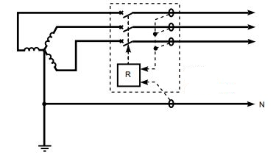
Fig. 2: Operation of RCD [2]
or copper clad steel. The switchyard fence Earthing practices are used by different utilities. The substation Earth grid is extended beyond the fence perimeter; and the fence is then bonded to the grid at regular intervals. Furthermore, the fence is placed beyond the perimeter of the switchyard Earthing grid and the fence is bonded to its own Earthing rod system. This Earthing rod system is not coupled to the main Earthing grid [7].
In designing the substation, three voltages have to be considered: Touch Voltage, Step Voltage and Mesh Voltage. Touch Voltage is the difference in potential between the surface potential and the potential at an earthed equipment whilst a man is standing and touching the earthed structure. Step Voltage is the potential difference developed when a man bridges a distance of 1m with his feet while not touching any other earthed equipment. Mesh Voltage is the maximum touch voltage that is developed in the mesh of the Earthing grid [7].
In high voltage networks, Earthing system design focuses mainly on reliability of protection and supply in the case of a short circuit fault. The Neutral can be Earthed using five techniques: Solid Earthed Neutral, Unearthed Neutral, Resistance Earthed Neutral, Resonant-Earthed Neutral and using Earthing Transformers [4]. In Solid Earthed Neutral, if a phase fault occurs, the other phases are unaffected since the voltage of neutral is pinned at zero volts. The neutral current is comparable to line currents and heavy insulation is needed. Unearthed Neutral technique provides no connection between the system and Earth hence the fault currents have no path to flow; except perhaps a high impedance capacitive path between underground cables and Earth [5]. In the case of fault on a phase, the Neutral attains a floating voltage and the other phases experience over-voltages equal to line-line voltage. Resonant-Earthed Neutral uses an inductor to match line-ground capacitance; and limit fault current [5]. In Resistance Earthed Neutral, a Grounding Resistor is added to limit the fault current to a desirable value [3]. Neutral Earthing transformers like zig-zag transformer are designed to suppress current harmonics and limit fault currents [6].
For Single phase circuits, the protection relays in Residual Current Devices are designed to operate by sensing the difference between line and Neutral currents as in Fig. 2. If they are unequal circuit breakers are triggered to break the circuit. This is achieved by using current transformers for vector addition of the currents. In the case of three-phase or poly-phase circuits, Wattmetric element, the source ground return or zero-phase currents can also be used to predict faults [2].

Standards

The International Standard IEC 60364 [2] distinguishes three categories of Earthing arrangements for low voltage distribution systems: TN, TT and IT. The first letter indicates the connection between Earth and power supply source (transformer). The second letter indicates the connection between Earth and electrical equipment (device). Five letters are used: T (Direct local connection to Earth), I (Source isolated from Earth), N (No direct local Earth connection at consumer end), C (Combined Earth and Neutral) and S (Separate Earth and Neutral).

A. TN Networks
In TN distribution networks, a direct Earth connection is provided at the star point of the distribution transformer. The consumer shares this Protective Earth (PE) Connection with the distribution transformer for protection i.e. a local Earth connection is not provided at the consumer end. The TN system includes three sub-systems: TN-S, TN-C and TN-C-S [7].
TN-S Network has separate Protective Earth (PE) and Neutral (N) conductors which are connected only near the distribution Transformer; as shown in Fig. 3. There is no direct local Earth connection at consumer end. This technique provides a low Earth fault loop impedance and is the safest of all techniques [2]. It has a high risk of broken Neutral, because if the Neutral is broken, it will attain a floating voltage due to load imbalances on different phases [5]. This will affect the voltage of Protective Earth conductor which is connected to it at the transformer end and is the only other alternative return path to Earth [5]. The grounded neutral prevents over-voltages on the phases during transient or line faults. The extra protective Earth conductor from source to consumer induces high cost.
TN-C Network, like the one in Fig. 4 has a combined Protective Earth and Neutral conductor called PEN. There is no direct local Earth connection at consumer end. This technique provides a low Earth fault loop impedance and saves the cost of extra protective Earth conductor. However, this technique is the least safe because if the Neutral is broken, the Neutral wire and hence the Earth wire will attain a floating voltage due to load imbalances on different phases [5]. This will make the metal body of the consumer device attain a dangerous voltage and lead to 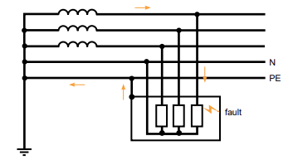
Fig. 3: TN-S Network [2]
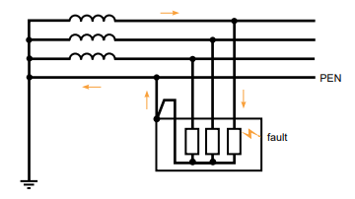
Fig. 4: TN-C Network [2]

hazardous results. The grounded neutral prevents over-voltages phases during transient or line faults [5]. In order to mitigate the risk of broken neutrals, special cable types are needed [2].
TN-C-S Network is a compromise between TN-C and TN-S techniques. It has a combined Protective Earth and Neutral conductor PEN between the distribution transformer and the building distribution point; but separate PE and N conductors are used in indoor wiring; as shown in Fig. 5. There is no direct local Earth connection at consumer end. Hence, the cost of conductors is intermediate between TN-C and TN-S techniques. This technique also provides a low Earth fault loop impedance to ensure safety [5]. If the Neutral is broken, the Neutral wire and hence the Earth wire will attain a floating voltage due to load imbalances on different phases. This will make the metal body of the consumer device attain a dangerous voltage and lead to hazardous results [5]. The grounded neutral prevents over-voltages on the phases during transient or line faults. It is less safe than TN-S but more safe than TN-C technique [2].

B. TT Networks
TT distribution networks have independent local Earth connections for the distribution transformer and the consumer. A 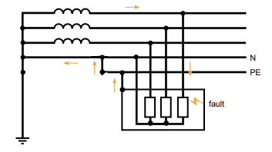
Fig. 5: TN-C-S Network [2]
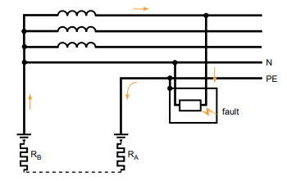
Fig. 6: TT Network [2]
direct Earth connection is provided at the star point of the distribution transformer; and the consumer has a separate local Earth connection using Earth electrode for protection as in Fig. 6. This saves the cost of Earth line from distribution Transformer to the consumer. The local Earth electrode results in a high fault loop impedance hence a Residual Current Device is needed for protection [5]. In case of broken Neutral, if the Neutral attains a floating voltage, the consumer end Earth conductor will not be affected because it is locally grounded; unlike the TN Network cases [2]. The potential of consumer end Earth is pinned at zero volts even in the case of load imbalances on different phases; or electromagnetic interference. This prevents over-voltages on the phases during transient or line faults. Hence, TT Networks are more reliable as compared to TN networks [2].

C. IT Networks
IT Networks do not have a local Earth connection at the distribution transformer; except perhaps through a high impedance (1500 Ω). The consumer is provided with a local Earth connection shown in Fig. 7. The local Earth electrode results in a high fault loop impedance but it saves the cost of Earth line from distribution Transformer to the consumer. 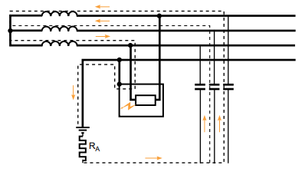
Fig. 7: IT Network [2]
If a fault occurs on two phases, circulation currents can lead to a double fault. In case of broken Neutral, the consumer end Earth conductor will not be affected because it is locally grounded; unlike the case of TN networks [2]. However, this can lead to over-voltages equal to line-line voltage during transient or line faults; unlike the cases of TT and TN networks which have grounded neutrals. Hence IT Networks ensure safety as well as continuity of service.

Conclusion

The methods of Earthing are dictated by stringent regulations formulated after decades of evolution. The general tendency for Earthing systems is to limit insulation fault currents. Although low impedance is vital for protection schemes, limiting the fault current simplifies maintainability of insulation, minimizes fire hazards, reduces contact voltage and minimizes disturbance to potential reference by current harmonics [4]. The presented Earthing systems (TN, TT and IT) guarantee personnel protection and continuity of service; but each has its own drawbacks. Although, the expensive TN systems are the safest because they provide the lowest Earth impedance, IT and TT networks provide a high impedance isolated Earth connection which prevents sensitive consumer devices from electromagnetic interference and ensures continuity of operation. It is safer to reduce fault loop impedance, but this affects the reliability of the system.
.
References
- G. K. Agrawal, YouTube, 16-Dec-2016. [Online]. Available: https://www.youtube.com/watch?v=Rydi3AqMgcw. [Accessed: 02-Dec-2018].
- Lacroix, B. and Calvas R. Earthing Systems Worldwide and Evolutions. [online] pp. 1-24. Available: https://download.schneider-electric.com/files?p_enDocType=Cahier+Technique&p_File_Name=ECT173.pdf&p_Doc_Ref=ECT173 [Accessed: 02-Dec-2018].
- Glenney, J. et al. The Importance of Neutral Grounding Resistor. [online] pp.24-46. Available: http://www.wmea.net/Technical%20Papers/The%20Importance%20of%20the%20Neutral%20Grounding%20Resistor%20-%20Nov%2006.pdf [Accessed: 02-Dec-2018].
- Jiguparmar, “Types of neutral earthing in power distribution (part 1),” EEP - Electrical Engineering Portal, 02-Jul-2018. [Online]. Available: https://electrical-engineering-portal.com/types-of-neutral-earthing-in-power-distribution-part-1. [Accessed: 02-Dec-2018].
- Guldbrand, A. System Earthing. [online] pp. 3-13. Available: http://www.iea.lth.se/publications/Reports/LTH-IEA-7216.pdf. [Accessed: 02-Dec-2018].
- Fischer, N. and Hou, D. Methods of Detecting Ground Faults in Medium Voltage Distribution Power Systems. [online] pp.1-19. Available: https://cdn.selinc.com/assets/Literature/Publications/White%20Papers/0001_MethodsDetectingGroundFaults_NF_20061010.pdf?v=20170218-001017. [Accessed: 02-Dec-2018].
- Bayliss, C. Transmission and Distribution Electrical Engineering. pp. 214-227. S.l.: NEWNES, 2017.

