# Instructions

**Downloading all the files**

1. Download and install git software (<https://git-scm.com/download>).

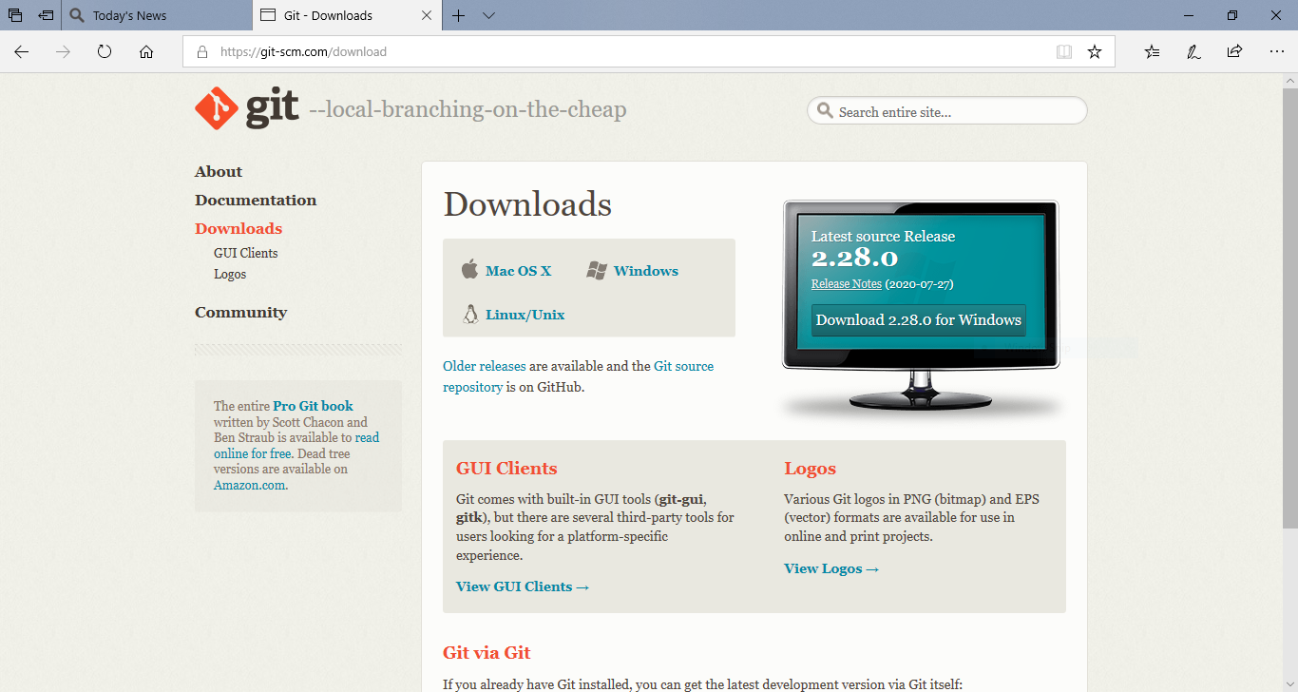

1. Make a new folder BLDCMotor.

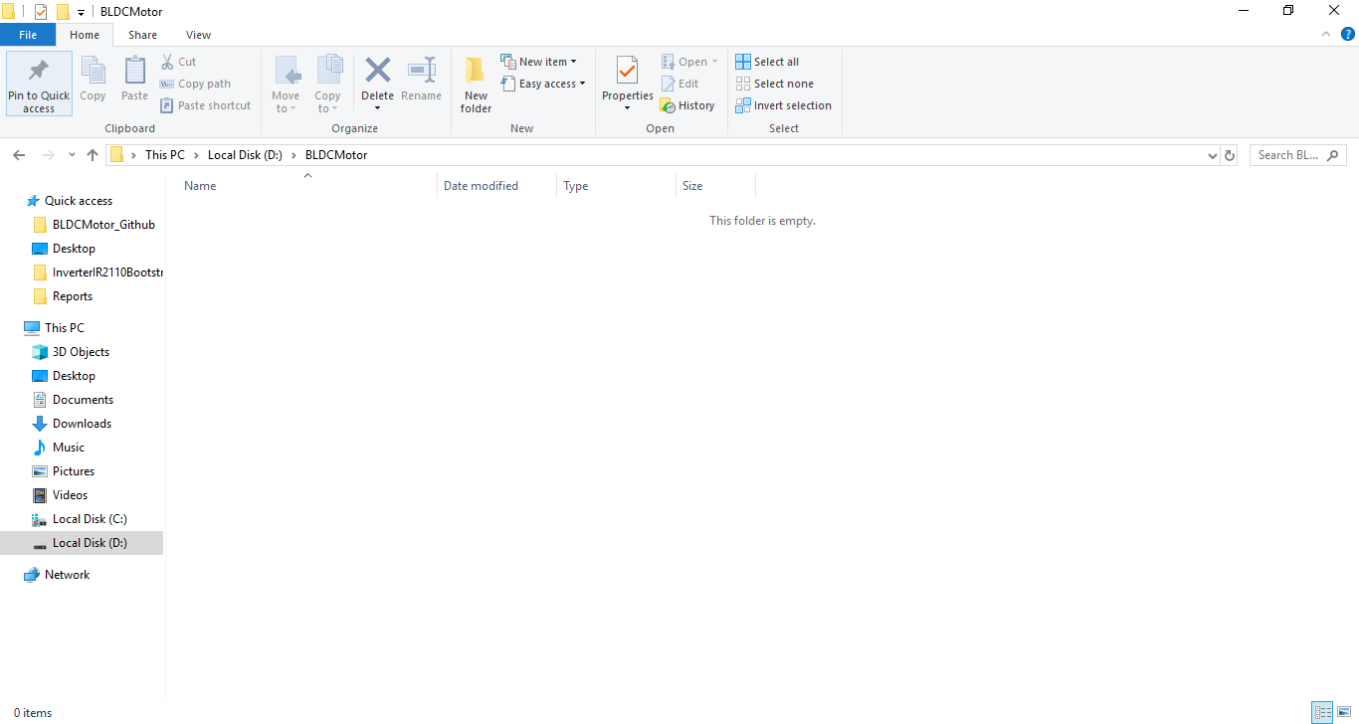

1. Open command prompt in the folder BLDCMotor. Write cmd in the bar and press enter

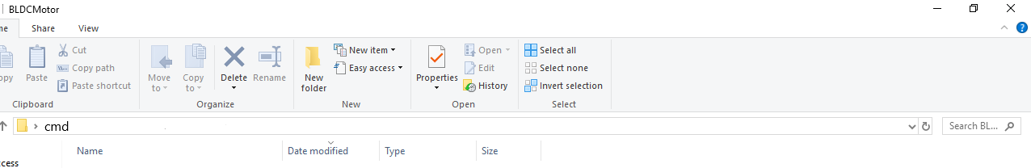

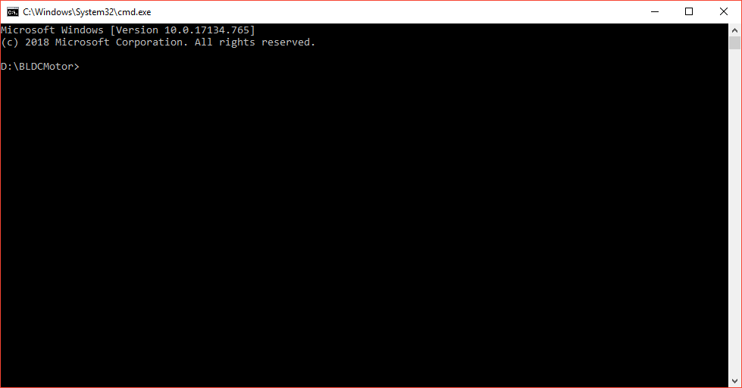

1. Run this command in command prompt: git clone https://github.com/MuhammadShamaasGLISTAR/BLDCMotor

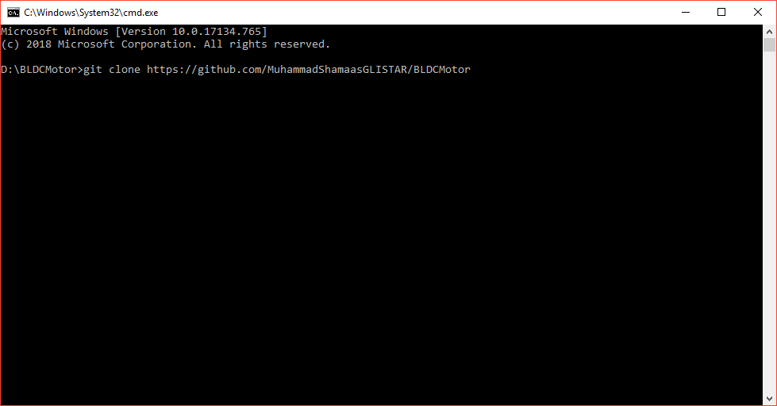

1. After the download is complete, the folder must contain all the files and folders and a hidden .git folder.

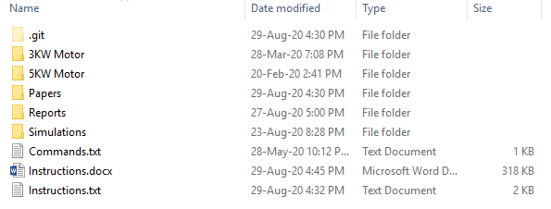

**Updating all the files and folders**

1. Open command prompt in the folder BLDCMotor.

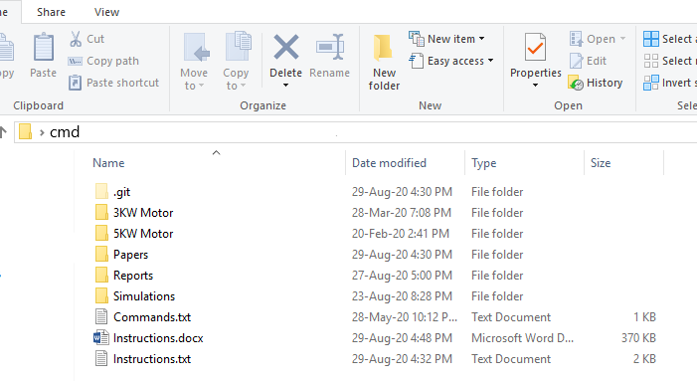

1. Run this command in the command prompt: git pull

