Muhammad Shamaas

14 April 2020

Design of Brushless DC Motor Driver and Controller

GLISTAR Research Laboratory University of Lahore

Contents

1. Working of Brushless DC Motor 1

2. Modeling of Brushless DC Motor 7

3. Design of Brushless DC Motor Controller 11

3.1. Direct Torque Control 14

3.2. Field Oriented Control 17

3.3. Space Vector PWM 19

3.4. Safety and Protection of Devices 31

3.5. Open Loop Control 32

3.6. Speed Control 38

3.7. Current Control 39

4. Progress 40

4.1. Inverter with Transformer Isolation 40

4.2. Inverter with Optical Isolation and Level Shifter 44

# Working of Brushless DC Motor

A brushless DC motor is a permanent magnet synchronous electric motor which is driven by direct current electricity. These motors an indispensable part of modern drive technology, most commonly employed for actuating drives, machine tools, electric propulsion, robotics, computer peripherals and also for electrical power generation. With the development of sensor-less technology besides digital control, these motors have become very effective in terms of total system cost, size and reliability.

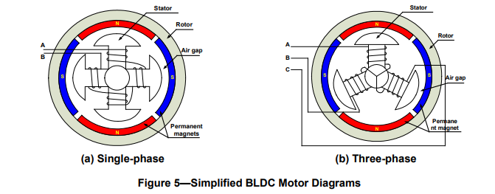

Brushless DC motor is driven by electronically controlled commutation. The phase currents are changed at appropriate times to rotate the rotor magnet to desired position. The energization of stator windings produces a magnetic field which attracts or repels the rotor for a short time so that the two magnetic fields align. 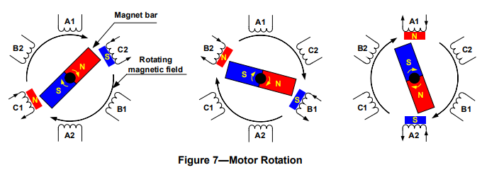

Commutation is achieved by controlling the switches of a three phase bridge.

Brushless DC Motor has a high efficiency and power to size ratio. It is capable of generating constant torque even at very high speeds. Moreover, it requires minimal maintenance due to superior thermal performance and absence of commutation brushes.

|  |  |  |  |
| --- | --- | --- | --- |
| Feature | Brushless DC Motor | Brushed DC Motor | Induction Motor |
| Rotor Structure | Field Magnets are made of permanent magnets. | Field Magnets are made of electromagnets. | Field Magnets are made of electromagnets. |
| Commutation | Electronic Commutation based on rotor position information. | Mechanical brushes and commutator. | Special Starting circuit required. |
| Efficiency | High. Electronic switches are more efficient than commutator/ brushes arrangement. | Moderate. Rotor Losses reduce efficiency. | Moderate. Rotor Losses reduce efficiency. |
| Maintenance | Little. No maintenance required for brushes/ commutator. | Periodic. Maintenance required for brushes/ commutator. | Little. No maintenance required for brushes/ commutator. |
| Thermal Performance | Better. The rotor does not generate heat. | Poor. Both the rotor and stator generate heat. | Moderate. Both the rotor and stator generate heat. |
| Output Power/ Frame size (Ratio) | High. Modern Permanent Magnet. | Moderate/ Low. Rotor Losses reduce efficiency. | Moderate/ Low. Rotor Losses reduce efficiency. |
| Speed/ Torque characteristics | Flat. | Moderately Flat. | Nonlinear. Lower Torque at lower speeds. |
| Dynamic Response | Fast. | Slow. | Slow. |
| Speed Range | High. No limitation imposed by brushes/ commutator. | Low. Rotor losses increase at high speeds. | Low. The rotor runs at a lower frequency than stator by slip frequency and slip increases with load. |
| Electric Noise | Low. | High. Sparking occurs at brushes. | Low. |
| Lifetime | Long. | Short. | Moderate. |
| Self-Starting | No. Synchronous operation. Controller is always required for variable speed. | Yes. Controller is only required for variable speed | Yes. Starting circuit is always required for starting. |
| Direction Reversal | Reversing the switching sequence. | Reversing the terminal voltage. | Changing two phases of motor input. |
| System Cost | High. The controller is expensive. | Low. | Low. |

The commutation is achieved based on the inputs of Hall sensors attached around the rotor.

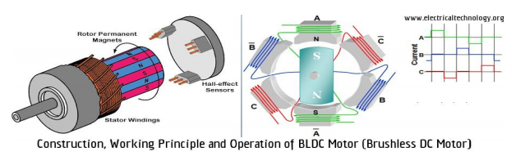

The Hall sensor inputs are used to control the 3-phase bridge switches and the voltages applied to the stator windings.

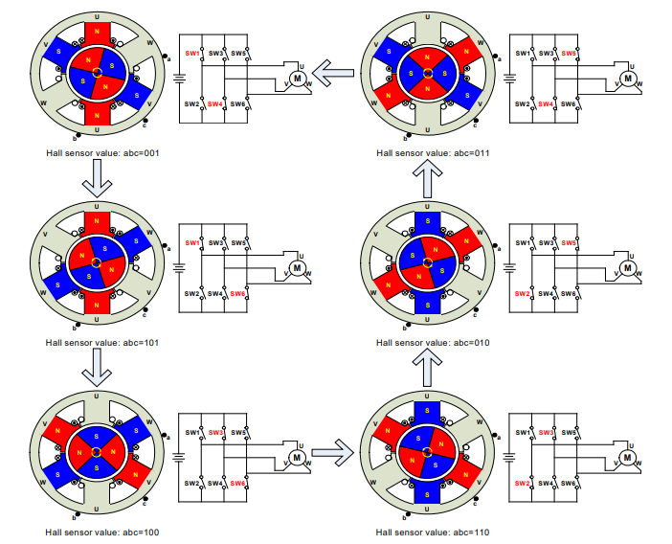

The resulting variation of Hall Sensor signals, Phase voltages and Line-Line voltages is shown below for one mechanical rotation.

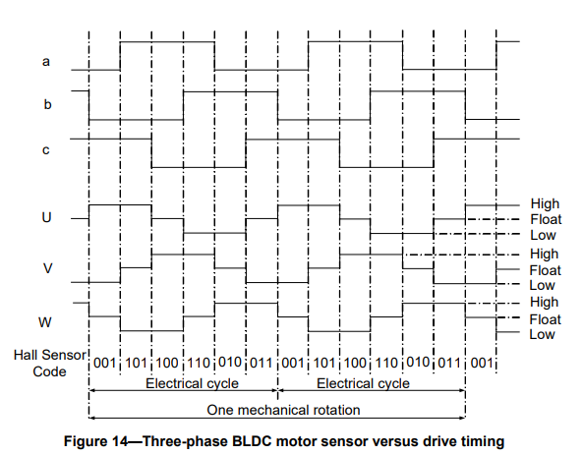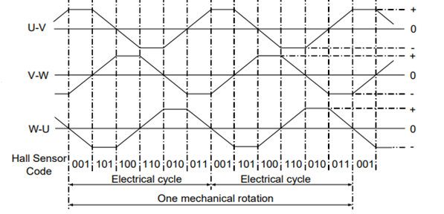

The motor properties of sample BLDC Motors is given in tabular form below.

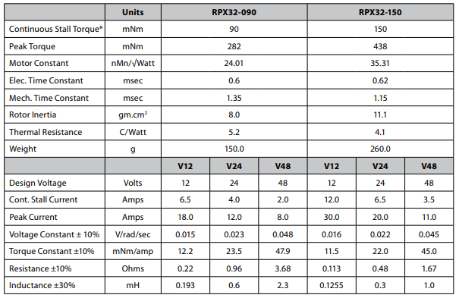

The Torque and Power characteristics are shown in graphical form below.

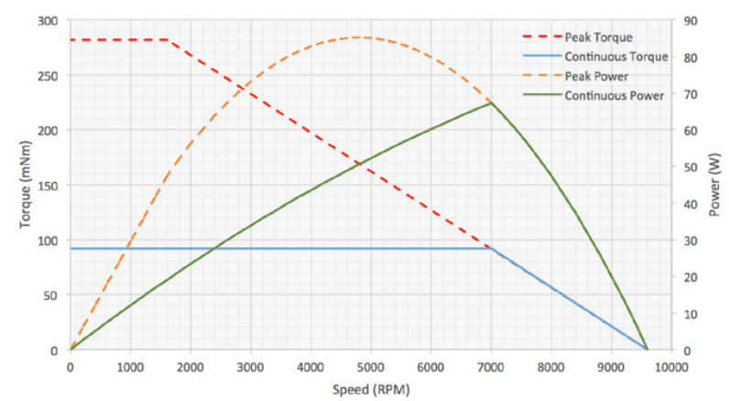

# Modeling of Brushless DC Motor

The equivalent motor electrical circuit is given below.

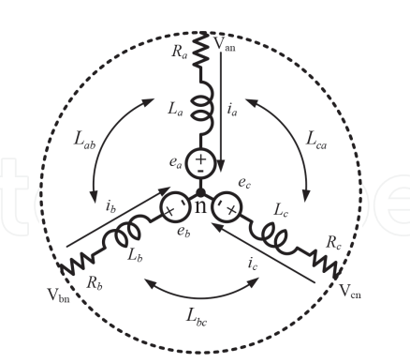

The motor equations are:

The Hall sensor signals and Back EMF waveforms are shown in the graphs below.

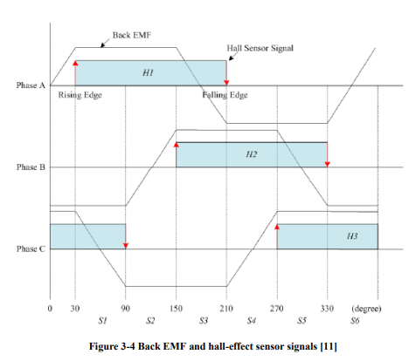

The Hall Signals are represented by

The Mechanical System Equations are,

For a balanced system,

In steady state,

The -axis model of the motor can be obtained by decomposing the voltage, current and flux linkage space-vectors into their corresponding α-axis and β-axis components.

If the α-axis is aligned with the a-axis,

The dq-axis rotating reference frame is derived by substituting θ = :

The -axis model of the motor can be obtained by decomposing the voltage, current and flux linkage space-vectors into their corresponding d-axis and q-axis components.

The resulting dq-axis model equations are:

1. Flux Linkage Equations:
2. Voltage Equations
3. Torque Equation

For balanced system, Maximum Torque Operation is achieved when

# Design of Brushless DC Motor Controller

The purpose of Brushless DC motor controller is to drive the motor. It may also control the motor speed, torque or current. The controller requires the information of rotor position to decide the switching sequence for the Bridge of Electronic switches.

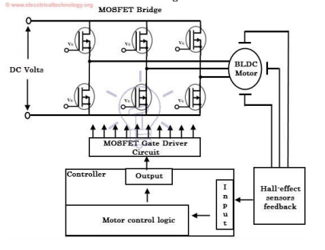

The Motor controllers can be classified as Scalar or Vector Controllers. Scalar Control relies on adjustment of stator voltage or frequency to keep the stator flux constant. Vector control techniques include Field Oriented Control and Direct Torque Control. These schemes will be discussed in the next section

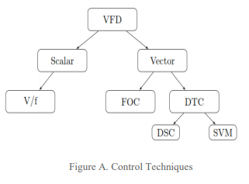

The plant model for the Brushless DC motor is

The current controller can be designed to adjust the average stator voltage applied across stator windings. This can be achieved using a Pulse Width Modulation technique. Before this, the currents must be sensed using current sensors and a low pass filter.

The current controller can be realized using a PI controller to track current reference and generate correction voltage command.

A speed controller can be designed to track a speed reference. It works by comparing the motor speed with the reference speed. The error is passed through a PI speed controller.

The controller generates a Torque/ current reference for the cascaded current controller. The complete cascaded controller is shown below.

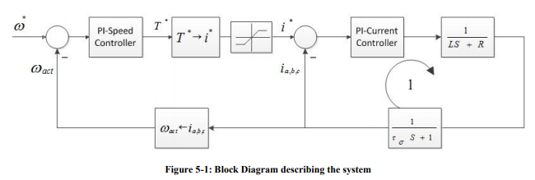

The complete system for speed control of Brushless DC Motor is shown below.

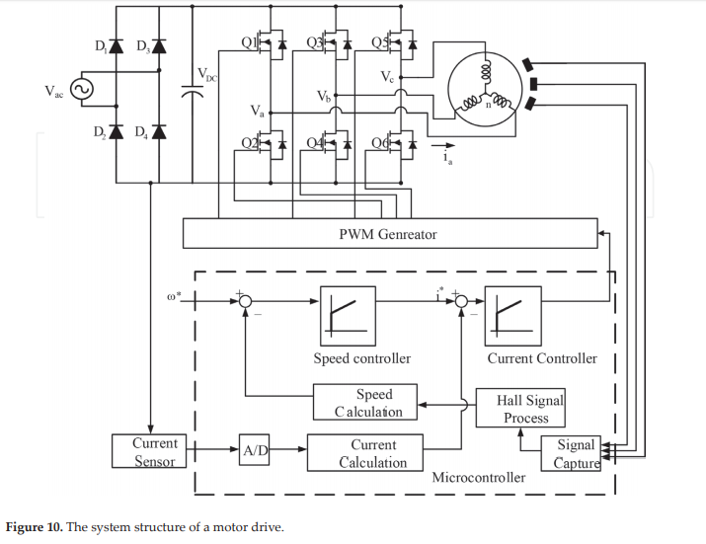

## Direct Torque Control

The Electromagnetic Torque of Brushless DC Motor can be expressed as

The first component of Torque results from field excitation. It is responsible for driving the load hence it must be maximized by controlling the stator flux , or the sine of angle between stator flux and rotor flux . This is the basis of Direct Torque Control.

The second component is responsible for producing pulsating reluctance torque which results in wastage of energy. For this reason, the second component of Torque must be zero by ensuring (non-salient motor) or .

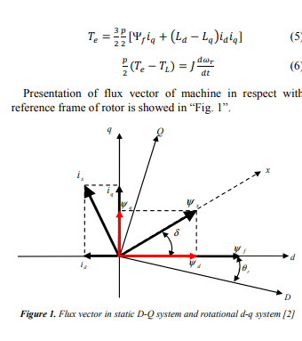

The Direct Torque Controller works by changing the stator flux , or the sine of angle between stator flux and rotor flux . This is achieved by applying the appropriate stator voltage vector to correct the stator flux.

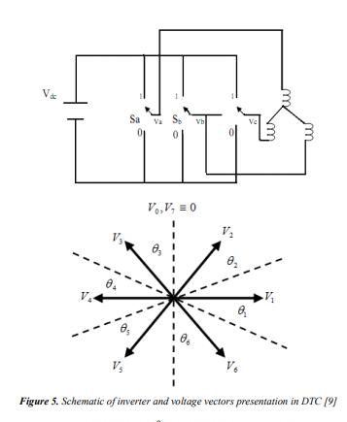

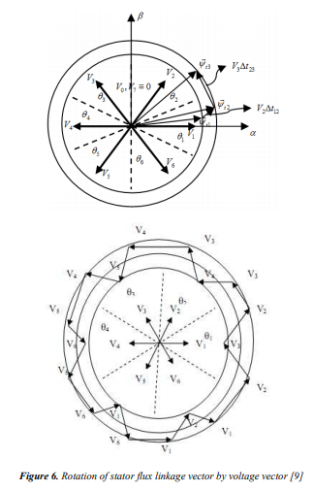

The resultant stator flux is approximately

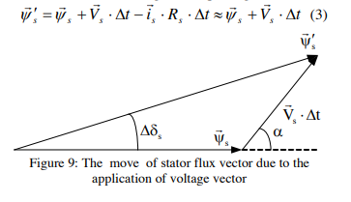

The Controller works by comparing stator flux and torque to their reference values. A hysteresis comparator generates correction commands to tweak the stator flux by application of correction voltage.

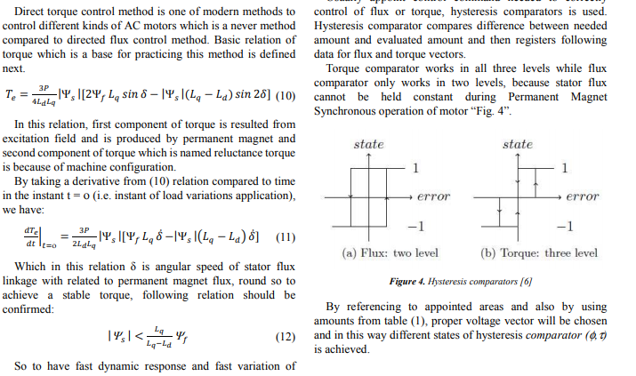

Correction voltage command depends on the voltage sector of Stator voltage. The commands are stored in a switching table to make the process efficient and fast. Usually a switching frequency of 10kHz is chosen.

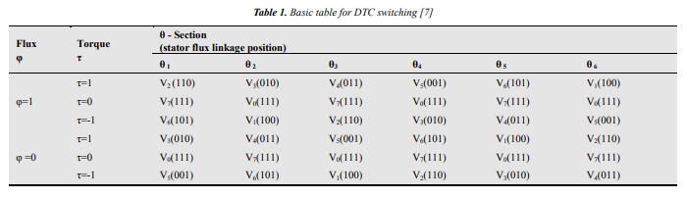

The overall block diagram for Direct Torque Control is given below.

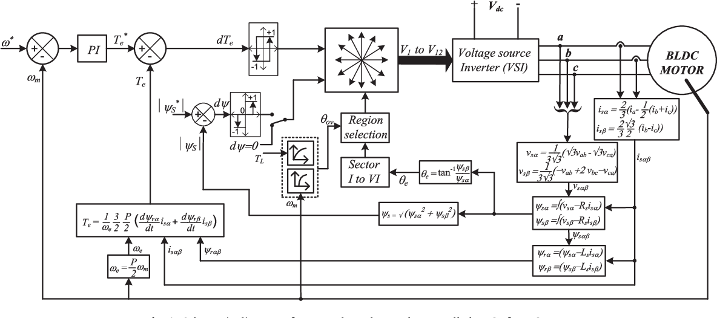

## Field Oriented Control

The Electromagnetic Torque of Brushless DC Motor can be expressed as

The first component of Torque results from field excitation. It is responsible for driving the load hence it must be maximized by controlling the quadrature component of stator current . This is the basis of Field Oriented Control.

The second component is responsible for producing reluctance torque which results in wastage of energy. For this reason, the second component of Torque must be zero by ensuring (non-salient motor) or .

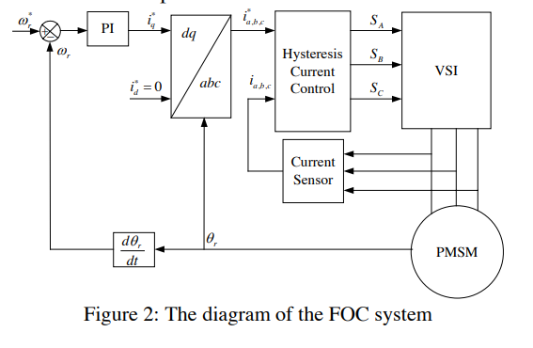

The abc/dq and dq/abc reference frame transformations require the measurement of rotor angle/ speed. A speed sensor can be used for this purpose. A Phase Locked Loop can also be used to track the motor speed using Hall Sensor signals.

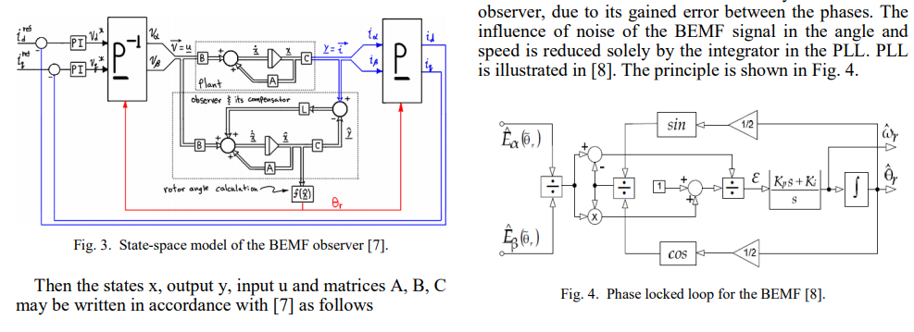

The Field Oriented Controller can be used for the direct control of Torque and stator flux. Separate Controllers must be designed as shown below.

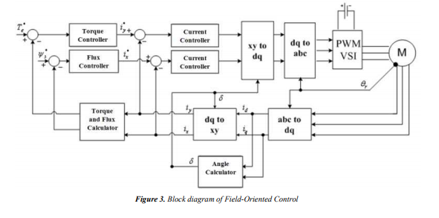

Field Oriented Control requires complex computations because it involves system transformations. It also needs the sensor position unlike Direct Torque Controller. Ultimately, Field Oriented Control is more precise and complex, much slower and more sensitive to sensor errors and parameter variation as compared to Direct Torque Control.

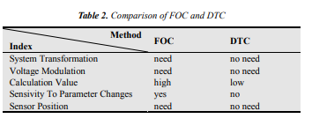

## Space Vector PWM

Space vector modulation (SVM) is a real-time modulation technique widely used for digital control of voltage source inverters. The operating status of the switches in the two-level inverter can be represented by switching states. The switching state ‘P’ denotes that the upper switch in an inverter leg is on and the inverter terminal voltage is positive (+Vdc) while ‘O’ indicates that the inverter terminal voltage is zero due to the conduction of the lower switch.

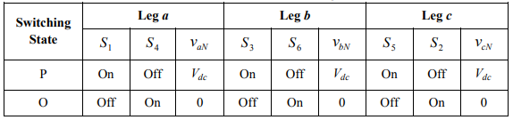

There are eight possible combinations of switching states in the two-level inverter. Among the eight switching states, [PPP] and [OOO] are zero states and the others are active states.

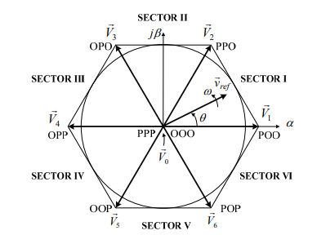

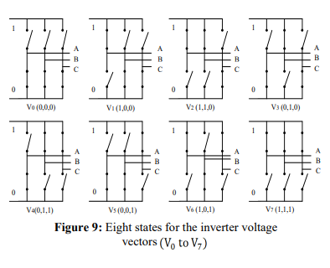

The active and zero switching states can be represented by active and zero space vectors, respectively in the αβ reference frame. The space vector diagram below represents the six active vectors which form a regular hexagon with six equal sectors (I to VI). The zero vector V0 lies on the center of the hexagon.

where k represents the sector.

For a given magnitude and position, can be synthesized by three nearby stationary vectors (OOO, POO and PPO in sector 1), based on which the switching states of the inverter can be selected, and gate signals for the active switches can be generated. When passes through sectors one by one, different sets of switches will be turned on or off. As a result, when rotates one revolution in space, the inverter output voltage varies one cycle over time.

The inverter output frequency corresponds to the rotating speed of while its output voltage can be adjusted by the modulation index:

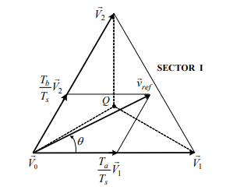

The dwell time for the stationary vectors represents the duty-cycle time of the chosen switches during a sampling period Ts. The dwell time calculation is based on ‘volt-second balancing’ principle, that is, the product of the reference voltage and sampling period Ts equals the sum of the voltage multiplied by the time interval of chosen space vectors. Assuming that the sampling period Ts is sufficiently small, the reference vector ref v r can be considered constant during Ts. Under this assumption, can be approximated by two adjacent active vectors and one zero vector. Ta , Tb and T0 are the dwell times for the vectors , and , respectively:

When is in other sectors, a multiple of π 3/ is subtracted from the actual angular displacement θ such that the modified angle θ ′ falls into the range between zero and π 3/ for use in the equation, that is,

for 0 ≤ θ′ <

where k = 1, 2, …6 for sectors I, II, …, VI, respectively. For example, when is in sector II, the calculated dwell times Ta, Tb and T0 are for vectors , and respectively.

With the space vectors selected and their dwell times calculated, the next step is to arrange switching sequence. In general, the switching sequence design for a given is not unique, but it should satisfy the following two requirements for the minimization of the device switching frequency:

a) The transition from one switching state to the next involves only two switches in the same inverter leg, one being switched on and the other switched off;

b) The transition for ref v r moving from one sector in the space vector diagram to the next requires no or minimum number of switching.

The optimized seven segment switching sequence is given in the table below.

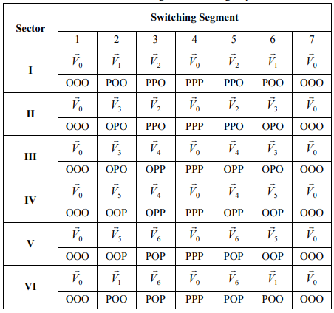

The switching commands are stored in a switching table to make the process efficient and fast.

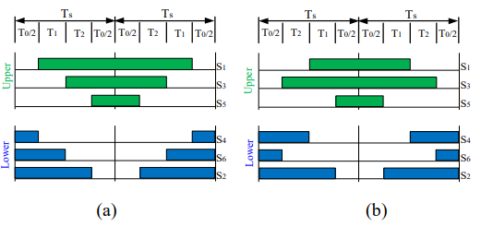

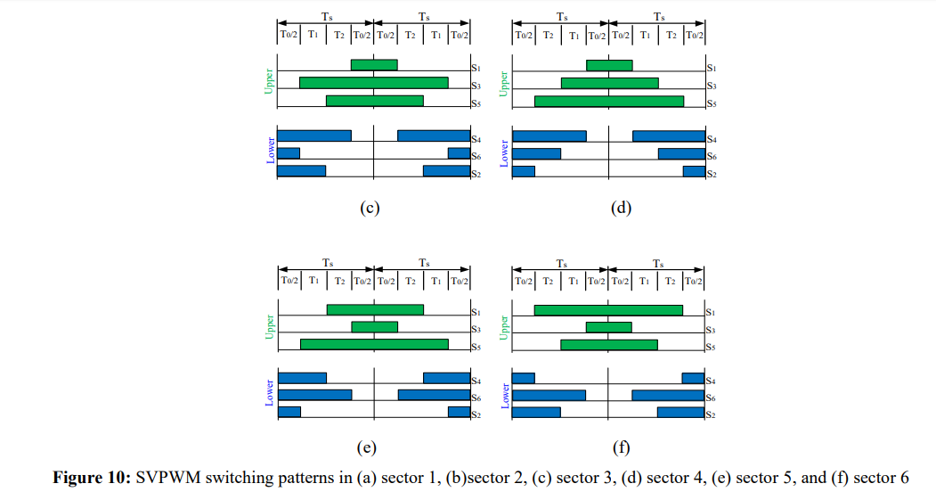

The resulting stator voltages for the eight sectors are shown in the table below.

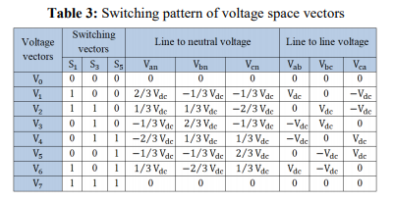

The results are presented in graphical form below.

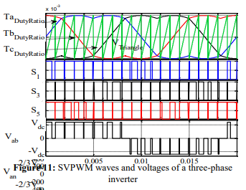

The overall Space Vector Modulation block diagram is given below.

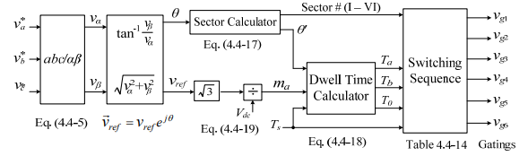

**MATLAB Simulation for Brushless DC Motor Field Oriented Control using SVPWM**

A Field Oriented Controller based on SVPWM was built in MATLAB to drive a sample Brushless DC Motor. The controller maximized torque by tracking id=0A and iq=2A using PI controllers. The Modulator switching frequency was 20kHz. The MATLAB model is given below.

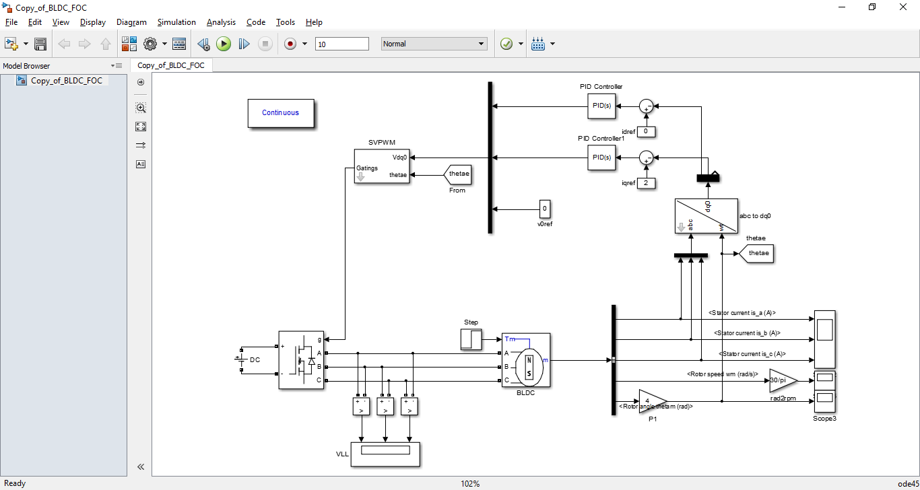

The stator currents in abc and dq0 reference frames, the line to line voltage and speed are plotted in the graphs below.

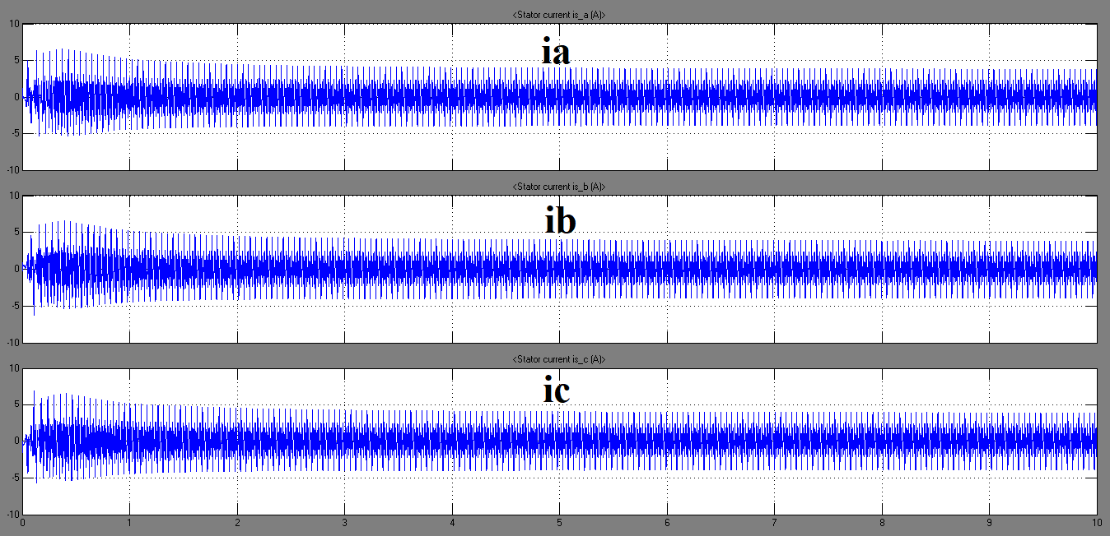

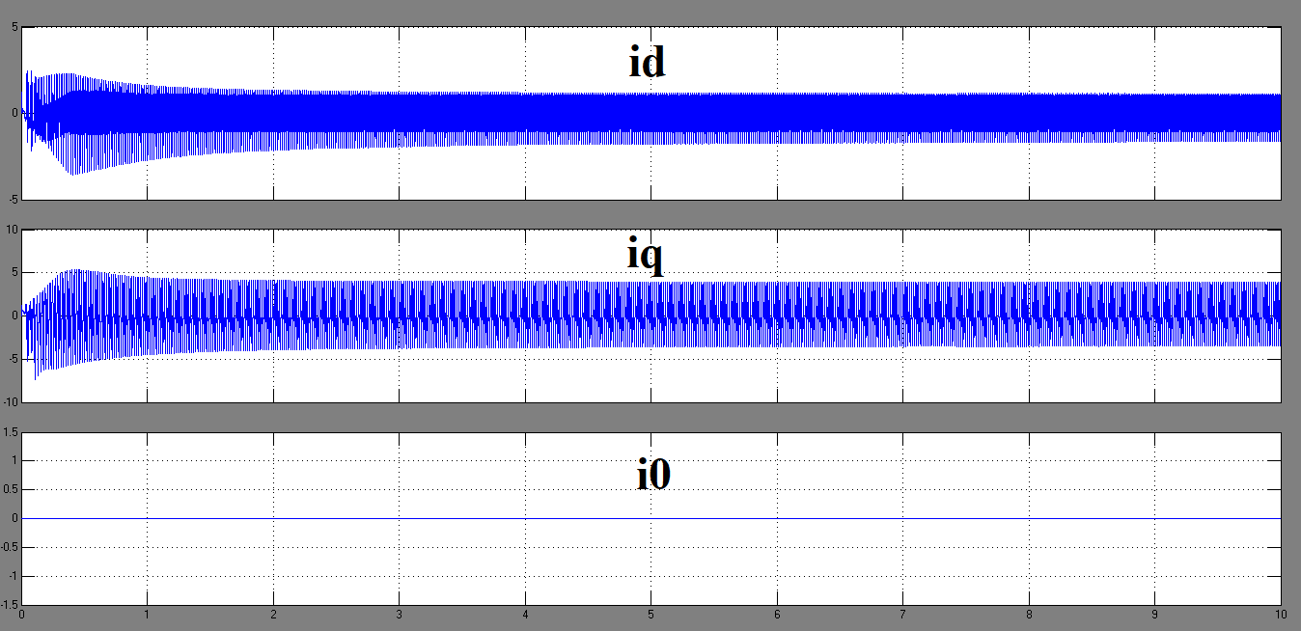

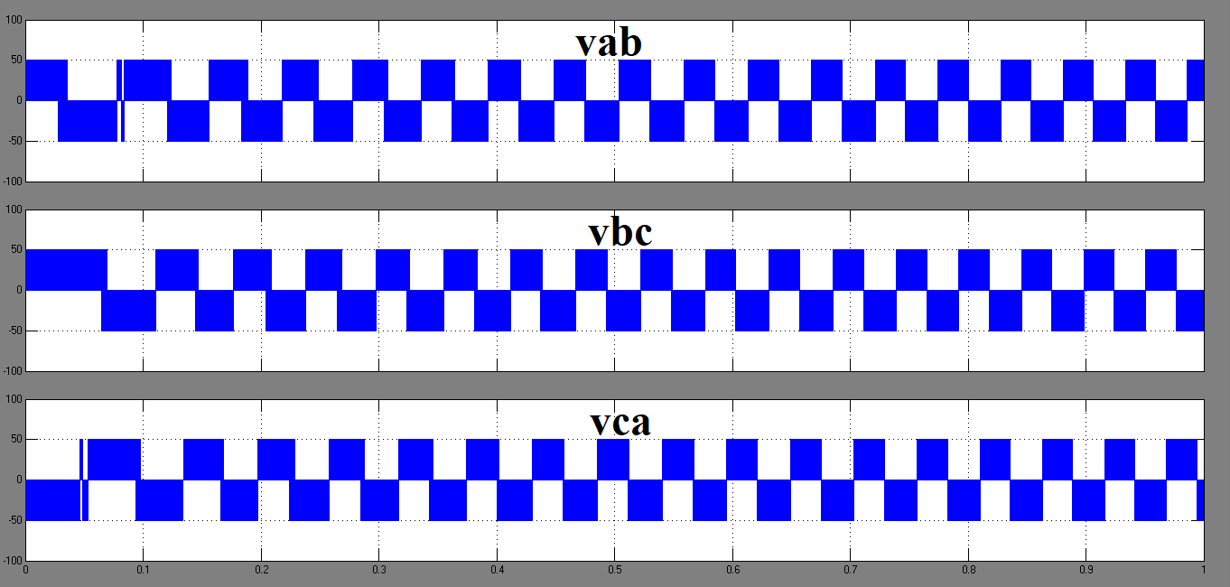

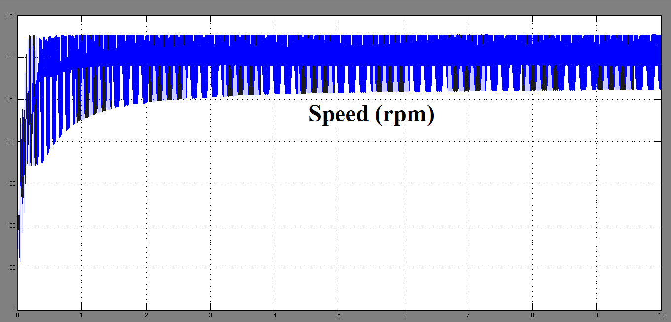

**Arduino Code for SVPWM Controller**

int PhaseaUpperPin=2;

int PhaseaLowerPin=3;

int PhasebUpperPin=4;

int PhasebLowerPin=5;

int PhasecUpperPin=6;

int PhasecLowerPin=7;

int HallaPin=8;

int HallbPin=9;

int HallcPin=10;

int IaPin=11;

int IbPin=12;

int IcPin=13;

int HALLA=LOW;

int HALLB=LOW;

int HALLC=LOW;

int oldstate, newstate;

double Ts=1e-3;

double vref=25;

double Vdc=50;

double thetam, oldthetam, thetae;

double oldspeed,newspeed;

int Poles=4;

double IA,IB,IC;

double VA,VB,VC;

double Id,Iq,I0;

double Vd,Vq,V0;

double Ialpha,Ibeta;

double Valpha,Vbeta;

double Idref,Iqref,I0ref;

double Vdref,Vqref,V0ref;

double IdErrorNew,IqErrorNew,I0ErrorNew;

double IdErrorOld,IqErrorOld,I0ErrorOld;

double T1,T2,T0;

int sector;

double kp,ki;

double oldtime,newtime,dt;

double theta0=PI/6;

void writeState (int s)

{

if ((s&B100)>>2)

{

digitalWrite(PhaseaUpperPin, HIGH);digitalWrite(PhaseaLowerPin, LOW);

}

else

{

digitalWrite(PhaseaUpperPin, LOW);digitalWrite(PhaseaLowerPin, HIGH);

}

if ((s&B010)>>1)

{

digitalWrite(PhasebUpperPin, HIGH);digitalWrite(PhasebLowerPin, LOW);

}

else

{

digitalWrite(PhasebUpperPin, LOW);digitalWrite(PhasebLowerPin, HIGH);

}

if (s&B001)

{

digitalWrite(PhasecUpperPin, HIGH);digitalWrite(PhasecLowerPin, LOW);

}

else

{

digitalWrite(PhasecUpperPin, LOW);digitalWrite(PhasecLowerPin, HIGH);

}

}

void setup()

{

pinMode(PhaseaUpperPin, OUTPUT);

pinMode(PhaseaLowerPin, OUTPUT);

pinMode(PhasebUpperPin, OUTPUT);

pinMode(PhasebLowerPin, OUTPUT);

pinMode(PhasecUpperPin, OUTPUT);

pinMode(PhasecLowerPin, OUTPUT);

pinMode(HallaPin, INPUT);

pinMode(HallbPin, INPUT);

pinMode(HallcPin, INPUT);

digitalWrite(PhaseaUpperPin, LOW);

digitalWrite(PhaseaLowerPin, LOW);

digitalWrite(PhasebUpperPin, LOW);

digitalWrite(PhasebLowerPin, LOW);

digitalWrite(PhasecUpperPin, LOW);

digitalWrite(PhasecLowerPin, LOW);

}

void loop()

{

oldstate=newstate;

HALLA=digitalRead(HallaPin);

HALLB=digitalRead(HallbPin);

HALLC=digitalRead(HallcPin);

newstate=(HALLC<<2)|(HALLB<<1)|(HALLA);

if(newstate!=oldstate)

{

oldtime=newtime;

newtime=millis();

dt=newtime-oldtime;

thetam=oldthetam+theta0;

oldthetam=thetam;

if(thetam>(2*PI))

{

thetam=thetam-(2*PI);

}

oldspeed=newspeed;

newspeed=theta0/dt;

}

else

{

dt=millis()-newtime;

thetam=thetam+newspeed*dt;

}

thetae=thetam*(Poles/2);

IA=analogRead(IaPin);

IB=analogRead(IbPin);

IC=analogRead(IcPin);

Ialpha=(2/3)*((1) *IA+(-1/2) *IB+(-1/2) *IC);

Ibeta =(2/3)*((0) *IA+(sqrt(3)/2)*IB+(-sqrt(3)/2)*IC);

I0= (2/3)*((1/2)*IA+(1/2) *IB+(1/2) *IC);

Id=Ialpha*( cos(thetae))+Ibeta*(sin(thetae));

Iq=Ialpha*(-sin(thetae))+Ibeta*(cos(thetae));

IqErrorOld=IqErrorNew;

IdErrorOld=IqErrorNew;

IqErrorNew=Iq-Iqref;

IdErrorNew=Id-Idref;

Vd=kp*IdErrorNew+ki*(0.5)*(IdErrorNew+IdErrorOld)*Ts;

Vq=kp*IqErrorNew+ki*(0.5)*(IqErrorNew+IqErrorOld)*Ts;;

vref=sqrt(Vd*Vd+Vq*Vq);

sector=(thetae/(PI/3))+1;

thetae=thetae-(sector-1)*(PI/3);

T1=sqrt(3)*Ts*vref*(1/Vdc)*sin((PI/3)-thetae);

T2=sqrt(3)*Ts*vref*(1/Vdc)*sin(thetae);

T0=Ts-T1-T2;

if (sector==1)

{

writeState(B000);delayMicroseconds(T0/2);

writeState(B100);delayMicroseconds(T1);

writeState(B110);delayMicroseconds(T2);

writeState(B111);delayMicroseconds(T0);

writeState(B110);delayMicroseconds(T2);

writeState(B100);delayMicroseconds(T1);

writeState(B000);delayMicroseconds(T0/2);

}

if (sector==2)

{

writeState(B000);delayMicroseconds(T0/2);

writeState(B010);delayMicroseconds(T2);

writeState(B110);delayMicroseconds(T1);

writeState(B111);delayMicroseconds(T0);

writeState(B110);delayMicroseconds(T1);

writeState(B010);delayMicroseconds(T2);

writeState(B000);delayMicroseconds(T0/2);

}

if (sector==3)

{

writeState(B000);delayMicroseconds(T0/2);

writeState(B010);delayMicroseconds(T1);

writeState(B011);delayMicroseconds(T2);

writeState(B111);delayMicroseconds(T0);

writeState(B011);delayMicroseconds(T2);

writeState(B010);delayMicroseconds(T1);

writeState(B000);delayMicroseconds(T0/2);

}

if (sector==4)

{

writeState(B000);delayMicroseconds(T0/2);

writeState(B001);delayMicroseconds(T2);

writeState(B011);delayMicroseconds(T1);

writeState(B111);delayMicroseconds(T0);

writeState(B011);delayMicroseconds(T1);

writeState(B001);delayMicroseconds(T2);

writeState(B000);delayMicroseconds(T0/2);

}

if (sector==5)

{

writeState(B000);delayMicroseconds(T0/2);

writeState(B001);delayMicroseconds(T1);

writeState(B101);delayMicroseconds(T2);

writeState(B111);delayMicroseconds(T0);

writeState(B101);delayMicroseconds(T2);

writeState(B001);delayMicroseconds(T1);

writeState(B000);delayMicroseconds(T0/2);

}

if (sector==6)

{

writeState(B000);delayMicroseconds(T0/2);

writeState(B001);delayMicroseconds(T2);

writeState(B011);delayMicroseconds(T1);

writeState(B111);delayMicroseconds(T0);

writeState(B011);delayMicroseconds(T1);

writeState(B001);delayMicroseconds(T2);

writeState(B000);delayMicroseconds(T0/2);

}

}

## Safety and Protection of Devices

In order to ensure safe and reliable operation of electronic switches and Brushless DC Motor, the switch voltages and currents must be sensed using special circuitry. Controllers must be designed to cause shutdown when necessary. The overall protection system containing sensors and amplifiers is shown below.

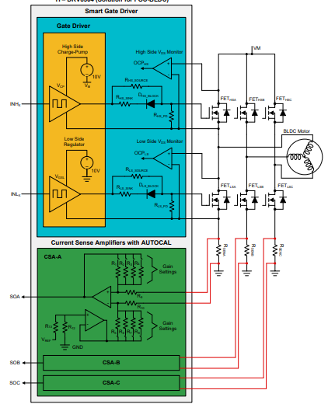

## Open Loop Control

The open loop controller drives the Brushless DC motor by electronically controlled commutation. The phase currents are changed at appropriate times to rotate the rotor magnet to desired position. The energization of stator windings produces a magnetic field which attracts or repels the rotor for a short time so that the two magnetic fields align.

The Simulink model for the simulation is shown below.

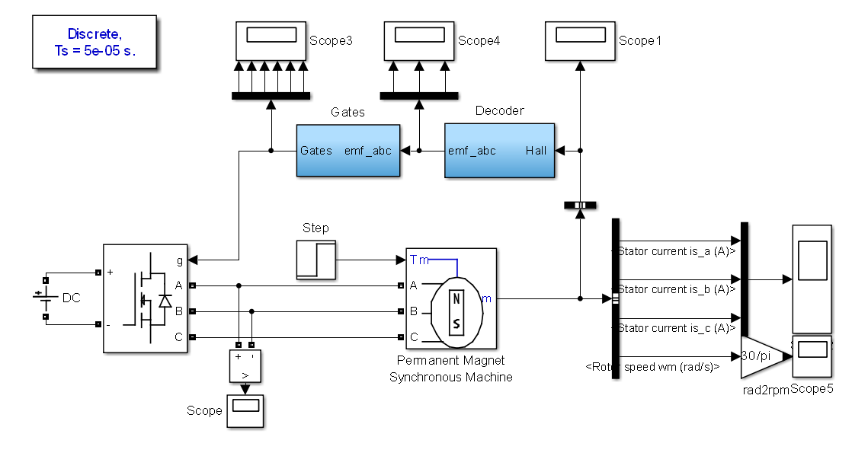

The switching scheme is based on the table and graphs below. 0 indicates logic low level. 1 indicates logic high level. Z indicates 0V. H indicates Vsource. L indicates –Vsource.

|  |  |  |
| --- | --- | --- |
| HALL Signals (ABC) | BACK EMF Signals (ABC) | GATE Signals (High Side ABC) |
| 000 | ZZZ | 000 |
| 001 | ZLH | 001 |
| 010 | LHZ | 010 |
| 011 | LZH | 001 |
| 100 | HZL | 100 |
| 101 | HLZ | 100 |
| 110 | ZHL | 010 |
| 111 | ZZZ | 000 |

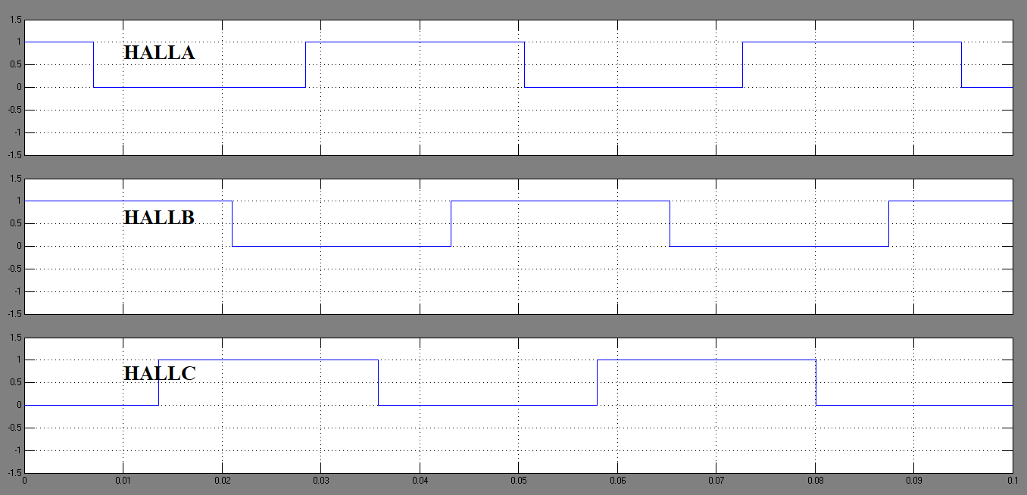

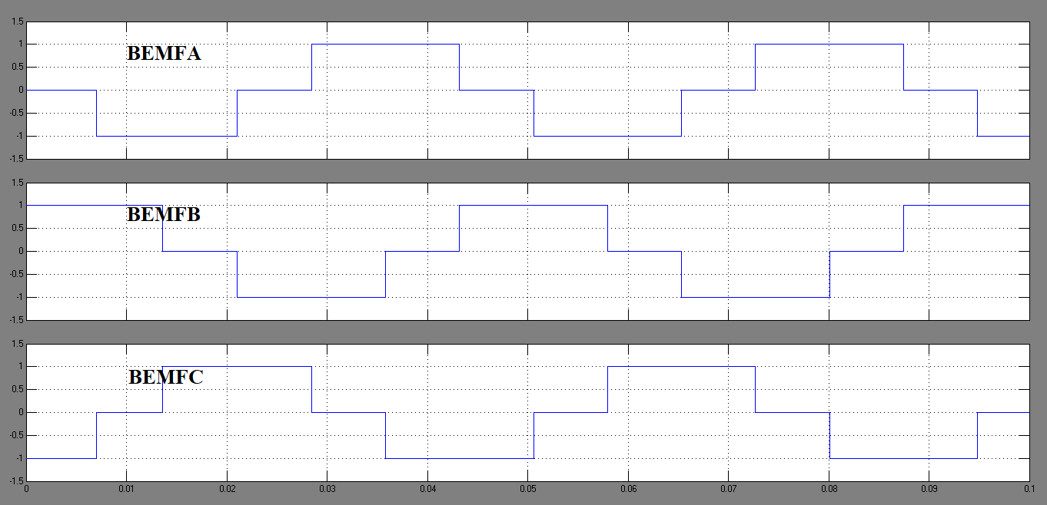

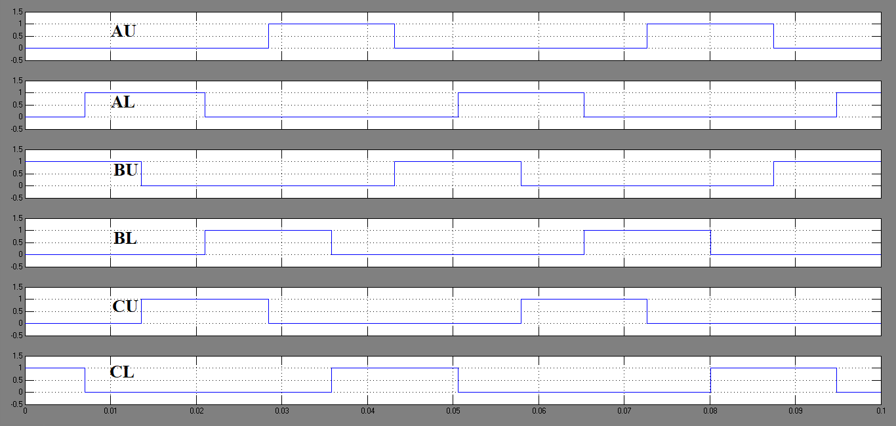

The motor speed, currents and line-line voltage are shown below.

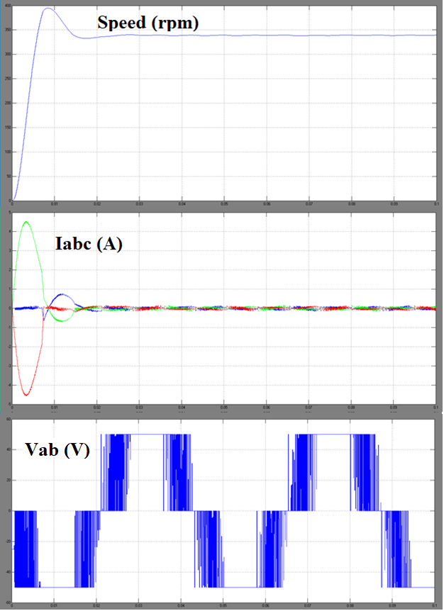

The PSIM Circuit for Open Loop Control is given below.

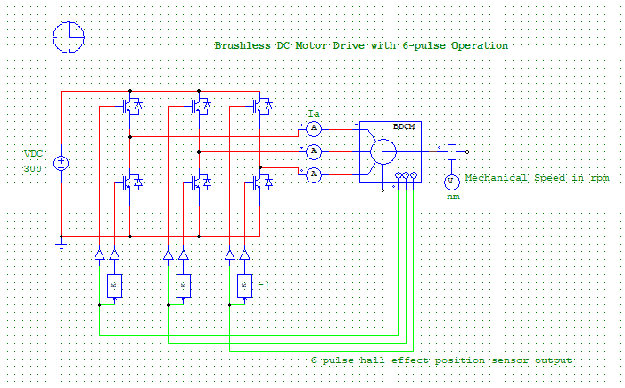

The Currents, speed and Torque are plotted below.

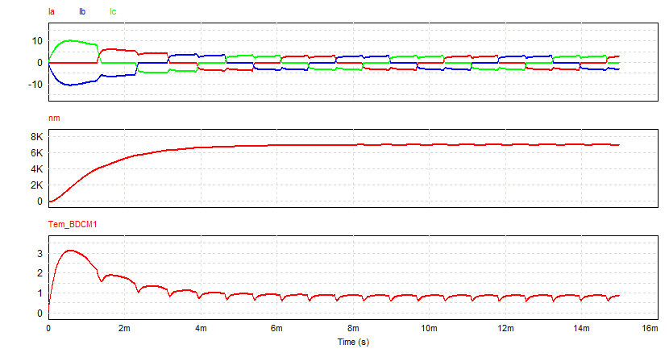

**Arduino Code for Open Loop Controller**

int PhaseaUpper=2;

int PhaseaLower=3;

int PhasebUpper=4;

int PhasebLower=5;

int PhasecUpper=6;

int PhasecLower=7;

int Halla=8

int Hallb=9

int Hallc=10

void setup()

{

pinMode(PhaseaUpper, OUTPUT);

pinMode(PhaseaLower, OUTPUT);

pinMode(PhasebUpper, OUTPUT);

pinMode(PhasebLower, OUTPUT);

pinMode(PhasecUpper, OUTPUT);

pinMode(PhasecLower, OUTPUT);

pinMode(Halla, INPUT);

pinMode(Hallb, INPUT);

pinMode(Hallc, INPUT);

digitalWrite(PhaseaUpper, LOW);

digitalWrite(PhaseaLower, LOW);

digitalWrite(PhasebUpper, LOW);

digitalWrite(PhasebLower, LOW);

digitalWrite(PhasecUpper, LOW);

digitalWrite(PhasecLower, LOW);

}

void loop()

{

digitalWrite(PhaseaUpper, digitalRead(Halla));

digitalWrite(PhaseaLower, !digitalRead(Halla));

digitalWrite(PhasebUpper, digitalRead(Hallb));

digitalWrite(PhasebLower, !digitalRead(Hallb));

digitalWrite(PhasecUpper, digitalRead(Hallc));

digitalWrite(PhasecLower, !digitalRead(Hallc));

}

## Speed Control

The PSIM model for Speed Control is shown below. The Speed, currents and Torque are plotted also.

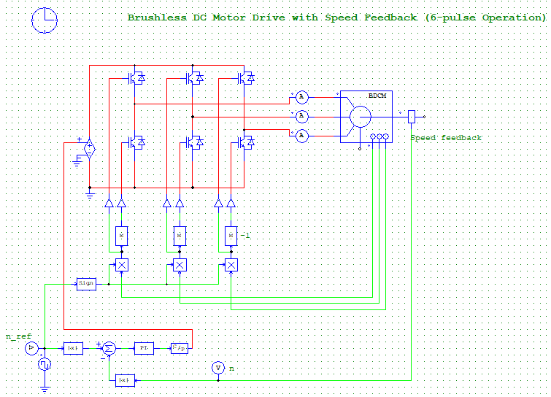

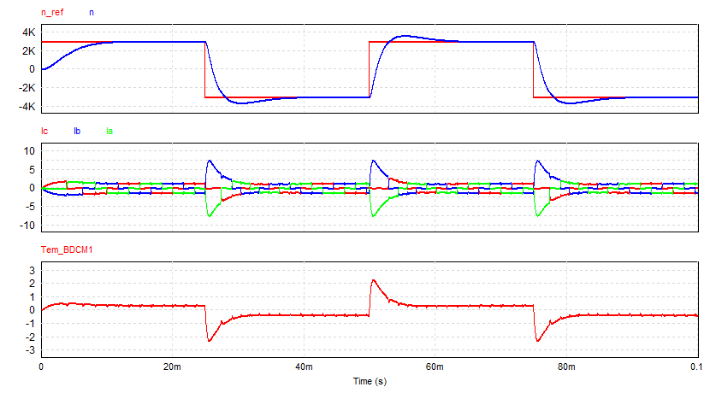

**Arduino Code for Speed Controller**

int PhaseaUpperPin=2;

int PhaseaLowerPin=3;

int PhasebUpperPin=4;

int PhasebLowerPin=5;

int PhasecUpperPin=6;

int PhasecLowerPin=7;

int HallaPin=8;

int HallbPin=9;

int HallcPin=10;

int SpeedPin=11;

int VoltageOutputPin=12;

int HALLA=LOW;

int HALLB=LOW;

int HALLC=LOW;

int oldstate, newstate;

double kp,ki, SpeedErrorNew, SpeedErrorOld;

double oldtime,newtime,dt;

double Speed, Speedref;

double Vref, Vdc, DutyCycle, Ts;

void writeState (int s)

{

if ((s&B100)>>2)

{

digitalWrite(PhaseaUpperPin, HIGH);digitalWrite(PhaseaLowerPin, LOW);

}

else

{

digitalWrite(PhaseaUpperPin, LOW);digitalWrite(PhaseaLowerPin, HIGH);

}

if ((s&B010)>>1)

{

digitalWrite(PhasebUpperPin, HIGH);digitalWrite(PhasebLowerPin, LOW);

}

else

{

digitalWrite(PhasebUpperPin, LOW);digitalWrite(PhasebLowerPin, HIGH);

}

if (s&B001)

{

digitalWrite(PhasecUpperPin, HIGH);digitalWrite(PhasecLowerPin, LOW);

}

else

{

digitalWrite(PhasecUpperPin, LOW);digitalWrite(PhasecLowerPin, HIGH);

}

}

void setup()

{

pinMode(PhaseaUpperPin, OUTPUT);

pinMode(PhaseaLowerPin, OUTPUT);

pinMode(PhasebUpperPin, OUTPUT);

pinMode(PhasebLowerPin, OUTPUT);

pinMode(PhasecUpperPin, OUTPUT);

pinMode(PhasecLowerPin, OUTPUT);

pinMode(VoltageOutputPin, OUTPUT);

pinMode(HallaPin, INPUT);

pinMode(HallbPin, INPUT);

pinMode(HallcPin, INPUT);

pinMode(SpeedPin, INPUT);

digitalWrite(PhaseaUpperPin, LOW);

digitalWrite(PhaseaLowerPin, LOW);

digitalWrite(PhasebUpperPin, LOW);

digitalWrite(PhasebLowerPin, LOW);

digitalWrite(PhasecUpperPin, LOW);

digitalWrite(PhasecLowerPin, LOW);

}

void loop()

{

HALLA=digitalRead(HallaPin);

HALLB=digitalRead(HallbPin);

HALLC=digitalRead(HallcPin);

newstate=(HALLC<<2)|(HALLB<<1)|(HALLA);

Speed=analogRead(SpeedPin);

SpeedErrorOld=SpeedErrorNew;

SpeedErrorNew=Speed-Speedref;

Vref=kp*SpeedErrorNew+ki*(0.5)*(SpeedErrorNew+SpeedErrorOld)*Ts;

DutyCycle=Vref/Vdc;

digitalWrite(VoltageOutputPin, HIGH);

writeState(newstate);

delayMicroseconds(DutyCycle*Ts);

digitalWrite(VoltageOutputPin, LOW);

delayMicroseconds((1-DutyCycle)*Ts);

}

## Current Control

The PSIM model for Current Control is shown below. The DC currents, phase currents and Speed are plotted also.

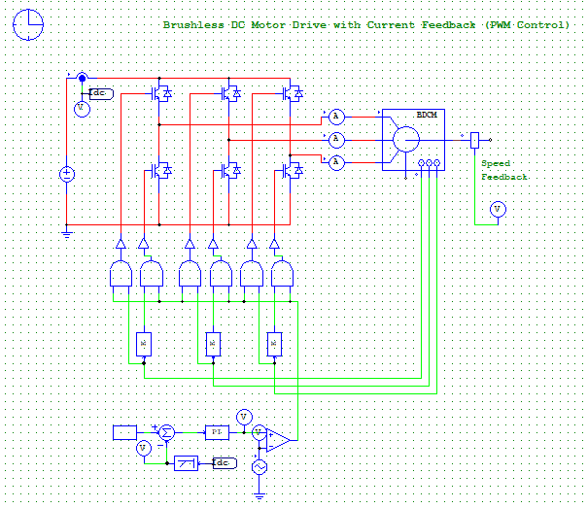

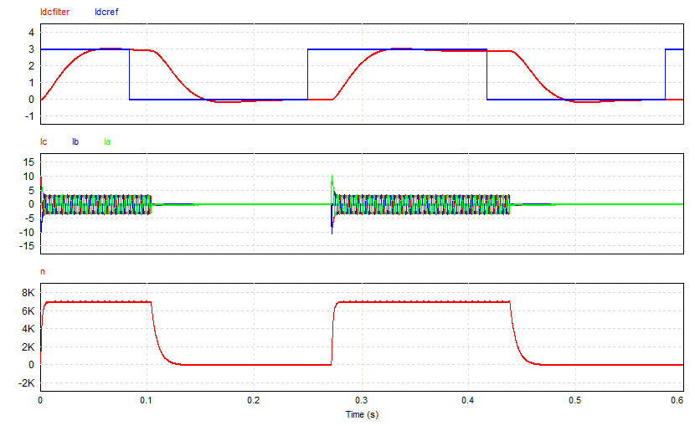

**Arduino Code for Current Control**

int PhaseaUpperPin=2;

int PhaseaLowerPin=3;

int PhasebUpperPin=4;

int PhasebLowerPin=5;

int PhasecUpperPin=6;

int PhasecLowerPin=7;

int HallaPin=8;

int HallbPin=9;

int HallcPin=10;

int SpeedPin=11;

int CurrentPin=12;

int HALLA=LOW;

int HALLB=LOW;

int HALLC=LOW;

int oldstate, newstate;

double kp,ki, CurrentErrorNew, CurrentErrorOld, OpAmpOutput, Vref;

double oldtime,newtime,dt;

double Current, Currentref;

double Vtriangle, Ttriangle, slope=1, Ts, Vmax=100;

void writeState (int s)

{

if ((s&B100)>>2)

{

digitalWrite(PhaseaUpperPin, HIGH);digitalWrite(PhaseaLowerPin, LOW);

}

else

{

digitalWrite(PhaseaUpperPin, LOW);digitalWrite(PhaseaLowerPin, HIGH);

}

if ((s&B010)>>1)

{

digitalWrite(PhasebUpperPin, HIGH);digitalWrite(PhasebLowerPin, LOW);

}

else

{

digitalWrite(PhasebUpperPin, LOW);digitalWrite(PhasebLowerPin, HIGH);

}

if (s&B001)

{

digitalWrite(PhasecUpperPin, HIGH);digitalWrite(PhasecLowerPin, LOW);

}

else

{

digitalWrite(PhasecUpperPin, LOW);digitalWrite(PhasecLowerPin, HIGH);

}

}

void setup()

{

pinMode(PhaseaUpperPin, OUTPUT);

pinMode(PhaseaLowerPin, OUTPUT);

pinMode(PhasebUpperPin, OUTPUT);

pinMode(PhasebLowerPin, OUTPUT);

pinMode(PhasecUpperPin, OUTPUT);

pinMode(PhasecLowerPin, OUTPUT);

pinMode(CurrentPin, INPUT);

pinMode(HallaPin, INPUT);

pinMode(HallbPin, INPUT);

pinMode(HallcPin, INPUT);

digitalWrite(PhaseaUpperPin, LOW);

digitalWrite(PhaseaLowerPin, LOW);

digitalWrite(PhasebUpperPin, LOW);

digitalWrite(PhasebLowerPin, LOW);

digitalWrite(PhasecUpperPin, LOW);

digitalWrite(PhasecLowerPin, LOW);

}

void loop()

{

HALLA=digitalRead(HallaPin);

HALLB=digitalRead(HallbPin);

HALLC=digitalRead(HallcPin);

newstate=(HALLC<<2)|(HALLB<<1)|(HALLA);

if((Vtriangle>Vmax)||(Vtriangle<(-Vmax)))

{

slope=slope*(-1);

}

Vtriangle=Vtriangle+slope*Ts;

Current=analogRead(CurrentPin);

CurrentErrorOld=CurrentErrorNew;

CurrentErrorNew=Current-Currentref;

Vref=kp*CurrentErrorNew+ki*(0.5)*(CurrentErrorNew+CurrentErrorOld)*Ts;

if(Vref>Vtriangle)

{

OpAmpOutput=1;

}

else

{

OpAmpOutput=0;

}

if (OpAmpOutput>0)

{

writeState(newstate);

}

else

{

writeState(B000);

}

delayMicroseconds(Ts);

}

## Speed and Current Control

The Speed and Current Controller is shown below.

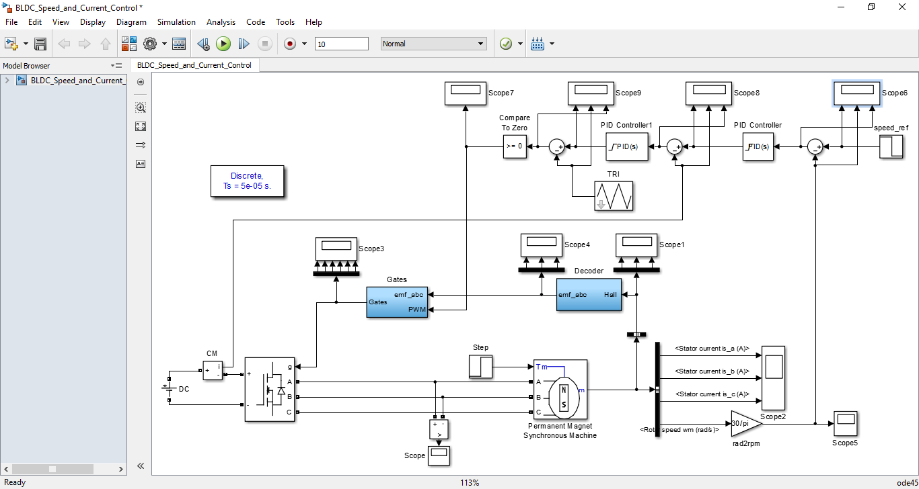

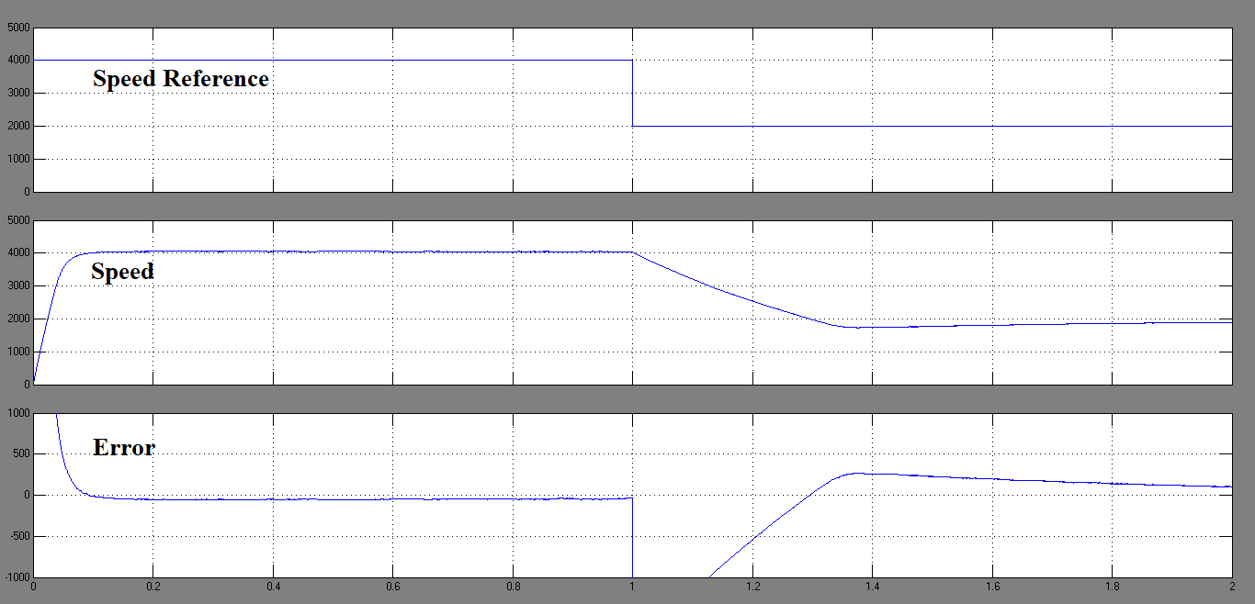

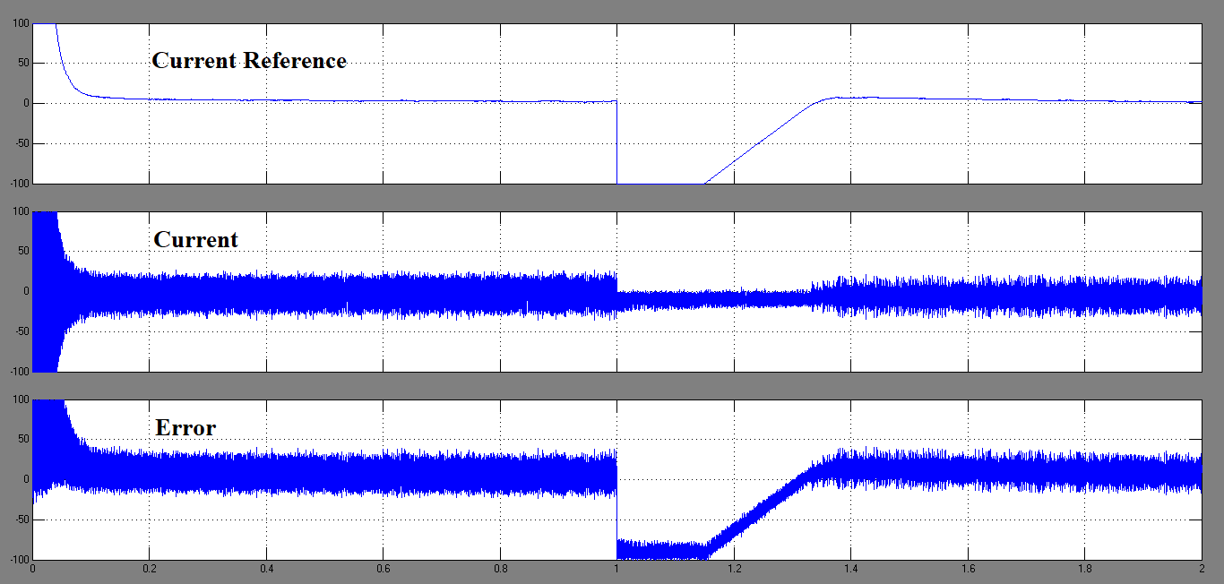

## Speed and Torque Control

The Speed and Torque Controller is shown below.

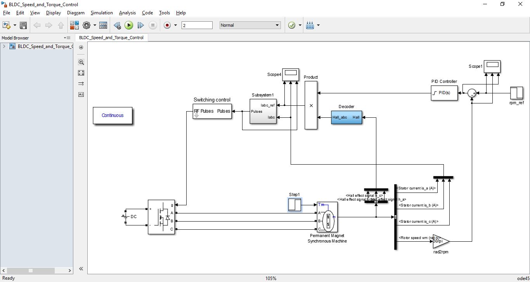

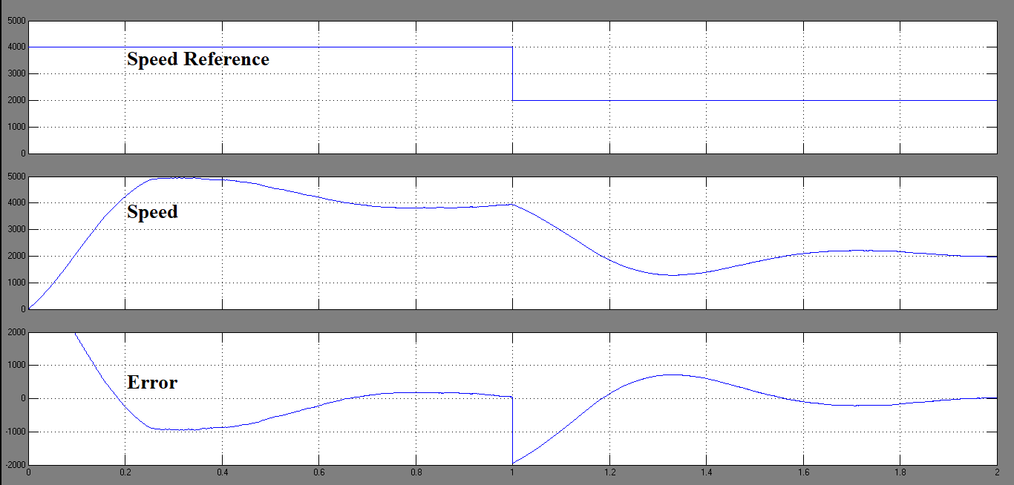

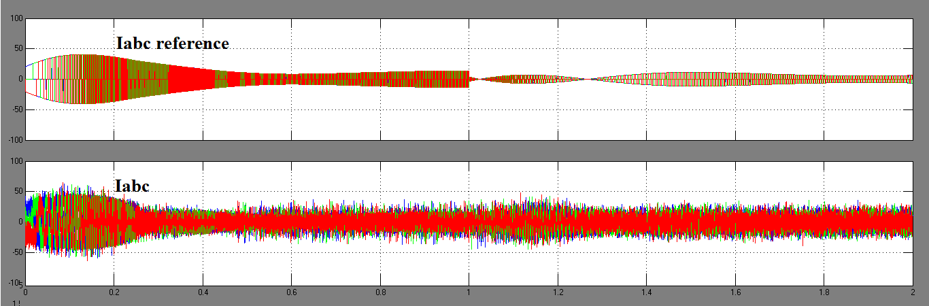

# Progress

## Inverter with Transformer Isolation

The PSIM model for Inverter with Transformer Isolation is shown below. All components were purchased from [www.hallroad.org](http://www.hallroad.org). The primary winding voltages, Main MOSFET Gate-Source voltages and Phase voltage are plotted below. The isolated 5V pulse and 2.5V (via potentiometer) are generated using Arduino.

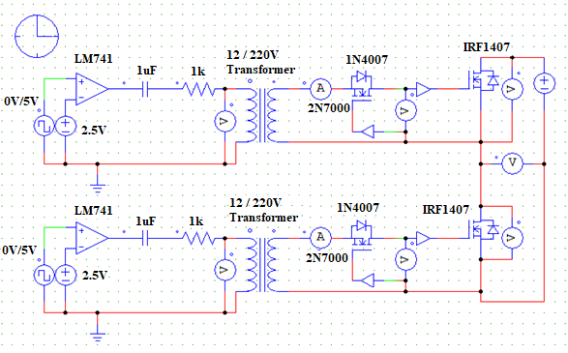

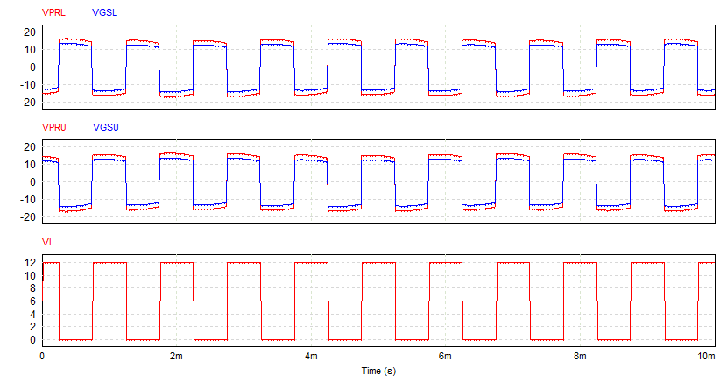

**Working of Inverter with Transformer Isolation**

The turn on signals are presented in the figure below. The 5V and 2.5 V are generated using Arduino.

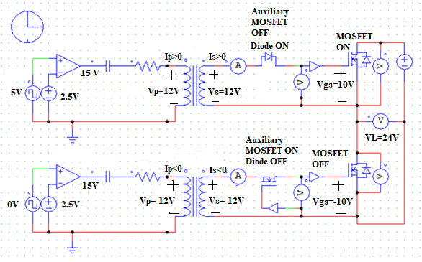

The turn off signals are presented in the figure below.

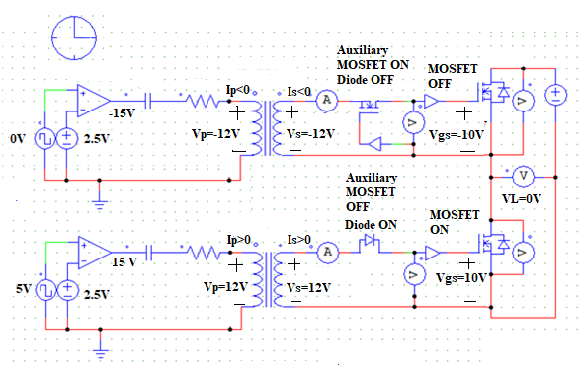

**Three Phase Inverter with Transformer Isolation**

Three Phase Transformer is shown below. The 2.5 V reference was generated using 5V Arduino output and a resistive potential divider. The 0/5V pulse was also generated using Arduino. The low side transformers were omitted because the transformers were very expensive. Although, the inverter works correctly from 1-7kHz, the Arduino ground and Main supply ground are no longer isolated.

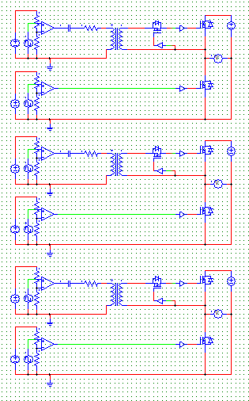

**Arduino Code for Inverter**

double frequency = 2500.0; //Set frequency in Hertz

double delayTime = (1000000.0 / (frequency * 2.0));//Half Period in microseconds

void setup()

{

pinMode(2, OUTPUT);

pinMode(3, OUTPUT);

pinMode(4, OUTPUT);

pinMode(5, OUTPUT);

pinMode(6, OUTPUT);

pinMode(7, OUTPUT);

pinMode(8, OUTPUT);

pinMode(9, OUTPUT);

pinMode(10, OUTPUT);

pinMode(11, OUTPUT);

pinMode(12, OUTPUT);

pinMode(13, OUTPUT);

digitalWrite(2, HIGH);

digitalWrite(3, HIGH);

digitalWrite(4, HIGH);

digitalWrite(5, HIGH);

digitalWrite(6, HIGH);

digitalWrite(7, HIGH);

}

void loop()

{

digitalWrite(8, LOW);

digitalWrite(9, HIGH);

delayMicroseconds(delayTime/3);

digitalWrite(12, HIGH);

digitalWrite(13, LOW);

delayMicroseconds(delayTime/3);

digitalWrite(10, LOW);

digitalWrite(11, HIGH);

delayMicroseconds(delayTime/3);

digitalWrite(8, HIGH);

digitalWrite(9, LOW);

delayMicroseconds(delayTime/3);

digitalWrite(12, LOW);

digitalWrite(13, HIGH);

delayMicroseconds(delayTime/3);

digitalWrite(10, HIGH);

digitalWrite(11, LOW);

delayMicroseconds(delayTime/3);

}

## Inverter with Optical Isolation and Level Shifter

The Inverter with transformer isolation was too expensive so Inverter with Optical isolation and Level shifter was designed.

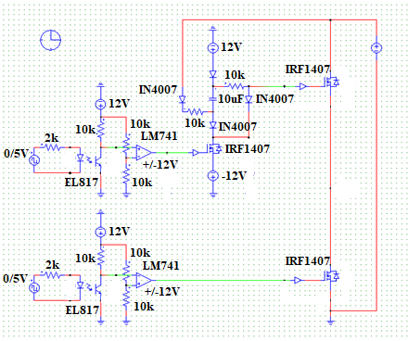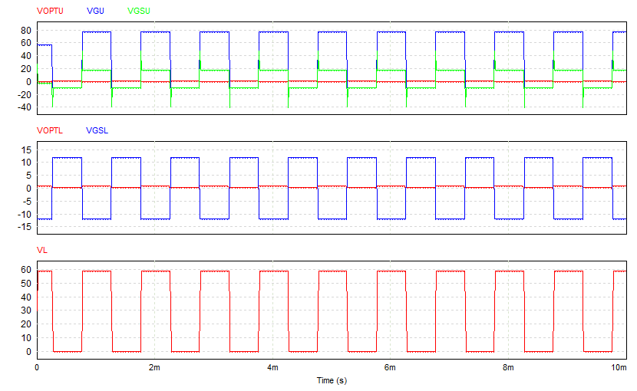

**Working of Inverter with Optical Isolation**

**Turn On**

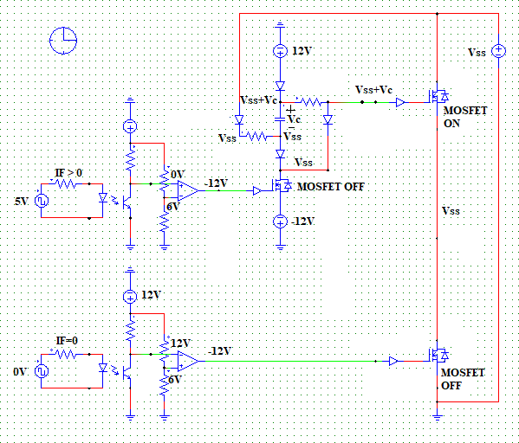

**Turn Off**

