Project Report: Job Recommendation

WorkFusion AI Recommendation Engine

Introduction
One of the core features of the WorkFusion platform is its AI-powered recommendation engine, which helps connect service seekers with relevant job opportunities. The recommendation engine analyzes user profiles and job requirements to generate personalized recommendations based on skills, experience, location, ratings, availability, and category preferences.
Traditional recommendation systems often rely solely on keyword matching or simple text similarity, which can produce unrealistic results. For example, a candidate may possess the required skills but lack sufficient experience or reside in a different city where the job is located. To overcome these limitations, WorkFusion employs a hybrid recommendation approach that combines Natural Language Processing (NLP) techniques with a multi-factor weighted ranking model.
The recommendation engine is designed to provide accurate, explainable, and practical recommendations while remaining computationally efficient.

Text Preprocessing
Before similarity calculations can be performed, textual information such as skills, portfolio descriptions, and job descriptions must be cleaned and standardized.
The preprocessing stage performs the following operations:
- Conversion of all text to lowercase.
- Removal of punctuation and unnecessary symbols.
- Tokenization of text into individual words.
- Removal of common stopwords such as "the", "is", "and", and "of".
These steps reduce noise and improve the quality of textual comparisons by ensuring that only meaningful words contribute to recommendation decisions.
For example:
Original Text:
"Experienced MERN Stack Developer with React.js and Node.js skills."
Processed Text:
"experienced mern stack developer react js node js skills"
By transforming text into a consistent format, the recommendation engine can compare candidate profiles and job requirements more accurately.

TF-IDF Vectorization
To measure the importance of words within user profiles and job descriptions, the system utilizes the Term Frequency-Inverse Document Frequency (TF-IDF) technique.
TF-IDF assigns higher weights to terms that are important within a document while reducing the influence of frequently occurring words.
The TF-IDF calculation consists of three components:
Term Frequency (TF):
The frequency of a term within a document.
Inverse Document Frequency (IDF):
Measures how unique a term is across all documents.
TF-IDF Weight:
- The product of TF and IDF values.
- The TF-IDF formula is given by:
- TF-IDF(t,d,D) = TF(t,d) × IDF(t,D)
Using TF-IDF enables the recommendation engine to identify important technical skills and project-related keywords while ignoring common words that provide little useful information.

Cosine Similarity
After TF-IDF vectorization, the recommendation engine measures similarity using Cosine Similarity.
Cosine Similarity calculates the angle between two vectors representing a candidate profile and a job description. The closer the angle is to zero, the more similar the documents are.
The similarity score ranges from 0 to 1:
- 1 indicates identical content.
- 0 indicates no similarity.
The formula is:
- Cosine Similarity = (A · B) / (||A|| ||B||)
where A and B represent TF-IDF vectors.
The recommendation engine applies cosine similarity to compare:
- Candidate skills with required job skills.
- Candidate portfolio descriptions with job descriptions.
This produces an initial measure of textual relevance.

Multi-Factor Weighted Ranking Model
Although skill similarity is important, real-world hiring decisions depend on additional factors. Therefore, WorkFusion uses a weighted ranking model that combines multiple criteria into a final recommendation score.
The final score consists of seven components:
Component | Weight
Skills Match | 45%
Portfolio Similarity | 15%
Experience | 10%
User Ratings | 10%
Category Match | 10%
Location Compatibility | 5%
Availability Match | 5%
The weighted model ensures that recommendations reflect practical employment considerations rather than relying solely on textual similarity.

Skills Match Score
The skills score measures similarity between a candidate's skills and the required job skills using TF-IDF and cosine similarity.
Weight:
- 45%
This factor contributes the largest portion of the overall recommendation score because technical competency is the most important requirement for most jobs.

Portfolio Similarity Score
The portfolio score evaluates how closely a candidate's previous work aligns with the job description.
Weight:
- 15%
A strong portfolio match indicates practical experience in relevant projects and technologies.

Experience Score
The experience score compares the candidate's years of experience with the job's experience requirements.
Weight:
10%
Candidates who meet or exceed the required experience receive higher scores.

Rating Score
The rating score reflects user reputation and service quality based on previous feedback.
Weight:
- 10%
Highly rated users are rewarded because they have demonstrated reliability and professional performance.

Category Match Score
The category score verifies whether the candidate's preferred category aligns with the job category.
Weight:
- 10%
This helps ensure that recommendations remain relevant to the user's professional interests.

Location Score
The location score evaluates geographical compatibility.
Weight:
- 5%
Remote jobs automatically receive full location points, while physical jobs consider city matching and proximity.
For example, Islamabad and Rawalpindi are treated as neighboring cities due to their close commuting distance.

Availability Score
The availability score determines whether a candidate's preferred working schedule matches the job requirements.
Weight:
- 5%
This ensures that users receive recommendations compatible with their working preferences.

Final Match Score Calculation
All weighted components are combined to produce the final recommendation score.
- Final Score = Skills + Portfolio + Experience + Rating + Category + Location + Availability
The final score is expressed as a percentage and used to rank job recommendations.
Higher scores indicate stronger compatibility between a service seeker and a job opportunity.

Explainable AI
A major advantage of the WorkFusion recommendation engine is its explainability.
Rather than presenting users with a score alone, the system also provides explanations describing why a recommendation was generated.
Examples include:
- Matched 4 of 4 required skills.
- Experience meets or exceeds requirements.
- Highly rated profile.
- Matches preferred category.
- Located in the same city.
These explanations improve transparency and help users understand recommendation decisions.

Skill Gap Analysis
The recommendation engine also identifies missing skills required for a particular job.
The system compares a candidate's skill set with the job's required skills and identifies skills that are absent.
For example:
Candidate Skills:
- React
- Node.js
- MongoDB
Job Requirements:
- React
- Node.js
- MongoDB
- Docker
- AWS
Missing Skills:
- Docker
- AWS
This feature provides users with actionable guidance for improving their employability and preparing for future opportunities.

Experimental Setup
To evaluate the performance of the recommendation engine, a simulation dataset was created containing:
- 5 Service Seekers
- 5 Job Vacancies
- Multiple professional domains including Web Development, UI/UX Design, Plumbing Services, Machine Learning, and Digital Marketing
The recommendation engine generated scores for every seeker-job combination, resulting in a complete recommendation matrix for analysis.

Results and Performance Evaluation

Seeker - Job Match Heatmap
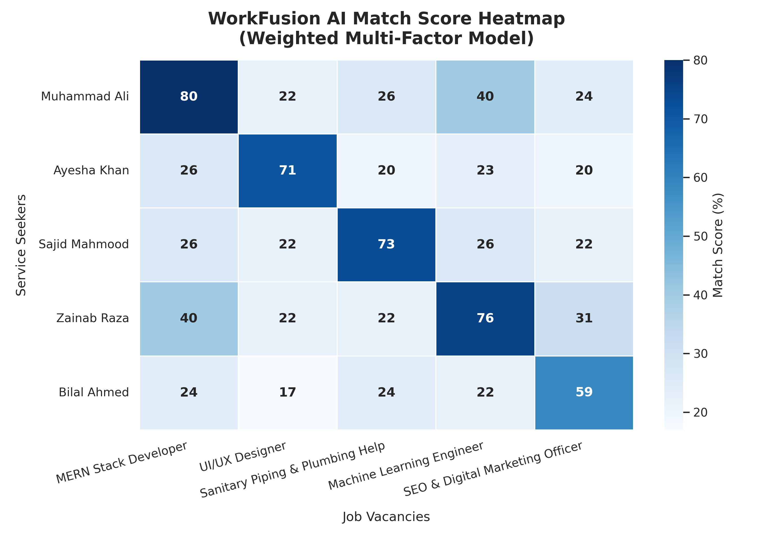

Figure: WorkFusion AI Match Score Heatmap
The heatmap presents recommendation scores generated for every seeker-job pair.
The highest scores appear along the diagonal of the matrix:
Service Seeker | Best Matching Job | Score
Muhammad Ali | MERN Stack Developer | 80%
Ayesha Khan | UI/UX Designer | 71%
Sajid Mahmood | Plumbing Services | 73%
Zainab Raza | Machine Learning Engineer | 76%
Bilal Ahmed | SEO & Digital Marketing Officer | 59%
The results demonstrate that the recommendation engine successfully identified the most appropriate job for each service seeker.
Low scores for unrelated jobs indicate strong separation between relevant and irrelevant recommendations.

Comparison of Cosine Similarity and Weighted Ranking
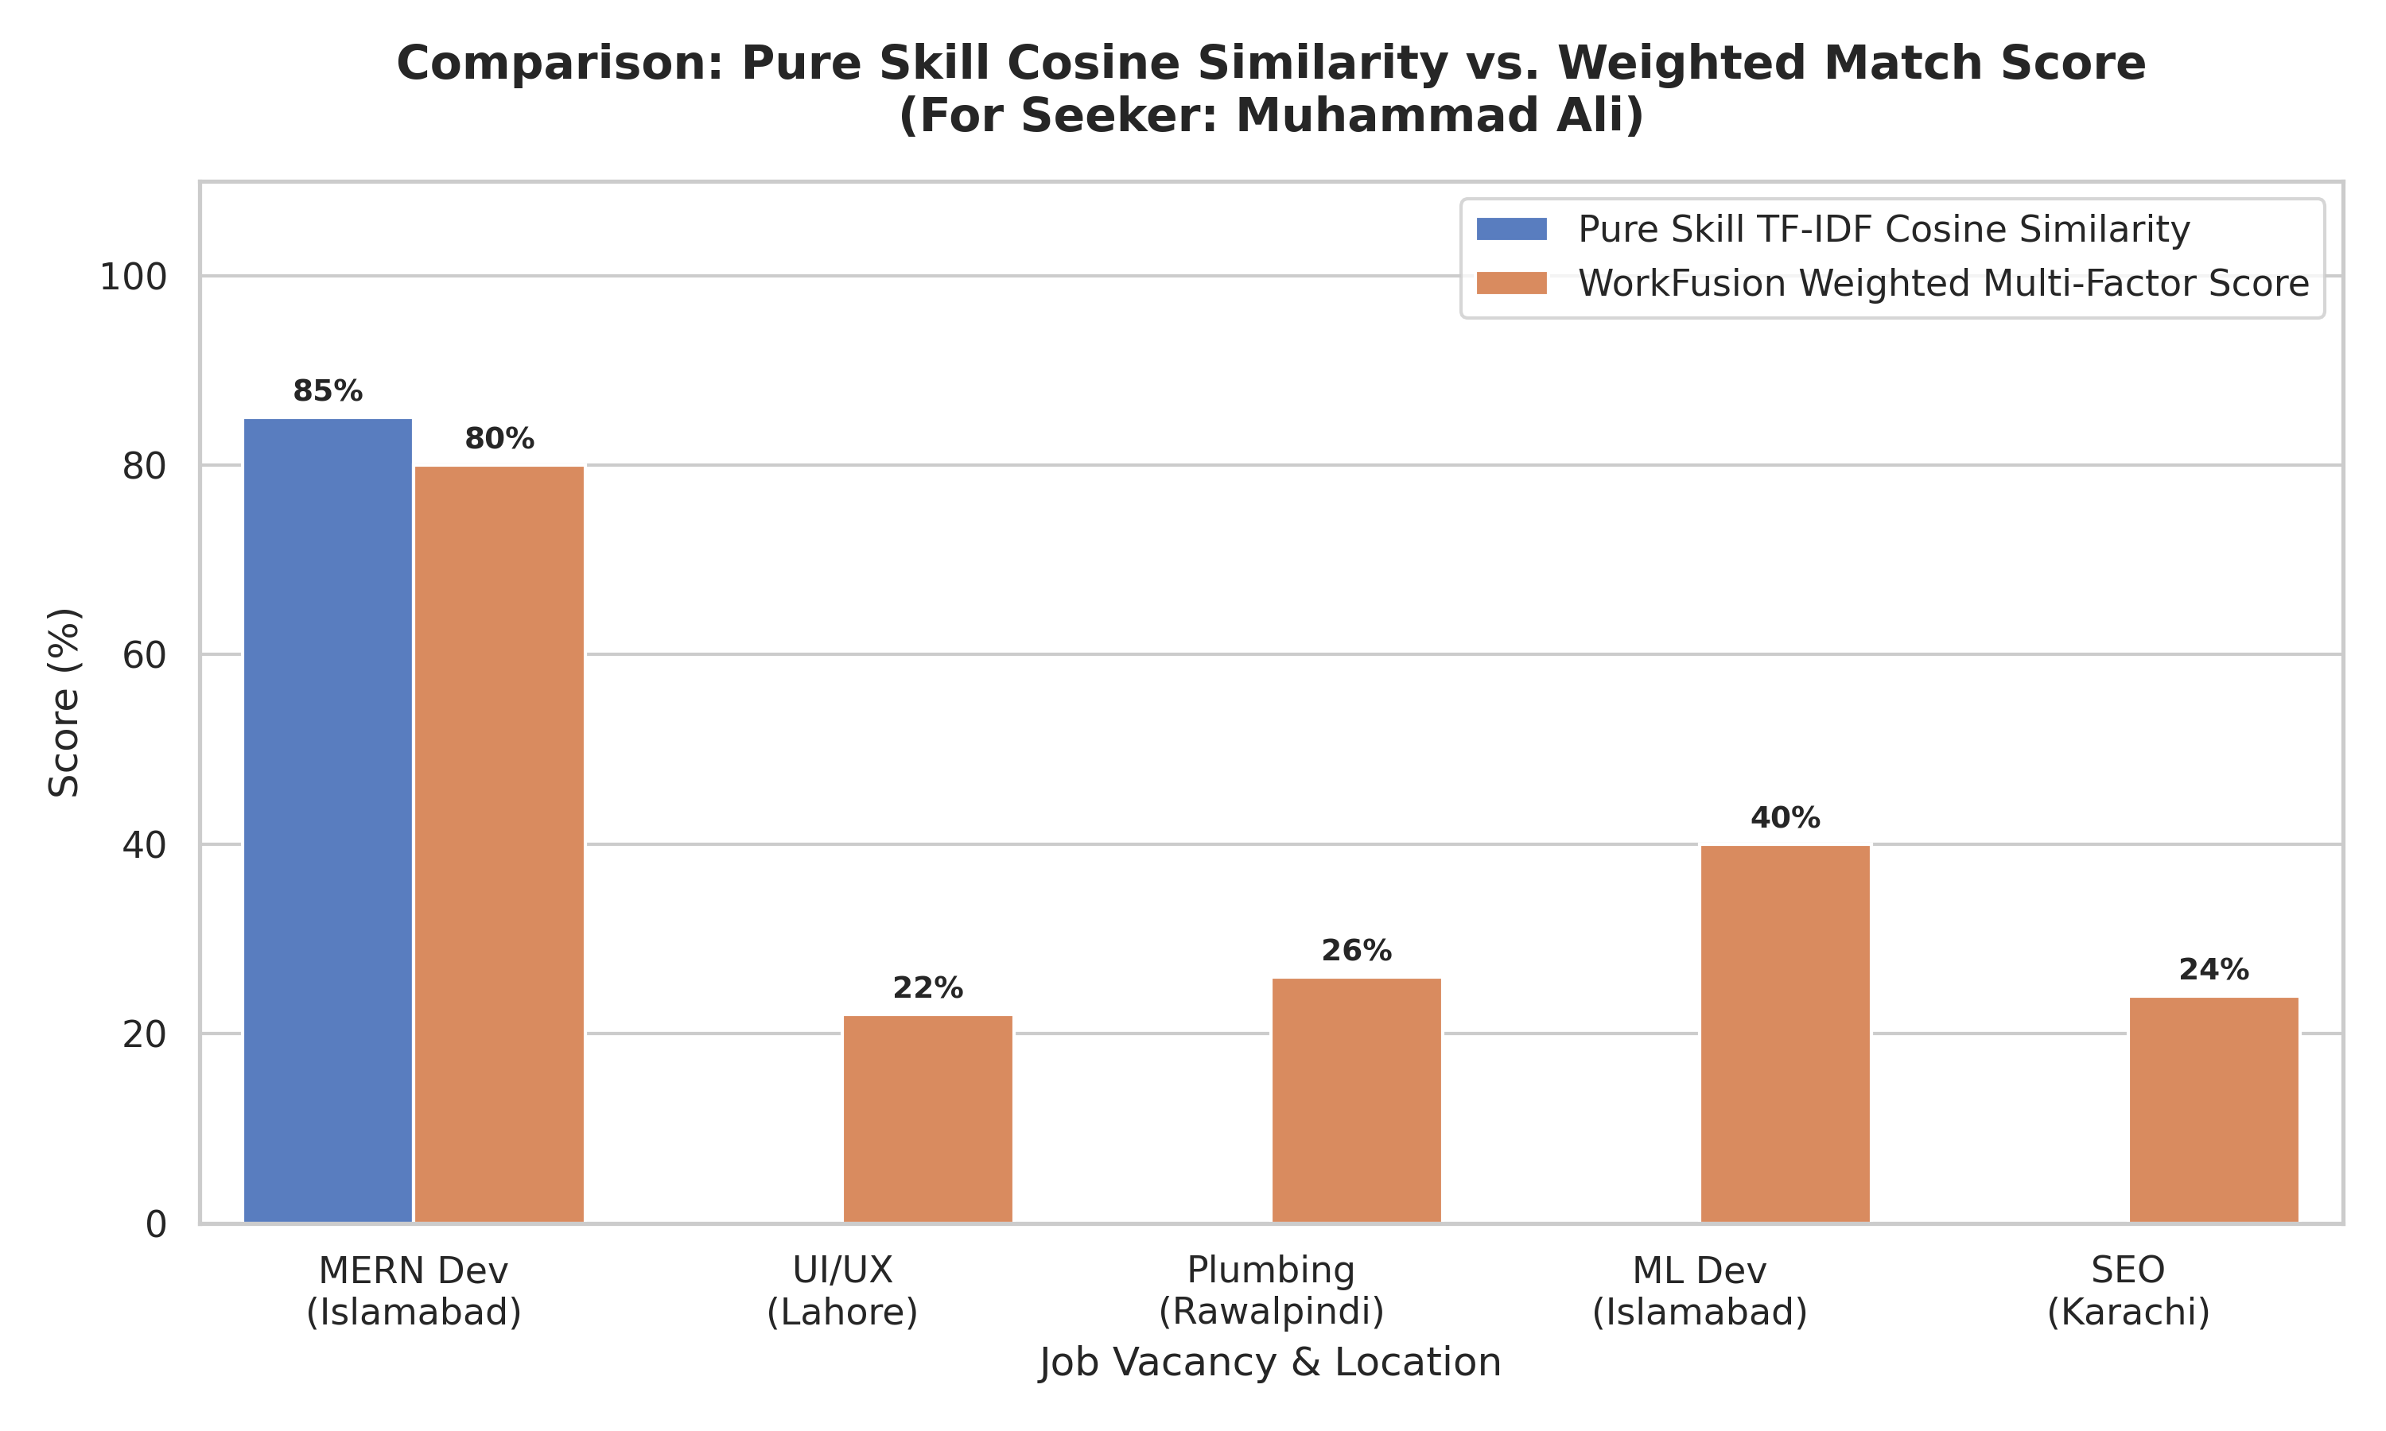
Figure: Pure Skill Similarity vs Weighted Match Score
A comparison was performed between traditional TF-IDF cosine similarity and the proposed weighted ranking model.
For Muhammad Ali:
- Pure Skill Similarity = 85%
- Weighted Match Score = 80%
Although both approaches identify the MERN Developer position as the best match, the weighted model incorporates additional factors such as experience, location, ratings, and availability.
This produces recommendations that more accurately reflect real-world hiring conditions.
The results demonstrate that relying solely on skill similarity may overlook important practical considerations.
Score Component Breakdown
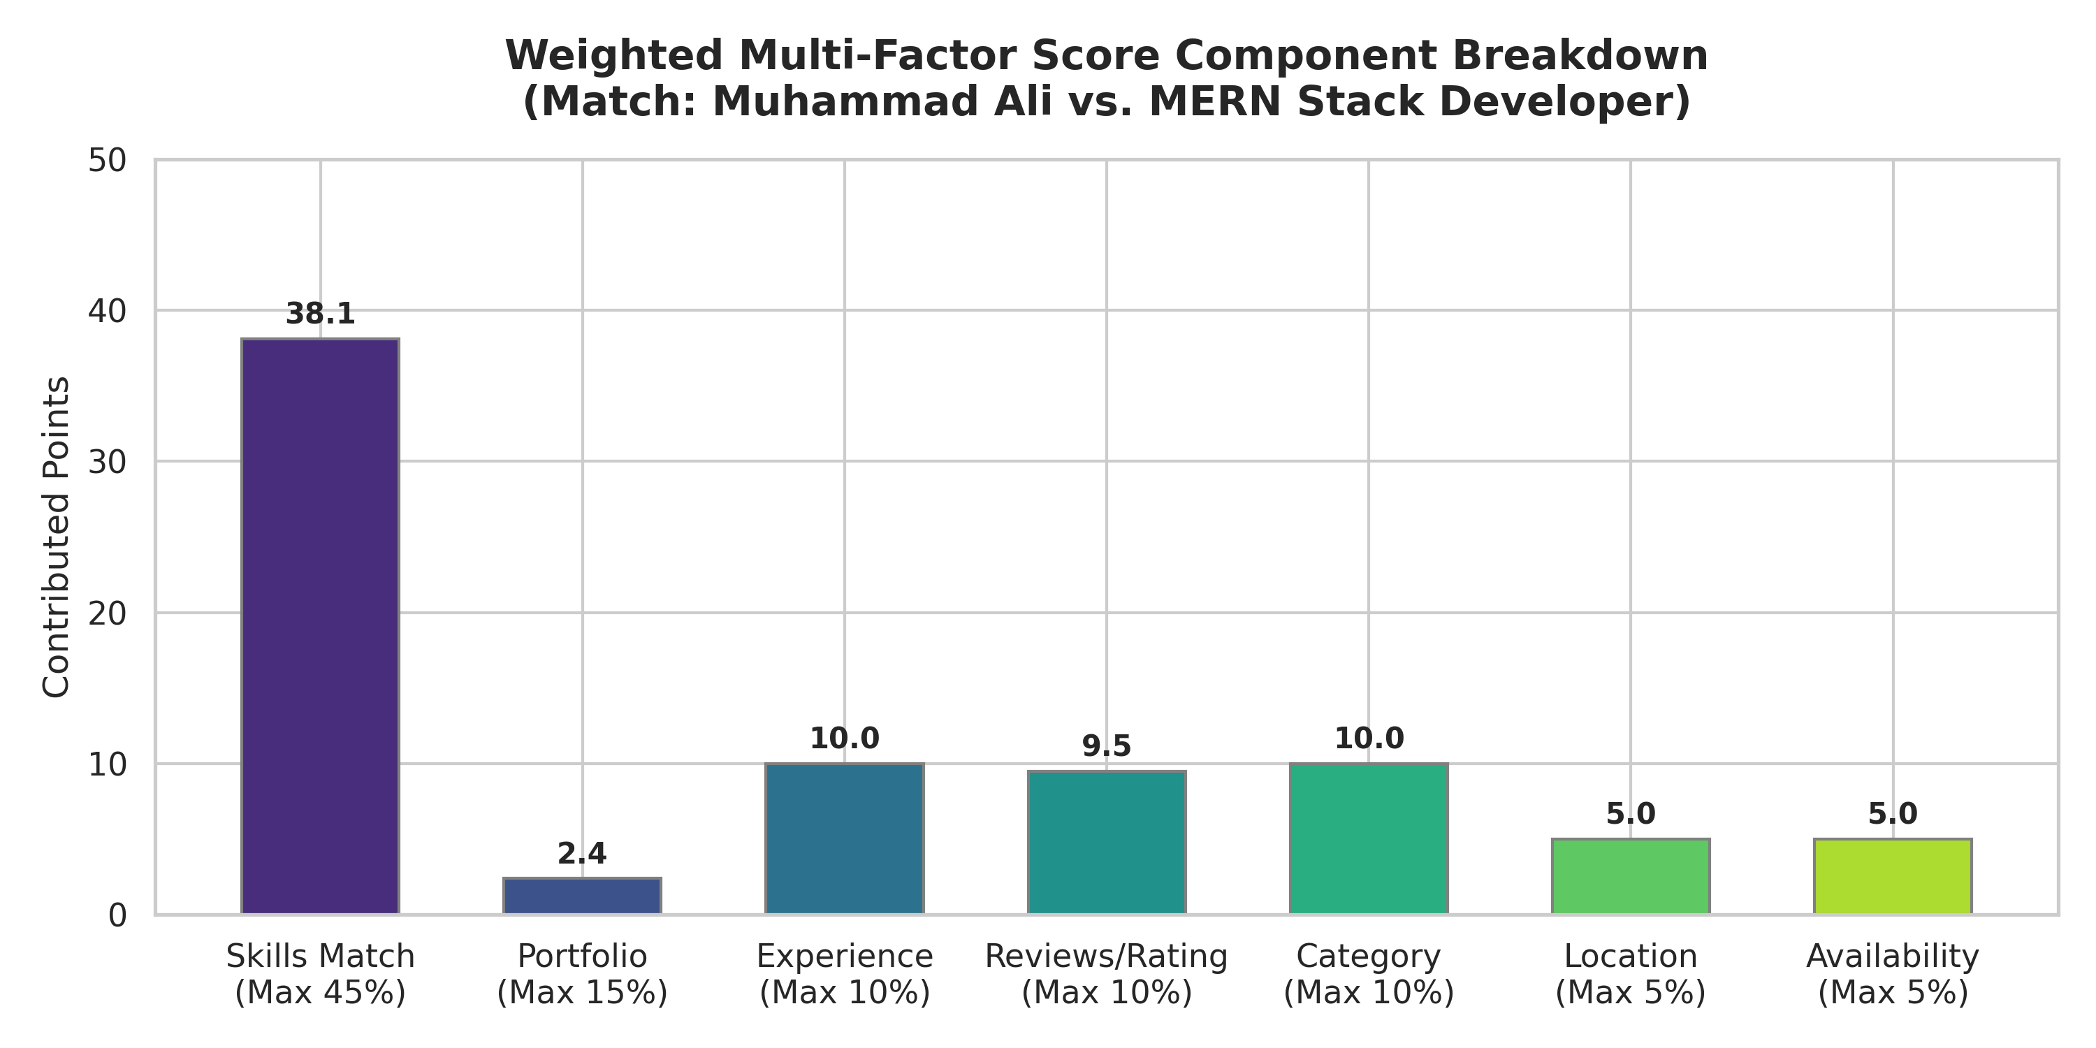
Figure: Match Score Component Breakdown
The contribution of each factor for Muhammad Ali's recommendation is shown below:
Component | Contribution
Skills Match | 38.1
Portfolio Similarity | 2.4
Experience | 10.0
Rating | 9.5
Category Match | 10.0
Location Match | 5.0
Availability Match | 5.0
Total Score | 80.0
The results show that skills contribute the largest share of the final score, while other factors improve recommendation quality by considering real-world constraints.

Evaluation Metrics
To assess recommendation quality, standard information retrieval metrics were calculated.

Mean Average Precision (MAP)
MAP measures how effectively relevant jobs are ranked above irrelevant jobs.
Result:
MAP = 1.0000
This indicates that relevant jobs consistently appeared at the top of recommendation lists.

Mean Reciprocal Rank (MRR)
MRR evaluates the position of the first relevant recommendation.
Result:
MRR = 1.0000
This indicates that the most suitable job was ranked first for every service seeker in the evaluation dataset.

Average Match Scores
Metric | Value
Average True Match Score | 62.71%
Average Mismatch Score | 23.28%
Discriminative Margin | 39.44%
The substantial difference between true matches and mismatches demonstrates the recommendation engine's ability to distinguish relevant opportunities from unrelated ones.

Discussion
The experimental results demonstrate that the proposed WorkFusion recommendation engine effectively combines Natural Language Processing techniques with domain-specific ranking factors.
The heatmap confirms that relevant seeker-job pairs receive significantly higher scores than unrelated pairs. The comparison experiment shows that the weighted ranking model provides more realistic recommendations than pure text similarity methods. Furthermore, the score breakdown illustrates that recommendations are explainable and transparent.
The inclusion of skill gap analysis and recommendation explanations further enhances user experience by providing practical guidance for career development.
Overall, the proposed recommendation engine successfully achieves accurate, interpretable, and practical job recommendations for the WorkFusion platform.

Conclusion
The WorkFusion AI Recommendation Engine provides an intelligent solution for matching service seekers with relevant job opportunities. By combining TF-IDF vectorization, cosine similarity, and a multi-factor weighted ranking model, the system generates personalized recommendations that consider both technical skills and real-world employment factors.
Experimental results demonstrate strong recommendation accuracy, effective ranking performance, and clear separation between relevant and irrelevant opportunities. The system also promotes transparency through explainable recommendations and skill gap analysis.
These findings indicate that the proposed approach is suitable for supporting intelligent recruitment and employment matching within the WorkFusion platform.

