**LAB#02**

**Lab Task#01:**

1.Write a program that initializes Vector with 10 integers in it. Display all the integers and sum of these integers.

**Code: Output:**

import java.util.*;

public class Lab02 {

public static void main(String[] args) {

Vector<Integer> no = new Vector<>();

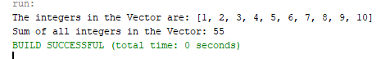 int sum = 0;

for (int i = 1; i <= 10; i++) {

no.add(i);

sum += i;

}

System.out.println("The integers in the Vector are: " + no);

System.out.println("Sum of all integers in the Vector: " + sum);

}

}

**Lab Task#02:**

2. Create an ArrayList of string. Write a menu driven program which:

a. Displays all the elements

b. Displays the largest String

**Code: Output:**

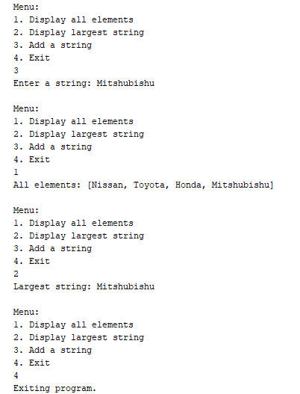import java.util.ArrayList;

import java.util.Scanner;

public class StringArrayListMenu {

public static void main(String[] args) {

ArrayList<String> strings = new ArrayList<>();

Scanner scanner = new Scanner(System.in);

while (true) {

System.out.println("\nMenu:\n1. Display all elements\n2. Display largest string\n3. Add a string\n4. Exit");

int choice = scanner.nextInt();

scanner.nextLine();

if (choice == 1) {

System.out.println("All elements: " + strings);

} else if (choice == 2) {

if (strings.size() == 0) {

System.out.println("The list is empty.");

} else {

String largest = "";

for (int i = 0; i < strings.size(); i++) {

String current = strings.get(i);

if (current.length() > largest.length()) {

largest = current;

}

}

System.out.println("Largest string: " + largest);

}

} else if (choice == 3) {

System.out.print("Enter a string: ");

strings.add(scanner.nextLine());

} else if (choice == 4) {

System.out.println("Exiting program.");

break;

} else {

System.out.println("Invalid choice. Try again."); }

}

}

}

**Lab Task#03:**

3. Create a Arraylist storing Employee details including Emp_id, Emp_Name, Emp_gender, Year_of_Joining (you can also add more attributes including these). Then sort the employees according to their joining year using Comparator and Comparable interfaces.

**Code: Output:**

import java.util.*;

class Employee implements Comparable<Employee> {

int empId;

String empName;

String empGender;

int yearOfJoining;

Employee(int empId, String empName, String empGender, int yearOfJoining) {

this.empId = empId;

this.empName = empName;

this.empGender = empGender;

this.yearOfJoining = yearOfJoining;

}

public String toString() {

return "Employee{" +"Emp_id=" + empId +", Emp_Name='" + empName + '\'' +", Emp_gender='" + empGender + '\'' +", Year_of_Joining=" + yearOfJoining +'}';

}

public int compareTo(Employee other) {

return this.yearOfJoining - other.yearOfJoining;

}

}

public class EmployeeManagement {

public static void main(String[] args) {

ArrayList<Employee> employees = new ArrayList<>();

employees.add(new Employee(1, "Alice", "Female", 2020));

employees.add(new Employee(2, "Bob", "Male", 2018));

employees.add(new Employee(3, "Charlie", "Male", 2019));

employees.add(new Employee(4, "Diana", "Female", 2021));

Collections.sort(employees);

System.out.println("Employees sorted by Year of Joining (using Comparable):");

for (Employee emp : employees) {

System.out.println(emp);

}

Collections.sort(employees, new Comparator<Employee>() {

public int compare(Employee emp1, Employee emp2) {

return emp1.yearOfJoining - emp2.yearOfJoining; }

});

System.out.println("\nEmployees sorted by Year of Joining (using Comparator):");

for (Employee emp : employees) {

System.out.println(emp);

}

}

}

**Lab Task#04:**

4. Write a program that initializes Vector with 10 integers in it.

• Display all the integers

• Sum of these integers.

• Find Maximum Element in Vector

**Code: Output:**

import java.util.*;

public class Lab02 {

public static void main(String[] args) {

Vector<Integer> numbers = new Vector<>();

int sum = 0, max = Integer.MIN_VALUE;

for (int i = 1; i <= 10; i++) {

numbers.add(i);

sum += i;

if (i > max){

max = i; }

}

System.out.println("The integers in the Vector are: " + numbers);

System.out.println("Sum of all integers in the Vector: " + sum);

System.out.println("Maximum element in the Vector: " + max);

}

}

**Lab Task#05:**

5. Find the k-th smallest element in a sorted ArrayList.

**Code: Output:**

import java.util.*;

public class Lab02 {

public static void main(String[] args) {

ArrayList<Integer> numbers = new ArrayList<>();

 int[] no = {3, 8, 15, 20, 25, 30, 40, 50};

for (int i = 0; i < no.length; i++) {

numbers.add(no[i]);

}

int k = 3;

if (k > 0 && k <= numbers.size()) {

int kthSmallest = numbers.get(k - 1);

System.out.println("The " + k + "-th smallest element is: " + kthSmallest);

} else {

System.out.println("k is out of bounds.");

}

}

}

**Lab Task#05:**

6. Write a program to merge two ArrayLists into one.

**Code: Output:**

import java.util.*;

public class Lab02 {

public static void main(String[] args) {

ArrayList<String> list1 = new ArrayList<>();

ArrayList<String> list2 = new ArrayList<>();

list1.add("Nissan");

 list1.add("Honda");

list1.add("Toyota");

list2.add("Suzuki");

list2.add("Ducati");

list2.add("Kawasaki");

ArrayList<String> mergedList = new ArrayList<>();

mergedList.addAll(list1);

mergedList.addAll(list2);

System.out.println("Merged ArrayList: " + mergedList);

}

}