Open-Ended Lab
Lab Task:
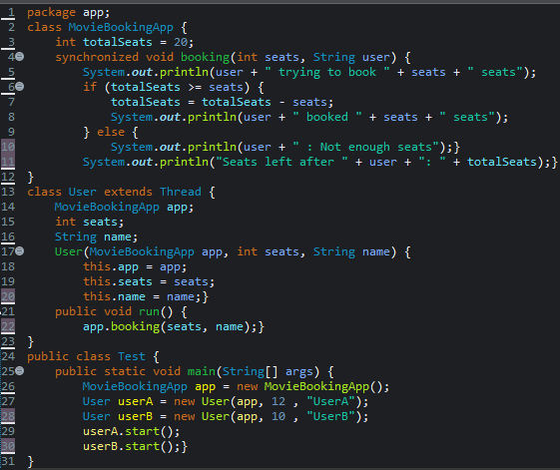
“Synchronized Movie Seat Booking System Using Multithreading in Java”.
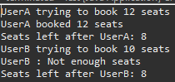

GITHUB SCREENSHOT:

