Lab # 9 SSUET/QR/114

LAB TASK:

Lab#9 Abstract Data Types

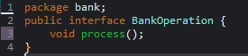
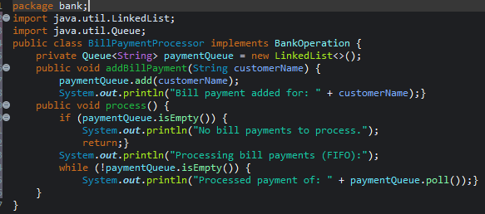
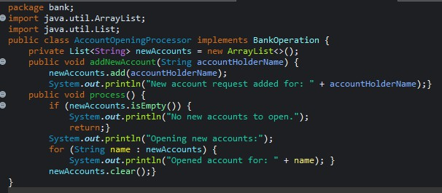
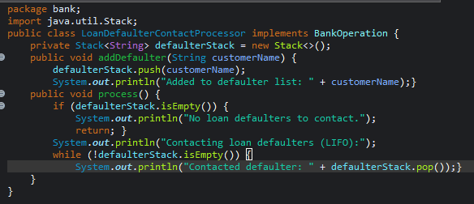
Considering a bank interface, it will have different concrete classes for receiving bill payments, opening of new accounts and contacting those loan takers whose limits of extension have been expired. Now, develop this scenario on the described ADT and decide which ADT should be used for each concrete class, also implement the whole scenario in multiple java classes.

2023F-BSE-088

Lab # 9 SSUET/QR/114
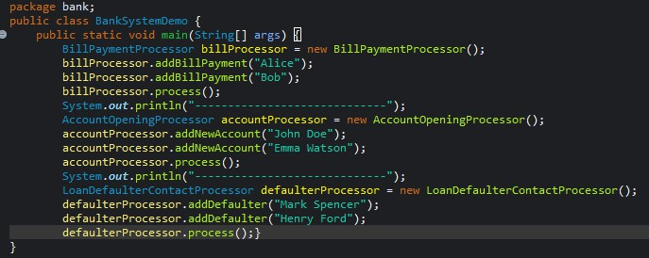
OUTPUT:
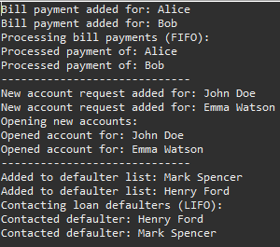

2023F-BSE-088

