22i-2675
Shayan Asghar
Lab 5

https://github.com/MuhammadShayanAsghar/22i2675_WebLabTasks2026/tree/main/Web_LabTasks/Lab5

Task 1

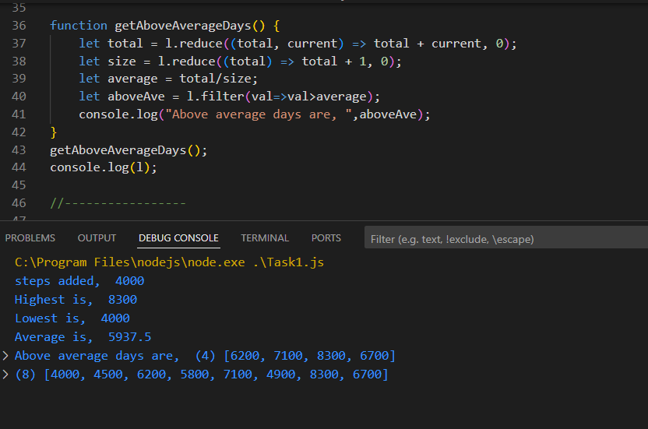

Task 2

