TASKNEST

App Flow Document
Every screen, route and user journey in TaskNest, from first visit to daily use.
Version 1.0 · 4 November 2026 · Project management SaaS · Related: PRD, TRD, UI/UX Brief

1. Purpose
This document maps how users move through TaskNest: which screens exist, how they connect, and what the system does at each step. Designers use it to plan screens, developers use it to build routes, and testers use it to write end-to-end tests.
Flows cover release v1.0 (MVP) unless marked v1.1 or v1.2. Requirement IDs (FR-xx) refer to the PRD.

2. Sitemap
TaskNest has two areas: public pages that anyone can open, and the signed-in app, where every route lives under a workspace slug (/w/:slug).
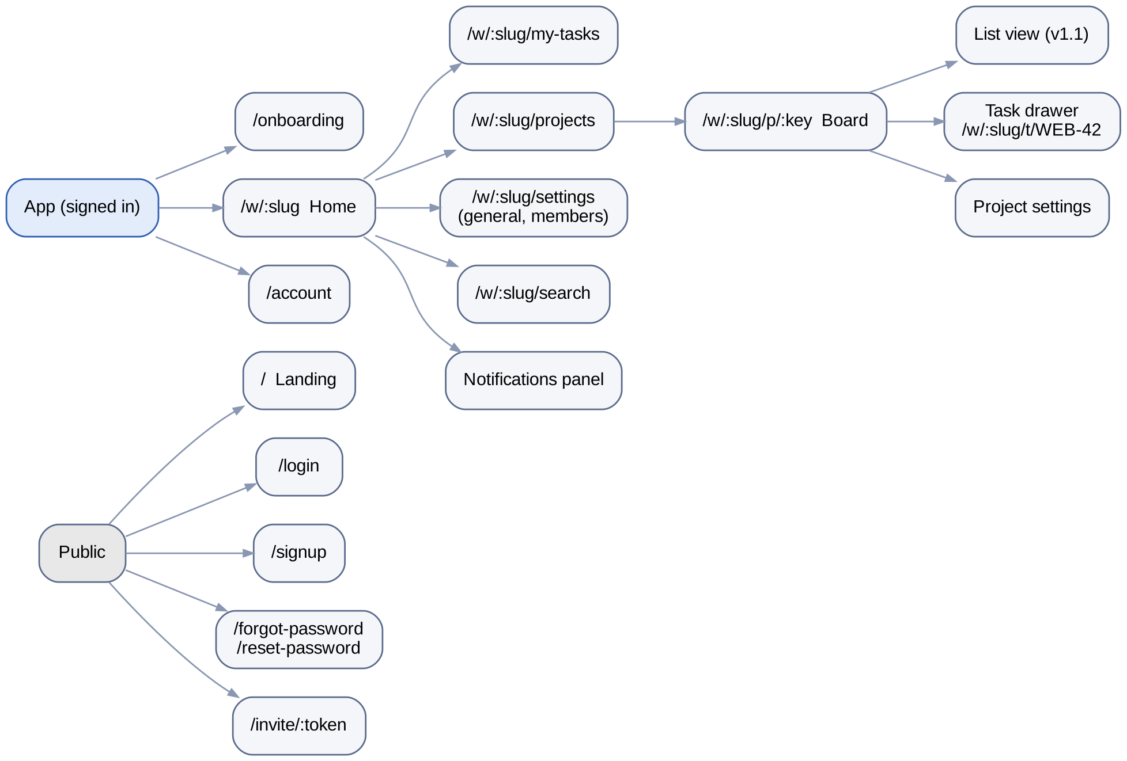
Figure 1. Sitemap of public and signed-in routes

2.1 Route rules
- A signed-out user who opens any app route is sent to /login?next=<route> and returned there after login.
- A signed-in user who opens /, /login or /signup is sent to their last-used workspace.
- A user who opens a workspace they are not a member of sees a 404 page (not 403), so workspace names are not revealed.
- The task drawer has its own URL (/w/:slug/t/WEB-42), so a task link can be shared and opens on top of its board.

3. Navigation model
Every signed-in screen uses the same app shell, so users always find navigation in the same place.
Area | Contents | Behaviour
Left sidebar (240 px) | Workspace switcher, Home, My tasks, Search, project list, Settings | Collapses to icons below 1024 px; becomes a slide-in drawer on mobile
Top bar (56 px) | Breadcrumb (Workspace / Project), global search, notification bell, avatar menu | Sticky on scroll
Main area | The current page: board, list, task, settings | Scrolls independently of sidebar
Task drawer (480 px) | Full task details and comments | Slides in from the right over the board; full screen on mobile
Command menu (v1.1) | Jump to project, task or action | Opens with Ctrl/Cmd + K

4. Flow 1: First-time onboarding
Goal: a new user reaches a project board with a first task in under 5 minutes (PRD success metric). Trigger: user clicks "Get started" on the landing page or opens an invite link.
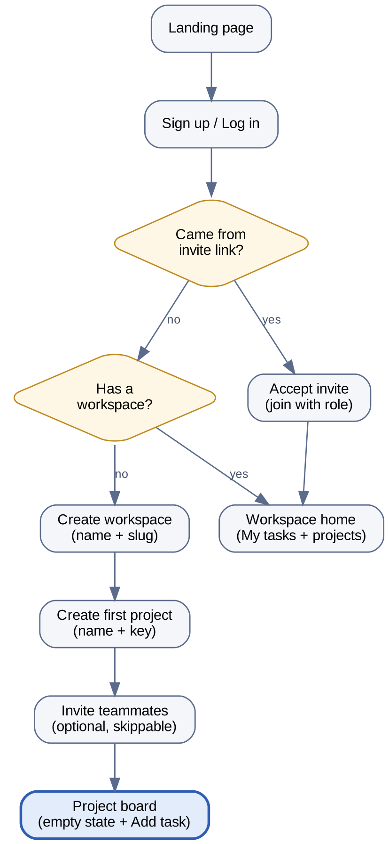
Figure 2. Onboarding decision flow
Step | User action | System response
1 | Opens /signup, enters name, email, password | Validates inline (email format, password ≥ 8 chars). Creates account, sets tokens, routes to /onboarding.
2 | Enters workspace name, e.g. "Sukkur IBA FYP" | Suggests slug sukkur-iba-fyp; checks availability as the user types (debounced 300 ms).
3 | Creates first project: name "Website", key "WEB" | Key auto-filled from the first letters of the name; uppercase only, 2–10 chars.
4 | Invites teammates by email, or clicks "Skip for now" | Sends invite emails; shows copyable invite link as fallback.
5 | Lands on the empty board | Shows empty state with "Add your first task" button and three example column headers.
6 | Adds first task | Task appears in "To do" as WEB-1; a one-time tip points to drag-and-drop.

Edge cases
- Email already registered: inline error with a "Log in instead" link.
- User closes the browser mid-onboarding: next login resumes at the first unfinished step.
- Slug taken: show "Taken" and suggest sukkur-iba-fyp-2.

5. Flow 2: Authentication

5.1 Log in
- User opens /login and enters email and password (or clicks "Continue with Google", v1.1).
- API checks credentials. On success it returns an access token and sets the refresh-token cookie.
- App routes to next if present, else to the last-used workspace.
- On failure: generic message "Email or password is incorrect" (never reveals which). After 5 failed attempts in a minute, the form shows "Too many attempts, try again in 1 minute".

5.2 Forgot and reset password
- User clicks "Forgot password?" and enters their email.
- App always shows "If an account exists, we sent a link" (prevents email discovery).
- Email link opens /reset-password?token=…; the user sets a new password twice.
- On success, all existing sessions are revoked and the user is logged in.
- Expired or used token: page explains and offers to send a new link.

5.3 Session expiry
The access token lasts 15 minutes. When an API call returns 401, the app silently calls /auth/refresh and retries once. If refresh fails, the app keeps the current URL, shows "Your session ended, please log in again", and routes to /login?next=…. Unsaved form text is kept in local draft storage.

6. Flow 3: Invite and join a workspace
Step | Actor | Action | Result
1 | Admin | Settings → Members → "Invite", enters emails and picks a role | Invitation rows created; emails sent with a 7-day link
2 | Invitee | Opens link /invite/:token | Sees workspace name, inviter and role
3a | Invitee (has account) | Logs in and clicks "Join" | Membership created; lands on workspace home
3b | Invitee (new) | Signs up from the invite page | Account + membership created; skips workspace creation
4 | Admin | Sees member appear in the list | Pending invite removed; inviter notified (v1.1)

- Expired link: "This invite has expired, ask an admin for a new one".
- Link opened by a signed-in user with a different email: warns and offers to switch account.
- Admin can resend or revoke a pending invite.

7. Flow 4: Create and manage a project
- Admin clicks "+" next to Projects in the sidebar.
- Modal asks for name, key (auto-suggested), lead (optional), start and due dates (optional).
- On save, the project appears in the sidebar and opens its empty board.
- Project settings (gear on the board header): rename, change lead and dates, archive (v1.1).
- Archived projects move to a collapsed "Archived" group in the sidebar and become read-only.

8. Flow 5: Create and work on tasks
This is the core daily loop. The board shows six columns: Backlog, To do, In progress, In review, Done, Cancelled (Backlog and Cancelled collapsed by default).

8.1 Quick add
- User clicks "+ Add task" at the bottom of a column (or presses C on the board).
- Types a title and presses Enter. The card appears instantly at the bottom of that column (optimistic update).
- API assigns the number (WEB-7) and returns the saved task; the card updates silently.
- If the save fails, the card shows a red "Retry" state and a toast explains the error.

8.2 Open and edit a task
Field | How it is edited | Saved when
Title | Click to edit inline | Blur or Enter
Description | Markdown editor with preview | Blur, or 1 s after typing stops
Status | Dropdown, or drag on the board | On select
Assignee | Member picker with search | On select
Priority | Low / Medium / High / Urgent picker | On select
Due date | Date picker with "Today", "Tomorrow", "Next week" | On select
Estimate | Number input (story points) | On blur
Subtasks (v1.1) | "Add subtask" inside the drawer | On Enter

8.3 Drag and drop on the board
- User drags a card to a new column or a new place in the same column (mouse, touch, or keyboard: Space to pick up, arrows to move, Space to drop).
- The card moves immediately; the app computes the new position as the midpoint between the two neighbouring cards.
- App sends PATCH /tasks/WEB-7/move with the new status and position.
- Moving to Done sets the completion time; moving out of Done clears it.
- If the API rejects the move, the card animates back and a toast says why.
Guests see the board but cannot drag cards or edit fields. Their cards show no drag handle, and fields render as plain text.

9. Flow 6: Comments and mentions
- User opens a task; comments load below the description, oldest first.
- User types in the composer. Typing @ opens a member list filtered as they type (v1.1).
- Ctrl/Cmd + Enter or the "Comment" button posts. The comment appears instantly.
- "Reply" under a comment opens an indented composer; replies are one level deep.
- Authors can edit (shows "edited") or delete their own comments. Admins can delete any comment.
- Mentioned users and the task assignee get a notification (v1.1).

10. Flow 7: My tasks, search and filters
Feature | Entry point | Behaviour
My tasks | Sidebar → My tasks | Open tasks assigned to me across all projects, grouped: Overdue, Today, This week, Later, No date
Board filters (v1.1) | Filter bar above the board | Assignee, priority, due date; filters stored in the URL so they can be shared
Search (v1.1) | Top bar search or / key | Full-text search over titles and descriptions; results show task ref, title, project, status
Task by ref | Paste "WEB-42" in search | Opens the task directly

11. Flow 8: Notifications (v1.1)
Event | Who is notified | Channel
Task assigned to me | New assignee | In-app
Mentioned in a comment | Mentioned user | In-app
Comment on my task | Assignee and reporter | In-app
Task due within 24 h | Assignee | In-app
Overdue digest (v1.2) | Assignee | Email, daily at 9:00 local time

The bell shows an unread count. Clicking a notification marks it read and opens the related task. "Mark all as read" clears the count.

12. Flow 9: Workspace settings and members
- General (Admin): rename workspace, change slug (old links redirect for 30 days), upload logo (v1.2).
- Members (Admin): list with role dropdowns, pending invites, "Remove" with confirmation. An admin cannot remove the owner or demote themselves if they are the last admin.
- Danger zone (Owner): transfer ownership to an admin; delete workspace (type the workspace name to confirm; recoverable for 30 days).
- Account (any user): name, avatar, timezone, password change, log out of all devices.

13. What each role sees
Screen element | Guest | Member | Admin | Owner
Board and task details | View | Edit | Edit | Edit
Drag cards, add tasks | Hidden | Shown | Shown | Shown
Comment composer | Shown | Shown | Shown | Shown
"+ New project" button | Hidden | Hidden | Shown | Shown
Settings → Members | Hidden | Read-only list | Full | Full
Danger zone | Hidden | Hidden | Hidden | Shown

14. Empty, loading and error states
Situation | What the user sees
Board loading | Skeleton columns with three grey card placeholders each
Empty board | Illustration, "No tasks yet", and "+ Add your first task" button
My tasks empty | "You are all caught up" with a link to the projects list
No search results | "No tasks match '…'" with a tip to check spelling or filters
Network offline | Banner at the top: "You are offline. Changes will sync when you reconnect."
Save failed | Red toast with the reason and a Retry button; the item keeps a warning icon
404 (task or workspace) | "We could not find that" with a link back to Home
Server error (500) | "Something went wrong on our side" with a Retry button; error reported to Sentry

15. Screen inventory
# | Screen | Route | Release
1 | Landing | / | v1.0
2 | Sign up | /signup | v1.0
3 | Log in | /login | v1.0
4 | Forgot / reset password | /forgot-password, /reset-password | v1.0
5 | Accept invite | /invite/:token | v1.0
6 | Onboarding (3 steps) | /onboarding | v1.0
7 | Workspace home | /w/:slug | v1.0
8 | Projects list | /w/:slug/projects | v1.0
9 | Project board | /w/:slug/p/:key | v1.0
10 | Task drawer | /w/:slug/t/:ref | v1.0
11 | My tasks | /w/:slug/my-tasks | v1.0
12 | Workspace settings | /w/:slug/settings | v1.0
13 | Account settings | /account | v1.0
14 | Search results | /w/:slug/search?q= | v1.1
15 | Notifications panel | Overlay from the bell | v1.1
16 | List view | /w/:slug/p/:key?view=list | v1.1

