TASKNEST

Backend Specification
How the TaskNest API is structured, secured and run: modules, data, business logic and operations.
Version 1.0 · 4 November 2026 · Project management SaaS · Related: TRD, schema.sql

1. Overview
The backend is a single Node.js 22 + Express 5 service written in TypeScript. It exposes a REST API at /api/v1, owns all access to PostgreSQL 16, runs scheduled jobs, and (from v1.2) pushes live board events over Socket.IO.
Responsibility | Implemented by
HTTP API and validation | Express routes + Zod schemas from packages/shared
Authentication | JWT access tokens, rotating refresh tokens, bcrypt, Passport Google (v1.1)
Authorization and tenant isolation | loadWorkspace + requireRole middleware; workspaceId required in every repository call
Business rules | Service layer (one per module)
Data access | Kysely query builder over node-postgres; SQL migrations with node-pg-migrate
Background work | node-cron jobs inside the API process
Email | Resend API through a small mailer wrapper
Observability | pino JSON logs with request IDs, Sentry, /health endpoint

2. Request lifecycle
Every request passes the same middleware chain before reaching a route handler. Any step can throw a typed AppError; the error handler turns it into one JSON shape.
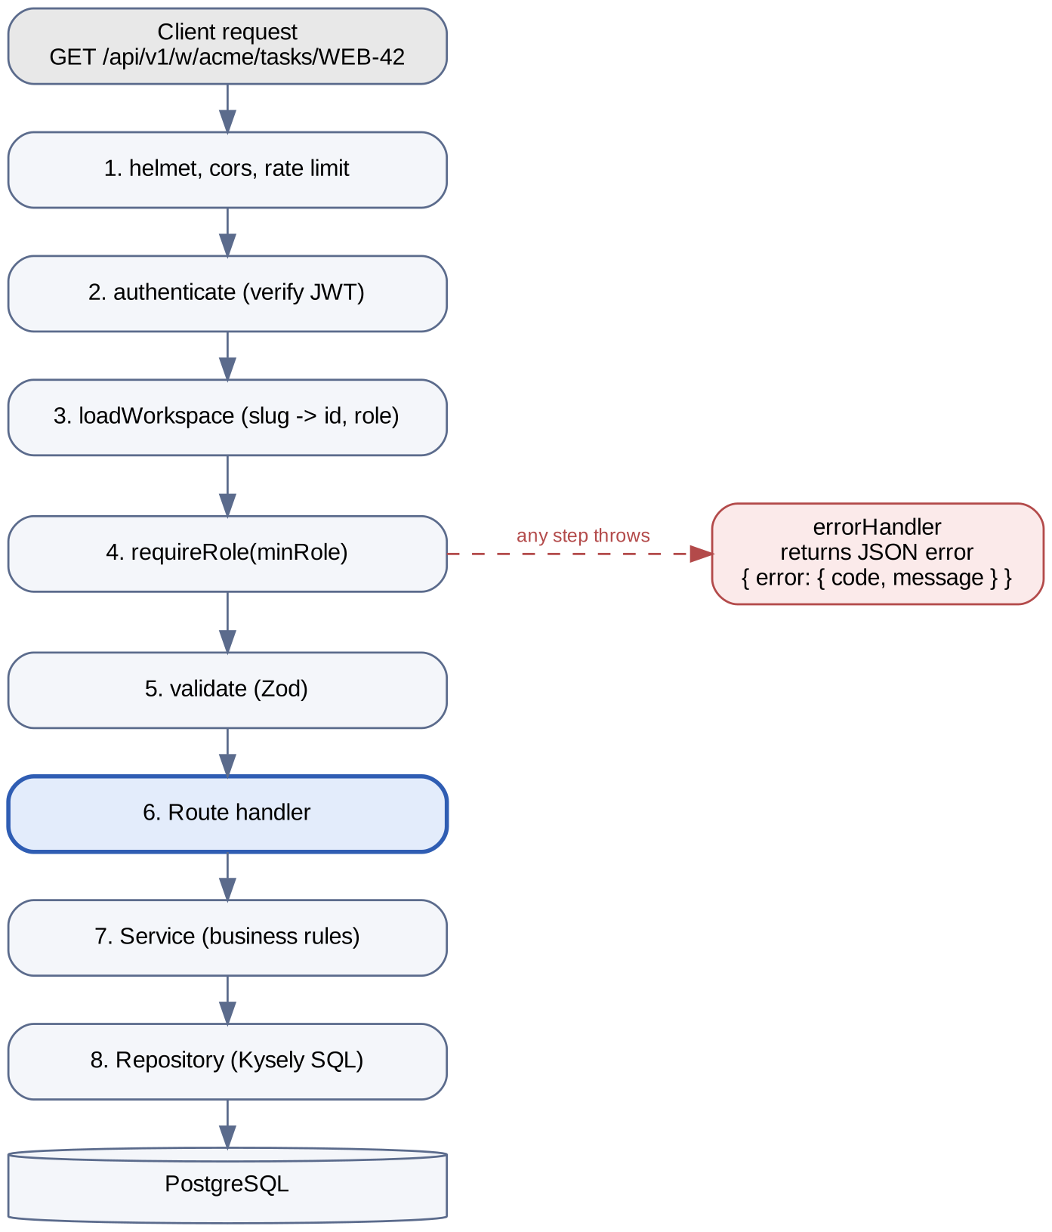
Figure 1. Request pipeline from client to database

3. Code structure and layering
apps/api/src/
├── app.ts # builds the Express app (used by server and tests)
├── server.ts # starts HTTP + Socket.IO, schedules cron jobs
├── config.ts # reads and validates env vars with Zod
├── db/
│ ├── index.ts # Kysely instance + pg Pool (max 10)
│ └── types.ts # generated by kysely-codegen
├── middleware/
│ ├── authenticate.ts # verifies JWT, sets req.user
│ ├── loadWorkspace.ts # slug -> workspace + caller role
│ ├── requireRole.ts
│ ├── validate.ts # Zod body/query/params
│ └── errorHandler.ts
├── modules/
│ ├── auth/ # routes, service, repo, tokens.ts
│ ├── workspaces/ # includes members + invitations
│ ├── projects/
│ ├── tasks/ # includes position.ts, move logic
│ ├── comments/ # includes mentions.ts
│ └── notifications/
├── jobs/ # dueSoon.ts, overdueDigest.ts, purgeDeleted.ts
├── realtime/ # socket.ts, emit helpers (v1.2)
└── lib/ # AppError, mailer, logger, pagination

Layer rules: routes handle HTTP only (parse, call service, send response). Services hold business rules and permission checks beyond role level (for example "only the author edits a comment"). Repositories contain SQL only and always take workspaceId. A layer may call only the layer below it.

4. Modules
Module | Responsibilities | Key endpoints
auth | Register, login, refresh rotation, logout, password reset, Google OAuth | /auth/*, /me
workspaces | Create, update, soft-delete workspaces; members; invitations; ownership transfer | /workspaces, /w/:slug, /w/:slug/members, /w/:slug/invitations
projects | CRUD, archive/restore, key uniqueness per workspace | /w/:slug/projects[/:key]
tasks | CRUD, board query, move with positions, subtasks, My tasks, search | /w/:slug/projects/:key/tasks, /w/:slug/tasks/:ref[/move], /w/:slug/my-tasks, /w/:slug/search
comments | Threaded comments, edit/delete rules, @mention parsing | /w/:slug/tasks/:ref/comments, /comments/:id
notifications | Create on events, list, mark read | /notifications[/read]

5. Database

5.1 v1.0 tables
The six core tables (users, workspaces, workspace_members, projects, tasks, comments) are defined in migrations/001_initial_schema.sql, which is the tested schema.sql. Triggers there handle updated_at, per-project task numbers, the denormalized workspace_id on tasks, and completed_at.

5.2 Supporting tables (migration 002)
CREATE TABLE refresh_tokens (
id UUID PRIMARY KEY DEFAULT gen_random_uuid(),
user_id UUID NOT NULL REFERENCES users (id) ON DELETE CASCADE,
token_hash TEXT NOT NULL UNIQUE, -- SHA-256 of the cookie value
family_id UUID NOT NULL, -- all rotations of one login
expires_at TIMESTAMPTZ NOT NULL,
revoked_at TIMESTAMPTZ,
created_at TIMESTAMPTZ NOT NULL DEFAULT now()
);
CREATE INDEX refresh_tokens_user_idx ON refresh_tokens (user_id);

CREATE TABLE invitations (
id UUID PRIMARY KEY DEFAULT gen_random_uuid(),
workspace_id UUID NOT NULL REFERENCES workspaces (id) ON DELETE CASCADE,
email CITEXT NOT NULL,
role workspace_role NOT NULL DEFAULT 'member',
token_hash TEXT NOT NULL UNIQUE,
invited_by UUID REFERENCES users (id) ON DELETE SET NULL,
expires_at TIMESTAMPTZ NOT NULL,
accepted_at TIMESTAMPTZ,
created_at TIMESTAMPTZ NOT NULL DEFAULT now()
);
CREATE UNIQUE INDEX invitations_pending_uq
ON invitations (workspace_id, email) WHERE accepted_at IS NULL;

CREATE TABLE password_resets (
token_hash TEXT PRIMARY KEY,
user_id UUID NOT NULL REFERENCES users (id) ON DELETE CASCADE,
expires_at TIMESTAMPTZ NOT NULL,
used_at TIMESTAMPTZ
);

CREATE TABLE notifications (
id UUID PRIMARY KEY DEFAULT gen_random_uuid(),
user_id UUID NOT NULL REFERENCES users (id) ON DELETE CASCADE,
workspace_id UUID NOT NULL REFERENCES workspaces (id) ON DELETE CASCADE,
type VARCHAR(30) NOT NULL, -- task_assigned, mentioned, ...
task_id UUID REFERENCES tasks (id) ON DELETE CASCADE,
actor_id UUID REFERENCES users (id) ON DELETE SET NULL,
read_at TIMESTAMPTZ,
created_at TIMESTAMPTZ NOT NULL DEFAULT now()
);
CREATE INDEX notifications_unread_idx
ON notifications (user_id, created_at DESC) WHERE read_at IS NULL;

5.3 Migration workflow
- Create a file: pnpm --filter api migrate create add_notifications.
- Write plain SQL for up and down.
- Run locally: pnpm --filter api migrate up, then regenerate types: pnpm --filter api db:types.
- CI runs all migrations on a fresh PostgreSQL 16 before tests; production runs them as a release step before the new API starts.

6. Authentication

6.1 Token design
Token | Format | Lifetime | Storage
Access token | JWT HS256, payload { sub, iat, exp } | 15 minutes | Memory in the web app (never localStorage)
Refresh token | 32 random bytes, base64url | 30 days, rotated on every use | HttpOnly Secure cookie; SHA-256 hash in refresh_tokens
Password reset | 32 random bytes | 30 minutes, single use | Hash in password_resets
Invitation | 32 random bytes | 7 days, single use | Hash in invitations

6.2 Refresh rotation and reuse detection
- Client calls POST /auth/refresh; the cookie is sent automatically.
- Server hashes the cookie and looks it up. Not found or expired → 401.
- If the token is already revoked, someone reused an old token: revoke every token in its family_id and return 401 (forces re-login on all devices for that login).
- Otherwise revoke it, insert a new token in the same family, set the new cookie, and return a new access token.

7. Authorization
Roles are ranked so a single comparison decides access. The workspace loader runs once per request and attaches the caller's role.
const rank = { guest: 0, member: 1, admin: 2, owner: 3 } as const;

export const loadWorkspace: RequestHandler = async (req, _res, next) => {
const row = await db.selectFrom('workspaces as w')
.innerJoin('workspace_members as m', 'm.workspace_id', 'w.id')
.select(['w.id', 'w.slug', 'w.name', 'm.role'])
.where('w.slug', '=', req.params.slug)
.where('w.deleted_at', 'is', null)
.where('m.user_id', '=', req.user.id)
.executeTakeFirst();
if (!row) throw new AppError(404, 'WORKSPACE_NOT_FOUND'); // 404, not 403
req.workspace = row;
next();
};

export const requireRole = (min: keyof typeof rank): RequestHandler =>
(req, _res, next) => {
if (rank[req.workspace.role] < rank[min]) throw new AppError(403, 'FORBIDDEN');
next();
};

Resource-level rules live in services: only a comment's author may edit it; authors or admins may delete it; the last admin cannot be demoted; the owner cannot be removed.

8. Core business logic

8.1 Task numbering
A BEFORE INSERT trigger increments projects.task_counter with UPDATE … RETURNING. The row lock serialises concurrent inserts in the same project, so two users creating tasks at once still get WEB-8 and WEB-9, never a duplicate. Numbers are never reused, even after deletion.

8.2 Moving a card (board ordering)
Cards are ordered by a NUMERIC position. A move writes only the moved row: its new position is the midpoint of its new neighbours.
// tasks/position.ts
const STEP = 1024;

export function positionBetween(before?: number, after?: number): number {
if (before === undefined && after === undefined) return STEP; // empty column
if (before === undefined) return after! / 2; // top of column
if (after === undefined) return before + STEP; // bottom of column
return (before + after) / 2; // between two cards
}

// tasks.service.ts (PATCH /tasks/:ref/move { status, beforeId?, afterId? })
async function moveTask(ws, ref, input) {
return db.transaction().execute(async (trx) => {
const [before, after] = await repo.neighbourPositions(trx, ws.id, input);
const position = positionBetween(before, after);
if (after !== undefined && Math.abs(after - position) < 1e-6) {
await repo.rebalanceColumn(trx, ws.id, input.projectId, input.status); // rare
return moveTask(ws, ref, input);
}
return repo.updateTask(trx, ws.id, ref, { status: input.status, position });
});
}

The client sends neighbour IDs, not positions, so the server stays the source of truth even if two people reorder the same column.

8.3 Soft delete and purge
- Deletes set deleted_at = now(). Repository list queries always add deleted_at IS NULL, matching the partial indexes.
- Deleting a task hides its comments with it; restoring brings them back.
- The nightly purgeDeleted job hard-deletes rows soft-deleted more than 30 days ago.

8.4 Mentions and notifications (v1.1)
- Comment bodies store mentions as @[Name](user:<uuid>); the editor inserts this format.
- On create or edit, mentions.ts extracts user IDs and keeps only current members of the workspace.
- The service inserts notifications for new mentions, the assignee and the reporter (never the comment author), in the same transaction as the comment.
- After commit, a realtime event notification.created is emitted to each recipient (v1.2).

9. Validation and errors
Request schemas live in packages/shared and are reused by the web app's forms. Every error response uses one shape:
{
"error": {
"code": "VALIDATION_FAILED",
"message": "Some fields are invalid",
"fields": { "title": "Title is required" },
"requestId": "req_01J9Z…"
}
}

HTTP status | Error code(s) | When
400 | BAD_REQUEST | Malformed JSON or unknown query parameter
401 | UNAUTHENTICATED, TOKEN_EXPIRED | Missing or invalid access token
403 | FORBIDDEN | Role too low, or not the author
404 | WORKSPACE_NOT_FOUND, PROJECT_NOT_FOUND, TASK_NOT_FOUND | Missing, deleted, or in another workspace
409 | SLUG_TAKEN, PROJECT_KEY_TAKEN, EMAIL_TAKEN | Unique constraint violated
422 | VALIDATION_FAILED | Zod validation failed; fields lists problems
429 | RATE_LIMITED | Too many requests; Retry-After header set
500 | INTERNAL | Unexpected error; logged and sent to Sentry, details hidden

PostgreSQL unique-violation errors (code 23505) are mapped to the matching 409 code by constraint name, so the service does not need a separate "check then insert" query.

10. API examples

Create a task
POST /api/v1/w/sukkur-iba-fyp/projects/WEB/tasks
Authorization: Bearer eyJhbGciOi…

{ "title": "Build login page", "priority": "high",
"assigneeId": "6f1c…", "dueDate": "2026-11-20T17:00:00Z" }

201 Created
{ "data": { "id": "a3d9…", "ref": "WEB-1", "title": "Build login page",
"status": "todo", "priority": "high", "position": 1024,
"assignee": { "id": "6f1c…", "fullName": "Bilal" },
"dueDate": "2026-11-20T17:00:00Z", "createdAt": "2026-11-09T10:12:03Z" } }

Move a task on the board
PATCH /api/v1/w/sukkur-iba-fyp/tasks/WEB-1/move
{ "status": "in_progress", "beforeId": "c81e…", "afterId": null }

200 OK
{ "data": { "ref": "WEB-1", "status": "in_progress", "position": 3072,
"updatedAt": "2026-11-10T08:40:11Z" } }

11. Background jobs
Job | Schedule | What it does | Release
dueSoon | Every hour | Notifies assignees of open tasks due in the next 24 h (once per task) | v1.1
overdueDigest | Hourly; sends at 09:00 in each user's timezone | Emails each user a list of their overdue tasks | v1.2
purgeDeleted | Daily 03:00 UTC | Hard-deletes rows soft-deleted over 30 days ago | v1.0
cleanupTokens | Daily 03:30 UTC | Deletes expired refresh, reset and invite tokens | v1.0

Jobs take a PostgreSQL advisory lock (pg_try_advisory_lock) before running, so a second API instance never runs the same job twice.

12. Real-time events (v1.2)
Event | Room | Payload
task.created | project:<id> | Full task card
task.updated | project:<id> | Task ID + changed fields
task.moved | project:<id> | Task ID, status, position
task.deleted | project:<id> | Task ID
comment.created | task:<id> | Comment with author
notification.created | user:<id> | Notification row

Sockets authenticate with the access token in the handshake. A client may join a project room only after the server checks workspace membership. Events are emitted after the database transaction commits, and include the sender's socket ID so the sender ignores its own echo.

13. Configuration
Variable | Example | Purpose
DATABASE_URL | postgres://…/tasknest | PostgreSQL connection (Neon pooled URL in production)
JWT_SECRET | 64+ random characters | Signs access tokens
WEB_ORIGIN | https://tasknest.vercel.app | CORS allowlist and email links
COOKIE_DOMAIN | .tasknest.app | Refresh-token cookie scope
RESEND_API_KEY | re_… | Transactional email
GOOGLE_CLIENT_ID / SECRET | … | Google OAuth (v1.1)
SENTRY_DSN | https://… | Error reporting
LOG_LEVEL | info | pino log level
PORT | 4000 | HTTP port

config.ts validates all variables with Zod at startup; the API refuses to start if one is missing or malformed.

14. Logging, monitoring and testing
- Logs: pino JSON lines with requestId, userId, workspaceId, route, status and duration. Passwords, tokens and cookies are redacted.
- Errors: Sentry captures unhandled errors with the request ID for cross-reference.
- Health: GET /health checks the database with SELECT 1 and returns version and uptime.
- Unit tests (Vitest): positionBetween, mention parsing, role ranking, token helpers.
- Integration tests (Supertest): each endpoint against a real PostgreSQL test database reset per file; every role for every write; a cross-tenant test per module expecting 404.
- Database tests: task numbering under 20 concurrent inserts; completed_at set and cleared; updated_at changes.

15. Local setup
git clone https://github.com/<you>/tasknest && cd tasknest
pnpm install
cp apps/api/.env.example apps/api/.env # fill in values
docker compose up -d db # PostgreSQL 16 on :5432
pnpm --filter api migrate up
pnpm --filter api db:seed # demo workspace, 3 users, 40 tasks
pnpm dev # api :4000, web :3000
pnpm test # unit + integration

