TASKNEST

Project Plan
A 14-week, week-by-week plan to build, ship and present TaskNest as a portfolio project.
Version 1.0 · 4 November 2026 · Project management SaaS · Related: PRD, TRD, App Flow, UI/UX Brief, Backend

1. Summary
TaskNest is built by one developer working about 15 hours a week, from Monday 9 November 2026 to Sunday 14 February 2027. The MVP goes live on 4 January 2027 (end of week 8); v1.1 and v1.2 follow, and the last week packages the project for the portfolio.
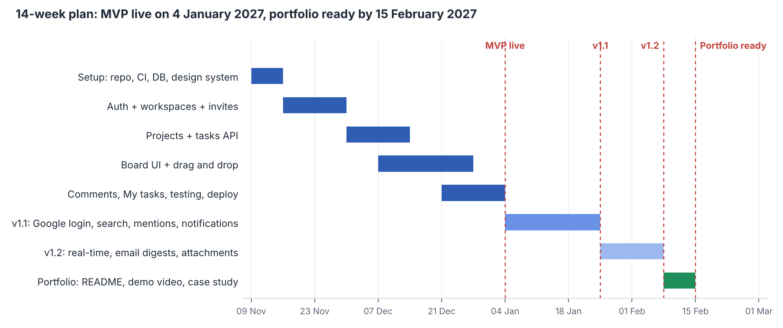
Figure 1. Phases and milestones
Milestone | Date | Exit criteria
M0: Foundations ready | Sun 15 Nov 2026 | Monorepo, CI green, local PostgreSQL with schema, design tokens in Tailwind
M1: MVP live | Mon 4 Jan 2027 | All PRD "Must" requirements deployed; demo workspace seeded; 5 Playwright flows pass
M2: v1.1 released | Mon 25 Jan 2027 | Google login, archive, subtasks, filters, search, mentions, notifications
M3: v1.2 released | Mon 8 Feb 2027 | Real-time board, email digests, attachments
M4: Portfolio ready | Mon 15 Feb 2027 | README, demo video, case study, resume and LinkedIn entries published

2. Working approach
- Method: one-week sprints (Monday to Sunday), applying the Agile practices from the Google Project Management certificate.
- Weekly rhythm: Monday 30-minute planning (pick issues from the backlog); build Tuesday to Saturday; Sunday 30-minute review, demo to yourself, update the plan.
- Tracking: GitHub Projects board with columns Backlog, This week, In progress, Review, Done, which is the same workflow TaskNest itself supports. Once the MVP is live, move tracking into TaskNest (dogfooding makes a good portfolio story).
- Time budget: about 15 h/week: 3 h on weekdays (5 × ~1.5 h) plus 7–8 h at weekends. Exam weeks drop to 6 h; the plan has buffer for this.
- Definition of done: code merged to main through a pull request, tests passing in CI, deployed to preview, and the related checklist item ticked.

3. Week-by-week plan

Phase 1: MVP (weeks 1–8)
Week | Dates | Goals | Deliverables
1 | 9–15 Nov | Foundations: pnpm monorepo, Next.js and Express apps, Docker PostgreSQL, migration 001, CI pipeline, Tailwind tokens and shadcn/ui setup | Repo on GitHub; CI green; app shell renders; DB schema migrated
2 | 16–22 Nov | Auth backend: register, login, refresh rotation, logout, password reset; auth middleware; tests | All /auth endpoints with Supertest coverage
3 | 23–29 Nov | Auth UI + workspaces: sign-up/login pages, onboarding wizard, workspace CRUD, members, invitations, role middleware | User can sign up, create workspace, invite a teammate
4 | 30 Nov–6 Dec | Projects API + UI: CRUD, key validation, sidebar project list, create-project modal | Projects appear in sidebar; key uniqueness enforced
5 | 7–13 Dec | Tasks API: create, read, update, delete, board query, move with positions; start board layout | Tasks endpoints tested; static board shows real tasks
6 | 14–20 Dec | Board UI: columns, cards, quick add, dnd-kit drag and drop with optimistic updates | Tasks can be added and dragged between columns
7 | 21–27 Dec | Task drawer (all fields, Markdown description) + comments API and UI + My tasks page | Full task editing; threaded comments; My tasks list
8 | 28 Dec–3 Jan | Hardening: empty/error/loading states, accessibility pass, Playwright flows, seed script, production deploy (Vercel, Render, Neon) | MVP live with a demo account

Phase 2: v1.1 (weeks 9–11)
Week | Dates | Goals | Deliverables
9 | 4–10 Jan | Google OAuth, project archive/restore, subtasks | Google sign-in works in production
10 | 11–17 Jan | Board filters (URL-synced), full-text search page, command menu | Search returns ranked results in < 200 ms on 100k seeded tasks
11 | 18–24 Jan | @mentions, notifications table, bell panel, due-soon job | Assign and mention trigger notifications

Phase 3: v1.2 and portfolio (weeks 12–14)
Week | Dates | Goals | Deliverables
12 | 25–31 Jan | Socket.IO rooms, live board events, cache patching on the client | Two browsers see each other's moves instantly
13 | 1–7 Feb | Overdue email digest, file attachments (object storage), performance check with EXPLAIN ANALYZE | v1.2 deployed; performance report in repo
14 | 8–14 Feb | Portfolio packaging (section 6) | All portfolio items published

4. MVP backlog with estimates
Estimates are in hours of focused work. The MVP totals about 112 hours, which fits 8 weeks at 15 h/week with roughly 8 hours of buffer.
# | Item | PRD ref | Estimate (h) | Week
1 | Monorepo, tooling, CI, Docker DB, migration 001 | — | 10 | 1
2 | Design tokens, app shell, sidebar, top bar | — | 6 | 1
3 | Auth API (register, login, refresh, logout, reset) + tests | FR-01, FR-03 | 12 | 2
4 | Auth pages + session handling in the web app | FR-01, FR-03 | 6 | 3
5 | Workspaces, members, invitations API + onboarding UI | FR-04, FR-05, FR-06 | 12 | 3
6 | Projects API + UI | FR-07 | 9 | 4
7 | Tasks API incl. move and positions + tests | FR-09, FR-10 | 12 | 5
8 | Board UI with drag and drop + quick add | FR-10 | 14 | 6
9 | Task drawer with all fields | FR-09 | 7 | 7
10 | Comments API + UI | FR-14 | 6 | 7
11 | My tasks page | FR-11 | 3 | 7
12 | States, accessibility, Playwright, seed, deploy | NFRs | 15 | 8
 | Total |  | 112

5. Git and release workflow
- Create a GitHub issue for each backlog item, labelled by module and release (v1.0, v1.1, v1.2).
- Branch from main: feat/42-board-drag-drop.
- Commit with Conventional Commits (feat(tasks): add move endpoint).
- Open a pull request; CI runs lint, type check and tests; Vercel and Render create preview deploys.
- Self-review using a checklist (tests added, no secrets, accessibility checked), then squash-merge.
- Tag releases (v1.0.0, v1.1.0, v1.2.0) and write release notes on GitHub. These double as portfolio evidence.

6. Portfolio packaging (week 14)
Item | Contents
README | One-line pitch, live demo link and demo login, screenshots/GIF, feature list, tech stack badges, architecture diagram, local setup, link to these six documents
Demo video (2–3 min) | Sign up → workspace → project → tasks → drag → comment → live update in a second browser
Case study page | Problem, users, process (PRD → TRD → design → build), key decisions (schema, positions, auth), results (performance numbers), what you would do next
Docs folder | PRD, TRD, App Flow, UI/UX Brief, Backend spec, Plan in /docs (PDF and source)
Resume entry | Two or three bullets with numbers (see below)
LinkedIn | Add to Projects section; post with the demo video and lessons learned

Draft resume bullets
- Built TaskNest, a multi-tenant project management SaaS (Next.js, Express, PostgreSQL, TypeScript) with Kanban boards, role-based access and threaded comments, deployed on Vercel, Render and Neon.
- Designed a PostgreSQL schema with partial indexes, full-text search and trigger-based task numbering; kept API p95 latency under 200 ms on 100k seeded tasks.
- Planned and delivered the project in 14 one-week Agile sprints, from PRD and technical design to CI/CD with 5 end-to-end test flows.
Replace the numbers in these bullets with your real measurements once the app is built.

7. Risks and buffer
Risk | Likelihood | Impact | Response
University exams or assignments cut weekly hours | High | Medium | MVP has ~8 h buffer; v1.2 scope can move to after February without hurting the portfolio
Drag and drop takes longer than estimated | Medium | High | Start board UI in week 5 alongside the API; fall back to status dropdown first, drag second
Auth bugs (cookies across Vercel and Render) | Medium | High | Test production auth in week 3 with a deploy spike; proxy /api through Next.js rewrites if needed
Free hosting limits or cold starts | Medium | Low | Keep-alive ping; note cold start in README
Losing motivation mid-project | Medium | High | Deploy early (week 3) so progress is visible; share weekly progress on LinkedIn

Scope rule: if a week slips, cut from the bottom of the priority list (Could → Should) rather than moving the MVP date.

8. Weekly checklist
- Monday: pick this week's issues; confirm hours available.
- Daily: one small pull request merged if possible.
- Sunday: demo the week's work, update the GitHub board, note blockers, and adjust next week's scope.
- End of each phase: tag a release, update README screenshots, write a short progress post.

