

Open Ended Lab

MID OEL PROJECT REPORT
Department of Computer Science
Car Rental System (Java OOP)
Course: Object Oriented Programming Lab (OOP)
Submitted To: Miss Aimen (OOP Lab Instructor)
Submitted By: MUHAMMAD SULEMAN
Student ID: 75003

Motivation
The motivation behind this project is to simplify the process of managing car rental operations. In small rental businesses, managing records manually can lead to confusion, errors, and inefficiency. This system provides a structured and easy way to manage cars, their availability, and rental operations using Object-Oriented Programming concepts.

Introduction
In small rental businesses, managing available and rented vehicles manually can create confusion, delays, and record issues. This project provides a simple computerized solution for handling car rental operations in a structured way. The Car Rental System helps manage car records, track rental status, and make the process of renting and returning cars easier. The system is implemented in Java using the Object-Oriented Programming approach, which makes the code organ ized, reusable, and easy to maintain.

Acknowledgement
I would like to thank my instructor for guiding me throughout this project. This assignment helped me strengthen my understanding of Object-Oriented Programming and how it can be used to build practical software solutions. While working on this project, I learned how to organize a Java program using classes, objects, methods, and encapsulation in a clear and structured way.

Concept
This project is a simple Car Rental System developed using Java programming language. The purpose of this system is to manage rental operations in a basic and efficient manner. The system allows the user to add cars to the rental list, rent a car to a customer, return a rented car, and view available cars. The project is developed using Object-Oriented Programming concepts such as classes, objects, encapsulation, abstraction, and modularity. It is designed as a console-based application so that the logic remains simple and easy to understand for learning purposes.

Objectives
- To create a simple car rental system using Java
- To apply Object-Oriented Programming concepts in a practical project
- To manage car availability and rental status efficiently
- To reduce manual errors in rental record handling
- To provide a simple and organized rental management solution

Project Scope
This system is designed for small-level use and includes the following features:
- Add a car to the rental system
- Rent a car if it is available
- Return a rented car
- Display all cars with their rental status
- Prevent renting of already rented cars
- Update car status automatically after rent or return
This project is limited to a console-based application and does not include database integration or a graphical user interface.

Tools and Technologies
- Programming Language: Java
- Concept Used: Object-Oriented Programming (OOP)
- IDE: VS Code / Eclipse / IntelliJ IDEA
- Platform: Console-based application

OOP Concepts Used
1. Class and Object Classes such as Car and RentalSystem are created. Objects are used to store car information and perform rental operations.
2. Encapsulation The data members in the Car class are kept private and accessed through getter and setter methods. This protects the data and controls direct access.
3. Abstraction The internal logic of renting and returning a car is hidden inside methods. The user only interacts with simple menu options.
4. Modularity Different tasks such as adding cars, renting, returning, and displaying records are handled in separate methods, making the program more organized.

System Modules
1. Car Module This module stores car information such as car ID, model name, and rental status.
2. Rental Module This module handles the renting and returning of cars.
3. Availability Management Module This module keeps track of which cars are available and which are currently rented.
4. User Interface Module This module handles user interaction using menu options in the console.

System Flow (Explanation)
The system works in the following steps:
- Program starts
- Rental system is initialized
- Menu is displayed to the user
- User selects an option
- - Add Car
- - Rent Car
- - Return Car
- - View Cars
- - Exit
- If adding is selected:
- - User enters car ID and model name
- - System stores the car record
- If renting is selected:
- - User enters the car ID
- - System checks whether the car is available
- - Car is rented if available
- If return is selected:
- - User enters the car ID
- - System marks the car as returned
- Program returns to menu

Procedure
• Created Car class with attributes
• Implemented RentalSystem class
• Used ArrayList to store cars
• Developed methods:
- addCar()
- rentCar()
- returnCar()
- viewCars()
• Created menu-driven program

Flowchart
Start -> Show Menu -> Add Car / Rent Car / Return Car / View Cars -> Update Status -> Return to Menu -> Exit

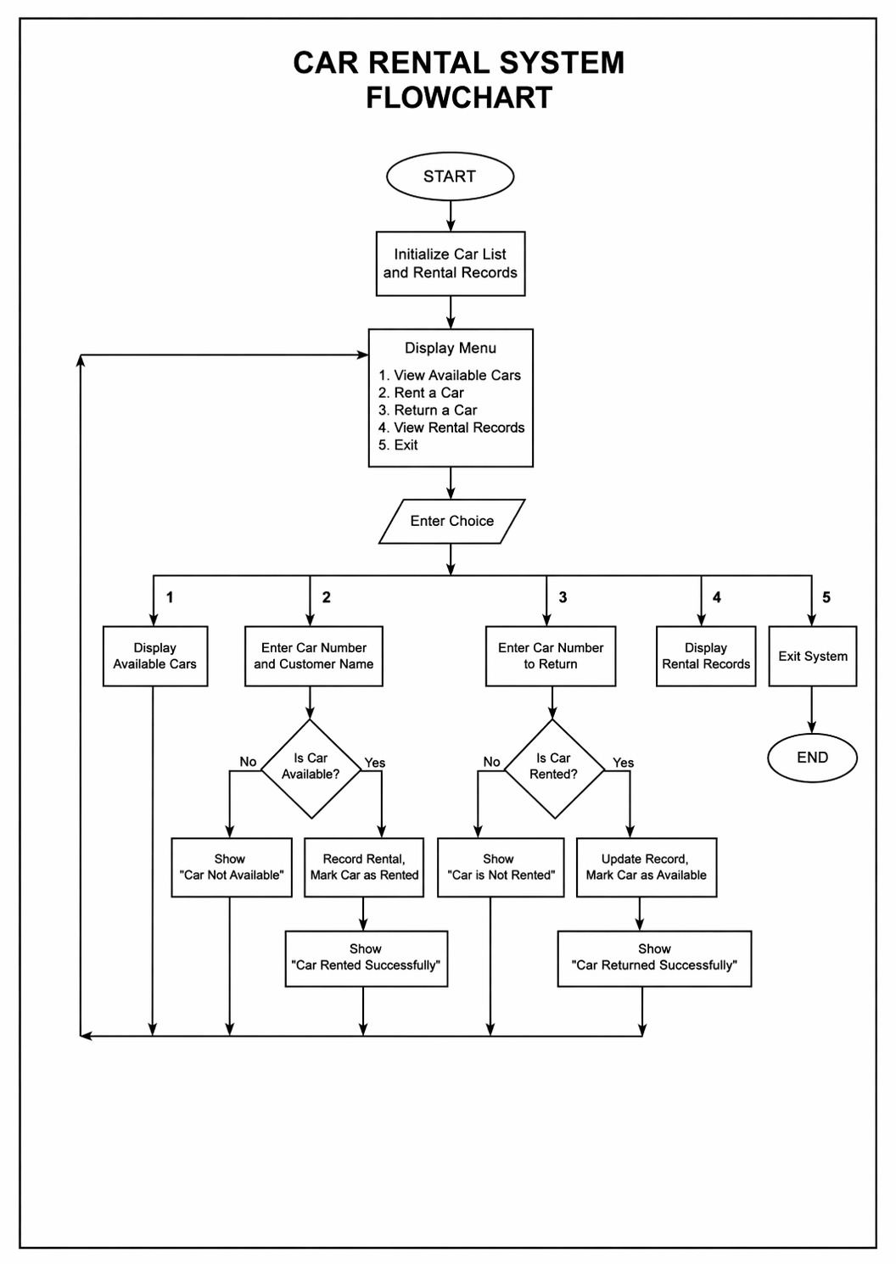

Sample Output
--- Car Rental System ---
1. Add Car
2. Rent Car
3. Return Car
4. View Cars
5. Exit
Enter your choice: 1
Enter Car ID: 101
Enter Car Model: Corolla
Car added successfully.
Enter your choice: 2
Enter Car ID to Rent: 101
Car rented successfully.
Enter your choice: 4
--- Car List ---
ID: 101 | Model: Corolla | Status: Rented
Enter your choice: 3
Enter Car ID to Return: 101
Car returned successfully.

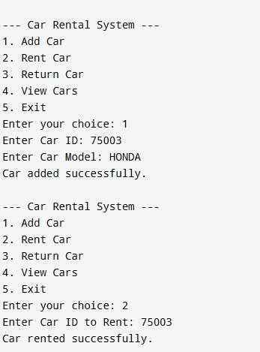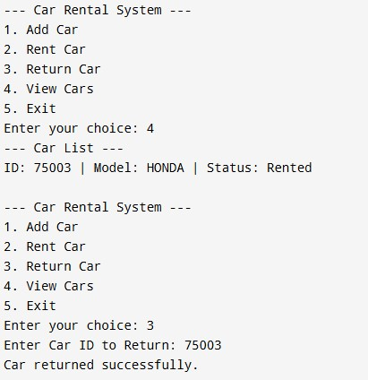

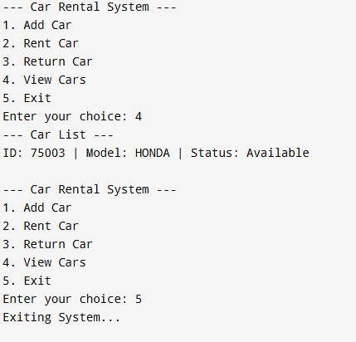

Analysis
The system successfully demonstrates OOP concepts and provides a simple way to manage rental operations. It ensures proper tracking of car availability.

Advantages of the System
- Simple and easy to use
- Reduces manual rental management errors
- Helps track car availability clearly
- Organized code using OOP concepts
- Easy to expand in future

Limitations
- No database support (data is not saved permanently)
- No graphical user interface
- Limited features for large rental businesses
- No customer account or payment system

Future Enhancements
- GUI using Java Swing or JavaFX
- Database connectivity using MySQL
- Customer details and booking records
- Rental duration and return date tracking
- Payment and bill generation
- Search and filter options for cars

Conclusion
This project helped in understanding how Object-Oriented Programming concepts are used in real applications. The Car Rental System successfully performs basic rental management tasks such as adding cars, renting them, returning them, and viewing their status. It is a good example of how programming can be used to solve real-world problems in a structured and practical manner.
Source Code
import java.util.ArrayList;
import java.util.Scanner;
// Car Class (Encapsulation)
class Car {
private int carId;
private String model;
private boolean isRented;
public Car(int carId, String model) {
this.carId = carId;
this.model = model;
this.isRented = false;
}
public int getCarId() {
return carId;
}
public String getModel() {
return model;
}
public boolean isRented() {
return isRented;
}
public void rentCar() {
isRented = true;
}
public void returnCar() {
isRented = false;
}
}
// Rental System Class
class RentalSystem {
private ArrayList<Car> cars = new ArrayList<>();
private Scanner scanner;
public RentalSystem(Scanner scanner) {
this.scanner = scanner;
}
public void addCar() {
System.out.print("Enter Car ID: ");
int id = scanner.nextInt();
scanner.nextLine();
System.out.print("Enter Car Model: ");
String model = scanner.nextLine();
cars.add(new Car(id, model));
System.out.println("Car added successfully.");
}
public void rentCar() {
System.out.print("Enter Car ID to Rent: ");
int id = scanner.nextInt();
for (Car car : cars) {
if (car.getCarId() == id) {
if (!car.isRented()) {
car.rentCar();
System.out.println("Car rented successfully.");
} else {
System.out.println("Car is already rented.");
}
return;
}
}
System.out.println("Car not found.");
}
public void returnCar() {
System.out.print("Enter Car ID to Return: ");
int id = scanner.nextInt();
for (Car car : cars) {
if (car.getCarId() == id) {
if (car.isRented()) {
car.returnCar();
System.out.println("Car returned successfully.");
} else {
System.out.println("Car is already available.");
}
return;
}
}
System.out.println("Car not found.");
}
public void viewCars() {
if (cars.isEmpty()) {
System.out.println("No cars available in the system.");
return;
}
System.out.println("--- Car List ---");
for (Car car : cars) {
String status = car.isRented() ? "Rented" : "Available";
System.out.println("ID: " + car.getCarId() + " | Model: " + car.getModel() + " | Status: " + status);
}
}
}
// Main Class
public class Main {
public static void main(String[] args) {
Scanner input = new Scanner(System.in);
RentalSystem rentalSystem = new RentalSystem(input);
while (true) {
System.out.println("\n--- Car Rental System ---");
System.out.println("1. Add Car");
System.out.println("2. Rent Car");
System.out.println("3. Return Car");
System.out.println("4. View Cars");
System.out.println("5. Exit");
System.out.print("Enter your choice: ");
int choice = input.nextInt();
if (choice == 1) {
rentalSystem.addCar();
} else if (choice == 2) {
rentalSystem.rentCar();
} else if (choice == 3) {
rentalSystem.returnCar();
} else if (choice == 4) {
rentalSystem.viewCars();
} else if (choice == 5) {
System.out.println("Exiting System...");
break;
} else {
System.out.println("Invalid Choice!");
}
}
input.close();
}
}

GitHub Repository
The complete source code of this project can be uploaded to GitHub for easy access and review.
Repository Link: https://github.com/MuhammadSulemanKhan/Car_Rental_services
This repository can contain all project files including source code, report, and flowchart. It helps in maintaining version control and sharing the project easily.

Thank You:
Thank you for giving us the opportunity to work on this project.

