Veer Advanced AI Candidate Assessment Question Bank
Rewritten, advanced and answer randomised version for website development
Company: Veer
Tagline: Towards Better
Purpose: Candidate screening for AI, Machine Learning, Software Development and Logic roles
Assessment design: 150 objective items, with 30 questions randomly selected per candidate attempt
Pass benchmark: 80 percent, equal to 24 correct answers out of 30

1. Recheck of the previous draft
The previous uploaded draft had a serious answer key pattern issue. Across the 150 objective items, 122 answers were A, 13 were B and all 15 choose three answers used the same A, B, C pattern. There were no C or D correct answers in the single choice and image based pool. That pattern makes the assessment easier to game and weakens score validity.
Check | Previous draft | Rewritten draft
Single choice and image correct A | 122 | 33
Single choice and image correct B | 13 | 34
Single choice and image correct C | 0 | 34
Single choice and image correct D | 0 | 34
Choose three answer pattern | Always A, B, C | Mixed patterns across A to E

2. Quality evaluation against a high standard
Criterion | Previous quality | Rewritten quality | Reason
Answer randomisation | Weak | Strong | Correct answers now rotate across A, B, C and D. Choose three combinations are also varied.
Distractor quality | Mixed | Improved | Distractors are more plausible and job related, with fewer obvious joke options.
Difficulty level | Basic to intermediate | Intermediate to advanced | More scenario based questions test applied judgement, safety and production thinking.
Role relevance | Good foundation | Stronger | Questions now align better with AI recruitment, LLMOps, RAG, governance, API integration and fair screening.
Assessment validity | Reduced by answer pattern | Improved | Balanced answers reduce guessing bias and improve score meaning.
Website readiness | Usable | Stronger | Question type tags, scoring rules and answer key remain developer friendly.

3. Developer implementation summary
Category | Pool size | Random pick from 30 | Weight
AI and Generative AI | 90 | 18 | 60 percent
Machine Learning | 15 | 3 | 10 percent
Software Development | 15 | 3 | 10 percent
Aptitude and Logic | 30 | 6 | 20 percent
Question type | Count | Approximate share | Developer tag
Single choice | 127 | 85 percent | single_choice
Choose three answers | 15 | 10 percent | choose_three
Image based question | 8 | 5 percent | image_based
Recommended random selection logic: pick 18 AI questions, 3 Machine Learning questions, 3 Software Development questions and 6 Aptitude questions. The frontend should randomise question order and option order during delivery while storing the correct answer server side only.
Scoring recommendation: single choice equals 1 point. Choose three equals 1 point only when all three correct options are selected and no incorrect option is selected. Image based questions equal 1 point. Written senior benchmark questions should be scored separately by a reviewer.

4. Candidate instructions for website
You will answer 30 randomly selected questions after uploading your CV or resume.
The pass benchmark is 80 percent, equal to 24 correct answers out of 30.
Some questions ask you to choose one answer. Some ask you to choose three answers. Some ask you to study a diagram before answering.
Your score helps Veer understand your current skill level. It does not guarantee a job offer and should be read together with your CV, project evidence, interview and work history.

5. Senior benchmark written questions
SBQ1. You are asked to design a production RAG system for a regulated financial services company. Explain how you would design the architecture, control document access, reduce hallucination, evaluate answers and monitor the system after launch.
Minimum answer length: 200 words.
Reviewer benchmark: A top 1 percent answer should discuss permission aware retrieval, source citations, chunking, reranking, evaluation sets, logging, model versioning, red team tests, fallback behaviour, human escalation, cost and latency controls, security review and GDPR or UK GDPR considerations.
SBQ2. A company wants to replace manual customer support triage with an AI agent that can classify tickets, search internal knowledge and draft replies. Explain the risks, the minimum safe launch design and how you would measure success.
Minimum answer length: 200 words.
Reviewer benchmark: A top 1 percent answer should separate low risk and high risk actions, discuss human approval gates, tool permissions, failure modes, escalation, audit trails, response quality, customer satisfaction, resolution time, safety testing and continuous monitoring.
SBQ3. You inherit an AI product where users complain that answers are slow, expensive and sometimes unsupported by sources. Explain how you would diagnose the system and improve it without breaking user trust.
Minimum answer length: 200 words.
Reviewer benchmark: A top 1 percent answer should break the pipeline into retrieval, model call, prompt length, caching, context size, reranking and frontend streaming. It should include baseline metrics, experiments, evaluation sets, user communication, regression testing and monitoring.
SBQ4. Two candidates both pass the MCQ assessment. One has a stronger score, while the other has shipped a real AI feature with monitoring and user feedback. Explain how Veer should assess both candidates fairly for a client shortlist.
Minimum answer length: 200 words.
Reviewer benchmark: A top 1 percent answer should avoid automatic ranking by score alone. It should use role criteria, project evidence, technical interview, communication, production depth, risk flags, salary fit, availability and client needs.

6. Objective question bank

AI and Generative AI
Q001 [Single choice] A company wants a knowledge assistant for contracts that change weekly. Which design choice best supports accurate answers?
A. Fine tuning once and removing retrieval
B. RAG with permission aware retrieval and source citations
C. A high temperature prompt with no references
D. A static FAQ copied into the system prompt
Correct answer: B
Explanation: Changing private knowledge needs retrieval, access checks and citations.
Q002 [Single choice] What is the strongest reason to evaluate retrieval before judging final LLM answers?
A. Retrieval scores always equal final answer quality
B. It removes the need to test generation
C. Poor retrieval can make a capable model answer from weak or irrelevant evidence
D. It proves the user interface is accessible
Correct answer: C
Explanation: RAG quality depends on both retrieval quality and generation quality.
Q003 [Single choice] A RAG answer cites three sources but the cited passages do not support the claim. What is the best diagnosis?
A. The model context window is always too small
B. The vector database has no use in the pipeline
C. The user prompt is automatically malicious
D. The system has weak citation grounding or answer attribution
Correct answer: D
Explanation: Citations must support claims, not merely appear beside them.
Q004 [Single choice] Which control best reduces the risk of one employee seeing another employee confidential file in RAG search?
A. Document level access filtering before retrieval results reach the model
B. Longer chunks for every document
C. Higher generation temperature
D. Client side sorting after the answer
Correct answer: A
Explanation: Permissions must apply before context enters the prompt.
Q005 [Single choice] A prompt injection appears inside a retrieved PDF. What should the application do?
A. Let the PDF override system instructions
B. Disable authentication for the session
C. Treat retrieved content as untrusted evidence, not as instructions
D. Send the content directly to every tool
Correct answer: C
Explanation: Retrieved documents should inform answers but never control higher priority instructions.
Q006 [Single choice] What does reranking add to a retrieval pipeline?
A. A permanent replacement for access control
B. A guarantee that every answer is true
C. A method for hiding source documents
D. A second relevance stage that improves the order of candidate passages
Correct answer: D
Explanation: Reranking can improve precision after initial retrieval.
Q007 [Single choice] Which chunking strategy is most defensible for a policy knowledge base?
A. Test chunk sizes and overlaps against real questions and expected citations
B. Use one paragraph for every file without testing
C. Always split every 50 characters
D. Always send the full document collection
Correct answer: A
Explanation: Chunking should be evaluated against realistic retrieval tasks.
Q008 [Single choice] A legal assistant must answer only from approved documents. Which fallback is safest when retrieval finds no support?
A. Invent a likely answer and mark it confidential
B. State that the answer cannot be confirmed from available sources
C. Use the model memory without disclosure
D. Ask the user to ignore citations
Correct answer: B
Explanation: Safe uncertainty protects trust and compliance.
Q009 [Single choice] What is the clearest use case for fine tuning instead of RAG?
A. Adding rapidly changing internal policies
B. Avoiding all evaluation work
C. Bypassing permission checks
D. Teaching a model a consistent response style or task pattern from high quality examples
Correct answer: D
Explanation: Fine tuning shapes behaviour. RAG supplies current knowledge.
Q010 [Single choice] What is the main risk of putting API keys or passwords into prompts?
A. They make embeddings impossible
B. They prevent tokenisation
C. They may leak through logs, outputs or prompt exposure
D. They remove network latency
Correct answer: C
Explanation: Secrets belong in secure secret management, not prompts.
Q011 [Single choice] Why does a golden test set matter in LLMOps?
A. It gives a stable benchmark for comparing prompts, models and retrieval changes
B. It replaces production monitoring
C. It guarantees no hallucinations
D. It removes the need for user feedback
Correct answer: A
Explanation: A fixed evaluation set helps detect regressions.
Q012 [Single choice] What should a high quality LLM evaluation set include?
A. Only simple demo questions
B. Representative normal cases, edge cases, failures and expected scoring criteria
C. Only examples the model wrote for itself
D. Only questions with no expected answer
Correct answer: B
Explanation: Evaluation should test real task performance and failure modes.
Q013 [Single choice] A customer support agent drafts replies and can refund customers. What is the safest launch pattern?
A. Give it unlimited refund authority from day one
B. Let it draft replies, but require human approval for refunds and high impact actions
C. Remove logs to protect speed
D. Let it decide policy exceptions without review
Correct answer: B
Explanation: Autonomous actions need permission limits and approval gates.
Q014 [Single choice] What is the practical purpose of tool calling in an LLM product?
A. To make every answer creative
B. To remove authentication from APIs
C. To request structured actions from approved systems such as search, CRM or ticketing APIs
D. To make prompts shorter by deleting context
Correct answer: C
Explanation: Tool calling connects language output with controlled software actions.
Q015 [Single choice] Which metric best captures whether retrieved passages contain the needed evidence in the top results?
A. CSS coverage
B. Server uptime only
C. Candidate conversion rate
D. Recall at k for relevant evidence
Correct answer: D
Explanation: Recall at k checks whether relevant material appears among retrieved results.
Q016 [Single choice] What does temperature usually control during generation?
A. The randomness of token selection
B. The encryption level of storage
C. The number of documents indexed
D. The amount of RAM in the server
Correct answer: A
Explanation: Lower values usually increase consistency. Higher values increase variation.
Q017 [Single choice] A compliance assistant gives varied answers to the same policy question. What setting should you check first?
A. Logo colour
B. Image resolution
C. Temperature and prompt constraints
D. Candidate salary field
Correct answer: C
Explanation: Precision tasks usually need lower randomness and stricter grounding.
Q018 [Single choice] What is model context window pressure?
A. A browser resizing problem
B. A database backup limit
C. A hiring manager availability issue
D. The limit created when instructions, retrieved context and output must fit within available tokens
Correct answer: D
Explanation: Context budget affects what evidence the model can use.
Q019 [Single choice] Which design reduces token cost without weakening sensitive access control?
A. Cache safe repeated outputs only when permission scope and inputs match
B. Cache every answer globally for all users
C. Send all documents on every request
D. Disable retrieval logging
Correct answer: A
Explanation: Caching must respect user permissions and context.
Q020 [Single choice] What is semantic search best at finding?
A. Only the longest files
B. Content close in meaning to a query even when wording differs
C. Only exact spelling matches
D. Only files created most recently
Correct answer: B
Explanation: Embeddings support meaning based retrieval.
Q021 [Single choice] What is the main limitation of vector similarity alone?
A. It cannot search text
B. It always ignores user queries
C. It prevents reranking
D. It may retrieve semantically close but legally or contextually wrong passages
Correct answer: D
Explanation: Similarity should be combined with filters, metadata and evaluation.
Q022 [Single choice] What does grounding mean in an enterprise AI answer?
A. Running the model without internet
B. Changing the interface layout
C. Connecting claims to approved evidence or context
D. Deleting logs after every request
Correct answer: C
Explanation: Grounding improves factual reliability.
Q023 [Single choice] An AI answer is fluent, confident and unsupported by available evidence. What is this most likely called?
A. Hallucination
B. Rate limiting
C. Normalisation
D. Token streaming
Correct answer: A
Explanation: Hallucination means unsupported or false output presented confidently.
Q024 [Single choice] What is a useful guardrail for a recruitment AI summariser?
A. Rank candidates by name length
B. Require job related evidence and block protected characteristic inference
C. Expose raw model chain of thought
D. Store all CVs forever
Correct answer: B
Explanation: Recruitment tools need relevance, fairness and privacy controls.
Q025 [Single choice] What is the purpose of a model card?
A. To pay cloud invoices
B. To document model purpose, performance, limitations and risks
C. To replace logs
D. To hide known limitations
Correct answer: B
Explanation: Model cards support transparent model use.
Q026 [Single choice] What is data leakage in AI evaluation?
A. A website background image fails
B. A user forgets a password
C. Test information appears in training, prompts or selection decisions and inflates results
D. A log file rotates daily
Correct answer: C
Explanation: Leakage makes evaluation unreliable.
Q027 [Single choice] Which practice improves reproducibility after changing a system prompt?
A. Overwrite old prompts without notes
B. Change several variables without tracking
C. Remove all failed examples
D. Record prompt version, model version, retrieval settings and evaluation results
Correct answer: D
Explanation: Versioning connects behaviour to configuration.
Q028 [Single choice] What is an AI audit trail?
A. A record of inputs, retrieved sources, model versions, outputs, decisions and human actions
B. A public marketing post
C. A list of office visitors
D. A colour palette file
Correct answer: A
Explanation: Audit trails support accountability and investigation.
Q029 [Single choice] Why should logs avoid plain text passwords and unnecessary personal data?
A. They make answers too short
B. They stop embeddings from working
C. They create avoidable privacy and security risk
D. They remove model latency
Correct answer: C
Explanation: Observability must respect privacy and security.
Q030 [Single choice] What is data minimisation in recruitment AI?
A. Collect every public profile available
B. Keep CV data permanently by default
C. Use unrelated personal details for ranking
D. Collect only personal data needed for a legitimate hiring purpose
Correct answer: D
Explanation: Recruitment systems should limit collection and retention.
Q031 [Single choice] What is the best response when an AI screening score conflicts with strong project evidence?
A. Review the case using role criteria, project proof and human judgement
B. Automatically reject based on score
C. Hide the project evidence
D. Raise the pass mark after the result
Correct answer: A
Explanation: Scores should support decisions, not replace fair review.
Q032 [Single choice] What is a candidate skills ontology used for?
A. Choosing brand colours
B. Structuring skills, tools, seniority signals and role requirements consistently
C. Calculating office rent
D. Removing interview notes
Correct answer: B
Explanation: A skills ontology improves matching and reporting.
Q033 [Single choice] Why is keyword count alone weak for AI talent matching?
A. It is always illegal
B. It always proves seniority
C. It replaces interviews
D. It misses depth, recency, project evidence and production responsibility
Correct answer: D
Explanation: Keywords need evidence and context.
Q034 [Single choice] Which evidence best supports a senior LLM engineer claim?
A. A list of model names with no examples
B. A generic interest in AI
C. A deployed feature with evaluation, monitoring, incident handling and user feedback
D. A polished profile photo
Correct answer: C
Explanation: Senior evidence shows production judgement and tradeoffs.
Q035 [Single choice] What is the main risk of autonomous agents with broad tool access?
A. They can compound mistakes through real actions across systems
B. They make text bold
C. They reduce screen brightness
D. They block all API calls automatically
Correct answer: A
Explanation: Agents need scope limits, approvals and monitoring.
Q036 [Single choice] What is human in the loop best used for?
A. Approving every harmless typo fix forever
B. Reviewing high risk, uncertain or irreversible AI actions
C. Replacing all logs
D. Removing candidate consent
Correct answer: B
Explanation: Human review should focus on meaningful risk.
Q037 [Single choice] What is red teaming for AI?
A. A branding exercise
B. Structured testing to find safety, security and misuse failures
C. A finance only review
D. A way to avoid testing
Correct answer: B
Explanation: Red teams find weaknesses before deployment.
Q038 [Single choice] What is prompt injection in an LLM application?
A. A CSS loading method
B. A normal database index
C. A user or document attempts to override trusted instructions or reveal protected data
D. A harmless spelling correction
Correct answer: C
Explanation: Prompt injection targets instruction hierarchy and data boundaries.
Q039 [Single choice] Which control helps defend tool calling from prompt injection?
A. Let retrieved text choose tools freely
B. Put secrets in the prompt
C. Disable all user authentication
D. Allowlist tools, validate arguments and separate untrusted content from instructions
Correct answer: D
Explanation: Tool use needs policy enforcement outside the model.
Q040 [Single choice] What is the role of an embedding model?
A. It converts content into vectors that represent semantic meaning
B. It encrypts payroll by default
C. It builds a Kubernetes cluster
D. It sends interview invitations
Correct answer: A
Explanation: Embeddings enable semantic retrieval.
Q041 [Single choice] What is quantisation used for in deployment?
A. Removing all evaluation data
B. Increasing prompt length
C. Reducing numerical precision to lower memory use or improve inference efficiency
D. Making citations more reliable
Correct answer: C
Explanation: Quantisation can trade precision for efficiency.
Q042 [Single choice] What is model distillation?
A. Deleting training data
B. Compressing images for a website
C. Changing candidate names
D. Training a smaller model to imitate a stronger model for efficiency or deployment fit
Correct answer: D
Explanation: Distillation transfers behaviour from larger to smaller models.
Q043 [Single choice] Why might a company choose an open source LLM?
A. Control over deployment, customisation and data handling, with maintenance responsibility
B. Guaranteed zero operations work
C. No security review required
D. Automatic legal compliance
Correct answer: A
Explanation: Open models can increase control but still need governance.
Q044 [Single choice] What is latency in an AI application?
A. Number of candidate profiles
B. Time between user request and usable response
C. The size of the logo
D. The amount of annual leave
Correct answer: B
Explanation: Latency affects user experience.
Q045 [Single choice] What is throughput in inference serving?
A. The number of CV pages
B. The screen width
C. The count of brand colours
D. The volume of requests or tokens processed per unit time
Correct answer: D
Explanation: Throughput measures serving capacity.
Q046 [Single choice] Which technique improves perceived latency in chat while full generation continues?
A. Hiding loading states
B. Removing error handling
C. Streaming partial output to the interface
D. Increasing prompt size
Correct answer: C
Explanation: Streaming makes responses feel more responsive.
Q047 [Single choice] What is a content moderation layer used for?
A. Detecting or blocking unsafe inputs and outputs according to policy
B. Increasing salary offers
C. Changing database passwords
D. Creating invoices
Correct answer: A
Explanation: Moderation supports safety and compliance.
Q048 [Single choice] What is online inference?
A. Training only overnight
B. Producing predictions in response to live user or system requests
C. Deleting old records
D. Writing monthly summaries
Correct answer: B
Explanation: Online inference supports real time product interactions.
Q049 [Single choice] What is batch inference?
A. Answering one chat message
B. Running predictions over many records together outside a live user request
C. Changing a profile photo
D. Sending one email only
Correct answer: B
Explanation: Batch inference suits offline processing.
Q050 [Single choice] What is model drift?
A. A laptop moving on a desk
B. A logo redesign
C. Performance or behaviour changes as data, users or context change over time
D. A candidate changing address
Correct answer: C
Explanation: Drift needs monitoring and response.
Q051 [Single choice] Which signal suggests retrieval quality is weak?
A. The interface loads quickly
B. The user has a strong password
C. The database has backups
D. Answers rely on irrelevant, missing or stale source material
Correct answer: D
Explanation: Bad retrieval often produces unsupported answers.
Q052 [Single choice] What is OCR used for in document AI?
A. Extracting text from scanned documents or images
B. Scoring interviews
C. Generating passwords
D. Building CSS layouts
Correct answer: A
Explanation: OCR makes visual text machine readable.
Q053 [Single choice] What is a knowledge graph useful for?
A. Making images smaller
B. Changing passwords
C. Representing entities and relationships for structured reasoning and constraints
D. Sending invoices
Correct answer: C
Explanation: Knowledge graphs help model relationships.
Q054 [Single choice] What is the key weakness of citations generated without retrieval or verification?
A. They always improve accuracy
B. They remove privacy risk
C. They reduce latency to zero
D. They may be fabricated or unrelated to the claim
Correct answer: D
Explanation: Citations need real source evidence.
Q055 [Single choice] Which practice best compares two prompt versions?
A. Use the same evaluation set with predefined success criteria
B. Choose whichever sounds better once
C. Change model, data and prompt together
D. Remove negative examples
Correct answer: A
Explanation: Controlled comparison makes change measurable.
Q056 [Single choice] What is a risk of relying only on human preference ratings?
A. They remove all bias
B. They can be subjective and miss factual or safety failures
C. They replace monitoring
D. They reduce cloud cost to zero
Correct answer: B
Explanation: Human ratings need criteria and factual checks.
Q057 [Single choice] What is synthetic data?
A. A handwritten CV
B. A browser cookie
C. A phone contact list
D. Artificially generated data used for development, testing or augmentation
Correct answer: D
Explanation: Synthetic data can help when real data is limited or sensitive.
Q058 [Single choice] What is one danger of synthetic data?
A. It always creates perfect accuracy
B. It removes all privacy issues
C. It may fail to reflect real distributions, rare cases or operational constraints
D. It cannot be stored
Correct answer: C
Explanation: Synthetic data can introduce unrealistic patterns.
Q059 [Single choice] What is a policy violation classifier used for?
A. Flagging content that may breach safety, legal or internal rules
B. Building a salary calculator
C. Changing email templates
D. Choosing a domain name
Correct answer: A
Explanation: Classifiers can support moderation and compliance workflows.
Q060 [Single choice] What is a fallback response?
A. A hidden password
B. A safe response used when confidence, evidence or system status is insufficient
C. A replacement logo
D. A new phone number
Correct answer: B
Explanation: Fallbacks prevent unreliable output from sounding certain.
Q061 [Single choice] What should happen when the retrieval index contains stale policy documents?
A. Trust the oldest document by default
B. Apply metadata, freshness checks and source governance before answer generation
C. Disable citations
D. Ask the model to guess the newest rule
Correct answer: B
Explanation: Stale sources can create outdated answers.
Q062 [Single choice] Which design best supports GDPR rights in a recruitment AI platform?
A. Unlimited retention because AI improves with data
B. Public sharing of all CVs
C. Data inventory, retention limits, deletion workflow and access controls
D. No record of data sources
Correct answer: C
Explanation: Privacy rights require operational controls.
Q063 [Single choice] What should Veer show recruiters about an AI score?
A. A single number with no context
B. Protected traits inferred by the model
C. Only the candidate profile photo
D. Category scores, confidence limits and evidence used, with human review guidance
Correct answer: D
Explanation: Recruiters need interpretable, job related information.
Q064 [Single choice] What is the best reason to keep written senior benchmark questions separate from MCQ scoring?
A. They assess architecture judgement, tradeoffs and communication beyond objective recall
B. They make the MCQ score irrelevant
C. They remove the need for interviews
D. They should be auto passed
Correct answer: A
Explanation: Senior assessment needs applied reasoning.
Q065 [Single choice] Which risk appears when a model ranks candidates using unexplained proxy variables?
A. Better font rendering
B. Higher monitor brightness
C. Unfair discrimination and weak accountability
D. Faster keyboard input
Correct answer: C
Explanation: Proxy features can create unfair outcomes.
Q066 [Single choice] What is the strongest operational metric for a deployed AI assistant?
A. Only total signups
B. Only prompt length
C. Only logo clicks
D. A combined view of answer quality, citation support, latency, cost, failures and user feedback
Correct answer: D
Explanation: Production monitoring needs multiple signals.
Q067 [Single choice] Which launch approach is safest for a new recruitment AI scoring feature?
A. Shadow mode, reviewer comparison, bias checks and gradual rollout
B. Immediate automatic rejection at scale
C. No monitoring until complaints arrive
D. Changing criteria after seeing candidates
Correct answer: A
Explanation: Shadow testing and gradual rollout reduce harm.
Q068 [Single choice] What is the best way to handle candidate challenge or appeal of an AI influenced decision?
A. Deny review because AI is objective
B. Provide a human review path and clear record of job related criteria used
C. Delete all decision records
D. Ask the model to defend itself only
Correct answer: B
Explanation: Fair processes need review and documentation.
Q069 [Single choice] Which design reduces hallucination in generated candidate summaries?
A. Infer missing skills from hobbies
B. Add impressive wording without evidence
C. Ignore source fields
D. Use only extracted CV facts and mark uncertain claims as missing
Correct answer: D
Explanation: Summaries should remain evidence based.
Q070 [Single choice] What is the value of separating retrieval evaluation from answer evaluation?
A. It doubles the pass mark
B. It removes privacy obligations
C. It identifies whether failures come from missing evidence or poor generation
D. It guarantees perfect answers
Correct answer: C
Explanation: Separate diagnosis leads to better fixes.
Q071 [Single choice] Which action improves long term maintainability of an AI workflow?
A. Document model choices, prompts, tools, failure modes and owner responsibilities
B. Keep architecture decisions informal
C. Store keys in frontend code
D. Remove all tests after launch
Correct answer: A
Explanation: Maintainability needs documentation and ownership.
Q072 [Single choice] What should the system do when the LLM API times out?
A. Keep waiting forever
B. Return a controlled error or retry according to policy without duplicating unsafe actions
C. Charge the candidate twice
D. Hide the failure in logs only
Correct answer: B
Explanation: Timeout handling protects reliability and user experience.
Q073 [Single choice] What is the safest way to use AI generated interview questions?
A. Generate personal questions from social media
B. Map questions to role criteria and review for relevance, bias and difficulty
C. Use different criteria for every candidate
D. Let the model decide legal suitability alone
Correct answer: B
Explanation: Assessment questions must stay job related and consistent.
Q074 [Single choice] What is the main purpose of rate limiting an AI endpoint?
A. Improving spelling automatically
B. Increasing model creativity
C. Protecting cost, service stability and abuse boundaries
D. Removing authentication
Correct answer: C
Explanation: Rate limits control load and misuse.
Q075 [Single choice] What is output validation in tool using agents?
A. Trusting every generated JSON object
B. Deleting schema constraints
C. Letting the model pick hidden tools
D. Checking model proposed actions and arguments before execution
Correct answer: D
Explanation: Validation prevents unsafe or malformed actions.
Q076 [Single choice] Which approach best protects a candidate assessment answer key?
A. Store it server side and never expose it in frontend responses
B. Put it in page source as hidden text
C. Send it to the browser and hide with CSS
D. Include it in the candidate instructions
Correct answer: A
Explanation: Answer keys must stay backend only.
Q077 [Choose three] Choose three controls that improve reliability in a RAG system.
A. Random unsupported answers
B. Source grounded answers
C. Ignoring stale documents
D. Retrieval evaluation
E. Permission aware document access
Correct answer: B, D, E
Explanation: Evidence, retrieval quality and access control are core reliability controls.
Q078 [Choose three] Choose three items that belong in a safe LLM application log.
A. Model version
B. Plain text password
C. Prompt template version
D. Error or refusal state
E. Private API key
Correct answer: A, C, D
Explanation: Logs need enough operational detail without secrets.
Q079 [Choose three] Choose three signs that an AI assistant may be hallucinating.
A. Confident claims without evidence
B. Citations to sources not retrieved
C. Contradiction of supplied context
D. Short answer length alone
E. Asking a clarification question
Correct answer: A, B, C
Explanation: Unsupported confidence, false citations and contradiction are strong warning signs.
Q080 [Choose three] Choose three tests before launching an AI support bot.
A. One founder demo question only
B. Representative customer issue set
C. Adversarial prompt testing
D. Privacy and access control testing
E. Unrecorded prompt changes
Correct answer: B, C, D
Explanation: Launch testing should cover real tasks, adversarial use and privacy.
Q081 [Choose three] Choose three skills expected from a strong LLM engineer.
A. RAG design
B. Only logo design
C. Evaluation design
D. Manual filing
E. API integration
Correct answer: A, C, E
Explanation: Strong LLM engineers combine retrieval, evaluation and integration.
Q082 [Choose three] Choose three ways to reduce LLM product cost safely.
A. Safe caching
B. Smaller models for simple tasks
C. Sending every document every time
D. Removing unnecessary prompt tokens
E. Disabling monitoring
Correct answer: A, B, D
Explanation: Cost control should not remove observability or access control.
Q083 [Choose three] Choose three privacy principles relevant to AI recruitment screening.
A. Public sharing of CVs
B. Data minimisation
C. Purpose limitation
D. Unlimited retention
E. Candidate access or deletion rights
Correct answer: B, C, E
Explanation: Recruitment AI should limit data, purpose and retention.
Q084 [Choose three] Choose three items that belong in a candidate shortlist pack.
A. Technical score by category
B. Verified project evidence
C. Notice period and salary expectation
D. Private password
E. Unverified personal assumptions
Correct answer: A, B, C
Explanation: Shortlists should use relevant verified hiring information.
Q085 [Choose three] Choose three risks in autonomous AI agents.
A. Tool misuse
B. Perfect accuracy
C. No need for monitoring
D. Compounding mistakes
E. Unauthorised data access
Correct answer: A, D, E
Explanation: Agents can act, so permissions and monitoring matter.
Q086 [Image based] Based on the RAG pipeline image above, which stage finds relevant knowledge before the LLM writes the answer?
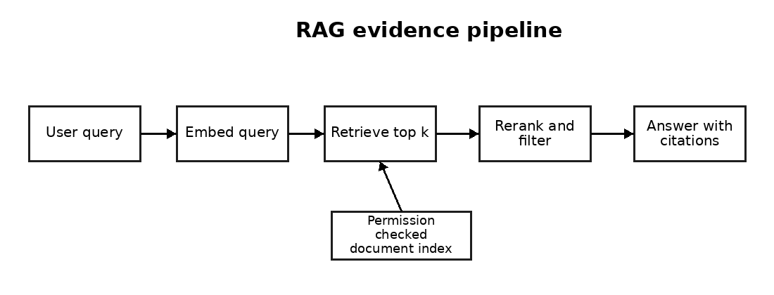
A. User query
B. Answer with citations
C. Retrieve top k
D. Frontend rendering
Correct answer: C
Explanation: The retrieval stage finds evidence before generation.
Q087 [Image based] Based on the agent loop image above, what is the main control risk if tool calls are not restricted?
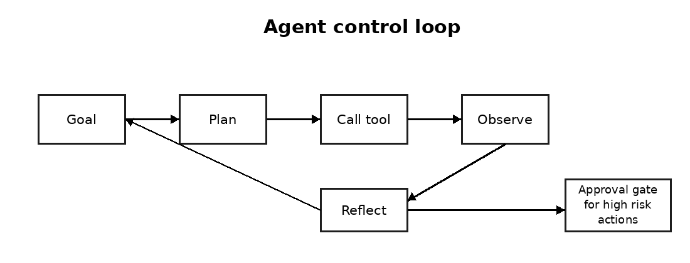
A. The text may become bold
B. The queue may disappear
C. The logo may shrink
D. The agent may take unintended or unauthorised actions
Correct answer: D
Explanation: Tool permissions and approval gates control agent risk.
Q088 [Image based] Based on the embedding space image above, what should semantic search retrieve first?
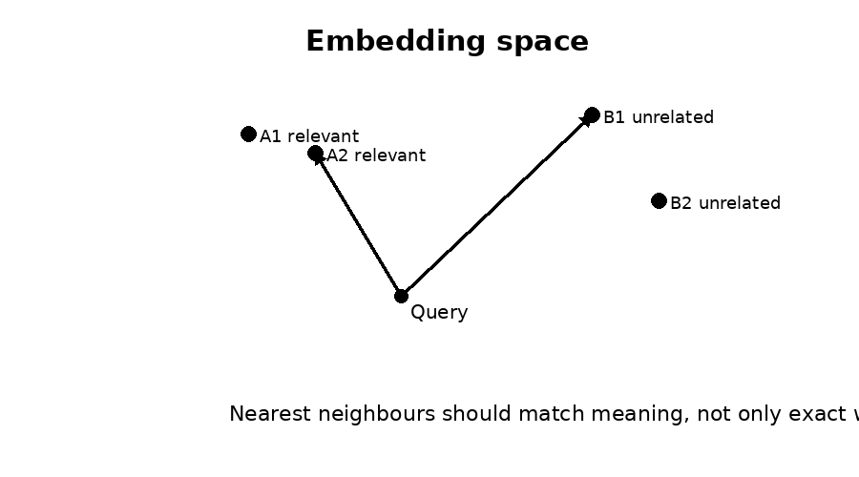
A. Items nearest in meaning to the query
B. Items with the longest filename
C. Items created on a Monday
D. Items with the largest font
Correct answer: A
Explanation: Embedding systems rank by semantic closeness.
Q089 [Image based] Based on the AI feature architecture image above, where should validation and error handling normally sit?
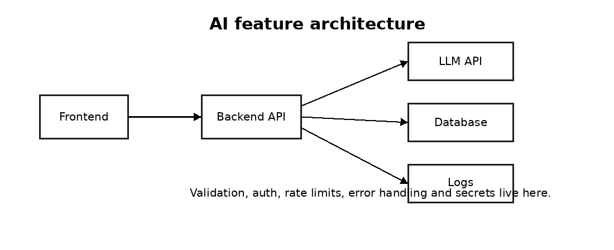
A. Logo file
B. Backend API
C. Candidate photograph
D. User chair
Correct answer: B
Explanation: The backend should validate inputs and outputs, handle errors and protect keys.
Q090 [Image based] Based on the task queue image above, why is a retry component useful?
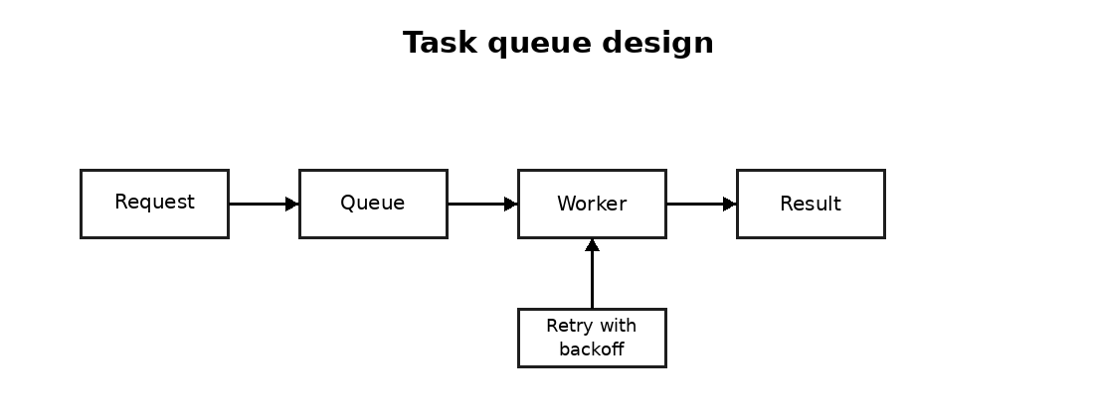
A. It changes salary range
B. It deletes all logs
C. It makes code unnecessary
D. It can reprocess temporary background job failures safely
Correct answer: D
Explanation: Retries improve reliability when transient tasks fail.

Machine Learning
Q091 [Single choice] What is overfitting in machine learning?
A. The model has no parameters
B. The model stores only images
C. The model fits training patterns too closely and performs poorly on unseen data
D. The model uses no features
Correct answer: C
Explanation: Overfitting means poor generalisation despite strong training performance.
Q092 [Single choice] What is the purpose of a validation set?
A. To tune choices before final testing
B. To train forever
C. To store passwords
D. To replace labels
Correct answer: A
Explanation: Validation data supports model selection without touching the final test set.
Q093 [Single choice] Which metric matters most when false negatives are costly?
A. File size
B. Recall
C. Screen width
D. Line count
Correct answer: B
Explanation: Recall measures how many actual positives the model catches.
Q094 [Single choice] Which metric matters most when false positives are costly?
A. RAM colour
B. Precision
C. Keyboard size
D. Number of folders
Correct answer: B
Explanation: Precision measures how many predicted positives are actually positive.
Q095 [Single choice] What does feature engineering mean?
A. Changing office furniture
B. Writing only CSS
C. Creating or transforming input variables to improve signal for a model
D. Deleting training rows randomly
Correct answer: C
Explanation: Feature engineering shapes useful model inputs.
Q096 [Single choice] What is cross validation?
A. Deleting all validation data
B. Testing only once on training data
C. Changing the model name
D. Training and validating across multiple splits for a more robust performance estimate
Correct answer: D
Explanation: Cross validation reduces dependence on one split.
Q097 [Single choice] What is class imbalance?
A. One class has far more examples than another
B. Every label is equal
C. The database has many columns
D. The model uses Python
Correct answer: A
Explanation: Imbalance can make accuracy misleading.
Q098 [Single choice] Which approach can help with class imbalance?
A. Use only accuracy
B. Delete all minority class examples
C. Use suitable metrics, resampling or class weights
D. Ignore labels
Correct answer: C
Explanation: Class imbalance needs careful metrics and training strategies.
Q099 [Single choice] What is gradient descent?
A. A cloud storage service
B. A browser extension
C. A hiring workflow
D. An optimisation method that updates parameters to reduce loss
Correct answer: D
Explanation: Gradient descent changes parameters in the loss reducing direction.
Q100 [Single choice] What is regularisation used for?
A. Reducing overfitting by penalising excessive complexity
B. Making the model remember passwords
C. Increasing image brightness
D. Removing all features
Correct answer: A
Explanation: Regularisation discourages overly complex models.
Q101 [Single choice] What is AUC ROC useful for?
A. Measuring website visits
B. Comparing ranking performance across classification thresholds
C. Counting CV pages
D. Checking phone signal
Correct answer: B
Explanation: AUC ROC assesses discrimination across thresholds.
Q102 [Single choice] What is a confusion matrix?
A. A website sitemap
B. A salary scale
C. A cloud invoice
D. A table comparing predicted classes with actual classes
Correct answer: D
Explanation: It shows true positives, false positives, true negatives and false negatives.
Q103 [Choose three] Choose three reasons accuracy may be a poor metric.
A. The model is written in Python
B. Classes are imbalanced
C. Costs of errors differ
D. The screen is small
E. The positive class is rare
Correct answer: B, C, E
Explanation: Accuracy can hide important error patterns.
Q104 [Choose three] Choose three actions that reduce overfitting.
A. Use regularisation
B. Train until validation loss rises forever
C. Use more representative data
D. Use early stopping
E. Evaluate on training data only
Correct answer: A, C, D
Explanation: These actions improve generalisation.
Q105 [Image based] Based on the training curve image above, what is the likely issue after epoch 5?
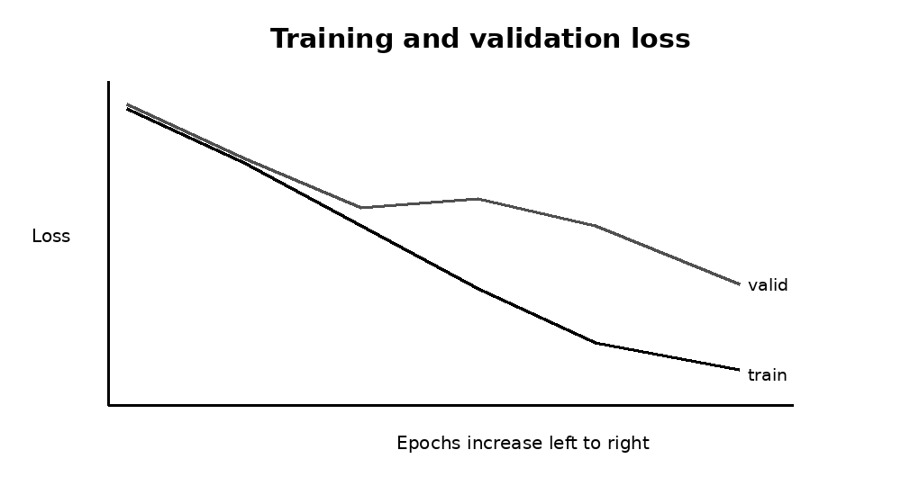
A. The model has no data
B. The graph proves perfect generalisation
C. Overfitting begins because validation loss rises while training loss falls
D. The labels are all missing
Correct answer: C
Explanation: Divergence between falling training loss and rising validation loss suggests overfitting.

Software Development
Q106 [Single choice] In Python, what will len(set([1, 2, 2, 3])) return?
A. 3
B. 4
C. 2
D. Error
Correct answer: A
Explanation: A set removes duplicates, leaving 1, 2 and 3.
Q107 [Single choice] Which Python structure is best for key value lookup by unique key?
A. list only
B. dict
C. tuple only
D. print statement
Correct answer: B
Explanation: A dictionary maps keys to values efficiently.
Q108 [Single choice] What does this Python expression return: [x*x for x in range(3)]?
A. [1, 2, 3]
B. [0, 1, 4]
C. [0, 2, 4]
D. Error
Correct answer: B
Explanation: range(3) gives 0, 1 and 2, then each is squared.
Q109 [Single choice] Which Python keyword introduces exception handling?
A. loop
B. html
C. try
D. select
Correct answer: C
Explanation: try introduces exception handling blocks.
Q110 [Single choice] What is the main benefit of unit tests?
A. They replace all architecture design
B. They guarantee no bugs in production
C. They remove documentation needs
D. They verify small pieces of code behave as expected
Correct answer: D
Explanation: Unit tests catch regressions and clarify expected behaviour.
Q111 [Single choice] In JavaScript, what does Array.prototype.map usually do?
A. Returns a new array after applying a function to each item
B. Deletes the original array
C. Sorts only numbers
D. Blocks the browser
Correct answer: A
Explanation: map transforms each element and returns a new array.
Q112 [Single choice] In JavaScript, what does async await help with?
A. Changing CSS colours
B. Removing all promises
C. Writing asynchronous code in a clearer style
D. Disabling APIs
Correct answer: C
Explanation: async await makes promise based flows easier to read.
Q113 [Single choice] Which HTTP status code usually means unauthorised?
A. 200
B. 301
C. 500 only
D. 401
Correct answer: D
Explanation: 401 indicates authentication is required or failed.
Q114 [Single choice] Which API method is usually used to create a new resource?
A. POST
B. GET
C. TRACE only
D. HEAD only
Correct answer: A
Explanation: POST commonly submits data to create resources.
Q115 [Single choice] Which database query language is most associated with relational databases?
A. HTML
B. SQL
C. CSS
D. YAML only
Correct answer: B
Explanation: SQL is used for relational querying and manipulation.
Q116 [Single choice] What does Big O notation describe?
A. How old a laptop is
B. How many candidates applied
C. How bright a monitor is
D. How algorithm cost grows with input size
Correct answer: D
Explanation: Big O describes complexity growth.
Q117 [Single choice] Which approach is best for handling user supplied input to an API?
A. Trust every input
B. Store raw secrets in logs
C. Validate and sanitise input before processing
D. Ignore errors
Correct answer: C
Explanation: Input validation protects reliability and security.
Q118 [Choose three] Choose three items that belong in a production ready API endpoint.
A. Plain text password storage
B. Input validation
C. Error handling
D. Logging without secrets
E. No tests
Correct answer: B, C, D
Explanation: Production APIs need validation, safe errors and safe observability.
Q119 [Choose three] Choose three good practices when integrating an LLM API into software.
A. Timeout handling
B. Hard coding secret keys in frontend code
C. Rate limit handling
D. Ignoring failed responses
E. Output validation
Correct answer: A, C, E
Explanation: LLM API integration needs resilience, security and validation.
Q120 [Image based] Based on the API architecture image above, where should the private LLM API key normally be stored and used?

A. Backend only, through secure environment variables or secret management
B. Frontend JavaScript visible to users
C. Inside a public GitHub README
D. Inside a browser cookie visible to everyone
Correct answer: A
Explanation: Private keys should never be exposed in frontend code.

Aptitude and Logic
Q121 [Single choice] If all AI engineers are software engineers and some software engineers are data engineers, which statement must be true?
A. Some AI engineers are data engineers
B. All AI engineers are software engineers
C. All data engineers are AI engineers
D. No software engineer is an AI engineer
Correct answer: B
Explanation: The first statement directly states this relationship.
Q122 [Single choice] A system processes 120 tasks in 6 minutes. At the same rate, how many tasks can it process in 15 minutes?
A. 240
B. 300
C. 360
D. 180
Correct answer: B
Explanation: 120 divided by 6 is 20 tasks per minute. 20 times 15 is 300.
Q123 [Single choice] What is the next number in the sequence: 2, 4, 8, 16, 32?
A. 48
B. 40
C. 64
D. 36
Correct answer: C
Explanation: Each number doubles.
Q124 [Single choice] What is the next number: 3, 6, 11, 18, 27?
A. 36
B. 39
C. 42
D. 38
Correct answer: D
Explanation: Differences are 3, 5, 7 and 9. The next difference is 11.
Q125 [Single choice] If a project has 5 tasks and each task depends on the previous one, what is the main scheduling risk?
A. One delay can delay the whole chain
B. Tasks become independent
C. No task can fail
D. The last task starts first
Correct answer: A
Explanation: Sequential dependency creates delay propagation.
Q126 [Single choice] A candidate scores 24 out of 30. What percentage is this?
A. 75 percent
B. 85 percent
C. 80 percent
D. 70 percent
Correct answer: C
Explanation: 24 divided by 30 equals 0.8.
Q127 [Single choice] If a shortlist has 5 candidates and 2 are interviewed, what percentage were interviewed?
A. 20 percent
B. 50 percent
C. 60 percent
D. 40 percent
Correct answer: D
Explanation: 2 divided by 5 equals 40 percent.
Q128 [Single choice] Which statement shows the strongest evidence?
A. The candidate built and deployed a RAG assistant used by 3 client teams
B. The candidate says they like AI
C. The CV uses many keywords
D. The profile photo looks professional
Correct answer: A
Explanation: Deployed project evidence is stronger than claims or appearance.
Q129 [Single choice] A recruiter must choose between speed and quality. What is the best first action?
A. Send random CVs
B. Clarify the minimum acceptable quality standard and deadline
C. Wait for perfect candidates forever
D. Ignore the client
Correct answer: B
Explanation: Good process starts by defining constraints.
Q130 [Single choice] If a model is accurate on old data but weak on new cases, what should be investigated?
A. The company logo
B. The keyboard layout
C. The office lease
D. Data drift or changed user behaviour
Correct answer: D
Explanation: New data behaviour can reduce performance.
Q131 [Single choice] Which option is the clearest problem statement?
A. We need someone good
B. We want a genius
C. We need an engineer who has deployed LLM features in production using Python and cloud APIs
D. Send anyone technical
Correct answer: C
Explanation: Clear requirements improve sourcing quality.
Q132 [Single choice] If three candidates have equal skills, which factor may decide priority?
A. Availability and salary fit
B. Alphabetical order only
C. Favourite colour
D. Photo quality
Correct answer: A
Explanation: Practical fit affects hiring speed.
Q133 [Single choice] What comes next: A, C, F, J, O?
A. T
B. U
C. S
D. V
Correct answer: B
Explanation: Letter gaps increase by 2, 3, 4, 5 and then 6.
Q134 [Single choice] If five interviews each take 45 minutes, what is the total time?
A. 180 minutes
B. 225 minutes
C. 200 minutes
D. 250 minutes
Correct answer: B
Explanation: 5 times 45 equals 225.
Q135 [Single choice] A client rejects every candidate for unclear reasons. What should Veer do first?
A. Send more random CVs
B. Stop recording feedback
C. Request structured feedback against agreed criteria
D. Increase the fee immediately
Correct answer: C
Explanation: Structured feedback improves search accuracy.
Q136 [Single choice] Which profile is most likely senior?
A. Candidate only lists tool names
B. Candidate refuses examples
C. Candidate has no project evidence
D. Candidate explains tradeoffs, failures, monitoring and deployment decisions
Correct answer: D
Explanation: Senior candidates explain decisions and consequences.
Q137 [Single choice] Which task tests practical thinking best?
A. Design a safe AI feature under constraints
B. Repeat a definition from memory
C. Choose a favourite framework
D. List every model name
Correct answer: A
Explanation: Practical design tests applied judgement.
Q138 [Single choice] If response time doubles after adding retrieval, what should be checked first?
A. Logo placement
B. Candidate phone number
C. Retrieval latency, chunk count and model call timing
D. Office location
Correct answer: C
Explanation: Latency issues should be isolated by pipeline stage.
Q139 [Single choice] Which is the best signal of communication skill?
A. Using the longest words
B. Speaking very fast
C. Avoiding questions
D. Explaining a technical decision clearly to a non technical stakeholder
Correct answer: D
Explanation: Clarity with non technical stakeholders is valuable.
Q140 [Single choice] If a hiring manager changes requirements weekly, what should the recruiter do?
A. Lock a written role brief and change log
B. Ignore the changes
C. Send candidates anyway
D. Delete the vacancy
Correct answer: A
Explanation: A written brief prevents confusion.
Q141 [Single choice] Which candidate answer is most honest?
A. I know every AI tool perfectly
B. I have used RAG in one project and can explain the tradeoffs
C. I never make mistakes
D. I do not need testing
Correct answer: B
Explanation: Clear scope and evidence are more credible than exaggerated claims.
Q142 [Single choice] What is the next number: 1, 1, 2, 3, 5, 8?
A. 11
B. 12
C. 14
D. 13
Correct answer: D
Explanation: It is a Fibonacci sequence.
Q143 [Single choice] If a task has a 20 percent failure rate, how many failures are expected in 50 attempts?
A. 5
B. 20
C. 10
D. 15
Correct answer: C
Explanation: 20 percent of 50 is 10.
Q144 [Single choice] Which is the best way to compare two candidates fairly?
A. Use the same role criteria and structured scorecard
B. Use only gut feeling
C. Read only the first CV page
D. Choose the cheaper candidate always
Correct answer: A
Explanation: Structured scoring supports fairness and consistency.
Q145 [Single choice] A pipeline has 4 stages with success rates of 90 percent, 80 percent, 75 percent and 100 percent. What is the approximate end to end success rate?
A. 72 percent
B. 54 percent
C. 90 percent
D. 45 percent
Correct answer: B
Explanation: 0.90 times 0.80 times 0.75 times 1.00 equals 0.54.
Q146 [Single choice] If candidate A has stronger MCQ score and candidate B has stronger shipped project evidence, what should happen first?
A. Automatically select the higher MCQ score
B. Compare both against the actual role criteria before shortlisting
C. Automatically select the lower salary
D. Reject both for inconsistency
Correct answer: B
Explanation: Fair assessment weighs evidence against job requirements.
Q147 [Single choice] Which decision is least defensible in recruitment screening?
A. Using a structured interview
B. Checking job related project evidence
C. Rejecting a candidate based on an unexplained AI score alone
D. Recording scorecard reasons
Correct answer: C
Explanation: Automated scores need context and human review.
Q148 [Choose three] Choose three indicators of a top 1 percent AI candidate.
A. Only memorises buzzwords
B. Explains tradeoffs clearly
C. Refuses code review
D. Has shipped systems into production
E. Understands evaluation and failure modes
Correct answer: B, D, E
Explanation: Top candidates show judgement, production evidence and evaluation maturity.
Q149 [Choose three] Choose three fair assessment principles.
A. Use job related criteria
B. Ask irrelevant personal questions
C. Apply the same process consistently
D. Keep records of scoring decisions
E. Hide pass marks from internal reviewers
Correct answer: A, C, D
Explanation: Fair assessment requires relevance, consistency and documentation.
Q150 [Image based] Based on the logic grid image above, what number should replace the question mark?
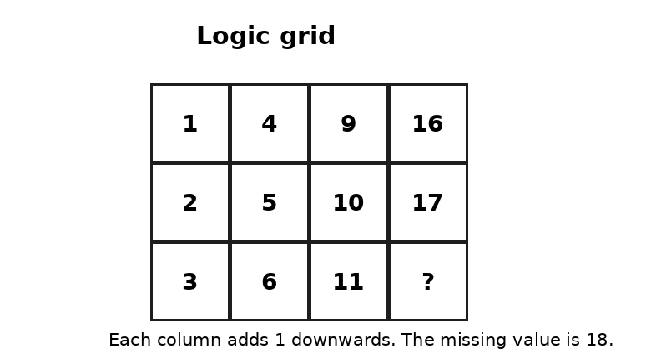
A. 12
B. 16
C. 20
D. 18
Correct answer: D
Explanation: Each column increases by 1 from top to bottom. The final column is 16, 17, 18.

7. Compact answer key for developer backend
Use this answer key in the backend only. Do not show correct answers to candidates during a live attempt.
Key 1 | Key 2 | Key 3 | Key 4 | Key 5
Q001: B | Q002: C | Q003: D | Q004: A | Q005: C
Q006: D | Q007: A | Q008: B | Q009: D | Q010: C
Q011: A | Q012: B | Q013: B | Q014: C | Q015: D
Q016: A | Q017: C | Q018: D | Q019: A | Q020: B
Q021: D | Q022: C | Q023: A | Q024: B | Q025: B
Q026: C | Q027: D | Q028: A | Q029: C | Q030: D
Q031: A | Q032: B | Q033: D | Q034: C | Q035: A
Q036: B | Q037: B | Q038: C | Q039: D | Q040: A
Q041: C | Q042: D | Q043: A | Q044: B | Q045: D
Q046: C | Q047: A | Q048: B | Q049: B | Q050: C
Q051: D | Q052: A | Q053: C | Q054: D | Q055: A
Q056: B | Q057: D | Q058: C | Q059: A | Q060: B
Q061: B | Q062: C | Q063: D | Q064: A | Q065: C
Q066: D | Q067: A | Q068: B | Q069: D | Q070: C
Q071: A | Q072: B | Q073: B | Q074: C | Q075: D
Q076: A | Q077: B, D, E | Q078: A, C, D | Q079: A, B, C | Q080: B, C, D
Q081: A, C, E | Q082: A, B, D | Q083: B, C, E | Q084: A, B, C | Q085: A, D, E
Q086: C | Q087: D | Q088: A | Q089: B | Q090: D
Q091: C | Q092: A | Q093: B | Q094: B | Q095: C
Q096: D | Q097: A | Q098: C | Q099: D | Q100: A
Q101: B | Q102: D | Q103: B, C, E | Q104: A, C, D | Q105: C
Q106: A | Q107: B | Q108: B | Q109: C | Q110: D
Q111: A | Q112: C | Q113: D | Q114: A | Q115: B
Q116: D | Q117: C | Q118: B, C, D | Q119: A, C, E | Q120: A
Q121: B | Q122: B | Q123: C | Q124: D | Q125: A
Q126: C | Q127: D | Q128: A | Q129: B | Q130: D
Q131: C | Q132: A | Q133: B | Q134: B | Q135: C
Q136: D | Q137: A | Q138: C | Q139: D | Q140: A
Q141: B | Q142: D | Q143: C | Q144: A | Q145: B
Q146: B | Q147: C | Q148: B, D, E | Q149: A, C, D | Q150: D

8. Suggested developer schema
{
"question_id": "Q001",
"category": "AI and Generative AI",
"type": "single_choice",
"question": "Question text",
"options": [
{"label": "A", "text": "Option text"},
{"label": "B", "text": "Option text"},
{"label": "C", "text": "Option text"},
{"label": "D", "text": "Option text"}
],
"correct_answer": "B",
"explanation": "Internal explanation for review mode",
"difficulty": "advanced",
"randomise_options": true
}

9. Recruiter interpretation guide
24 to 30 correct: Strong evidence of technical readiness. Review CV, project evidence and interview performance before recommending.
20 to 23 correct: Good base knowledge. Suitable for further screening, especially if project evidence is strong.
15 to 19 correct: Developing level. May suit junior roles, internships or training paths.
Below 15 correct: Do not reject automatically. Review whether the candidate applied for a different role type or needs a more suitable assessment.

10. Website recommendation
After CV upload, the website should show the candidate a short explanation, then start the 30 question assessment. The system should prevent answer key exposure, randomise options where possible, record time taken and store category level scores. For senior candidates, the website should unlock the written benchmark questions after the objective test or allow a recruiter to send them manually.

