# Report on Model Performance Metrics and Analysis

## 1. Introduction

This report aims to explain key performance metrics used in regression analysis and to analyze the results of different models based on the provided data. The focus is on understanding how the training timeline, feature selection, and dataset choice affect model performance.

## 2. Explanation of Performance Metrics

### 2.1 Root Mean Squared Error (RMSE)

* **Definition:** RMSE is the square root of the average of the squared differences between the predicted and actual values.

RMSE=1n∑i=1n(yi−y^i)2\text{RMSE} = \sqrt{\frac{1}{n} \sum_{i=1}^{n} (y_i - \hat{y}_i)^2}RMSE=n1​∑i=1n​(yi​−y^​i​)2​

* **Interpretation:** It measures the standard deviation of the residuals (prediction errors), providing insight into how concentrated the data is around the line of best fit.
* **Goal:** **Decrease** RMSE. A lower RMSE indicates that the model's predictions are closer to the actual values, signifying better performance.

### 2.2 Mean Squared Error (MSE)

* **Definition:** MSE is the average of the squared differences between the predicted and actual values.

MSE=1n∑i=1n(yi−y^i)2\text{MSE} = \frac{1}{n} \sum_{i=1}^{n} (y_i - \hat{y}_i)^2MSE=n1​∑i=1n​(yi​−y^​i​)2

* **Interpretation:** It quantifies the average squared difference between the estimated values and the actual value.
* **Goal:** **Decrease** MSE. A lower MSE indicates better model accuracy.

### 2.3 Mean Absolute Error (MAE)

* **Definition:** MAE is the average of the absolute differences between the predicted and actual values.

MAE=1n∑i=1n∣yi−y^i∣\text{MAE} = \frac{1}{n} \sum_{i=1}^{n} |y_i - \hat{y}_i|MAE=n1​∑i=1n​∣yi​−y^​i​∣

* **Interpretation:** It measures the average magnitude of the errors in a set of predictions, without considering their direction.
* **Goal:** **Decrease** MAE. A lower MAE means the model predictions are, on average, closer to the actual values.

### 2.4 Mean Absolute Percentage Error (MAPE)

* **Definition:** MAPE is the average of the absolute percentage errors between the predicted and actual values.

MAPE=100%n∑i=1n∣yi−y^iyi∣\text{MAPE} = \frac{100\%}{n} \sum_{i=1}^{n} \left| \frac{y_i - \hat{y}_i}{y_i} \right|MAPE=n100%​∑i=1n​​yi​yi​−y^​i​​​

* **Interpretation:** It expresses accuracy as a percentage, making it easier to interpret the error magnitude relative to the actual values.
* **Goal:** **Decrease** MAPE. Lower MAPE values indicate higher accuracy.

### 2.5 Coefficient of Determination (R²)

* **Definition:** R² measures the proportion of the variance in the dependent variable that is predictable from the independent variables.

R2=1−∑i=1n(yi−y^i)2∑i=1n(yi−yˉ)2R^2 = 1 - \frac{\sum_{i=1}^{n} (y_i - \hat{y}_i)^2}{\sum_{i=1}^{n} (y_i - \bar{y})^2}R2=1−∑i=1n​(yi​−yˉ​)2∑i=1n​(yi​−y^​i​)2​

* **Interpretation:** An R² of 1 indicates perfect prediction, while 0 indicates that the model does not explain any variability in the response data.
* **Goal:** **Increase** R². A higher R² signifies a better fit of the model to the data.

### 2.6 Explained Variance Regression Score

* **Definition:** Measures the proportion to which a model accounts for the variation of a given data set.

Explained Variance=1−Var(y−y^)Var(y)\text{Explained Variance} = 1 - \frac{\text{Var}(y - \hat{y})}{\text{Var}(y)}Explained Variance=1−Var(y)Var(y−y^​)​

* **Interpretation:** Similar to R², but can be negative when the model is worse than predicting the mean.
* **Goal:** **Increase** the score. Values closer to 1 indicate that the model explains most of the variability.

### 2.7 Mean Gradient Difference (MGD)

* **Definition:** MGD measures the average difference between the gradients (slopes) of the predicted and actual values.
* **Interpretation:** It assesses how well the model captures the trend or rate of change in the data.
* **Goal:** **Decrease** MGD. A lower MGD indicates that the model's predicted rate of change closely matches the actual rate.

### 2.8 Mean Percentage Difference (MPD)

* **Definition:** MPD is the average percentage difference between the predicted and actual values.

MPD=100%n∑i=1n(yi−y^iyi)\text{MPD} = \frac{100\%}{n} \sum_{i=1}^{n} \left( \frac{y_i - \hat{y}_i}{y_i} \right)MPD=n100%​∑i=1n​(yi​yi​−y^​i​​)

* **Interpretation:** Provides a relative measure of the average difference between predictions and actual values.
* **Goal:** **Decrease** MPD. Lower values indicate better model performance.

## 3. Analysis of Results

### 3.1 Base Paper Results

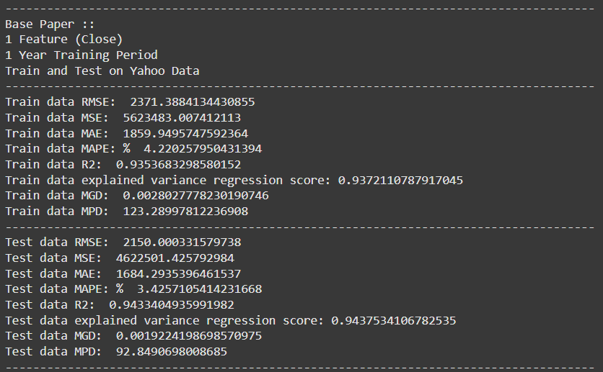

**Configuration:**

* **Features:** 1 (Close)
* **Training Period:** 1 Year
* **Dataset:** Yahoo Data (Train and Test)

**Performance Metrics:**

* **Train Data:**
  + RMSE: 2371.39
  + MSE: 5,623,483.01
  + MAE: 1859.95
  + MAPE: 4.22%
  + R²: 0.9354
  + Explained Variance: 0.9372
  + MGD: 0.0028
  + MPD: 123.29
* **Test Data:**
  + RMSE: 2150.00
  + MSE: 4,622,501.43
  + MAE: 1684.29
  + MAPE: 3.43%
  + R²: 0.9433
  + Explained Variance: 0.9438
  + MGD: 0.0019
  + MPD: 92.85

**Observation:**

* The model shows decent performance with moderate error metrics and high R² values.
* Slightly better performance on test data indicates good generalization.

### 3.2 Base Paper Comparison

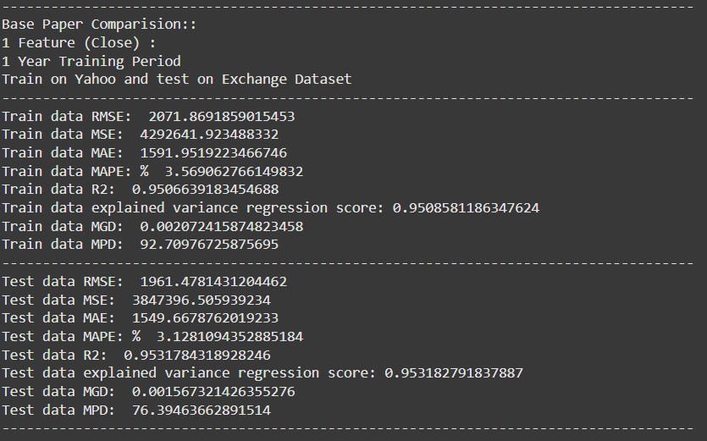

**Configuration:**

* **Features:** 1 (Close)
* **Training Period:** 1 Year
* **Dataset:** Train on Yahoo Data, Test on Exchange Data

**Performance Metrics:**

* **Train Data:**
  + RMSE: 2071.87
  + MSE: 4,292,641.92
  + MAE: 1591.95
  + MAPE: 3.57%
  + R²: 0.9507
  + Explained Variance: 0.9509
  + MGD: 0.0021
  + MPD: 92.71
* **Test Data:**
  + RMSE: 1961.48
  + MSE: 3,847,396.51
  + MAE: 1549.67
  + MAPE: 3.13%
  + R²: 0.9532
  + Explained Variance: 0.9532
  + MGD: 0.0016
  + MPD: 76.39

**Observation:**

* The model generalizes well to a different dataset (Exchange Data) with improved performance metrics.
* Lower error metrics and higher R² on test data suggest robustness.

### 3.3 Our Code with 1 Feature

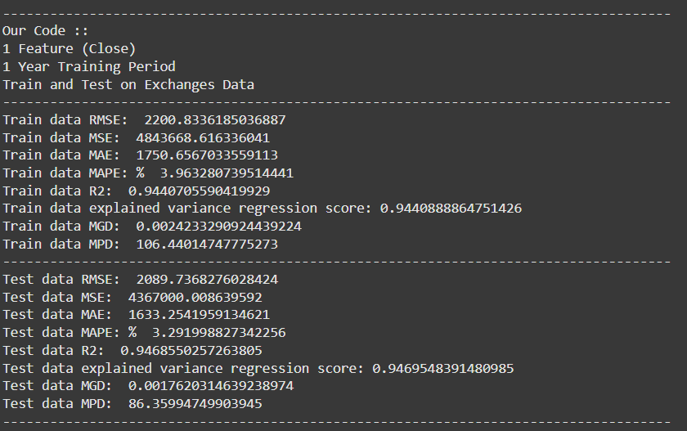

**Configuration:**

* **Features:** 1 (Close)
* **Training Period:** 1 Year
* **Dataset:** Exchange Data (Train and Test)

**Performance Metrics:**

* **Train Data:**
  + RMSE: 2200.83
  + MSE: 4,843,668.62
  + MAE: 1750.66
  + MAPE: 3.96%
  + R²: 0.9441
  + Explained Variance: 0.9441
  + MGD: 0.0024
  + MPD: 106.44
* **Test Data:**
  + RMSE: 2089.74
  + MSE: 4,367,000.01
  + MAE: 1633.25
  + MAPE: 3.29%
  + R²: 0.9469
  + Explained Variance: 0.9470
  + MGD: 0.0018
  + MPD: 86.36

**Observation:**

* Similar performance to the base paper, indicating consistent results when using the same feature set.
* Slight improvements in error metrics and R² values on test data.

### 3.4 Our Code with 4 Features (1-Year Training)

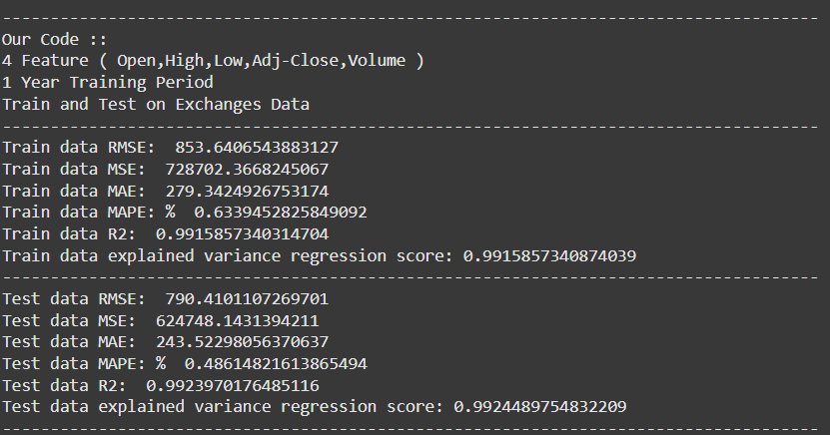

**Configuration:**

* **Features:** 4 (Open, High, Low, Adj-Close, Volume)
* **Training Period:** 1 Year
* **Dataset:** Exchange Data (Train and Test)

**Performance Metrics:**

* **Train Data:**
  + RMSE: 853.64
  + MSE: 728,702.37
  + MAE: 279.34
  + MAPE: 0.63%
  + R²: 0.9916
  + Explained Variance: 0.9916
* **Test Data:**
  + RMSE: 790.41
  + MSE: 624,748.14
  + MAE: 243.52
  + MAPE: 0.49%
  + R²: 0.9924
  + Explained Variance: 0.9924

**Observation:**

* Significant reduction in RMSE and other error metrics compared to models using only the 'Close' feature.
* High R² values indicate a strong fit.
* Including additional features greatly improves model accuracy.

### 3.5 Our Code with 4 Features (2-Year Training)

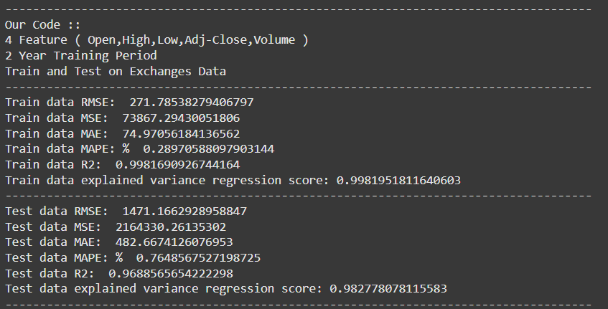

**Configuration:**

* **Features:** 4 (Open, High, Low, Adj-Close, Volume)
* **Training Period:** 2 Years
* **Dataset:** Exchange Data (Train and Test)

**Performance Metrics:**

* **Train Data:**
  + RMSE: 271.79
  + MSE: 73,867.29
  + MAE: 74.97
  + MAPE: 0.29%
  + R²: 0.9982
  + Explained Variance: 0.9982
* **Test Data:**
  + RMSE: 1471.17
  + MSE: 2,164,330.26
  + MAE: 482.67
  + MAPE: 0.76%
  + R²: 0.9689
  + Explained Variance: 0.9828

**Observation:**

* Training error metrics improved further, indicating a better fit on training data.
* However, test error metrics worsened compared to the 1-year training model, suggesting potential overfitting.
* The model performs exceptionally well on training data but not as well on unseen data.

## 4. Conclusions

### 4.1 Effect of Training Timeline

* **Observation:** Increasing the training period from 1 year to 2 years reduced training errors but increased test errors.
* **Conclusion:** A longer training period led to overfitting, where the model learns the training data too well, including its noise, and fails to generalize to new data.
* **Implication:** There is a need to balance the amount of training data to avoid overfitting. Techniques like cross-validation, regularization, or pruning the model can help mitigate this issue.

### 4.2 Effect of Feature Selection

* **Observation:** Including additional features (Open, High, Low, Adj-Close, Volume) significantly improved performance metrics.
* **Conclusion:** More relevant features provide the model with better information, leading to more accurate predictions.
* **Implication:** Feature engineering and selection are critical steps in model development. Careful selection of informative features can enhance model performance.

### 4.3 Effect of Dataset Choice

* **Observation:** Training on Yahoo data and testing on Exchange data yielded better performance compared to training and testing on the same dataset.
* **Conclusion:** The model's ability to generalize across different datasets indicates robustness. However, variations in data distributions can affect performance.
* **Implication:** It's essential to consider dataset characteristics and ensure that training data is representative of the data the model will encounter in production.

## 5. Recommendations

* **Optimize Training Period:** Avoid overfitting by selecting an appropriate training timeline. Consider using validation sets to monitor model performance on unseen data.
* **Enhance Feature Set:** Continue exploring additional relevant features and perform feature importance analysis to understand their impact.
* **Dataset Analysis:** Evaluate the consistency between training and testing datasets. If discrepancies exist, data normalization or augmentation techniques might be necessary.
* **Model Regularization:** Implement regularization methods to prevent overfitting when using larger training datasets.

## 6. Summary

The analysis demonstrates that:

* **Training Timeline:** Longer training periods can lead to overfitting, negatively impacting model generalization.
* **Feature Selection:** Incorporating multiple relevant features significantly improves model accuracy.
* **Dataset Choice:** Models trained on one dataset can perform well on another if the data distributions are similar, but care must be taken to ensure data compatibility.

By carefully considering these factors, we can develop more robust and accurate predictive models.