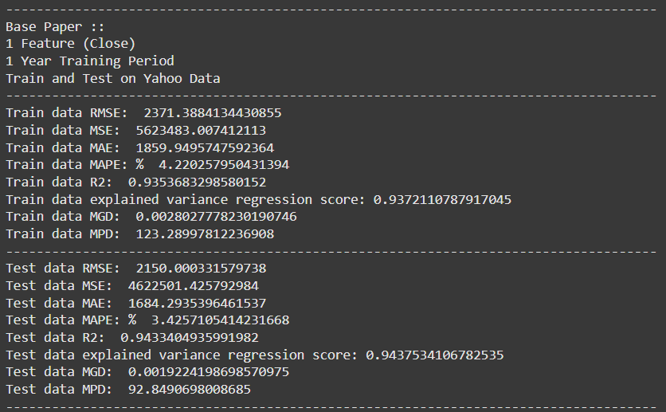

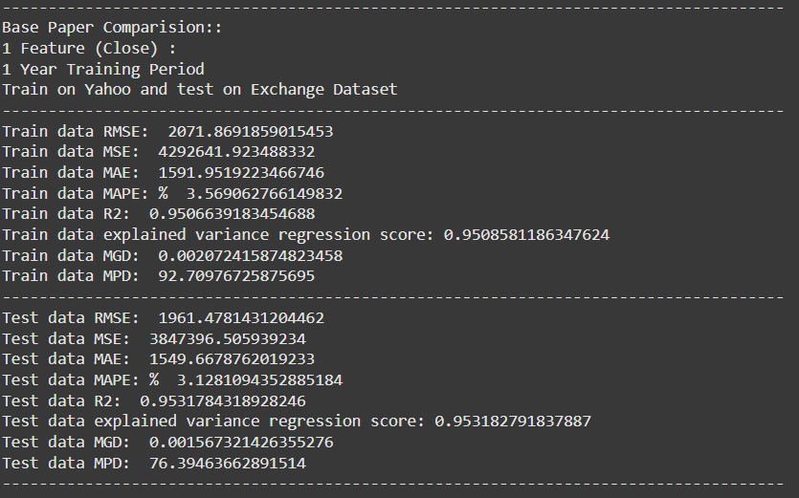

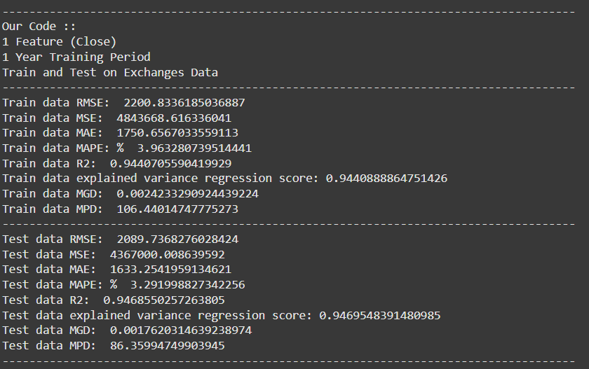

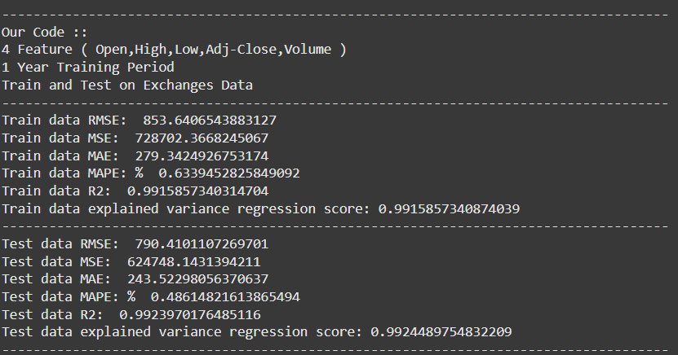

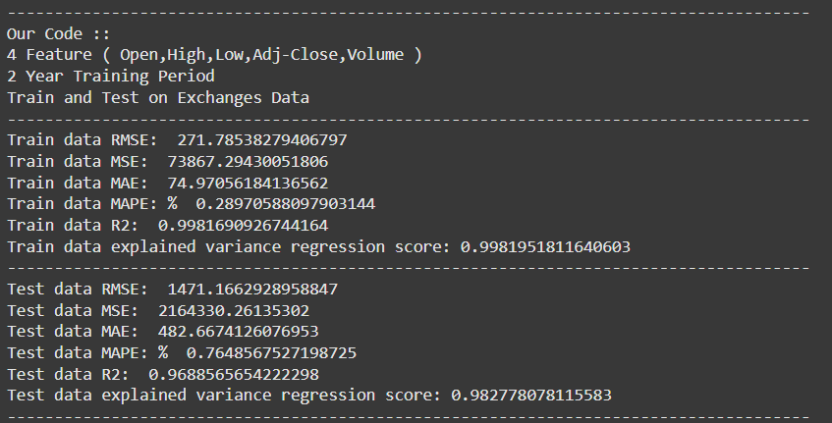

--

--

--

-------------------------------------------------------------------------------------

Base Paper ::

1 Feature (Close)

1 Year Training Period

Train and Test on Yahoo Data

-------------------------------------------------------------------------------------

Train data RMSE: 2371.3884134430855

Train data MSE: 5623483.007412113

Train data MAE: 1859.9495747592364

Train data MAPE: % 4.220257950431394

Train data R2: 0.9353683298580152

Train data explained variance regression score: 0.9372110787917045

Train data MGD: 0.0028027778230190746

Train data MPD: 123.28997812236908

-------------------------------------------------------------------------------------

Test data RMSE: 2150.000331579738

Test data MSE: 4622501.425792984

Test data MAE: 1684.2935396461537

Test data MAPE: % 3.4257105414231668

Test data R2: 0.9433404935991982

Test data explained variance regression score: 0.9437534106782535

Test data MGD: 0.0019224198698570975

Test data MPD: 92.8490698008685

--

--

--

-------------------------------------------------------------------------------------

Base Paper Comparision::

1 Feature (Close) :

1 Year Training Period

Train on Yahoo and test on Exchange Dataset

-------------------------------------------------------------------------------------

Train data RMSE: 2071.8691859015453

Train data MSE: 4292641.923488332

Train data MAE: 1591.9519223466746

Train data MAPE: % 3.569062766149832

Train data R2: 0.9506639183454688

Train data explained variance regression score: 0.9508581186347624

Train data MGD: 0.002072415874823458

Train data MPD: 92.70976725875695

-------------------------------------------------------------------------------------

Test data RMSE: 1961.4781431204462

Test data MSE: 3847396.505939234

Test data MAE: 1549.6678762019233

Test data MAPE: % 3.1281094352885184

Test data R2: 0.9531784318928246

Test data explained variance regression score: 0.953182791837887

Test data MGD: 0.001567321426355276

Test data MPD: 76.39463662891514

--

--

--

-------------------------------------------------------------------------------------

Our Code ::

1 Feature (Close)

1 Year Training Period

Train and Test on Exchanges Data

-------------------------------------------------------------------------------------

Train data RMSE: 2200.8336185036887

Train data MSE: 4843668.616336041

Train data MAE: 1750.6567033559113

Train data MAPE: % 3.963280739514441

Train data R2: 0.9440705590419929

Train data explained variance regression score: 0.9440888864751426

Train data MGD: 0.0024233290924439224

Train data MPD: 106.44014747775273

-------------------------------------------------------------------------------------

Test data RMSE: 2089.7368276028424

Test data MSE: 4367000.008639592

Test data MAE: 1633.2541959134621

Test data MAPE: % 3.291998827342256

Test data R2: 0.9468550257263805

Test data explained variance regression score: 0.9469548391480985

Test data MGD: 0.0017620314639238974

Test data MPD: 86.35994749903945

--

--

--

--

-------------------------------------------------------------------------------------

Our Code ::

4 Feature ( Open,High,Low,Adj-Close,Volume )

1 Year Training Period

Train and Test on Exchanges Data

-------------------------------------------------------------------------------------

Train data RMSE: 853.6406543883127

Train data MSE: 728702.3668245067

Train data MAE: 279.3424926753174

Train data MAPE: % 0.6339452825849092

Train data R2: 0.9915857340314704

Train data explained variance regression score: 0.9915857340874039

-------------------------------------------------------------------------------------

Test data RMSE: 790.4101107269701

Test data MSE: 624748.1431394211

Test data MAE: 243.52298056370637

Test data MAPE: % 0.48614821613865494

Test data R2: 0.9923970176485116

Test data explained variance regression score: 0.9924489754832209

--

--

--

-------------------------------------------------------------------------------------

Our Code ::

4 Feature ( Open,High,Low,Adj-Close,Volume )

2 Year Training Period

Train and Test on Exchanges Data

-------------------------------------------------------------------------------------

Train data RMSE: 271.78538279406797

Train data MSE: 73867.29430051806

Train data MAE: 74.97056184136562

Train data MAPE: % 0.28970588097903144

Train data R2: 0.9981690926744164

Train data explained variance regression score: 0.9981951811640603

-------------------------------------------------------------------------------------

Test data RMSE: 1471.1662928958847

Test data MSE: 2164330.26135302

Test data MAE: 482.6674126076953

Test data MAPE: % 0.7648567527198725

Test data R2: 0.9688565654222298

Test data explained variance regression score: 0.982778078115583