**StudEasy**

**Final Deliverable**



**INTRODUCTION:**

Our Web Application facilitates the onboarding process of undergraduate students to shortlist the universities offering scholarships according to their academic performance and financial conditions.

Hence, taking financial burden off from parents, reducing stress and saving time of students, distributing scholarship reserved amount to the deserving class.

**PERSONAS:**

* **For primary users (Students)**

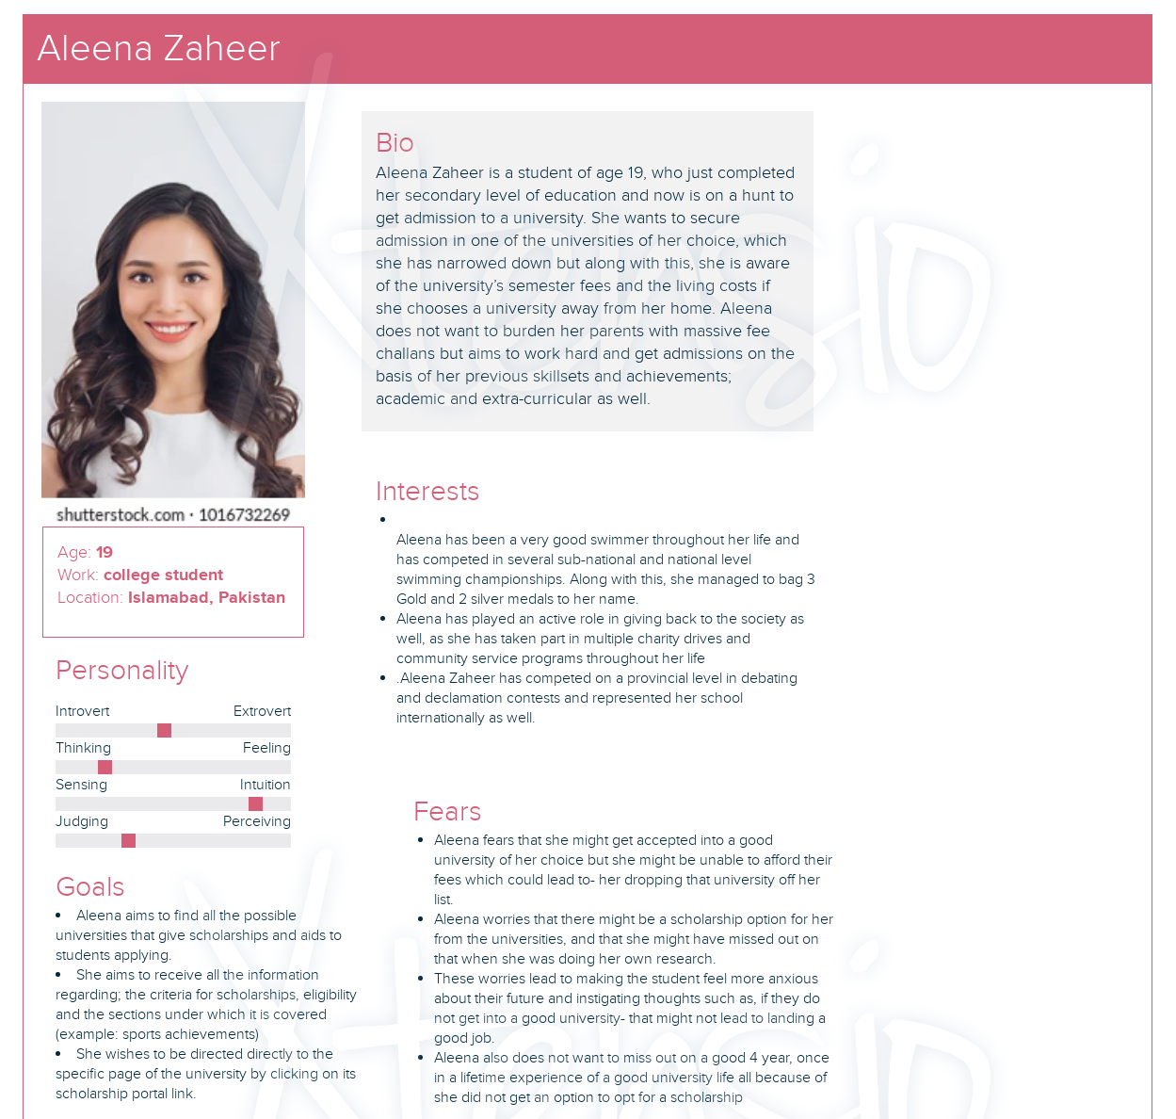

**SCENARIOS:**

(1)

Aleena Zaheer wants to sign up as a student so that she can view the relevant scholarship opportunities offered by the prestigious universities.

* Aleena will open the web application as the first-time user.
* She will select the sign up as student button and will then be directed to the sign up as a student page.
* On that page she will provide her email/phone number, password, check the terms and conditions box or she can sign up through any of her socials.
* After clicking on the sign-up button, she will be registered as a student.

(2)

Aleena Zaheer wants to set up her student profile so that she can proceed to search for the desired scholarship.

* Aleena will click on the user profile option from the side menu and will be directed to the student profile page.
* She will then enter her credentials and upload her academic documents/certificates on the given slots.
* After entering the related information, she will click on the save button and will be forwarded to the family information page where she will provide her family’s credentials such as name, income et cetera.
* After saving the family information, her profile will be set up.

(3)

Aleena Zaheer wants to search for the scholarships.

* Aleena will click on the web application logo “StudEasy” which will direct her to the initial homepage where she will be given the option to either search through criteria or program.
* She will click on one of the options as she wills and will be directed to the relevant pages.
* On the page she will be asked to choose relevant details for instance the degree she is opting for, scholarship type and so on.
* After selecting the details, she will click on the fetch result button that will take her to the page consisting of shortlisted universities providing that specific scholarship.
* From there she can check out the scholarships or even put it into her Wishlist to view them later.
* **For secondary users (Financial Aid Administrative Staff)**

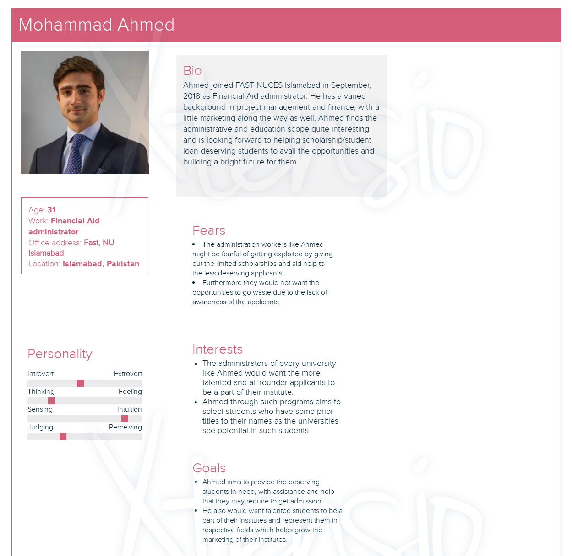

**SCENARIOS:**

(1)

Mohammad Ahmed wants to sign up as a university administrator so that he can offer scholarships offered by the respective university.

* Ahmed will open the web application as the first-time user.
* He will select the sign up as university button and will then be directed to the sign up as a university page.
* On that page he will provide the university email, password and check the terms and conditions box.
* After clicking on the sign-up button, he will be registered as a university administrator.

(2)

Ahmed wants to set up his university profile so that he can proceed to offer diverse scholarships on the web application.

* Ahmed will click on the user profile option from the side menu and will be directed to the university profile page.
* He will then enter university information such as university name, location and UAN on the given slots.
* After entering the related information, he will click on the save button to save the information.
* After saving the details, the university profile will be set up.

(3)

Mohammad Ahmed wants to offer the scholarships from the university perspective.

* Ahmed will select offer scholarship option from the side menu then be directed to offer scholarship page.
* He will then click on edit /update scholarship icon that will allow him to add a new scholarship to the web app.
* On the page he will enter the relevant details of the scholarship for instance the degree, scholarship type and so on.
* After entering the details, he will click on the apply changes button that will take him to the offered scholarship page and that specific scholarship will be displayed.

**STRUCTURED SPECIFICATIONS:**

(1)

Attribute – Reset the password by the user

|  |  |
| --- | --- |
| **Measuring concept** | Reset the password when the user forgets the current one |
| **Measuring method** | Number of clicks required to reset the password |
| **Now level** | The existing products allow such a feature |
| **Worst case** | The interface is not predictable hence user would take a greater number of clicks to perform the action |
| **Planned level** | A maximum of 6 clicks |
| **Best case** | 4 clicks to complete the action |

(2)

Attribute – User asking for help

|  |  |
| --- | --- |
| **Measuring concept** | Ask for help from the web app |
| **Measuring method** | Number of clicks required to ask for the help |
| **Now level** | The existing products allow such a feature |
| **Worst case** | The interface is not predictable hence user would take a greater number of clicks to perform the action |
| **Planned level** | A maximum of 5 clicks |
| **Best case** | 3 clicks to complete the action |

(3)

Attribute – Edit/Update scholarship by the university financial aid administrator

|  |  |
| --- | --- |
| **Measuring concept** | Edit/Update scholarship by the university financial aid administrator on the web app |
| **Measuring method** | Number of clicks required to edit/update scholarship |
| **Now level** | The existing products allow such a feature |
| **Worst case** | The interface is not predictable hence user would take a greater number of clicks to perform the action |
| **Planned level** | A maximum of 8 clicks |
| **Best case** | 6 clicks to complete the action |

**PROTOTYPES:**