User guide for 8086 Simulation

Group members:

Muhammad Talal Faiz

Muhammad Uzair Khan

Umar Tariq

Abdul Basit

Sardar Muhammad Sheroze Khan

Documentation

# 8086 Simulation

# Prerequisite:

In order to execute our **“XYZ.py”** file for 8086 simulation, you must have any version of **python** above version 3.5.0 and **PyQt5** installed on your computer. PyQt5 is a utility of python to display the Graphical User Interface. To install PyQt5, write ***pip install pyqt5*** and ***pip install pyqt5-tools*** in your command line, if you have python already installed.

# How to Run?

Download the code of **“XYZ.py”** file from [this](https://github.com/MuhammadTalalFaiz/8086Simulation) github repo and open it in any code editor of your choice. After executing the code, the following window should appear on your screen

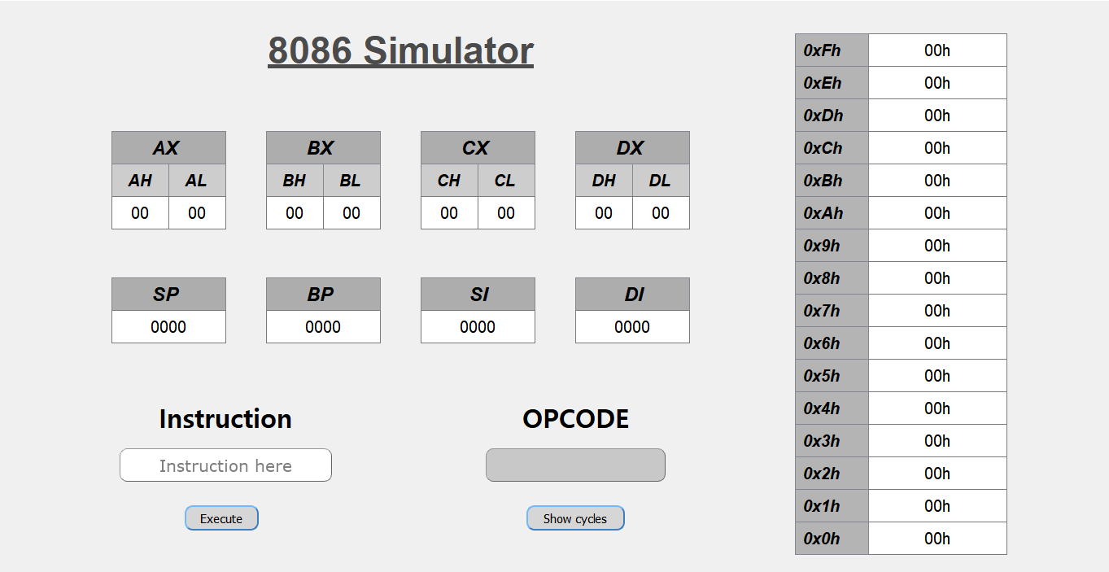

This is the initial interface of our application.

To write an assembly language instruction, write the command containing any of the instructions from

1. Mov
2. Add
3. Sub
4. Mul
5. Div
6. Inc
7. Dec
8. And
9. Not
10. Or
11. Xor
12. Rol
13. Ror
14. In
15. Out

In the highlighted textbox below under the **Instruction** heading:

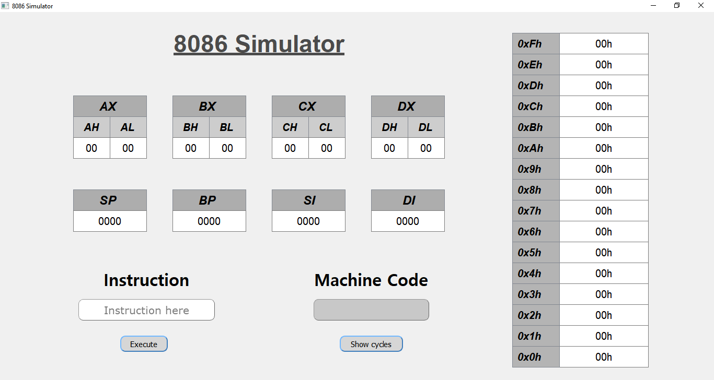

**Show cycles** button opens a new window that displays the related cycles:



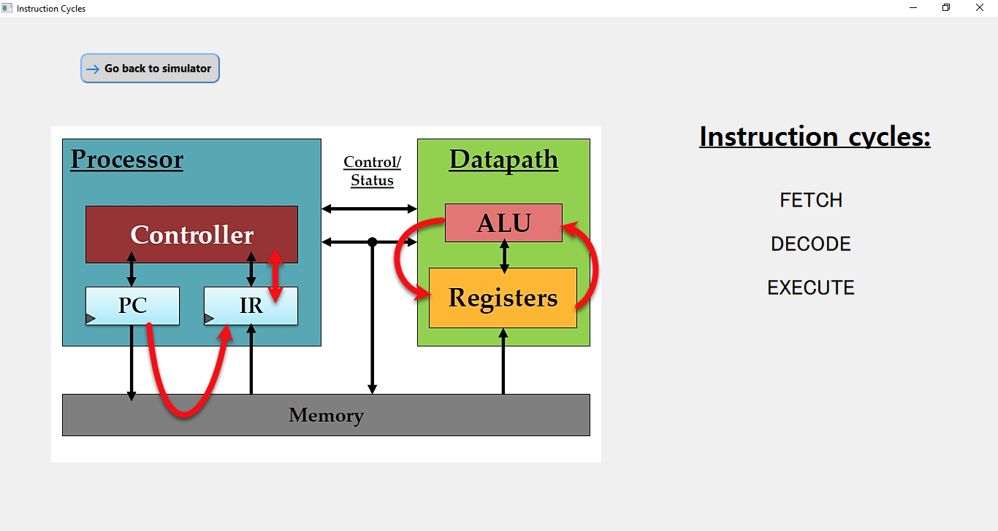

After Clicking on the **Execute** button after writing the instruction, our program checks if the instruction is valid from our instruction set and there is no syntax or logical error in your command. If the instruction is valid, our program would execute the instruction, perform the respective operations, and show the corresponding **machine instruction format** in the text area below **‘Machine Code’**

For example, if we write **mov ax,bx**  instructions it gives us the respective machine instruction format as shown below: 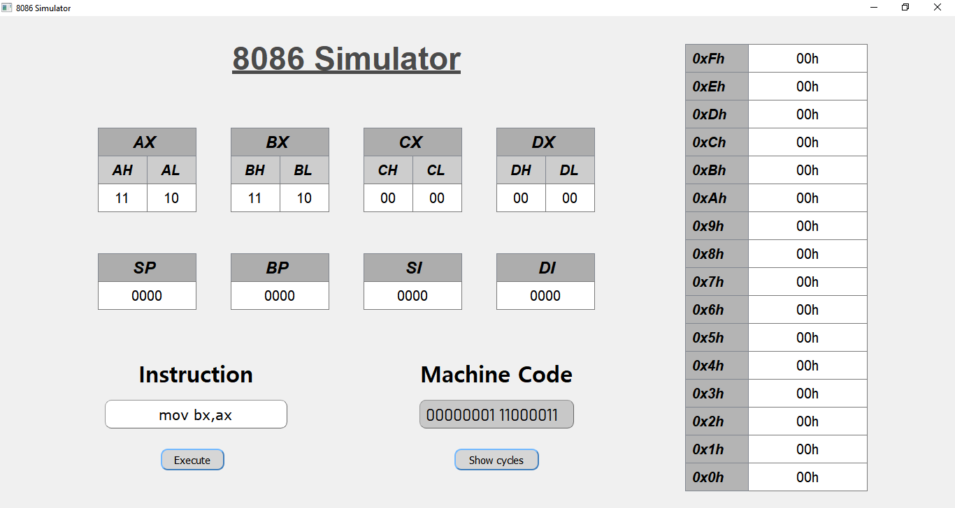

To show the respective cycles for our instruction, clicking on **show cycles** button would open the following window:

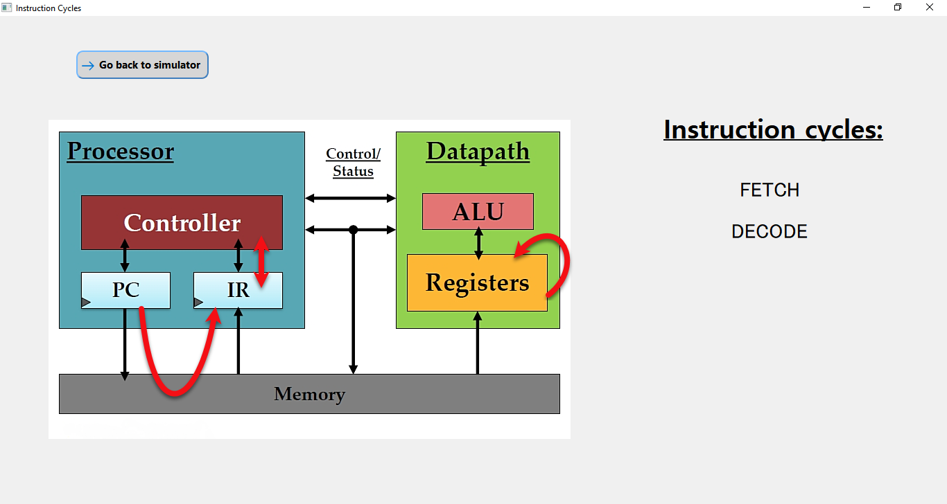

In this way, you can give your own instruction and check its machine code and cycles involved