PROJECT FINAL REPORT
“CCN Hotel Connectivity System”
Computer Communication & Networks

Table of Contents

S no. | CONTENTS | Pg no.
1 | Problem Statement | 1
2 | Implemented Solution | 2
3 | Theory Discussion | 3
4 | Software Tool(s) | 4
5 | Steps of Working | 5
6 | Topology | 6
7 | Limitations | 7
8 | Final Results | 8
9 | Applications | 9
10 | References | 10

i

PROBLEM STATEMENT
CCN Hotel Connectivity System requires the design and implementation of a secure, efficient, and scalable network infrastructure that spans across three floors, with each floor hosting multiple departments. The network must connect the departments through distinct VLANs, ensuring dynamic IP address allocation via DHCP for all devices. Each floor will have a dedicated router and switch, interconnected using serial DCE cables with specified subnets for routing between floors. The routers will utilize OSPF as the routing protocol to ensure efficient and dynamic routing across the network. The network must also implement secure communication protocols, including SSH for remote login to routers, and enforce port security on the IT department’s switch, limiting access to only one device (Test-PC) using the sticky method for MAC address learning. Additionally, the network should ensure seamless communication between all devices, including printers and Wi-Fi-enabled devices, across different VLANs while maintaining security and performance.[1]

IMPLEMENTED SOLUTION
To implement the network design at CCN Hotel Connectivity System, three routers will be installed, one on each floor, connected via serial DCE cables with unique subnets for inter-router communication, and OSPF configured for dynamic routing. Switches will be deployed on each floor, with VLANs created for each department (Reception, Store, Logistics on the 1st floor; Finance, HR, Sales/Marketing on the 2nd floor; Admin and IT on the 3rd floor), each assigned unique VLAN IDs and IP subnets. Routers will act as DHCP servers for dynamic IP allocation, and Wi-Fi access points will be set up for mobile devices and printers within respective VLANs. SSH will be configured on all routers for secure remote management, and port security will be applied to the IT switch to restrict access to the Test-PC. Comprehensive testing will ensure seamless communication across VLANs, proper DHCP functionality, secure remote access via SSH, and Wi-Fi connectivity, meeting all performance and security requirements.

THEORY DISCUSSION
The CCN Hotel Connectivity System network design emphasizes creating a robust, scalable, and secure infrastructure to meet the operational needs of various departments spread across three floors. The theoretical foundation of the design lies in leveraging routers, switches, and VLANs to achieve traffic segregation, efficient routing, and enhanced security. Each floor's departments will be segmented into distinct VLANs, facilitating network management and minimizing broadcast traffic. OSPF will serve as the routing protocol to enable dynamic and efficient inter-router communication. Dynamic Host Configuration Protocol (DHCP) will streamline IP address allocation, ensuring seamless device connectivity. Security is a key consideration, with SSH configured on all routers for secure remote access and port security implemented to restrict unauthorized access, particularly in sensitive areas like the IT department. Wi-Fi integration will cater to the mobility needs of devices and printers while maintaining network segmentation for security. Overall, this design ensures the network's scalability, operational efficiency, and ability to adapt to the growing technological needs of the hotel.[1]

SOFTWARE TOOL

- Cisco Packet Tracer [2]

STEPS OF WORKING
- Network Design:
  - Three routers and switches per floor (F1, F2, F3).
  - VLANs for each department (Reception, Store, Logistics, Finance, HR, Sales, Admin, IT). [1]
- VLAN Setup:
  - VLANs configured for each department with their respective IP subnets.
- Inter-VLAN Routing:
  - OSPF configured on routers for dynamic routing between VLANs using serial connections. [3]
- DHCP:
  - Routers act as DHCP servers for their VLANs, assigning dynamic IP addresses. [4]
- Switch Configuration:
  - Trunking enabled between switches and routers, access ports assigned to VLANs.
- SSH:
  - SSH configured on all routers for secure remote access. [3]
- Wi-Fi:
  - Wireless access points configured for each floor’s VLAN.
- Printer Setup:
  - Printers assigned to appropriate VLANs for each department.

TOPOLOGY

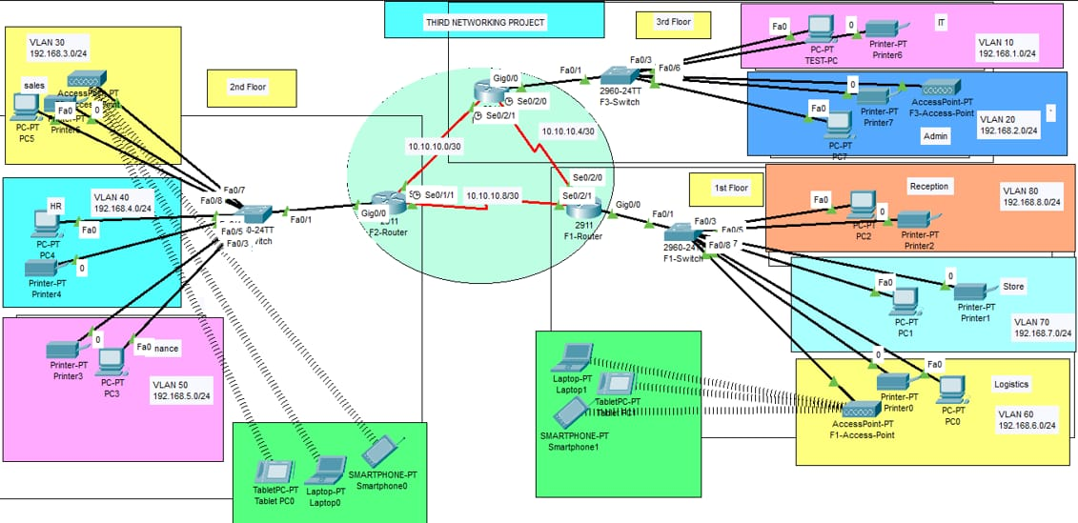
Fig. No. 1 “Topology of Network” [1]

LIMITATIONS:
The expected results for the network project are as follows: Devices across different VLANs should be able to communicate with each other through the routers, with OSPF providing dynamic routing between them. All devices will receive IP addresses dynamically from their respective routers, based on their assigned VLANs. Port security will ensure that only the Test-PC in the IT department can access the designated port on the F3-Switch, blocking any unauthorized devices. SSH access will be enabled on all routers, allowing secure remote access for configuration and management. Mobile devices, such as smartphones, tablets, and laptops, will be able to connect to the network through wireless access points, each corresponding to a specific VLAN. Printers within each department will be accessible to devices in the same VLAN, and cross-VLAN printing will be supported through routing. The overall network should remain stable, with seamless communication between both wired and wireless devices. Security measures like port security and SSH will help safeguard network devices, while the network’s performance can be monitored and troubleshooted using Cisco Packet Tracer’s simulation tools. [3] [4]

FINAL RESULT:
The CCN Hotel Connectivity System network design aims to establish a robust, scalable, and secure infrastructure to support the hotel’s operations efficiently across three floors. By utilizing routers, switches, and VLANs, the network achieves effective traffic segregation, seamless communication, and simplified management. OSPF is implemented as the routing protocol to enable dynamic inter-router communication, while DHCP ensures dynamic IP address allocation for all connected devices. Security measures include configuring SSH on all routers for secure remote access and implementing port security to restrict unauthorized access, particularly within critical areas like the IT department. The inclusion of Wi-Fi provides mobility support for devices and printers while maintaining network segmentation to ensure security. This comprehensive design ensures reliable connectivity, efficient communication, and scalability, meeting the operational and technological needs of the hotel.

APPLICATIONS
- Improved Network Segmentation:
  - VLANs ensure logical separation of departments, enhancing security and traffic management. Each department's devices (e.g., PCs, printers) are isolated within their VLAN, reducing broadcast traffic and improving network efficiency.
- Dynamic IP Addressing:
  - DHCP servers configured on routers dynamically assign IP addresses to devices, simplifying network management and reducing manual configuration errors. [3]
- Secure Remote Access:
  - SSH provides secure, encrypted access for network administrators to configure and troubleshoot routers remotely, improving management efficiency and security.
- Wi-Fi Access for Mobility:
  - Wireless access points provide employees and guests with mobility and flexibility in the hotel, allowing them to connect laptops, smartphones, and tablets to the network, ensuring constant access to services.
- Cross-department Communication:
  - Inter-VLAN routing ensures smooth communication between departments, facilitating collaboration across different areas of the hotel (e.g., HR communicating with Finance, IT assisting Admin).
- Enhanced Security:
  - Port security on switches prevents unauthorized access, especially in critical areas like the IT department, ensuring only authorized devices (e.g., the Test-PC) can connect to sensitive network segments. [3]
- Efficient Printing Services:
  - Each department’s printers are accessible only to its respective devices, streamlining print services while also allowing for cross-departmental printing through routing.
- Scalability and Future Growth:
  - The modular and flexible network design can accommodate future expansion, such as adding new departments or floors, without major changes to the existing infrastructure.
REFERENCES
[1] Building the topology, “Idea”, 2024. [Online], Available:
https://youtu.be/RwFJTJTe-OM?si=JSYAT3_WxlAL-5zn.
[Accessed: 01-December-2024].
[2] Cisco-packet-tracer, “Software”, 2024. [Online], Available:
https://www.netacad.com/cisco-packet-tracer [Accessed: 01-December-2024].
[3] Routing Protocols and their Security in Cisco. [Online], Available:
https://www.cisco.com/[Accessed: 01-December-2024].
[4] How to use Ips, 2024. [Online], Available:
https://www.wix.com[Accessed: 01-December-2024].

