TABLE OF CONTENTS
S. No. | Content | Page No.
1 | Table of Contents | i
2 | Problem Statement | 1
3 | Proposed Solution | 2
4 | Description | 3
5 | Components | 4
6 | Methodology | 5
7 | Circuit Diagram | 6
8 | Expected Results | 7
9 | Practical Applications | 8
10 | References | 9

PROBLEM STATEMENT
Air quality and gas leakage represent critical safety hazards in both residential and industrial environments. Toxic and flammable gases such as ammonia, carbon dioxide (CO2), carbon monoxide (CO), benzene, and LPG can accumulate without any visible sign, posing serious health risks including respiratory damage, unconsciousness, and even death.
Conventional gas detection systems are either expensive, difficult to install, or lack real-time alerting capabilities for everyday users. Most industrial-grade detectors are unaffordable for households, while cheaper consumer alarms often lack reliability or fast response time.
There is a pressing need for a low-cost, easy-to-build, and effective gas detection system that provides an immediate warning when hazardous gas concentrations exceed safe thresholds. Such a system should be accessible to students, hobbyists, and small workshops without requiring expensive equipment.
The proposed IoT project addresses this problem using an Arduino UNO microcontroller, an MQ-135 gas sensor, and an active buzzer. The system is designed for home safety demonstrations, educational use, and as a base prototype for larger IoT-based air quality monitoring solutions.

PROPOSED SOLUTION
The proposed solution is an Arduino-based Gas Detector System that continuously monitors ambient air for harmful gases. The MQ-135 gas sensor module detects the presence of gases such as ammonia, benzene, carbon dioxide, alcohol, and smoke, while the Arduino UNO processes the sensor reading and compares it against a defined threshold value.
When the gas concentration surpasses the predefined threshold, the Arduino activates an active buzzer that emits an immediate audio alarm to warn the user. The reading can also be observed through the Arduino IDE Serial Monitor for testing and calibration.
- The system detects hazardous gases in real time without manual checking.
- An audible buzzer alarm provides an unmistakable warning when gas is detected.
- The circuit uses affordable and easily available electronic components.
- No soldering is required; the circuit is built on a breadboard with jumper wires.
- The design can be extended with a Wi-Fi module (such as ESP8266) for IoT cloud monitoring, SMS alerts, or smartphone notifications in future versions.
This solution is suitable for students because it combines sensor interfacing, microcontroller programming, analog signal reading, and real-time threshold-based control in one compact project.

DESCRIPTION
The project is a digital gas detection device that uses chemo-resistive sensing technology. The MQ-135 sensor contains a sensitive material whose internal electrical resistance changes when it comes into contact with target gases. This change in resistance is converted into a voltage signal that the Arduino can read.
The Arduino UNO uses its built-in 10-bit Analog-to-Digital Converter (ADC) to map sensor voltage levels in the range of 0 to 5 volts into integer values from 0 to 1023. A threshold value (commonly around 300) is defined in the program code. When the sensor reading exceeds this threshold, the Arduino sets digital pin 8 to HIGH, which activates the buzzer.
The MQ-135 module provides both a digital output (DO) and an analog output (AO). This project uses the analog output because it gives a variable, threshold-adjustable reading suitable for fine sensitivity tuning.
Input: Ambient air sampled by the MQ-135 gas sensor.
Processing: Arduino reads the analog voltage and compares it with the programmed threshold.
Output: Active buzzer sounds an alarm when gas concentration exceeds the safe limit.
The project demonstrates a practical embedded system where hardware and software work together to convert a physical environmental condition into an immediate safety response.

COMPONENTS
The following hardware and software components are used in the Gas Detector System:
S/No | Component | Quantity | Description
1 | Arduino UNO | 1 | ATmega328P-based microcontroller; main processing unit of the system.
2 | MQ-135 Gas Sensor Module | 1 | Detects NH3, CO2, benzene, smoke, and alcohol; provides analog output.
3 | Active Buzzer (5V) | 1 | Emits continuous sound when powered; used as the alarm output device.
4 | Breadboard | 1 | Solderless prototyping board used for temporary circuit assembly.
5 | Jumper Wires | ~10 | Used for connecting Arduino pins with the sensor and buzzer.
6 | USB Cable / Power Supply | 1 | Powers the Arduino and uploads the program from the Arduino IDE.
7 | Arduino IDE | — | Software used for writing, compiling, and uploading the sketch.

Arduino UNO Specifications:
Operating voltage 5V, 14 digital I/O pins, 6 analog input pins (10-bit ADC), 32KB flash memory, and 16 MHz clock speed.
MQ-135 Sensor Specifications:
Operating voltage 5V DC, detection range 10–300 ppm, sensitive to NH3, benzene, CO2, alcohol, and smoke. Requires approximately 2 minutes of preheat time for stable readings.
Active Buzzer Specifications:
Operating voltage 3.5–5.5V DC, approximately 30 mA current draw, with an internal oscillator that does not require PWM signals.
These components were selected because they are low-cost, easy to interface, and suitable for IoT and embedded systems learning.

METHODOLOGY
The methodology follows a step-by-step hardware and software development process. First, the required components are selected according to the project objective. After that, the circuit is assembled on a breadboard and the program is written and uploaded to the Arduino UNO.
Step 1 — Hardware Assembly (Pin Connections):
Connect the MQ-135 sensor and active buzzer to the Arduino UNO as shown in the table below.
Component | Component Pin | Arduino Connection
MQ-135 | VCC | 5V
MQ-135 | GND | GND
MQ-135 | AO (Analog Out) | A0
MQ-135 | DO (Digital Out) | Not connected
Active Buzzer | + (Positive) | Digital Pin 8
Active Buzzer | – (Negative) | GND
Step 2 — Testing and Calibration:
After uploading the code, the MQ-135 sensor is exposed to a detectable gas source (such as a brief lighter flame nearby or a small amount of aerosol spray). Rising values are observed on the Serial Monitor. The threshold value in the code can be adjusted to tune the sensitivity for the testing environment.
During testing, readings will be taken in clean air and with controlled gas exposure to verify the stability and response time of the system. The buzzer should activate within 1–2 seconds when gas is detected.

CIRCUIT DIAGRAM

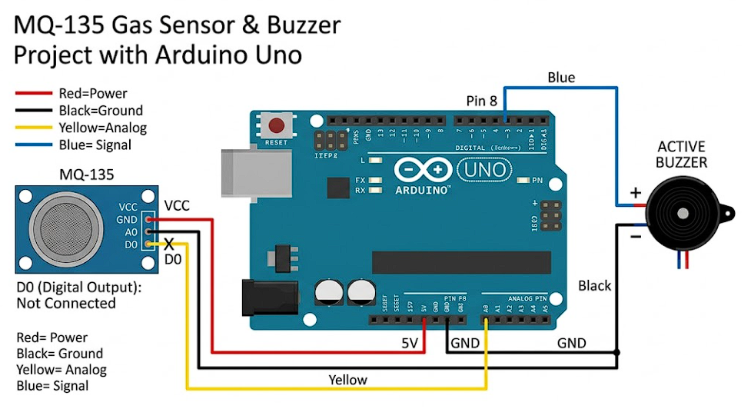
Fig. 1: Arduino UNO with MQ-135 gas sensor and active buzzer circuit layout.
The circuit connections of the Gas Detector System are summarized in the table below:
Module Pin | Arduino Connection | Purpose
MQ-135 VCC | Arduino 5V | Supplies power to the gas sensor
MQ-135 GND | Arduino GND | Common ground connection
MQ-135 AO | Analog Pin A0 | Sends analog gas concentration signal
Buzzer (+) | Digital Pin 8 | Arduino controls buzzer ON/OFF
Buzzer (–) | Arduino GND | Common ground connection

All components are placed on a breadboard. The Arduino is powered via a USB cable connected to a computer or USB power source. The MQ-135 module is powered directly from the Arduino's 5V rail. The buzzer is controlled by digital pin 8 acting as a simple HIGH/LOW switch.
The circuit uses common 5V and GND connections shared between the MQ-135 sensor and the buzzer, which keeps the wiring simple and easy to assemble without soldering.

PRACTICAL APPLICATIONS
The Gas Detector System has a wide range of practical applications across home, industrial, agricultural, and educational settings:
- Home safety: Detecting LPG leaks in kitchens and monitoring carbon monoxide from gas heaters or generators.
- Industrial use: Air quality monitoring in factories and chemical plants, and safety monitoring in paint shops and welding areas.
- HVAC and ventilation: Triggering ventilation systems automatically when air quality drops below safe limits.
- Agriculture: Monitoring ammonia levels in poultry farms and livestock enclosures, and detecting methane in biogas plants.
- Smart buildings: Server room hazard detection, parking garage CO and exhaust monitoring, and integration with smart home systems.
- Education and research: Demonstrating IoT sensor integration in academic settings and serving as a foundation for advanced projects with Wi-Fi modules, cloud dashboards, or SMS alerts.
- Security and safety systems: Early warning in residences and small workshops with gas appliances or chemical storage.
Because the system is inexpensive and easy to assemble, it can be used as a base prototype for many larger IoT and automation projects, including cloud-connected air quality monitoring networks.

REFERENCES
[1] YouTube Tutorial. "Gas Detector Using Arduino (MQ-135 + Buzzer)." Accessed May 2026. https://youtu.be/4_601_Izu-0.
[2] Arduino. "Language Reference — analogRead() and digitalWrite()." Arduino Documentation. Accessed May 2026. https://www.arduino.cc/reference/en/.
[3] Henan Hanwei Electronics Co., Ltd. "MQ-135 Gas Sensor Datasheet." Accessed May 2026.
[4] Arduino. "Arduino UNO Rev3 Product Page." Accessed May 2026. https://store.arduino.cc/products/arduino-uno-rev3.
[5] Banzi, M., and Shiloh, M. Getting Started with Arduino. 3rd Edition. O'Reilly Media, 2014.
[6] Autodesk. "Tinkercad Circuits — Online Arduino Simulation Tool." Accessed May 2026. https://www.tinkercad.com/circuits.

