Data not avalable Same as them Changes done

Finalize content ocmb

Pass 1

Home Page :

Header : Put transparent logo and change color of background

(Logo not available)

Will give source logo (red in head and white in footer)

Banner :

Easy, fee-free Banking for personal and entrepreneurs

Get the financial tools and insights to start, build, and grow your business and your personal finance.

Must be changes there is personal there not in theme

Button: Features and Get start (to join us form)

Transparent princing: Enjoy the Convenience of Banking at your Fingertips without hidden fees.

Fully encrypted: We use the best industry-accepted security practices. It includes high-end encryption and firewalls that secure your personal financial information

Instant Cashout: Your Money Will Never be Idle Again - Earn Up To 1.2% Interest

Safe and secure: Reach Your Money SECURELY from Anywhere with OCMB

Freelancers, entrepreneurs and personal

### **Earn Interest**

### Your Money Will Never be Idle Again - Earn Up To 1.2% Interest

Yes, this is correct, we offer up to 1.2% interest on your saving and chequing account. With no hidden charges or minimum balance, enjoy unlimited e-transfers. Keep your money safe with us and enjoy the interest.

### **Accounts**

#### **Saving**

Whether you want to save money for the future or looking for a special purchase, we offer you a variety of saving options. NO HIDDEN CHARGES

#### **Chequing**

Our chequing account lets our customers access their money easily and spend it on their day-to-day banking needs. Deposit your earnings and withdraw whenever you want.

### **Online Banking**

### We Offer Secure, Quick, and Easy Access to Your Money

With our online banking, it’s easy to manage all aspects of your account. It was never this easy to send and receive money, pay utility bills, and shop with free email alerts. We also offer online statements so you can keep an eye on your spendings.

### **Mobile App**

### Manage your Account with Our High-End Encrypted App on Your Mobile Phone or Tablet

With the encrypted OCMB mobile app, you can deposit checks, pay bills, transfer money to your own account, or send money to your friends and family without any fear. We have brought everyday banking to your fingertips.

### **Debit Card**

### No Cash? No Issue - Use Our Credit Card for Instant Payments

You can use our debit card in various ways - shop and pay bills in person, online, in-app, or over a call. With our debit card, you can access your chequing or saving account from any part of the country.

### **Moving Money**

### Need to Send Money to Someone? Transfer Funds Faster with Interac e-Transfer

This feature of OCMB allows you to transfer funds faster to yourself and others. Transferred money is available immediately typically within 30 minutes. Spend your time doing what is important and use our *money moving* feature for secure fund transfers.

Delete :

Small to medium size business

Large or entreprise level business

Compare us with others (will be deployed later)

Our features : (put features on home page)

Esay payment to borrow free get better…:

One of the most important parts of every month’s budget is the payment of bills. With OCMB, you can pay all bills right from your mobile phone or tablet from anywhere anytime. Usually, a chequing account is used to pay bills, but you can also use your savings account.

-Put image there!

We always try to understand…:

With our convenient and flexible banking options, we meet a variety of financial needs of our customers. We are proud to launch products and services our clients deserve and want.

50 K Downloads

10 K feedback

25 K customers

100 Contributors

-Button contact us : to contact form (not available)

Look on diff pages on trash for contact form

What’s customers say about us (will deployed with blog)

Our trusted partner (will be put there at the end)

You can find all thing you need …:

### Manage your Account with Our High-End Encrypted App on Your Mobile Phone or Tablet

With the encrypted OCMB mobile app, you can deposit checks, pay bills, transfer money to your own account, or send money to your friends and family without any fear. We have brought everyday banking to your fingertips.

-Put image for mobile payment

The news from our blog:

Our team is keen to take the time to know you, your needs, and your unique situation to help you allow us to offer you the best solution that can bring results to you and make a difference.

-Then put blogs (will be given at the and)

Make change on footer

Footer: Put this address, description, copyrite and transparent logo:

Logo: you have it,

Description:

We pride ourselves as a strong locally-owned online mobile bank. Our company has created an environment where every employee feels valued, respected, and has equal growth opportunities.

Address: 1 Place Ville Marie, Suite 2000, Montréal (Qc) H3B 2C4, Canada

Phone : +14384887050

Mail : [info@ocmb.ca](mailto:info@ocmb.ca)

Social media: will be given at the end.

Sing In /Join Now : will be given to you when the backend is ready at the end.

-Add get your account barre in buttom of evry page :

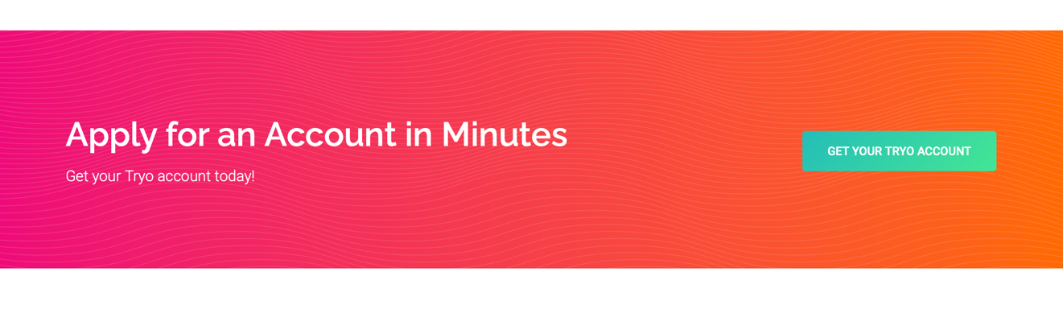

-Add background on head of each of page.

-Add contact form and rederict send button to [info@ocmb.ca](mailto:info@ocmb.ca)