CS114: Fundamentals of Programming

Introduction to Dev C++

First Program

Instructor: Qurrat-ul-ain Babar

Objectives
The purpose of this lab is to understand the programming and its syntax (C++) and environment.
Tools/Software Requirement: Dev C++
Follow the step by step tutorial and write and execute your first C++ program!
Step 1: Click on start menu and select DevC++
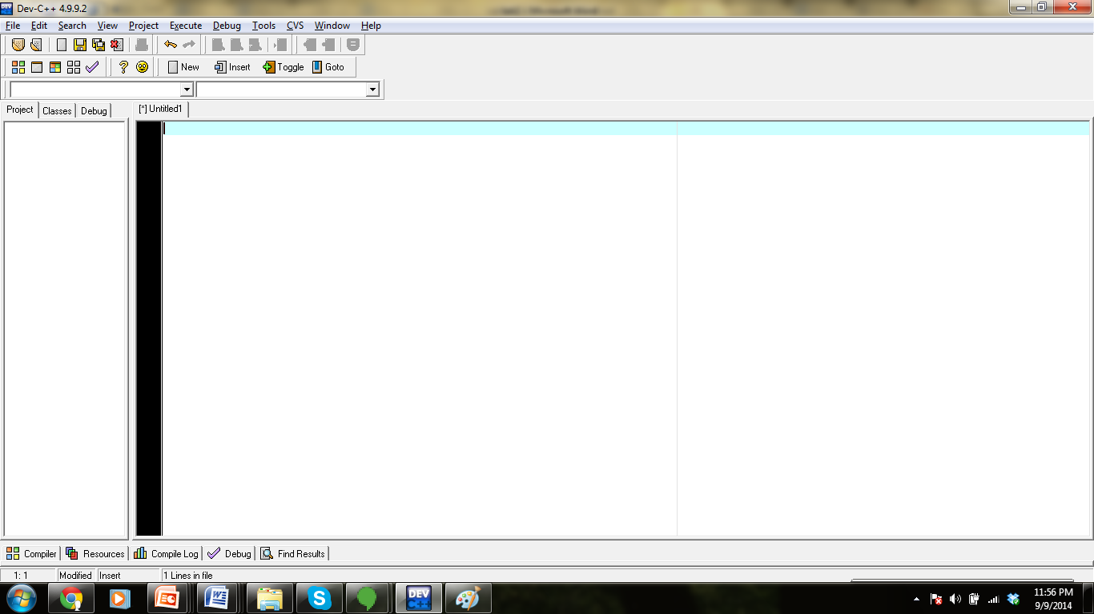
Step 2: After selection of DevC++, a screen like this will be shown.

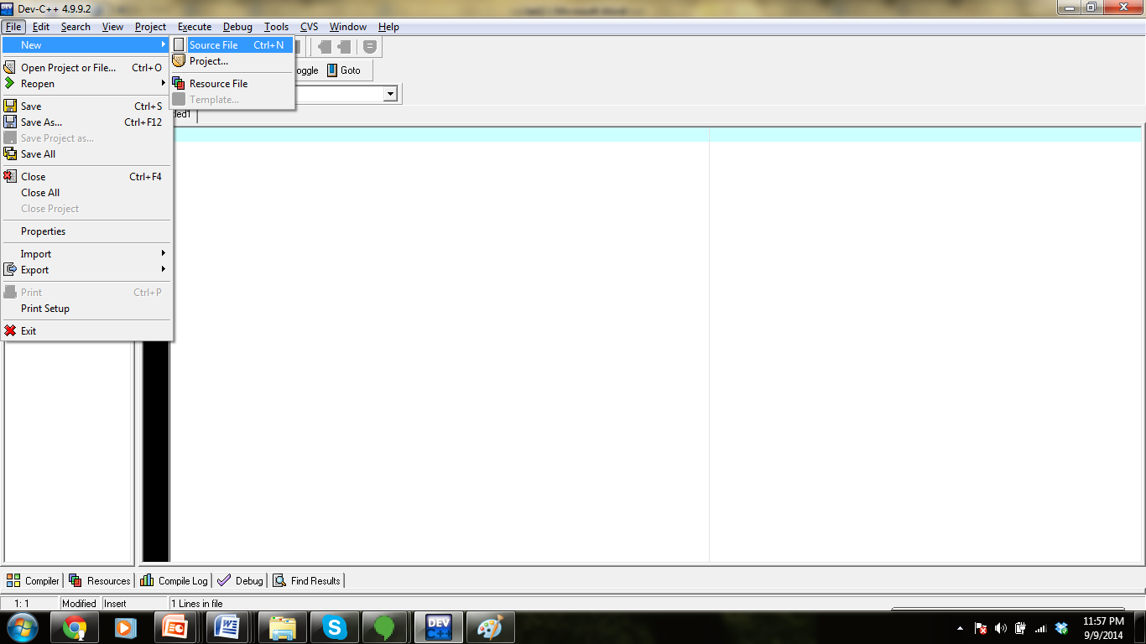
Step 3: Now to create a file select “New” from “File” menu and choose “Source File”.
Step 4: Type the following code:
#include <iostream>
using namespace std;

int main()
{
cout << "Hello, Class of 2018";
}

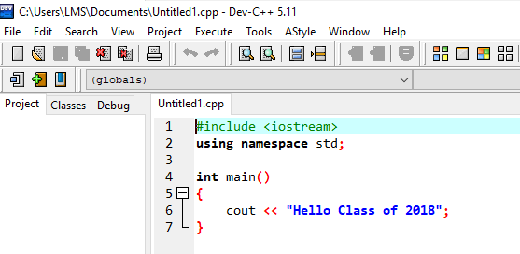
To understand the meaning of each line read the passages at the end of the document.

Step 5: To compile your code select “Compile” from “Execute” menu.
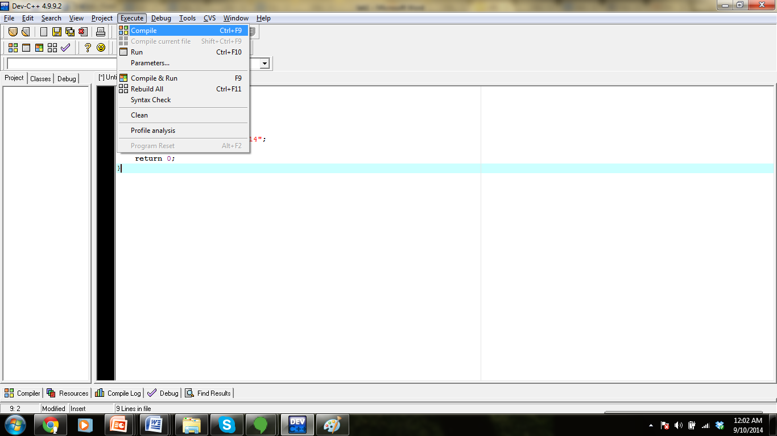
Step 6: Save the file as “FirstProgram” or give name according to your own choice.
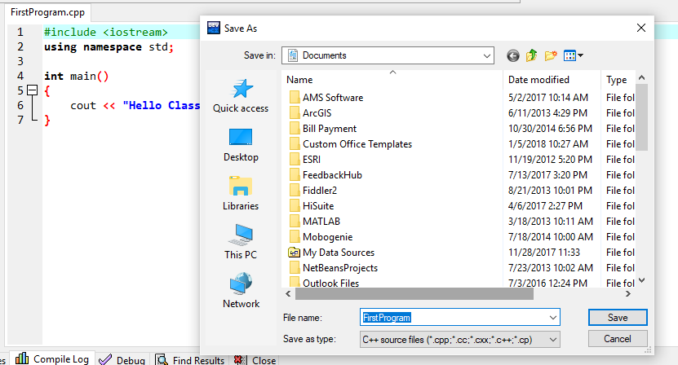

Step7: After successful compilation of the code, click on “Run” in “Execute” menu.
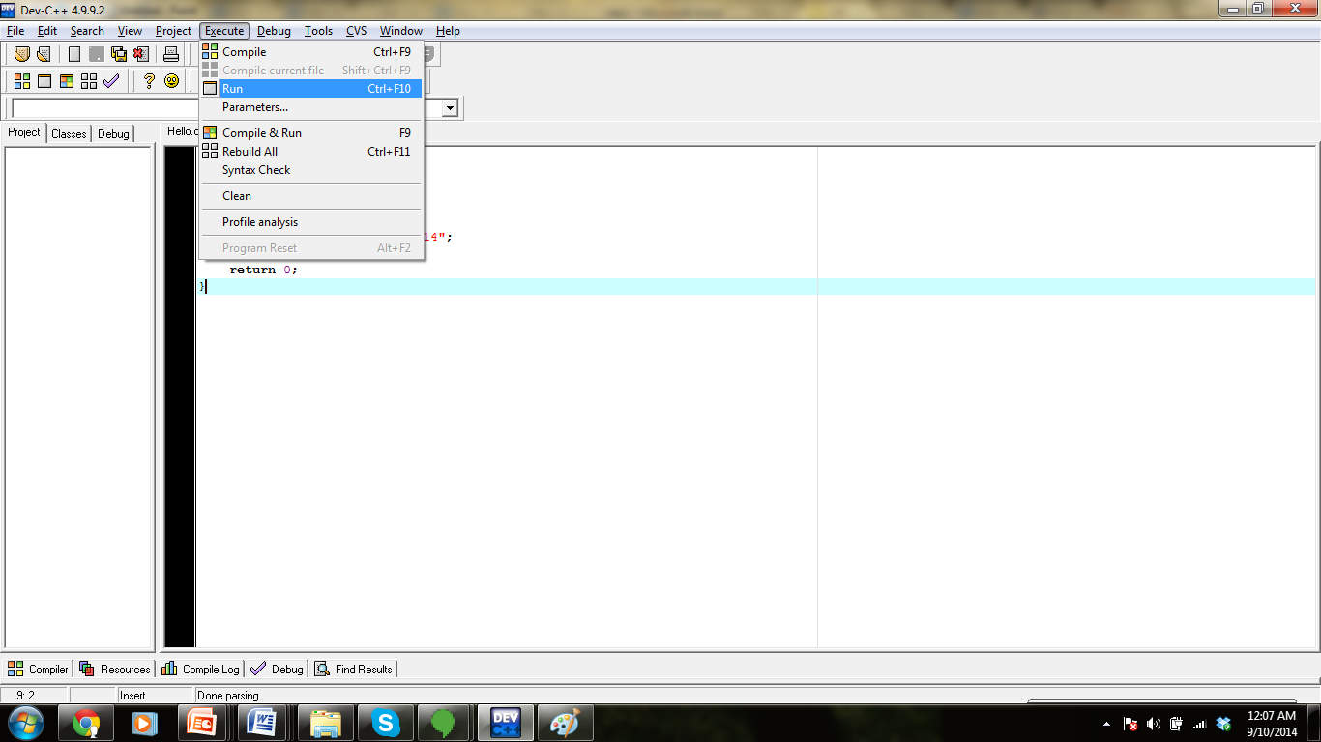
If there are no errors you will see your output as shown below:
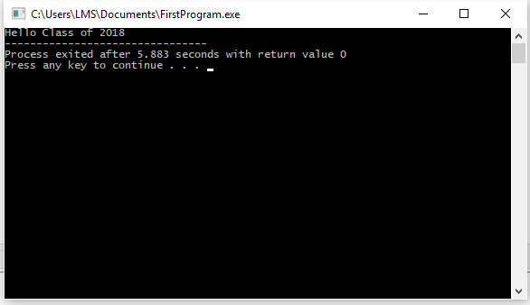

Explanation of Code:

#include <iostream>
Lines beginning with a hash sign (#) are directives for the preprocessor. They are not regular code lines with expressions but indications for the compiler's preprocessor. In this case the directive #include <iostream> tells the preprocessor to include the iostream standard file. This specific file (iostream) includes the declarations of the basic standard input-output library in C++, and it is included because its functionality is going to be used later in the program.

int main ()
This line corresponds to the beginning of the definition of the main function. The main function is the point by where all C++ programs start their execution, independently of its location within the source code. It does not matter whether there are other functions with other names defined before or after it – the instructions contained within this function's definition will always be the first ones to be executed in any C++ program. For that same reason, it is essential that all C++ programs have a main function.
The word main is followed in the code by a pair of parentheses ( ). That is because it is a function declaration: In C++, what differentiates a function declaration from other types of expressions are these parentheses that follow its name. Optionally, these parentheses may enclose a list of parameters within them. Right after these parentheses we can find the body of the main function enclosed in braces { }. What is contained within these braces is what the function does when it is executed.

cout << "Hello, Class of 2018!";
This line is a C++ statement. A statement is a simple or compound expression that can actually produce some effect. In fact, this statement performs the only action that generates a visible effect in our first program. cout represents the standard output stream in C++, and the meaning of the entire statement is to insert a sequence of characters (in this case the Hello, Class of 2018 sequence of characters) into the standard output stream (which usually is the screen). cout is declared in the iostream standard file within the std namespace, so that's why we needed to include that specific file and to declare that we were going to use this specific namespace earlier in our code. Notice that the statement ends with a semicolon character (;). This character is used to mark the end of the statement and in fact it must be included at the end of all expression statements in all C++ programs (one of the most common syntax errors is indeed to forget to include some semicolon after a statement).

return 0;
The return statement causes the main function to finish. return may be followed by a return code (in our example is followed by the return code 0). A return code of 0 for the main function is generally interpreted as the program worked as expected without any errors during its execution. This is the most usual way to end a C++ console program.
You may have noticed that not all the lines of this program perform actions when the code is executed. There were lines containing only comments (those beginning by //). There were lines with directives for the compiler's preprocessor (those beginning by #). Then there were lines that began the declaration of a function (in this case the main function) and, finally lines with statements (like the insertion into cout), which were all included within the block delimited by the braces ({}) of the main function.

The program has been structured in different lines in order to be more readable, but in C++, we do not have strict rules on how to separate instructions in different lines.

