CS114: Fundamentals of Programming

Class: BECE2018

Lab 11: Arrays

Instructor: Qurrat-ul-ain Babar

Lab 10: Arrays

In this lab Arrays are covered in detail
Our aims today are:
- Array definition
- When to use Array
- Array declaration
- Array Initialization
- Accessing Array elements

What is Array?
Array is a data structure in C++, which stores a fixed size sequential collection of elements of the same type. An array is used to store a collection of data. It is often useful to think of an array as a collection of variables of the same type.
Instead of declaring individual variables, such as number0, number1, ..., and number99, you declare one array variable such as numbers and use numbers[0], numbers[1], and ..., numbers[99] to represent individual variables. A specific element in an array is accessed by an index.
All arrays consist of contiguous memory locations. The lowest address corresponds to the first element and the highest address to the last element.

When to use Array
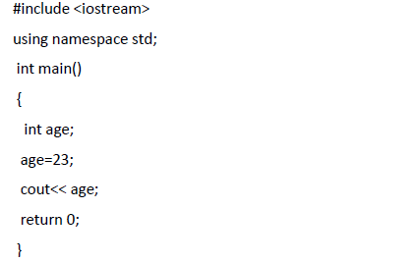
Let's start by looking at Example 1 where a single variable is used to store a person's age.

Example 1:

It is quite simple. The variable age is created at line (5) as int. A value is assigned to it. Finally, age is printed to the screen.
Now let's keep track of 4 ages instead of just one. We could create 4 separate variables, but creating 4 separate variables is not a good approach. (If you are using 4 separate variables for it, then consider keeping track of 1000 ages instead of just 4). Rather than using 4 separate variables, we'll use an array because it is quite easy to handle one variable instead of 1000.

Declaration of Array
To declare an array in C++, the programmer specifies the type of the elements and the number of elements required by an array as follows:
type arrayName [ arraySize ];

This is called a single-dimension array. The arraySize must be an integer constant greater than zero and type can be any valid C++ data type. For example, to declare a 4-element array called age of type int, use this statement: int age[4];

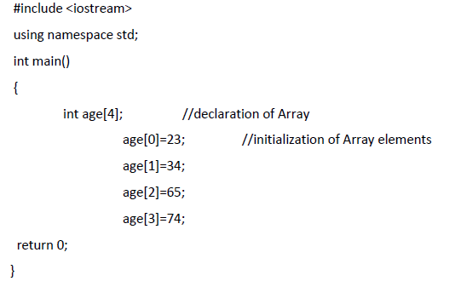
Example 2:

On line (5), an array of 4 int is created. Values are assigned to each variable in the array on line (6) through line (9). In memory these are contiguous set of locations shown in following figure.
age[0] age[1] age[2] age[3]
23 | 34 | 65 | 74

Example 3:
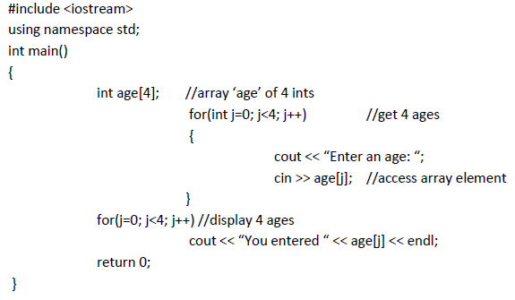

Initialization of Array:
Just like a variable, an array can be initialized. To initialize an array, we provide initializing values which are enclosed within curly braces in the declaration and placed following an equals sign after the array name. Here is an example of initializing an integer array.
int age[4]={23,34,65,74};
Now how to initialize all the values in array to 0? It can be done by the following statement;
int age[4]={0};

Accessing elements of Array:
At any point of a program in which an array is visible, we can access the value of any of its elements individually as if it was a normal variable, thus being able to both read and modify its value. array_name[index];

Following the previous examples in which “age” had 4 elements and each of those elements was of type int, the name which we can use to refer to each element is the following:
age[0] age[1] age[2] age[3]
For example, to store the value 75 in the third element of age, we could write the following statement:
age[2]=75; //note : array index start with 0 in C.
And, for example, to store the value of the third element of age to a variable called a, we could write:
int a=age[2];
Here’s another example of an array at work. This one, SALES, invites the user to enter a series of six values representing widget sales for each day of the week (excluding Sunday), and then calculates the average of these values. We use an array of type double so that monetary values can be entered.

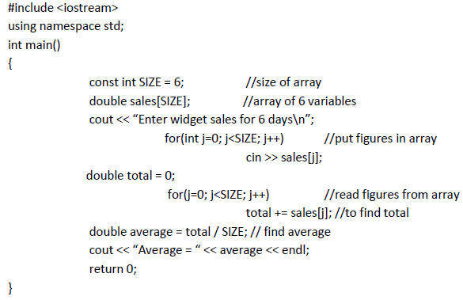
Example 4:

Dealing with characters using arrays
You can also store characters and other type data (float etc.) in the arrays. Just declare it as we’ve done in the case with int. There is no difference in dealing with characters except you’ve to enclose the value in a single quote.
Char ar[3];
Ar[0]=’a’ ; ar[1]=’b’; ar[2]=’c’;

Task 1
Take 20 values as input from the user and save it in an array and display their average.

Task 2
Initialize an array with following values; Array = { 1, 2, 6, 4, 8, 5, 9, 7, 8, 10, 1, 6, 3, 8, 6, 10, 3, 8, 2, 7, 6, 5, 7, 6, 8, 6, 7, 5, 6, 6, 5, 6, 7, 5, 6, 4, 8, 6, 8, 10 }
Write a program that determines frequencies for numbers 1-10 in array above and displays it in the following manner:
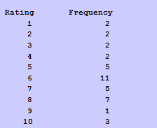

Task 3
Write a program that takes a value from user and check whether it is present in the array or not? (Array should be there and initialed in the code).

Task 4
Take 20 values as input from the user and save it in an array and display maximum and minimum values from them.

