MUHAMMAD UMER BASIT
REGISTRATION NUMBER 259084
SECTION C
GIS LAB ASSIGNMENT
SUPERVISED CLASSIFICATION AND ACCURACY ASSESSMENT IS PERFORMED IN STEPS AS SHOWN IN DIAGRAMS BELOW:
LAYER STACKING
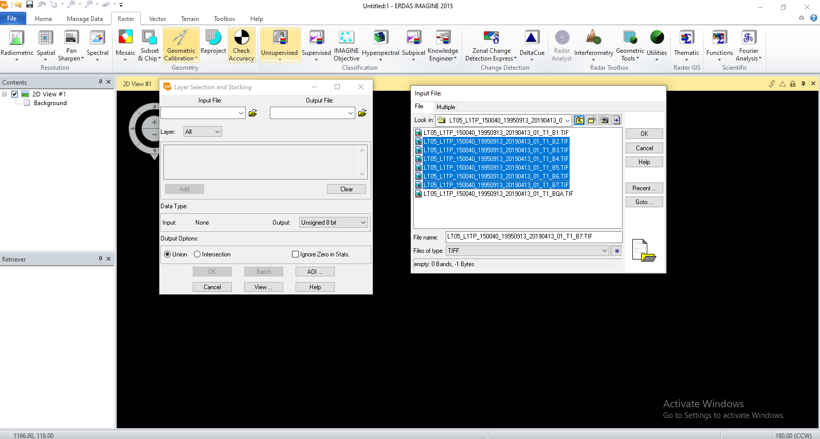

TIFF FILE
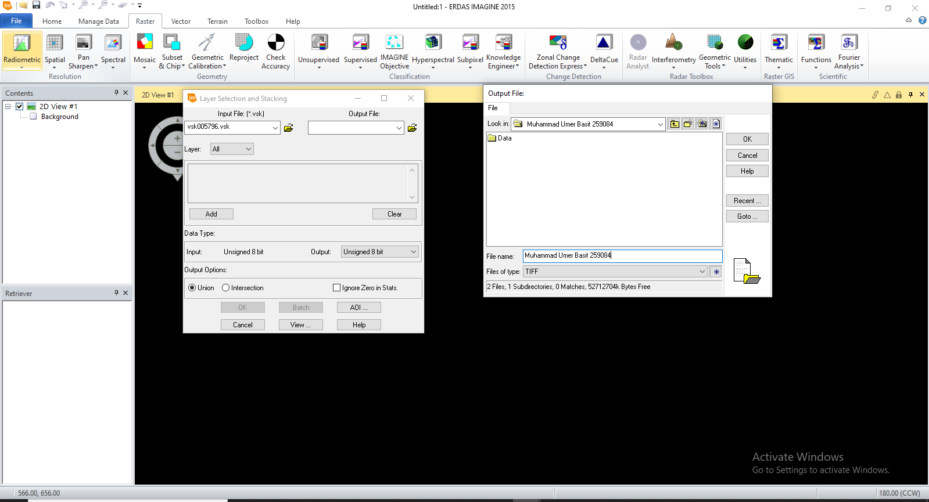

PROCESSING
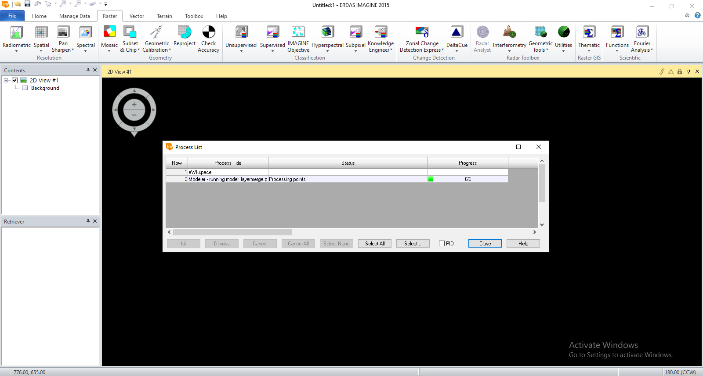

PROCESSING DONE
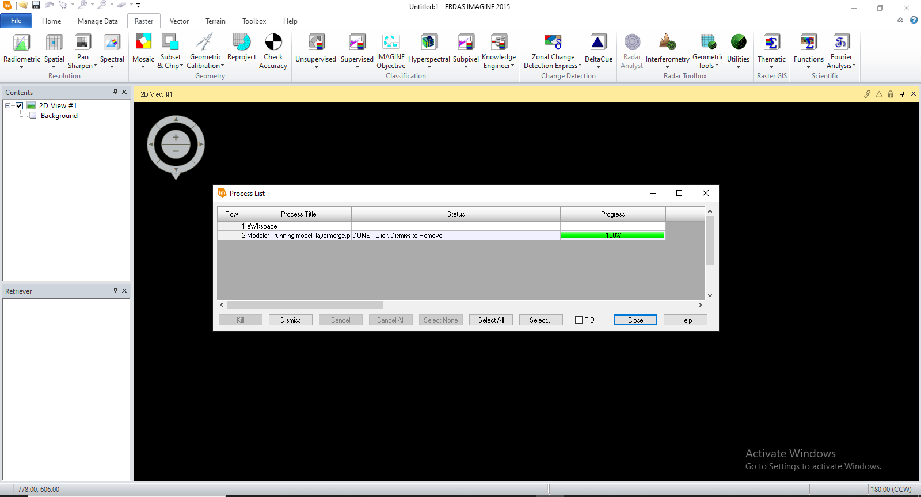

PREVIEW
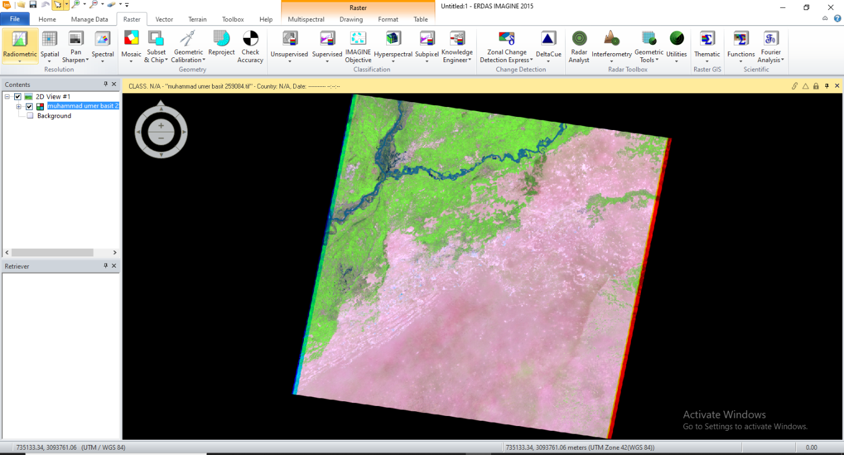

MARKING COORDINATES OF BAHAWALPUR DISTRICT
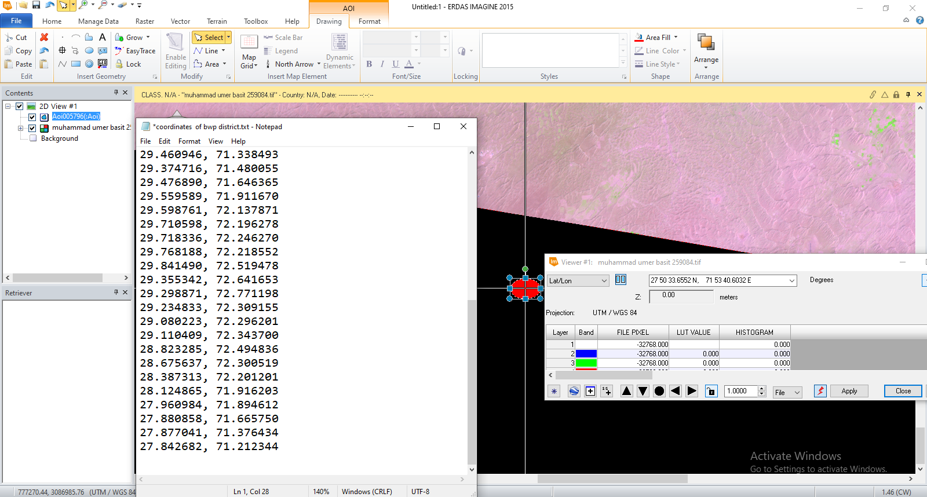

MARKED COORDINATES USING CIRCLE AND INQUIRY
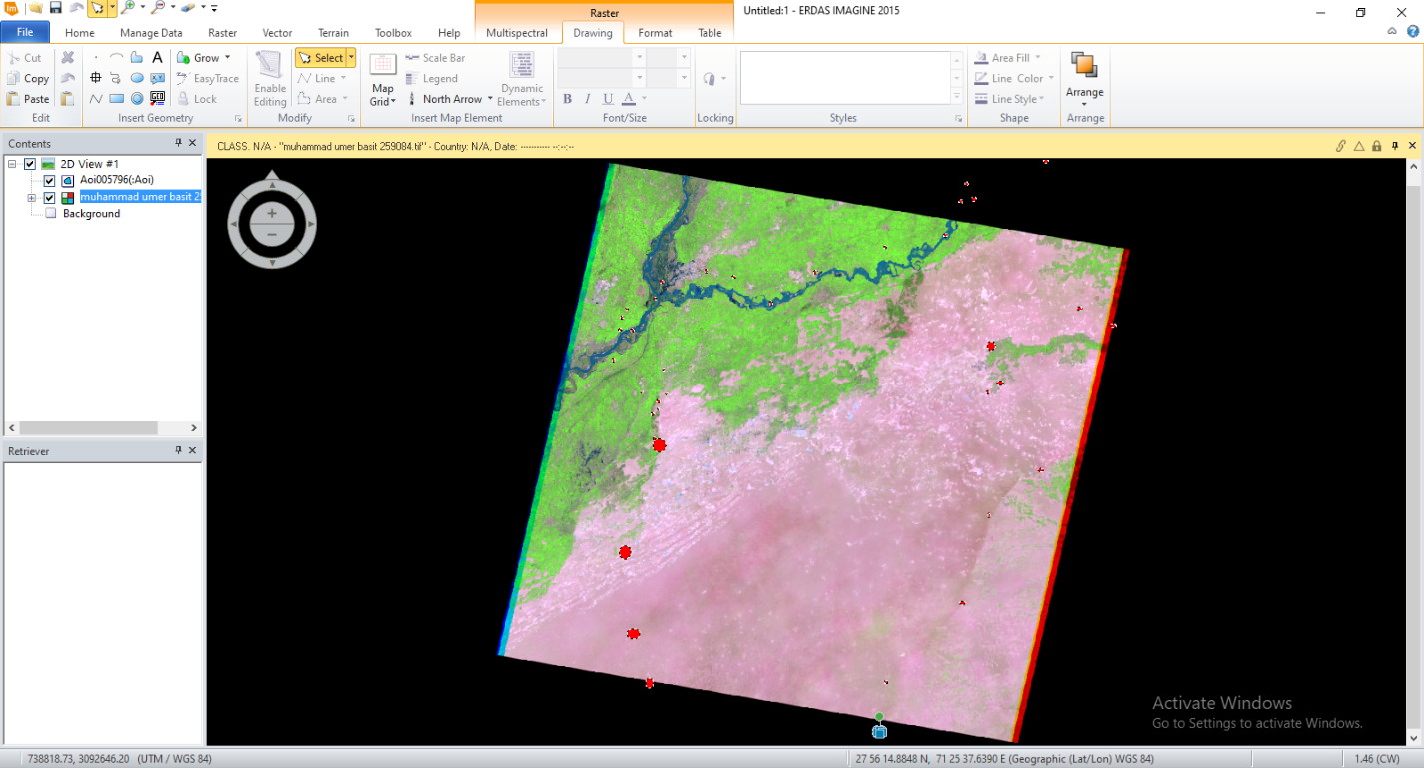

MARKING BOUNDARY OF BAHAWALPUR DISTRICT
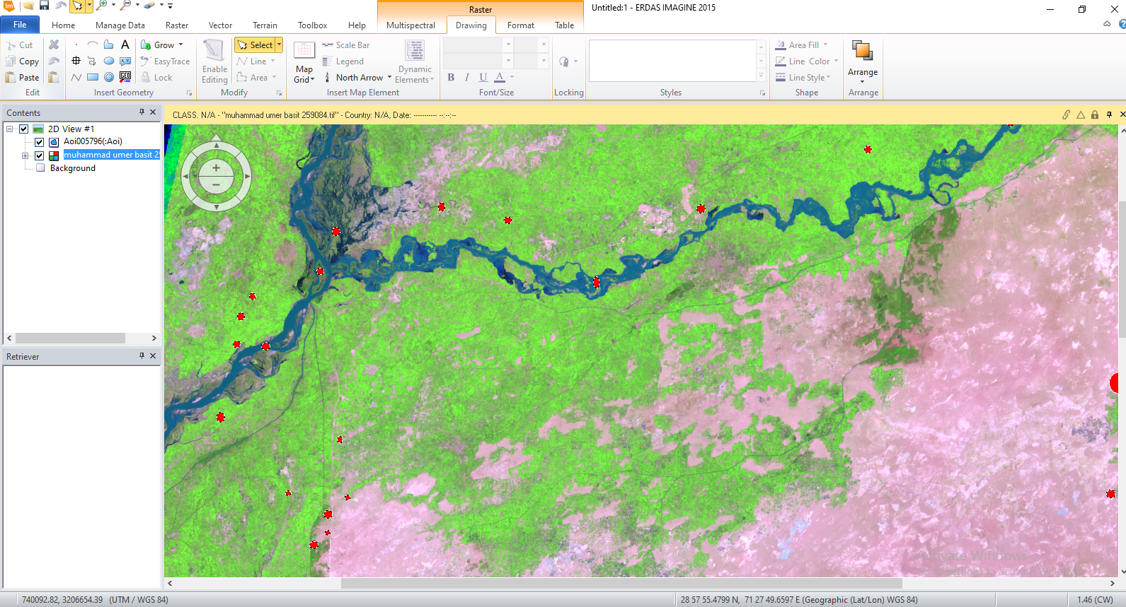

BOUNDARY OF BAHAWALPUR DISTRICT AS A POLYGON
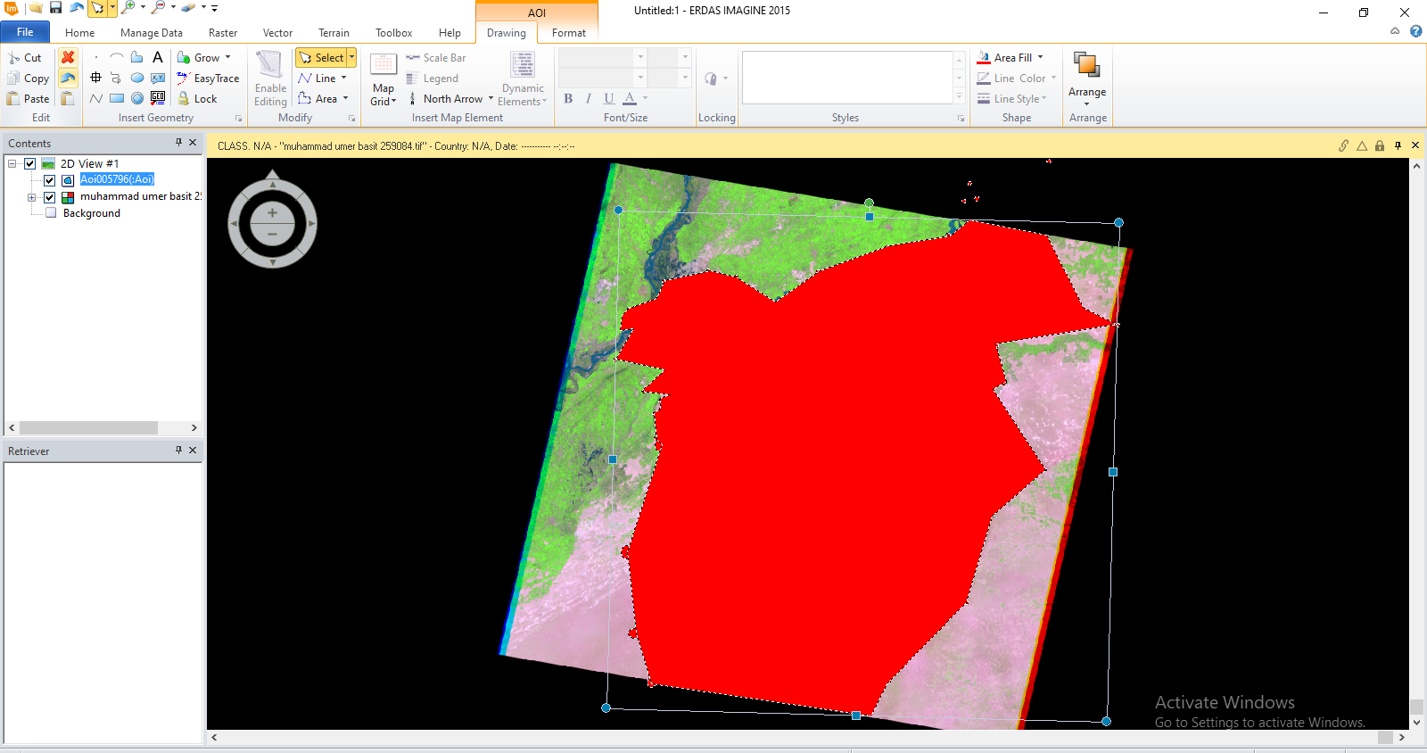

SAVING AOI FILE
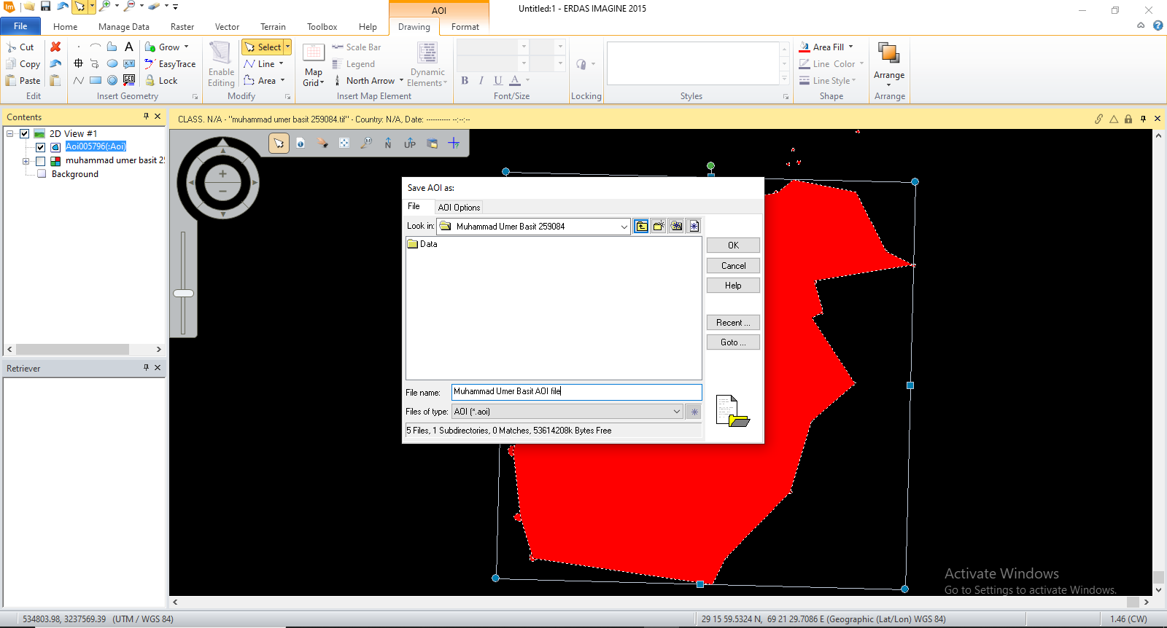

CLIPPING FILE
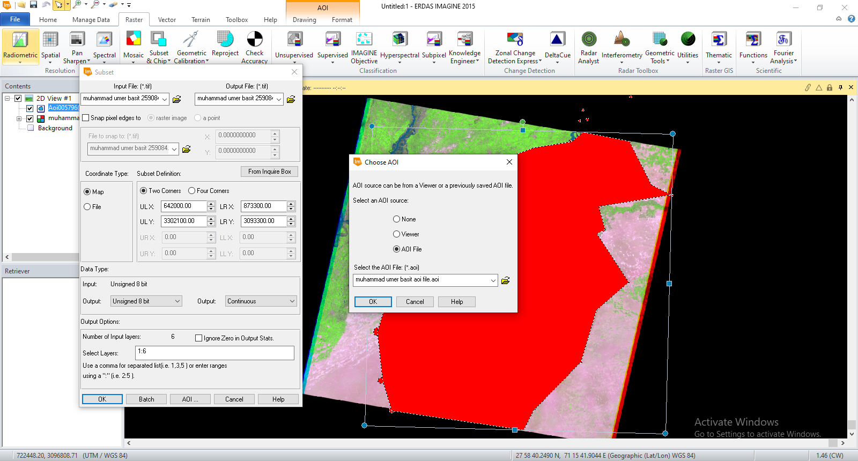

CLIPPING PROCESSING
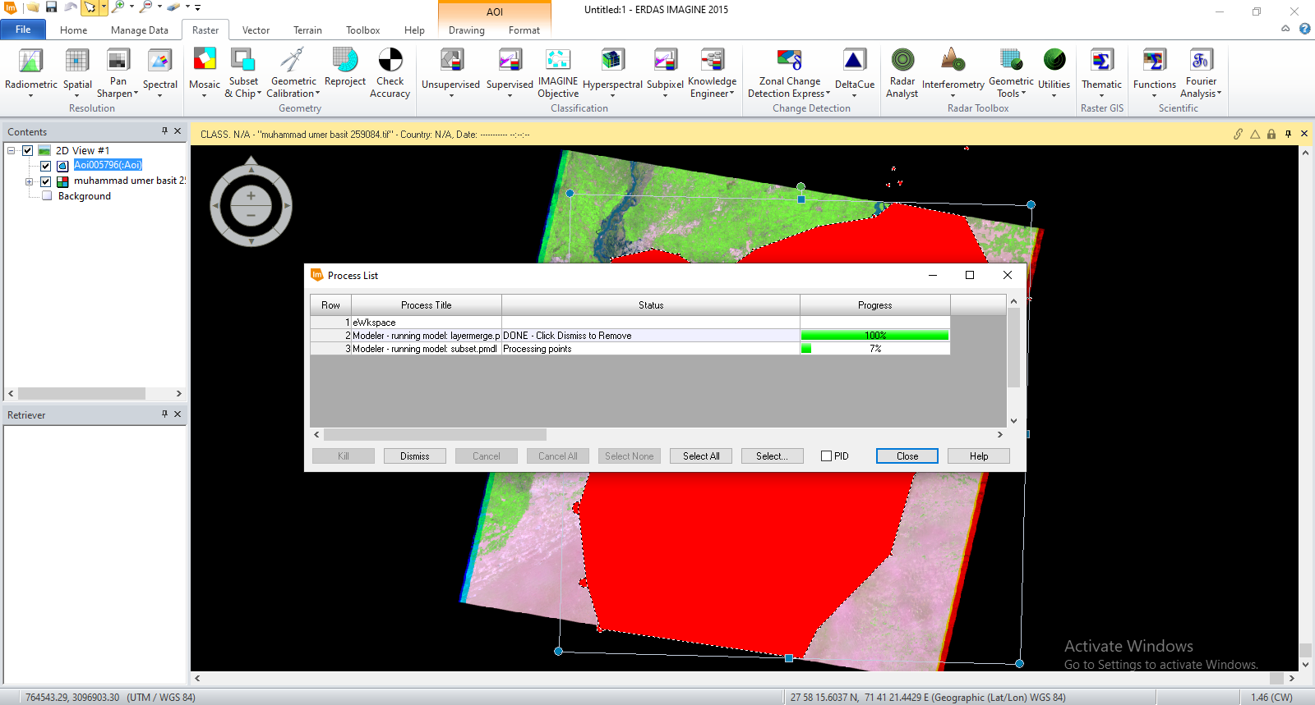

CLIPPED FILE PREVIEW
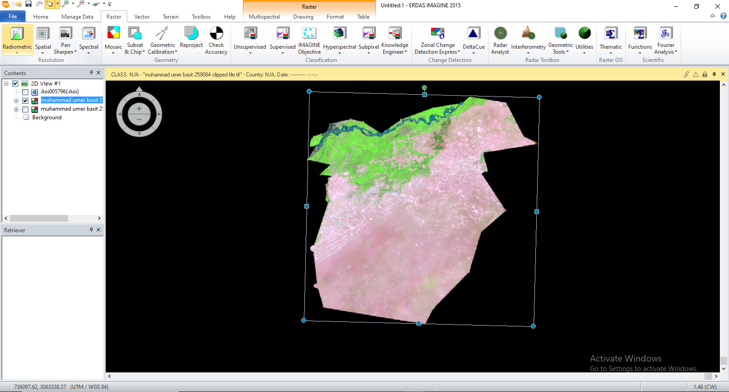

USING SIGNATURE EDITOR
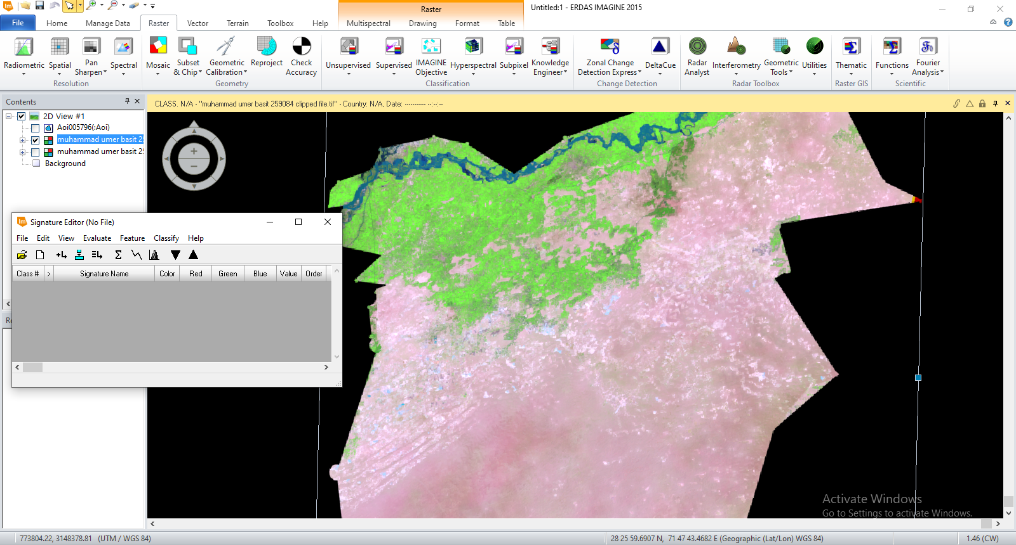

ADDING SIGNATURES
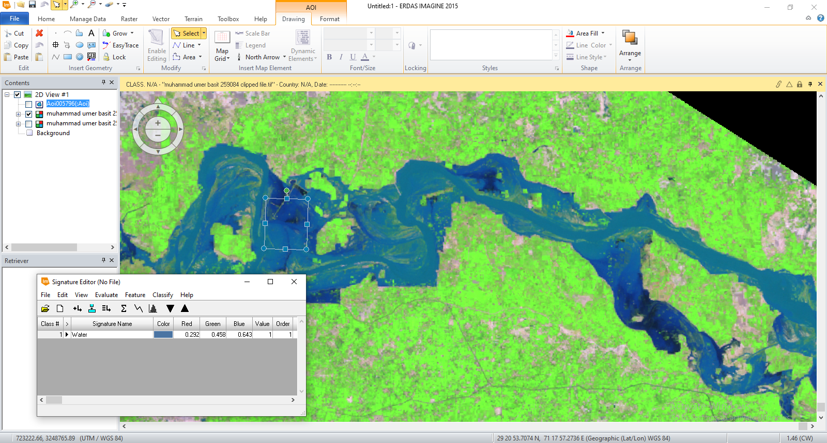

SELECTING WATER FROM SIGNATURE FROM VARIOUS LOCATIONS
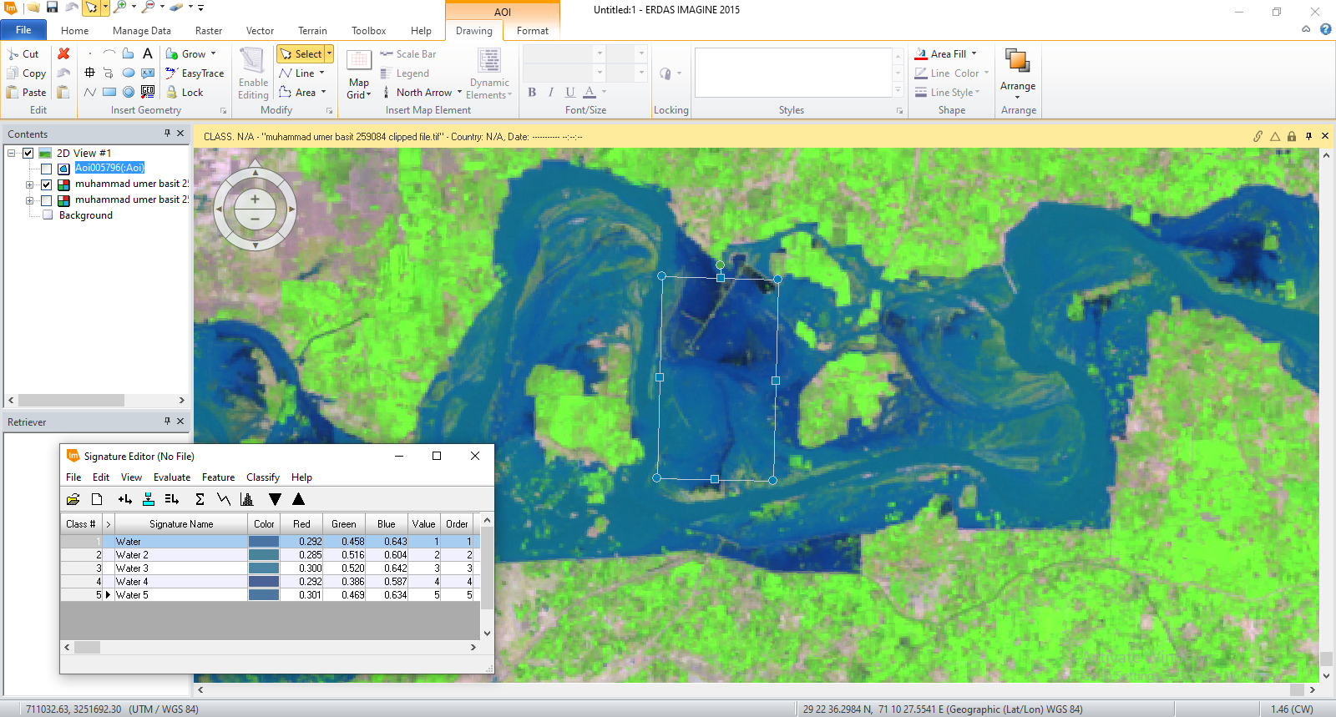

MERGING WATER LAYERS
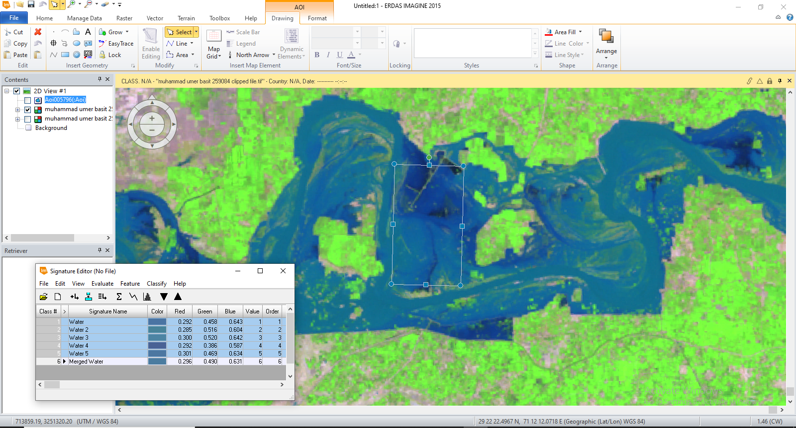

SIGNATURE FILE
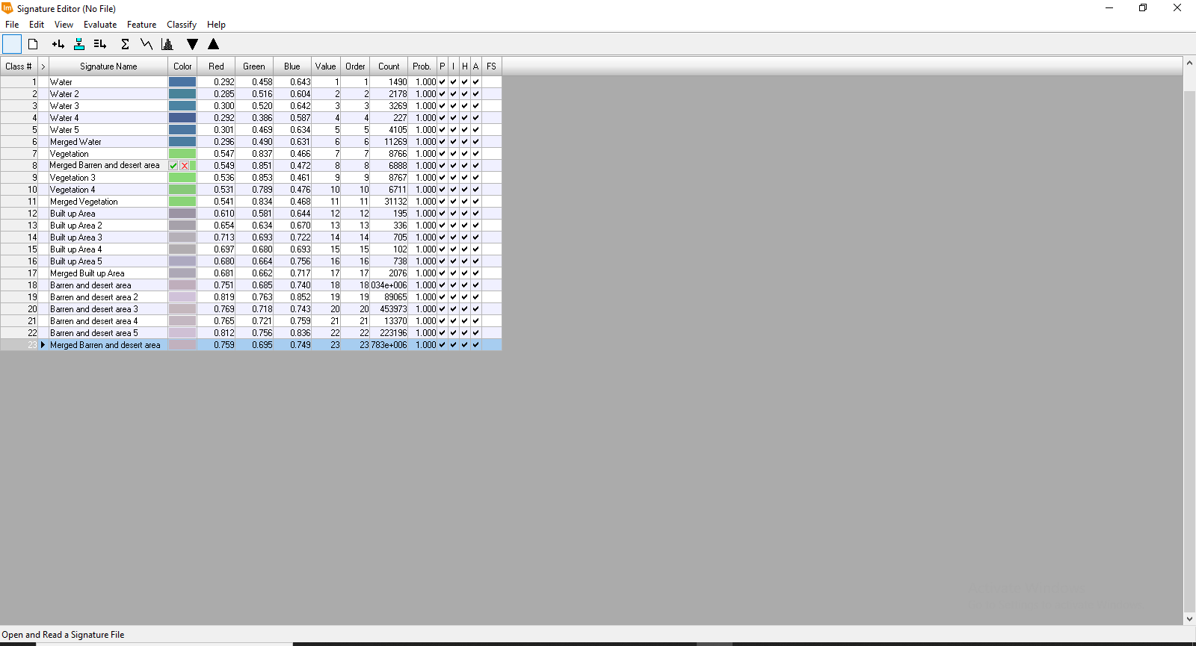

SAVING SIGNATURE FILE
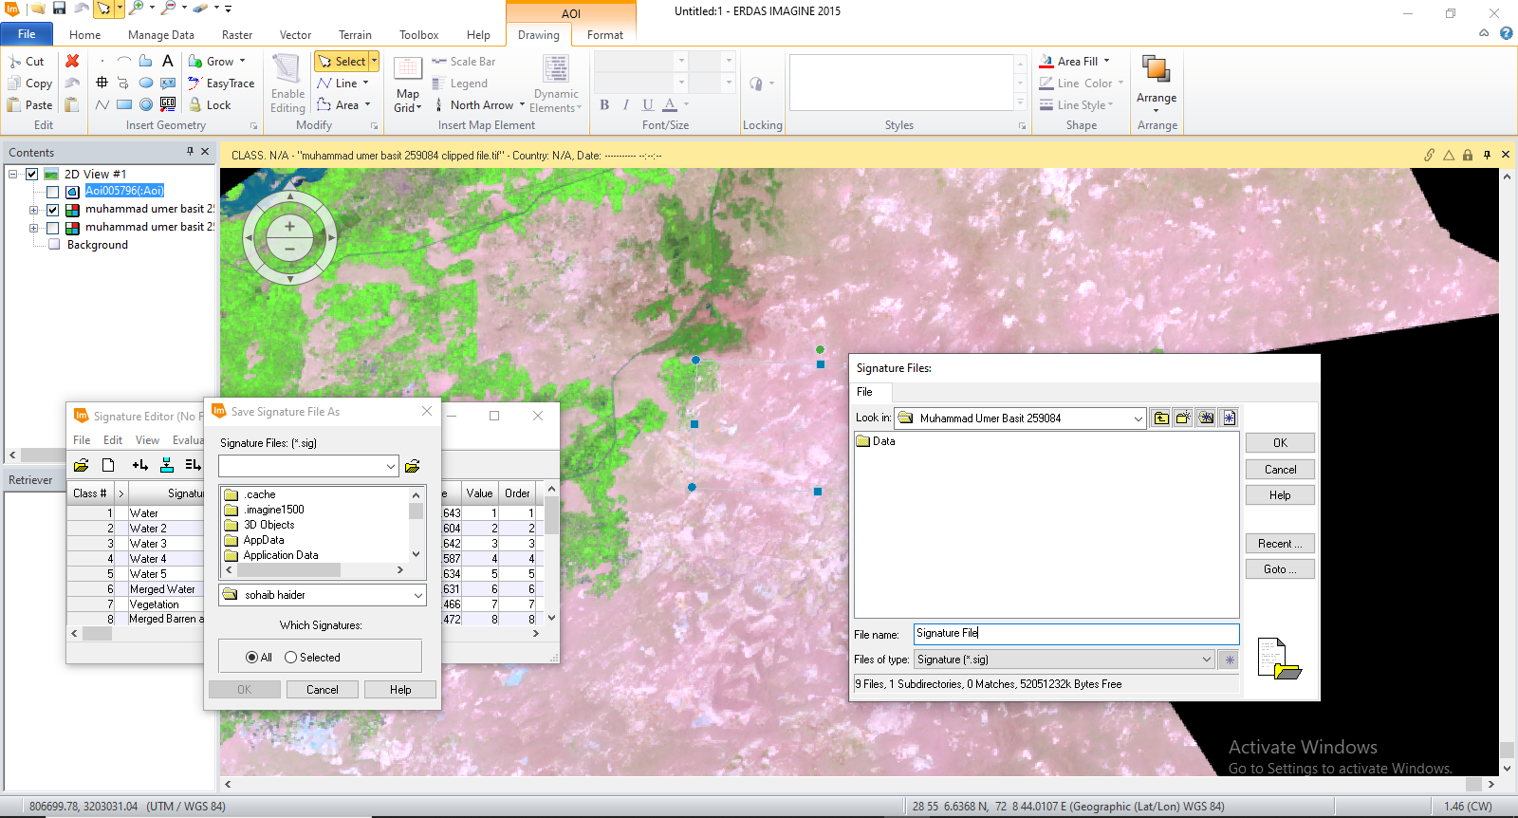

SUPERVISED CLASSIFICATION
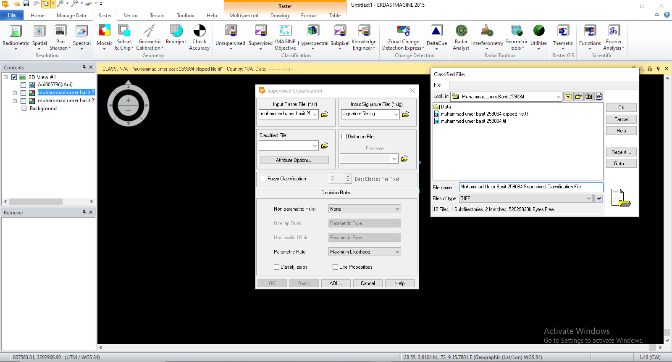

PROCESSING SUPERVISED CLASSIFICATION
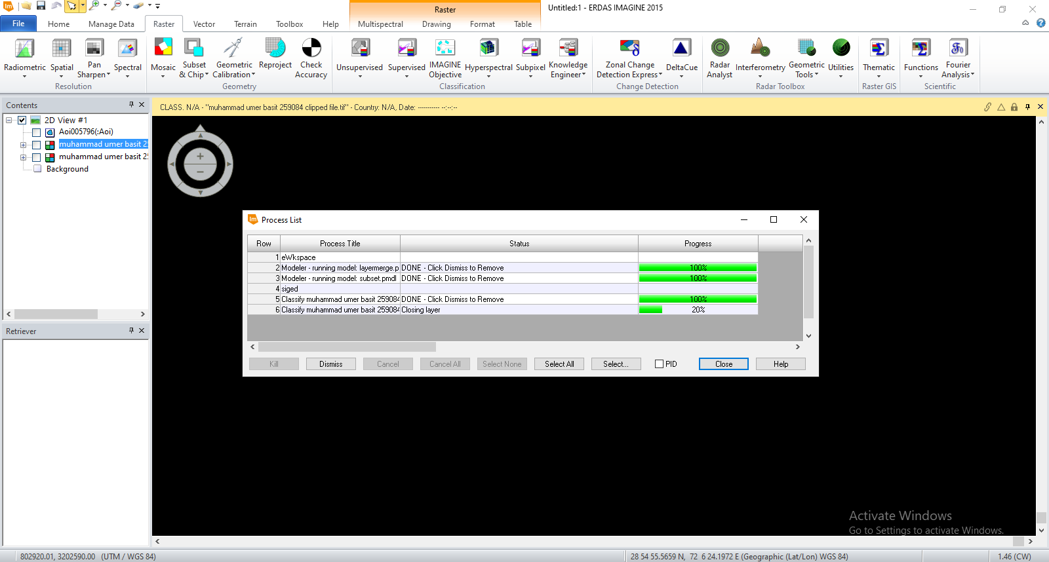

USED SIGNATURE
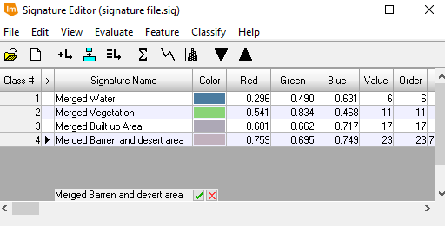

SUPERVISED CLASSIFIED PREVIEW
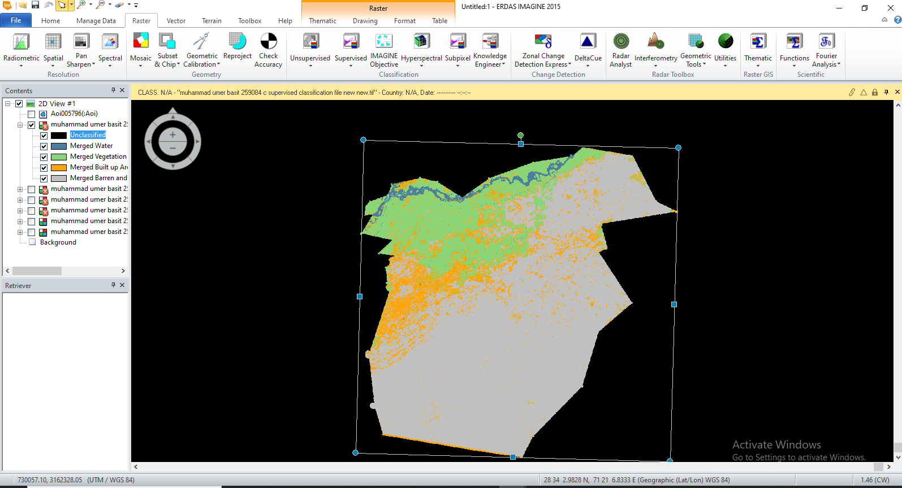

USING ACCURACY ASSESSMENT
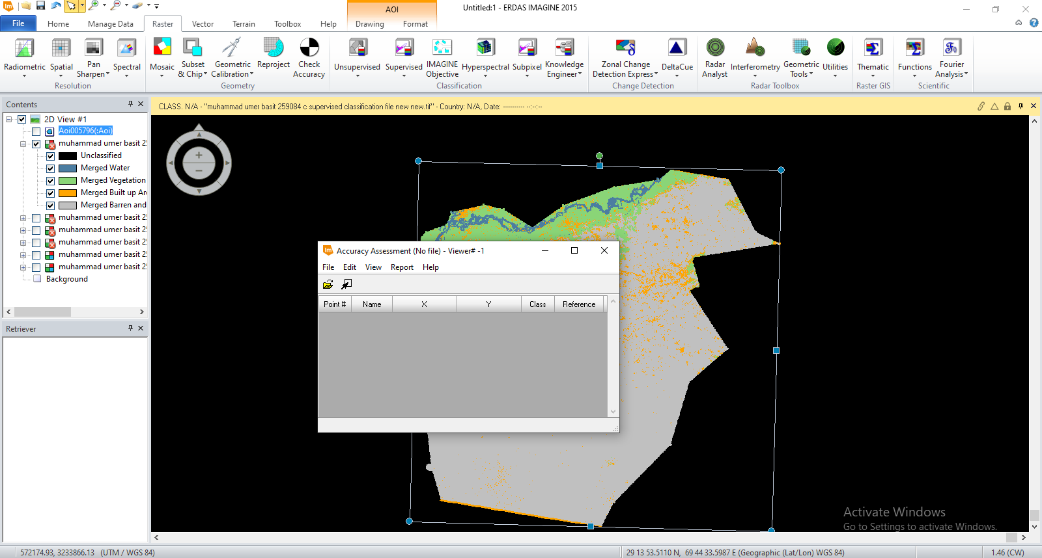

OPENING SECOND VIEW
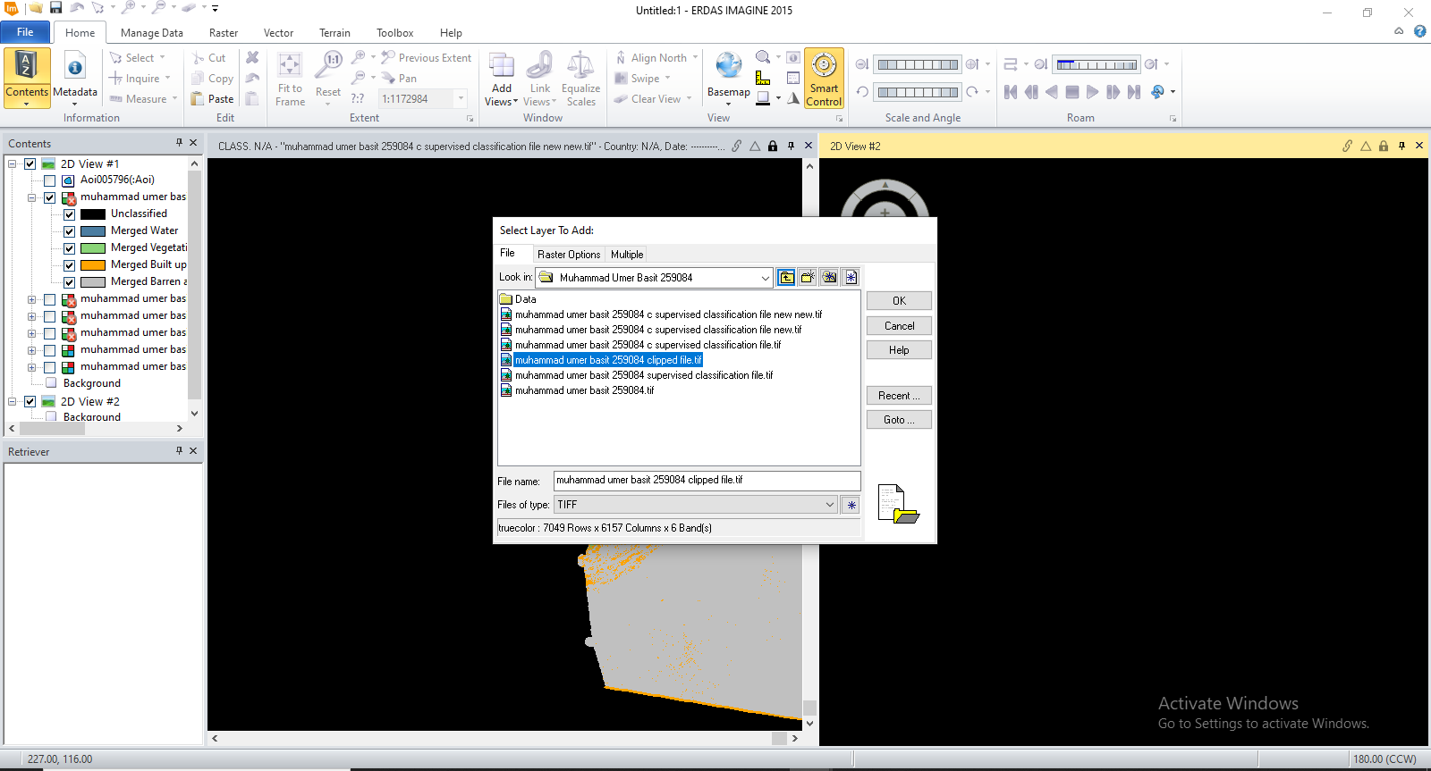

ADDING RANDOM POINTS
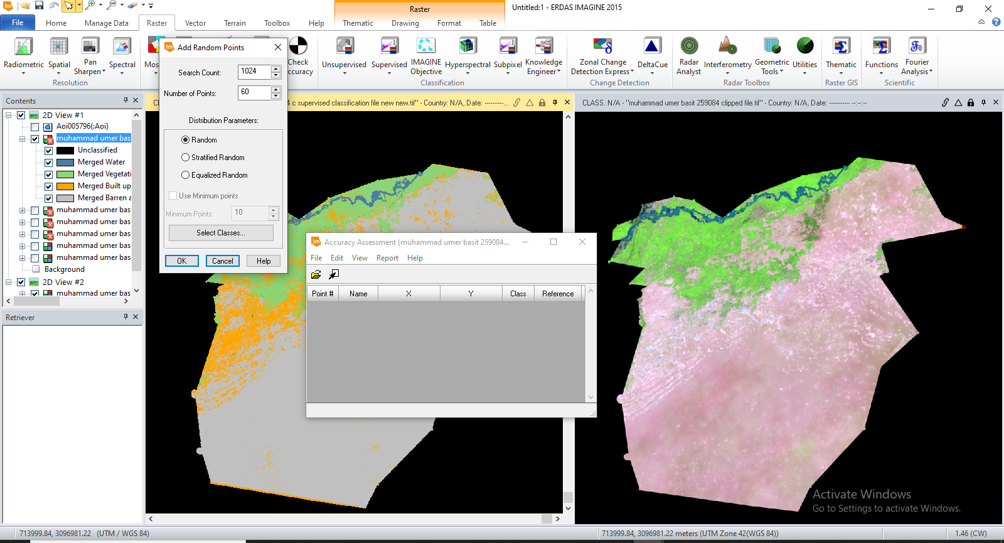

CREATED POINTS
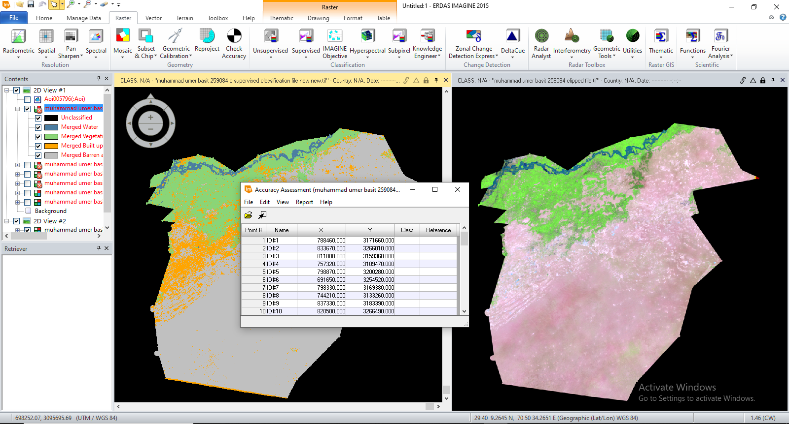

SHOWING CLASS VALUES
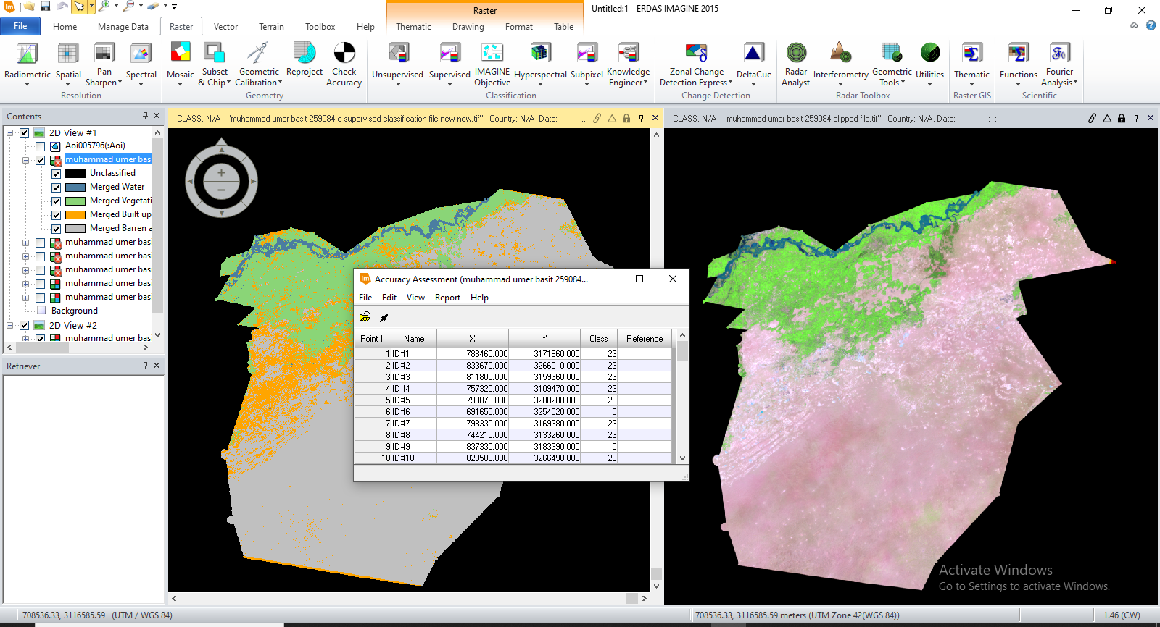

ATTRIBUTE DATA FOR CLASSIFIED FILE
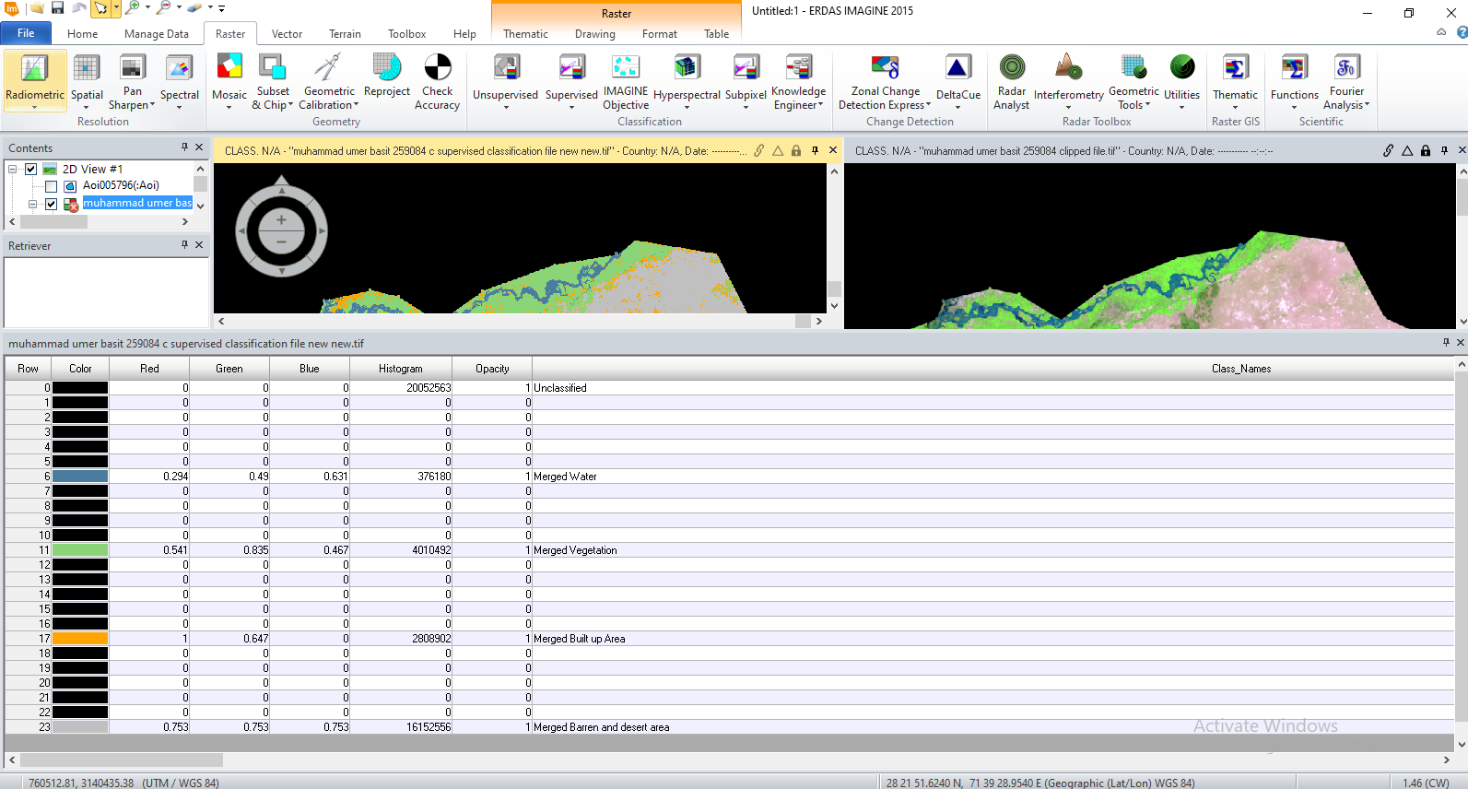

SELECTING VIEWER
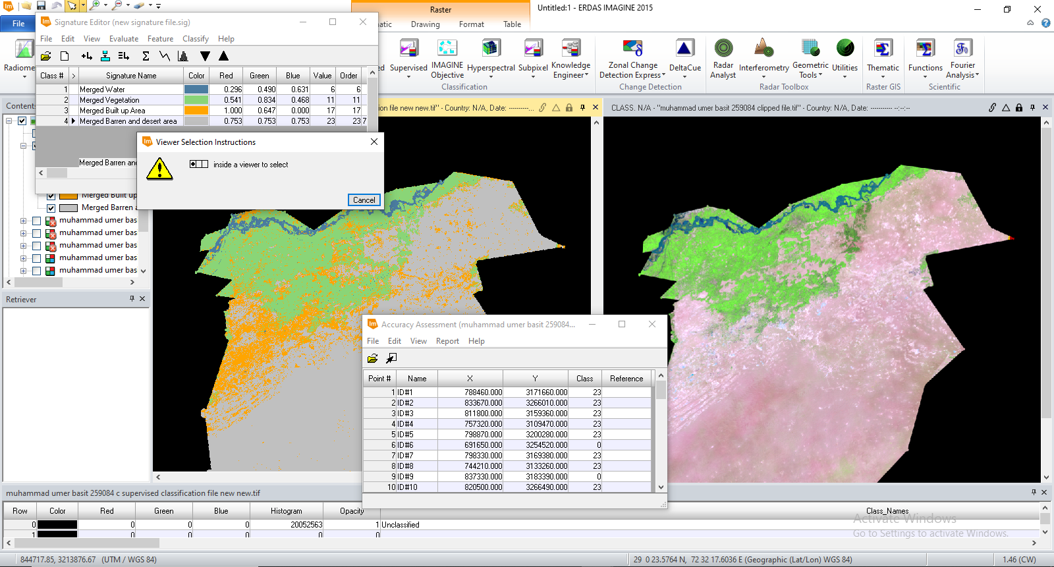

SHOWING ALL POINT FOR VIEW 02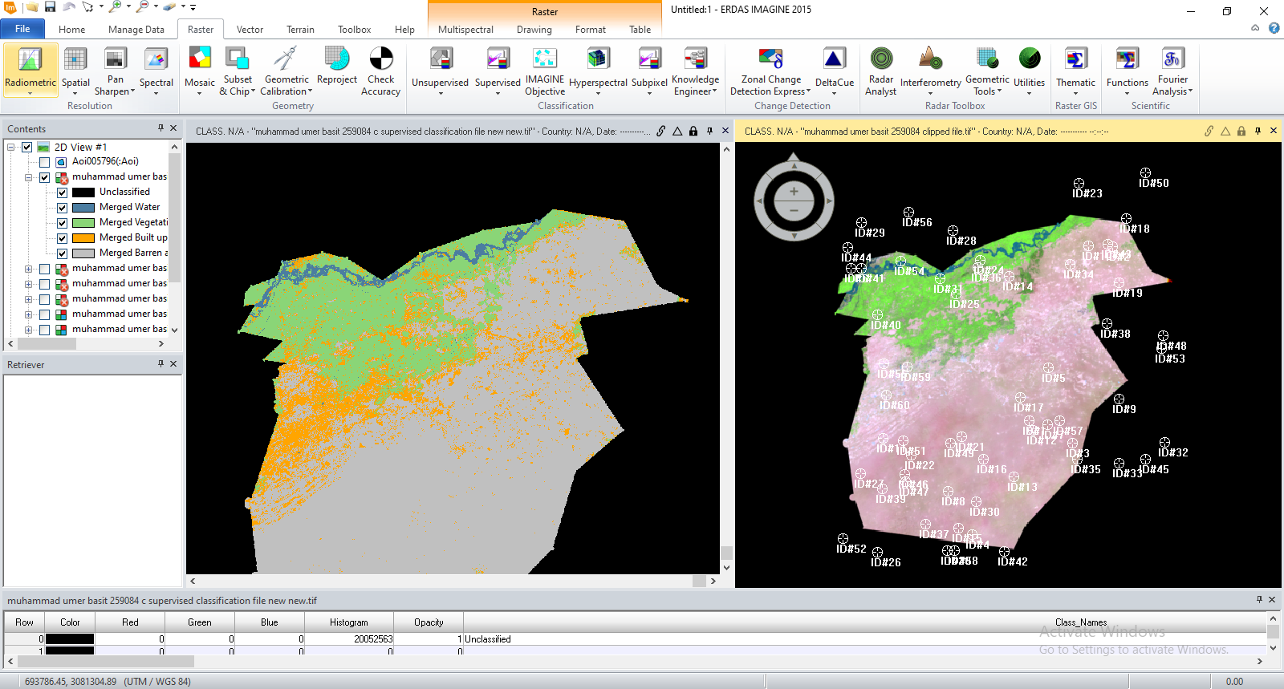

SIMILARLY SHOWING POINTS FOR VIEW 01
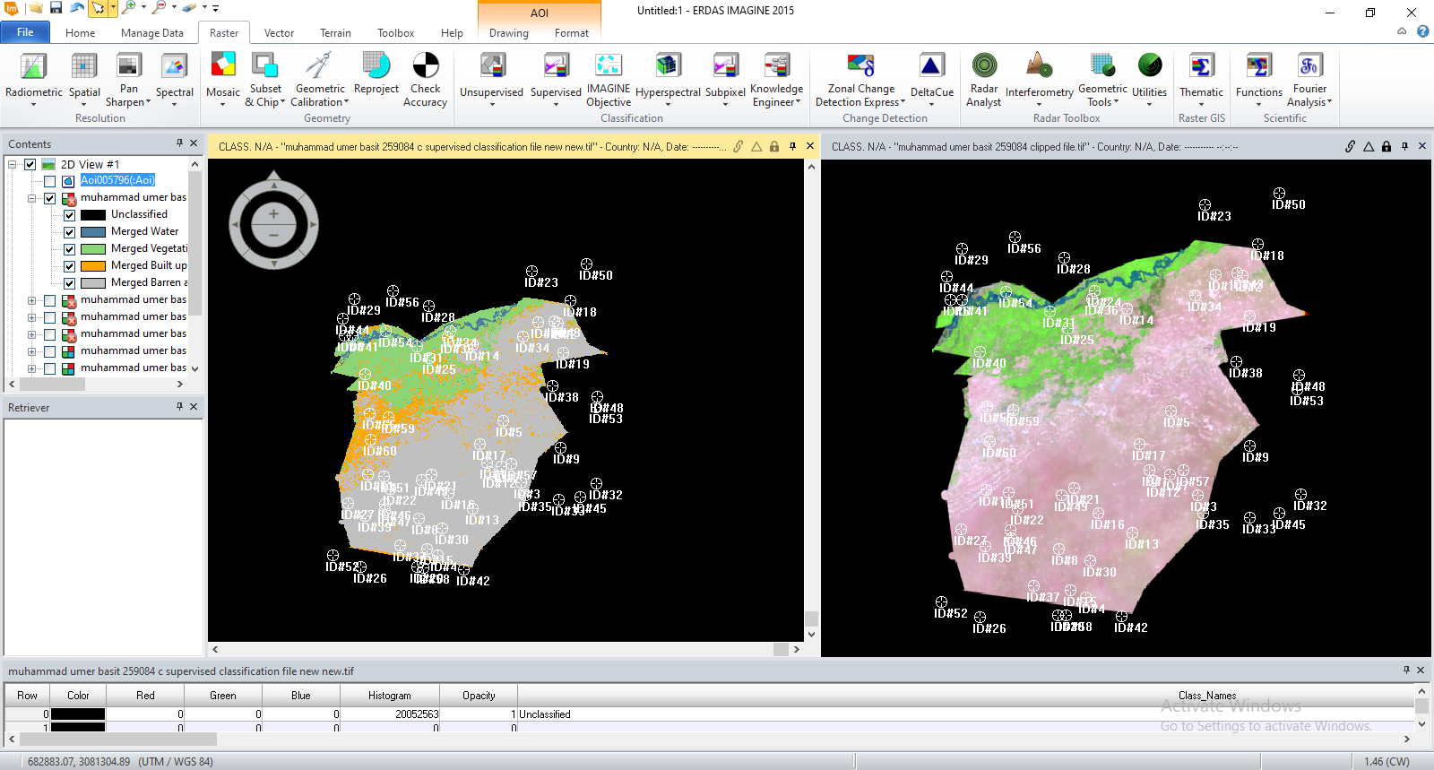

SELECTING CLASS OF ZERO VALUES
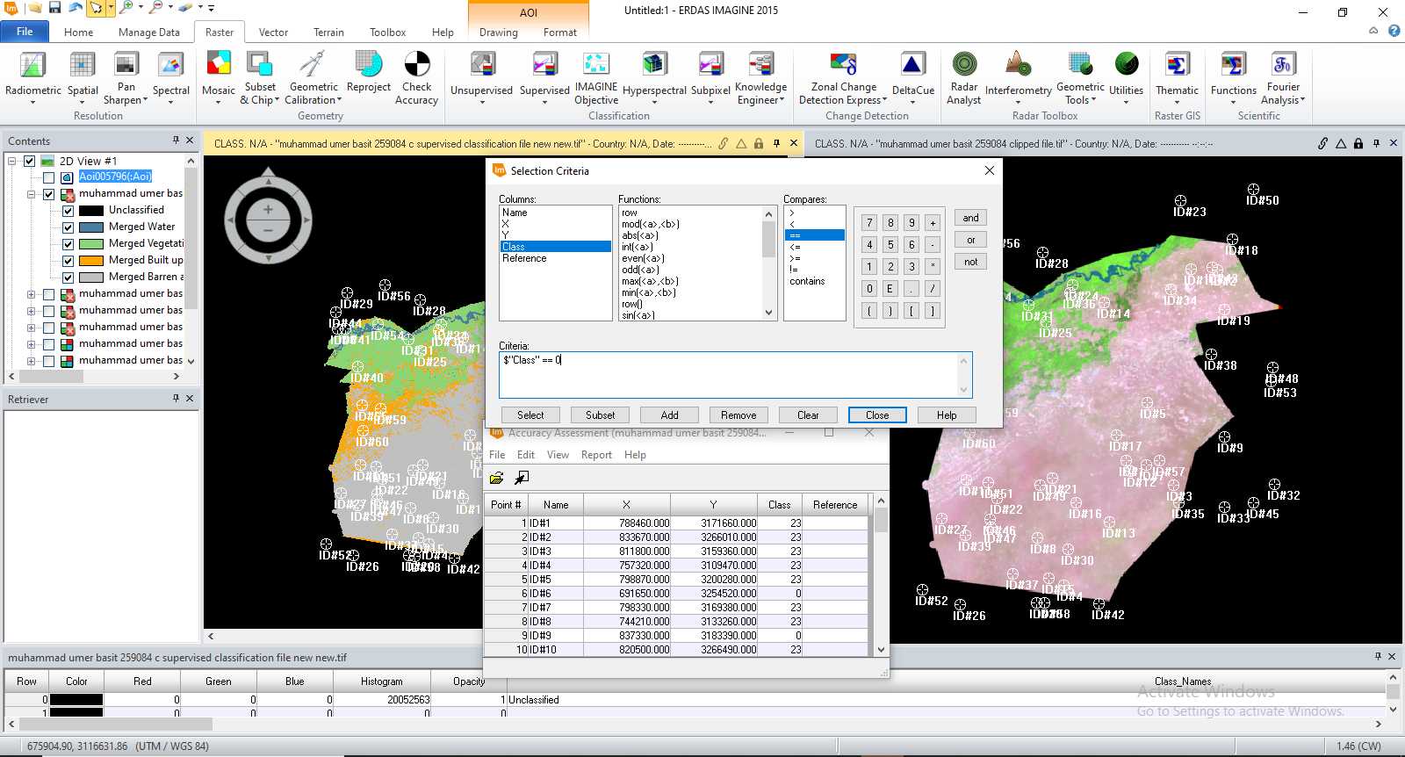

SELECTED CLASSES
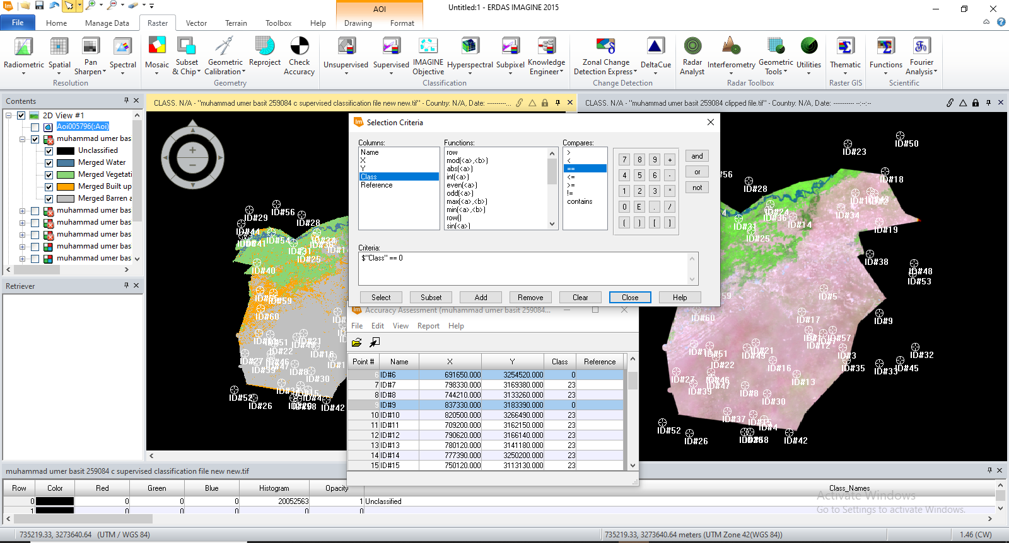

ACCURACY ASSESSMENT WINDOW
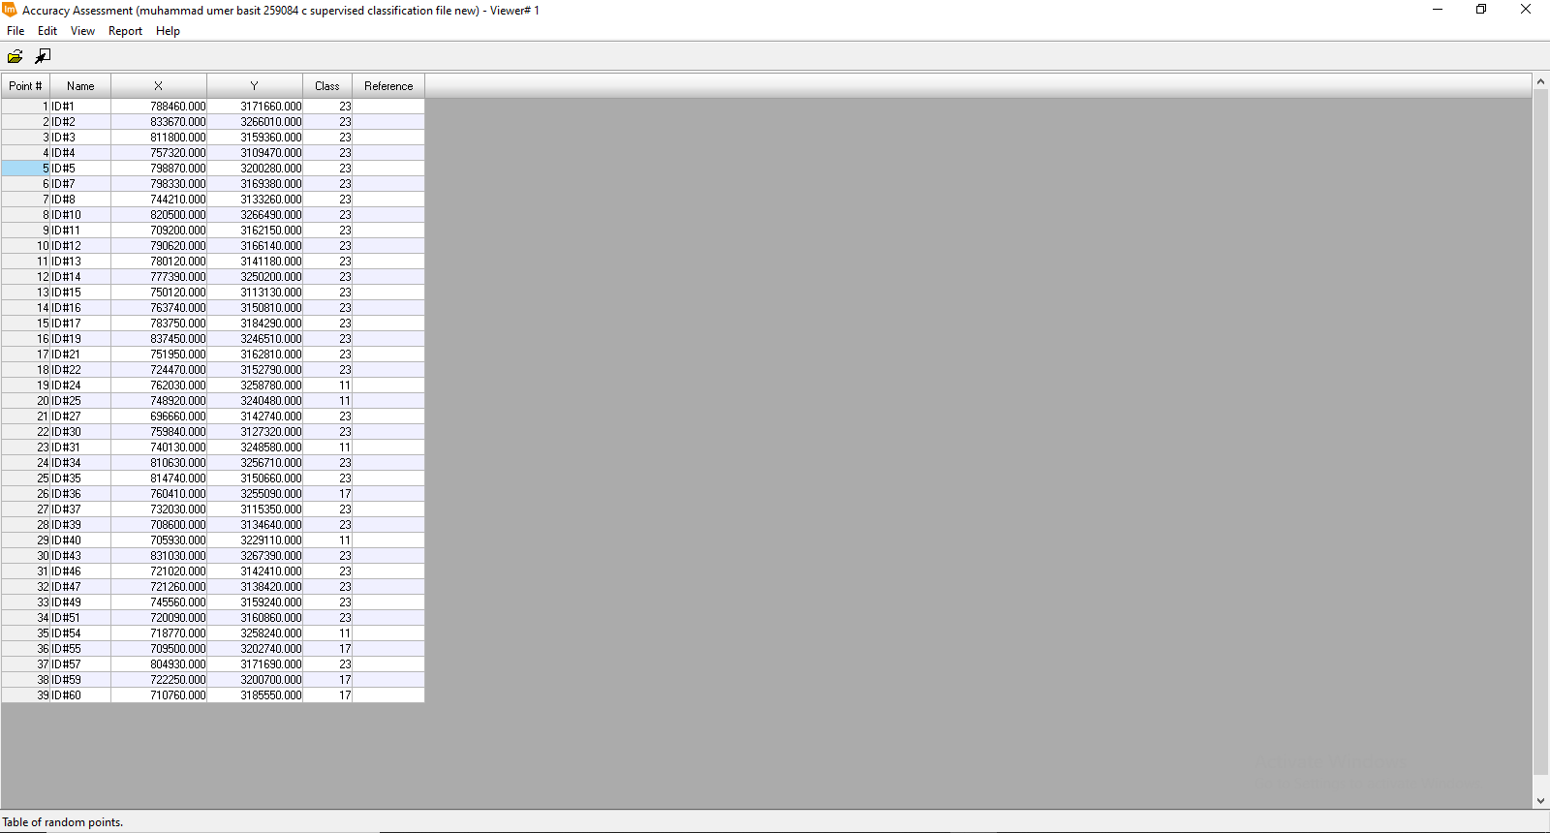

REFERENCING POINTS FROM VIEW 01
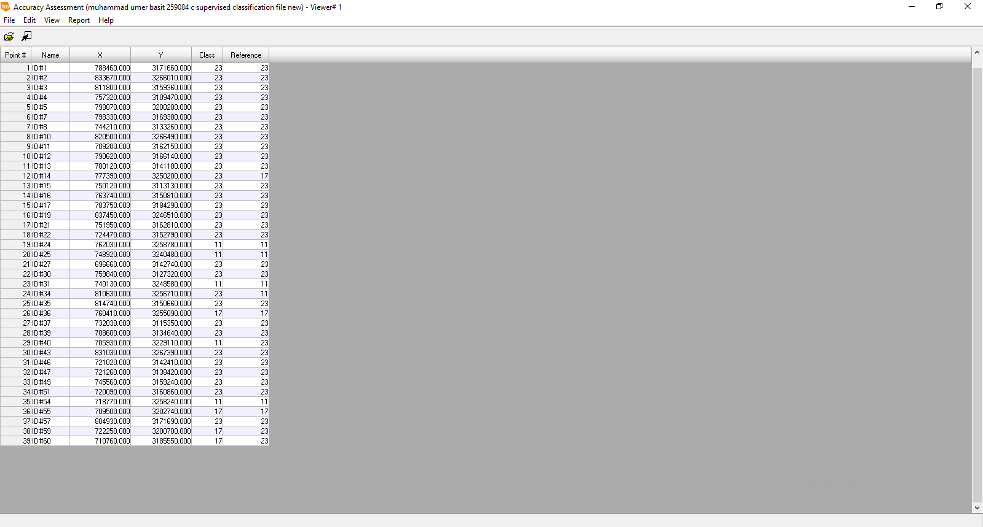
REFERENCING
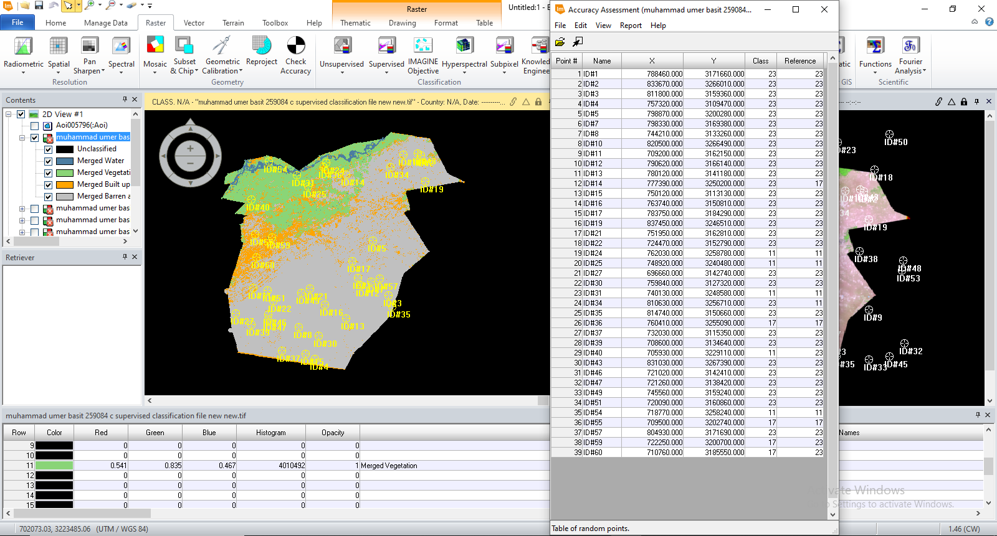

ACCURACY OF 87.18: SUPERVISED POST-CLASSIFICATION RESULT
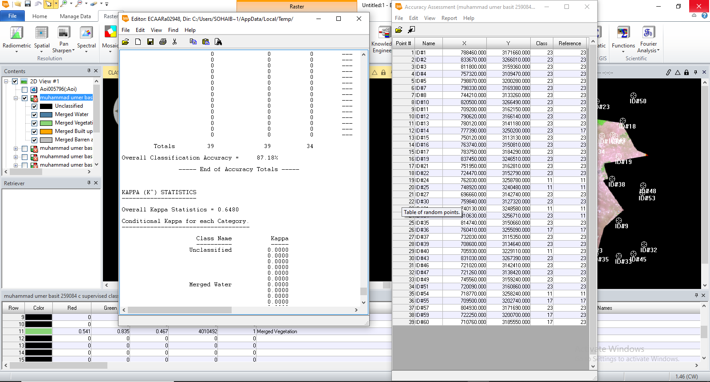
Conclusion:
Following the successful classification of data from the district of Bahawalpur using supervised classification, an accuracy assessment was conducted, yielding an accuracy of 87.18 %. Several signatures of a same class were collected from several sites and then merged, which improved classification accuracy. The machine learning model's accuracy may be improved even further by increasing the training signatures. Landsat 4-5 data is taken, with cloud cover ranging from 0% to 20% and path 150 and row 40, and then clipped into the shape of the Bahawalpur district using a polygon with coordinates extracted from Google Maps of year 1995. The data is divided into four categories: water, barren and desert areas, built-up areas, and vegetation. Raster's accuracy assessment is used to determine the data's accuracy. Unsupervised classification did not classify data correctly, and accuracy was too low, thus the procedure was abandoned.
Areas of different layers in sq. miles are as follows:
Layer | Area (sq. miles)
Water | 130.72
Vegetation | 1393.61
Built up Area | 976.071
Barren and Desert Area | 5612.88
Total Area | 8113.281

