Muhammad Umer Basit
Registration No 259084
Section C
LAB 03
Task 01
(a)

Function of Union and Intersection in the layer stacking window
The function of union and intersection can be best explained with the help of below diagrams:
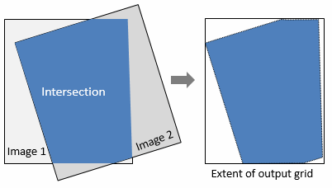
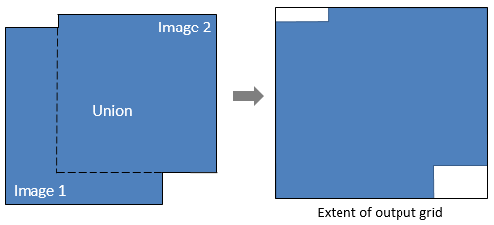

Adding layer using Union

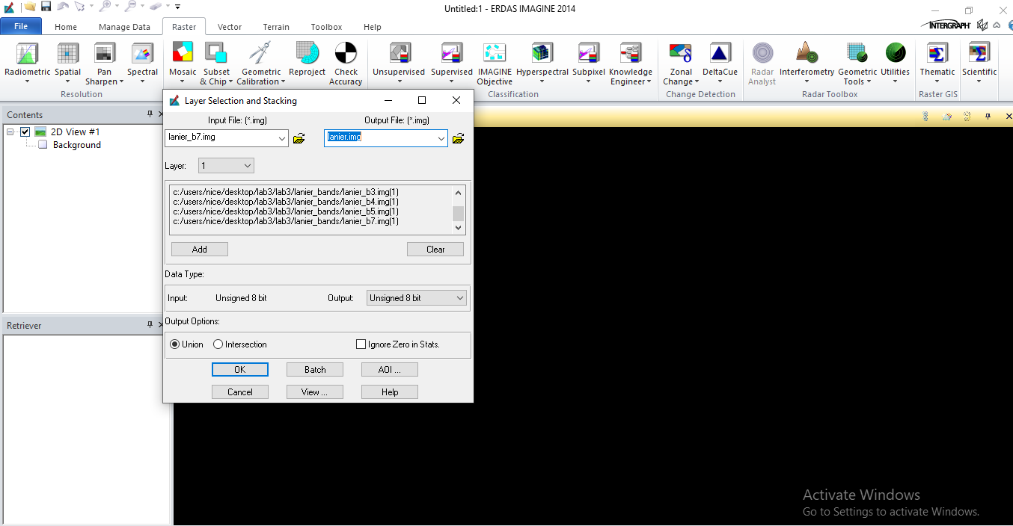
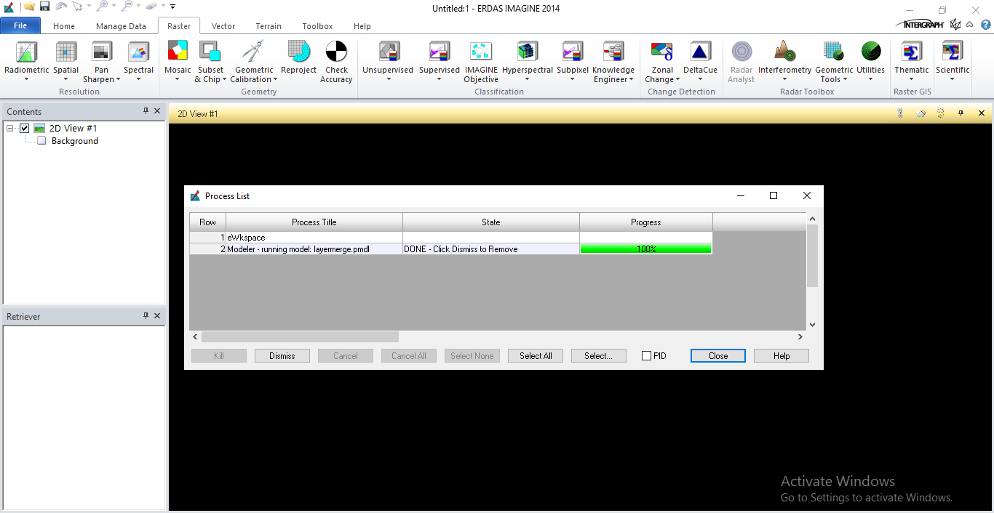

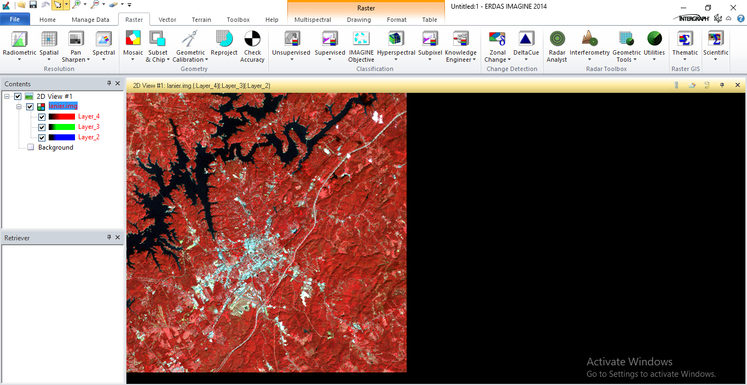

Adding layer using Intersection

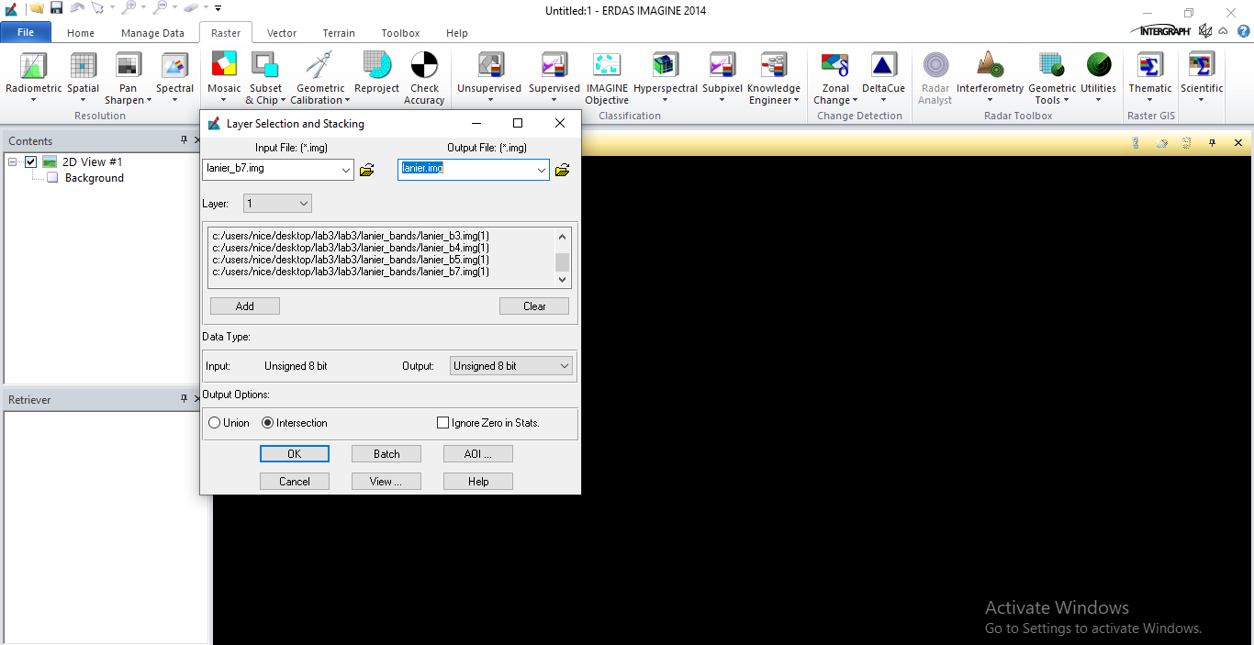
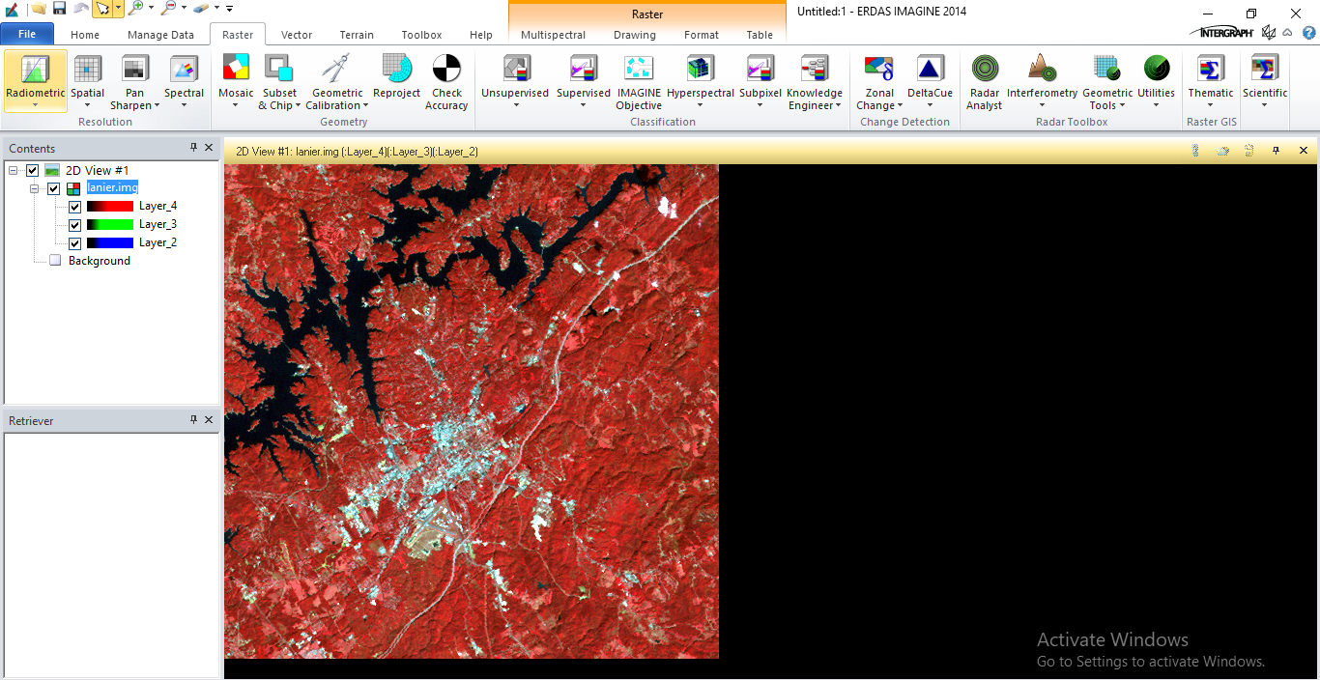

(b)

2 random inquiry readings
Sr.No. | X | Y | Band 1 | Band 2 | Band 3 | Band 4 | Band 5 | Band 6 | Band 7
1 | 241575.00 | 3798580.00 | 76.000 | 29.000 | 34.000 | 62.000 | 63.000 | 136.000 | 27.000
2 | 239565.00 | 3800380.00 | 71.000 | 25.000 | 28.000 | 47.000 | 60.000 | 134.000 | 24.000
(c)
LUT

Indicates what number is to be substituted for each pixel value after applied to the image (processing)
Straight line LUT does not change the image (shows the substituted number is the same as the original value)
For the display characteristic to change, the LUT needs to substitute numbers that are different than the original values
Shape of the curve is similar to a characteristic curve
Histogram
Takes the image data from sampling and a histogram is generated
System finds the useful signal by locating the minimum and maximum signal within the anatomic regions of interest on the image
All intensities of the signal are then plotted on the histogram
Shows the distribution of pixel values for any given exposure

(d)
Adding one more layer in the stacked image

TASK 02
EXPLORING MEASUREMENT TOOL
Polyline
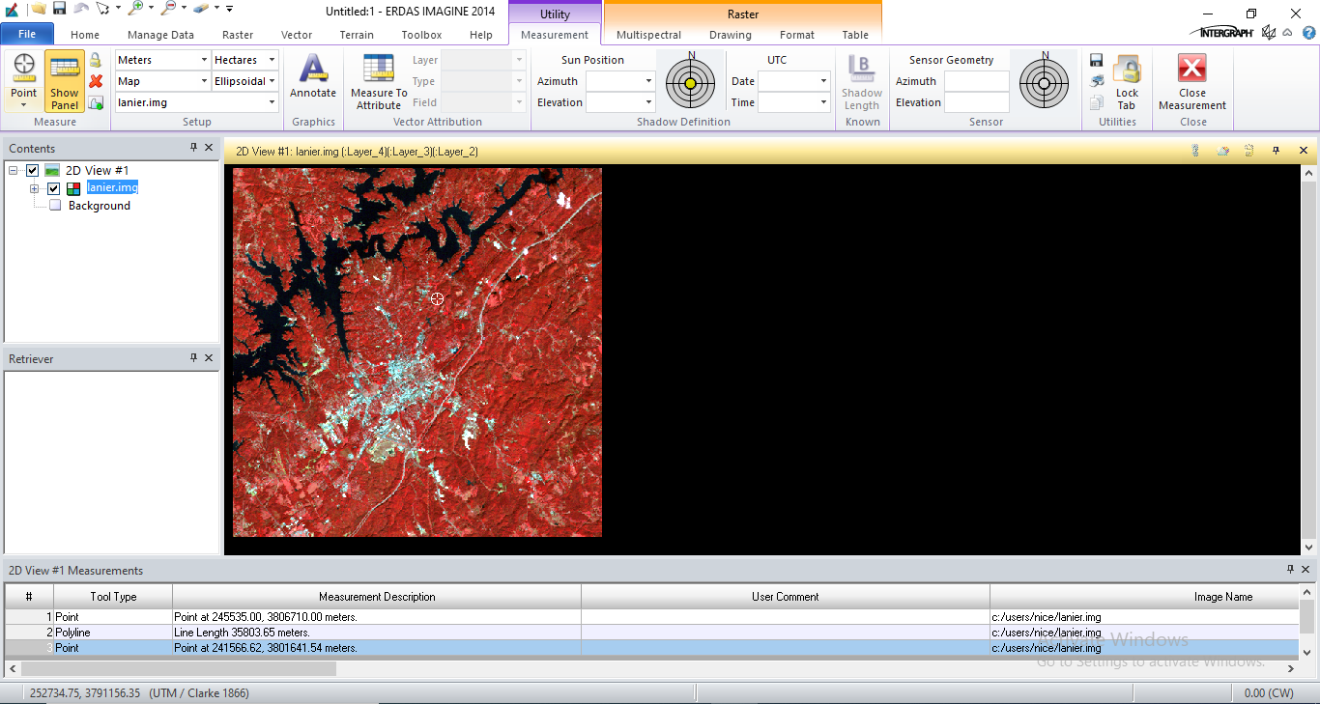
Polygon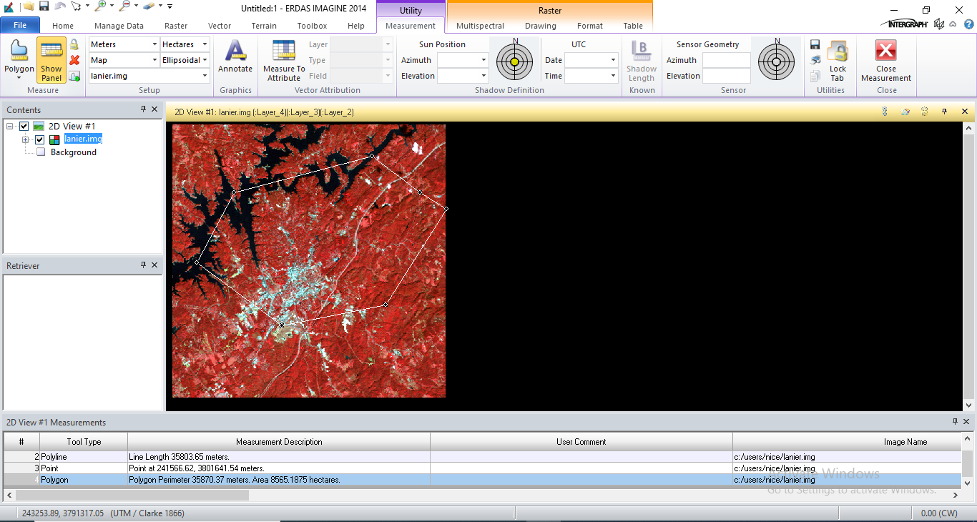
Grow Region
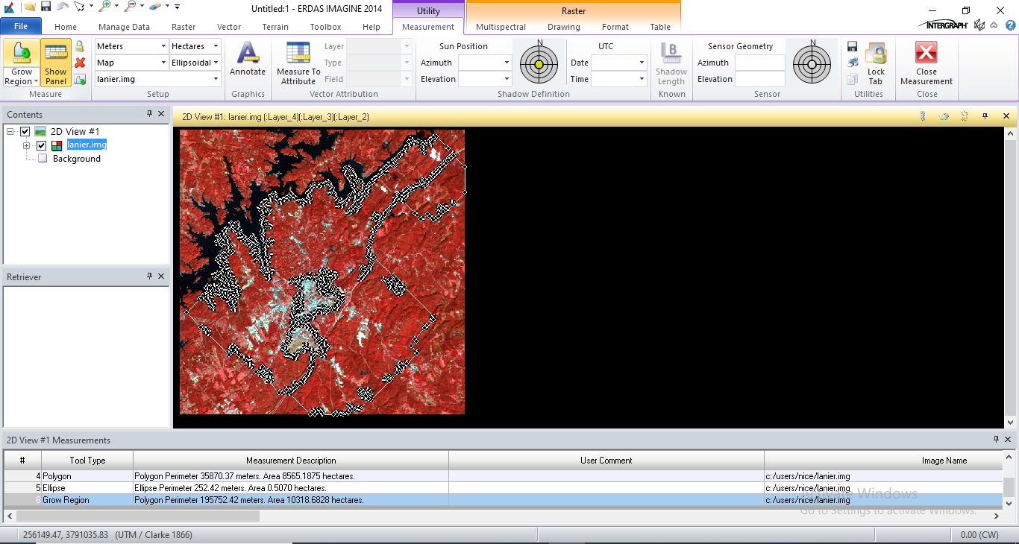
Rectangle
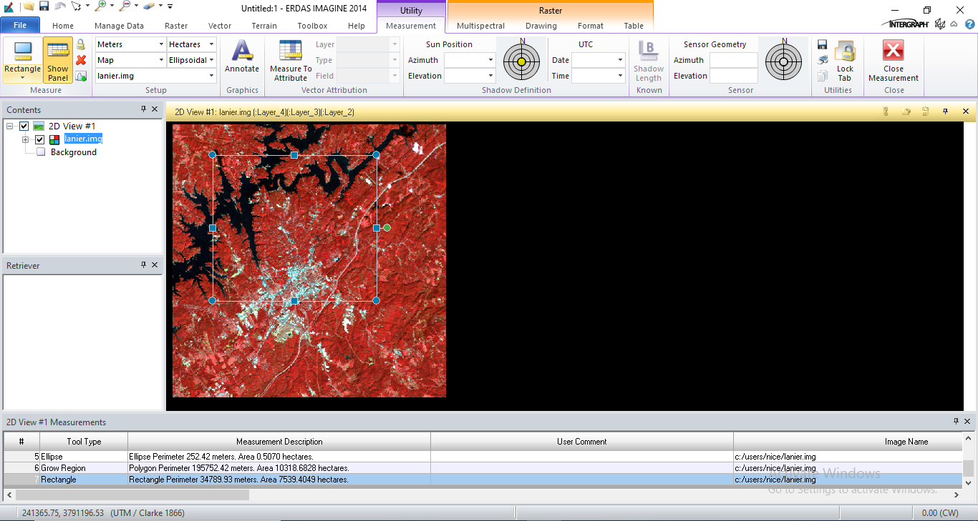

Ellipse
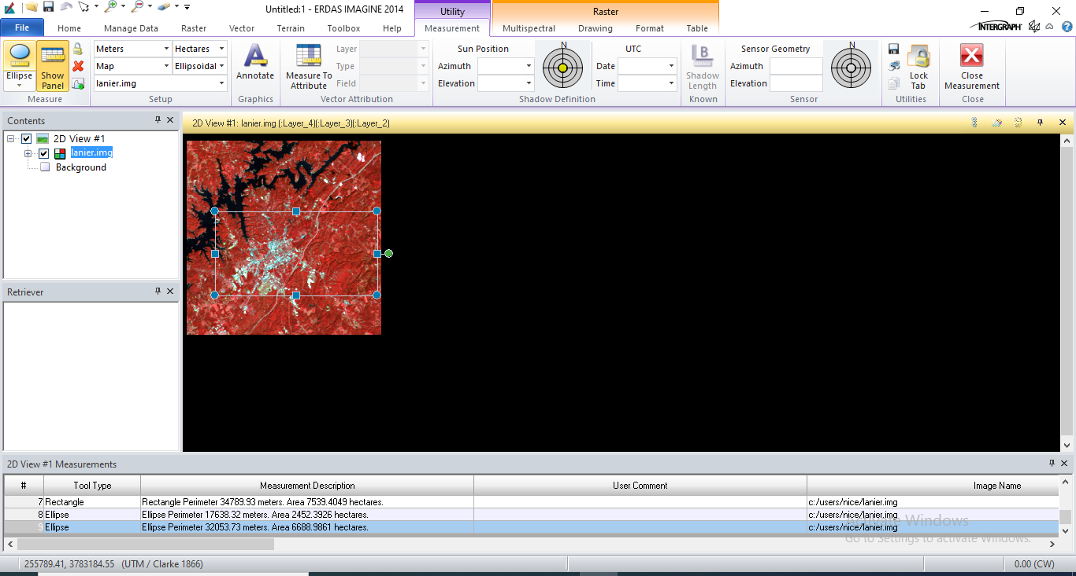

Cylinder

