Muhammad Umer Basit
Registration No 259084
Section C
LAB 04
Original File
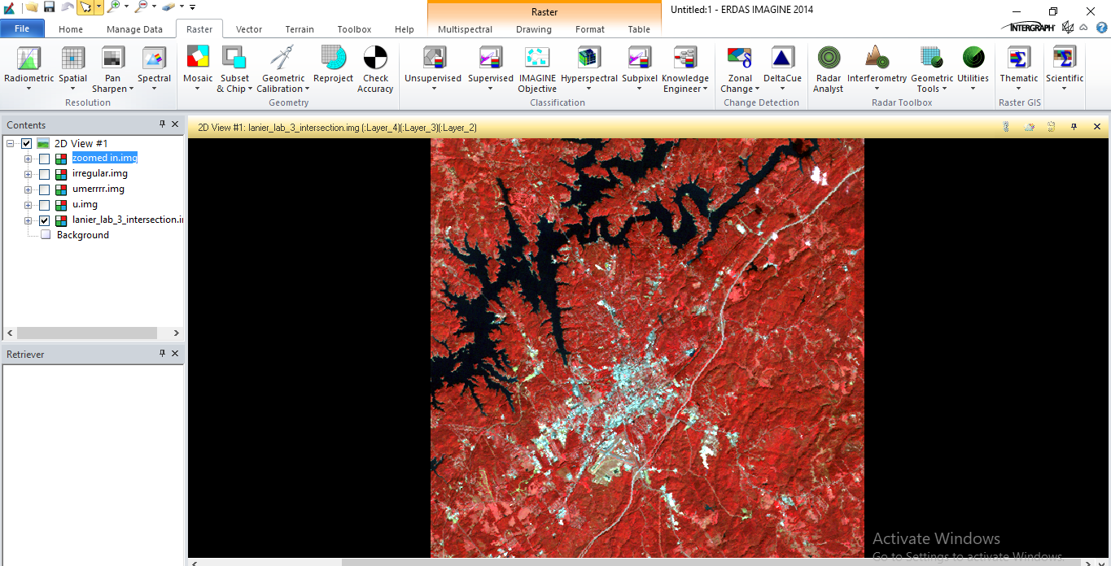

TASK 01
Clipping Area of Interest using extent
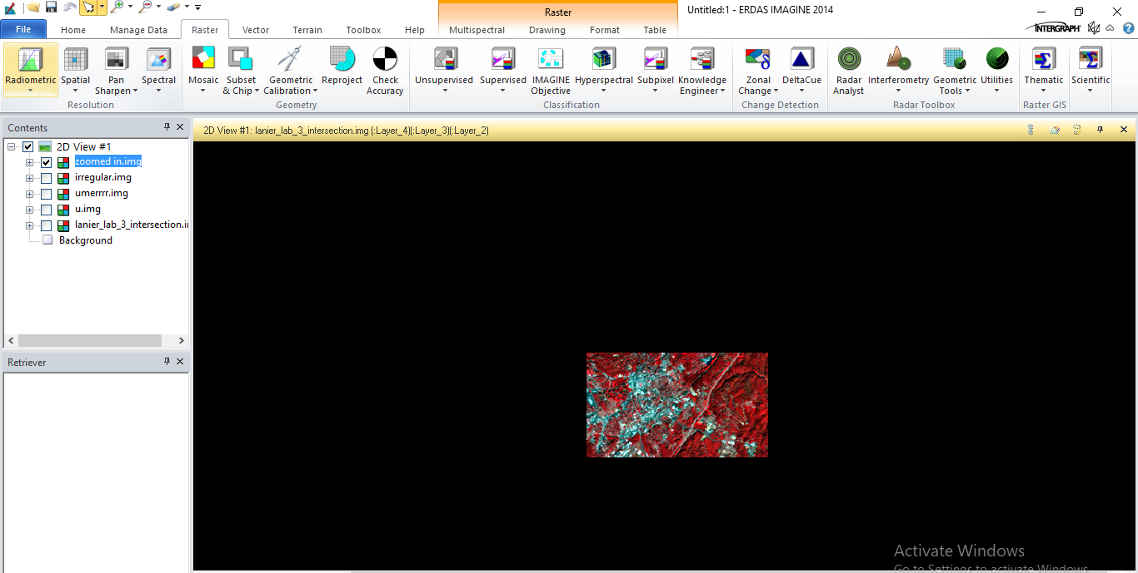

TASK 02
Clipping Area of Interest using Shapefiles
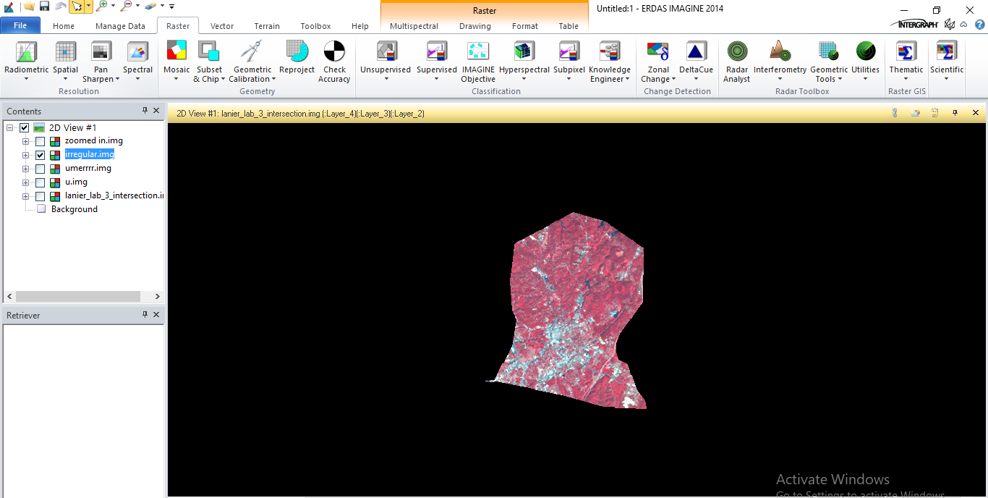
Cropping using shapefile R
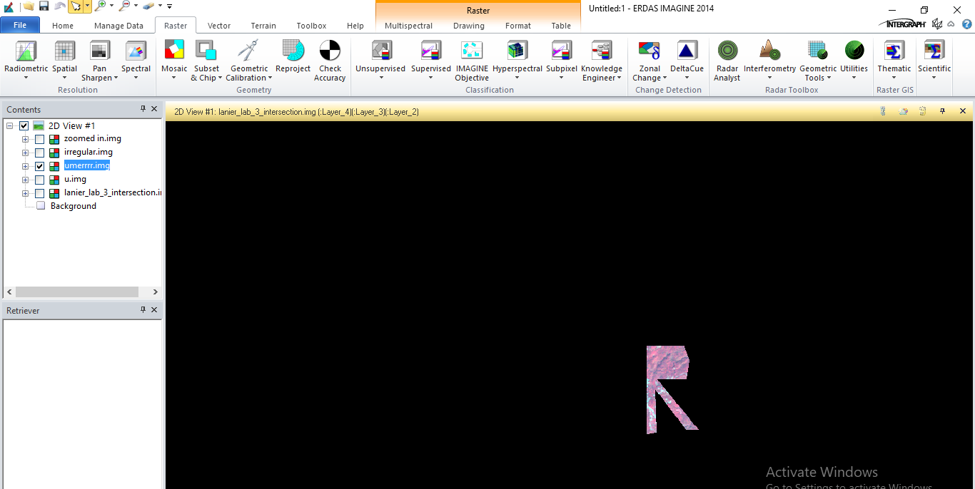
Cropping using shapefile U
