
NUST INSTITUTE OF CIVIL ENGINEERING (NICE), SECTOR H-12, ISLAMABAD
CE-411 Steel Structures, Group-2

COMPLEX ENGINEERING PROBLEM
Factory for production and storage of polythene
1.Client’s Requirements
A multi-national polythene manufacturer requires a large, 200 ft. (60m) square, single-storey factory, on a green field site. The client’s Architect has stipulated that one central column only is to be allowed in the factory, which is clad with profiled steel sheet sandwich panels (50% roof lighting, no windows in the sides of the factory). Apart from small personnel doors, the figure also shows the requirement for one large sliding door opening, 16 ft. (5m) high, and a minimum clearance inside the building of 20ft. (6m) Only the major structural members are offered as calculation in this example, and only selected important connections are designed. Also, several checks normally included in a full design, such as secondary bending and local buckling of the truss member walls, have been omitted
Roof loading (offices and factory) – 0.75 kN/m2
Factory roof services - 0.65 kN/m2
Loading – wind load
Basic wind speed 46m/sec (outskirts of a town- level site)
Soil safe bearing capacity
Stiff clay, safe bearing 250 kN/m2
Design Aids
The roof purlins can be taken from manufacturers design tables
Prepare a design appraisal with appropriate sketches indicating a viable solution for the proposed structure including the foundations. Indicate clearly the functional framing, load transfer, serviceability, and stability aspects. Review and critically appraise the proposed scheme.
• A technical note narrating the client requirement and how these will be addressed
• Concept Sketches showing functional framing, load transfer, stability of the structure
• A statement about the proposed scheme and its advantages and disadvantages
For the proposed scheme, prepare sufficient design calculations to establish the form and size of all the structural elements including the foundations.
- Prepare design calculation for critical elements, i.e. the main load bearing slabs, beams, columns and foundation loads.
Prepare general arrangement drawings, which may include plans, section and elevations, to show the dimensions, layout and disposition of the structural elements.
• Prepare layout drawings, plans, sections and elevations

2.Initial thoughts
- Large span (200 ft * 200 ft) i.e serviceability would be affected.
- Single story structure which means reduced lateral load.
- Green field site i.e no construction was done before.
- Side panels are cladded showing increased lateral load.
- One large sliding door of 16 ft height and 20 ft wide.
- Roof loading (offices and factory) – 0.75 kN/m2
- Factory roof services - 0.65 kN/m2.
- Design of the building on SAP2000.

3.Assumptions
- The ground is levelled i.e. having no cut or fill.
- Access for all types of vehicles is adequate.
- Site has sufficient storage space.
- Existing buildings are far away.
- Ground conditions are constant across the site.
- Bracing is allowed on external elevations.
- Bracing is allowed on the roof.

4.Design code and references
We used the” AISC Steel construction manual fifteen edition” as our reference and selected our sections accordingly.
5.Scheme Design
5.1Introduction
The structure will have frames which would take the gravity load. For lateral load we have provided bracing in roof and sideways.

5.2 client requirements
- Client requires the steel design for a multi-national polythene manufacturer site, 200 ft.
- Only a single column at center of whole span is acceptable.
- There isn’t any requirement of windows apart from small personnel doors. There is a need of 16 ft. (5m) high & minimum clearance inside the building of 20ft. (6m) for a large sliding door.
5.3 Load combination:
1.4D.L.
1.2D.L+1.6L.L.
0.9D.L+1.0W
1.0L.L+1.0D.L

5.4 Scheme Options:
- Scheme 1 offers the design with a column at the center of the whole span which supports the truss which continues with whole span along the roof up to the parallel surrounding walls. It also has the vertical bracings to support the frames.
- Scheme 2 offers the whole spread framed trusses all over the roof & the walls. It has no column used in the middle. The continuous frames directly transfer the loads to the ground without any other structural member. We’ve used this scheme of connected frames.
- Scheme 3 uses columns in the walls, on which braced trusses rest which support the roof in both directions.

5.5 LOAD PATH
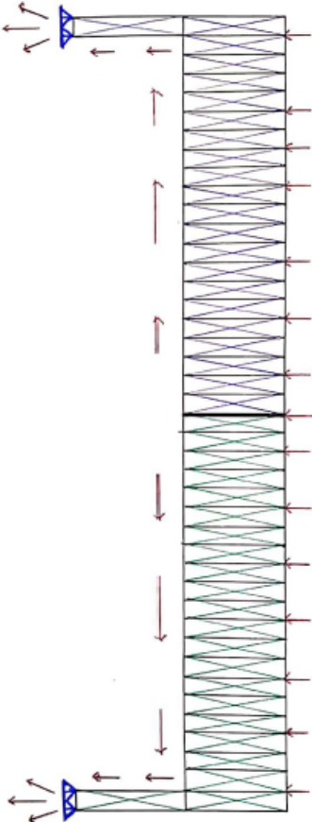
VERTICAL LOAD PATH

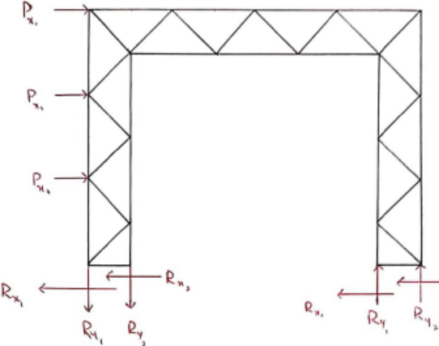
LATERAL LOAD PATH

5.6 Loads and Other Details
Vertical loads include the dead load and roof loading (super-imposed load) of 0.75 kN/m² & 0.65 kN/m² respectively and horizontal load is the only wind load. The load exerting wind blows at the speed of 46 m/s. The soil bearing capacity of the field is 250 kN/m² and soil type is stiff clay.

SCHEME DESIGN SKETCHES:
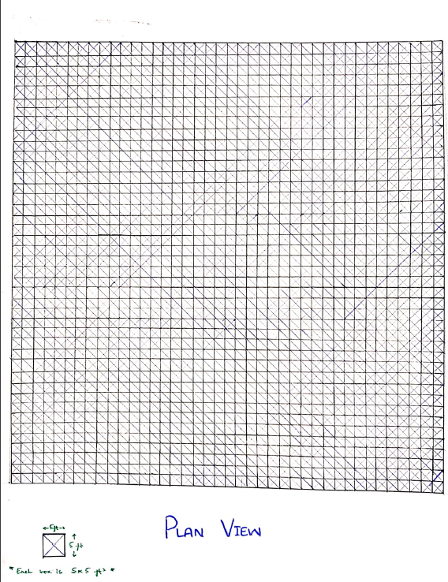

7.modelling SAP2000
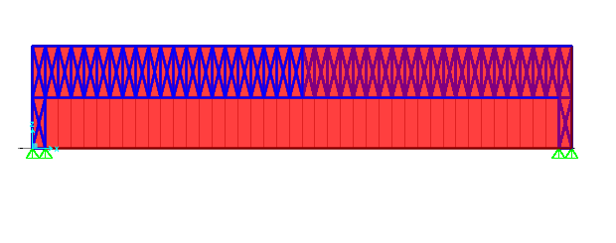
EVELVATION

PLAN VIEW
8.Scheme Recommendation
- The adopted scheme has no column involved; thus, it provides the complete clear span across the whole area.
- It has relatively less connections between different structural members because it has continuous frames.
- Its self-weight is very high because of large number of trusses used and it will be very costly as well.
- Due to high self-weight and no columns in the span & it showed deflections.

