

STEEL STRUCTURES (CE-411)
COMPLEX ENGINEERING PROBLEM

DESIGN REPORT – SCHEME 1

SUBMITTED TO: DR. AZIM KHAN

NUST INSTITUTE OF CIVIL ENGINEERING
SCHOOL OF CIVIL AND ENVIRONMENTAL ENGINEERING
Contents
1. Problem Statement 3
2. Initial Thoughts 3
3. Assumptions 3
4. Design Code & References 3
5. Scheme Design Report 4
5.1. Introduction 4
5.2. Description (Client Requirements) 4
5.3. Load & Loading combination 4
5.4. Plan view 5
5.5. Sections of primary and secondary trusses 5
5.6. Load path 6
5.7. 3D view showing lateral system 6
6. Scheme Design Sketches 7
7. Modelling - SAP2000 8
8. Scheme Recommendations 9

Problem Statement
A multi-national polythene manufacturer requires a large, 200 ft. (60m) square, single-storey factory, on a green field site. The client’s Architect has stipulated that one central column only is to be allowed in the factory, which is clad with profiled steel sheet sandwich panels (50% roof lighting, no windows in the sides of the factory). Apart from small personnel doors, the figure also shows the requirement for one large sliding door opening, 16 ft. (5m) high, and a minimum clearance inside the building of 20ft. (6m) Only the major structural members are offered as calculation in this example, and only selected important connections are designed. Also, several checks normally included in a full design, such as secondary bending and local buckling of the truss member walls, have been omitted.
Prepare a design appraisal with appropriate sketches indicating a viable solution for the proposed structure. Indicate clearly the functional framing, load transfer, serviceability, and stability aspects. Review and critically appraise the proposed scheme.

Initial Thoughts
There are 3 available schemes to complete this task. We will be using Scheme 1 as provided by our instructor, which basically consists of 1 central column, primary & secondary trusses and lateral & elevation bracing. The model will be created in SAP2000 and checked for deformations.

Assumptions
- The ground is level across site
- Access for all types of vehicles is adequate
- Site has sufficient storage place
- Existing buildings are far away
- Ground conditions are constant across the site
- Bracing is allowed on external elevations
- Bracing is allowed on roof

Design Code & References
- AISC & LRFD

Scheme Design Report

Introduction
The structure consists of 2 systems:
- Gravity System:
  - Primary Truss
  - Secondary Truss
  - Central Column
  - Edge Columns

- Lateral System:
  - Lateral Roof Bracing
  - Elevation Bracing
Furthermore, the structure is cladded from all sides.

Description (Client Requirements)
- Client requirement 1: 200 ft. square, single storey factory
- Client requirement 2: Only one central column allowed
- Client requirement 3: One large sliding door opening 16ft. high
- Client requirement 4: Minimum clearance inside the building of 20.ft
- Client requirement 5: Structure has no windows

Load & Loading combination
- Live load (L.L):
Roof snow load: 0.75 kN/m²
Factory roof services: 0.65 kN/m²
- Dead load (D.L):
Cladding load: 0.30 kN/m²
Steel load: 0.20 kN/m²
- Wind load (W.L):
Wind load: 2.0 kN/m²
- Load Combination:
- 1.2 D.L + 1.6 L.L (we will use this combination)
- 1.4 D.L
- 0.9 D.L + 1.0 W.L
- 1.0 D.L + 1.0 L.L (F^{n})
L.L = (0.75+0.65) x 21 = 29.4 Psf
D.L = (0.30+0.20) x 21 = 10.5 Psf
W.L = 2.0 x 21 = 42 Psf
Factored Load = 1.2 D.L + 1.6 L.L
= 1.2 (10.5) + 1.6 (29.4)
= 59.64 Psf ≈ 60.0 Psf

Plan view
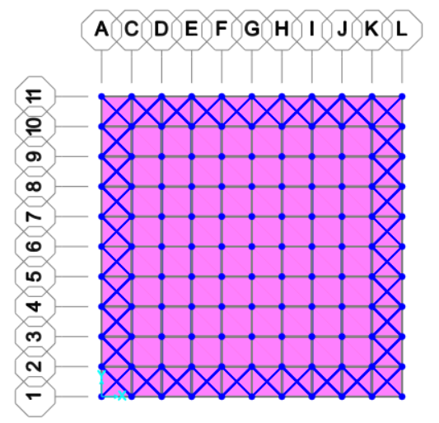

Sections of primary and secondary trusses
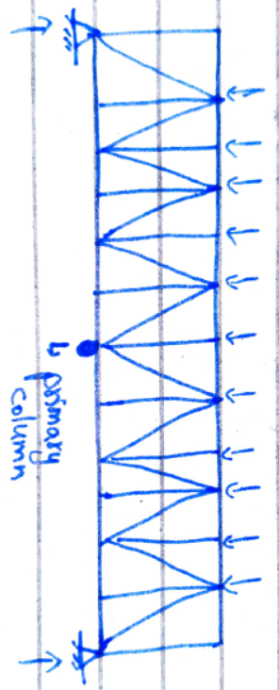

Primary Truss

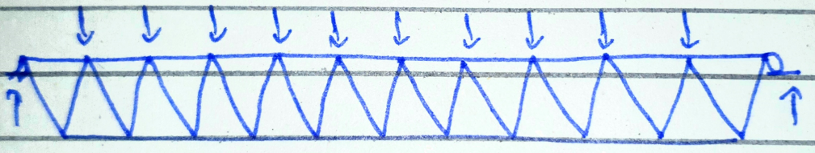

Secondary Truss

Load path
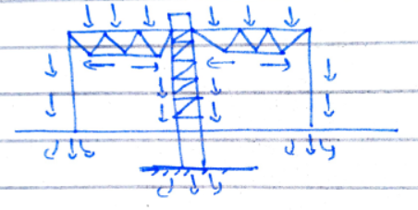

3D view showing lateral system
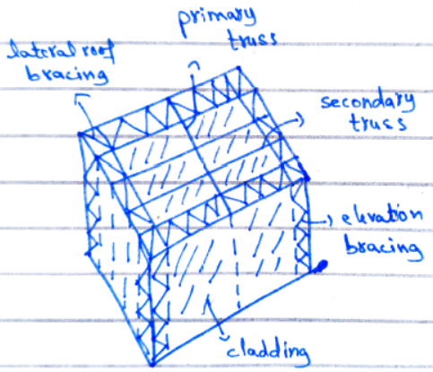

Scheme Design Sketches
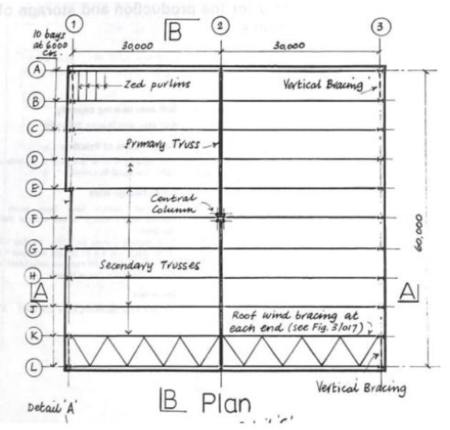

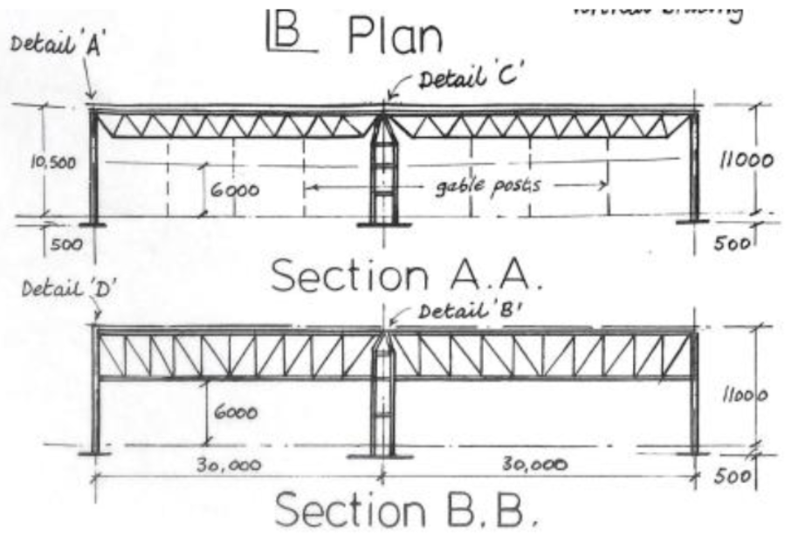

Modelling - SAP2000
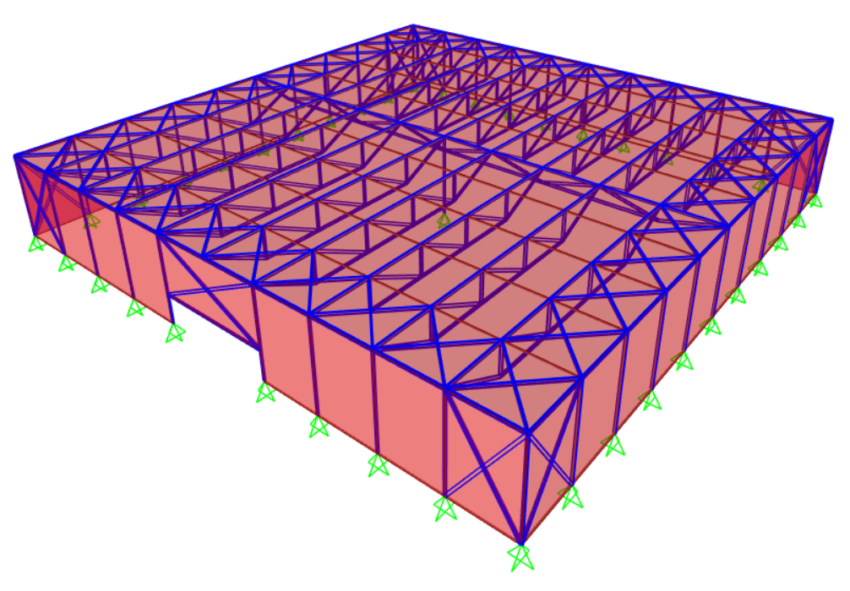
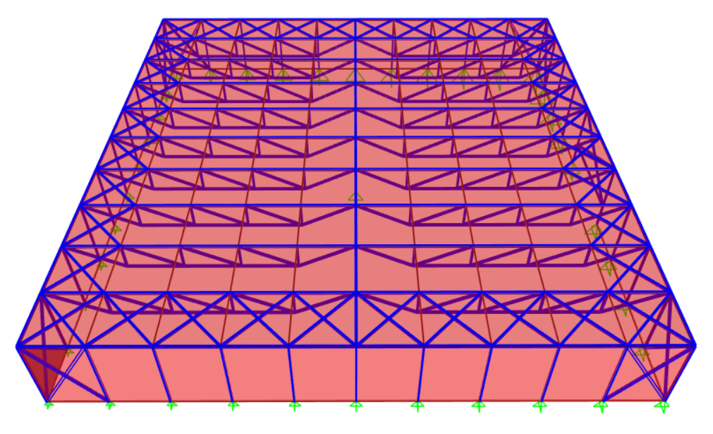

Scheme Recommendations
Advantages of Scheme 1:
- Central Column will reduce internal loads and moments on structure
- Less chances of deflection
- Less steel involved as less dead load of structure
- Less load running into foundation, as load is well distributed
Disadvantages of Scheme 1:
- Central Column takes up space
- Lots of primary connections – dangerous in case of seismic activity

