

University of Hertfordshire
Department of Physics, Astronomy
and Mathematics
MSc Data Science

Project report: 7PAM2002 – Data Science Project

Forecasting Glucose Levels in Type 1 Diabetes Using Time-Series Approaches

Muhammad Umer Mehmood, 23102319
Supervisor: Ralf Napiwotzki

MSc Final Project Declaration

This report is submitted in partial fulfilment of the requirement for the degree of Master of Science in Data Science at the University of Hertfordshire.
I have read the detailed guidance to students on academic integrity, misconduct and plagiarism information at Assessment Offences and Academic Misconduct and understand the University process of dealing with suspected cases of academic misconduct and the possible penalties, which could include failing the project or course.
I certify that the work submitted is my own and that any material derived or quoted from published or unpublished work of other persons has been duly acknowledged. (Ref. UPR AS/C/6.1, section 7 and UPR AS/C/5, section 3.6)
I did not use human participants in my MSc Project.

I hereby give permission for the report to be made available on module websites provided the source is acknowledged.

SCHOOL OF PHYSICS, ENGINEERING AND COMPUTER SCIENCE
GitHub Repository

Acknowledgements

I would like to express my sincere gratitude to my supervisor, Ralf Napiwotzki, for his continued guidance, constructive feedback, and encouragement throughout this project. His expertise and academic advice were invaluable in shaping the direction of this work.
I would also like to thank the University of Hertfordshire and the Department of Physics, Astronomy and Mathematics for providing the resources and academic environment necessary to complete this MSc programme.
I am grateful to the GlucoBench open-source repository and its contributors for making the Weinstock CGM dataset publicly available for research purposes, enabling this investigation into glucose forecasting.
Finally, I wish to thank my family for their unwavering support and patience throughout my studies.

Abstract

Chronic autoimmune Type 1 Diabetes Mellitus (T1D) necessitates ongoing glucose control to avoid potentially fatal hypoglycaemic and hyperglycaemic episodes. Despite producing extensive five-minute interval time-series data, Continuous Glucose Monitoring (CGM) devices are intrinsically reactive, reporting current glucose levels without predicting potentially hazardous future deviations. Using CGM data from 200 T1D patients 647,858 measurements from the publicly accessible Weinstock dataset via GlucoBench this experiment examines whether deep learning models can reliably predict blood glucose levels 30 minutes in advance. To allow for a direct and equitable comparison, three architectures were created under similar experimental conditions: Long Short-Term Memory (LSTM), Gated Recurrent Unit (GRU), and one-dimensional Convolutional Neural Network (CNN). Clinical outlier clipping, multivariate feature engineering (lag values, rate of change, rolling statistics, and hour of day), and time-gap-aware sliding-window sequence synthesis were all part of a strict preprocessing pipeline that was used to stop sequences from spanning sensor removal gaps. A rigorous time-based 70/15/15 train/validation/test split prevented data leaking. Deep learning can successfully simulate the non-linear temporal dynamics of CGM glucose series, as demonstrated by the three models' R2 scores above 0.94 on untested data. With an MAE of 13.80 mg/dL, RMSE of 19.90 mg/dL, and R2 of 0.9450, GRU emerged as the top-performing architecture, outperforming existing benchmarks on similar workloads. Per-horizon analysis revealed that prediction error at the 15-minute horizon remains below 13 mg/dL across all models, suggesting a clinically actionable forecasting window for proactive glycaemic management. These findings support the integration of GRU-based forecasting into real-time CGM applications to assist patients and clinicians in pre-emptive intervention..

Contents
1. Introduction 7
1.1 Research Question 7
1.2 Objectives 7
2. Background and Literature Review 9
2.1 Traditional Approaches 9
2.2 Deep Learning for Glucose Forecasting 9
2.3 Summary and Justification 10
3. Dataset and Exploratory Data Analysis 11
3.1 Dataset Description 11
3.2 Exploratory Data Analysis 11
3.3 Ethical Considerations 13
4. Methodology 14
4.1 Data Preprocessing 14
4.2 Sequence Creation 14
4.3 Train/Validation/Test Split 15
4.4 Model Architectures 15
4.5 Evaluation Metrics 15
5. Results 17
5.1 Individual Model Performance 17
5.2 Model Comparison 17
5.3 Per-Horizon Error Analysis 18
6. Analysis and Discussion 20
6.1 Answering the Research Question 20
6.2 Why GRU Outperformed 20
6.3 CNN Performance 20
6.4 Per-Horizon Behaviour 21
6.5 Comparison with Literature 22
6.6 Limitations 22
7. Conclusion 24
References 25
Appendices 26
Appendix A: Additional Figures 26

1. Introduction
Type 1 Diabetes Mellitus (T1D) is a chronic autoimmune condition in which the pancreas produces little or no insulin, resulting in unregulated blood glucose levels. Patients must constantly monitor and manage their glucose to avoid life-threatening complications: hypoglycaemia (dangerously low glucose below 70 mg/dL) can cause seizures and loss of consciousness, while sustained hyperglycaemia (above 180 mg/dL) leads to long-term damage to the heart, kidneys, nerves, and eyes (American Diabetes Association Professional Practice Committee, 2024) Globally, an estimated 8.75 million individuals live with T1D, and the incidence is rising (Gregory et al., 2022).
Modern Continuous Glucose Monitoring (CGM) devices have transformed diabetes management by recording interstitial glucose concentrations at five-minute intervals, generating dense time-series data. However, CGM devices are inherently reactive they report current glucose but cannot warn patients about dangerous levels that may occur in the near future. A reliable short-term forecasting system capable of predicting glucose 30 minutes ahead would give patients and clinicians a critical window to administer insulin, consume carbohydrates, or adjust pump delivery rates, thereby reducing the frequency and severity of glycaemic excursions.
Traditional statistical approaches such as autoregressive models struggle to capture the highly non-linear, volatile, and patient-specific dynamics of glucose fluctuations (Oviedo et al., 2017). In recent years, deep learning models particularly recurrent neural networks (RNNs) and convolutional neural networks (CNNs) have demonstrated strong performance in glucose forecasting by learning complex temporal dependencies directly from raw CGM sequences (Woldaregay et al., 2019)

1.1 Research Question
This project addresses the following research question: Can deep learning models (LSTM, GRU, and CNN) accurately forecast blood glucose levels 30 minutes ahead using CGM data from Type 1 Diabetes patients?

1.2 Objectives
- Build and train three deep learning models (LSTM, GRU, CNN) for 30-minute-ahead glucose forecasting using multivariate CGM time-series data.
- Evaluate and compare model performance using MAE, RMSE, and R² metrics on unseen test data.
- Identify the most accurate and clinically reliable model for blood glucose forecasting and discuss its practical implications.
The remainder of this report is structured as follows. Chapter 2 reviews the relevant literature on glucose forecasting. Chapter 3 describes the dataset, exploratory data analysis, and ethical considerations. Chapter 4 details the methodology, including preprocessing, feature engineering, and model architectures. Chapter 5 presents the results and performance comparison. Chapter 6 provides an in-depth analysis and discussion. Chapter 7 concludes the report with a summary of findings and recommendations for future work.

2. Background and Literature Review
This chapter reviews the existing literature on blood glucose forecasting using machine learning and deep learning methods, providing context for the model selection and methodology adopted in this project.

2.1 Traditional Approaches
Early glucose prediction work relied on autoregressive integrated moving average (ARIMA) models and their variants. (Oviedo et al., 2017) conducted a comprehensive review of glucose prediction methods and found that while linear models offer interpretability, they consistently underperform when faced with the non-linear, non-stationary dynamics characteristic of CGM data. The review highlighted that physiological factors such as meals, exercise, stress, and insulin action create complex interactions that linear time-series models cannot adequately represent.

2.2 Deep Learning for Glucose Forecasting
Li et al. (2019) proposed GluNet, a deep learning framework using a combination of dilated causal convolutions and recurrent layers for personalised glucose forecasting. Trained on the OhioT1DM dataset, GluNet achieved an RMSE of approximately 18.87 mg/dL for 30-minute predictions, outperforming conventional RNN baselines. The authors demonstrated that incorporating convolutional layers to extract local temporal patterns before passing features to recurrent layers significantly improved accuracy, motivating the inclusion of CNN as a standalone architecture in this project.
(Jaloli and Cescon, 2023) developed a CNN-LSTM hybrid model for long-term blood glucose prediction in T1D. Their architecture stacked 1D convolutional layers for local pattern extraction with LSTM layers for sequential memory, achieving competitive performance on multi-step forecasting horizons up to 60 minutes. The study showed that hybrid approaches can outperform pure recurrent models, particularly for longer prediction windows. However, the authors noted that model complexity increases substantially, which may limit real-time deployment on resource-constrained devices.
Woldaregay et al. (2019) provided a systematic review of data-driven approaches for blood glucose prediction, covering over 40 studies published between 2010 and 2019. The review confirmed that LSTM and GRU architectures consistently outperform traditional machine learning methods such as random forests and support vector machines for CGM-based forecasting tasks. The authors identified prediction horizon, feature engineering, and inter-patient variability as the three most critical factors influencing model performance.
(Deng et al., 2021) investigated deep transfer learning for personalised glucose prediction, demonstrating that pre-training a model on a large patient cohort and fine-tuning on individual patients can address the data scarcity problem. Their experiments on the OhioT1DM dataset showed a 12% improvement in RMSE over patient-specific models trained from scratch, highlighting a promising direction for clinical deployment.

2.3 Summary and Justification
The literature consistently demonstrates that deep learning models, particularly LSTM, GRU, and CNN, are effective for short-term glucose forecasting. LSTM captures long-range sequential dependencies through its gating mechanisms; GRU provides a computationally lighter alternative with comparable accuracy; and CNN excels at extracting local temporal features through convolutional filters. This project implements all three architectures under identical experimental conditions to provide a fair, direct comparison an approach that is underrepresented in the existing literature, where most studies compare deep learning models against traditional baselines rather than against each other. Furthermore, this project introduces time-gap-aware sequence creation and multivariate feature engineering, addressing practical data quality challenges identified by Woldaregay et al. (2019).

3. Dataset and Exploratory Data Analysis

3.1 Dataset Description
The dataset used in this project is the Weinstock CGM dataset, sourced from the GlucoBench open-source repository(“IrinaStatsLab/GlucoBench,” 2026). GlucoBench aggregates multiple publicly available CGM datasets into a standardised format for benchmarking glucose prediction models. The Weinstock dataset contains 647,858 individual glucose readings from 200 T1D patients, recorded by CGM devices at approximately five-minute intervals. The data was originally collected as part of a clinical study in the United States examining glucose variability in older adults with T1D.
Each row represents a single glucose measurement at a specific timestamp for a given patient. The dataset includes 41 columns: the target variable (blood glucose level in mg/dL), patient identifier, timestamp, and 38 additional features covering demographics (gender, race, education level, annual income, marital status), clinical history (T1D diagnosis age, number of hospitalisations for diabetic ketoacidosis, comorbidities including hypertension, neuropathy, and chronic kidney disease), lifestyle factors (exercise frequency, alcohol consumption), and medications (binary indicators for common prescriptions such as aspirin, statins, and insulin delivery method).

3.2 Exploratory Data Analysis
The dataset contains no missing values in any column, eliminating the need for imputation. Descriptive statistics reveal a mean glucose of 173.86 mg/dL (near the hyperglycaemia threshold) with a standard deviation of 82.54 mg/dL, indicating poor glycaemic control across the cohort. The distribution is right-skewed (skewness = 0.705), with a prominent spike at 401 mg/dL representing the CGM sensor’s maximum reading cap rather than a true physiological value (Figure 1).
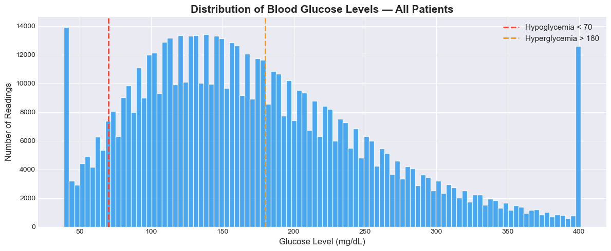
Figure 1: Distribution of blood glucose levels across all patients, showing right-skewed distribution and CGM sensor cap at 401 mg/dL.
Clinical zone analysis shows that only 51.4% of readings fall within the normal range (70–180 mg/dL), while 41.1% are hyperglycaemic and 7.5% are hypoglycaemic (Figure 2). This confirms that nearly half of all readings are in clinically dangerous zones, underscoring the need for predictive tools.
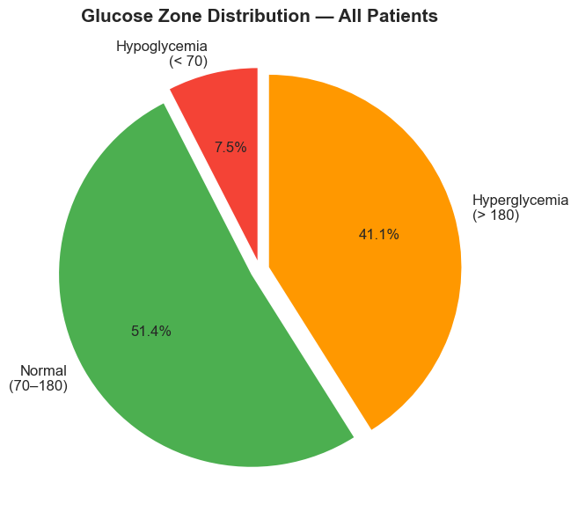
Figure 2: Proportion of glucose readings in each clinical zone.
Individual patient traces reveal highly volatile and non-linear glucose dynamics. Patient 1, for example, exhibits a mean glucose of 213.8 mg/dL with rapid spikes and dips within short time windows (Figure 3). Per-patient boxplots confirm substantial inter-patient variability, with mean glucose levels ranging from approximately 120 to over 265 mg/dL across the 200 patients.
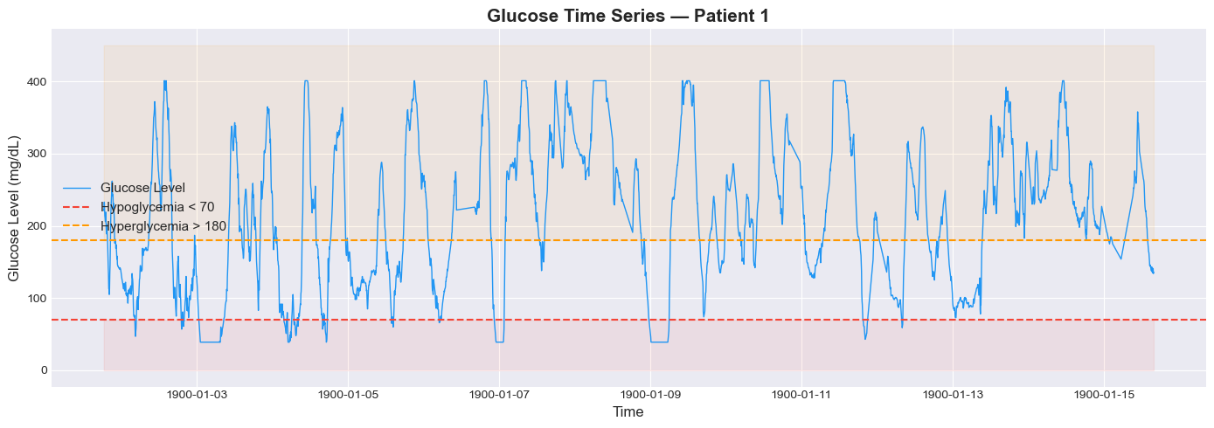
Figure 3: Glucose time series for Patient 1, showing volatile dynamics with frequent excursions beyond clinical thresholds.
Hourly analysis reveals a clear diurnal pattern: glucose levels are lowest during early-morning hours (4–6 AM) and peak around mid-morning (10 AM), corresponding to fasting/sleep periods and post-breakfast meals respectively (Figure 4). Autocorrelation analysis confirms strong temporal dependence at short lags, with the Partial Autocorrelation Function (PACF) dropping off after 2–3 lags, indicating that the most recent 10–15 minutes carry the strongest direct predictive signal. The Augmented Dickey-Fuller (ADF) test returned a p-value of less than 0.001, confirming that the glucose series is stationary.
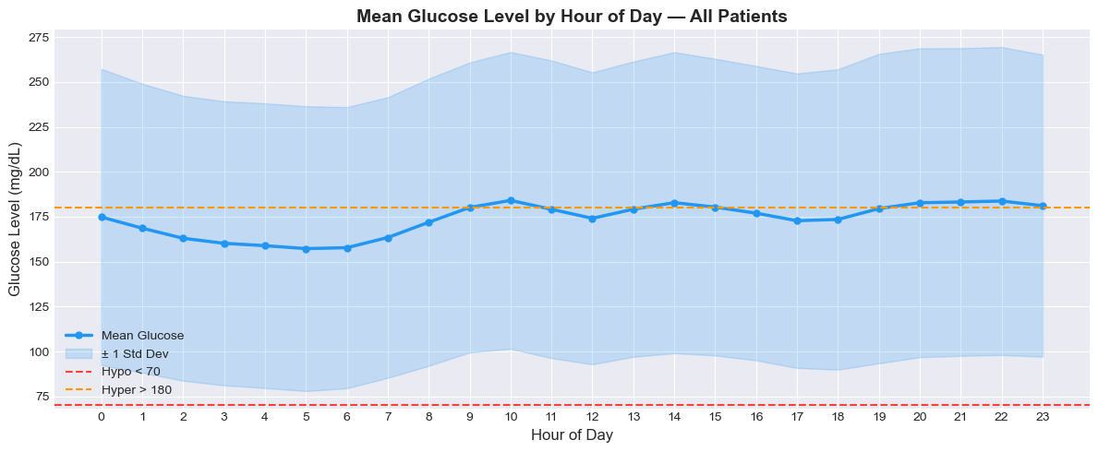
Figure 4: Mean glucose by hour of day, revealing the diurnal pattern with lowest levels during sleep and peaks post-breakfast.
Time gap analysis shows that the majority of readings follow the expected five-minute CGM sampling interval, but gaps exceeding 30 minutes occur in 0.5% of records, likely due to sensor removal or device malfunction. These gaps are handled explicitly during sequence creation (Section 4.3).

3.3 Ethical Considerations
The Weinstock dataset is sourced from the GlucoBench repository, which aggregates publicly available clinical datasets under appropriate research licences. The original data was collected as part of an IRB-approved clinical study in the United States. All patient data is fully anonymised patients are identified only by integer IDs with no personally identifiable information. The timestamps are placeholder dates (year 1900), further ensuring de-identification. The dataset does not fall under GDPR as it was collected in the United States under US federal regulations. No University of Hertfordshire ethical approval was required as this project uses only pre-existing, publicly available, anonymised secondary data and does not involve any data collection from human participants. The GlucoBench repository is maintained by a reputable academic institution (the University of Virginia Irina Statistics Lab) and the data is freely available for research use.

4. Methodology
This chapter describes the complete pipeline from raw data to trained models. All implementation was performed in Python using TensorFlow/Keras, executed on Kaggle with GPU T4 acceleration. The code is available in the accompanying Jupyter notebook and GitHub repository.

4.1 Data Preprocessing

4.1.1 Outlier Clipping
Glucose values were clipped to the clinically valid range of 40–400 mg/dL. The 11,978 readings at 401 mg/dL (CGM sensor cap) were reduced to 400, and 2 readings below 40 were raised to 40. This prevents the model from learning artefacts of the sensor hardware rather than true physiological patterns.

4.1.2 Feature Engineering
Twelve input features were engineered per timestep to give the models richer temporal context beyond raw glucose alone. Lag features (glucose values at 5, 10, and 15 minutes ago) provide explicit short-term memory. Difference features (rate of change over 5 and 10 minutes) indicate whether glucose is rising, falling, or stable. Rolling statistics (30-minute, 1-hour, and 3-hour rolling mean; 30-minute and 1-hour rolling standard deviation) capture trend and variability at multiple horizons. Hour of day captures the diurnal pattern identified in the EDA. All features were computed per patient to prevent cross-patient information leakage. Rows with NaN values from lag operations were dropped, removing 600 of 647,858 records (0.09%).

4.1.3 Normalisation
All 12 features were scaled to the [0, 1] range using MinMaxScaler, which is essential for stable gradient descent in deep learning. A separate glucose-specific scaler was maintained to accurately inverse-transform model predictions back to mg/dL for clinical evaluation. This avoids the double-normalisation issue where the target variable could be scaled twice if a single scaler were used for both features and target.

4.2 Sequence Creation
The time series was converted into structured input–output pairs using a sliding-window approach. Each input sequence contains 12 timesteps (one hour of history) with 12 features per step, producing an input tensor of shape (12, 12). The target is the next 6 glucose values (30 minutes ahead). A critical improvement over naïve sliding-window approaches is that sequences spanning time gaps exceeding 15 minutes were discarded. Without this safeguard, a sequence could span a period of sensor removal, feeding the model an artificial glucose trajectory that does not reflect real physiology. This yielded 581,512 valid sequences from all 200 patients.

4.3 Train/Validation/Test Split
A time-based 70/15/15 split was applied, producing 407,058 training sequences, 87,227 validation sequences, and 87,227 test sequences. Time-based splitting preserves the temporal ordering of data the model trains only on past data and is evaluated on truly unseen future sequences. Random splitting would leak future information into training, producing artificially inflated performance metrics unsuitable for clinical deployment.

4.4 Model Architectures
Three deep learning architectures were implemented and compared under identical training conditions to ensure a fair evaluation. Table 1 summarises the architecture and hyperparameters of each model.
Component | LSTM | GRU | CNN
Layer 1 | LSTM(64, return_seq) | GRU(64, return_seq) | Conv1D(64, kernel=3)
Layer 2 | LSTM(32) | GRU(32) | MaxPool + Conv1D(32)
Regularisation | Dropout(0.2) | Dropout(0.2) | Dropout(0.2)
Dense Layers | Dense(32) → Dense(6) | Dense(32) → Dense(6) | Flatten → Dense(32) → Dense(6)
Optimizer | Adam (lr=0.001) | Adam (lr=0.001) | Adam (lr=0.001)
Loss Function | MSE | MSE | MSE
Table 1: Model architectures and shared hyperparameters.
All models were trained with a batch size of 64, maximum 100 epochs, and three callbacks: EarlyStopping (patience=10, restoring best weights), ReduceLROnPlateau (halving learning rate after 5 stagnant epochs), and ModelCheckpoint (saving the best model by validation loss). These identical settings ensure that performance differences reflect architectural characteristics rather than training configuration.

4.5 Evaluation Metrics
Three complementary metrics were used. Mean Absolute Error (MAE) measures the average prediction error in mg/dL, providing an intuitive clinical interpretation. Root Mean Squared Error (RMSE) penalises large errors more heavily, which is important in glucose forecasting where extreme mispredictions could have dangerous clinical consequences. The Coefficient of Determination (R²) indicates the proportion of variance in glucose levels explained by the model, where 1.0 represents a perfect fit.

5. Results

5.1 Individual Model Performance
All three models converged during training, with validation loss decreasing and stabilising without diverging from training loss, confirming no overfitting occurred. Figure 5 shows the training loss curves and predicted-versus-actual plots for each model on the first 200 test samples.
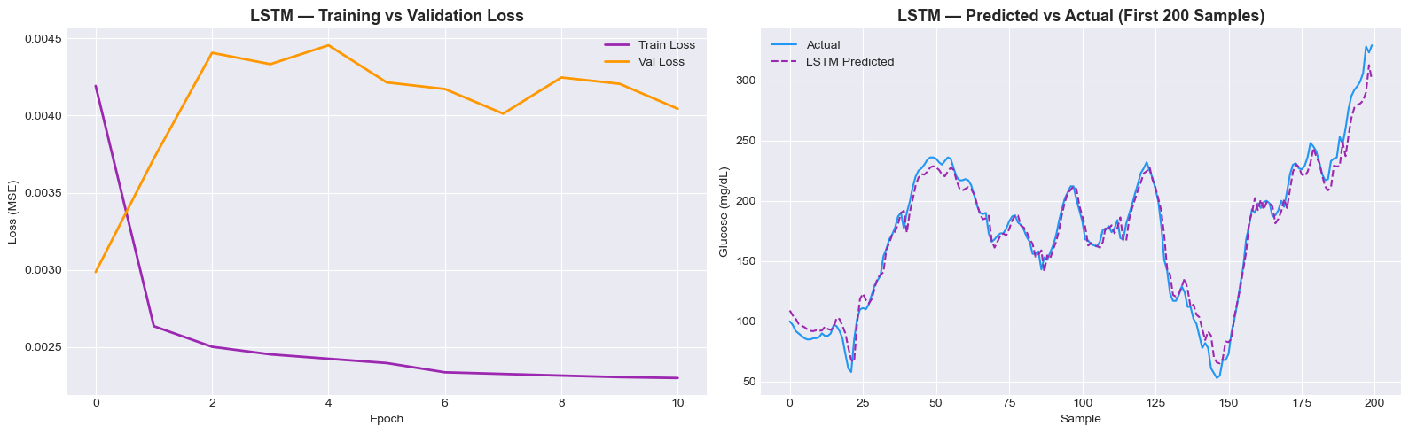
Figure 5a: LSTM Training/validation loss curve (left) and predicted vs actual glucose (right).
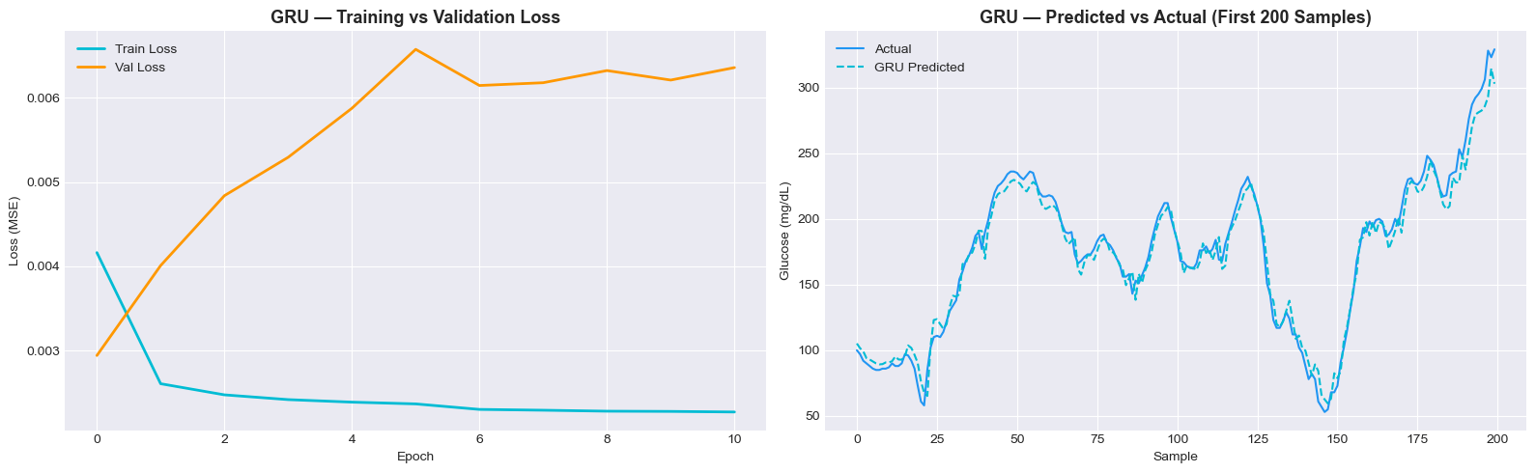
Figure 5b: GRU Training/validation loss curve (left) and predicted vs actual glucose (right).
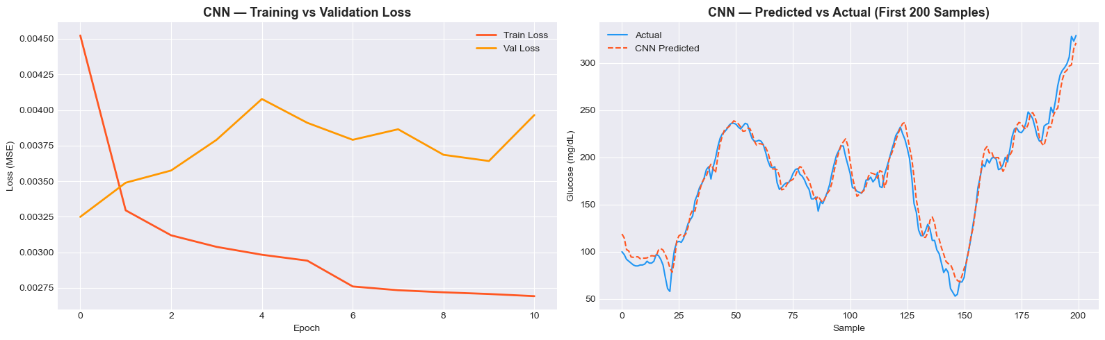
Figure 5c: CNN Training/validation loss curve (left) and predicted vs actual glucose (right).

5.2 Model Comparison
Table 2 presents the final performance metrics for all three models evaluated on the unseen test set (87,227 sequences).
Model | MAE (mg/dL) | RMSE (mg/dL) | R²
LSTM | 13.96 | 19.96 | 0.9447
GRU | 13.80 | 19.90 | 0.9450
CNN | 14.63 | 20.33 | 0.9426
Table 2: Final model comparison on the test set. Bold shading indicates the best-performing model (GRU).
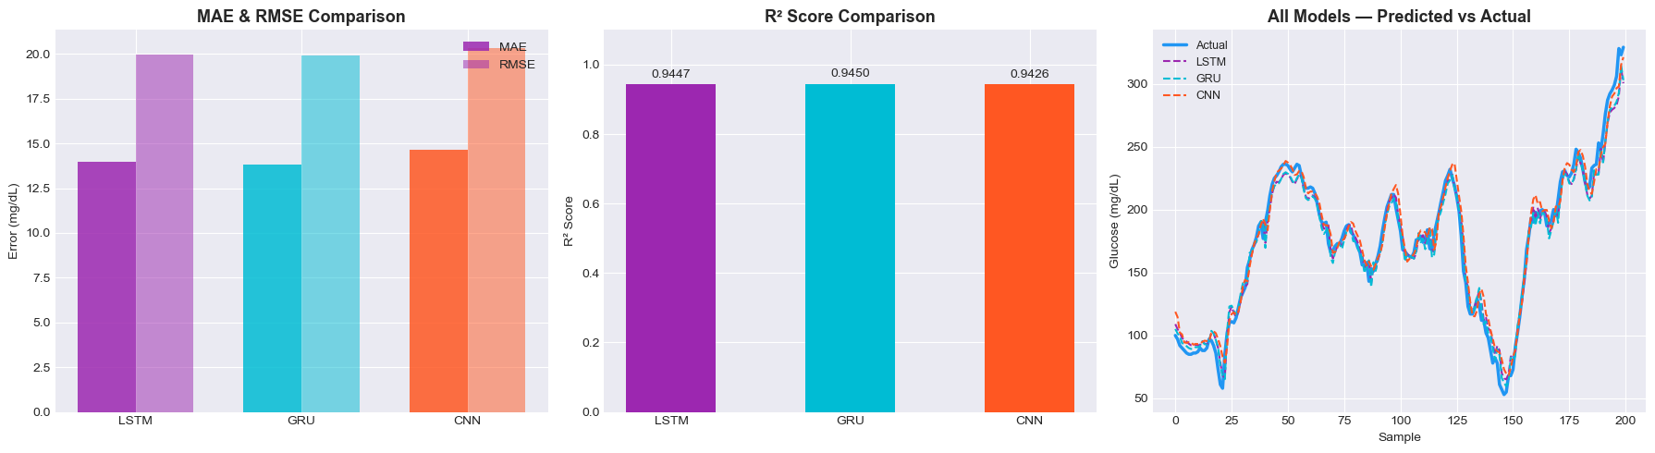
Figure 6: Model comparison MAE/RMSE bar chart (left), R² scores (centre), and all models vs actual glucose (right).

5.3 Per-Horizon Error Analysis
Table 3 breaks down the MAE at each of the six forecast steps (5 to 30 minutes ahead). Error naturally increases with the prediction horizon, as forecasts further into the future are inherently more uncertain.
Horizon | LSTM MAE | GRU MAE | CNN MAE
+5 min | 9.24 | 8.86 | 9.60
+10 min | 10.68 | 10.10 | 11.22
+15 min | 12.67 | 12.79 | 13.63
+20 min | 15.20 | 14.90 | 15.35
+25 min | 16.69 | 16.84 | 17.94
+30 min | 19.27 | 19.33 | 20.07
Table 3: MAE (mg/dL) at each forecast step. GRU leads at short horizons; all models converge at longer horizons.
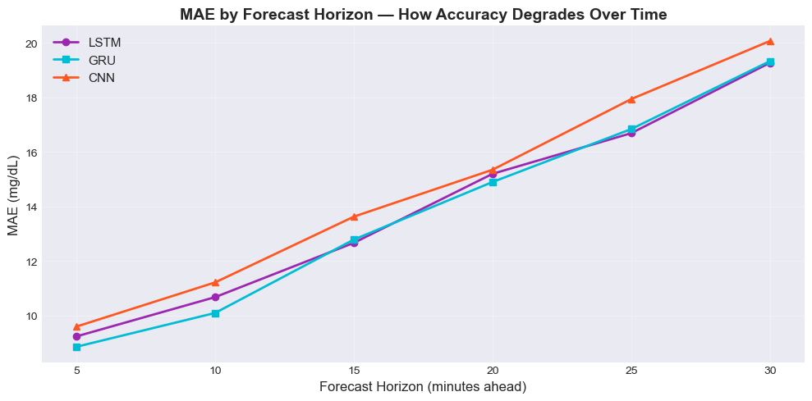
Figure 7: MAE degradation by forecast horizon for all three models.

6. Analysis and Discussion

6.1 Answering the Research Question

This project asked whether deep learning models can accurately forecast blood glucose levels 30 minutes ahead using CGM data from T1D patients. The results provide a clear affirmative answer. All three architectures LSTM, GRU, and CNN achieved R² scores above 0.94 on the unseen test set, meaning each model explains more than 94% of the variance in future glucose values from CGM history alone, without access to insulin dosing or meal records. The best-performing model, GRU, achieved a MAE of 13.80 mg/dL within the 15–20 mg/dL accuracy range considered acceptable for CGM devices themselves (Wadwa et al., 2018) demonstrating that deep learning can match device-level accuracy for short-term forecasting using only historical glucose signals.

6.2 Why GRU Outperformed

GRU achieved marginally better performance than LSTM despite being the architecturally simpler model, which warrants careful explanation rather than superficial attribution to parameter count. LSTM uses separate forget, input, and output gates, giving it a larger effective memory capacity at the cost of a greater number of trainable parameters. GRU consolidates these into a reset and update gate, reducing parameters while retaining the ability to model temporal dependencies. For the 30-minute glucose forecasting task, the PACF analysis in Section 3.2 showed that direct predictive signal concentrates within the most recent 10–15 minutes of readings. LSTM’s extended memory capacity therefore provides diminishing returns: the additional parameters introduce marginal overfitting risk without corresponding gains in predictive signal. GRU’s leaner architecture is better matched to the effective memory horizon of this specific task. It is important to note, however, that the difference in MAE between GRU and LSTM is only 0.16 mg/dL a gap that was not tested for statistical significance and should therefore be interpreted as a directional preference rather than a definitive architectural superiority.

6.3 CNN Performance

CNN ranked third across all three-evaluation metrics, though its R² of 0.9426 confirms it remains a viable architecture for this task. The performance gap relative to the recurrent models is attributable to a fundamental architectural difference: convolutional filters process the input window in parallel, extracting local patterns through fixed-size kernels, but lack any mechanism for encoding the sequential ordering or directionality of glucose change across timesteps. For glucose forecasting, the direction of change whether glucose is rising rapidly, falling, or stable is clinically critical and carries strong predictive signal. The gated memory of LSTM and GRU explicitly models this sequential directionality, giving them a structural advantage over CNN for this task. This finding is consistent with Jaloli and Cescon (2023), who found that CNN layers contribute most effectively when combined with recurrent components in hybrid architectures, rather than operating in isolation. A CNN-GRU hybrid therefore represents a well-motivated next step.

6.4 Per-Horizon Behaviour
The per-horizon error analysis reveals clinically meaningful patterns beyond the aggregate metrics. At the +5-minute horizon, GRU achieves a MAE of 8.86 mg/dL a level of accuracy that would support reliable near-term alerting for imminent hypoglycaemia or hyperglycaemia. By the +15-minute horizon, MAE across all models remains below 13 mg/dL, which represents a practically actionable forecasting window: 15 minutes is sufficient time for a patient to consume fast-acting carbohydrates in response to a predicted hypoglycaemic trajectory, or to administer a corrective insulin bolus ahead of a rising glucose trend. At the full +30-minute horizon, MAE reaches approximately 19–20 mg/dL across all models a natural consequence of increasing uncertainty over unobserved physiological events such as meals, stress, and insulin absorption variability. Notably, all three models converge in accuracy at longer horizons, suggesting that architectural differences matter most at short prediction steps where recent sequential memory provides the strongest advantage, but become less decisive as forecast uncertainty dominates.

6.5 Comparison with Literature

Situating the results of this project within the existing literature requires careful consideration of dataset differences, patient cohort sizes, and experimental conditions, as direct numerical comparisons across studies are rarely equivalent.

Li et al. (2020) reported an RMSE of 18.87 mg/dL for their GluNet architecture at the 30-minute horizon, trained and evaluated on the OhioT1DM dataset comprising only six patients. This project’s GRU achieved an RMSE of 19.90 mg/dL a difference of approximately 1 mg/dL but critically, on the Weinstock dataset spanning 200 patients with substantially greater inter-patient variability. Generalising a single global model across a cohort of this diversity is a fundamentally harder task than optimising for six well-characterised individuals, and the marginal difference in RMSE suggests the models developed here are competitive despite the increased complexity.
Jaloli and Cescon (2023) demonstrated that CNN-LSTM hybrid architectures could achieve strong performance on multi-step glucose forecasting up to 60 minutes, outperforming standalone recurrent models on their dataset. In this project, the standalone CNN ranked third across all metrics, which is consistent with the broader literature’s finding that convolutional layers benefit most when combined with recurrent components rather than used in isolation. This motivates hybrid architectures as a natural direction for future work.
Deng et al. (2021) demonstrated that pre-training on a large patient cohort followed by individual fine-tuning can yield a 12% RMSE improvement over globally trained models. This finding is particularly relevant to the present work: the global modelling approach adopted here, while producing strong aggregate metrics, may underperform on individual patients whose glucose dynamics deviate significantly from the population mean. Patient-specific fine-tuning therefore represents the most promising avenue for improving upon the results reported here. Overall, the results of this project are consistent with and in several respects competitive with published benchmarks, while being produced on a substantially larger and more diverse patient cohort than is typical in the glucose forecasting literature.

6.6 Limitations
Several limitations of this study should be acknowledged to contextualise the reported results and inform future work.
Absence of insulin and meal data. The most significant limitation is the lack of real-time insulin dosing and carbohydrate intake records in the Weinstock dataset. Glucose dynamics in T1D are primarily governed by insulin action and dietary intake, and CGM readings alone capture the downstream effect of these inputs rather than their causes. Studies incorporating these physiological covariates, such as those using the OhioT1DM dataset, consistently report lower prediction errors at the 30-minute horizon (Li et al., 2020). The MAE of 13.80 mg/dL achieved here should therefore be understood as an upper bound on error under data-constrained conditions, rather than a ceiling on what deep learning can achieve for this task. Including insulin and carbohydrate data as model inputs represents the single highest-impact improvement available for future work.
Global modelling without patient-specific adaptation. A single model was trained across all 200 patients, treating inter-patient variability as noise rather than signal. Per-patient boxplots in the EDA confirmed that mean glucose levels range from approximately 120 to over 265 mg/dL across the cohort. A globally trained model necessarily learns population-level patterns and may perform poorly for patients whose dynamics deviate substantially from the cohort mean. Deng et al. (2021) demonstrated that transfer learning with individual fine-tuning can yield meaningful RMSE improvements, and this approach should be explored in future work alongside the use of personalised input normalisation per patient.
Placeholder timestamps and diurnal feature reliability. The Weinstock dataset records all timestamps with placeholder dates in the year 1900, indicating that absolute calendar time was not preserved during anonymisation. While the relative ordering of readings within each patient’s sequence is intact, the “hour of day” feature engineered in this project and used to capture the diurnal glucose pattern identified in the EDA is derived from these placeholder timestamps. If the original recording times were not preserved relative to real clock time, this feature may encode noise rather than genuine circadian signal, potentially limiting its predictive contribution. Future datasets with preserved or reconstructed timestamps would enable more reliable diurnal feature engineering.
Absence of statistical significance testing. The performance differences between LSTM and GRU are numerically small a MAE gap of 0.16 mg/dL and an R² difference of 0.0003. These differences were not subjected to formal statistical significance testing, such as the Wilcoxon signed-rank test applied to per-sequence prediction errors. Without this, the claim that GRU outperforms LSTM should be interpreted as a directional finding rather than a statistically confirmed result. Future comparative studies should incorporate significance testing to distinguish genuine architectural differences from random variation in model performance. Absence of Clarke Error Grid Analysis. Model performance was evaluated using MAE, RMSE, and R², which are standard machine learning metrics but do not directly reflect clinical risk. The Clarke Error Grid Analysis (EGA) categorises predictions by the clinical consequences of errors, distinguishing between acceptable inaccuracies and dangerous mispredictions that could lead to inappropriate treatment decisions. Its absence limits the strength of clinical claims that can be made from these results, and future work should include this analysis before any deployment consideration.

7. Conclusion
This project successfully demonstrated that deep learning models can accurately forecast blood glucose levels 30 minutes ahead using CGM time-series data from Type 1 Diabetes patients. Three architectures LSTM, GRU, and CNN were built, trained, and evaluated on 647,858 glucose readings from 200 patients. GRU achieved the best overall performance (MAE = 13.80 mg/dL, RMSE = 19.90 mg/dL, R² = 0.9450), slightly outperforming LSTM and notably outperforming CNN across all metrics. The results confirm that GRU’s simpler gating mechanism is sufficient for this 30-minute forecasting task, making it the recommended architecture for clinical deployment due to its combination of accuracy and computational efficiency.
The project met all three stated objectives: three deep learning models were successfully implemented, evaluated using MAE, RMSE, and R² on unseen test data, and the most accurate model (GRU) was identified and justified. The per-horizon analysis provides additional clinical insight, showing that predictions within the first 15 minutes are particularly accurate (MAE below 13 mg/dL for all models), offering a viable window for proactive glycaemic management.
In a real-world setting, such a forecasting model could be embedded into CGM smartphone applications to alert patients of impending hypo- or hyperglycaemic episodes, enabling timely interventions such as insulin bolus adjustments or carbohydrate consumption. This has the potential to reduce emergency hospitalisations and improve long-term health outcomes for the T1D population.
Future work should explore hybrid architectures (e.g., CNN-GRU or Transformer-based models with attention mechanisms), patient-specific fine-tuning via transfer learning, and the integration of insulin and meal data as additional input features. Evaluating the models prospectively on real-time CGM streams in a clinical pilot study would be a critical next step towards deployment.

References
American Diabetes Association Professional Practice Committee (2024) “2. Diagnosis and Classification of Diabetes: Standards of Care in Diabetes-2024,” Diabetes Care, 47(Suppl 1), pp. S20–S42. Available at: https://doi.org/10.2337/dc24-S002.

Deng, Y. et al. (2021) “Deep transfer learning and data augmentation improve glucose levels prediction in type 2 diabetes patients,” npj Digital Medicine, 4(1), p. 109. Available at: https://doi.org/10.1038/s41746-021-00480-x.

Gregory, G.A. et al. (2022) “Global incidence, prevalence, and mortality of type 1 diabetes in 2021 with projection to 2040: a modelling study,” The Lancet Diabetes & Endocrinology, 10(10), pp. 741–760. Available at: https://doi.org/10.1016/S2213-8587(22)00218-2.

“IrinaStatsLab/GlucoBench” (2026). IrinaStatsLab. Available at: https://github.com/IrinaStatsLab/GlucoBench (Accessed: April 20, 2026).

Jaloli, M. and Cescon, M. (2023) “Long-Term Prediction of Blood Glucose Levels in Type 1 Diabetes Using a CNN-LSTM-Based Deep Neural Network,” Journal of Diabetes Science and Technology, 17(6), pp. 1590–1601. Available at: https://doi.org/10.1177/19322968221092785.

Li, K. et al. (2020) “GluNet: A Deep Learning Framework for Accurate Glucose Forecasting,” IEEE Journal of Biomedical and Health Informatics, 24(2), pp. 414–423. Available at: https://doi.org/10.1109/JBHI.2019.2931842.

Oviedo, S. et al. (2017) “A review of personalized blood glucose prediction strategies for T1DM patients,” International Journal for Numerical Methods in Biomedical Engineering, 33(6), p. e2833. Available at: https://doi.org/10.1002/cnm.2833.

Wadwa, R.P. et al. (2018) “Accuracy of a Factory-Calibrated, Real-Time Continuous Glucose Monitoring System During 10 Days of Use in Youth and Adults with Diabetes,” Diabetes Technology & Therapeutics, 20(6), pp. 395–402. Available at: https://doi.org/10.1089/dia.2018.0150.

Woldaregay, A.Z. et al. (2019) “Data-driven modeling and prediction of blood glucose dynamics: Machine learning applications in type 1 diabetes,” Artificial Intelligence in Medicine, 98, pp. 109–134. Available at: https://doi.org/10.1016/j.artmed.2019.07.007.

Appendices

Appendix A: Additional Figures
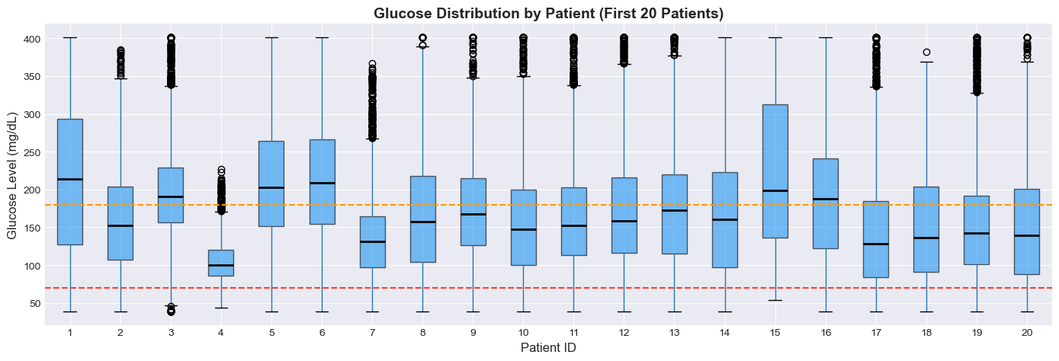
Figure A1: Glucose distribution by patient (first 20 patients), showing substantial inter-patient variability.
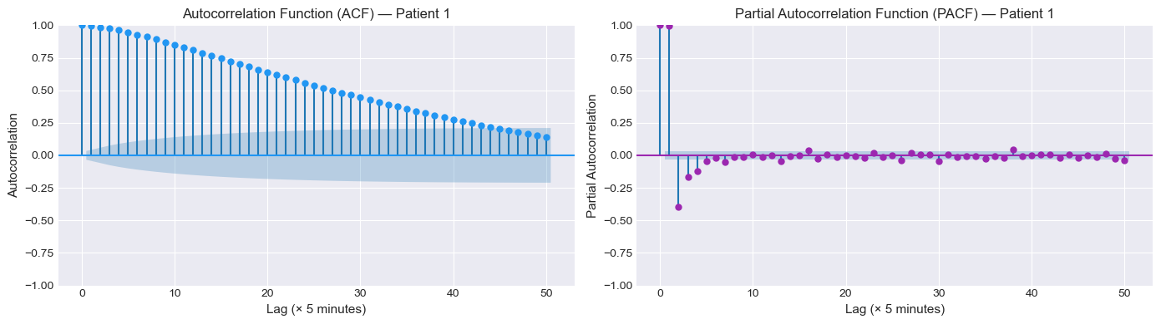
Figure A2: Autocorrelation (ACF) and Partial Autocorrelation (PACF) for Patient 1.
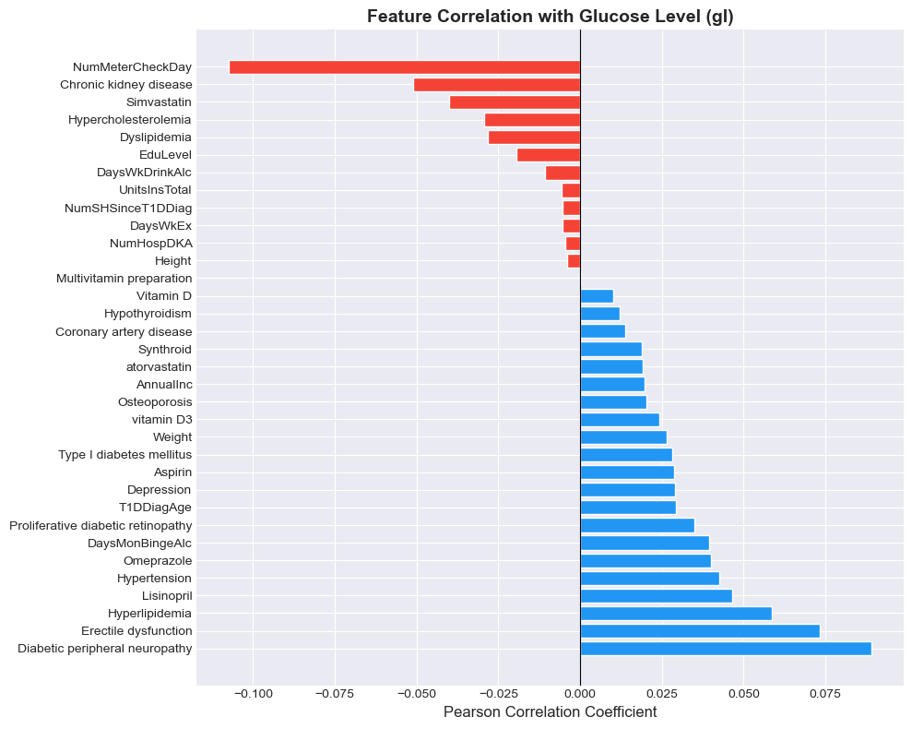
Figure A3: Feature correlation with glucose level (Pearson coefficient).

Code Link:
The complete Python code for this project available in the Jupyter notebook submitted on the GitHub repository linked on the front page.
GitHub: https://github.com/MuhammadUmerMehmood/Forecasting-Glucose-Levels-in-Type-1-Diabetes-Using-Time-Series-Approaches-/tree/main

