Brain Tumor Segmentation Using Attention U-Net and Standard U-Net
Course | Medical Image Computing
Student | Muhammad Usama Anwar
Roll No | PHDAIF25M004
Supervisor | Dr. Muhammad Farooq
Dataset | Dataset contained 57,195 H5 slice files and was split into 40,036 training, 8,579 validation, and 8,580 testing slices

Abstract:
Brain tumor segmentation is a crucial task in medical image computing, as accurate delineation of tumor regions supports diagnosis, treatment planning, surgical assessment, and post-treatment monitoring. Manual segmentation of magnetic resonance imaging (MRI) scans is time-consuming and may vary between clinical experts. This project therefore investigates automated brain tumor segmentation using deep learning-based semantic segmentation models trained on the BraTS 2020 dataset.
The project uses multi-modal MRI slices containing four input channels: FLAIR, T1, T1CE, and T2. These modalities provide complementary information about edema, anatomical structure, contrast-enhancing tumor tissue, and fluid-sensitive regions. The output consists of three tumor mask channels representing tumor sub-regions. Two models were implemented and compared: Attention U-Net as the main architecture and Standard U-Net as the baseline model. Both networks follow an encoder-decoder design, while Attention U-Net additionally applies attention gates to skip connections to highlight relevant tumor regions.
The models were trained for 5 epochs using an input size of 128 x 128 pixels, batch size 8, Adam optimizer, and BCE + Dice loss. The dataset contained 57,195 H5 slice files and was split into 40,036 training, 8,579 validation, and 8,580 testing slices. The Attention U-Net achieved a test loss of 0.2423 and test score of 0.7664. The Standard U-Net achieved a lower test loss of 0.2195 and a higher test score of 0.7881. The visual results show that both models learned meaningful tumor representations and produced useful segmentation overlays. The study concludes that U-Net-based architectures are effective for brain tumor segmentation, while longer training and higher-resolution inputs may further improve the attention-based model.

Table of Contents:
1. Introduction
2. Problem Statement and Objectives
3. Dataset Description and Preprocessing
4. Methodology
5. Experimental Setup
6. Quantitative Results
7. Training Curve Analysis
8. Visual and Qualitative Results
9. Comparative Discussion
10. Limitations
11. Future Work
12. Conclusion
References

List of Figures:
Figure 1. Multi-modal MRI sample with ground truth mask
Figure 2. Test loss comparison between Attention U-Net and Standard U-Net
Figure 3. Test score comparison between Attention U-Net and Standard U-Net
Figure 4. Final validation metric comparison
Figures 5-8. Attention U-Net training curves
Figures 9-12. Standard U-Net training curves
Figures 13-17. Attention U-Net vs Standard U-Net qualitative comparisons
Figures 18-22. Loaded Attention U-Net prediction visualizations
Figures 23-27. Additional prediction overlay visualizations

List of Tables:
Table 1. Dataset and input-output configuration
Table 2. Model architecture summary
Table 3. Training configuration
Table 4. Final validation metrics
Table 5. Test performance comparison
Table 6. Epoch-wise Attention U-Net training log
Table 7. Epoch-wise Standard U-Net training log
1. Introduction:
Brain tumors are abnormal growths of cells within the brain and are among the most challenging conditions in neurological imaging. Accurate tumor localization is essential for treatment planning, radiotherapy, surgery, and monitoring disease progression. MRI is commonly used because it provides rich soft-tissue contrast and can reveal tumor extent more clearly than many other imaging techniques.
A major challenge in clinical workflow is that tumor segmentation is often performed manually or semi-automatically by experts. This process is time-consuming, requires medical expertise, and may produce slightly different boundaries depending on the observer. Automated segmentation can help reduce this workload and provide consistent support for clinical decision-making.
Deep learning has become one of the most effective approaches for medical image segmentation. In particular, U-Net and its variants are widely used because they combine low-level spatial features with high-level semantic features through skip connections. This project applies U-Net-based segmentation to brain tumor MRI slices and compares a Standard U-Net baseline with an Attention U-Net model.

2. Problem Statement and Objectives:
The main problem addressed in this project is automatic segmentation of tumor regions from multi-modal MRI images. The goal is not simple classification of whether a tumor exists; rather, the system must produce pixel-level masks that identify where tumor tissue is located in each MRI slice.
The major objectives of the project are:
- To use real multi-modal MRI data from the BraTS 2020 dataset.
- To preprocess MRI slices and convert them into a trainable format for deep learning.
- To implement Attention U-Net for brain tumor segmentation.
- To implement Standard U-Net as a baseline comparison model.
- To evaluate both models using loss, Dice coefficient, IoU, pixel accuracy, and visual overlays.
- To discuss strengths, limitations, and possible future improvements.

3. Dataset Description and Preprocessing:
The dataset used in this project is BraTS 2020 Training Data in H5 slice format. The notebook detected 57,195 H5 slice files. Each H5 file contains an image tensor and a mask tensor. The original sample shape observed was 240 x 240 x 4 for the image and 240 x 240 x 3 for the mask.
Table 1. Dataset and input-output configuration
Item | Description
Dataset | BraTS 2020 Training Data
Data format | H5 slice files
Total slice files | 57,195
Training files | 40,036
Validation files | 8,579
Testing files | 8,580
Input modalities | FLAIR, T1, T1CE, T2
Input channels | 4
Output mask channels | 3 tumor-region channels
Training image size | 128 x 128 pixels

The dataset was split into training, validation, and testing sets using a 70:15:15 strategy. Every MRI slice was resized to 128 x 128 pixels to reduce memory usage and allow training in the Kaggle environment. Image normalization was applied slice-wise using the mean and standard deviation of each image. The segmentation masks were binarized after resizing so that each pixel represented tumor or non-tumor tissue.
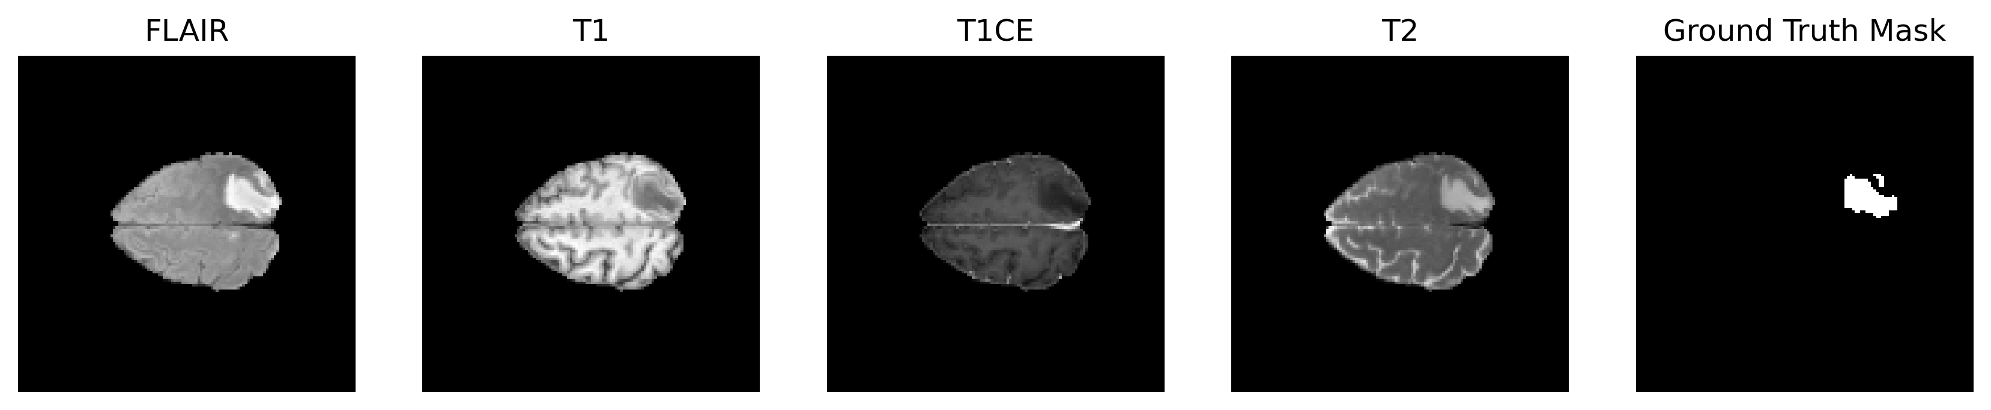
Figure 1. Sample BraTS MRI modalities and corresponding ground truth mask.
The figure shows the four MRI channels used as model input: FLAIR, T1, T1CE, and T2. FLAIR and T2 highlight abnormal fluid-sensitive regions, T1 provides anatomical structure, and T1CE emphasizes enhancing tumor tissue. The final panel shows the expert ground truth mask used during supervised training.

4. Methodology:
This project follows a supervised semantic segmentation pipeline. MRI slices are loaded from H5 files, resized, normalized, and passed to the segmentation model. The model outputs a three-channel mask with sigmoid activation. During training, predicted masks are compared with ground truth masks using BCE + Dice loss. The final prediction is visualized by combining mask channels and overlaying the result on the FLAIR image.

4.1 Standard U-Net
Standard U-Net is used as the baseline model. It contains an encoder path for feature extraction and a decoder path for mask reconstruction. Skip connections transfer spatial information from encoder layers to corresponding decoder layers. This is important in medical segmentation because tumor boundaries can be small and spatially detailed.

4.2 Attention U-Net
Attention U-Net extends the standard architecture by adding attention gates to the skip connections. Instead of passing all encoder features directly to the decoder, the attention gates learn to emphasize relevant regions and suppress less useful background information. In theory, this is useful for brain tumor segmentation because tumors may occupy only a small portion of the image.
Table 2. Model architecture summary
Component | Attention U-Net | Standard U-Net
Input | 128 x 128 x 4 MRI slice | 128 x 128 x 4 MRI slice
Encoder filters | 32, 64, 128, 256 | 32, 64, 128, 256
Bottleneck filters | 512 | 512
Decoder filters | 256, 128, 64, 32 | 256, 128, 64, 32
Skip connection handling | Filtered through attention gates | Direct concatenation
Output | 3-channel sigmoid mask | 3-channel sigmoid mask
Purpose | Main segmentation model | Baseline comparison model

5. Experimental Setup:
Table 3. Training configuration
Parameter | Value
Platform | Kaggle Notebook
Framework | TensorFlow / Keras
Input size | 128 x 128 pixels
Batch size | 8
Epochs | 5
Optimizer | Adam
Learning rate | 0.0001
Loss function | BCE + Dice Loss
Callbacks | EarlyStopping, ModelCheckpoint, ReduceLROnPlateau, CSVLogger
Evaluation metrics | Dice coefficient, IoU, binary accuracy, loss

The loss function used in the notebook combines Binary Cross-Entropy and Dice Loss: Loss = BCE + Dice Loss. This combination is suitable for segmentation because BCE supports pixel-wise learning, while Dice Loss helps improve overlap between predicted and ground truth masks, especially when tumor pixels are much fewer than background pixels.

6. Quantitative Results:
The final validation and testing results provide a direct comparison between Attention U-Net and Standard U-Net. Although Attention U-Net was the main proposed model, the Standard U-Net baseline achieved slightly stronger numerical performance in this particular experimental configuration.
Table 4. Final validation metrics after 5 epochs
Metric | Attention U-Net | Standard U-Net | Better Model
Training Dice | 0.7743 | 0.7887 | Standard U-Net
Validation Dice | 0.7715 | 0.7909 | Standard U-Net
Training IoU | 0.6512 | 0.6699 | Standard U-Net
Validation IoU | 0.6457 | 0.6728 | Standard U-Net
Training Loss | 0.2342 | 0.2188 | Standard U-Net
Validation Loss | 0.2374 | 0.2174 | Standard U-Net
Validation Pixel Accuracy | 0.9984 | 0.9987 | Standard U-Net

Table 5. Test performance comparison
Model | Test Loss | Test Score
Attention U-Net | 0.2423 | 0.7664
Loaded Attention U-Net | 0.2423 | 0.7664
Standard U-Net | 0.2195 | 0.7881

Standard U-Net reduced the test loss by approximately 0.0228 compared with Attention U-Net and improved the test score by approximately 0.0218. The difference is not extremely large, but it is consistent with the final validation metrics.
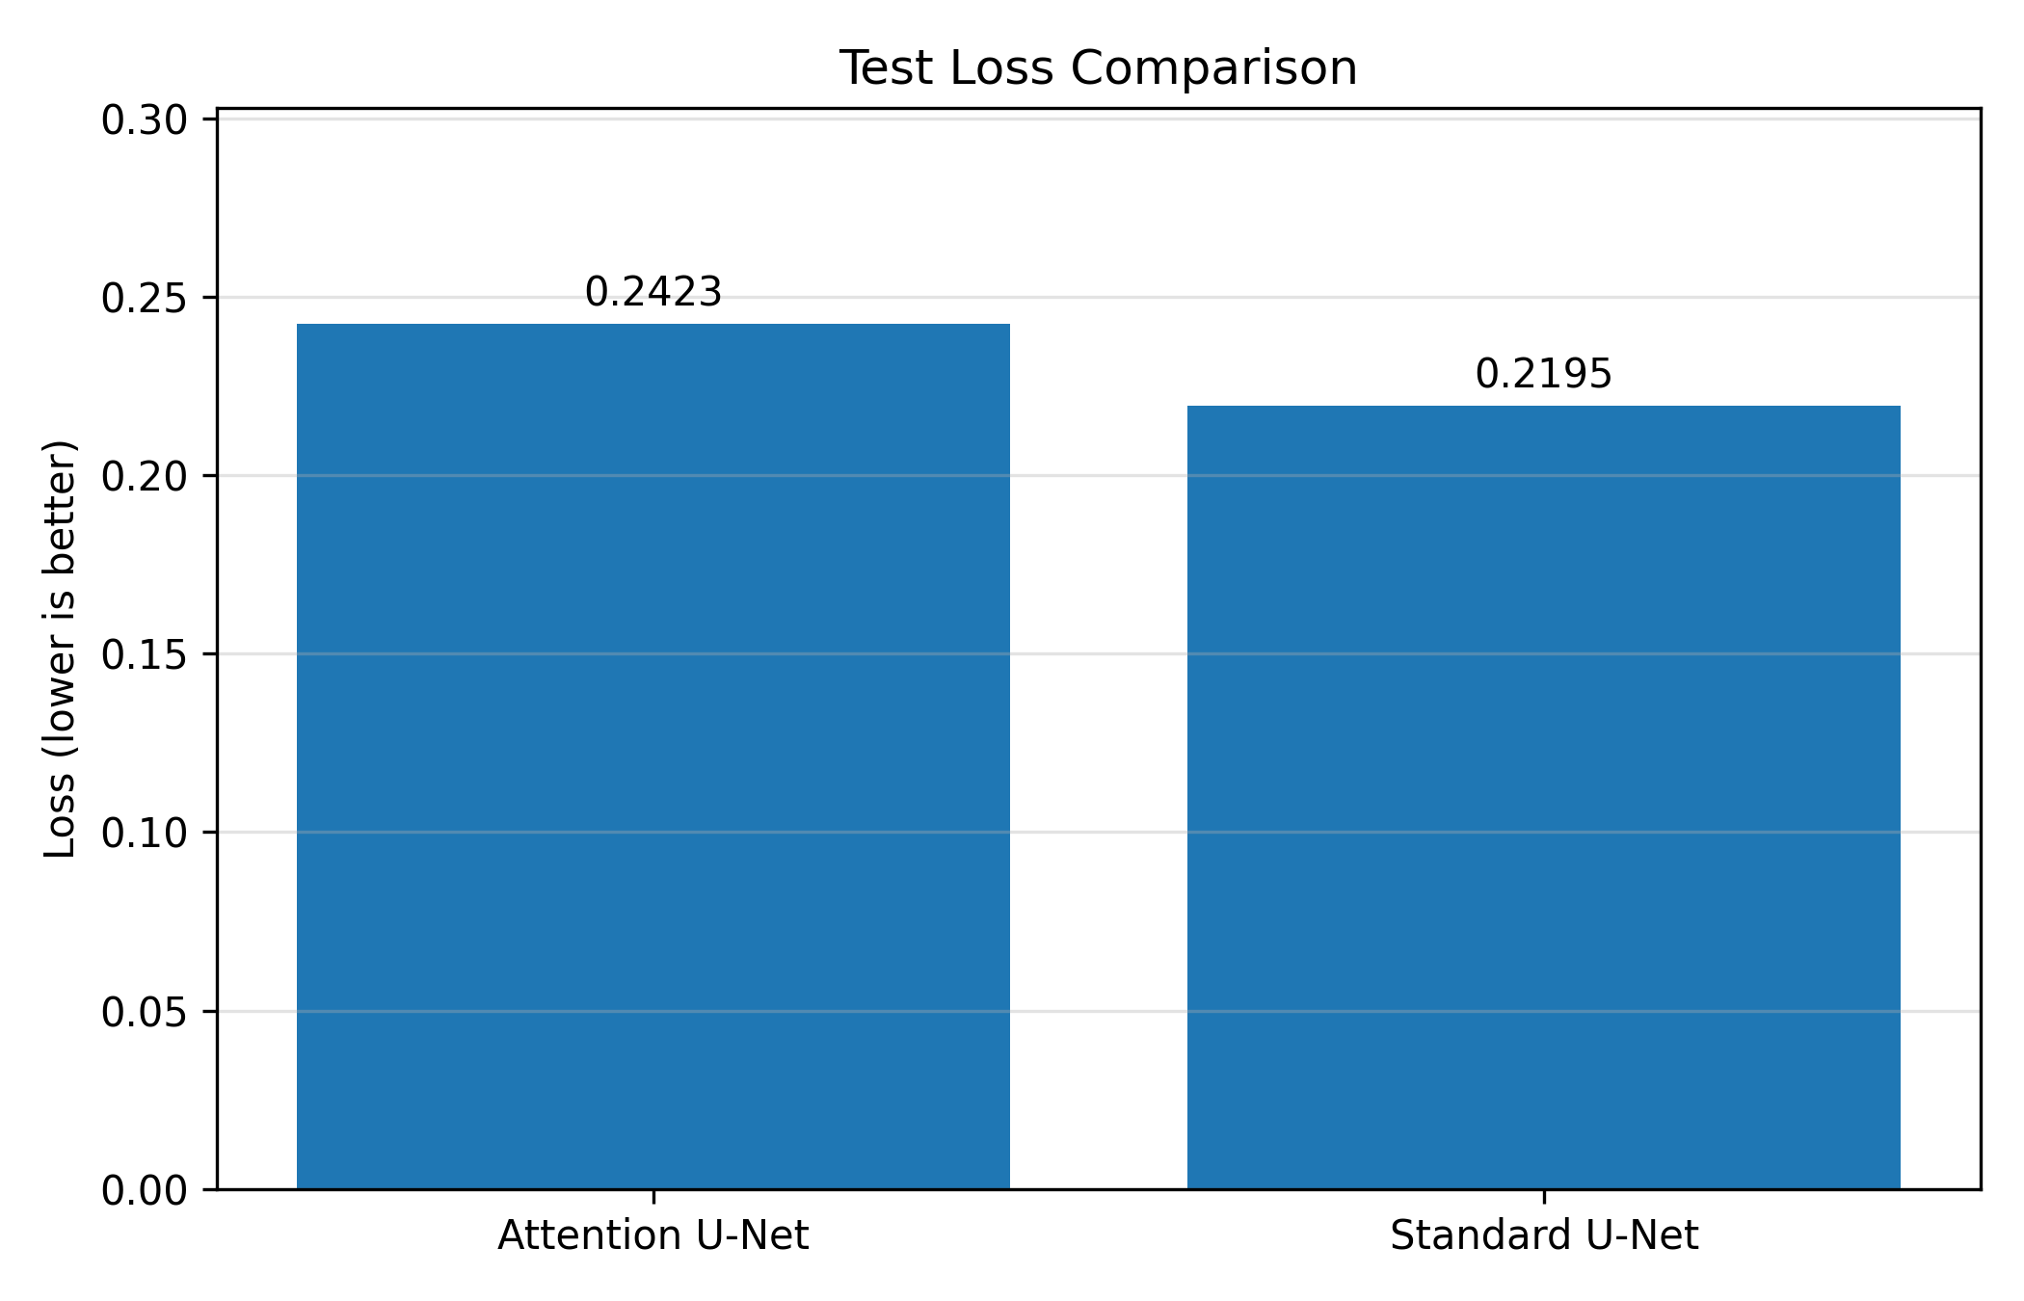
Figure 2. Test loss comparison between Attention U-Net and Standard U-Net.
Lower loss indicates better agreement between predicted segmentation masks and the target masks. Standard U-Net achieved the lower test loss in this experiment.
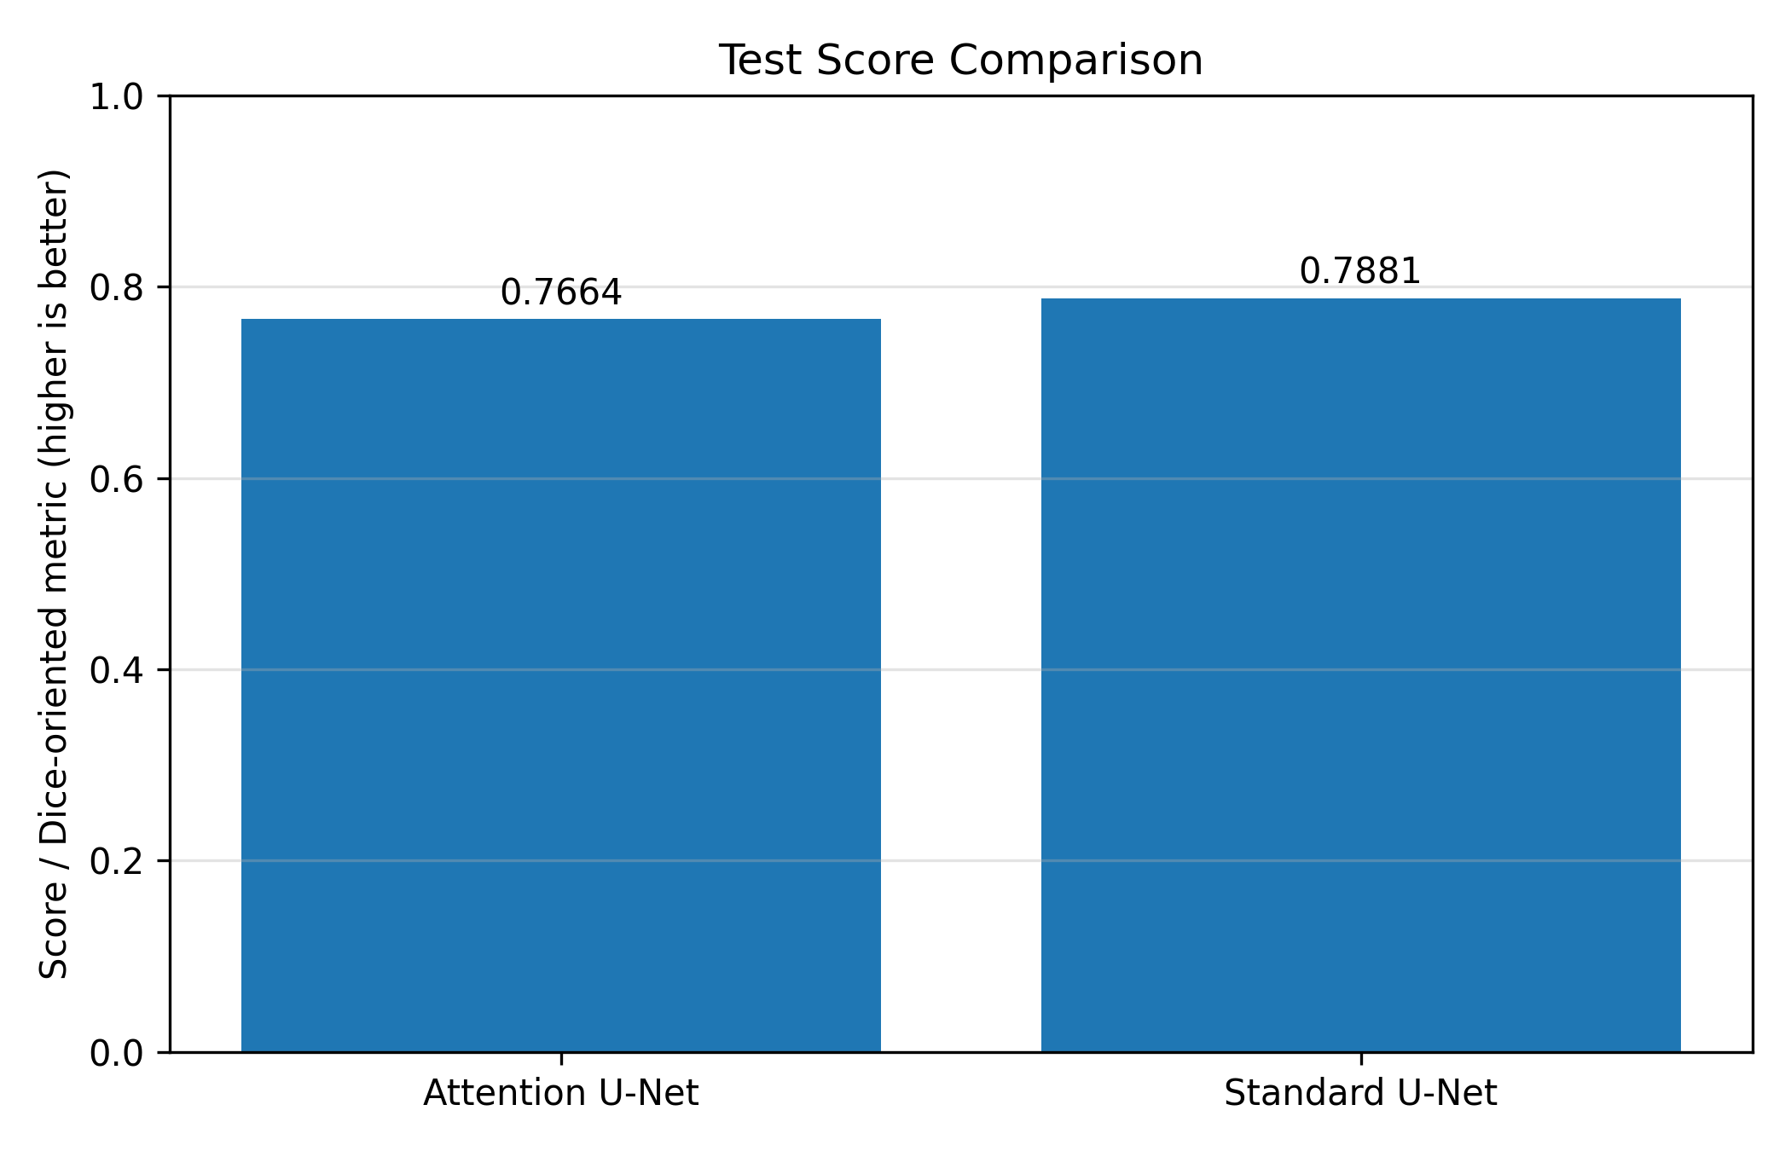
Figure 3. Test score comparison between Attention U-Net and Standard U-Net.
The Standard U-Net achieved the higher test score. This confirms the quantitative observation that the simpler baseline model performed slightly better under the current training settings.
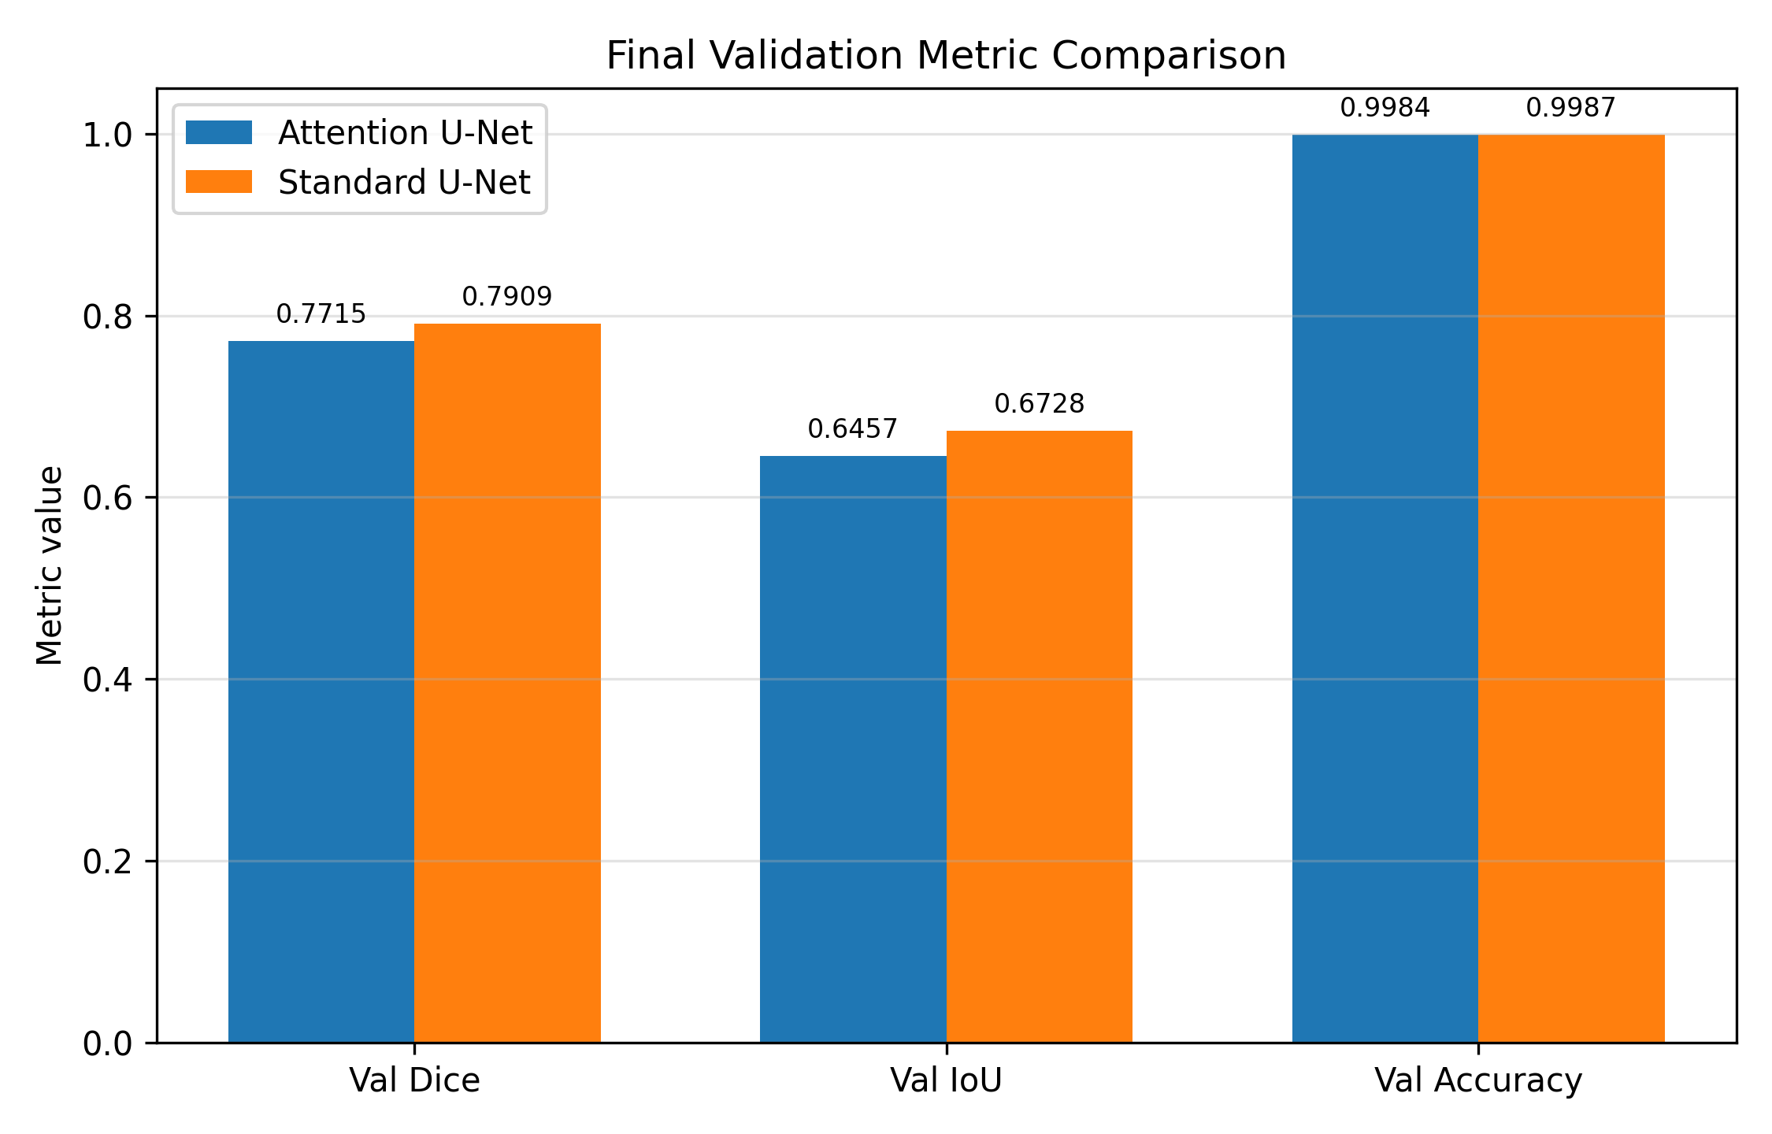
Figure 4. Final validation metric comparison.
The validation comparison shows that Standard U-Net achieved higher final Dice, IoU, and pixel accuracy. However, both models reached stable and clinically meaningful segmentation performance.

6.1 Epoch-wise Training Logs
Table 6. Epoch-wise Attention U-Net training log
Epoch | Train Loss | Val Loss | Train Dice | Val Dice | Train IoU | Val IoU | Val Acc.
1 | 0.6533 | 0.3185 | 0.4024 | 0.6917 | 0.2963 | 0.5486 | 0.9982
2 | 0.2848 | 0.3243 | 0.7250 | 0.6879 | 0.5891 | 0.5428 | 0.9977
3 | 0.2627 | 0.2496 | 0.7467 | 0.7597 | 0.6171 | 0.6317 | 0.9985
4 | 0.2472 | 0.2409 | 0.7618 | 0.7684 | 0.6356 | 0.6438 | 0.9985
5 | 0.2342 | 0.2374 | 0.7743 | 0.7715 | 0.6512 | 0.6457 | 0.9984

Table 7. Epoch-wise Standard U-Net training log
Epoch | Train Loss | Val Loss | Train Dice | Val Dice | Train IoU | Val IoU | Val Acc.
1 | 0.7061 | 0.3023 | 0.3599 | 0.7072 | 0.2610 | 0.5674 | 0.9982
2 | 0.2760 | 0.2494 | 0.7325 | 0.7588 | 0.5980 | 0.6301 | 0.9985
3 | 0.2490 | 0.2413 | 0.7593 | 0.7676 | 0.6325 | 0.6413 | 0.9985
4 | 0.2330 | 0.2157 | 0.7751 | 0.7922 | 0.6516 | 0.6743 | 0.9987
5 | 0.2188 | 0.2174 | 0.7887 | 0.7909 | 0.6699 | 0.6728 | 0.9987

7. Training Curve Analysis:
Training curves are important because they show whether the model is learning consistently or overfitting. In this project, both models show a sharp improvement after the first epoch and then gradual refinement. The validation curves remain close to training curves, suggesting stable generalization during the short training schedule.

7.1 Attention U-Net Curves
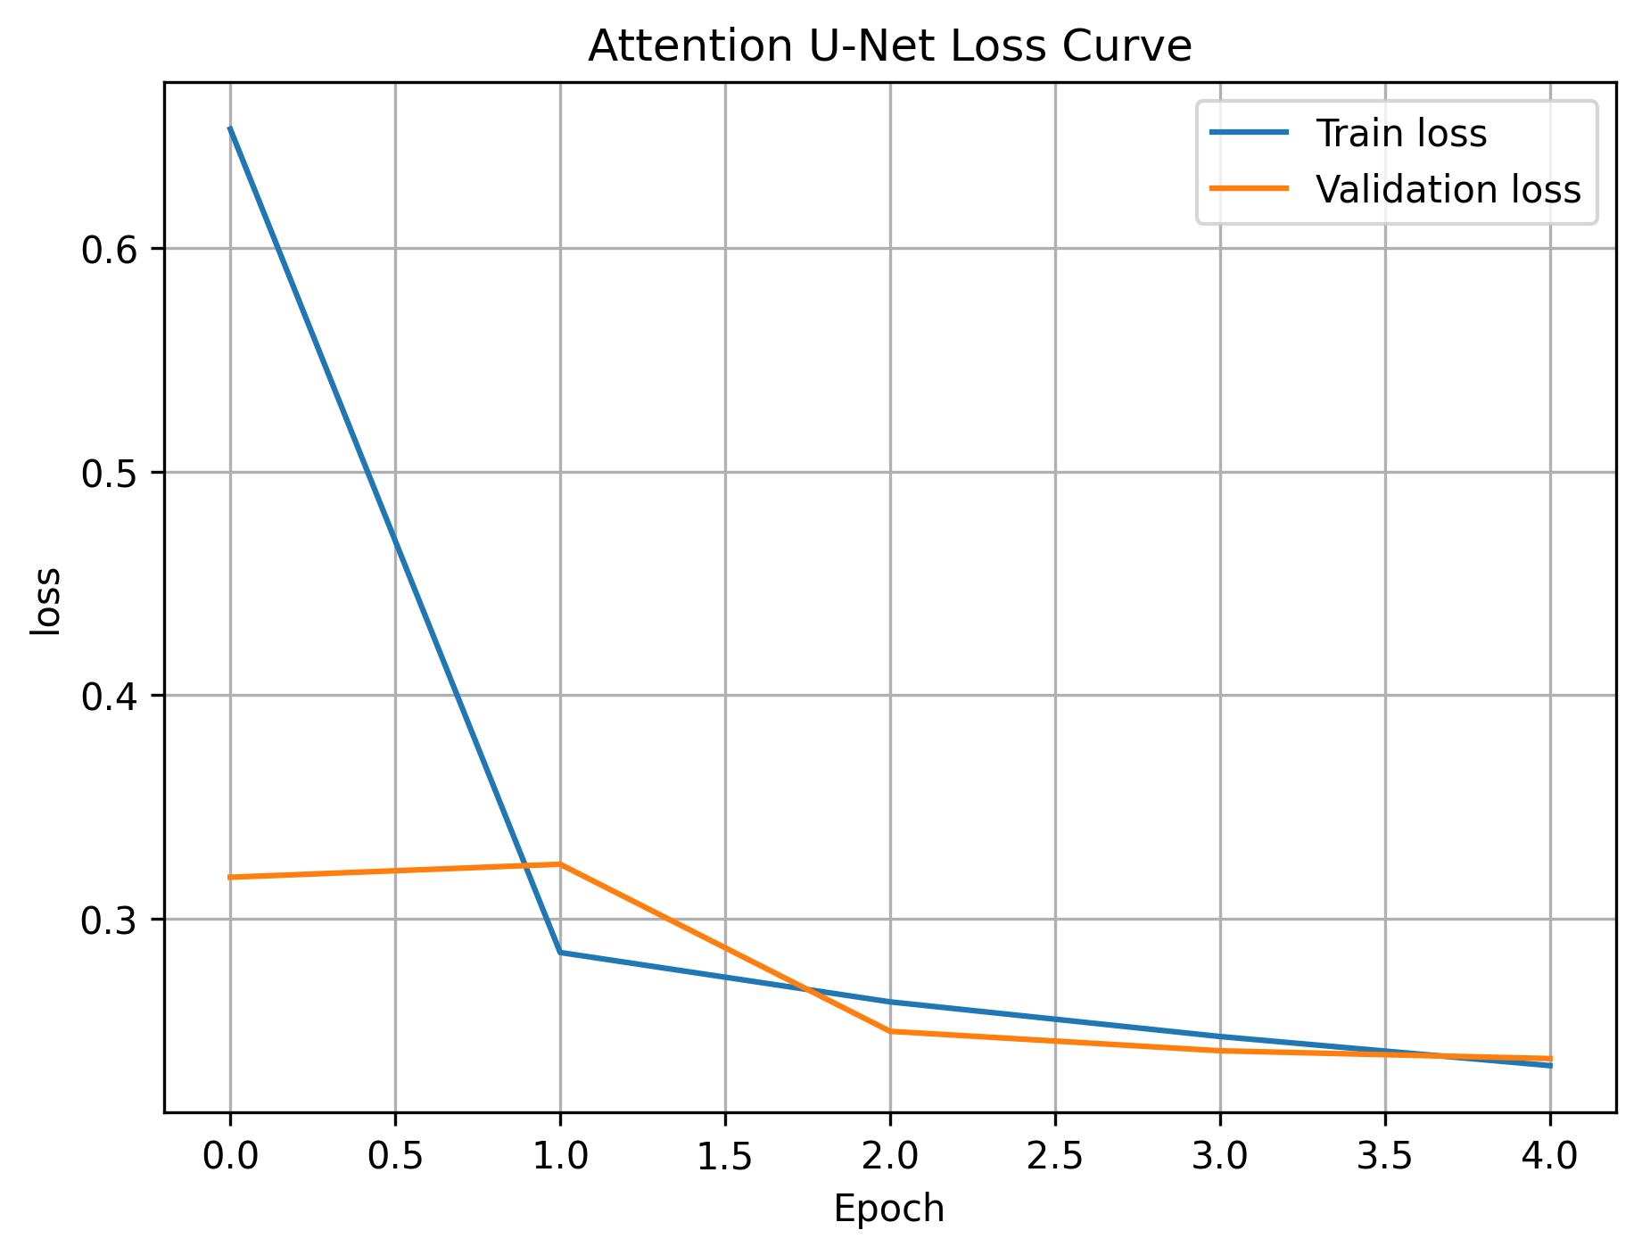
Figure 5. Attention U-Net loss curve.
The loss decreased sharply from the first epoch and continued to improve gradually until epoch 5. Validation loss also decreased, showing that the model learned useful features without major overfitting.
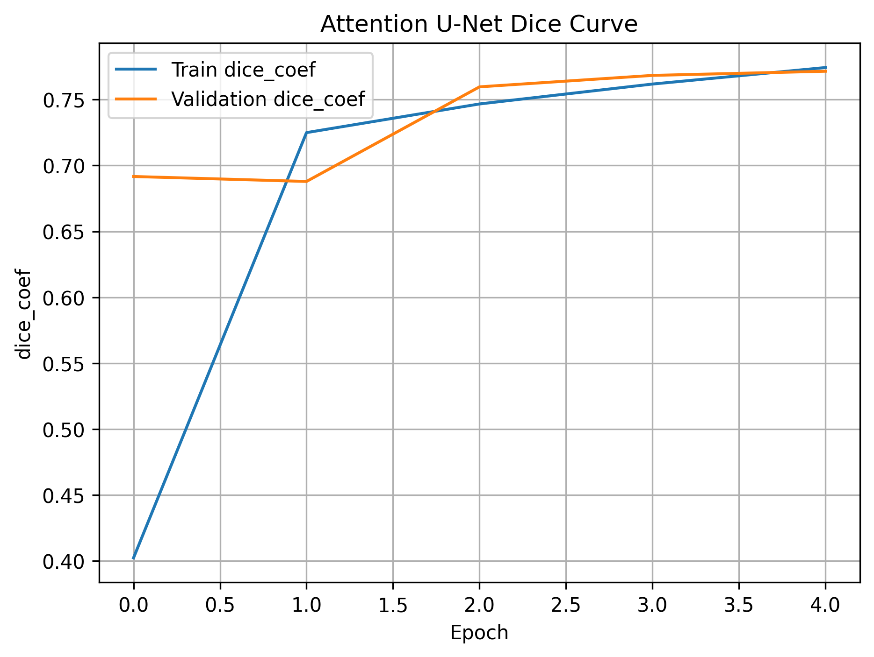
Figure 6. Attention U-Net Dice coefficient curve.
The training Dice increased from 0.4024 to 0.7743, while validation Dice reached 0.7715. This indicates that the predicted masks increasingly overlapped with the ground truth masks.
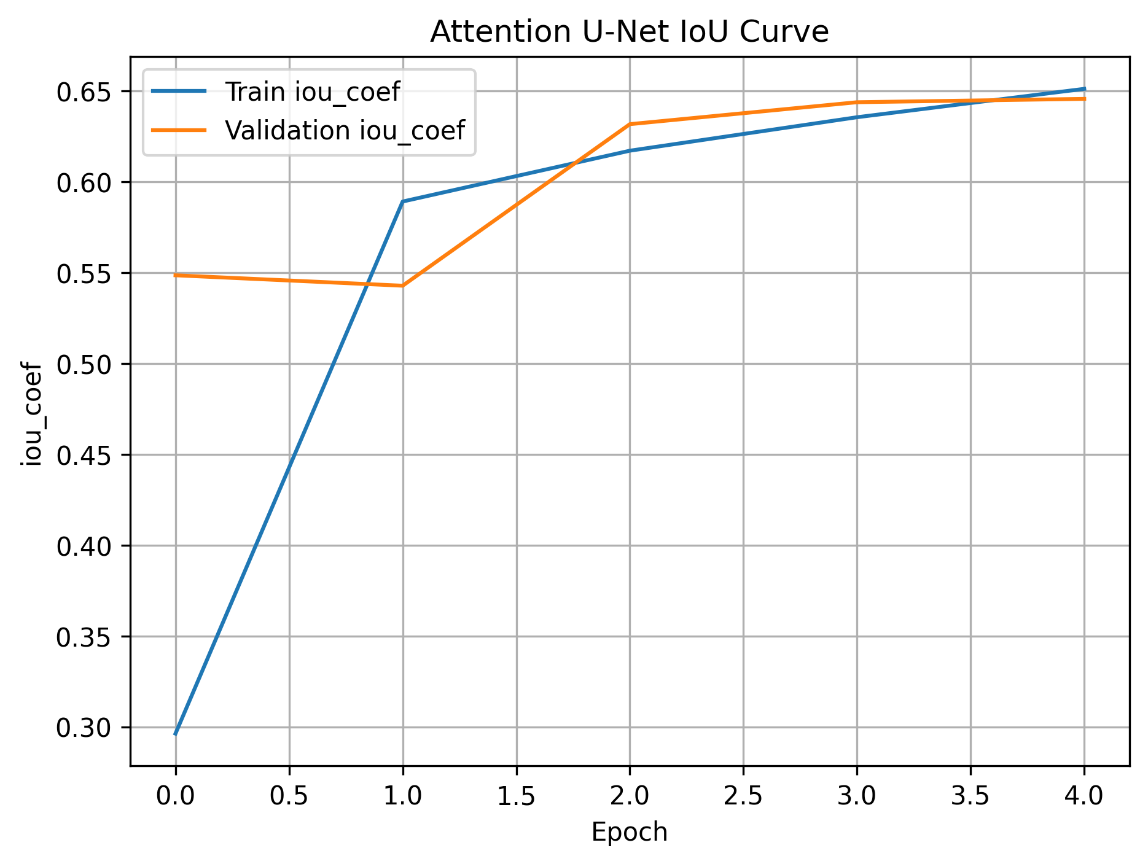
Figure 7. Attention U-Net IoU curve.
The IoU increased from 0.2963 to 0.6512 on training data and reached 0.6457 on validation data. This confirms improvement in intersection-over-union between predicted and annotated tumor regions.
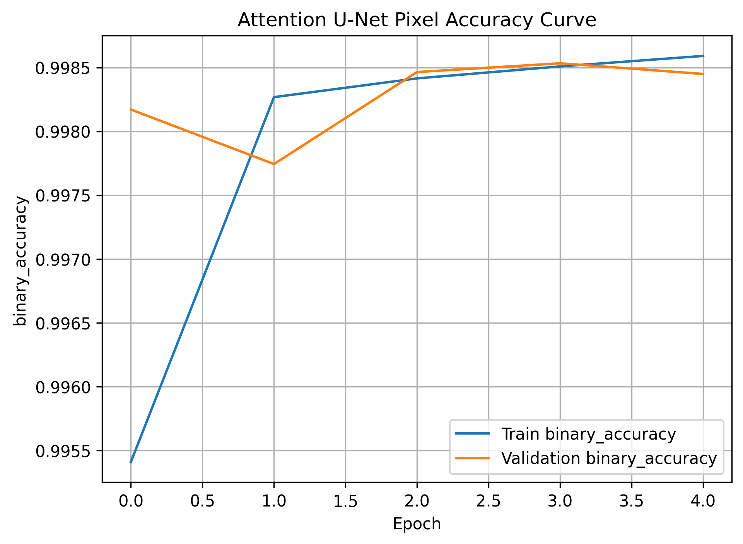
Figure 8. Attention U-Net pixel accuracy curve.
Pixel accuracy remained above 99.7% on validation data. This high value reflects stable pixel-wise classification, although Dice and IoU remain more meaningful for tumor segmentation because the background class dominates many slices.

7.2 Standard U-Net Curves
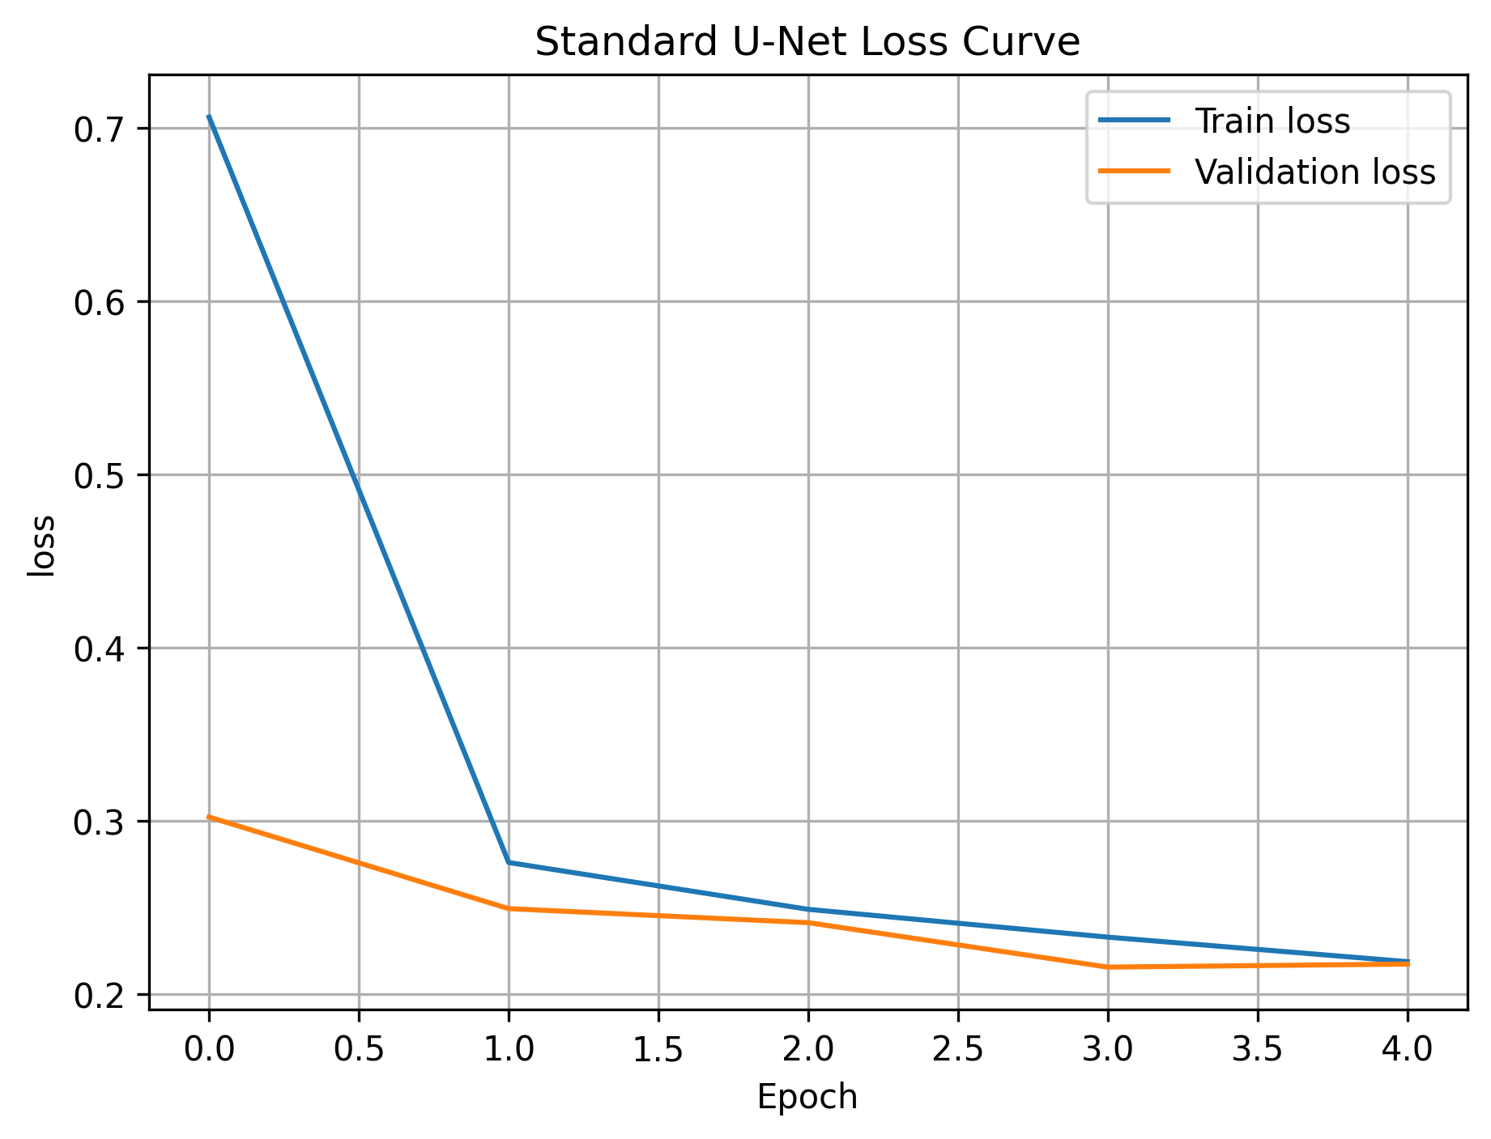
Figure 9. Standard U-Net loss curve.
The Standard U-Net loss decreased from 0.7061 to 0.2188 on training data and reached 0.2174 on validation data. The final validation loss was lower than Attention U-Net.
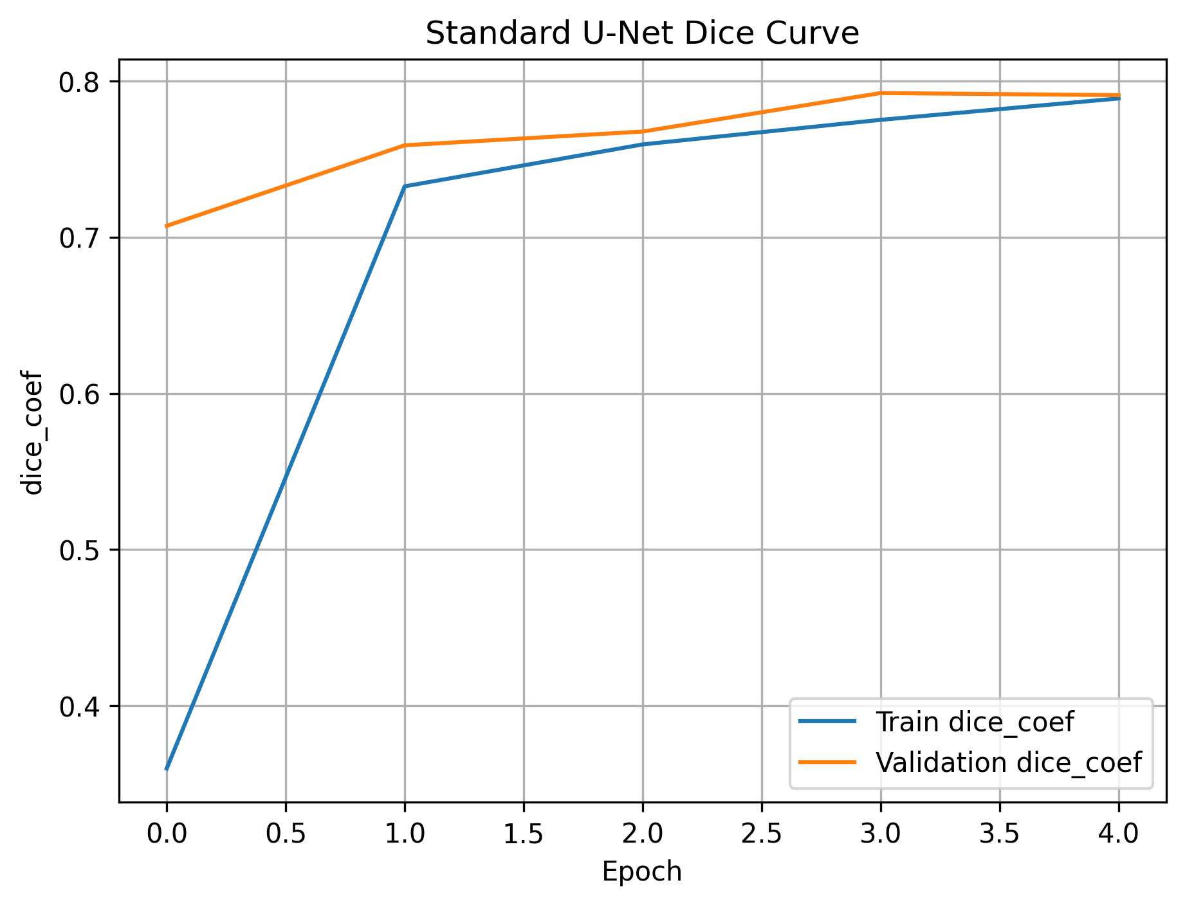
Figure 10. Standard U-Net Dice coefficient curve.
The Standard U-Net validation Dice increased to 0.7909 by the final epoch. This was the strongest Dice performance observed in the experiment.
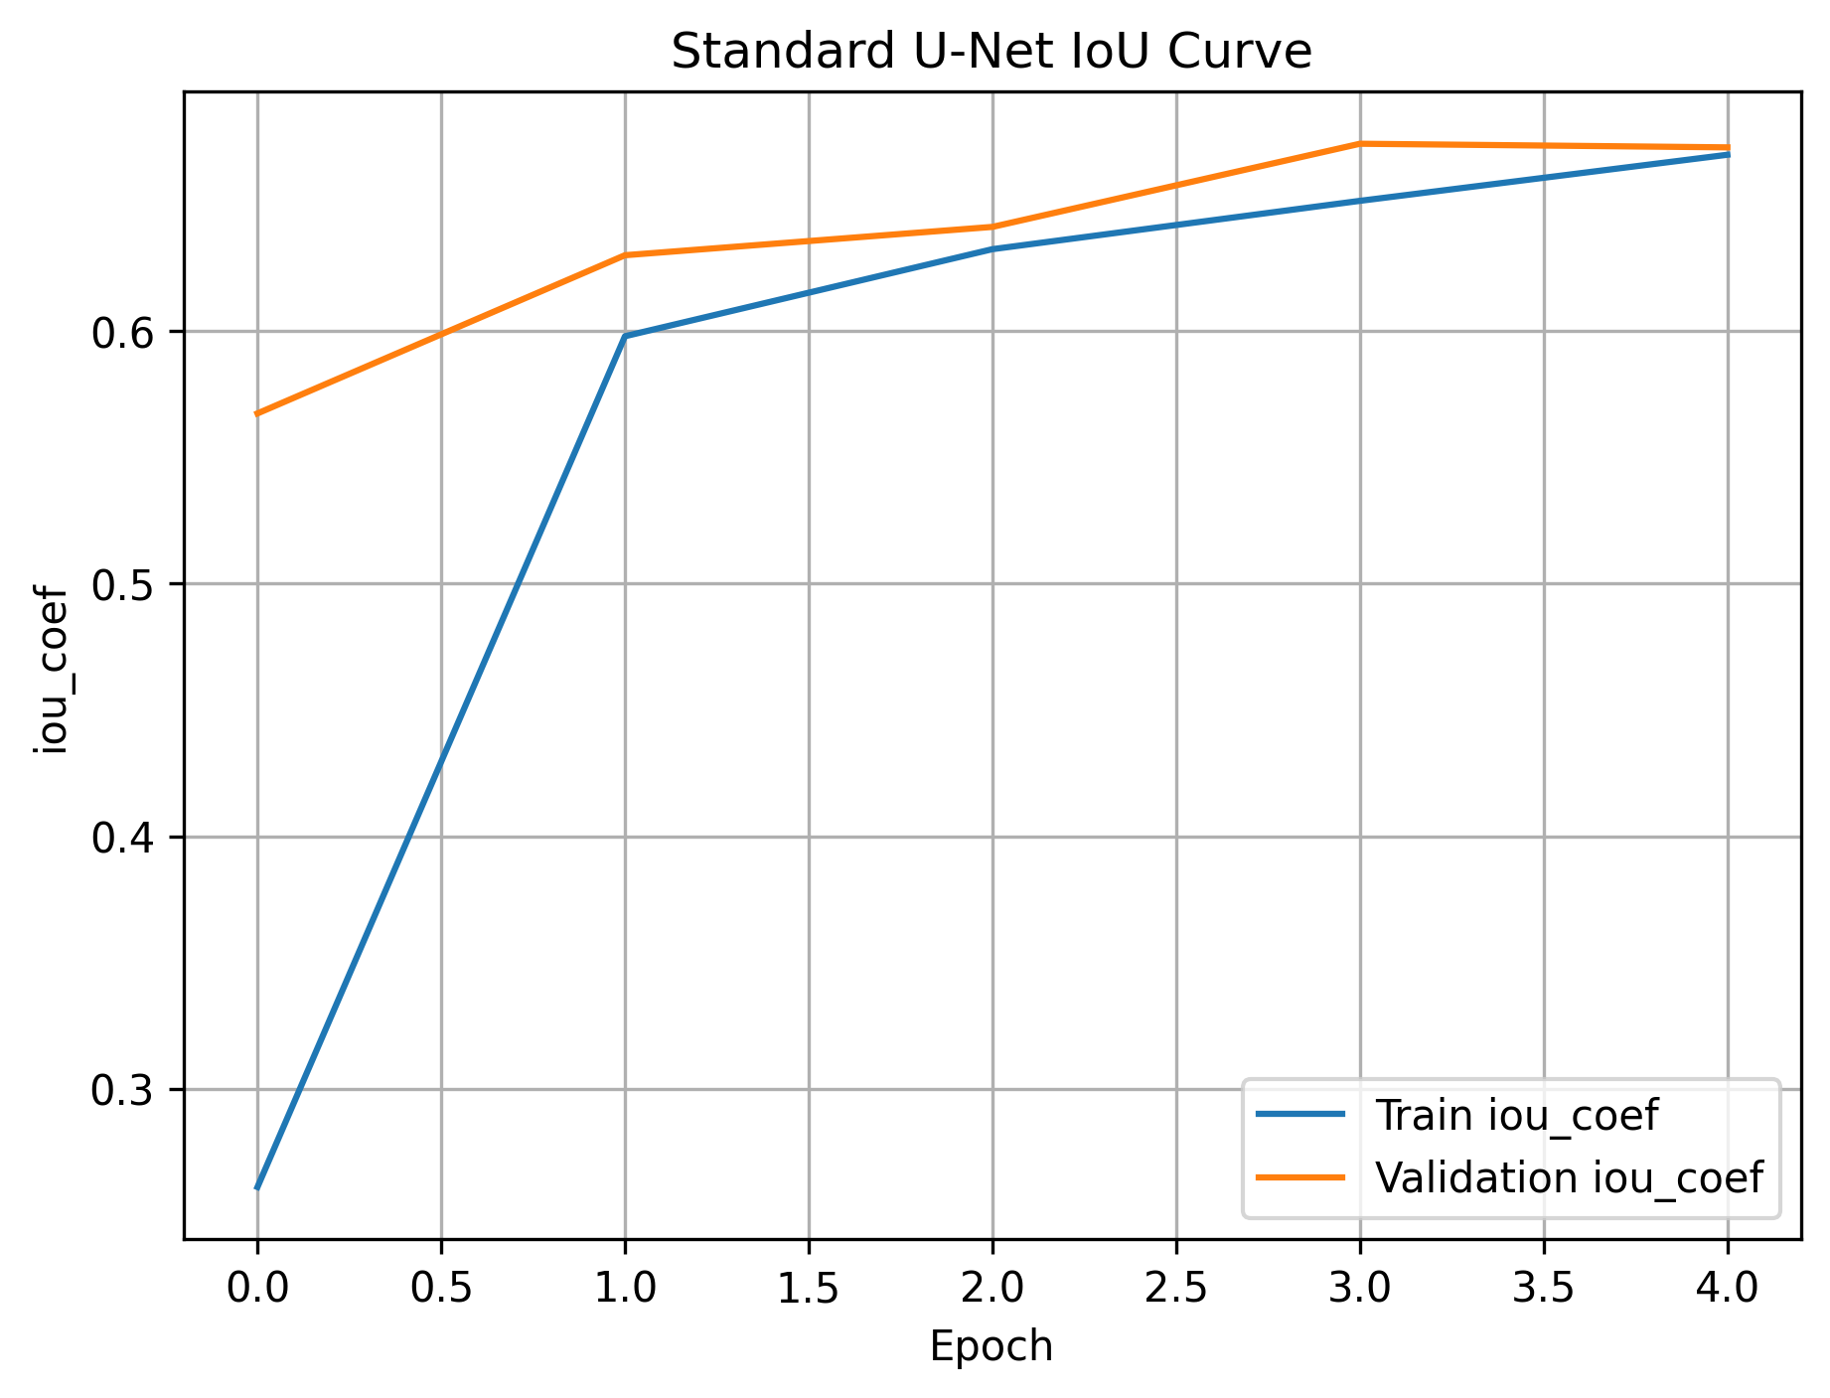
Figure 11. Standard U-Net IoU curve.
The Standard U-Net validation IoU reached 0.6728, which was higher than the Attention U-Net validation IoU. This indicates better overlap with expert masks under the same training duration.
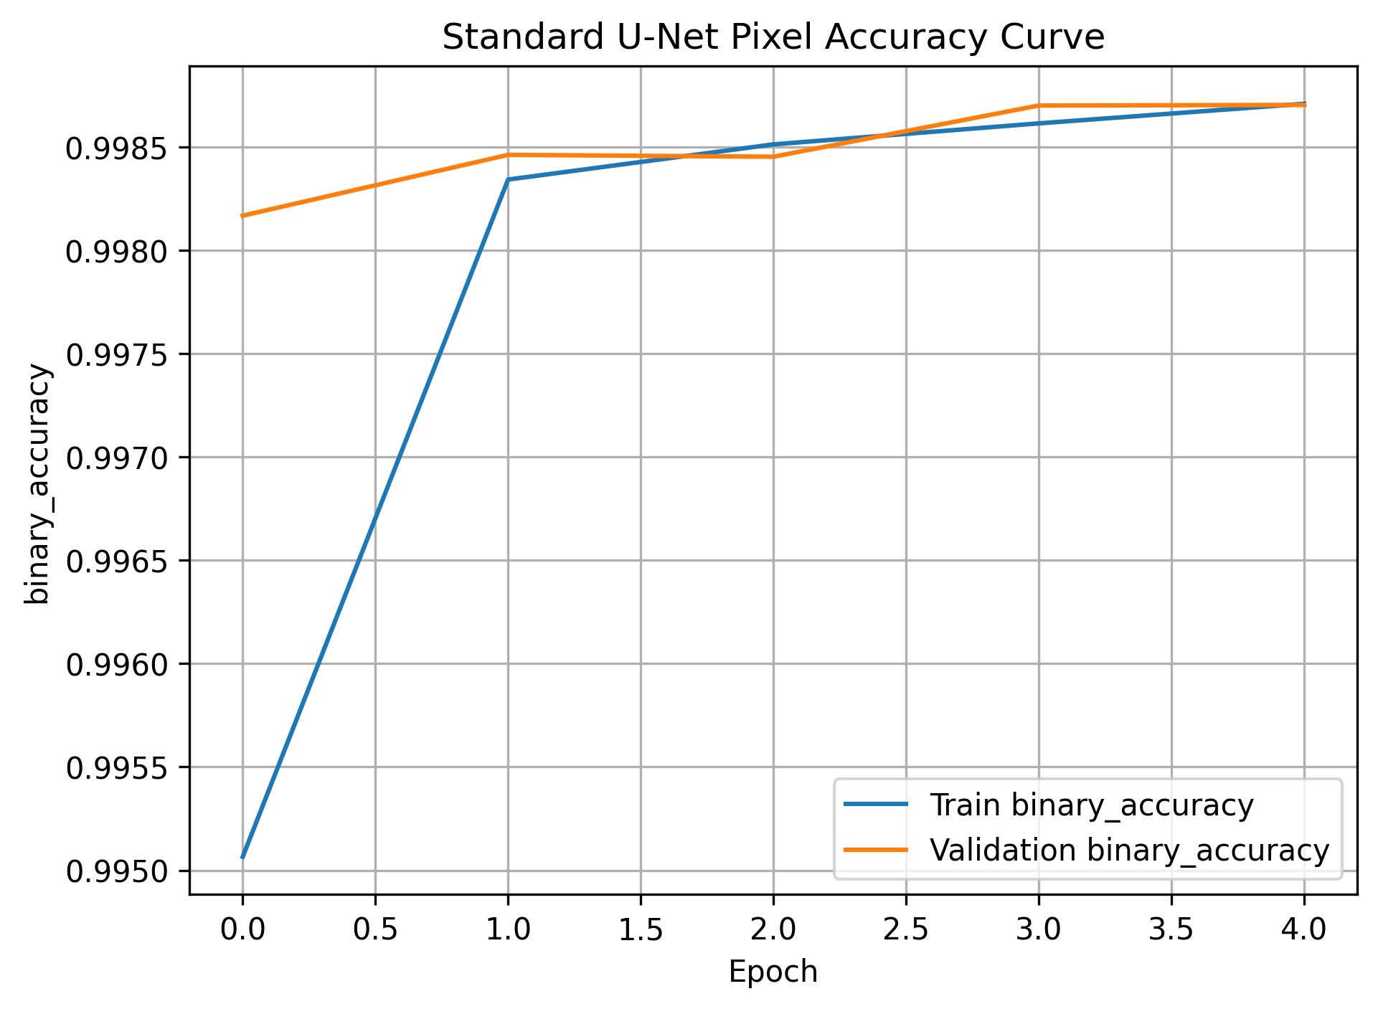
Figure 12. Standard U-Net pixel accuracy curve.
The pixel accuracy curve remains highly stable and exceeds 99.8% on validation data, showing consistent pixel-level classification performance.
8. Visual and Qualitative Results:
Quantitative metrics are important, but qualitative visual inspection is also necessary in medical segmentation. The following figures show MRI slices, ground truth masks, model predictions, and overlay views. The visual results help assess whether the predicted masks are placed in medically meaningful regions and whether the tumor boundaries are reasonable.

8.1 Attention U-Net vs Standard U-Net Visual Comparison
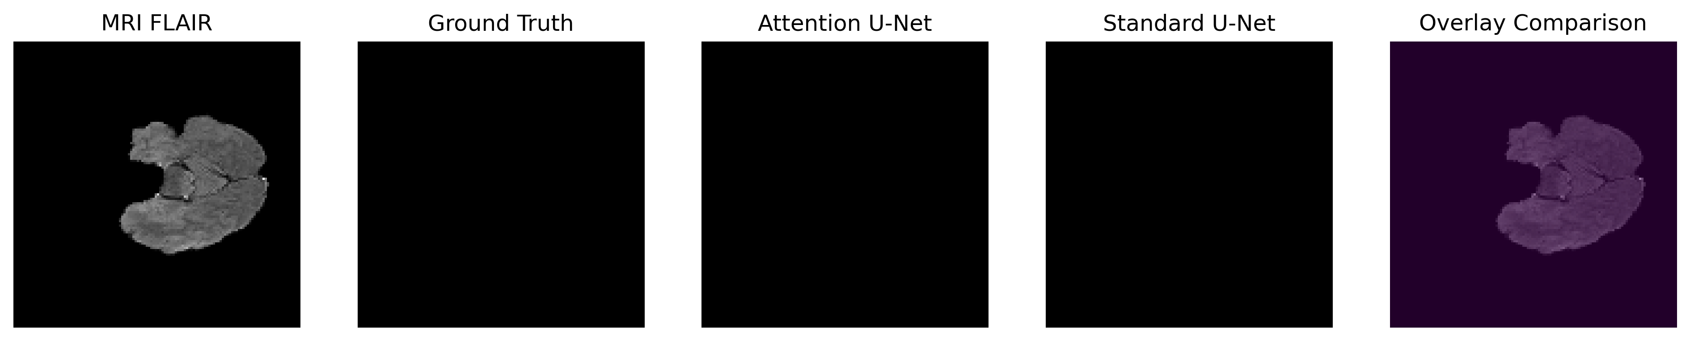
Figure 13. Attention U-Net vs Standard U-Net comparison - test case 1.
This example is a negative or near-negative slice in which no tumor mask is visible in the ground truth. Both models avoid producing a visible false positive, which is important because false detections can reduce clinical confidence.
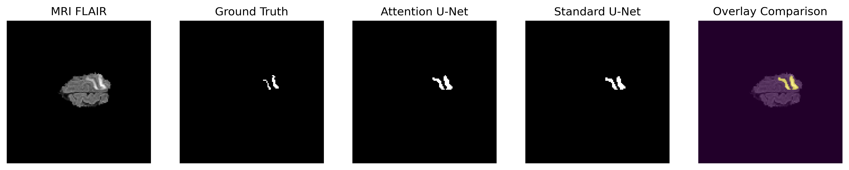
Figure 14. Attention U-Net vs Standard U-Net comparison - test case 2.
This example contains a small tumor region. Both models detect the tumor area and the overlay highlights the predicted region on the MRI slice. The result shows that even relatively small structures can be captured after limited training.
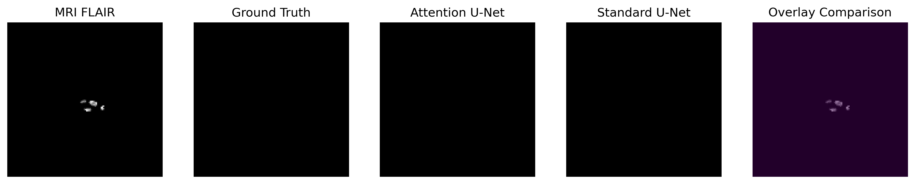
Figure 15. Attention U-Net vs Standard U-Net comparison - test case 3.
This case contains very small bright regions in the MRI input. The ground truth and model prediction panels remain mostly empty, suggesting that the networks did not incorrectly segment every bright structure as tumor tissue.
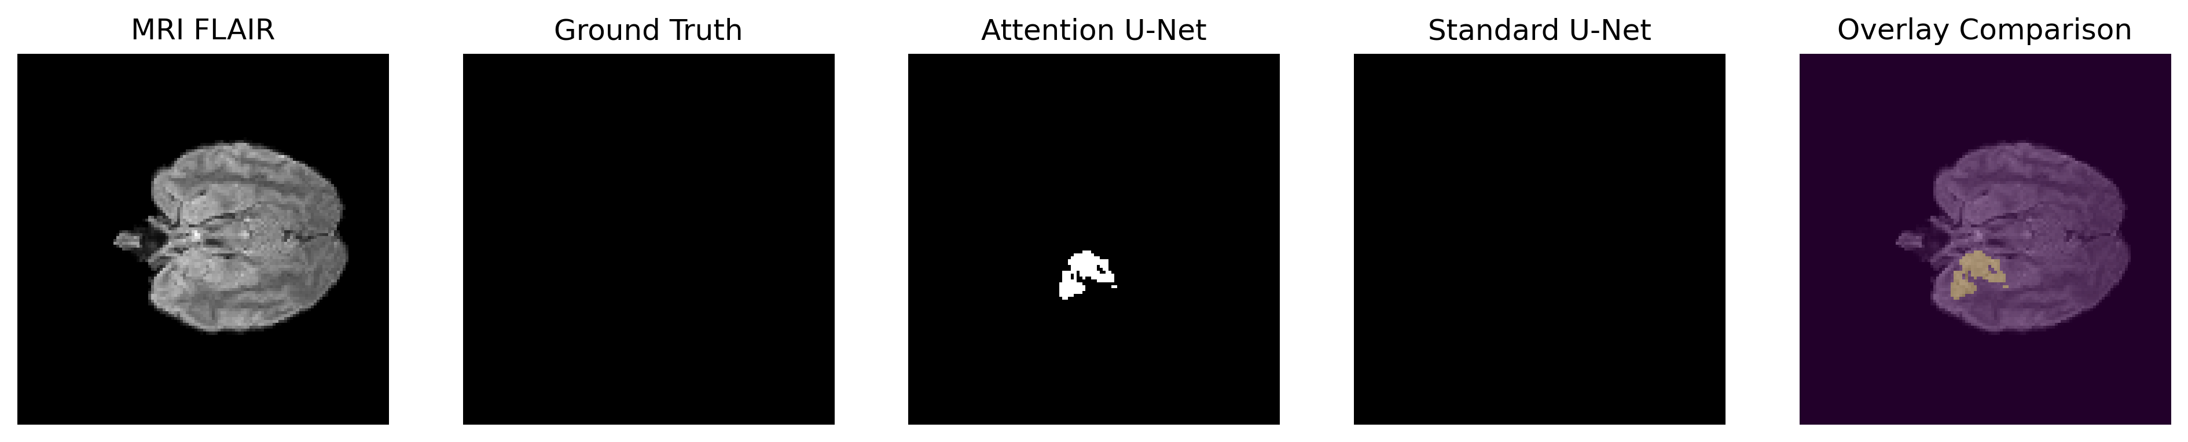
Figure 16. Attention U-Net vs Standard U-Net comparison - test case 4.
This case shows a challenging example where Attention U-Net predicts a region while the ground truth panel appears empty. This may represent a false positive prediction. It demonstrates the need for longer training, threshold tuning, or post-processing to suppress uncertain predictions.
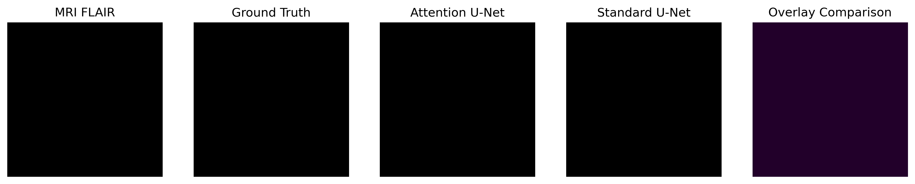
Figure 17. Attention U-Net vs Standard U-Net comparison - test case 5.
This is another negative or near-negative slice. The empty prediction panels indicate that both models can correctly keep the mask blank when no relevant tumor annotation is present.

8.2 Loaded Attention U-Net Prediction Results
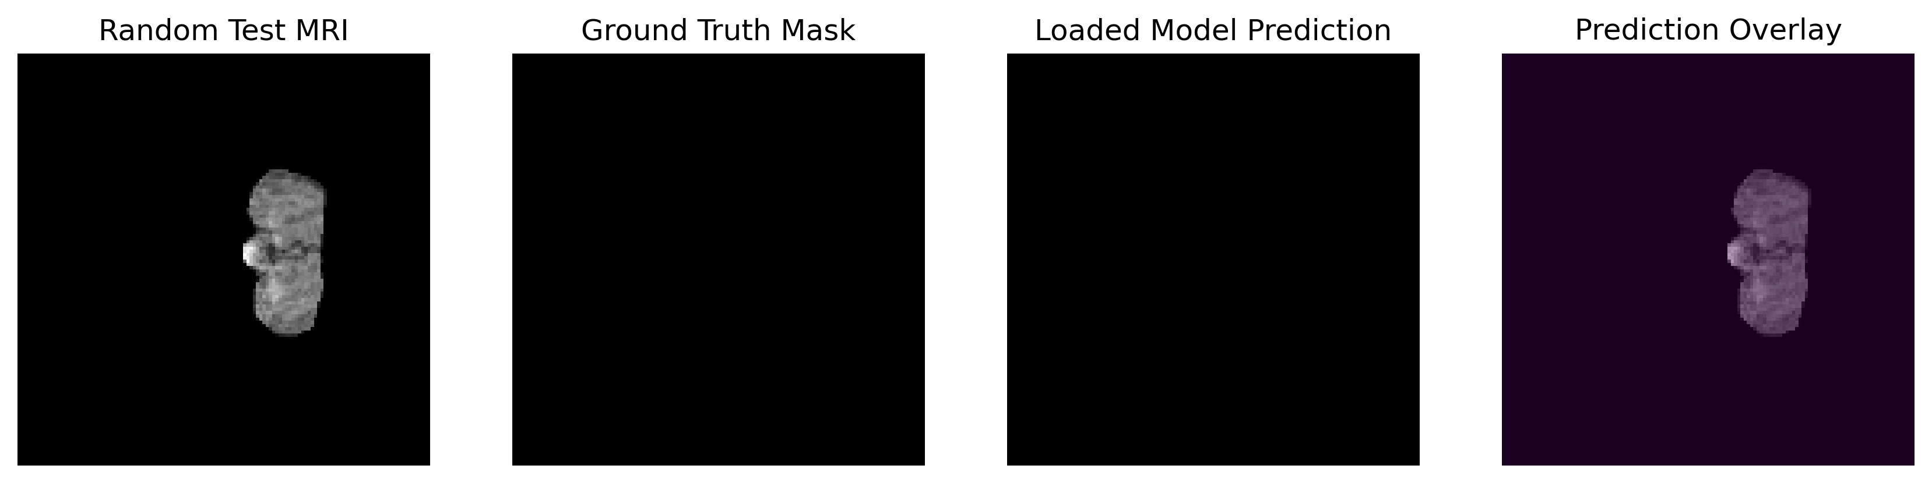
Figure 18. Loaded Attention U-Net random test prediction - case 1.
The loaded model produces a blank prediction when the ground truth mask is also blank. This indicates consistent behavior after saving and reloading model weights.
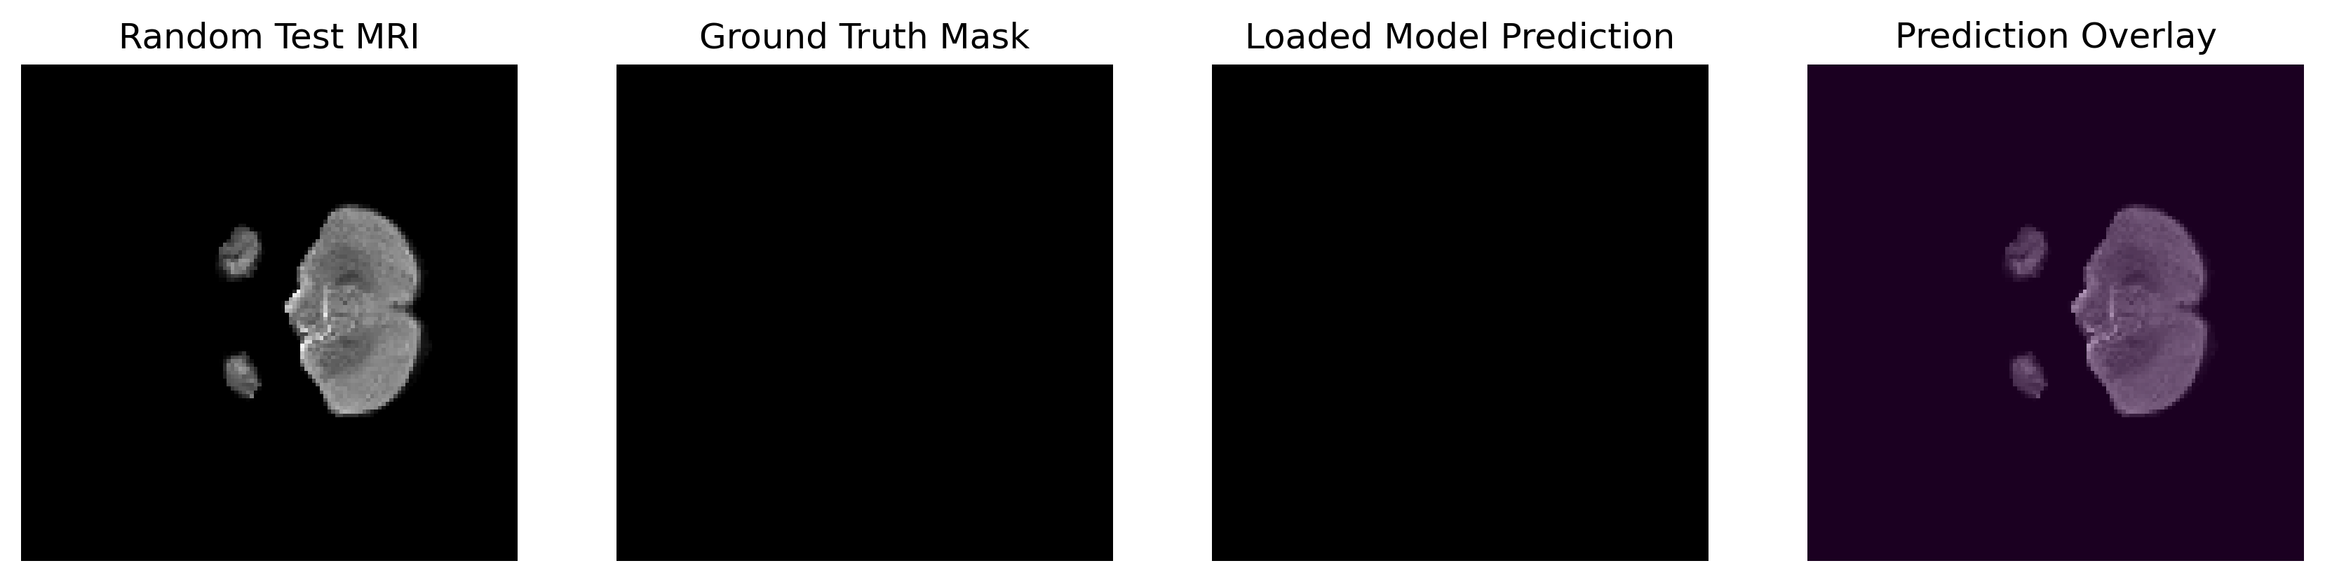
Figure 19. Loaded Attention U-Net random test prediction - case 2.
The second loaded-model sample also shows no tumor mask in the ground truth and no predicted tumor. This confirms that the model is not generating strong false positives in all negative slices.
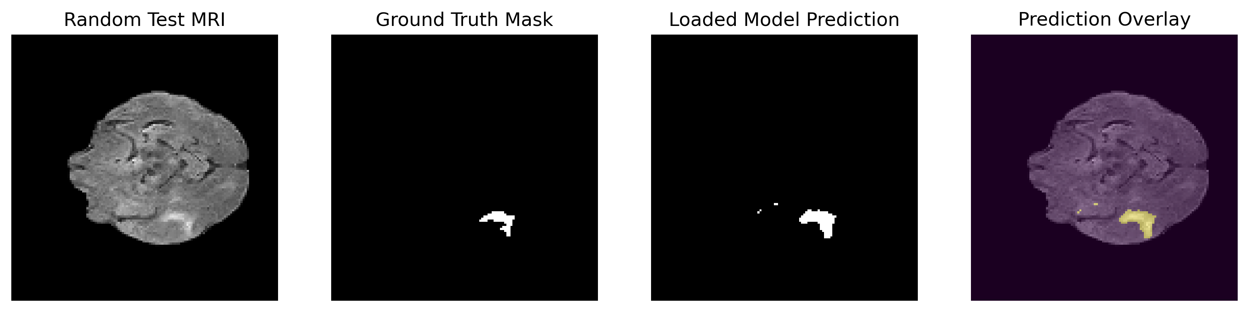
Figure 20. Loaded Attention U-Net random test prediction - case 3.
This case contains a visible ground truth region and the model predicts a similar tumor area. A few small extra pixels can be seen, but the main tumor structure is captured successfully.
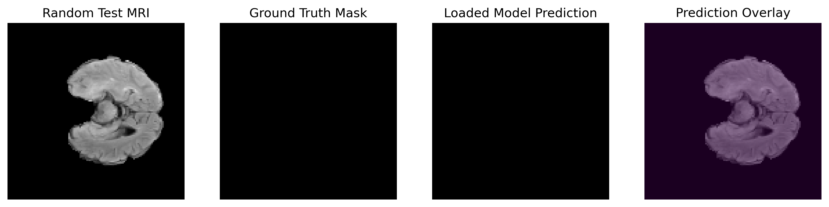
Figure 21. Loaded Attention U-Net random test prediction - case 4.
This negative slice remains blank in the prediction output. Such cases are important because many BraTS slices may contain little or no visible tumor tissue.
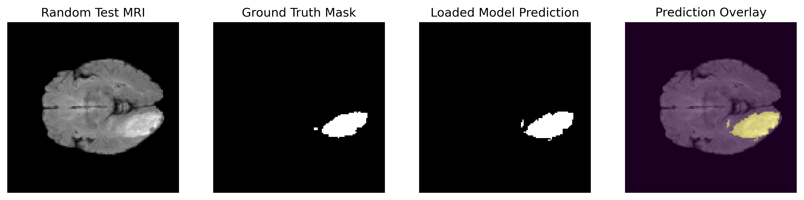
Figure 22. Loaded Attention U-Net random test prediction - case 5.
This case contains a large tumor region. The prediction closely follows the main annotated area and the overlay clearly shows tumor localization on the MRI image.

8.3 Additional Prediction Overlay Analysis
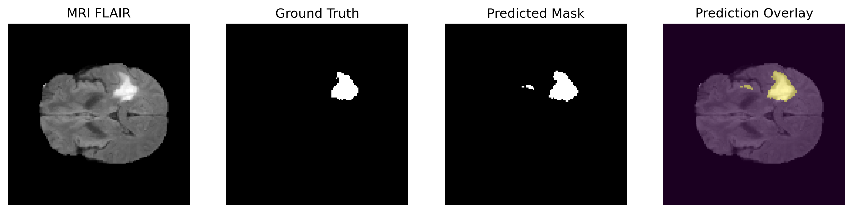
Figure 23. Attention U-Net prediction overlay - case 1.
The predicted mask overlaps the main ground truth region, and the overlay makes the tumor location easy to interpret. A small additional predicted region is visible, suggesting minor over-segmentation.
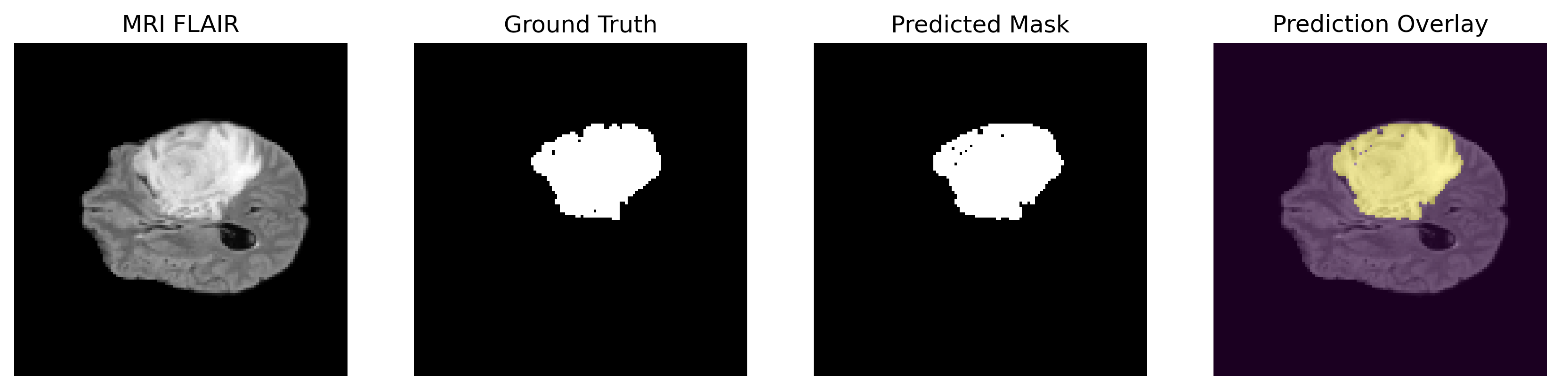
Figure 24. Attention U-Net prediction overlay - case 2.
The model performs well on a large tumor structure. The predicted mask covers the main high-intensity tumor region and follows the general shape of the ground truth.
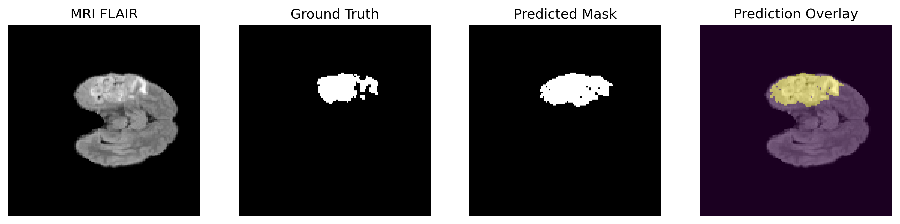
Figure 25. Attention U-Net prediction overlay - case 3.
The predicted mask captures the broad tumor area but smooths or simplifies some irregular boundaries. This is common when images are resized to 128 x 128 pixels.
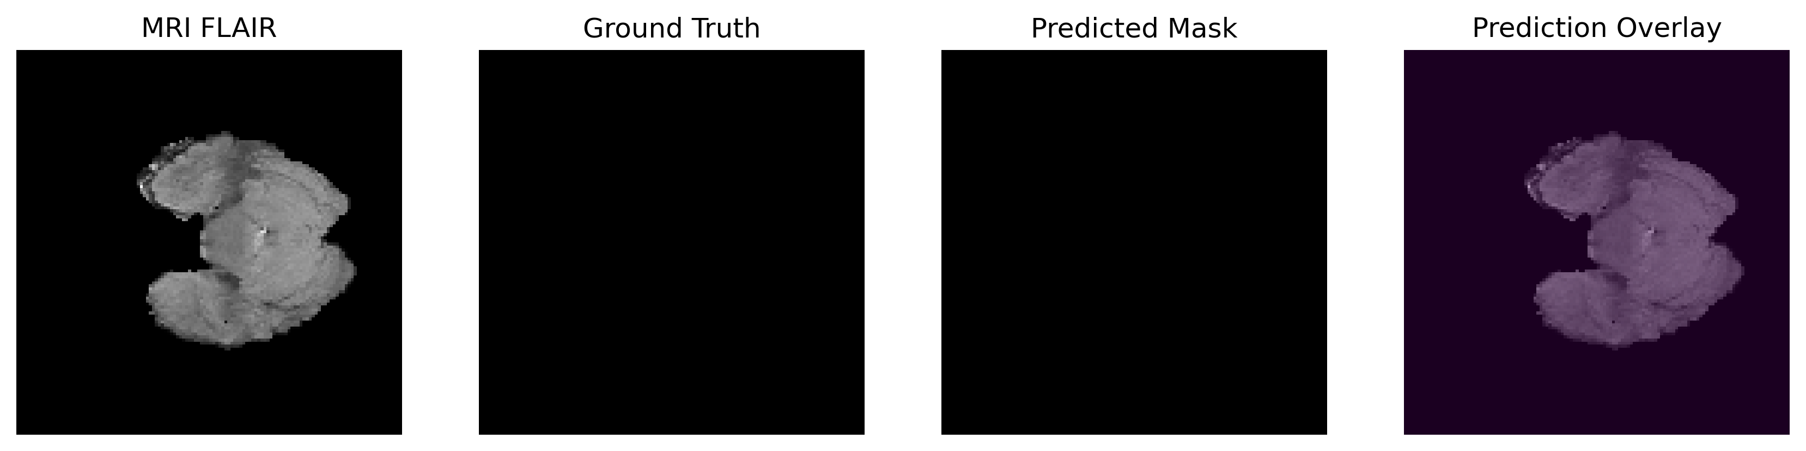
Figure 26. Attention U-Net prediction overlay - case 4.
The prediction remains blank in a slice where the ground truth is blank. This is a useful true-negative result.
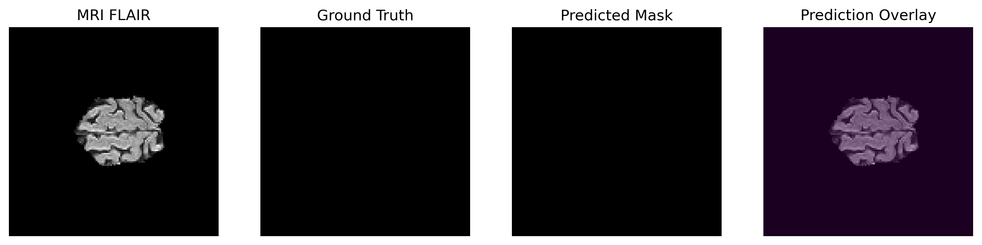
Figure 27. Attention U-Net prediction overlay - case 5.
The final overlay example also shows no predicted tumor where no mask is present, demonstrating stability on non-tumor or background-heavy slices.

9. Comparative Discussion:
The experiment produced an interesting result: the Standard U-Net slightly outperformed Attention U-Net in the final quantitative metrics. This is scientifically valid and important to report honestly. The expected advantage of Attention U-Net is improved focus on relevant regions through attention gates, but this advantage does not always appear under every training configuration.
A likely reason is the short training duration. Attention mechanisms introduce additional parameters and gating operations. With only 5 epochs, the attention gates may not have had enough time to learn optimal feature filtering. Standard U-Net, being simpler, may converge faster under limited training. The reduced image resolution of 128 x 128 pixels may also limit the benefit of attention because fine boundary details are compressed.
The visual outputs show that both models are capable of producing meaningful masks. In several cases, blank ground truth slices are correctly predicted as blank. In tumor-positive slices, the models identify the main tumor areas with reasonable shape agreement. Some false positives and boundary smoothing are visible, which are expected limitations in a short training experiment.

10. Limitations:
- The models were trained for only 5 epochs, which is useful for quick experimentation but not enough for maximum medical segmentation performance.
- All slices were resized to 128 x 128 pixels, which reduces computational cost but may remove fine tumor boundary details.
- The experiment used 2D slice-based segmentation rather than full 3D volumetric context.
- Some visual examples show small false-positive regions, especially in difficult or ambiguous slices.

11. Future Work:
- Train both models for 50-100 epochs with carefully monitored validation performance.
- Use higher resolution inputs to preserve more boundary information.
- Implement 3D U-Net or 3D Attention U-Net to exploit volumetric context across MRI slices.
- Add advanced data augmentation such as rotation, scaling, intensity shifts, elastic deformation, and random cropping.
- Apply post-processing to remove tiny false-positive islands from predicted masks.
- Explore Transformer-based segmentation models such as UNet Transformer variants.
- Store all evaluation metrics explicitly in JSON, including Dice, IoU, binary accuracy, precision, recall, and Hausdorff distance.
- Evaluate on additional BraTS validation/test splits or multi-center datasets for stronger generalization assessment.

12. Conclusion:
This project successfully implemented brain tumor segmentation from multi-modal MRI using Attention U-Net and Standard U-Net. The BraTS 2020 H5 slice dataset was used with four MRI modalities as input and three tumor mask channels as output. The pipeline included data loading, resizing, normalization, model training, testing, and visual prediction overlays.
Attention U-Net achieved a test loss of 0.2423 and test score of 0.7664. Standard U-Net achieved a lower test loss of 0.2195 and a higher test score of 0.7881. The final validation results also favored Standard U-Net, with validation Dice of 0.7909 compared with 0.7715 for Attention U-Net.
Overall, the results confirm that U-Net-based architectures are highly suitable for medical image segmentation. The Standard U-Net provided the strongest numerical performance in this short experiment, while Attention U-Net remained competitive and demonstrated meaningful tumor localization. With longer training, higher-resolution inputs, and volumetric context, the attention-based model may become more effective.

References
[1] Ronneberger, O., Fischer, P., & Brox, T. (2015). U-Net: Convolutional Networks for Biomedical Image Segmentation. MICCAI.
[2] Oktay, O., Schlemper, J., Folgoc, L. L., et al. (2018). Attention U-Net: Learning Where to Look for the Pancreas. arXiv preprint.
[3] Menze, B. H., Jakab, A., Bauer, S., et al. (2015). The Multimodal Brain Tumor Image Segmentation Benchmark (BRATS). IEEE Transactions on Medical Imaging.
[4] Bakas, S., Akbari, H., Sotiras, A., et al. (2017). Advancing The Cancer Genome Atlas glioma MRI collections with expert segmentation labels and radiomic features. Scientific Data.
[5] Bakas, S., Reyes, M., Jakab, A., et al. (2018). Identifying the Best Machine Learning Algorithms for Brain Tumor Segmentation. MICCAI BraTS Challenge.
[6] Isensee, F., Jaeger, P. F., Kohl, S. A. A., Petersen, J., & Maier-Hein, K. H. (2021). nnU-Net: a self-configuring method for deep learning-based biomedical image segmentation. Nature Methods.
[7] Milletari, F., Navab, N., & Ahmadi, S. A. (2016). V-Net: Fully Convolutional Neural Networks for Volumetric Medical Image Segmentation. 3DV.
[8] Çiçek, O., Abdulkadir, A., Lienkamp, S. S., Brox, T., & Ronneberger, O. (2016). 3D U-Net: Learning Dense Volumetric Segmentation from Sparse Annotation. MICCAI.
[9] Kingma, D. P., & Ba, J. (2015). Adam: A Method for Stochastic Optimization. ICLR.
[10] Goodfellow, I., Bengio, Y., & Courville, A. (2016). Deep Learning. MIT Press.

