**Research Hub**

**Design Document**

**Version 1.0**



**Group Id: S2402A5702**

**Supervisor Name: Syed Aun Ali Bukhari**

**Revision History**

|  |  |  |  |
| --- | --- | --- | --- |
| **Date (dd/mm/yyyy)** | **Version** | **Description** | **Author** |
| 11/7/2024 | 1.0 | The design document lays out the technical plan for the Research Hub. It explains what features the platform will have, how we will arrange the data, and how users will use the system. This makes sure that everyone working on the project (developers, designers) understands the plan and knows how to build the Research Hub. | BC200405081 |
|  |  |  |  |
|  |  |  |  |
|  |  |  |  |

**Table of Contents**

1. **Introduction of Design Document**
2. **Entity Relationship Diagram (ERD)**
3. **Sequence Diagrams**
4. **Architecture Design Diagram**
5. **Class Diagram**
6. **Database Design**
7. **Interface Design**
8. **Test Cases**

**Introduction of Design Document**

This document explains the needs for the Research Hub, an online platform made to help with research cooperation. It describes how the platform should work according to a user's view and what features it should offer.

**Benefits and Purpose**

**Clarity and Alignment:**

It clearly explains what the Research Hub should do for everyone involved (developers, users, administrators). This removes confusion and makes sure everyone is aiming for the same targets.

**Foundation for Design:**

The functional requirements are the basis for the design phase. They help make choices about user interface elements, data structures, and the overall system design.

**Testing and Evaluation:**

These conditions help create testing scenarios to confirm that the final product works as expected.

**Document inclusions:**

**Functional Requirements:**

This section details the functionalities the Research Hub should offer, categorized into user roles (regular users and administrators). These functionalities are further broken down into specific actions and features.

**Entity Relationship Diagram (ERD):**

This is a Diagram that shows the connections between different pieces of data in the system. It helps us know what data we need and how we can store and use it.

**Sequence diagrams:**

Sequence diagrams illustrate the flow of interactions between different parts of the system (users, database) for a specific task. They show the messages exchanged and the order of events.

**Architecture Design Diagram:**

This diagram depicts the high-level architecture of the Research Hub, including components like the user interface, database, and application logic. It clarifies how these components interact to deliver the functionalities.

**Class Diagram:**

This Diagram shows the classes (objects) in the software, what data they have, and what they do. It helps us see the design of the Research Hub.

**Database Design:**

This explains how the database that holds all the data (like user information, resources, project details, etc.) for the Research Hub is set up. It talks about tables, columns, types of data, and how they're connected.

**Interface Design:**

This explains the design of the user interface (where users input information) for the Research Hub. It talks about the layout, items like buttons and menus, and how the user interacts with it.

**Test Cases:**

Test scenarios are developed based on what the Research Hub should do. They lay out specific situations and what we expect to happen to make sure the system is working as it should.

This phase will involve creating the ERD, sequence diagrams, architecture design diagram, class diagram, and UI mockups. In parallel, the database design will be finalized. Finally, test cases will be developed to ensure the Research Hub meets all the specified functionalities.

**Entity Relationship diagram**

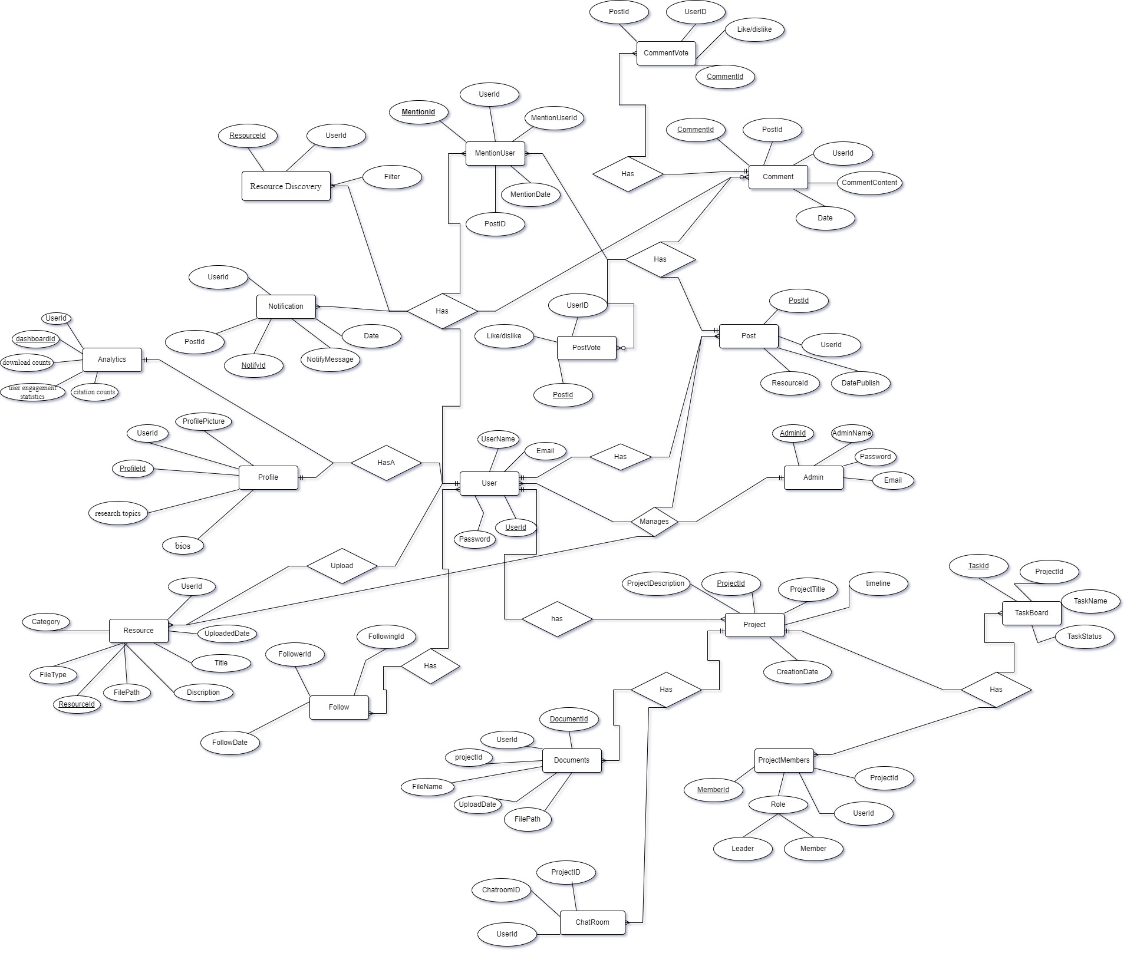

**Sequence Diagram**

**User Registration and Authentication**

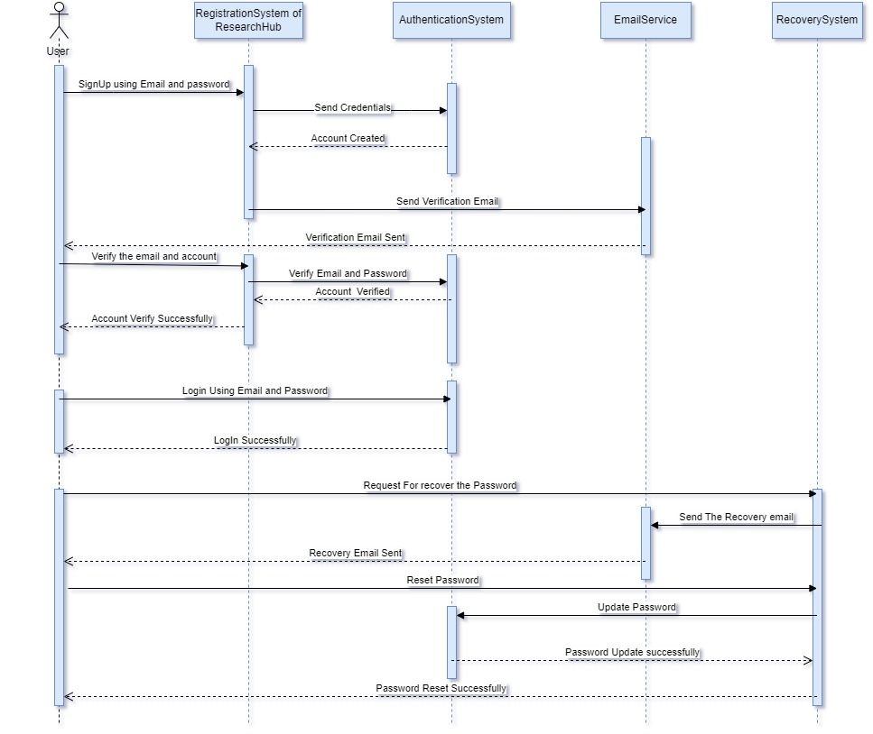

**Admin Dashboard**

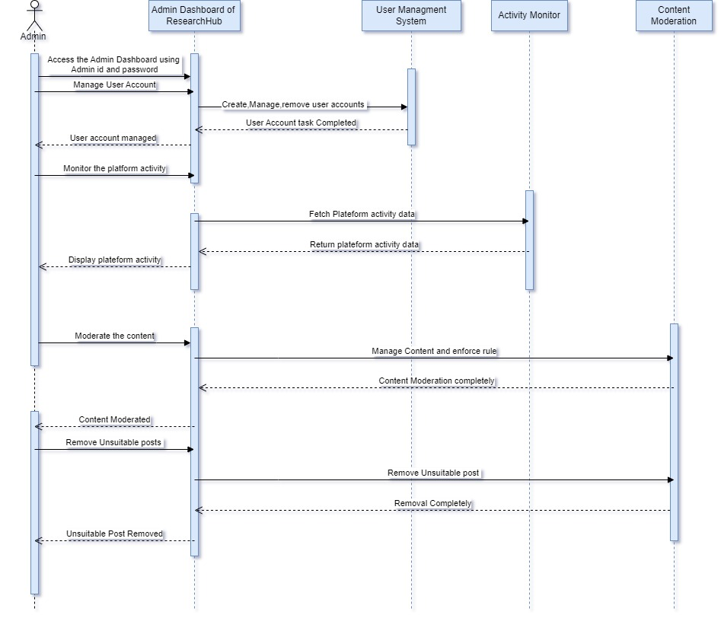

**Profile Management**

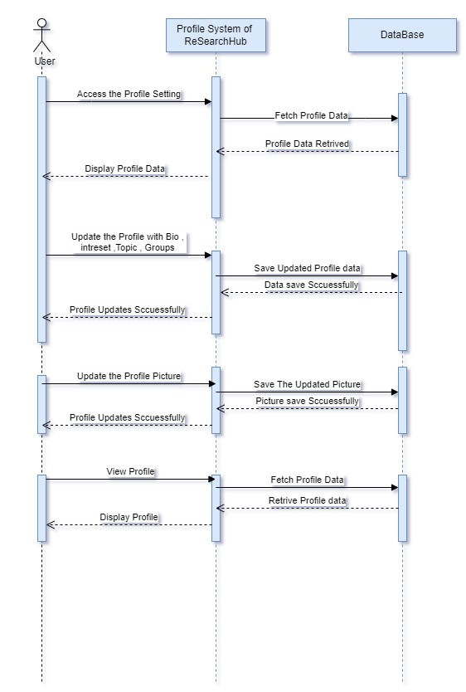

**Resource Upload and Sharing:**

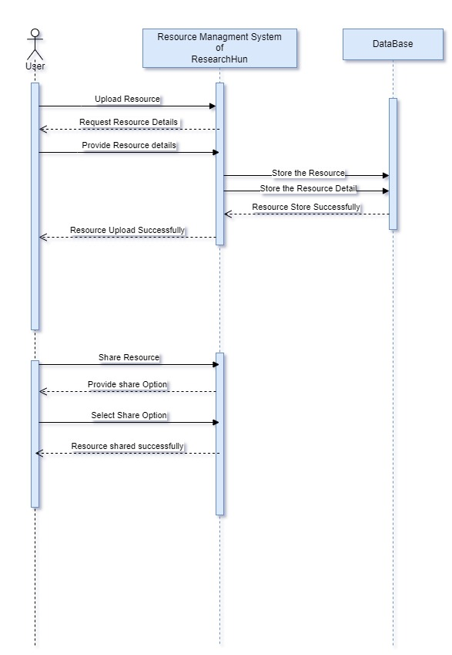

**Resource Discovery:**

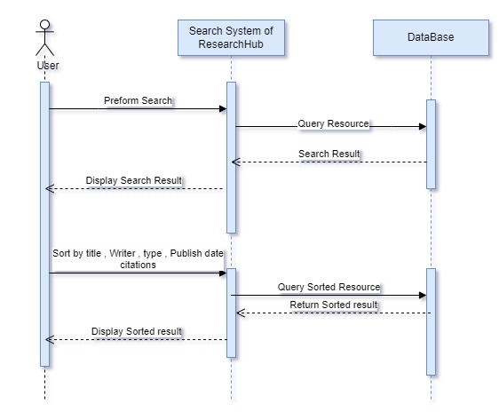

**Discussion Forums:**

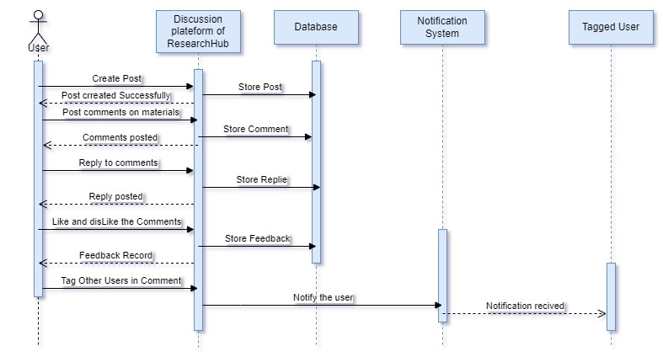

**Collaborative Projects:**

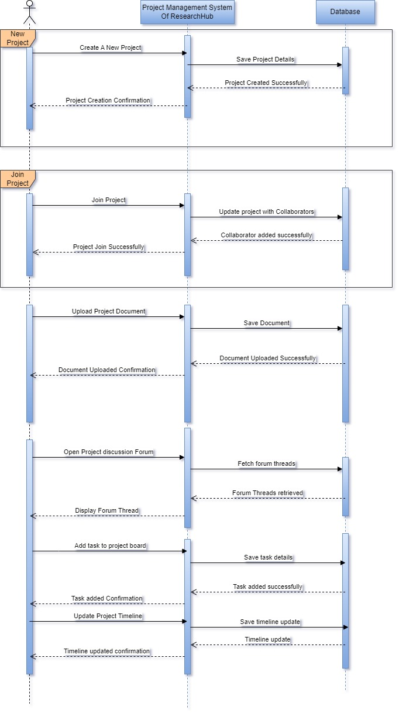

**Social Networking Features:**

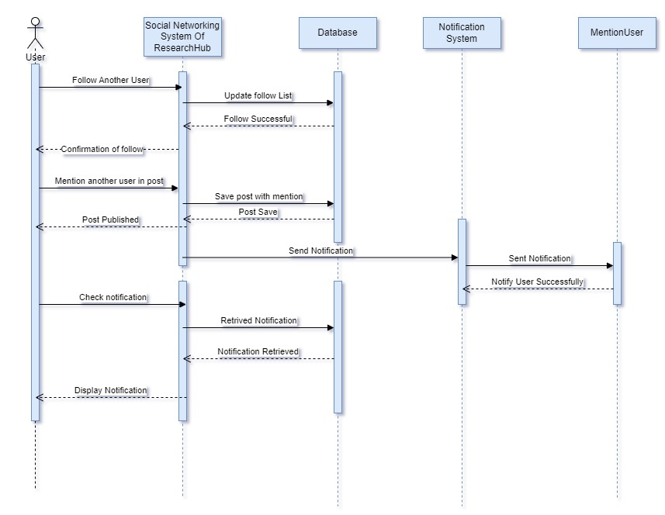

**Analytics and Reporting:**

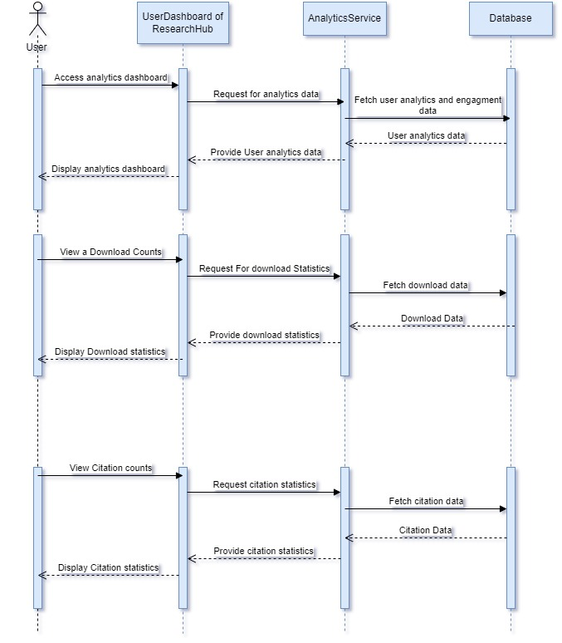

**Architecture Design Diagram**

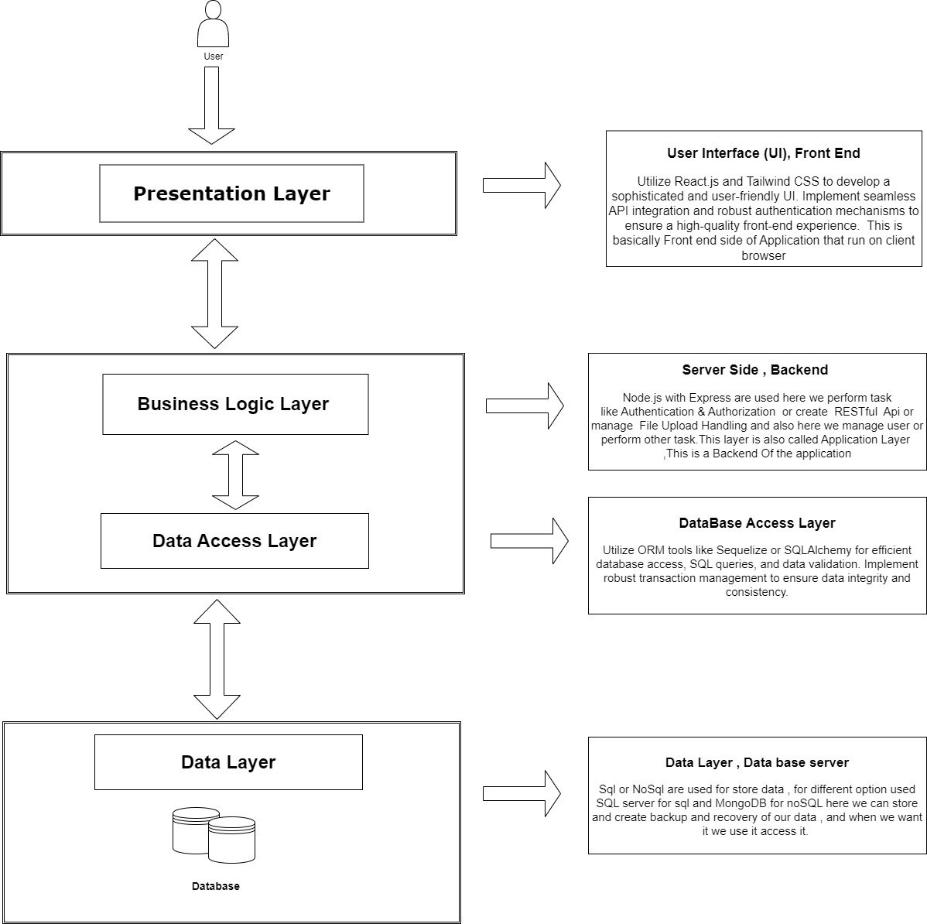

**Class diagram**

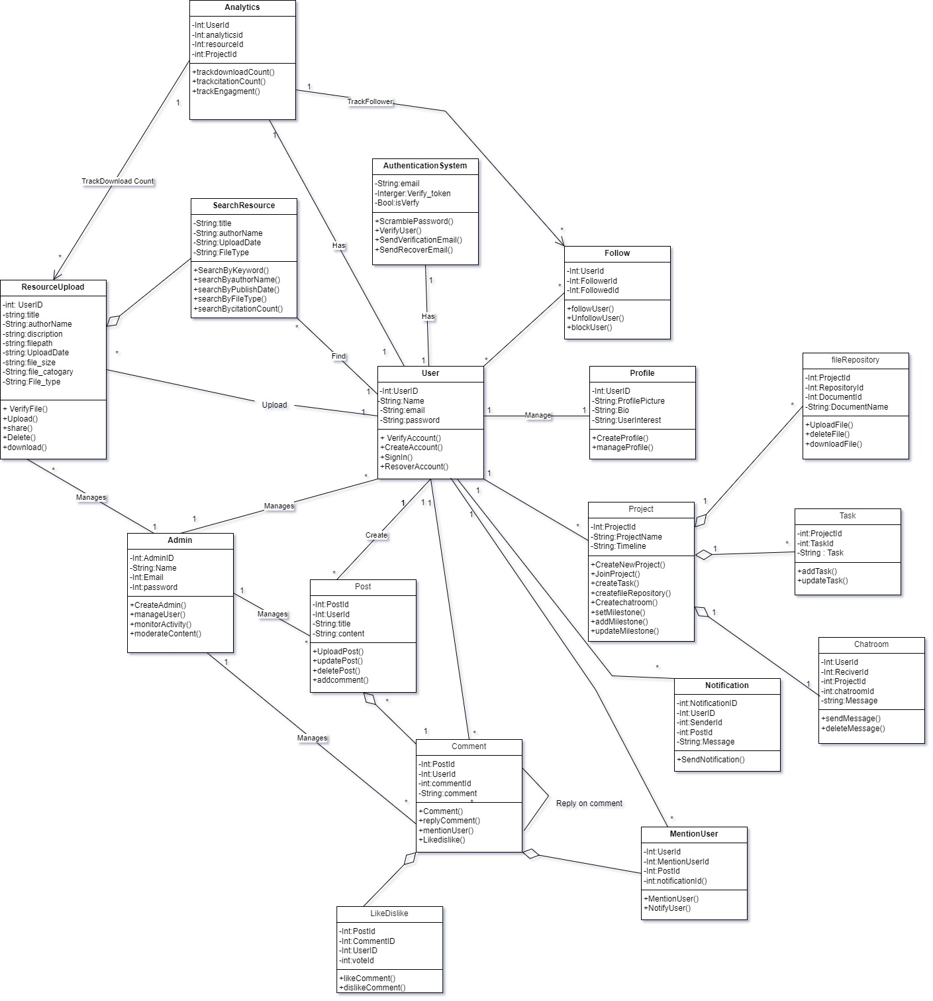

**Database Design**

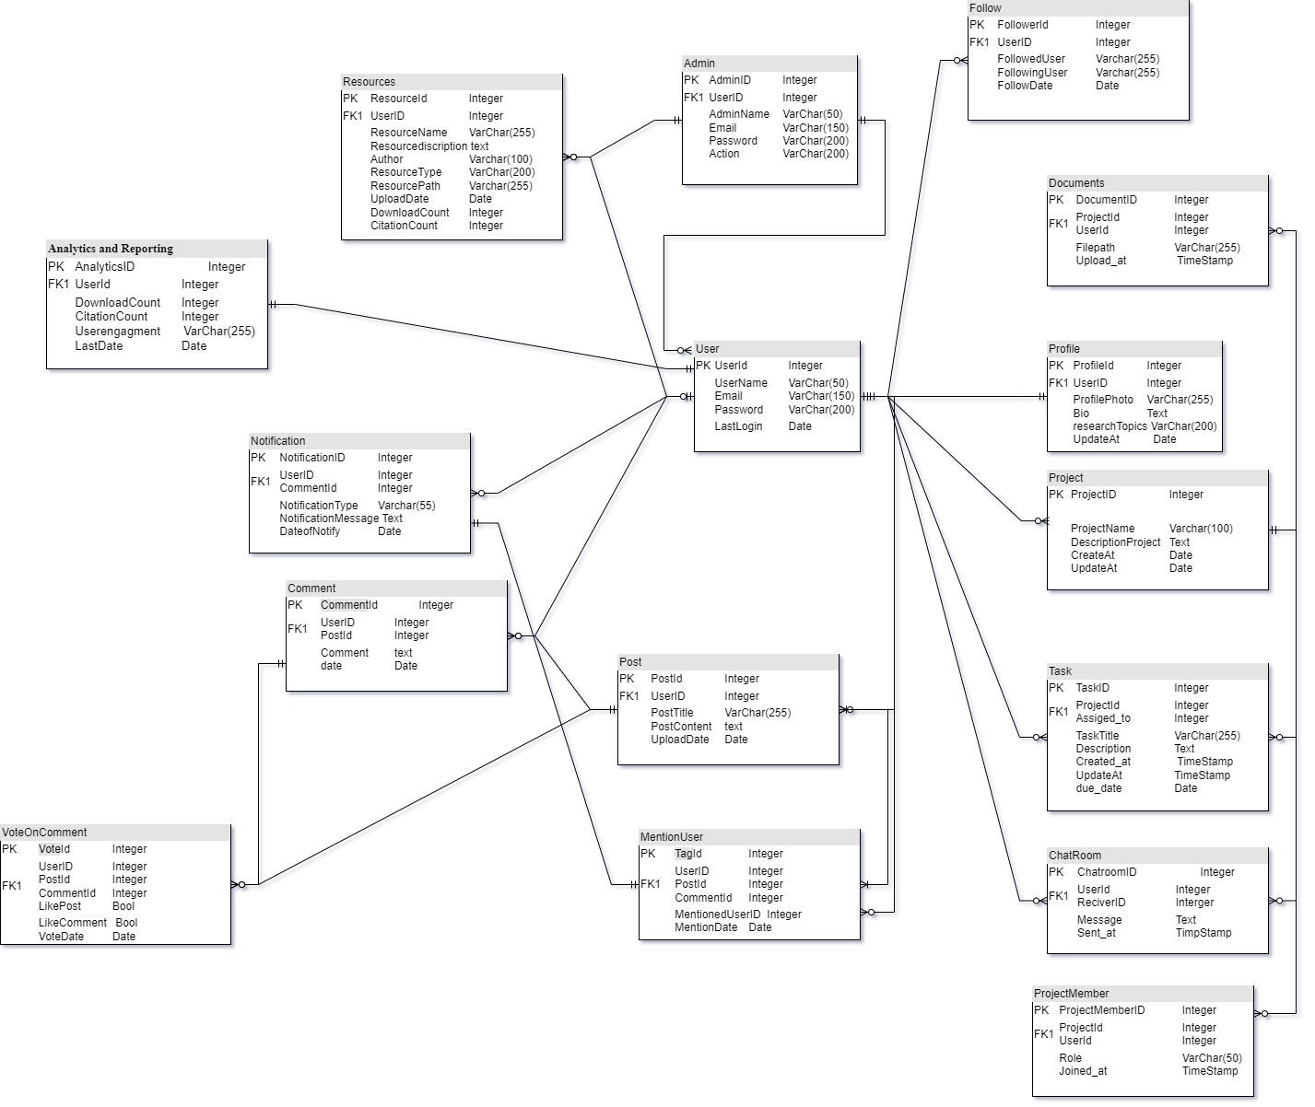

**Interface Design**

**Signup**

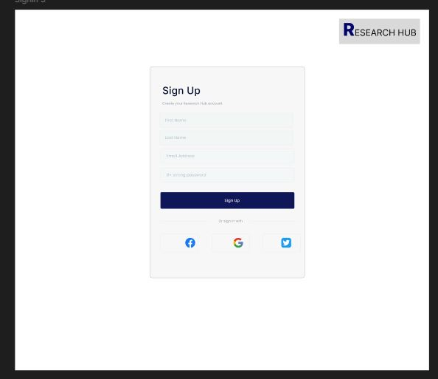

**Login**

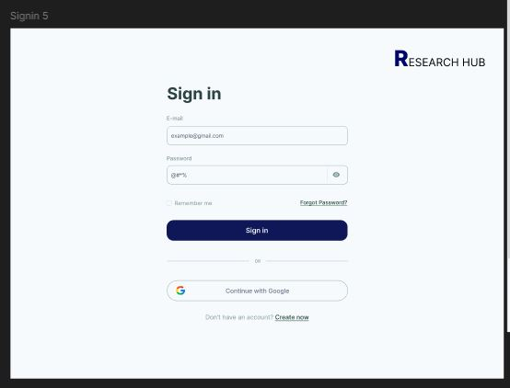

**Home Page**

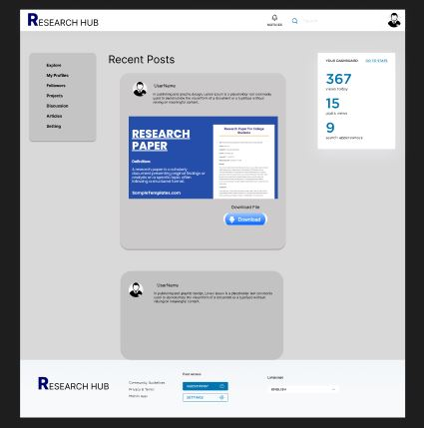

**User Profile**

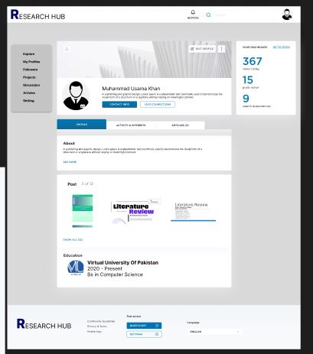

**User Dashboard**

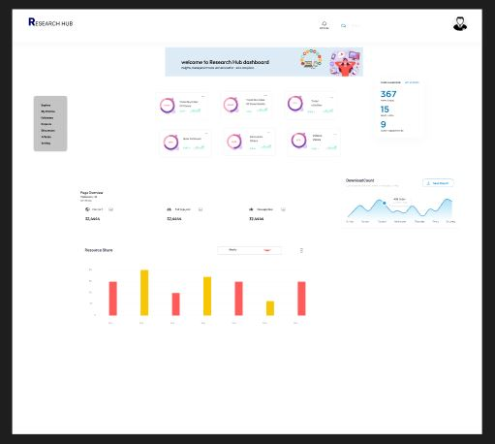

**Test Case**

**User Signup**

| **Test Case No** | **TC_1** |
| --- | --- |
| **Test Case Name** | Signup |
| **System** | User Registration and Authentication |
| **Preconditions** | The user must have a valid email address. |
| **Actions** | 1. Navigate to the registration page.  2. Enter a valid email address.  3. Enter a secure password.  4. Click on the "Sign Up" button. |
| **Expected Results** | User receives a verification email.  User account is created in a pending verification state. |
| **Post Condition** | User receives an email verification link. |
| **Result** | Pass |
| **Tested By** | Bc200405081 |

**Login User**

| **Test Case No** | **TC_2** |
| --- | --- |
| **Test Case Name** | Login User Account |
| **System** | User Registration and Authentication |
| **Preconditions** | User account is registered and verified. |
| **Actions** | 1. Navigate to the login page.  2. Enter the registered email address.  3. Enter the correct password.  4. Click on the "Log In" button. |
| **Expected Results** | User is successfully logged in and redirected to the dashboard or homepage. |
| **Post Condition** | User is logged into their account and can access their profile and other features. |
| **Result** | Pass |
| **Tested By** | Bc200405081 |

**Profile Management:**

| **Test Case No** | **TC_3** |
| --- | --- |
| **Test Case Name** | Profile Management |
| **System** | Profile Management |
| **Preconditions** | User is logged into their account. |
| **Actions** | 1. Navigate to the profile page.  2. Click on the "Edit Profile" button.  3. Update profile details such as profile photo, bio, group ties, and research topics. 4. Click on the "Save Changes" button. |
| **Expected Results** | Profile details are successfully updated and saved.  Updated profile information is displayed on the profile page. |
| **Post Condition** | User's profile is updated with the new information. |
| **Result** | Pass |
| **Tested By** | Bc200405081 |

**Upload / Share Resource:**

| **Test Case No** | **TC_4** |
| --- | --- |
| **Test Case Name** | Upload / Share Resources |
| **System** | Resource Upload and Sharing |
| **Preconditions** | User is logged into their account. |
| **Actions** | 1. Navigate to the resource upload page.  2. Click on the "Upload Resource" button.  3. Select a file to upload (e.g., research paper, article, data set, presentation).  4. Enter relevant details about the resource (e.g., title, description, keywords).  5. Click on the "Share" button. |
| **Expected Results** | Resource is successfully uploaded.  Uploaded resource is displayed in the user's profile and available for other users to discover. |
| **Post Condition** | Resource is available in the system for discovery and download by other users. |
| **Result** | Pass |
| **Tested By** | Bc200405081 |

**Resource Discover:**

| **Test Case No** | **TC_5** |
| --- | --- |
| **Test Case Name** | Search Resources |
| **System** | Resource Discovery |
| **Preconditions** | User is logged into their account. |
| **Actions** | 1. Navigate to the search page.  2. Enter search criteria (e.g., keywords, authors, types, date of publish, citation measurements) in the search bar.  3. Click on the "Search" button. |
| **Expected Results** | A list of resources matching the search criteria is displayed.  Resources are sorted based on the specified criteria. |
| **Post Condition** | User can view and access the details of the searched resources. |
| **Result** | Pass |
| **Tested By** | Bc200405081 |

**Engaging the Discussion Form:**

| **Test Case No** | **TC_6** |
| --- | --- |
| **Test Case Name** | Engaging the Discussion Forum |
| **System** | Discussion Forums |
| **Preconditions** | User is logged into their account. |
| **Actions** | 1. Navigate to the discussion forum section.  2. Select a discussion thread or create a new one.  3. Post a comment or reply to an existing comment.  4. Optionally, like or dislike comments.  5. Optionally, mention other users by tagging them in comments. |
| **Expected Results** | Comment or reply is successfully posted in the discussion thread.  Likes and mentions are reflected appropriately. |
| **Post Condition** | User's interaction (comments, likes, mentions) is visible in the discussion thread. |
| **Result** | Pass |
| **Tested By** | Bc200405081 |

**Collaborative Project:**

| **Test Case No** | **TC_7** |
| --- | --- |
| **Test Case Name** | Collaborative Project |
| **System** | Collaborative Projects |
| **Preconditions** | User is logged into their account. |
| **Actions** | 1. Navigate to the collaborative projects section.  2. Create a new collaborative project or join an existing one.  3. Set up a chat room specific to the project for discussions.  4. Share and store files related to the project.  5. Use a task board to manage project tasks and assign responsibilities.  6. Monitor progress with a set timeline and key milestones. |
| **Expected Results** | Collaborative project is successfully created or joined.  Project files are shared and accessible to project members.  Tasks are managed effectively using the task board.  Progress can be tracked based on the timeline and milestones. |
| **Post Condition** | Project details and progress are visible and manageable for project members. |
| **Result** | Pass |
| **Tested By** | Bc200405081 |

**Social Networking Feature:**

| **Test Case No** | **TC_8** |
| --- | --- |
| **Test Case Name** | Social Networking Features |
| **System** | Social Networking Features |
| **Preconditions** | User is logged into their account. |
| **Actions** | 1. Navigate to the user profile or activity feed.  2. Follow other users to track their activities.  3. Receive notifications for mentions or important discussions. |
| **Expected Results** | User successfully follows other users and receives notifications for relevant activities. |
| **Post Condition** | User's followed users and notifications are managed and visible in their profile or activity feed. |
| **Result** | Pass |
| **Tested By** | Bc200405081 |

**View Analytics Dashboard:**

| **Test Case No** | **TC_9** |
| --- | --- |
| **Test Case Name** | View Analytics Dashboard |
| **System** | Analytics and Reporting |
| **Preconditions** | User is logged into their account. |
| **Actions** | 1. Navigate to the analytics dashboard section.  2. View metrics such as download counts, citation counts, user engagement statistics, etc. |
| **Expected Results** | User can see relevant analytics metrics for their uploaded resources and overall platform engagement. |
| **Post Condition** | Analytics data is displayed accurately and can be used for user insights and decision-making. |
| **Result** | Pass |
| **Tested By** | Bc200405081 |

**Admin Dashboard**

| **Test Case No** | **TC_10** |
| --- | --- |
| **Test Case Name** | Admin Dashboard |
| **System** | Admin Dashboard |
| **Preconditions** | Admin user is logged into their account. |
| **Actions** | 1. Navigate to the admin dashboard section.  2. Manage user accounts (create, edit, delete).  3. Monitor platform activity and user interactions.  4. Moderate content (e.g., remove inappropriate posts, manage flagged content). |
| **Expected Results** | Admin can successfully manage user accounts and platform content.  Platform activity and user interactions are monitored effectively. |
| **Post Condition** | Changes made by the admin are reflected in the user accounts and content moderation. |
| **Result** | Pass |
| **Tested By** | Bc200405081 |

**Log Out**

| **Test Case No** | **TC_11** |
| --- | --- |
| **Test Case Name** | Logout |
| **System** | User Authentication |
| **Preconditions** | User is logged into their account. |
| **Actions** | 1. Locate the logout button or link.  2. Click on the logout button or link. |
| **Expected Results** | User session is terminated. User is redirected to the login page or homepage. |
| **Post Condition** | User is logged out and cannot access secured pages without logging back in. |
| **Result** | Pass |
| **Tested By** | Bc200405081 |