**Comparative Process Mining**

# **User Manual**

* **Uploading Event log:**

1. Press the **Choose File** button.

1. Select the event log file you want to upload and press **Open**.

1. After the event log file has been selected, press the **Upload Eventlog** button to upload it to the server. Graphical user interface, text, application

   Description automatically generated
2. You will be able to see the uploaded event log in the event log selection menu. Graphical user interface, text, application

   Description automatically generated

* **Comparing different Models:**

1. Select the event log that you want to analyze and press the **Set** button to set it as your chosen event log. 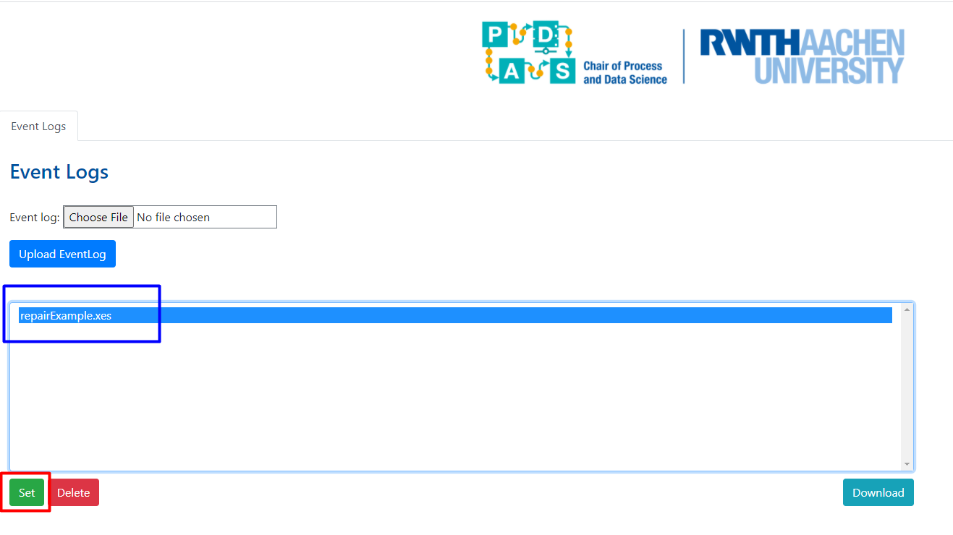
2. After you have selected the event log, an **Add Model** button will appear. Press this button to add a pair of process models. Graphical user interface, application

   Description automatically generated
3. You will able to see two unfiltered Directly Folowed Graphs (DFGs) on the left and right hand side of the window: Graphical user interface, application

   Description automatically generated
4. Select the column from the event log you want to filter on.
5. Select the value of the column on which you want to filter the DFG.
6. Check this checkbox if you want to filter out all the other values except the selected column value, otherwise leave it unchecked.
7. Select the type of the value you want to be shown on the edges. It can be either Frequency or Performance.
8. Move the slider to select the percentage of edges you want to filter.
9. This window shows all the stats of the respective DFGs on the left and right hand side.
10. After you have selected all the filter values for both left and right DFGs, you can press the **Compare** button to get the filtered DFGs.
11. These are the DFGs you get after you have selected the required filter values and press the **Compare** button: A picture containing text, map, indoor, several

    Description automatically generated
12. You can press the **Add Model** button to add as many pairs of comparison models as you want. Graphical user interface

    Description automatically generated

* **Exporting filtered event logs, DFGs and stats:**

1. After you have performed your comparisons, you can also export the filtered event logs, the filtered DFGs or a PDF with both DFGs and their statistics. Graphical user interface, application

   Description automatically generated
   1. Press this button to export the left filtered event log.
   2. Press this button to download the left DFG.
   3. Press this button to download a PDF containing both DFGs and their respective statistics.
   4. Press this button to export the right filtered event log.
   5. Press this button to download the right DFG.

* **Deleting the uploaded event log:**

1. After you have performed your comparisons, you can also delete the event log from the server by selecting the event log and pressing the **Delete** button. Graphical user interface, text, application

   Description automatically generated