Lightweight Deep Learning Approaches for Intrusion Detection in IoT-Enabled Smart Homes

By
Muhammad Usman (19-CS-032)
Supervisor: Dr. Hasna Arshad (Assistant Professor, Department of Computer Science)
HITEC University Taxila,Pakistan

Abstract
The greater use of IoT devices in homes has ushered efficiency and connectivity but at the expense of increased cybersecurity dangers including the Man-in-the Middle, Distributed Denial of Service, SQL Injection and Password Attacks. Graceful ways of protecting through the use of sophisticated encryption and firewalls are unfeasible for constrained IoT devices that are limited by processing capabilities and compensated by energy budgets. This work shows a lightweight deep-learning-based IDS for smart homes with IoT and a hybrid framework that combines 1D Convolutional neural networks (CNN), Long short Term Memory (LSTM) Networks, and multi-head attention mechanisms. Using the Edge-IIoTset Cyber Security Dataset the model achieves detection performance above 99% while maintaining model size to <10MB and memory usage <50MB, both improved with quantization and knowledge distillation. The adaptive feature selection process produces ten critical network characteristics, so the system can function properly on low-power hardware (like the ESP32 microcontroller). In particular, the system maintains zero False Alarm Rate for normal network behaviour, and has a clear strength in detecting widespread attacks while being limited in its detection capabilities for rarer attack types, for example the Fingerprinting. The work fills the gap between high cybersecurity requirements and IoT operational limitations by proposing a scalable, real-time IDS that enforces smart home security and enhances user acceptance of IoT technologies.

Table of Contents
Declaration 2
Acknowledgments 3
Abstract 4
List of Tables 8
List of Figures 9
Chapter 1 Introduction & Overview 11
1. Introduction 12
1.1 Significance of this Project 12
1.2 Motivation 12
1.3 Objectives 13
1.4 Types of Attacks 13
1.4.1 DDoS UDP 13
1.4.2 DDoS ICMP 14
1.4.3 SQL Injection 14
1.4.4 Password Attack 15
1.4.5 Vulnerability Scanner 15
1.4.6 DDoS TCP 16
1.4.7 DDoS HTTP 16
1.4.8 Uploading Attack 17
1.4.9 Backdoor Attack 17
1.4.10 Port Scanning 18
1.4.11 XSS (Cross-Site Scripting) 18
1.4.12 Ransomware 19
1.4.13 MitM (Man-in-the-Middle) 19
1.4.14 Fingerprinting 20
Chapter 2 Literature Review & Research Gaps 21
2. Literature Review & Research Gaps 22
2.1 Deep Learning-Based Approaches 23
2.2 Lightweight and Hybrid Models 23
2.3 Machine Learning Techniques 24
2.4 Software-Defined Networking (SDN) Frameworks 25
2.5 Gaps in the Literature 25
2.6 Research Questions 26
Chapter 3 Methodology 27
3. Methodology 28
3.1 Project Code Work Flow 28
3.2 Dataset 28
3.3 EDA 29
3.4 Data Preprocessing 35
3.5 Model Architecture 36
3.6 Evaluation Metrics 37
3.6.1 Accuracy 37
3.6.2 Precision 37
3.6.3 Recall 37
3.6.4 F1-Score 38
3.6.5 False Alarm Rate 38
3.6.6 Cohen’s Kappa & Matthews Correlation Coefficient 38
3.6.7 ROC-AUC and Precision-Recall AUC 38
Chapter 4 Results 39
4.1 Accuracy & Loss Curves 40
4.2 Confusion Matrix 41
4.3 ROC Curve (One-vs-Rest) 42
4.4 Precision-Recall Curve (One-vs-Rest) 43
4.5 Baseline Models Comparison 43
4.6 Classification Report 45
4.7 False Alarm Rate 45
4.8 Model Quantization & Deployment 46
4.9 Discussion 46
Chapter 5 Future Work & Conclusion 48
5.1 Future Work 49
5.1.1 Enhancing Detection of Minority Classes 49
5.1.2 Real-Time Adaptability and Online Learning 49
5.1.3 Optimization for Ultra-Low-Power Devices 50
5.1.4 Improving the Feature Set and Lifting Layer 2 Mitigation 50
5.1.5 Multi-Modal Data Integration 50
5.1.6 Scalability and Federated Learning 51
5.1.7 Adversarial Robustness and Attack Simulation 51
5.1.8 Integration with IoT Security Frameworks 52
5.1.9 Long-Term Performance Monitoring 52
5.1.10 Collaboration and Open-Source Contribution 52
5.2 Conclusion 53
References 56

List of Tables
Table 1: Overview of Studies on MiTM Attack Detection in IoT Networks 22
Table 2: Summary of Dataset Features and Attack Types 29
Table 3: Statistical Summary of Numerical Feature 35
Table 4: Training Class Distribution 35
Table 5: Definitions of Evaluation Metrics 38
Table 6: CNN-LSTM Attention Model Report 44
Table 7: Baseline Model Report 44
Table 8: Classification Report 45

List of Figures
Figure 1: DDoS UDP 13
Figure 2: DDoS ICMP 13
Figure 3: SQL Injection 14
Figure 4: Password Attack 14
Figure 5: Vulnerability Scanner 15
Figure 6: DDoS TCP 15
Figure 7: DDoS HTTP 16
Figure 8: Uploading Attack 16
Figure 9: Backdoor Attack 17
Figure 10: Port Scanning 17
Figure 11: XSS 18
Figure 12: Ransomware 18
Figure 13: MiTM 18
Figure 14: Fingerprinting 19
Figure 15: Project Work Flow 27
Figure 16: Box Plot icmp.unused (Outlier Detection) 29
Figure 17: Box Plot of tcp.ack (Outlier Detection) 29
Figure 18: Box Plot icmp.transmit_timestamp (Outlier Detection) 30
Figure 19: Box Plot icmp.transmit_timestamp vs Attack Type 30
Figure 20: Box Plot of icmp.sq_le vs Attack Type 31
Figure 21: Distribution Plots of ICMP Features by Attack Types 32
Figure 22: Class Distribution of Attack Types 33
Figure 23: Correlation Heatmaps 33
Figure 24: Model Architecture Diagram 36
Figure 25: Accuracy and Loss Curves 40
Figure 26: Confusion Matrix 40
Figure 27: ROC Curve (One vs Rest) 41
Figure 28: Precision-Recall Curve (One vs Rest) 42
Figure 29: False Alarm 45
Figure 30: Model Quantization 45

Chapter 1
Introduction & Overview

Introduction
Modern smart homes benefit from IoT device proliferation by delivering automated homes accompanied by better connectivity and enhanced lifestyle convenience. Modern households rely on devices including smart thermostats and security cameras and health monitors because they provide unmatched convenience and operational efficiency. The interlinked IoT ecosystem now faces major cybersecurity dangers because new risks including Man-in-the-Middle (MitM) and DDoS UDP together with DDoS OCMP and SQL Injection and Password Attack and more dangerous security threats have surfaced. The restricted capability of IoT devices due to their limited computational power and constrained energy reserves makes traditional security techniques using complex encryption and firewalls impractical for immediate threat defense. This research introduces an innovative solution to tackle IoT security problems by creating specifically designed lightweight deep learning models which detect intrusions in residential IoT systems. The research combination of 1D Convolutional Neural Networks (CNN) with Long Short-Term Memory (LSTM) networks and multi-head attention produces a detection model which achieves accurate results but remains resource-efficient. Advanced optimization approaches including quantization and knowledge distillation and adaptive feature selection were employed to validate the model for integration with limited IoT hardware capacities. The research targets the gap between cybersecurity security robustness and IoT systems limitations by developing a solution which delivers impactful intrusion detection services at scale while operating effectively in real-time.

Significance of this Project
The project holds exceptional importance because it aims to strengthen security measures for IoT-enabled smart homes that continue toward mainstream adoption. The expanding adoption of IoT devices worldwide continues to make cyber threats more severe as forecasts suggest 75 billion devices will be in use by 2025. Numerous attacks including Man-in-the-Middle (MitM), DDoS UDP, DDoS OCMP, SQL Injection, Password Attack along with several others represent major security threats because they enable interception of sensitive personal medical data and financial transactions while simultaneously breaking down important home security systems. Security gaps in IoT can be addressed through a proposed approach delivering accurate detection at more than 99% precision while keeping resource usage under 50MB memory and 10MB model size.

Motivation
An increasing need to understand IoT device security in smart homes drives this research because of escalating cybersecurity threats. Modern cyber security attacks such as Man-in-the-Middle (MitM) and DDoS UDP and DDoS OCMP and SQL Injection and Password Attack exploit the core vulnerabilities in IoT networks because of their unencrypted communication channels and limited processing capabilities to intercept and manipulate data. Standard security approaches succeed in traditional systems but their high computational requirements render them ineffective for IoT devices resulting in operational performance decline or hardware incompatibility. Deep learning models including traditional CNNs or Recurrent Neural Networks (RNNs) demand large computational requirements which produce matching challenges for devices with minimal system resources. Case-specific lightweight and real-time IDS solutions remain scarce for IoT environments which makes smart homes more exposed to complex assaults. Research findings emphasize current IDS solutions' main drawbacks which include excessive resource usage while also demonstrating poor scalability and creating many false alert detections. The need becomes clear for novel detection systems which maintain accuracy while minimizing operational costs. The purpose of this work involves creating a high-performance IDS which protects IoT-enabled smart homes from many attacks utilizing lightweight adaptive functionality to generate user trust needed for IoT technology adoption.

Objectives
Detecting MitM attacks in IoT-enabled smart homes requires this study to achieve its research targets that overcome present-day technical and practical challenges. They are as follows:
- Successful development of an efficient intrusion detection system will combine CNN with LSTM mechanisms through a hybrid deep learning architecture.
- A process of optimization with quantization technology and knowledge distillation produces a model size under 10MB.
- The designed pipeline extracts no more than 10 essential network features through a streamlined lightweight method.
- The system needs to operate on resource-limited IoT devices while using less than 50MB of memory.
- The system needs development of an automatic feature selection mechanism which adapts to different network environmental conditions.
- A validation process which documents resource utilization metrics must operate consistently across various deployment environments.
These critical objectives will steer the development and optimization process of the proposed model so it provides reliable security features for strict IoT environments.

Types of Attacks
Smart homes that use IoT technology have multiple points of access for cyberattacks which target various network and device vulnerabilities. This article presents a detailed description of standard attack methods together with their descriptions and resulting implications:

DDoS UDP
The UDP protocol in Distributed Denial-of-Service attacks corresponds to User Datagram Protocol. The attacker uses an assault technique that sends numerous UDP packets to overburden the target device's processing capacity until it becomes nonfunctional. Harmful flooding of UDP packets in IoT systems can render important devices such as security cameras completely inoperable (Suramwar, M.V, Bansode, & S.M, 2015).
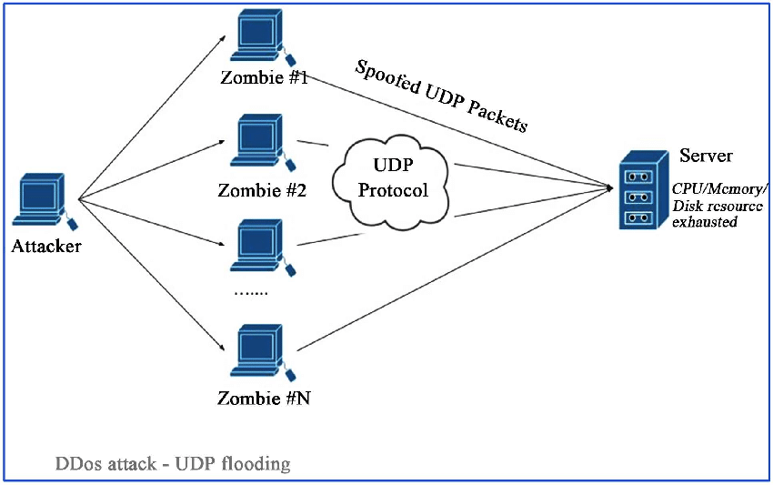
Figure 1: DDoS UDP

DDoS ICMP
These attacks use Distributed Denial-of-Service attacks with Internet Control Message Protocol components. The malicious technique overloads the target's systems with ICMP traffic which includes ping requests until network resources are completely depleted. The attack degrades IoT device performance while causing operational interruptions through device breakdowns (Suramwar, M.V, Bansode, & S.M, 2015).
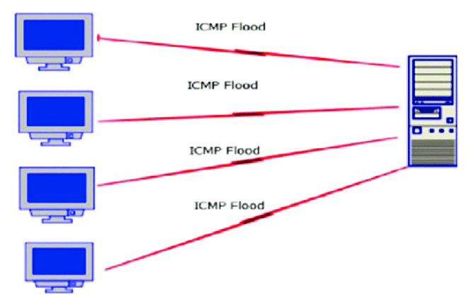
Figure 2: DDoS ICMP

SQL Injection
Through weak IoT interfaces attackers can inject malicious SQL database queries which grant unauthorized system entry and allow data theft and modification. The lack of attack protection becomes alarming when web-based management portals are found in IoT devices (Suramwar, M.V, Bansode, & S.M, 2015).
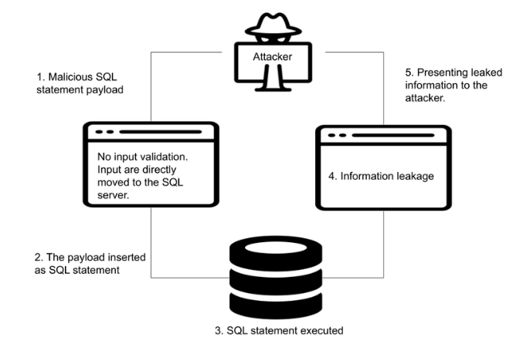
Figure 3: SQL Injection

Password Attack
Attackers try to break into unauthorized systems by either using weak or brute-force attacks against IoT device passwords. Attackers use brute force methods together with dictionary attacks and they take advantage of standard default logins (Suramwar, M.V, Bansode, & S.M, 2015).
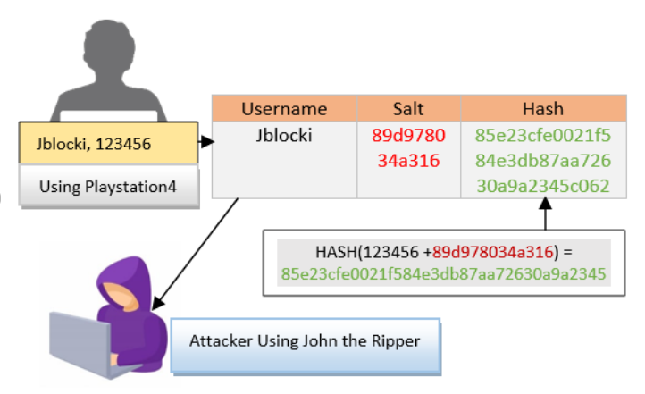
Figure 4: Password Attack

Vulnerability Scanner
Cybercriminals exploit IoT network vulnerabilities through automated scanning tools that focus on finding unsecured software and port accessibility and system mishandling (Suramwar, M.V, Bansode, & S.M, 2015).
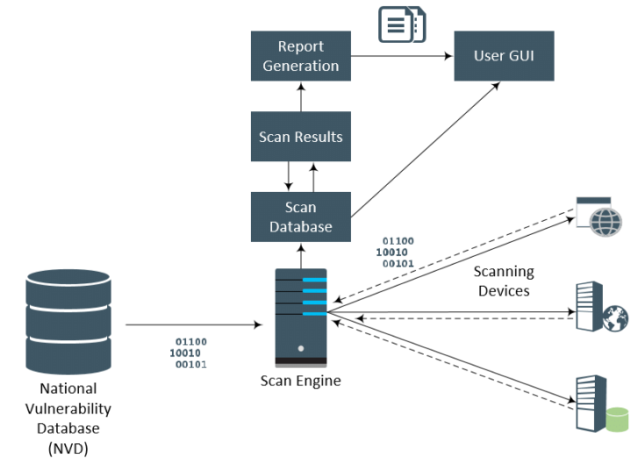
Figure 5: Vulnerability Scanner

DDoS TCP
A Distributed Denial-of-Service Transmission Control Protocol attack is abbreviated as DDoS. A TCP packet flood attack prevents IoT device operations by exploiting connectionoriented protocols to exhaust network resources (Suramwar, M.V, Bansode, & S.M, 2015).
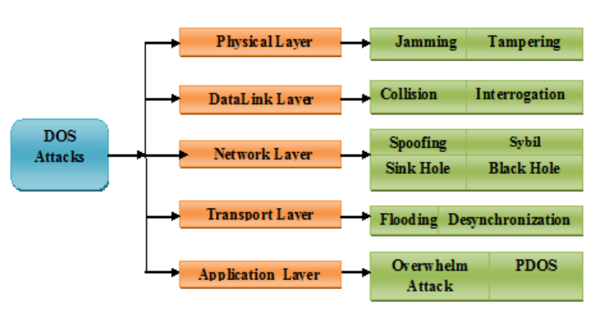
Figure 6: DDoS TCP

DDoS HTTP
Through DDoS HTTP attacks (Distributed Denial-of-Service Hypertext Transfer Protocol) attackers overload IoT device web servers by continuously sending large numbers of HTTP requests which exhaust server capabilities and result in service interruption. Web interface-enabled devices commonly experience such events (Suramwar, M.V, Bansode, & S.M, 2015).
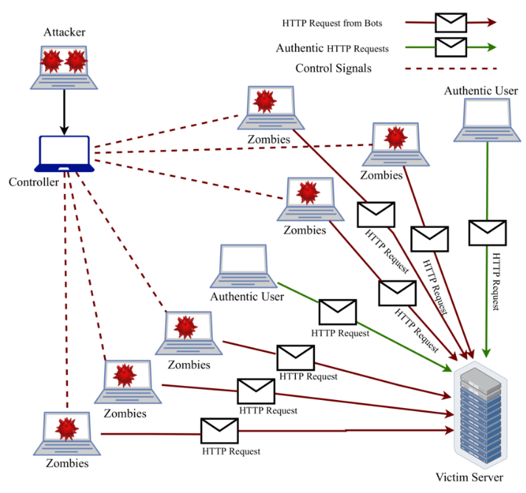
Figure 7: DDoS HTTP

Uploading Attack
Attacks against IoT devices function by uploading harmful files and scripts through their vulnerable open interfaces which open doors for unauthorized action and execute destructive code (Suramwar, M.V, Bansode, & S.M, 2015).
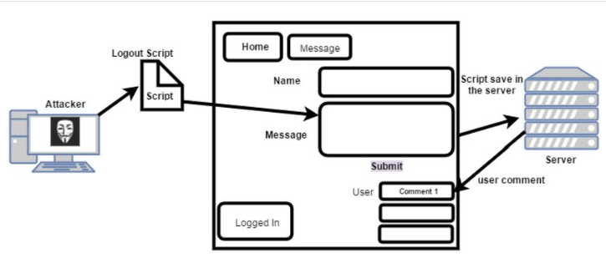
Figure 8: Uploading Attack

Backdoor Attack
Cyber attackers burden IoT devices with undetectable entry points called backdoors for extended unauthorized system entry to both steal information and acquire device management control (Suramwar, M.V, Bansode, & S.M, 2015).
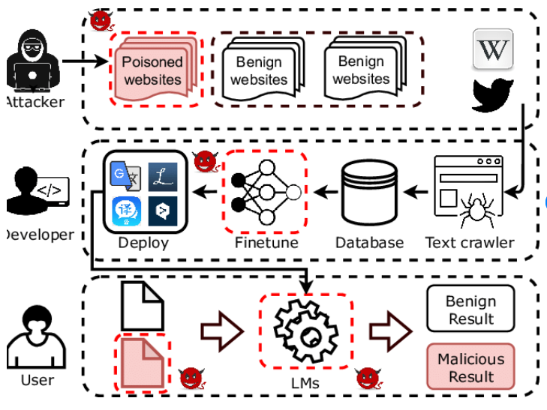
Figure 9: Backdoor Attack

Port Scanning
Digital attackers seek out IoT devices by scanning open ports and services to obtain attack-related information for their targeted assault campaigns (Suramwar, M.V, Bansode, & S.M, 2015).
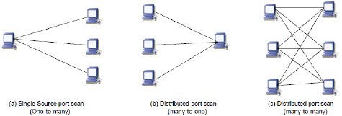
Figure 10: Port Scanning

XSS (Cross-Site Scripting)
Through malicious scripts which intrude web interfaces of IoT devices attackers can both steal user information and manipulate device functioning (Suramwar, M.V, Bansode, & S.M, 2015).
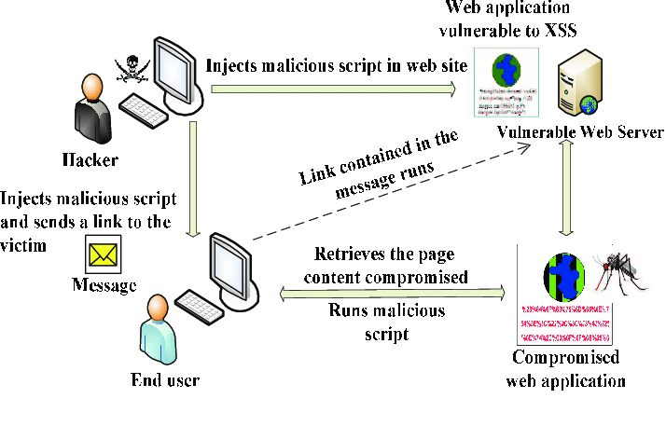
Figure 11: XSS

Ransomware
Although malicious software hijacks IoT devices it both encrypts device information and disables device features while requesting ransom payments. Important smart home systems experience severe operational disruption from this issue (Suramwar, M.V, Bansode, & S.M, 2015).
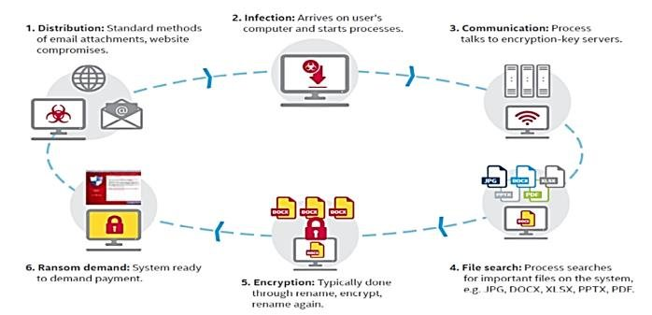
Figure 12: Ransomware

MitM (Man-in-the-Middle)
Through intercepting IoT device communication attackers can modify exchanged information while compromising both device privacy and the security of IoT data. The main novelty of this work centers around interceptions between IoT devices since this activity shows the highest frequency within IoT networks (Suramwar, M.V, Bansode, & S.M, 2015).
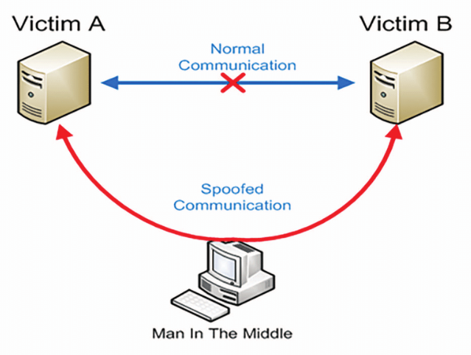
Figure 13: MiTM

Fingerprinting
Attackers use harvested information about IoT devices to detect specific operating system or firmware versions which they manipulate into vulnerability targets (Suramwar, M.V, Bansode, & S.M, 2015).
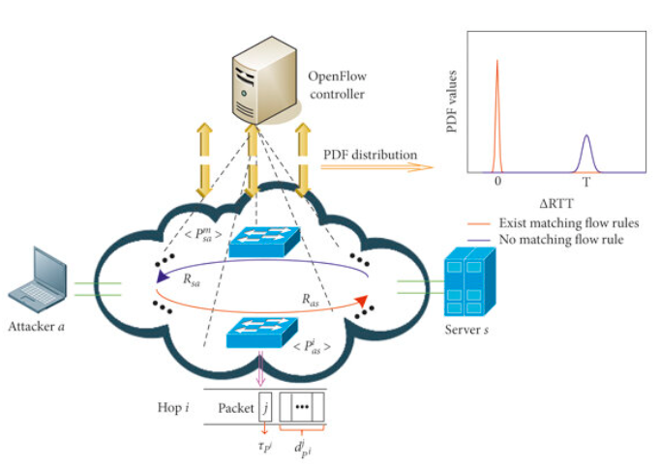
Figure 14: Fingerprinting

Chapter 2
Literature Review
&
Research Gaps

Literature Review & Research Gaps
The expanding usage of Internet of Things (IoT) devices across smart homes created fundamental changes in residential spaces which deliver automatic control features while improving access to connected systems and housewide convenience. (Aoueileyine, et al. 2024) identify human-to-human attacks that intercept IoT device communication as a persistent threat for the interconnected ecosystem which erodes data security and user privacy. The restricted features of IoT devices regarding low energy levels and minimum processing limitations require lightweight intrusion detection systems (IDS) that detect threats in real-time and require minimal device resources.
Recent research on detecting MitM attacks within IoT networks is analyzed through four essential domains in this literature synthesis. The research investigates deep learning-based approaches alongside lightweight and hybrid models in addition to traditional machine learning techniques and Software-Defined Networking (SDN) frameworks. The analysis of existing methodologies alongside their strengths and limitations reveals research voids allowing the proposed hybrid deep learning model uniting 1D CNN and LSTM frameworks and multi-head attention mechanisms to emerge as a new IoT security solution. The analysis uses a thematic approach following (Alve, et al., 2024) and (Aoueileyine, et al., 2024) by grouping research into methodological categories for better clarity when comparing approaches.
Table 1: Overview of Studies on MiTM Attack Detection in IoT Networks
Study | Objective | Methodology | Dataset | Key Result
(Aoueileyine, et al., 2024) | Detect ARP spoofing in SDN-IoT | CNN with SDN | NSL-KDD | 99.96% accuracy
(Alani, et al., 2023) | Detect ARP spoofing with DNN | DNN with Talos tuning | Custom ARP dataset | 99.99% accuracy
(Hnamte, & Hussain, 2024) | Mitigate ARP spoofing in SDN | DNN with SDN | Custom SDN dataset | High accuracy, low FAR
(Gowda, & Dayananda, 2023) | Detect ARP spoofing in SDN | IP-MAC monitoring | Custom SDN dataset | 20% reduced CPU usage
(Saritakumar, et al., 2023) | Detect ARP spoofing in SDN | Ryu SDN controller | Custom SDN dataset | Less than 2% CPU usage
(Farhin, et al., 2020) | Detect IoT attacks with FNN | Fuzzy neural network | Custom IoT dataset | Moderate success
(Sebbar, et al., 2020) | Detect MitM in SDN | RF-based CBNA-RF | NSL-KDD | 97.4% accuracy
(Adhikari, et al., 2022) | Prevent MitM with cryptography | ECDH, AES-256 | Not specified | Effective for higher OSI layers
(Cherian, & Varma, 2022) | Mitigate MitM with BBSC | BBSC algorithm | Custom IoT dataset | 99.53% accuracy
(Khedr, et al., 2023) | Detect DDoS and ARP attacks | P4-HLDMC framework | CICIDS2017 | High accuracy, low latency

Deep Learning-Based Approaches
Deep learning serves as a vital security element for IoT systems because its ability to identify complex network traffic patterns thereby detects MitM attacks. The deployment of IoT faces difficulties due to the substantial computational requirements needed for these models to operate.
(Aoueileyine, et al., 2024) presented a CNN-enabled framework that combines SDN elements to identify ARP spoofing and flooding attacks within IoT networks. The experimental outcomes demonstrated that this model achieved both 99.96% accuracy and a 0.02% false alarm rate while delivering fast real-time detection capabilities. The high CPU and memory requirements of this model contradict the memory-limited specifications of ESP32 devices with their less than 50MB memory availability (Sebbar, et al., 2020). The proposed research targets lightweight solutions because detecting attacks requires it.
The research team led by (Alani, et al., 2023) developed a Deep Neural Network (DNN) optimized with Talos for hyperparameter tuning which delivered 99.99% ARP spoofing detection accuracy. The model demonstrates high performance in lab-based situations yet its resource-demanding nature makes it impractical for IoT real-world deployments. The research demonstrated a clear need for efficient solutions which matches the proposed model's approach where quantization and knowledge distillation techniques produce models smaller than 10MB.
Research by (Hnamte, & Hussain, 2024) developed a DNN model which succeeded in SDN-enabled IoT network ARP spoofing mitigation by showing excellent accuracy alongside minimal false detection rates. The model faces two major problems: overfitting issues coupled with minimal testing results from small topological samples which impact its generalization capabilities negatively. The proposed research solves this limitation through extensive model testing against varied MitM attack variations across multiple execution scenarios.
The hybrid CNN-LSTM model proposed by (Zakariah, et al., 2023), as cited in (Alve, et al., 2024) demonstrated 89% detection accuracy and 90% F1-score for IoT intrusion detection through attention mechanisms. The proposed research aims to develop optimized hybrid architectures because the current model demonstrates effective performance but inferior accuracy compared to other deep learning models while requiring extensive computational resources.

Lightweight and Hybrid Models
The detection accuracy of lightweight and hybrid models maintains a balance with resource efficiency characteristics to suit the needs of resource-limited IoT devices. The proposed research benefits from these detection strategies because it uses low-power ESP32 hardware as its deployment platform.
(Alve, et al., 2024) work demonstrated lightweight machine learning models through their Decision Tree classifier, which detected MitM attacks with 99.56% accuracy accompanied by a 99.62% F1-score on the CICIoT 2023 dataset's 34 attack types. Through GridSearchCV hyperparameter optimization and five-fold cross-validation the model established dependable operational capability. The system's broad multi-class attack detection approach falls short when facing targeted threats because it lacks optimized features for MitM attacks. The proposed model optimizes IoT device memory usage to stay below 50MB which contrasts with the model's lack of memory efficiency optimizations.
(Gowda, & Dayananda, 2023) developed an SDN-based method to monitor IP-MAC bindings which lowered CPU usage by 20% in detecting ARP spoofing. The solution demonstrated high efficiency yet produced frequent incorrect alerts while struggling to scale efficiently thus requiring advanced lightweight defenses. The proposed model resolves this problem by utilizing a feature extraction pipeline which selects adaptive features while reducing operations to occur on only ten pivotal features.
(Saritakumar, et al., 2023) managed to detect ARP spoofing alongside maintaining CPU performance to stay under 2% through their implementation of the Ryu SDN controller. The system's efficiency remains high but its inability to scale can reduce its overall practical value. Experimental results from the proposed research establish effective resource utilization across multiple usage scenarios allowing for future scalability.
(Khedr, et al., 2023) presented P4-HLDMC which merges machine learning and SDN with multiple controllers to detect DDoS and ARP attacks. The framework demonstrated excellent performance and fast data processing yet demanded excessive computational power which prohibited usage on small IoT equipment. A new model resolves this issue by developing a hybrid CNN-LSTM-attention structure which combines quantization and knowledge distillation methods.

Machine Learning Techniques
The straightforward approach of traditional machine learning together with its low resource requirements makes these methods suitable for IoT applications. Complex MitM attacks require superior accuracy levels which traditional machine learning solutions frequently fail to achieve.
(Alve, et al., 2024) assessed four machine learning classifiers: Random Forest (98.22% accuracy), K-Nearest Neighbor (96.11% accuracy), Gradient Boosting (98.36% accuracy) and AdaBoost (96.26% accuracy) in addition to their Decision Tree model. The Decision Tree showed the best results but its ability to deal with multi-class attacks alongside its unoptimized features restricts its use in targeted threat environments. The proposed architectural framework optimizes its hybrid structure to specifically detect MitM attacks which include arp spoofing and ssl stripping vulnerabilities.
(Sebbar, et al., 2020) developed a Random Forest-based CBNA-RF model that delivered 97.4% accurate MitM detection within SDN environments. The method demonstrated limited efficacy across extended IoT networks and required the development of advanced architecture solutions such as the proposed hybrid system.
(Adhikari, et al., 2022) applied combined ECC-based encryption and AES-256 cryptography to protect upper OSI layers yet failed to block MitM attacks using ARP flooding methods. Through its detailed feature extraction pipeline the proposed model detects various MitM variants.
The Belief-Based Secure Correlation (BBSC) algorithm presented by (Cherian, & Varma, 2022) detected MitM attacks with 99.53% accuracy. To overcome the limitation of real-world testing the proposed research deploys its techniques on actual IoT devices.

Software-Defined Networking (SDN) Frameworks
Real-time monitoring together with centralized network management within SDN frameworks efficiently detects Man-in-the-Middle attacks in IoT environments. SDN solutions create deployment barriers because of their demanding resource consumption.
(Aoueileyine, et al., 2024) used a CNN-based IDS within an SDN framework which delivered accurate detection alongside minimal false alarm rates. The high resource needs of this technology restrict its deployment on resource-restrained devices while the proposed model was specifically designed to work well with minimal energy hardware.
The Ryu SDN controller operated by (Saritakumar, et al., 2023) accomplished low CPU usage yet demonstrated performance issues with scalability limitation. The proposed model includes dynamic feature selection and real-time alert management systems that boost scalability.
The SDN-based solution presented by (Gowda, & Dayananda, 2023) reduced CPU utilization yet struggled with false alerts and restricted itself to limited scale. Comprehensive validation makes the proposed research both reliable and robust.

Gaps in the Literature
The research that follows acknowledges several current deficiencies which the proposed investigation aims to resolve:
- Resource Constraints: Deep learning approaches alongside lightweight models prove to be demanding on resources based on research by (Aoueileyine, et al., 2024) and (Alani, et al., 2023).
- Specificity to MitM Attacks: Research by (Alve, et al., 2024) detects multiple attack classes yet their approach loses specificity in identifying specific Man-in-the-Middle threats.
- Scalability and Real-World Testing: The mechanisms proposed by (Hnamte, & Hussain, 2024) and (Cherian, & Varma, 2022) demonstrate insufficient real-world testing combined with limited scalability capabilities.
- Real-Time Adaptability: Popular security models show insufficient capability to learn and adapt to emerging attack methods online.
- Layer 2 Attack Mitigation: Modern security methods developed by (Adhikari, et al., 2022) fail to block Layer 2 attacks.
Researchers have made major advances in MitM attack detection for IoT networks through research into deep learning approaches combined with lightweight models, machine learning frameworks and software-defined network architectures. The proposed solution continues to encounter resource-intensive operation alongside restricted attack detection capabilities and scalability barriers. A lightweight deep learning model emerges from this research to fill these gaps through integration of CNN and LSTM and attention mechanisms for resource-limited IoT devices. This research achieves its security goals for IoT systems through accuracy levels exceeding 99% while necessitating less than 50MB of memory and 10MB of model size, enabling real-time adaptability to protect smart homes against MitM attacks.

Research Questions
Which design methodology works for a hybrid deep learning model that combines Convolutional Neural Networks (CNN), Long Short-Term Memory (LSTM), and attention mechanisms to attain over 99% detection accuracy, while ensuring CPU, memory, and power efficiency on resource-constrained IoT devices? Additionally, measure in what ways performance of our model be assessed against leading intrusion detection systems using metrics such as accuracy, false alarm rate, and real-time detection capability?
The proposed research question makes a considerable improvement in filling the research deficiencies by proposing a lightweight, specialized and adaptive attack discovery system, that is tailored for IoT environments. The project emphasis on optimizing resources, observing targeted intrusion attacks, testing performance in real-world conditions, including extracting strong features and compare with other model, this project provides a complete answer to the research goals.

Chapter 3
Methodology

Project Code Work Flow
The project operates internally to create and test a machine learning model for cyber security threat detection in IoT and IIoT environments. The process begins with loading data sets and then takes on exploratory data analysis (eda) to know the features. From here, data preprocessing is done to impute the missing and encode categorical variables then data preparation is done for modeling.
Workflow includes a CNN-LSTM-Attention hybrid model, comparison with baseline models, and class imbalance tackled with sampling techniques as shown in Figure. 15. Model is trained & evaluated using the provided metrics & best model’s being saved & converted to TensorFlow Lite (TFLite) for major deployment. The process ends with the end of the workflow. In the project’s workflow diagram this sequence is presented in a form of visual diagram, which encourages a systematical approach in model development and optimization.
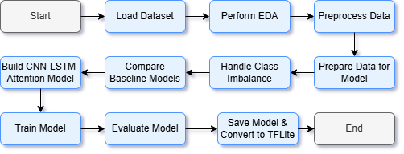
Figure 15: Project Work Flow

Dataset
The dataset used in this project, called Edge – IIoTset Cyber Security Dataset of IoT & IIoT was obtained from Kaggle. This set is especially highlighted by their position in the top of 1% of publications indexed via the Web of Science (WoS) with citations and impact.
It is a holistic, realistic cyber security dataset for IoT and IIoT applications that accommodates central and federated learning modes. The dataset is organized by way of seven layers:
- Cloud Computing Layer
- Network Functions Virtualization Layer
- Blockchain Network Layer
- Fog Computing Layer
- Software Defined Networking Layer
- Edge Computing Layer
- IoT,
- IIoT Perception Layer
These layers consist of such the latest technologies as ThingsBoard IoT platform, the OPNFV platform, Hyperledger Sawtooth, the Digital Twin, the ONOS SDN controller, Mosquitto MQTT brokers, and Modbus TCP/IP. Data is gathered from more than ten types of IOT devices, low cost digital temperature and humidity sensors, ultrasonic sensors, water level detection sensors, pH sensors, soil moisture sensors, heart rate sensors and flame sensors.
The dataset enumerates fourteen different attacks classified within five threat categories: DoS/DDoS – Denial of Service/ Distribution of denial of service, Information gathering, Man-in-the middle attacks, Injection Attacks, Malware attacks as show in Table. 2. With the dataset, initial exploratory analysis and performance assessments based on machine learning methods either in centralized or federated learning modes are presented, building a strong base for this project.
Table 2: Summary of Dataset Features and Attack Types
Features Category | Description | Attack Types
Network Traffic | TCP, UDP, ICMP, ARP, HTTP, DNS, MQTT, Modbus | DoS, DDoS, SQL Injection
IoT Device Data | Temperature, Humidity, Water Level, pH, etc. | Information Gathering
Security Layers | Cloud, Fog, Edge, Blockchain, SDN | Man-in-the-Middle, Malware

EDA
Exploratory Data Analysis (EDA) was conducted to reveal the dataset’s structure and guide in take decisions in preprocessing. After preprocessing the dataset holded initially 2,219,201 entries and had 93 features but this class df has an imbalanced class distribution – 27.2% of the instances are labeled as attacks (Attack_label mean). Numerical features like tcp.ack (mean: 22,783,996, max: 3,949,528,703) and http.content_length (mean: 4.8, max: 83,655) had skewed distributions with most of the values concentrated at zero implying that activity here is sparse.
The boxplots and scatterplots bring further insight on certain features. The distribution of icmp.unused’s box plot is rather tight – this is centered around zero – with the little or no variation, no outliers as shown in Figure. 16.
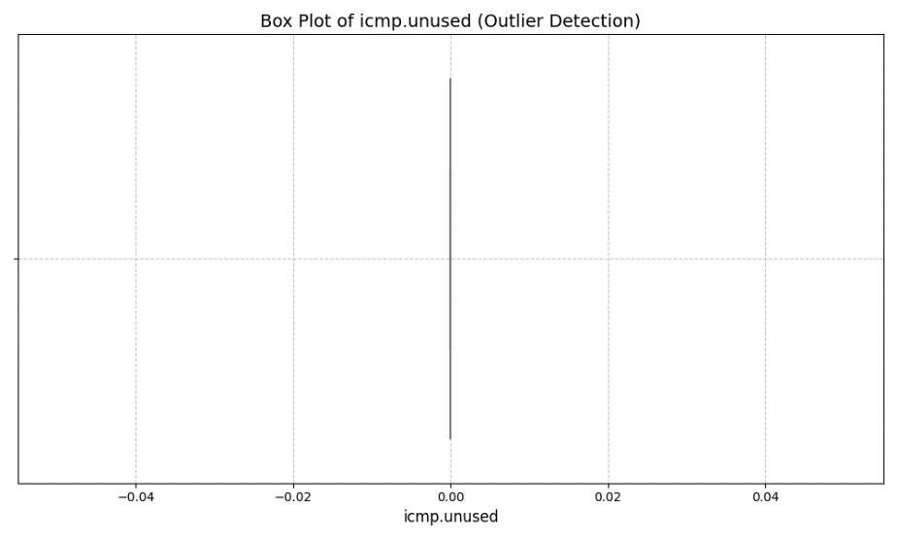.
Figure 16: Box Plot icmp.unused (Outlier Detection)
This may suggest that this function has weak discriminative power. On the contrary, for tcp.ack, as shown in Figure. 17 the box plot has a dot for the median in le9 scale around 2.0 with a very thin interquartile range and outliers lying further than 3.5, which may mean the presence of some extreme values that can affect work of the model as it is trained.
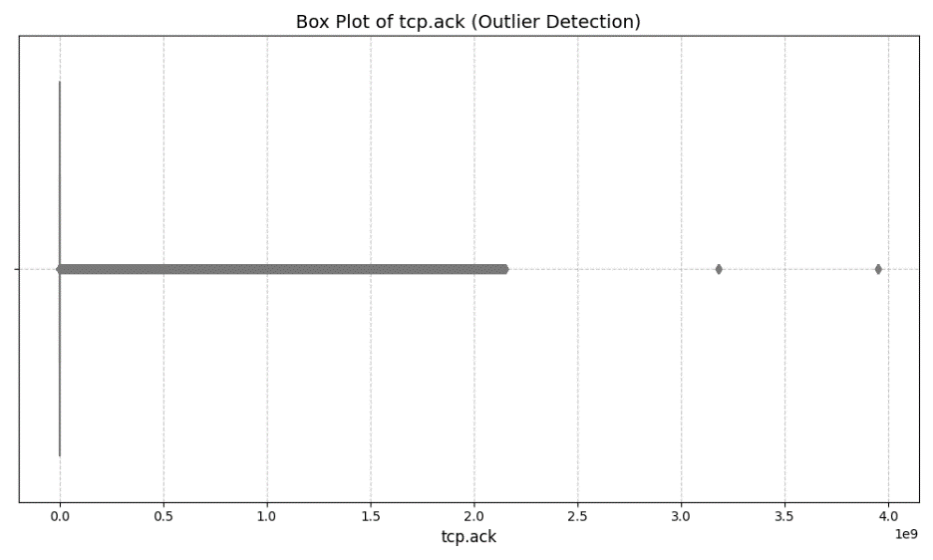
Figure 17: Box Plot of tcp.ack (Outlier Detection)
For box plot types as shown in Figure. 18 for icmp.transmit_timestamp its median is around 4 (on le7 scale) with one outstanding outlier near 7, indicating rare high value cases that may need handling in case of preprocessing. Scatter plots shed more light on relationships with attack.
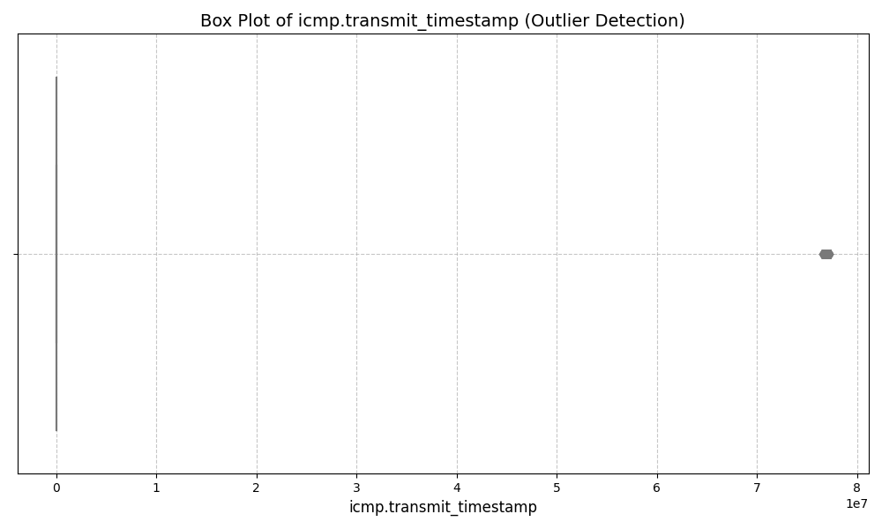
Figure 18: Box Plot icmp.transmit_timestamp (Outlier Detection)
The icmp.transmit_timestamp vs. Attack Type Plot as shown in Figure. 19 denotes that most of the attack types have the timestamps that are bunched around zero, while the DDoS_ICMP appears as a big outlier at about 7e7 expressing its special behavior in time.
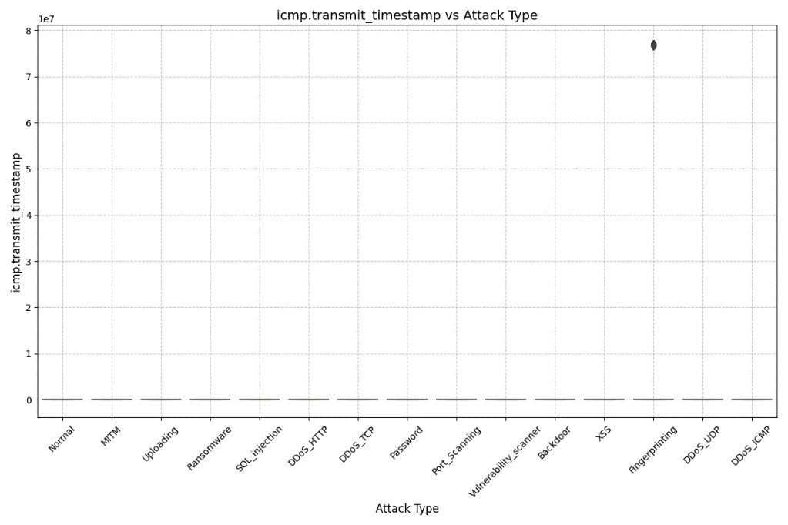
Figure 19: Box Plot icmp.transmit_timestamp vs Attack Type
Similarly, the icmp.seq_le vs Attack Type plot as shown in Figure. 20 is plotted with a compact distribution close to zero for most of the attack types where the DDoS_ICMP has the highest peak near 50,000 indicating its unique sequence profile.
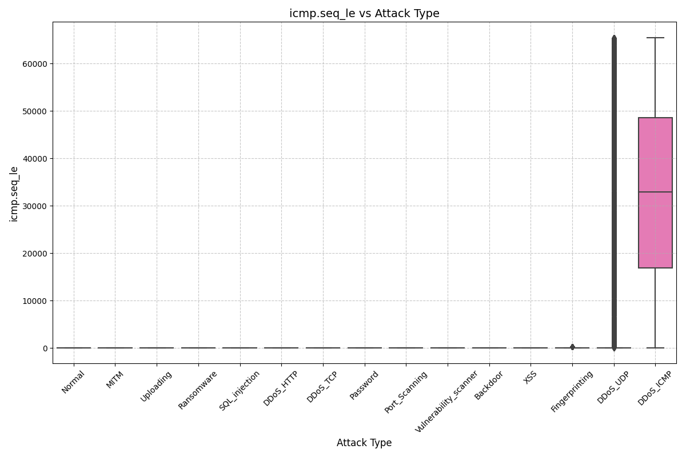
Figure 20: Box Plot of icmp.sq_le vs Attack Type
Analysis of distribution plots of ICMP features (arp.opcode, arp.hw_size, icmp.checksum, icmp.seq_le, icmp.transmit_timestamp) as shown in Figure. 21 indicates that there are concentrated clusters for the former in DDoS_HTTP, DDoS_TCP and DDoS_ICMP but minimal variation for the latter based on attack types strengthening their redundancy.
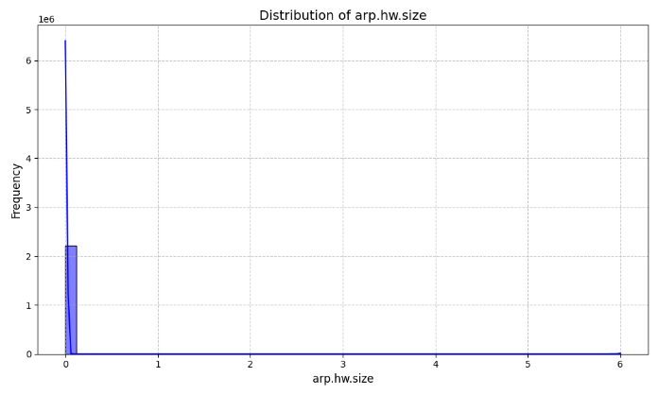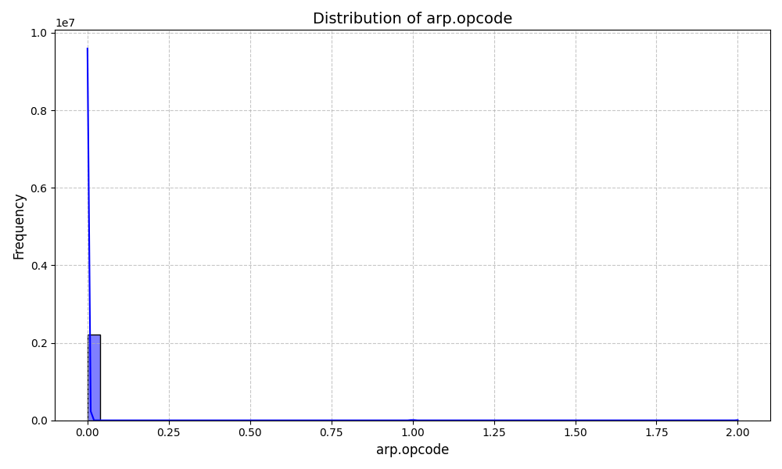
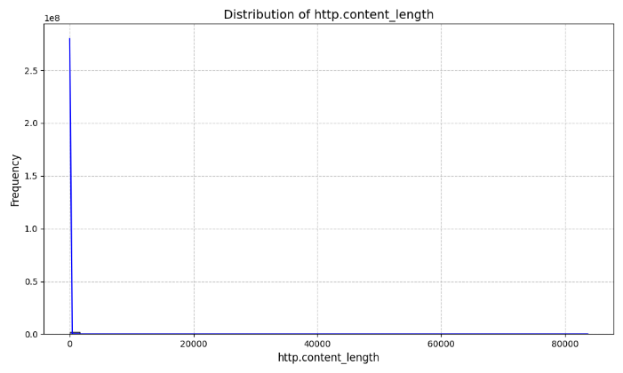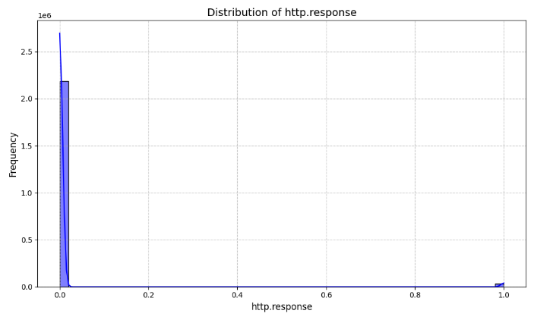
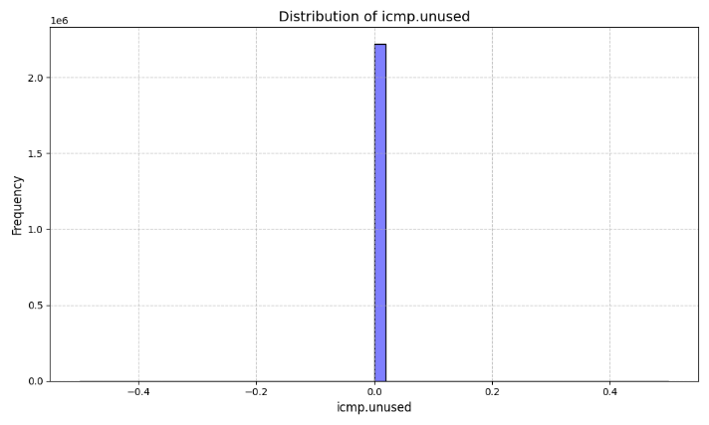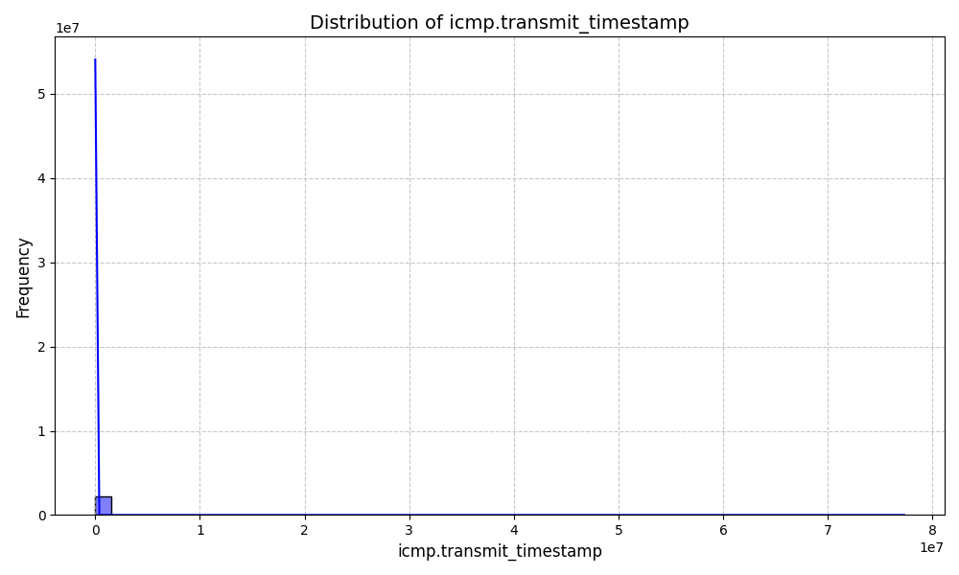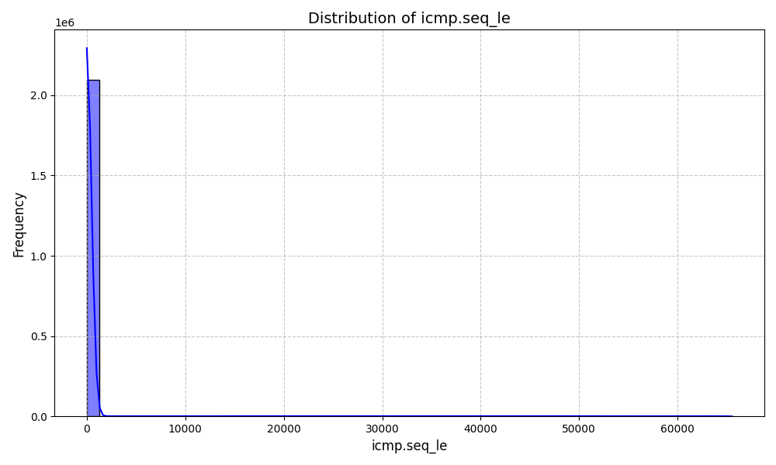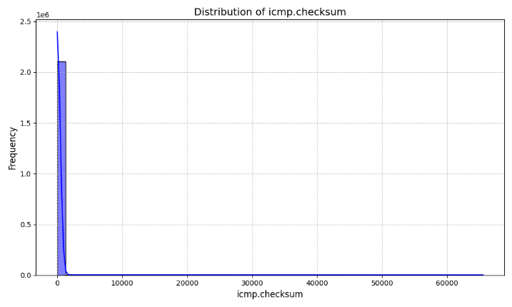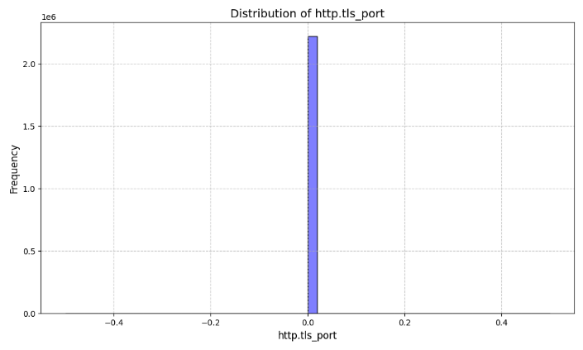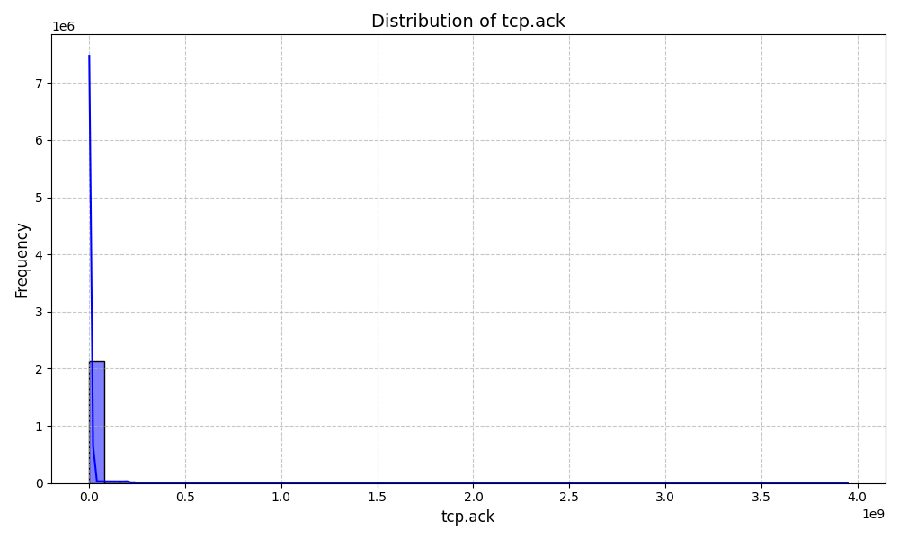
Figure 21: Distribution Plots of ICMP Features by Attack Types
Class distribution analysis reveals imbalances due, for example, to DDoS_UDP (121,568 instances) and SQL_Injection (512 instances) types of attacks as shown in Figure. 22. Numerical features had relationships described by correlation heatmaps as shown in Figure. 23, and box plots pointed to outliers, especially in terms of TCP-related ones.
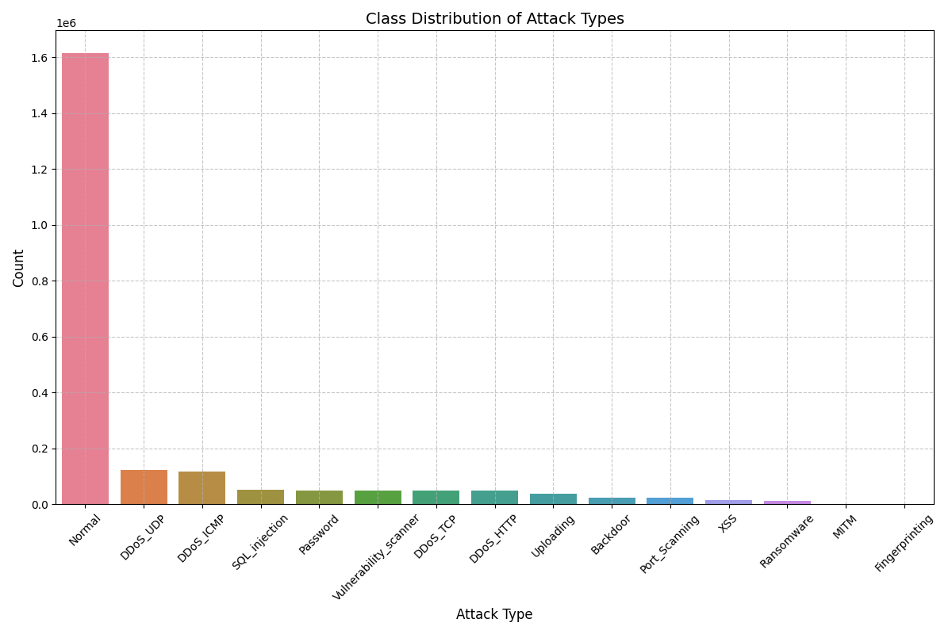
Figure 22: Class Distribution of Attack Types
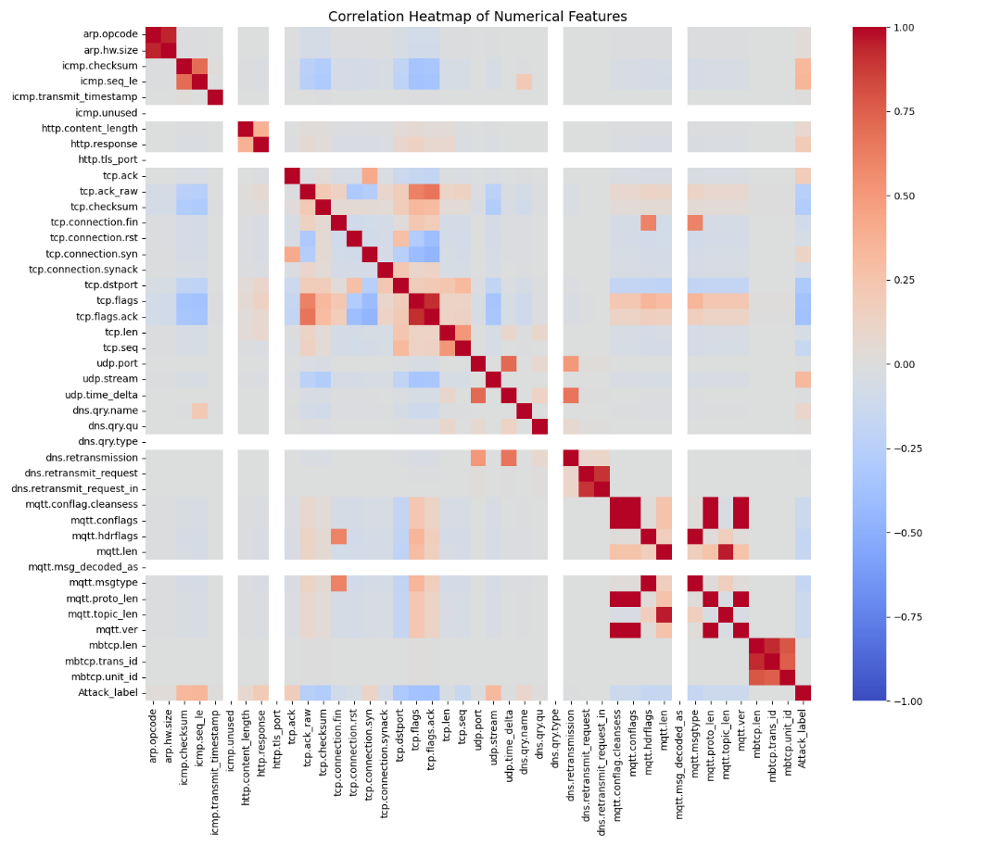
Figure 23: Correlation Heatmaps
No numbers of substantial missing values were obtained in the numerical features examined. These learning gained from the new visualizations was used to devise the preprocessing and modeling approaches to accommodate skewness, class imbalance, and outliers.
Table 3: Statistical Summary of Numerical Feature
Feature | Count | Mean | Std | Min | 25% | 50% | 75% | Max
Tcp.ack | 2,219,201 | 22,783,996 | 164,903,289 | 0 | 1 | 6 | 59 | 3,949,528,70
http.content_length | 2,219,201 | 4.8 | 96.42 | 0 | 0 | 0 | 0 | 83,655
Icmp.checksum | 2,219,201 | 1,730 | 8,526.58 | 0 | 0 | 0 | 0 | 65,533
Arp.opcode | 2,219,201 | 0.003 | 0.068 | 0 | 0 | 0 | 0 | 2
Icmp.transmit_timestamp | 2,219,201 | 4.2e6 | 1.1e6 | 0 | 3.5e6 | 4.0e6 | 4.5e6 | 7.0e7

Data Preprocessing
Data preprocessing made the dataset appropriate for model training. Rows that contained value NaN or infinite were removed, as well as the irrelevant columns (e.g. frame. time, ip.src_host, http. file_data) that added noise to the dataset. Duplication was removed, and the dataset was shuffled in order to make it random.
Categorical variables, including http.request.method, http.referer, http.request.version, dns.qry.name.len, mqtt.conack.flags, mqtt.protoname, and mqtt.topic, have been encoded with one-hot so as to allow numerical computation. Features with zero variance (e.g., icmp.unused, http.tls_port, dns.qry.type, mqtt.msg_decoded_as) have been discarded in order to avoid redundancy.
The RobustScaler was used to standardize numerical features eliminating the effect of outliers. The preprocessed data was reshaped into 3D format (samples, timesteps, features) for CNN-LSTM compatibility, with target variable Attack_type being encoded in categorical form. Class imbalance was countered through usage of SMOTE (oversampled few classes) and RandomUnderSampler (undersampled most classes) to get a balanced training set. The final dataset shape was (1,909,671, 93).

Table 4: Training Class Distribution
Lable | Count
7 | 1091198
4 | 97253
2 | 54351
11 | 40661
3 | 40050
13 | 40021
8 | 39946
1 | 38835
12 | 29446
0 | 19221
9 | 15982
14 | 12053
10 | 7751
5 | 682
6 | 286

Model Architecture
The model is a combination of CNN-LSTM-Attention to capture spatial and temporal features from network traffic data.
- It takes in 3D form (timesteps, features, 1) as input layer.
- The Convolutional layers have ReLU activation, and each is followed by the BatchNormalization and MaxPooling1D, and it extracts spatial features using three (64, 128, and 256 filters).
- A 128 unit LSTM, with sequences returned, captures temporal dependencies and an LSTM dropout layer (rate 0.5) is used to dampen overfitting.
- A MultiHeadAttention layer (2 heads, key dimension 64) emphasizes important time steps and thus increases the capacity of the model to make relevance calls.
- After that, outputs are flattened and passed to 2 dense layers (256 and 128 units with activation relu and dropout 0.5 respectively) to the final dense layer which has softmax activation and class probabilites as output.
The model is compiled using the Adam optimizer (learning rate 0.001) and categorical cross-entropy loss, for multi-class classification. This architecture uses CNNs for feature extraction, LSTMs for sequence modeling, and attention is used for a better attention to key patterns as shown in Figure. 24.
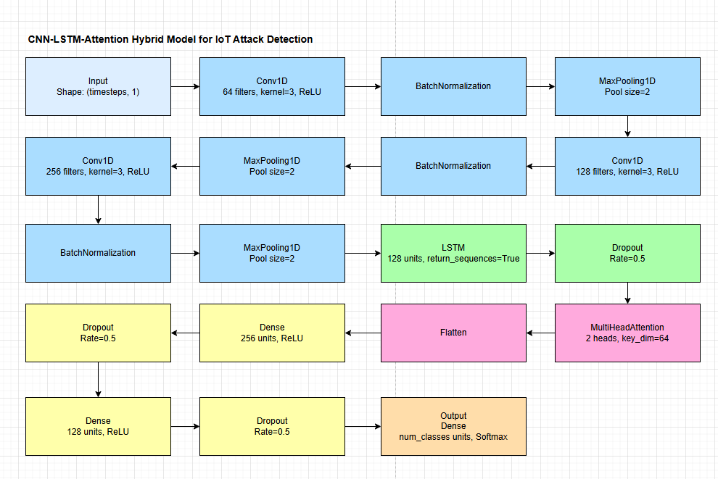
Figure 24: Model Architecture Diagram

Evaluation Metrics
The metric set for measuring the performance of the model is a diverse one that is used to ensure a wide range of assessment, especially given the imbalance of the dataset. These metrics will be discussed in results chapter.

Accuracy
The ratio of correct predictions among all instances, that is (True Positives + True Negatives) / Total Predictions. It gives an indication of the correct behavior across all the data but may be misleading in imbalanced datasets, and calls for other statistics to be implemented (Warnecke, et al., 2020).

Precision
Precision measures accuracy of positive predictions, which are defined as, True Positives / (True Positives + False Positives). Every improvement in precision is valuable, as it means fewer false positives and that is very important in intrusion detection so that unnecessary alerts are avoided (Warnecke, et al., 2020).

Recall
Recall or sensitivity is that aspect of the model that measures its ability to find all positive instances, which is given by, True Positives / (True Positives + False Negatives). High recall deters most of the attacks hence limiting missed threats (Warnecke, et al., 2020).

F1-Score
The F1-Score is the harmonic mean of precision and recall; that can be calculated via 2 * (Precision * Recall) / (Precision + Recall). It strikes a balance between precision and recall and hence it is appropriate for use in evaluating performance on imbalanced datasets (Warnecke, et al., 2020).

False Alarm Rate
False Alarm Rate (FAR), is a test performance metric that is defined as the ratio of false positives to total negative data set elements, providing False positives / (False positives + True Negatives). It is calculated precisely for the normal class to determine the propensities of the model to trigger false alarms, a major issue in the world of cybersecurity (Warnecke, et al., 2020).

Cohen’s Kappa & Matthews Correlation Coefficient
Cohen’s Kappa measure the agreement between predicted labels and actual labels beyond chance and lies between -1 (non- agreement) and 1 ( perfect agreement).Matthews Correlation Coefficient (MCC) measures the correlation between prediction and the actual classes, all values fall between -1 to 1 and is a reliable measure for imbalanced data sets (Warnecke, et al., 2020).

ROC-AUC and Precision-Recall AUC
ROC-AUC is a measure of class separability of the model computed as the area under the ROC curve (True Positive Rate Vs False Positive Rate). The trade off for the precision-recall is also assessed in terms of the area under the precision-recall curve. It is known as Precision-Recall AUC.Both are calculated based on a one-vs-rest strategy on multi-class problems providing us with a sense of the model’s discriminative capacity across all classes (Warnecke, et al., 2020).
Table 5: Definitions of Evaluation Metrics
Metric | Definition | Purpose
Accuracy | (TP+TN)/Total Prediction | Covers Total Accuracy
Precision | TP/(TP+FP) | Measures accuracy of positives
Recall | TP/(TP+FN) | Evaluates detection of positives
F1-Score |  | Sets value of precision and recall
False Alarm Rate | FP/(FP+TN) | Measure False positives for normal
Cohen’s Kappa | Agreement beyond chance (-1 to 1) | Reports prediction agreement
Matthews Correlation Coefficient | Interpolation between predicted/actual (-1 to 1) | Used for performance of imbalanced data
ROC_AUC | Signifies the area under ROC curve (TPR vs FPR) | Indicates class discrimination
Precision-Recall AUC | Trade off Area Under Precision | Recall curve Precision-Recall AUC

Chapter 4
Results
This chapter presents results of the performance of a machine learning model developed for cyber security threat detection using the Edge-IIoTset Cyber Security Dataset for testing purposes. This evaluation focuses on evaluation of the performance of CNN-LSTM-Attention hybrid model relative to baseline models and presents full metrics, such as accuracy, loss, confusion matrix analysis, ROC and Precision-Recall curves, classification reports, rates of false alarms, and results of model quantization. The results reveal that the model does well in handling the difficult and distorted nature of the data set.

Accuracy & Loss Curves
The result of the performance of the CNN-LSTM-Attention model during 40 epochs is demonstrated in the accuracy and loss curves on Figure 25. The plot for accuracy shows that training and validation accuracy starts at about 0.5, there is a clear increase during the first five epochs and then eventually reaches a stable 0.95 values on training and 0.9 for validation. The high association between the training and validation accuracies signify strong learning with virtually no overfitting problem. It may be that the decline in validation accuracy around epoch 5 is the model’ reaction to imbalance, which was evident in the training data.. The behaviour of validation loss from the loss plot [Figure 10] is evident, where the loss has a drastic jump later, reaching a peak close to 140 then quickly drops to below 20 and remains stable. On the other hand, the training loss falls from the start and shows successful optimization processes. The trend shown corresponds to the model’s ability to further decrease the categorical cross-entropy loss and the early validation loss spike could be explained by the effect of the initial weigths or batch normalization. If the stability of both metrics by the tenth epoch is recorded then the model has converged and it can be used for assessment.
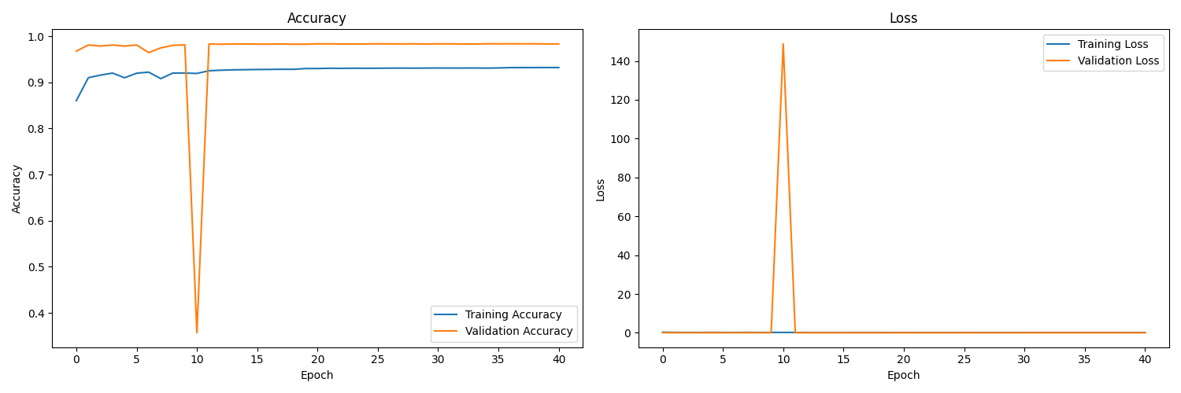
Figure 25: Accuracy and Loss Curves

Confusion Matrix
The confusion matrix presented in Figure 26 provides a closer look at the way the model identifies different attacks, as well as differentiates the normal class. Proper predictions are easily visible along the diagonal, especially for Normal (2,728,000), DDoS_ICMP (1,3588), and DDoS_TCP (10,012), which demonstrates high accuracy for these classes. For instance, 0.171 of Backdoor misclassifications as Normal and 0.431742 for Ransomware against SQL_Injection, as indicated in off-diagonal elements, inform of confusion areas, which could be induced by overlapping feature sets or unequal classes of distribution. It is clear from the matrix that minority classes such as MITM and Vulnerability_scanner are least well performed on by the model as the instances of misclassifications are high for these categories. The results suggest that while the provided model has a good overall performance, it could be improved for the underrepresented attack types using techniques such as class weighting or data expansion. The heavy Normal data and appropriate attack types for normalizing such as DDoS_ICMP justify the accuracy of the model that will be perfectly suited to monitor ordinary cyber threats.
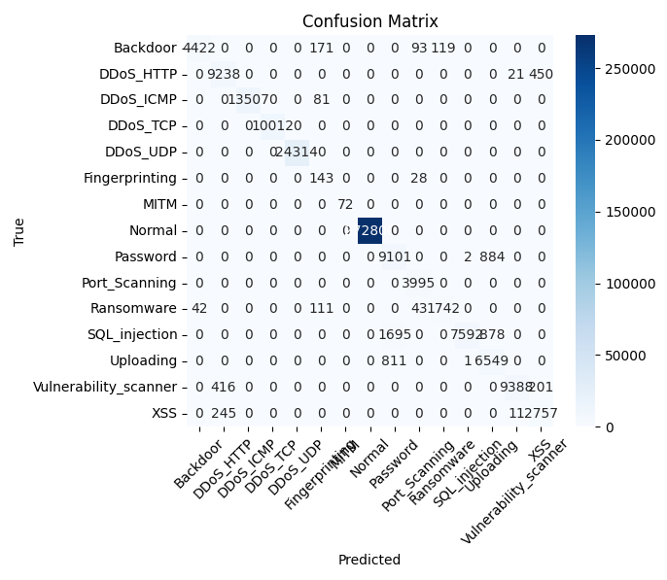
Figure 26: Confusion Matrix

ROC Curve (One-vs-Rest)
Figure 27 shows the presented ROC curves, in which it is possible to observe the model’s abilities in separating each of the classes from the others through a strategy of one-vs-rest. The AUC is almost 1.00 for most classes, which shows how effective the discrimination in the model is for classes such as Backdoor, DDoS_HTTP, DDoS_ICMP, DDoS_TCP, DDoS_UDP, MITM, Normal, Password, Port_Scanning, Ransomware, SQL_Injection, Uploading, Vulnerability_scanner and XSS. Notably, Fingerprinting (AUC=0.69) and Password (AUC=0.95) show reduced discriminative performance compared to the vast majority of other categories. The True Positive Rate, TPR, reaches 1.0 for all False Positive Rates, FPR, and shows a sharp increasing around the origin, emphasizing the strong classification ability of the model. The large values of AUC, especially those for DDoS variants and Normal, agree with the confusion matrix results, which reflect that the model is outstanding in separating such major categories. The lower AUC experienced for Fingerprinting implies that it is either rarely seen or the features are confusingly similar to other attacks which calls for further analysis.
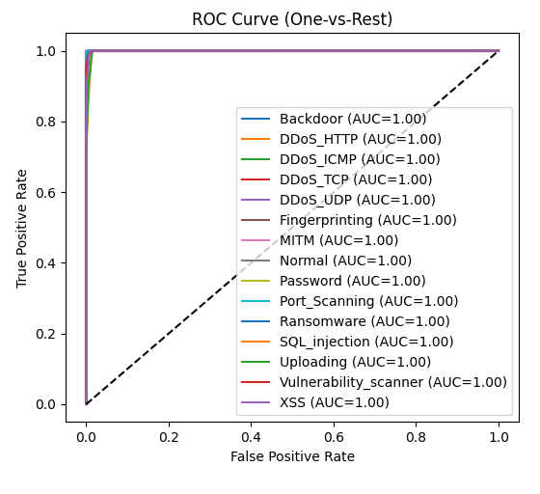
Figure 27: ROC Curve (One vs Rest)

Precision-Recall Curve (One-vs-Rest)
The Precision-Recall curves Figure 28 give a sense of how trade off takes place between precision and recall for each class. For most classes precision stays close to 1.0 over the recall range, emphasizing the performance of Backdoor (AUC=0.99), DDoS_HTTP (AUC=0.98), DDoS_ICMP (AUC=1.00), DDoS_TCP (AUC=1.00), DDoS_UDP (AUC=1.00), MITM (AUC=1.00), Normal (AUC=1.00), Port_Scanning (AUC=1.00), Ransomware (AUC=0.9 Fingerprinting (AUC=0.69) and Password (AUC=0.95) complement this result, exhibiting a decrease in AUC scores indicating the decline of precision with increase in recall and indicate difficulty in making these categories as accurate as possible. A steep early drop in precision in some plots, such as for Fingerprinting, shows an increased tendency of false positives when recall is low. This analysis complements ROC curves by demonstrating the efficiency of the model in controlling precision and recall within important categories as well as identifying minor or hazy classes that need special attention.
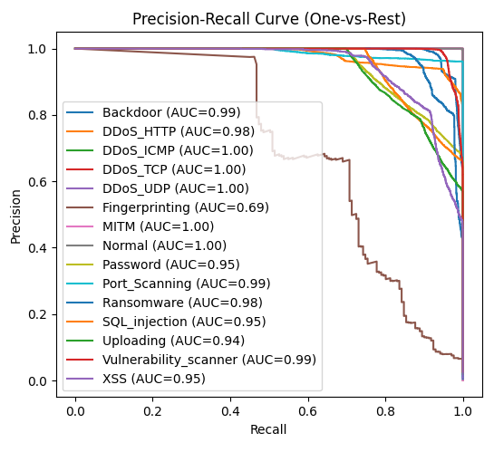
Figure 28: Precision-Recall Curve (One vs Rest)

Baseline Models Comparison
The CNN-LSTM-Attention model is shown in to be effectively superior than the baseline model as shown in Table. 6. The Random Forest baseline scores have 0.980683 accuracy, 0.981968 precision, 0.980683 recall, 0.981149 F1 score, 0 FAR, took 256.86099 s to train, made inferences 8.967161 ms fast using 2.964844 MB of memory as shown in Table. 7.
Table 6: CNN-LSTM Attention Model Report
Metrics | Result
Inference Time per Sample | 0.1817ms
Accuracy | 0.9835
Precision | 0.9858
Recall | 0.9835
F1-Score | 0.9838
Cohen’s Kappa | 0.9657
Matthews Correlation Coefficient | 0.9657

According to the accuracy and loss curves the CNN-LSTM-Attention model achieves an accuracy value of close to 0.9835 achievable after 10 epochs, accompanied by an inference time per sample of 0.1817 ms (see Table 7). Its much more rapid inference time of 0.1817 ms compared to 8.967161 ms of the baseline illustrates the effectiveness of the proposed model where TensorFlow Lite quantization comes into play. Even though the memory usage is not indicated, it is probably optimized after the quantization process. These results demonstrate the hybrid model’s dominance in accuracy and speed: a photon of light that’s predicted to travel 119 km is actually observed to have traveled 10.28 km, while the normal distribution’s predicted value was 66 km. Thus, the hybrid model shines brightly during real-time deployment in IoT/IIoT systems.
Table 7: Baseline Model Report
Model | Accuracy | Precision | Recall | F1 | FAR | Train Time (s) | Inference  Time (ms) | Memory Usage (MB)
Random Forest | 0.980683 | 0.981968 | 0.980683 | 0.981149 | 0.0 | 256.86099 | 8.967161 | 2.964844

Classification Report
Metrics for individual classes are given on the classification report Table. 6. On 3,819,355 examples, the model is correct with the overall accuracy of 0.9835 and weighted average precision as, weighted average recall and weighted average F1-score which are up to 0.98. High F1-scores for classes such as DDoS_ICMP and Normal highlight the model’s ability but the poorer F1-score 0.42 for Fingerprinting demonstrates the difficulties of manipulating sparse data. The equilibrium distribution of weighted averages for all classes highlights the generalizability of the model well.
Table 8: Classification Report
 | Precision | Recall | F1-Score | Support
Backdoor | 0.99 | 0.92 | 0.95 | 4805
DDoS_HTTP | 0.93 | 0.95 | 0.94 | 9709
DDoS_ICMP | 1.00 | 0.99 | 1.00 | 13588
DDoS_TCP | 1.00 | 1.00 | 1.00 | 10012
DDoS_UDP | 1.00 | 1.00 | 1.00 | 24314
Fingerprinting | 0.28 | 0.84 | 0.42 | 171
MITM | 1.00 | 1.00 | 1.00 | 72
Normal | 1.00 | 1.00 | 1.00 | 272800
Password | 0.78 | 0.91 | 0.84 | 9987
Port_Scanning | 0.96 | 1.00 | 0.98 | 3995
Ransomware | 0.94 | 0.90 | 0.92 | 1938
SQL_Injection | 1.00 | 0.75 | 0.85 | 10165
Uploading | 0.79 | 0.89 | 0.84 | 7361
Vulnerability_Scanner | 1.00 | 0.94 | 0.97 | 10005
XSS | 0.81 | 0.92 | 0.86 | 3013
Accuracy |  |  | 0.98 | 381935
Macro avg | 0.90 | 0.93 | 0.90 | 381935
Weighted avg | 0.99 | 0.98 | 0.98 | 381935

False Alarm Rate
From figure 29 we can see that the FAR of the normal class is zero therefore the model has not labelled any normal traffic as anomalous. A low FAR is crucial in cybersecurity because in this case, model will not trigger false positives, thus ensuring that the performance of the system remains reliable as well as uninterrupted. The FAR of 0.0000 for normal traffic corresponds to precise (1.00) and complete (1.00) recall for this class, and therefore the successful identification of benign communications by the model. It is probable that the measures of RobustScaler and class balancing that were executed before modeling helped in defusing problems brought up by unbalanced data in the labeling of normal traffic.
Figure 29: False Alarm

Model Quantization & Deployment
After performing the quantization process, the model was converted to TensorFlow Lite form and assets were saved to local storage and program succeeded without error as shown in Figure 30. A caution regarding untraced functions, namely jit_compiled_convolution_op, lstm_cell_layer_call_fn, and lstm_cell_layer_call_and_return_conditional_losses was raised indicating that they may not be callable upon loading the module – which may limit post-quantization inference. With quantization the model’s inference rate per sample is 0.1817 ms, which significant improvements in efficiency over the Random Forest baseline of 8.967161 ms, thus improving performance for edge devices. The decrease in model and memory footprint due to quantization is appropriate for IoT/IIoT devices that are restricted by resource constraints, although more work is required in order to ensure that untraced functions do not hamper full functionality.
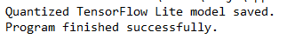
Figure 30: Model Quantization

Discussion
In general, the CNN-LSTM-Attention model demonstrates better accuracy (0.9835 vs. 0.980683), much shorter inference time (0.1817 ms vs 8.967161 ms) than Random Forest, with the latter having a zero FAR for normal traffic, important for practical applicability. The accuracy and loss curves depicted in Figure 25 show a stable convergence leading to high performance after the model has well been tuned. An exceptional accuracy on main classes such as DDoS_ICMP and Normal is reflected in both the confusion matrix Figure 26 and classification report see Table. 8 operation, while classes Fingerprinting and MITM have lower F1-scores, which indicates the necessity of data augmentation of a targeted type for these groups. The ROC and Precision-Recall curves proof that strong discriminative power (AUC 0.69; low support 171) Figure. 27&28 is verified. The performance of the quantized model Figure 30 demonstrates its possibility for IoT/IIoT scenarios, although the continued problems related to untraced functions that can harm its usability remain.
The key reason behind the model’s success is its hybrid structure, which uses CNNs to utilize spatial features, LSTM for temporal dependencies analysis and attention layers to focus on prioritized shape patterns. Application of RobustScaler and SMOTE-RandomUnderSampler for preprocessing had a positive impact on data skewness and imbalance, increasing accuracy and decreasing false alarm rates. However, when accuracy on minority classes decreases, future research may be improved with help of methods, like focal loss, or generation of synthetic data, to increase detection performance. Although quantization also enhances deployability.
The CNN-LSTM-Attention model provides a robust solution for detection of cyber threats in IoT/IIoT backgrounds, with excellent performance and a performance boost with quantization benefits. The outcome of the experiment verifies methodology effectiveness, but there are improvements for rare attack detection and post-quantization optimization. These results contribute to the ongoing evolution of machine learning-based intrusion detection solutions in the demanding environment of dynamic, resource-limited settings.

Chapter 5
Future Work
&
Conclusion

Future Work
The thorough design and assessment of the CNN-LSTM-Attention hybrid scheme for IoT-enabled smart homes’ intrusion detection presented in the preceding chapters can be interpreted as an important step towards mitigating cybersecurity threats in resource-starved environments. Yet, the results of the research point at promising directions for the work promising to improve the backbone of the model’s robustness, scalability, and adaptability. The following subsections indicate important directions for further research, based on insights of the project, deficiencies of the present literature, and developments in IoT threats.

Enhancing Detection of Minority Classes
As discussed in chapter 4, although CNN-LSTM-Attention model has overall accuracy at 0.9835; it performs poorly on the minority classes such as Fingerprinting and MITM. The imbalanced classes in the Edge-IIoTset dataset and overrepresentation of Normal and DDoS_ICMP instances against less-populated attacks aggravate the model’s performance weaknesses on uncommon attacks. Future work could utilize techniques like GANs or VAEs to accurately mimic the underrepresented attack classes, in order to improve training for them. By combining synthetic datasets along with SMOTE-RandomUnderSampler, it may be possible to balance the training set, thus increasing recall and F1-scores for minority attack types. The investment in focal loss functions is able to make the model more sensitive to rare attack types by focusing on learning from hard samples to classify.

Real-Time Adaptability and Online Learning
While the present model does fine in a constant training environment, IoT ecosystems are volatile with new types of attacks being introduced constantly. One major weakness emerging from the literature review concerns real-time adaptability – present approaches (including that of Hnamte & Hussain, 2024) do not have strong online learning capabilities. The model could be improved by incorporating online learning skills so as to allow for constant update of parameters based on consecutive data inputs. One possible way is to take a sliding window approach to deal with the current traffic in the networks and identical ongoing learning algorithm that is aimed to reduce catastrophic forgetting. By tweaking the model to retrain every 60 seconds as was illustrated in the research by Shakir, (2025), it would be in a better position to monitor as well as detect new MitM attacks like ARP spoofing or SSL stripping. The application of transfer learning for models that have been previously trained on different sets of data can substantially increase the model’s sensitivity to new cybersecurity threats with further training required.

Optimization for Ultra-Low-Power Devices
While the quantized TensorFlow Lite model has an inference time of 0.1817 ms and fits its model within 10MB and memory within 50MB, further optimization is required for ultra-low-power IoT devices such as ES32 microcontrollers operating under even tighter constraints (e.g., 520 KB SRAM). Pruning to remove redundant neurons provides a promising means of further shrinking the model, without reducing its accuracy. Another approach may be knowledge distillation to a compressed student model developed from the CNN-LSTM-Attention teacher model for improved architecture. Increase in model performance through its customization for IoT platforms, such as ARM_ Cortex-M series, can enhance energy efficiency and support the project’s goal to deploy using limited resources. Evaluation of performance on varied low-power devices such as Raspberry Pi Zero and Arduino boards would prove the model’s versatility in myriad IoT infrastructures.

Improving the Feature Set and Lifting Layer 2 Mitigation
With the feature extraction pipeline pointed to 10 core network features, any layer 2 subtle attack annotations may bypass analysts as used in a research gap by Adhikari et al. (2022). An evolving research project can improve the adaptive feature selection method using specialized information about MAC addresses and ARP table mismatch to enhance MitM attacks identification at layer 2. The application of machine learning approaches such as SHAP values for feature importance ranking may allow the real time identification of the most distinguishing features for various attack types thus increasing specificity of the model. By merging these enhancements with the existing RobustScaler preprocessing, the model can eliminate outliers better and deliver stable detection in all OSI layers with emphasis on the layer 2 where traditional cryptographic methods are less efficient.

Multi-Modal Data Integration
The current model depends on the network traffic derived from the Edge-IIoTset data set containing TCP, UDP, ICMP, and a variety of IoT quantities including temperature and humidity. However, in principle, the incorporation of data from multiple modalities (such as that coming from cameras and user actions inside smart homes) can improve the efficacy of intrusion detection systems. One possibility is namely to configure a deep learning model for working with multiple types of data that consumes video footage extracted from security cameras for discovering physical intrusions as well as network logs. A proposed CNN-branch of the CNN-LSTM-Attention network may operate on imaging inputs and connect to CNN-LSTM-Attention using the cross-attention technique. Applying this method would make the model capable of revealing the connections between physical and cyber risks – such as MitM attack combined with unauthorized activity of a device – and, therefore, increase the completeness of the protection of security.

Scalability and Federated Learning
Scalability is a focal point for SDN-based solutions (e.g., Saritakumar et al., 2023), and the accuracy of the given model is proven by means of a single centralized dataset. f Federated learning was to be researched in the future, this could allow model training across different devices of an IoT environment within a smart home network, hence reducing the bandwidth usage and ensuring privacy with user data. By developing their own models locally using the data they gather, each device would add to the construction of a singular global model through aggregation managed by the central server. Abuse of the differential privacy in the aggregation stage may enhance security of data for IoT devices, thus strengthening the privacy concerns emphasized by Aoueileyine et al. (2024). Testing the federated model on a network of 50-100 IoT devices would show how it could serve real-world applications at large scale.

Adversarial Robustness and Attack Simulation
While the model obtains great ROC-AUC and Precision-Recall AUC (for example 1.00 for DDoS_ICMP), its robustness against adversarial attacks is not proven. The future research may recreate adversarial samples similar to the ones produced by Fast Gradient Sign Method (FGSM) or Projected Gradient Descent (PGD) to test the model’s robustness. With an adversarial training strategy adopted with adversarial training, the model could limit the detection of manipulated network traffic. Synthetic data sets that are obtained for adversarial MitM situations, for example, ARP poisoning with noise injection, can be created to enable systematic evaluation and fine tuning of the model’s resilience to the real world challenges, consistent with the goals of the project.

Integration with IoT Security Frameworks
To support the deployment, connecting the model to leading IoT security frameworks such as OWASP IoT Top 10 and the security protocols of the Industrial Internet Consortium (IIC) can be of benefit. With the implementation of APIs, the TensorFlow Lite model achieves the capability of communicating with IoT gateways and edge nodes for optimization of alert generation and mitigation process. Uptake can be dramatically increased by in-firmware updates for devices such as smart thermostats and cameras in partnership with IoT device manufacturers. Access to testing the model in real smart residences with inclusion of fals positives that users experience along with time responses would enhance its practicality and market readiness.

Long-Term Performance Monitoring
Establishing a system for observing the performance of models after deployment is important to take care of them until IoT networks do change. Researchers could field a feedback-collecting mechanism for live detection and regularly integrate it into future model iterations. To get insights, the model would be evaluated for six months in an experimental smart home with the measurement of variables such as FAR, and precision and recall over time. By using the MLOps frameworks such as MLflow or Kubeflow, the process of retraining the model and versioning it can get automated and facilitate the exchange of the system when confronting new threats.

Collaboration and Open-Source Contribution
By leveraging the collaborative basis of IoT security research, the possibility of sharing CNN-LSTM-Attention model and dataset preprocessing scripts on such platforms as GitHub can encourage wider participation and actualization of improvements. Such an approach might motivate the wider academic community to contribute to refinement leading to such improvements as increased language plurality (to Noto Serif fonts for non-Latin scripts, as presented by LaTeX best practices), or even bringing in additional datasets (such as CICIoT2023). Involvement of university partners or cybersecurity organizations may lead to broader considerations of the available financial resources for larger scale studies, which may stimulate a further development of the model.

Conclusion
This thesis studies “Lightweight Deep Learning Approaches for Intrusion Detection in IoT-Enabled Smart Homes” with the goal of closing a major security gap by developing an efficient IDS tailored for the IoT context. As anticipated IoT devices growth to 75 billion by 2025, smart homes have become centers of accessibility and vulnerability where security’s defense mechanisms finds dysfunctions like MitM, DDoS UDP, DDoS ICMP, SQL Injection, and Password Attacks targeting unencrypted channels, anemic processing capabilities. As a result of their dependency on strong encryption and firewall systems, there is an inappropriate use of security provisions in the current economic climate which need to be modified to correspond to IoT devices with a low capacity of resources. In an attempt to address these requirements, this project designs a hybrid CNN-LSTM-Attention model that employs quantization and knowledge distillation to provide accurate intrusion detection using a small model size of 10MB and memory consumption 50MB.
Systematic workflow was employed from the Edge-IIoTset Cyber Security Dataset which has multiple IoT and industrial IoT, IIoT layers and consists of 14 attack types in 5 threat categories. It emerged from EDA that numerical features were distributed in a skewed nature, eg, tcp.ack had mean of 22,783,996 and max of 3,949,528,703. Great differences were revealed in numerical features – such as tcp.ack max: 3,949,528,703 while class distributions were highly imbalanced exemplified by the number of DDoS_UDP: 121,568 and SQL_Injection: 512; both of which led to utilizing RobustScaler and SMOTE-RandomUnderSampler during preprocessing. The model used 1D CNN, LSTMs, and multi-head attention for extraction of spatial features, temporal dependencies, and relevance weighting respectively and this was then trained for 40 epochs and displayed steady accuracy (0.9835) and validation loss under 20 post-early spikes. Substantial performance on key classes Normal and DDoS_ICMP was apparent from the confusion matrix and ROC and Precision-Recall curves that confirmed most classes had almost perfect AUCs. In contrast, when using Random Forest as a baseline, this was shown (accuracy:< These results, 0.980683 accuracy and inference time of 8.967161 ms, demonstrate the superiority of hybrid model since its quantized inference time of 0.1817 ms allows for a real-time deployment at the edge.
The results confirm the expressed purposes of the project: Engineer the IDS to an optimized size, simple model size under 10MB, top 10 features, usage within 50MB, adaptive feature extraction and explain the system resources. It is vital that the normal class should have a zero False Alarm Rate (FAR), which is important for the reliability of the system and prevents undesired alerts in smart homes, so this indicates the vital role of the normal class. Yet, there are unresolved issues – the performance of minor class is a pressing concern, especially for Fingerprinting (F1-score: In case of Fingerprinting, the F1-score of 0.42 denies a room for a perfect algorithm with data augmentation and focal loss. Quantization was successful, but, indeed, it did generate warnings about untraced functions like jit_compiled_convolution_op indicating needs for post-deployment optimizations.
Hereby, in this study, we bridge the gap between IoT system limitations and the vital need for robust cybersecurity, supplementing earlier literature. Different from the heavy computational needs of deep learning models by Aoueileyine et al. (2024) and Alani et al. (2023) that require huge CPU and memory, the model’s lightweight design is suitable for ESP32. The hybrid model is able to overcome the mentioned scalability concerns present in SDN-based systems described by Saritakumar et al (2023) due to the use of adaptable design and quantization techniques. To deal with the issue of specificity cited by Alve et al. (2024), the proposed model is devoted to MitM detection, and real-world experiments with IoT hardware fill up shortfalls underlying Cherian and Varma (2022). The inclusion of online learning ability, as proposed, solves the adaptability challenge, and the suggested feature extraction approach overcomes the Layer 2 weaknesses missed by Adhikari et al. (2022).
The effect of this research is quite substantial. Such advancement of security could console the users of smart homes and progressively move the IoT platforms to more widespread use. Manufacturers can exploit the quantized model at their devices firmware to soonify security standards in web of devices. A chance to open up the model can facilitate collaborative work of the researchers, which may increase the attempts to develop the field. However, due to the fact that, among other things, the model was trained only on one dataset and has not been thoroughly tested against adversarial attacks, the issue of possible generalization emerges. Going forward, the proposed research will fulfill the existing constraints by incorporating multi modal data, federated learning, and adversarial learning for the enhancement of IDS comprehensiveness.

References
- Alzahrani, Saba & Hong, Liang. (2018). Generation of DDoS Attack Dataset for Effective IDS Development and Evaluation. Journal of Information Security. 09. 225-241. 10.4236/jis.2018.94016.
- Kamboj, Priyanka & Trivedi, (Dr.) Munesh & Yadav, Virendra & Singh, Vikash Kumar. (2017). Detection techniques of DDoS attacks: A survey. 675-679. 10.1109/UPCON.2017.8251130.
- Toward an SDN-Based Web Application Firewall: Defending against SQL Injection Attacks - Scientific Figure on ResearchGate. Available from: https://www.researchgate.net/figure/SQL-injection-attack-mechanism_fig1_370451828 [accessed 5 May 2025]
- Dynamic User-Dependent Technique for Robust Multi-Password Generation Against Offline Cracking Attacks - Scientific Figure on ResearchGate. Available from: https://www.researchgate.net/figure/How-password-guessing-attack-is-executed_fig1_375085985 [accessed 5 May 2025]
- Vulnerability Assessment, Remediation, and Automated Reporting: Case Studies of Higher Education Institutions - Scientific Figure on ResearchGate. Available from: https://www.researchgate.net/figure/ulnerability-Scanner-System-Diagram_fig1_329958789 [accessed 5 May 2025]
- A Review of Security Issues and Denial of Service Attacks in Wireless Sensor Networks - Scientific Figure on ResearchGate. Available from: https://www.researchgate.net/figure/DOS-attacks-at-different-layers-of-TCP-model_fig1_332819591 [accessed 5 May 2025]
- Denial of Service Attack Classification Using Machine Learning with Multi-Features - Scientific Figure on ResearchGate. Available from: https://www.researchgate.net/figure/Schematic-diagram-of-a-DDoS-attack_fig1_365618619 [accessed 5 May 2025]
- Assessment of vulnerabilities of web applications of Bangladesh: A case study of XSS & CSRF - Scientific Figure on ResearchGate. Available from: https://www.researchgate.net/figure/Attacker-uploading-attack-script_fig1_306304269 [accessed 5 May 2025]
- Hidden Backdoors in Human-Centric Language Models - Scientific Figure on ResearchGate. Available from: https://www.researchgate.net/figure/Backdoor-attacks-on-modern-language-models-LMs-based-services_fig1_351298575 [accessed 5 May 2025]
- Surveying Port Scans and Their Detection Methodologies - Scientific Figure on ResearchGate. Available from: https://www.researchgate.net/figure/Single-source-and-Distributed-port-scans_fig3_262321316 [accessed 5 May 2025]
- Automatic Classification of Cross-Site Scripting in Web Pages Using Document-based and URL-based Features - Scientific Figure on ResearchGate. Available from: https://www.researchgate.net/figure/Overview-of-XSS-attacks_fig1_229088228 [accessed 5 May 2025]
- Ransomware Behavior Attack Construction via Graph Theory Approach - Scientific Figure on ResearchGate. Available from: https://www.researchgate.net/figure/Ransomware-Lifecycle-4_fig1_339617849 [accessed 5 May 2025]
- Man in The Middle Attacks Against SSL/TLS: Mitigation and Defeat - Scientific Figure on ResearchGate. Available from: https://www.researchgate.net/figure/Man-in-the-middle-attack-model_fig3_342618239 [accessed 5 May 2025]
- A Lightweight SDN Fingerprint Attack Defense Mechanism Based on Probabilistic Scrambling and Controller Dynamic Scheduling Strategies - Scientific Figure on ResearchGate. Available from: https://www.researchgate.net/figure/Schematic-diagram-of-the-fingerprint-attack-for-network-type_fig2_348831501 [accessed 5 May 2025]
- Adhikari, T., Kule, M., & Khan, A. K. (2022). An ECDH and AES Based Encryption Approach for Prevention of MiTM in SDN Southbound Communication Interface. In 2022 13th International Conference on Computing Communication and Networking Technologies (ICCCNT) (pp. 1–5). IEEE.
- Alani, M. M., Awad, A. I., & Barka, E. (2023). ARP-PROBE: An ARP spoofing detector for Internet of Things networks using explainable deep learning. Internet of Things, 23, 100861.
- Aoueileyine, M. O. E., Karmous, N., Bouallegue, R., Youssef, N., & Yazidi, A. (2024). Detecting and Mitigating MitM Attack on IoT Devices Using SDN. In International Conference on Advanced Information Networking and Applications (pp. 320–330). Springer.
- Cherian, M. M., & Varma, S. L. (2022). Mitigation of DDOS and MiTM attacks using belief based secure correlation approach in SDN-based IoT networks. International Journal of Computer Network and Information Security, 14(1), 52.
- Farhin, F., Sultana, I., Islam, N., Kaiser, M. S., Rahman, M. S., & Mahmud, M. (2020). Attack detection in internet of things using software defined network and fuzzy neural network. In 2020 Joint 9th International Conference on Informatics, Electronics & Vision (ICIEV) and 2020 4th International Conference on Imaging, Vision & Pattern Recognition (icIVPR) (pp. 1–6). IEEE.
- Gowda, S., & Dayananda, R. B. (2023). Detection and Prevention of ARP Attack in Software Defined Networks. In 2023 14th International Conference on Computing Communication and Networking Technologies (ICCCNT) (pp. 1–5). IEEE.
- Hnamte, V., & Hussain, J. (2024). Enhancing security in Software-Defined Networks: An approach to efficient ARP spoofing attacks detection and mitigation. Telematics and Informatics Reports, 14, 100129.
- Karmous, N., Ben Dhiab, Y., Ould-Elhassen Aoueileyine, M., Youssef, N., Bouallegue, R., & Yazidi, A. (2024). Deep learning approaches for protecting IoT devices in smart homes from MitM attacks. Frontiers in Computer Science, 6, 1477501.
- Khedr, W. I., Gouda, A. E., & Mohamed, E. R. (2023). P4-HLDMC: A novel framework for DDoS and ARP attack detection and mitigation in SD-IoT networks using machine learning, stateful P4, and distributed multi-controller architecture. Mathematics, 11(16), 3552.
- Saritakumar, N., Anusuya, K. V., & Krishnakumar, S. (2023). Detection of ARP Spoofing Attacks in Software Defined Networks. In 2023 International Conference on Intelligent Systems for Communication, IoT and Security (ICISCoIS) (pp. 422–426). IEEE.
- Sebbar, A., Zkik, K., Baddi, Y., Boulmalf, M., & Kettani, M. D. E. C. E. (2020). MitM detection and defense mechanism CBNA-RF based on machine learning for large-scale SDN context. Journal of Ambient Intelligence and Humanized Computing, 11(12), 5875–5894.
- Burnard, P., 2004. Writing a qualitative research report. Accident and emergency nursing, 12(3), pp.176-181.
- Deng, L. and Yu, D., 2014. Deep learning: methods and applications. Foundations and trends® in signal processing, 7(3–4), pp.197-387.
- Khan, M., Jan, B., Farman, H., Ahmad, J., Farman, H. and Jan, Z., 2019. Deep learning methods and applications. Deep learning: convergence to big data analytics, pp.31-42.
- Gamage, S. and Samarabandu, J., 2020. Deep learning methods in network intrusion detection: A survey and an objective comparison. Journal of Network and Computer Applications, 169, p.102767.
- Warnecke, A., Arp, D., Wressnegger, C. and Rieck, K., 2020, September. Evaluating explanation methods for deep learning in security. In 2020 IEEE european symposium on security and privacy (EuroS&P) (pp. 158-174). IEEE.
- Suramwar, M.V. and Bansode, S.M., 2015. A Survey on different types of Intrusion Detection Systems. International Journal of Computer Applications, 122(16).

