**Business Problem**

In recent years, City Hotel and Resort Hotel have seen high cancellation rates. Each hotel is now dealing with a number of issues as a result, including fewer revenues and less than ideal hotel room use.

Consequently, lowering cancellation rates is both hotels ‘primary goal in order to increase their efficiency in generating revenue, and for us to offer thorough business advice to address this problem,

The analysis of hotel booking cancellations as well as other factors that have no bearing on their business and yearly revenue generation are the main topics of this report.

**Assumptions**

1. No unusual occurrences between 2015 and 2017 will have a substantial impact on the data used.

2. The information is still current and can be used to analyze a hotel's possible plans in an efficient manner.

3. There are no unanticipated negatives to the hotel employing any advised technique.

4. The hotels are not currently using any of the suggested solutions.

5. The biggest factor affecting the effectiveness of earning income is booking

cancellations.

6. Cancellations result in vacant rooms for the booked length of time.

7. Clients make hotel reservations the same year they make cancellations.

**Research Question**

1. What are the variables that affect hotel reservation cancellations?

2. How can we make hotel reservations cancellations better?

3. How will the Hotel be assisted in making pricing and Promotional Decisions.

**Hypothesis**

1. More cancellations occur when prices are higher.

2. When there is a longer waiting list, customers tend to cancel more frequently

3. Most clients come from offline travel agents to make their reservations.

1. Import libraries like Panda, Seaborn Matplotlib.
2. Collect Dataset from Kaggle.
3. Loading Dataset.
4. Remove empty columns and duplicate Data.
5. Drop Some Heigh Data Columns.

**Data Analysis and Visualization**

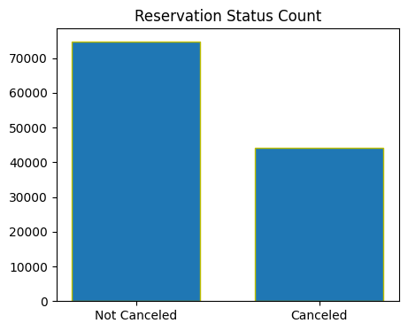

Cancellation Rate to Much Higher. Its also effect on Hotels Revenue.

Cancellation rate in City Hotels Higher as Compared to Resort Hotels.

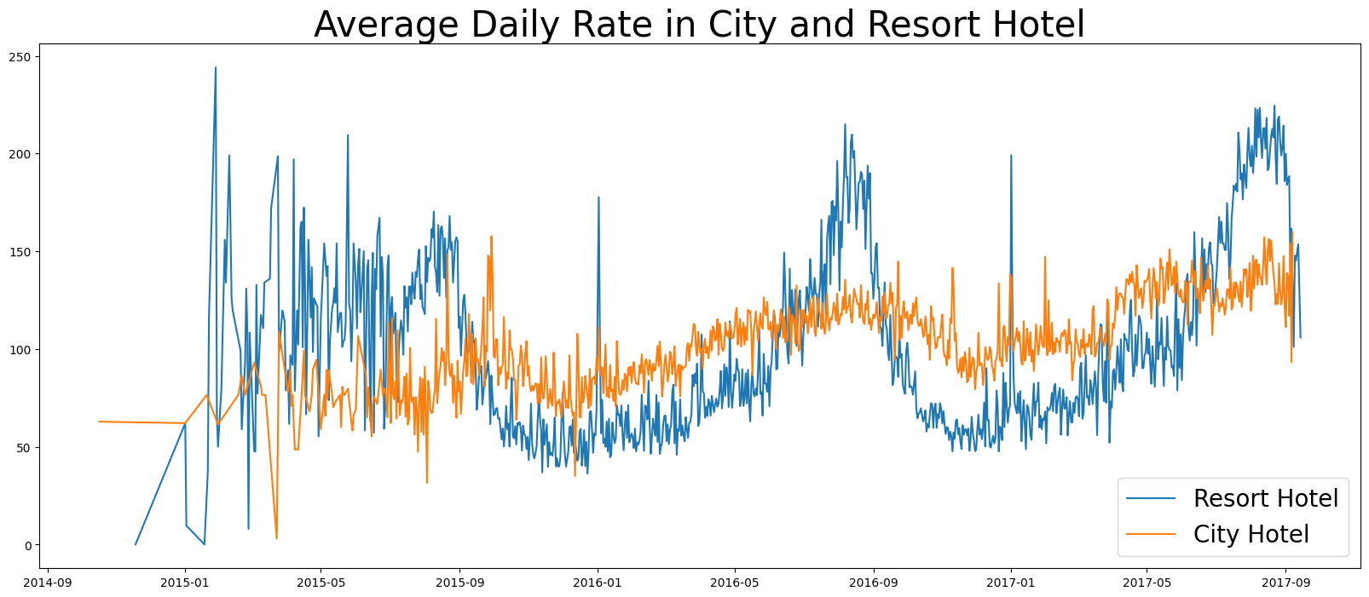

This Graph shows the Daily Rates of City and Resort Hotels. Resort Hotels Have Higher Price then City Hotels.

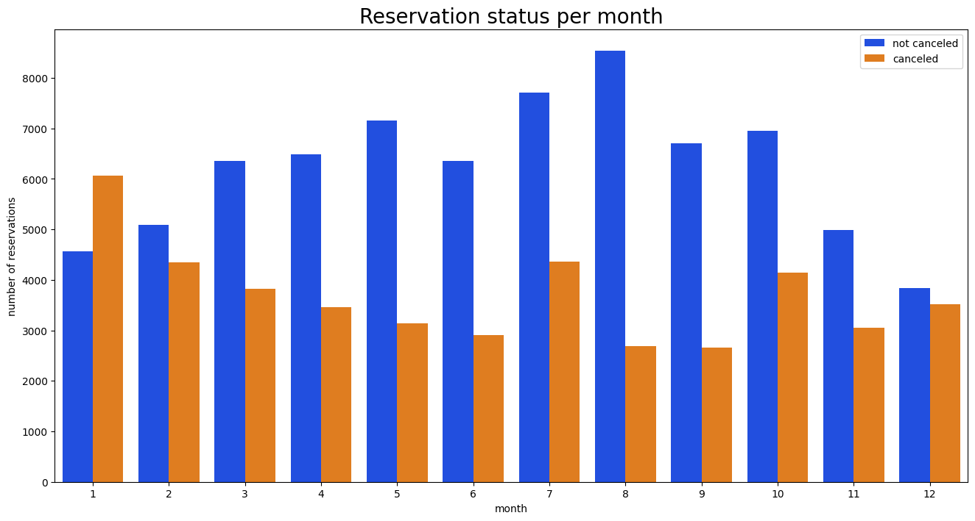

First and Last Month Fined High Cancellation Rate as Compare other Months.

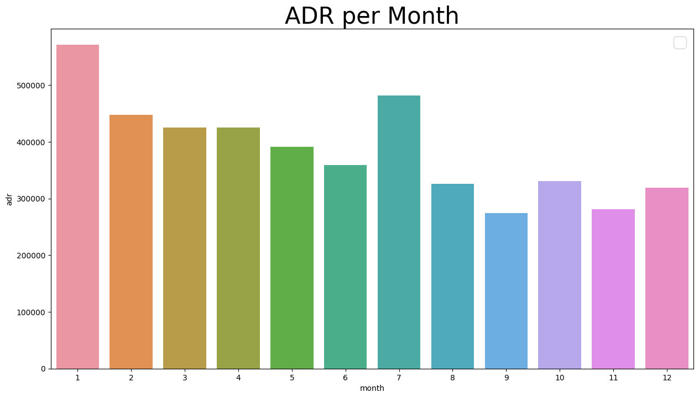

**Suggestion**

1. Implement Flexible Cancellation Policies: Offer guests flexible cancellation options, allowing them to modify or cancel their reservations within a reasonable timeframe without penalties.
2. Improve Booking Experience: Enhance the booking process by ensuring a user-friendly website, a smooth online reservation system, and clear communication of reservation details and policies.
3. Enhance Customer Service: Provide exceptional customer service throughout the entire guest journey, promptly responding to inquiries, resolving issues, and addressing concerns to minimize the likelihood of cancellations.
4. Engage with Guests: Regularly engage with guests before their arrival through personalized emails or messages, helping, sharing useful information, and creating a sense of anticipation for their stay.
5. Offer Incentives for Non-Cancellation: Provide incentives for guests who commit to their reservations, such as exclusive discounts, complimentary upgrades, or special perks to encourage them to keep their bookings.
6. Utilize Guest Data: Leverage guest data to understand booking patterns, preferences, and trends. This information can help in personalizing offers and anticipating potential cancellations to take proactive measures.
7. Encourage Direct Bookings: Promote direct bookings through your hotel's website by offering exclusive benefits like lower rates, room upgrades, or additional amenities. This reduces reliance on third-party platforms and decreases cancellation rates.
8. Implement Prepayment or Deposits: Require guests to make a prepayment or deposit at the time of booking. This helps ensure a higher commitment level and reduces the likelihood of last-minute cancellations.
9. Maintain Competitive Pricing: Conduct regular market analysis to stay competitive with pricing. Offering attractive rates and value-added packages can entice guests to book and minimize cancellations in favor of other options.
10. Analyze Cancellation Patterns: Analyze cancellation patterns to identify common reasons for cancellations, such as specific room types or booking periods. Use this data to make targeted improvements or adjustments to address the underlying causes.

Remember, implementing these suggestions may require a comprehensive understanding of your hotel's unique circumstances and target market. Regular monitoring and adaptation of strategies are key to reducing cancellation rates effectively.