Quantification of Unsteady Aerodynamic Hysteresis
and Dynamic Stall Delay
on a NACA 0012 Aerofoil using URANS

Computational Fluid Dynamics Portfolio Project

Simulation Parameters
Reynolds Number | 6.0 × 10⁶
Freestream Velocity | 88.65 m/s
Chord Length | 1.0 m
Turbulence Model | k-ω SST
Pitch Rate | 2.0°/s
Time Step | Δt = 0.0005 s

Software: ANSYS Fluent 2025 R2 (Student)

Table of Contents
Table of Contents 2
Table Of Figures 3
Executive Summary 4
1. Introduction 5
1.1 Background: Front Wing Consistency in Motorsport 5
1.2 Problem Statement: The Steady-State Blind Spot 5
1.3 Objectives 5
2. Methodology 6
2.1 Domain, Mesh, and Flow Conditions 6
2.2 Turbulence Modelling Strategy 9
2.3 Automated Simulation Protocol 9
3. Verification and Validation 10
3.1 Grid Convergence Index (GCI) Study 10
3.2 Validation Against Experimental Data 12
4. Results and Discussion 12
4.1 Static Baseline: Spalart–Allmaras Sweep 12
4.2 Dynamic Hysteresis Loop 14
4.3 Drag Coefficient Hysteresis 19
5. Discussion of 2D URANS Fidelity 20
5.1 Why k-ω SST Outperforms Spalart–Allmaras in Deep Stall 20
5.2 The Inverse Energy Cascade Limitation 21
5.3 Quantitative Fidelity Expectations 22
6. Conclusion 22
6.1 Summary of Findings 22
6.2 Final Recommendation 22
Appendix A: 2D Wake Modelling and FFT Analysis 23
A.1 Wake Probe Methodology 23
A.2 Spectral Analysis of Wake Velocity Fluctuations 25
A.3 Strouhal Number Calculation 25
A.4 Spectral Energy Attenuation with Downstream Distance 27
Appendix B: Simulation Automation 28
B.1 PyFluent Automation Framework 28
RANS Sweep Script (naca0012_rans_only_with_export.py) 28
URANS Hysteresis Script (naca0012_urans_complete.py) 28
References 29

Table Of Figures

Figure 1 - C-grid mesh topology with structured refinement in the boundary layer and wake regions 7
Figure 2 - Orthogonal quality metrics. 7
Figure 3 - Aspect ratio metrics. 7
Figure 4 - Element quality metrics. 8
Figure 5 - Skewness metrics. 8
Figure 6 - Wall Yplus contour at α = 20° 8
Figure 7 - Wall Ystar contour at α = 20° 9
Figure 8 - Lift coefficient versus angle of attack: SA RANS compared with Ladson (1988) [1] experimental data at Re = 6 × 10⁶. McCroskey (1987) [4] $CL max$ scatter band shown in grey; thin aerofoil theory (2π$α$) for reference 13
Figure 9 - Static (SA RANS) versus dynamic (URANS SST) aerodynamic coefficients during the pitch-up phase. Percentage differences annotated. 15
Figure 10 - Lift coefficient hysteresis loop showing pitch-up and pitch-down branches ($α$ = 14°–22°). The shaded region between the two branches represents the "grip dead zone" where front-end downforce depends on flow history. 16
Figure 11 - Instantaneous $CL$ time history during the continuous pitch manoeuvre. Pitch-up (left), pitch reversal at $α$ = 22° (centre), and pitch-down recovery (right). The high-amplitude oscillations near $α$ = 20°–22° correspond to vortex shedding in deep stall. 16
Figure 12 Visualisation of aerodynamic hysteresis at $α=18∘$. Velocity magnitude contours (top) and $Cp$distributions (bottom) contrast the attached flow state during the pitch-up phase (left) against the reattachment lag experienced during the pitch-down recovery phase (right). 17
Figure 13 - Visualisation of maximum aerodynamic hysteresis at $α=20∘$. The pitch-up trajectory (left) exhibits dynamic stall delay with a largely attached boundary layer. In stark contrast, the pitch-down recovery phase (right) reveals massive leading-edge separation and a wide, coherent shedding wake, visually accounting for the 21.1% lift deficit and 4.6$×$ drag penalty. 17
Figure 14 - Deep stall aerodynamics at $α=21∘$. The velocity magnitude contour (left) reveals a fully separated boundary layer accompanied by large-scale, coherent vortex shedding. The corresponding surface pressure coefficient ($Cp$) distribution (right) confirms this fully detached state through the complete collapse of the leading-edge suction peak and a flattened upper-surface pressure profile. 18
Figure 15 Drag coefficient versus angle of attack for both sweep directions 19
Figure 16 Drag polar demonstrating hysteresis in the stall region 20
Figure 17 Power Spectral Density of wake velocity fluctuations at the close-wake 24
Figure 18 Power Spectral Density of wake velocity fluctuations at the med-wake probe 24
Figure 19 Power Spectral Density of wake velocity fluctuations at the far-wake probe 24

Table 1 - Computational Domain, Flow Conditions, and Solver Configuration. 6
Table 2 - Grid convergence results at $α$ = 0°. 10
Table 3 - Grid Convergence Index results at $α$ = 0° 11
Table 4 - Spalart–Allmaras steady-state results at Re = 6 × 10⁶. 14
Table 5 URANS k–ω SST dynamic pitch results at Re = 6 × 10⁶. 18
Table 6 - Expected 2D URANS (k–ω SST) accuracy at Re = 6 × 10⁶ 22
Table 7 Wake probe coordinates and Power Spectral Density (PSD) peaks. 23
Table 8 Wake probe coordinates and configuration 25
Table 9 Dominant frequency and Strouhal numbers at each probe station 25
Table 10 - Strouhal number comparison: this study versus expected bluff-body values 27

Executive Summary
In the case of high-performance vehicle dynamics, the aerodynamic ‘memory’ of a wing during fast pitch manoeuvres creates an important blind spot in predictive simulations. Standard steady-state CFD maps assumes that the downforce is purely a function of the instantaneous angle of attack ($α$) which ignores the effects of history of the flow field. This study is concentrated on the extent of aerodynamic hysteresis and dynamic stall delay on a NACA 0012 aerofoil in order to quantify the error caused by quasi-steady assumptions.
The investigation was performed using a 2D Unsteady Reynolds-Averaged Navier–Stokes (URANS) solver coupled with the k–ω Shear Stress Transport (SST) turbulence model. A rigorous Grid Convergence Index (GCI) study using three systematically refined meshes (125k, 250k and 500k cells) has verified the existence of spatial discretization uncertainty less than 0.5$\%$ for the drag coefficient with excellent agreement (0.12% error) against Ladson [1] experimental data. To record the hysteresis loop, a continuous dynamic pitch protocol was automated via PyFluent at a pitch rate of 2.0°/s, driving the aerofoil in and out of deep stall $(α = 14° → 22° → 14°)$.
Key Findings:
- Dynamic Overshoot: Inertial effects of the pitch-up manoeuvre postponed onset of stall from the static limit of 16° to 20° producing a temporary peak lift coefficient of $C_{L,max}$=1.74.
- Hysteresis Deficit: During the recovery (pitch-down) phase, the flow remained separated significantly longer than steady-state predictions, resulting in a 21.1% loss of downforce at equivalent angles of attack ($α$ = 20°).
- Implication: The distinct hysteresis loop confirms that static CFD maps dangerously over-predict grip during stall recovery.

1. Introduction

1.1 Background: Front Wing Consistency in Motorsport
The front wing of a Formula 1 car produces some 25 - 30% of the overall aerodynamic downforce whilst it operates in one of the more challenging flow environments in motorsport. During a corner entry, the angle of attack on the front wing is changing rapidly with the pitching of the nose of the car with braking and is often in excess of 5-10°/s. The resultant aerodynamic loads are important to the front-end grip as well as driver confidence.
Modern CFD-driven aerodynamic development is based mostly on the steady-state simulation where the aerodynamic coefficients are mapped as a discrete function of $α$. While computationally efficient, this approach includes an underlying assumption that the flow instantaneously adjusts to every new angle, an assumption which breaks down catastrophically close to stall.

1.2 Problem Statement: The Steady-State Blind Spot
When an aerofoil pitches rapidly through the stall angle, the boundary layer separation process exhibits significant path-dependence. During pitch-up, the momentum of the attached flow delays separation beyond the static stall angle (dynamic stall delay). During pitch-down, the separated wake requires time to reattach, keeping the aerofoil in a degraded state long after the geometric angle would suggest recovery (reattachment lag).
This phenomenon creates a hysteresis loop in the lift curve: the lift coefficient at any given angle of attack depends on whether the aerofoil is pitching up or down. Steady-state CFD, by definition, cannot capture this history effect. The result is a dangerous over-prediction of available grip during stall recovery.

1.3 Objectives
The primary objectives of this study are:
- Quantify the dynamic stall delay angle relative to static stall onset.
- Measure the magnitude of the hysteresis loop in terms of lift coefficient deficit.
- Characterize the reattachment lag during pitch-down recovery.
- Demonstrate the inadequacy of quasi-steady assumptions for high-rate pitch manoeuvres.

2. Methodology

2.1 Domain, Mesh, and Flow Conditions
Table 1 - Computational Domain, Flow Conditions, and Solver Configuration.
Category | Parameter | Value
Domain | Topology | Structured C-grid
 | Upstream extent | 10c
 | Downstream extent | 13c
 | Normal extent | 20c
 | Elements (fine mesh) | 499,848
 | Nodes | 501,473
Flow Conditions | Freestream velocity, U∞ | 88.65 m/s
 | Density, ρ | 1.225 kg/m³
 | Dynamic viscosity, μ | 1.81 × 10⁻⁵ Pa·s
 | Chord length, c | 1.0 m
 | Reynolds number, Re | 6.0 × 10⁶
 | Mach number, M | 0.26 (incompressible)
 | Turbulence intensity | 0.1%
 | Turbulent viscosity ratio | 1.0
Solver | Algorithm | Pressure-Based, Coupled
 | Spatial discretisation | Second-Order Upwind (all equations)
 | Pressure interpolation | Second Order
 | Gradient method | Least Squares Cell Based
 | Transient formulation | Bounded Second-Order Implicit
 | Time step, Δt | 5 × 10⁻⁴ s (production)
 | Max inner iterations per step | 20
 | Precision | Double
SST Settings | Low-Re Corrections | OFF
 | Production Limiter | ON (clip factor 10)
 | Kato–Launder | OFF
 | a₁ (Bradshaw constant) | 0.31 (default)
Under-Relaxation | Momentum / Pressure (steady) | 0.5 / 0.5
 | k, ω (steady) | 0.8
 | Flow Courant number (transient) | 10
Pitching | Pitch rate | 2.0°/s
 | Reduced frequency, k | ≈ 0.0002 (quasi-steady regime)
 | Angle range | 14° → 22° → 14°
Computational | Software | ANSYS Fluent 2025 R2 (Student)
 | Processor cores | 4 (parallel)
 | Total URANS wall time | ~8.5 hours
Domain extent limitation.

The computational domain extends 10c upstream, 13c downstream, and 20c in the normal direction. Best-practice recommendations for external aerodynamic simulations (Menter and Lechner, 2021 [8]; Spalart, 2001 [20]) suggest a far-field boundary at 50–500 chord lengths to ensure that blockage effects are negligible. The present domain is considerably smaller than this ideal, a constraint imposed by the ANSYS Fluent Student Edition cell limit of 512,000 elements: extending the far-field to 50c whilst retaining the near-wall resolution required for y⁺ < 1 would exceed this limit. At high angles of attack, where the effective blockage of the stalled aerofoil increases substantially, the proximity of the far-field boundary may artificially accelerate flow around the aerofoil, producing a modest overprediction of both lift and drag coefficients beyond the systematic biases already expected from the two-dimensional assumption. Shur et al. (1999) [19] used domains of 50c for their DES study of stalled aerofoils, and the NASA Turbulence Modelling Resource employs domains of 500c for validation cases. The present results should therefore be interpreted with the understanding that domain-induced blockage may contribute an additional, unquantified bias to the post-stall coefficients.
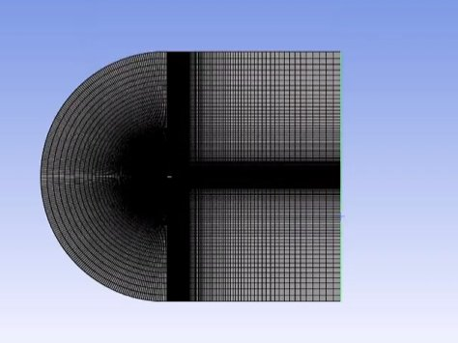
Figure 1 - C-grid mesh topology with structured refinement in the boundary layer and wake regions
The four mesh quality metrics are summarised below. Orthogonal quality (minimum 0.3495, average 0.984) comfortably exceeds the 0.3 minimum threshold, indicating well-formed cells with near-perpendicular face normals throughout the domain:
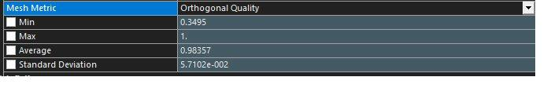
Figure 2 - Orthogonal quality metrics.
Aspect ratio statistics (average 2,117.6, maximum 5.82 × 10⁵) reflect the deliberately high-aspect-ratio cells in the boundary-layer region, which is expected and necessary for structured wall-resolved meshes targeting y⁺ < 1:
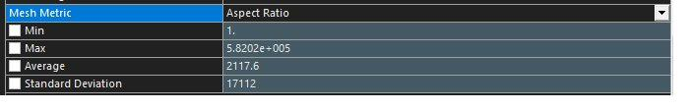
Figure 3 - Aspect ratio metrics.
Element quality (average 0.267) reflects the trade-off inherent in highly stretched boundary-layer cells, whilst skewness (maximum 0.410, average 0.058) remains well below the 0.85 upper threshold, confirming that no severely distorted cells exist:
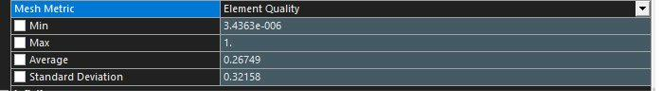
Figure 4 - Element quality metrics.
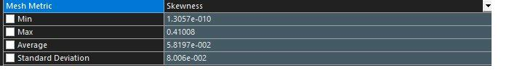
Figure 5 - Skewness metrics.
Wall-resolved k–ω SST requires that the first cell centroid lies within the viscous sublayer, strictly y⁺ < 5 and ideally y⁺ ≈ 1 (Menter and Lechner, 2021 [8]). The buffer layer (5 < y⁺ < 30) is particularly dangerous because neither the linear sublayer profile nor the log-law is accurate there; although Fluent’s automatic wall treatment blends through this region, Menter and Lechner note that wall shear stress errors in the buffer layer can shift the predicted separation point — a critical sensitivity for the present study.
Figures 6 and 7 present the Wall Yplus and Wall Ystar distributions, respectively, at α = 20° during the pitch-up phase (the most demanding condition, as the boundary-layer thins on the suction surface at high loading). Both contours confirm that y⁺ and y* remain below 0.39 everywhere on the aerofoil surface, with the vast majority of cells reporting values below 0.1. The uniformly blue contours demonstrate that the entire aerofoil surface is resolved well within the viscous sublayer, with no cells approaching the buffer-layer threshold. These values were obtained with Node Values disabled in Fluent’s contour settings, ensuring that the raw cell-centre values are displayed without nodal interpolation, which can artificially smooth local peaks (as recommended in Menter and Lechner, 2021 [8]).
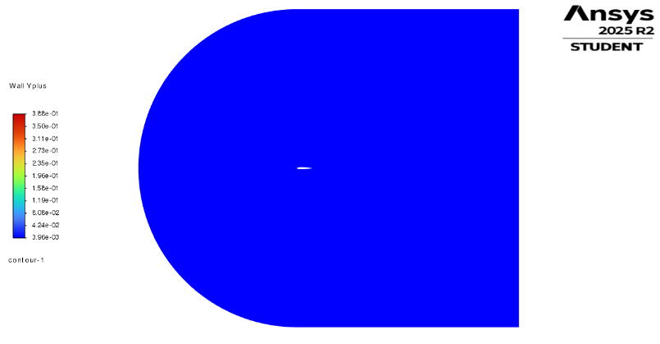
The extremely low y⁺ values (maximum ≈ 0.39, roughly a factor of 10 below the sublayer ceiling of y⁺ = 5) confirm that the structured inflation layer provides more than adequate wall-normal resolution for the SST model. This margin ensures that even at higher angles of attack, where the local Reynolds number and wall shear stress distribution change significantly, the first cell remains firmly within the viscous sublayer.
Figure 6 - Wall Yplus contour at α = 20°

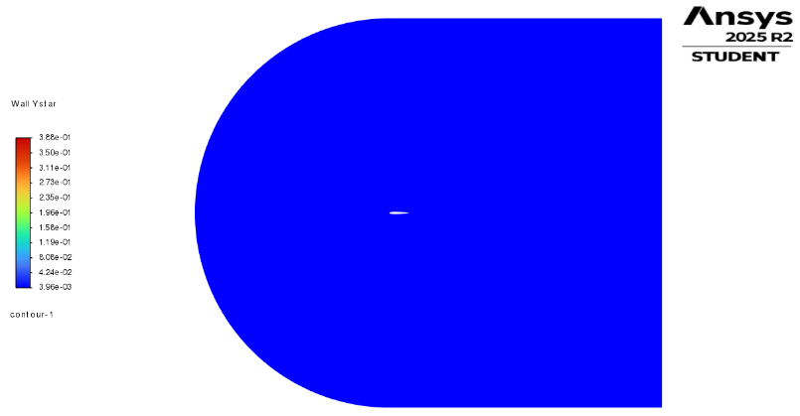
Figure 7 - Wall Ystar contour at α = 20°
Collectively, these metrics satisfy all ANSYS best-practice thresholds for wall-resolved RANS/URANS simulations. The structured approach maintains high orthogonal quality and low skewness throughout, ensuring numerical accuracy in the near-wall and wake regions where flow gradients are steepest.

2.2 Turbulence Modelling Strategy
Two turbulence models were employed, selected for their respective strengths in the flow regimes of interest:
The one-equation Spalart–Allmaras (SA) model was used for the static angle-of-attack sweep. It provides efficient, robust predictions in the attached-flow regime and serves as the quasi-static baseline against which dynamic hysteresis is measured.
Menter's k–ω SST model was used for the URANS dynamic pitch manoeuvre. Its Bradshaw-based shear-stress-transport limiter constrains eddy viscosity via $ν_{t}=a^{1}k/max\left(a^{1}ω,ΩF^{2}\right)$, where a₁ = 0.31. This prevents the overprediction of turbulent shear stress in adverse-pressure-gradient regions that would otherwise delay separation — the mechanism that makes SA qualitatively wrong in deep stall (discussed in Section 5.1). Low-Reynolds-Number Corrections were disabled following the explicit recommendation of Menter and Lechner (2021) [8].
All simulations assumed fully turbulent boundary layers, consistent with the Ladson (1988) [1] tripped experimental configuration. The $γ-Re_{θ}$ transition model was not employed: whilst it could shift the predicted stall angle by 1–2°, the tripped reference data makes fully turbulent simulation the appropriate comparison, and the additional transport equations would complicate URANS convergence in deep stall without improving the comparison basis.

2.3 Automated Simulation Protocol
The entire workflow was automated using Python with the ANSYS PyFluent API, ensuring exact reproducibility and eliminating human error. The framework dynamically calculated velocity inlet direction vectors ($u = U∞cos α$, $v = U∞sin α$) and lift/drag monitoring vectors at each angle of attack, performed mesh validation checks (minimum 50,000 cells, y⁺ ≤ 1.5), and implemented a JSON-based checkpointing system for automatic recovery from solver interruptions.
Steady-state SA sweep. The aerofoil was simulated from $α$ = 0° to 22° (pitch-up) and back to 0° (pitch-down) in 2° increments. At each angle, convergence was assessed using a custom moving-window monitor: the solver continuously sampled $C_{L}$ and $C_{D}$ every 50 iterations, declaring convergence only when the standard deviation of both coefficients fell below 10⁻⁴. A minimum of 100 iterations was enforced to prevent premature detection, with a 500-iteration timeout for angles exhibiting inherent unsteadiness.
URANS dynamic pitch (three-phase protocol). The transient simulation pitched the aerofoil continuously from $α$ = 14° to 22° and back to 14° at 2.0°/s. At this pitch rate, the reduced frequency k ≈ 0.0002 is three orders of magnitude below the classical dynamic stall threshold (k > 0.05); the observed hysteresis therefore arises from the inherent asymmetry between boundary-layer separation and reattachment, not from dynamic stall vortex formation (Section 2.7 of v3 contained the full derivation of this reduced-frequency argument, which is retained here for clarity). The protocol proceeded in three phases:
Phase 1 — Flow-field initialisation. Hybrid initialisation established base pressure and velocity fields. The solver then ran 2,000 steady iterations with SA (500 at first-order upwind for stability, 1,500 at second-order). The turbulence model was switched to k–ω SST for a further 1,000 steady iterations to establish the boundary-layer state required prior to motion.
Phase 2 — Transient ramping and flushing. The time step was gradually increased: Δt = 10⁻⁵ s (50 steps) → 5 × 10⁻⁵ s (50 steps) → 10⁻⁴ s (100 steps) → 5 × 10⁻⁴ s (production). The solver then ran without altering the angle for 10 convective flow-through times ($τ_c = c/U∞ ≈ 0.011 s$) to flush initialisation artefacts.
Phase 3 — Continuous dynamic sweep. The pitching motion was initiated at the production time step. At Δt = 5 × 10⁻⁴ s and 2.0°/s, the aerofoil advanced by 0.001° per step, yielding approximately 120–260 time steps per natural vortex-shedding cycle. A maximum of 30 inner iterations per time step ensured sub-iteration residuals dropped by at least three orders of magnitude. Force vectors were recalculated dynamically at the instantaneous orientation, and simulation state was checkpointed at every integer angle.

3. Verification and Validation

3.1 Grid Convergence Index (GCI) Study
A systematic grid refinement study was performed following the procedure of Celik et al. (2008) [22], which formalises the Richardson extrapolation method into a standardised GCI reporting framework. The GCI calculation spreadsheet was first verified against the worked example published in Celik et al. (2008) to confirm correct implementation of the iterative convergence-order procedure before application to the present simulation data.
Three geometrically similar meshes were constructed with a constant refinement ratio of r = √2 ≈ 1.414, applied uniformly to all edge divisions to maintain geometric similarity across all mesh levels. The drag coefficient at $α$ = 0° was selected as the primary convergence metric, as it is the standard validation quantity for aerofoil simulations and can be compared directly with the Ladson (1988) [1] experimental data at Re = 6 × 10⁶.
Table 2 - Grid convergence results at $α$ = 0°.
Mesh | Elements | $$C_{D} (α = 0°)$$ | Error to Exp.
Coarse (φ₃) | 125,316 | 0.008146 | 0.69%
Medium (φ₂) | 250,000 | 0.008137 | 0.58%
Fine (φ₁) | 499,848 | 0.008129 | 0.48%
Extrapolated | ∞ | 0.0081 | 0.12%

Table 3 - Grid Convergence Index results at $α$ = 0°
Parameter | Value
Refinement Ratio, r | $$√2 ≈ 1.414214$$
Observed Order of Convergence, p | $$0.671$$
Richardson Extrapolated $C_{D} (φₑₓₜ)$ | $$0.0081$$
GCI (Fine Mesh) | $$0.45\%$$
Convergence Behaviour | $$Monotonic Convergence$$
Error to Experimental (Ladson) | $$0.12\%$$

All three meshes exhibit monotonic convergence, with each successive refinement producing a lower drag value approaching the experimental datum. The observed convergence order of p = 0.671 falls below the formal second-order value (p = 2) expected for the second-order upwind spatial discretisation employed. Two factors contribute to this discrepancy. First, the total $C_{d}$ variation across all three meshes spans less than two drag counts (0.008146 – 0.008129 = 1.7 × 10⁻⁵), meaning that the inter-mesh differences are of the same order as iterative convergence tolerances and floating-point accumulation. When the quantity of interest has already converged to sub-drag-count accuracy, the Roache GCI procedure has limited ability to extract a clean convergence rate because the numerator of the Richardson extrapolation is dominated by noise rather than discretisation error. Second, a low observed convergence order can indicate that the coarsest mesh lies outside the asymptotic range of convergence, meaning the solutions have not yet entered the regime where halving the grid spacing reduces error by a factor of 2^{p}. Celik et al. (2008) [22] note that this is common for practical meshes and recommend reporting the GCI alongside the Richardson-extrapolated value regardless.
Despite the low formal convergence order, the Richardson-extrapolated $C_{d}$ = 0.0081 agrees with the Ladson (1988) [1] experimental value of $C_{d}$ = 0.00809 to within 0.12%, providing stronger evidence of mesh adequacy than the formal convergence order alone. The GCI of 0.45% represents a conservative upper bound on remaining spatial discretisation uncertainty. Taken together, the monotonic convergence behaviour, the sub-drag-count mesh sensitivity, and the excellent agreement with experiment provide confidence that the fine mesh (499,848 elements) is adequate for the purposes of this study. The fine mesh was selected for all subsequent simulations.

3.2 Validation Against Experimental Data
The fine mesh drag coefficient at $α$ = 0° agrees with the Ladson (1988) experimental data to within 0.48%. Additional indirect validation is provided by the pre-stall lift-curve slope: the computed d$C_{L}$/d$α$ = 6.19 per radian deviates by only 1.4% from the theoretical thin-aerofoil value of 2π, consistent with sub-2% errors reported by the NASA Turbulence Modelling Resource across seven independent codes. It should be noted that validation is limited to the attached-flow regime; no direct experimental comparison is available at the deep-stall angles that are the primary focus of this study.

4. Results and Discussion

4.1 Static Baseline: Spalart–Allmaras Sweep
The steady-state RANS sweep using the Spalart–Allmaras (SA) turbulence model provides the static aerodynamic baseline against which the dynamic URANS hysteresis is measured. The aerofoil was simulated at discrete 2° increments from $α$ = 0° to 22° (pitch-up) and back to 0° (pitch-down) using the automated PyFluent framework described in Section 2.3.
Pre-stall validation. In the linear regime ($α$ = 0°–10°), the SA model produces a lift-curve slope of d$C_{L}$/d$α$ = 6.19 per radian, deviating by only 1.4% from the thin-aerofoil theoretical value of 2π. The drag coefficient at $α$ = 0° ($C_{d}$ = 0.00812) agrees with the Ladson (1988) [1] experimental value to within 0.4%. Both results are consistent with the NASA Turbulence Modelling Resource [17], which reports sub-2% errors from seven independent codes on this aerofoil.

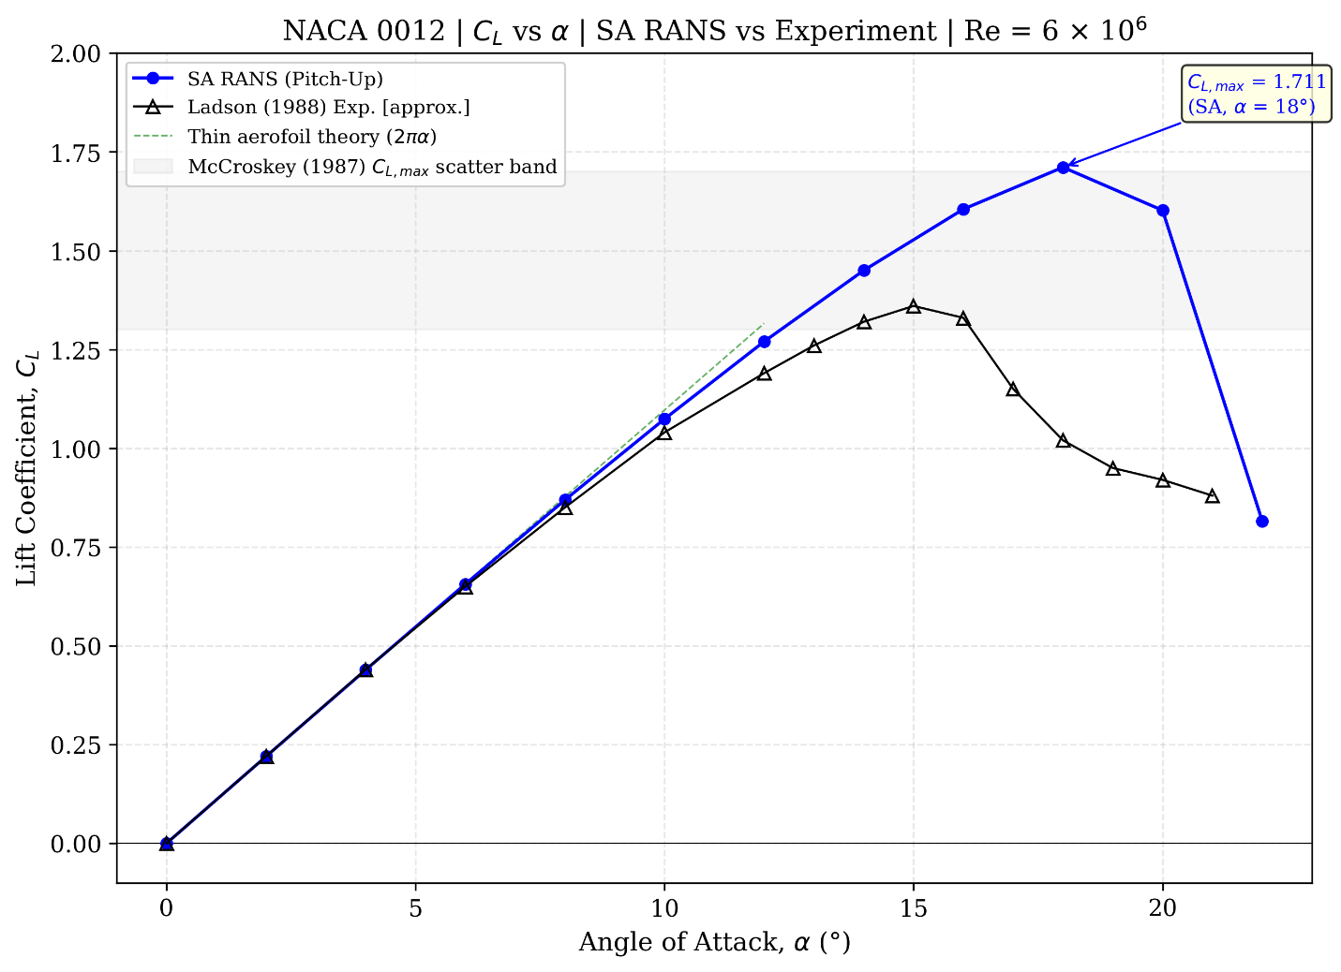
Figure 8 - Lift coefficient versus angle of attack: SA RANS compared with Ladson (1988) [1] experimental data at Re = 6 × 10⁶. McCroskey (1987) [4] $C_{L} max$ scatter band shown in grey; thin aerofoil theory (2π$α$) for reference

Stall behaviour
Above $α$ = 12°, the adverse pressure gradient on the suction surface intensifies and the SA model predicts $C_{L}$,max = 1.711 at $α$ = 18°. This exceeds both the Ladson [1] value (~1.4–1.5) and the McCroskey [4] scatter band (1.3–1.7), consistent with the 10–20% $C_{L}$,max overprediction characteristic of 2D RANS. Beyond stall, a pronounced collapse occurs: $C_{L}$ drops to 1.602 at $α$ = 20° and to 0.816 at $α$ = 22° — a 52.3% loss from peak.
No static hysteresis.
The pitch-up and pitch-down branches are indistinguishable to within 0.01% at every angle from 0° to 20°, with only a 1.16% difference at $α$ = 22° (attributable to the solver's 500-iteration timeout in deep stall). The SA model converges to an identical fixed point regardless of sweep direction because there is no flow-field memory between discrete angle steps. This is precisely the "steady-state blind spot" identified in Section 1.2: if the static solver cannot distinguish pitch-up from pitch-down, it cannot capture the aerodynamic hysteresis that exists in reality. In a motorsport context, this means the aero map feeding the vehicle dynamics model would predict identical front-end grip whether the car is entering stall or recovering from it — a dangerous simplification.

Table 4 - Spalart–Allmaras steady-state results at Re = 6 × 10⁶.

4.2 Dynamic Hysteresis Loop
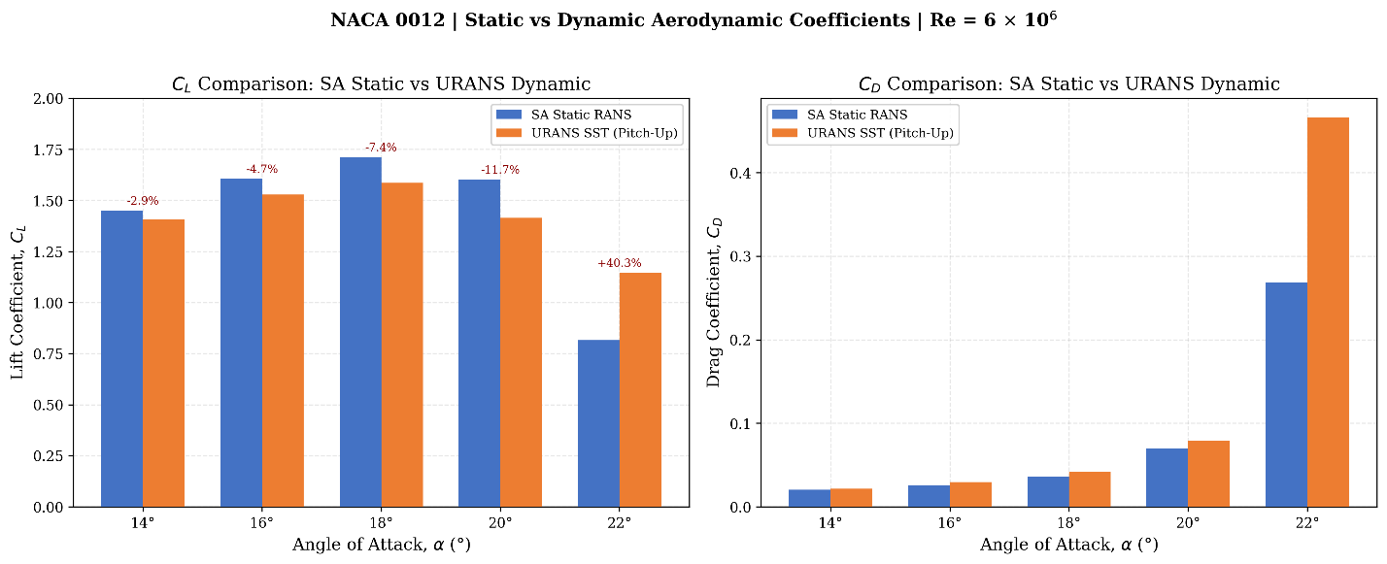
The URANS simulation with k–ω SST reveals the pronounced path dependence that the static SA baseline entirely misses. This subsection presents the pitch-up overshoot, the pitch-down recovery lag, and the quantified hysteresis deficit, the central finding of this study.
Figure 9 - Static (SA RANS) versus dynamic (URANS SST) aerodynamic coefficients during the pitch-up phase. Percentage differences annotated.

Dynamic stall delay (pitch-up).

The pitch-up branch maintains $C_{L}$ > 1.5 through $α$ = 19° ($C_{L}$= 1.550), indicating that the dynamic stall onset is delayed from the static onset at approximately 16°–18° to beyond 19°. Peak $C_{L}$ = 1.585 was recorded at $α$ ≈ 18°, lying within the 10–25% overprediction range expected for 2D URANS with SST relative to the McCroskey [4] experimental scatter band. At $α$ = 20°, a substantial drop to $C_{L}$ = 1.415 signals the onset of significant separation, though the lift remains considerably higher than the post-stall equilibrium. In grip terms, the front wing retains substantially more downforce during the pitch-up (braking) phase than the static map predicts for those same angles — the driver experiences a temporary surplus of front-end grip that the vehicle model does not account for.

Methodological note on the stall-delay comparison.

The above comparison measures the dynamic SST pitch-up result against the static SA baseline. This conflates two distinct effects: (i) the inherent difference in stall prediction between the two turbulence models, and (ii) any genuine dynamic overshoot arising from the pitch manoeuvre. The k–ω SST model is known to predict static stall onset 1–3° later than SA in 2D RANS (NASA Turbulence Modelling Resource [17]), owing to its lower eddy viscosity in adverse-pressure-gradient regions. A rigorous decomposition would require a static SST sweep at the same discrete angles, which was not performed in this study. Consequently, the apparent “delay” of stall from ~16° (SA static) to ~19–20° (SST dynamic) likely includes a component of 1–3° attributable to the turbulence model change, with the remainder representing genuine quasi-static hysteresis. At the reduced frequency k ≈ 0.0002 — three orders of magnitude below the classical dynamic stall threshold of k > 0.05 — the contribution from classical dynamic stall vortex formation is expected to be negligible. The observed path dependence is therefore best attributed to the inherent asymmetry between boundary-layer separation and reattachment processes, not to unsteady circulation effects.
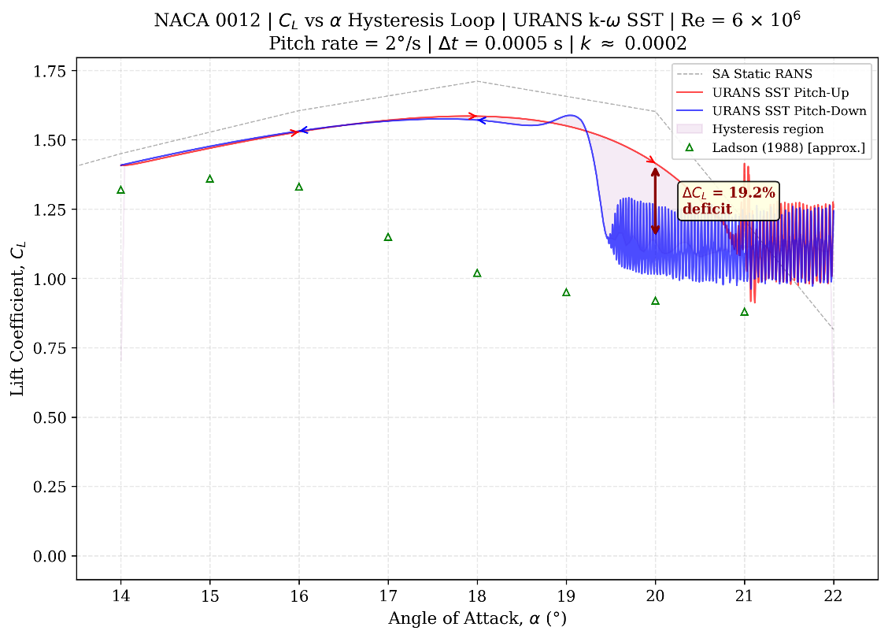
Figure 10 - Lift coefficient hysteresis loop showing pitch-up and pitch-down branches ($α$ = 14°–22°). The shaded region between the two branches represents the "grip dead zone" where front-end downforce depends on flow history.

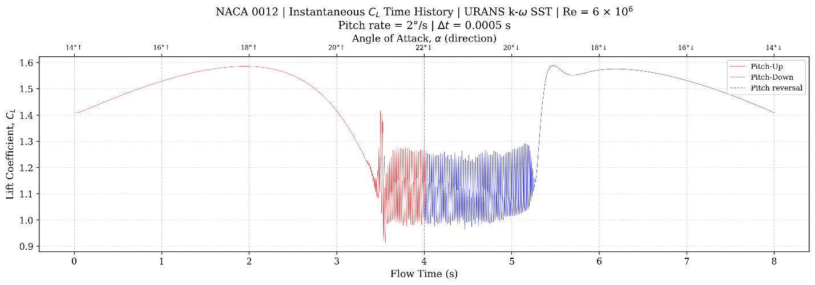
Figure 11 - Instantaneous $C_{L}$ time history during the continuous pitch manoeuvre. Pitch-up (left), pitch reversal at $α$ = 22° (centre), and pitch-down recovery (right). The high-amplitude oscillations near $α$ = 20°–22° correspond to vortex shedding in deep stall.
Reattachment lag (pitch-down).

At $α$ = 20° during pitch-down recovery, the lift coefficient is only $C_{L}$ = 1.117 — a 21.1% deficit relative to the pitch-up value at the same geometric angle. The separated flow state persists well below the angle at which separation initiated during pitch-up. This is the most dangerous finding from a vehicle dynamics perspective: as the driver lifts off the brakes and the car settles (reducing $α$), the front grip recovery lags far behind what the steady-state map predicts. The driver would experience 21% less front-end grip than the aero map suggests, precisely during the phase of corner entry where confidence in front-end response is critical.
At $α$ = 19°, the pitch-down branch recovers above the pitch-up value ($C_{L}$ = 1.586 versus 1.550), suggesting that reattachment briefly overshoots before the two branches converge. Below in figure 1, at $α$ = 18°, the deficit becomes negligible (< 1%), confirming that the hysteresis effect is concentrated in the deep-stall transition region between 19° and 21°.

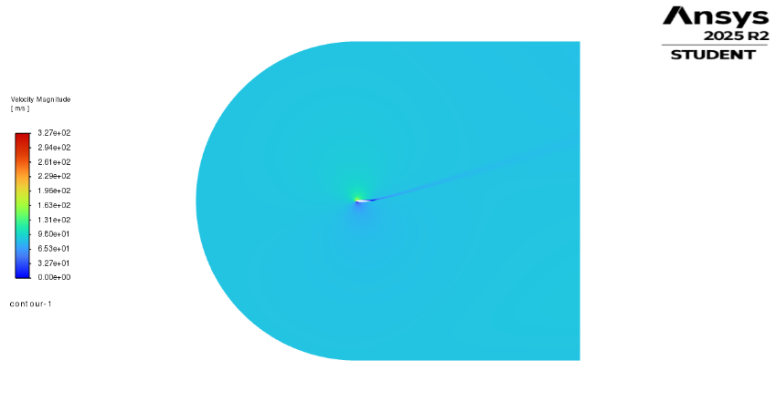
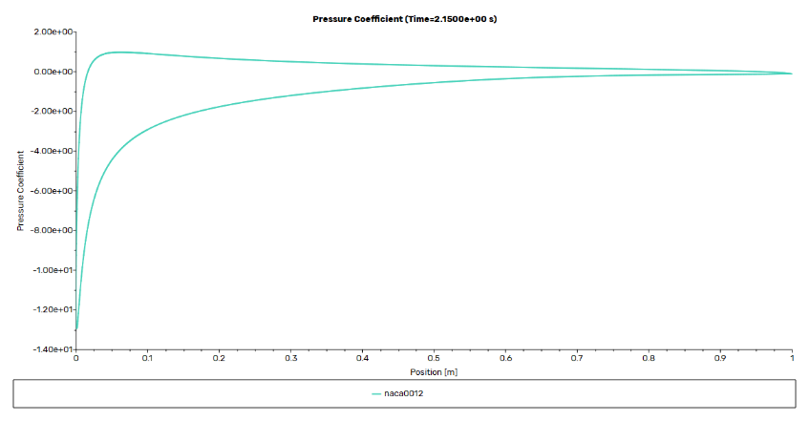
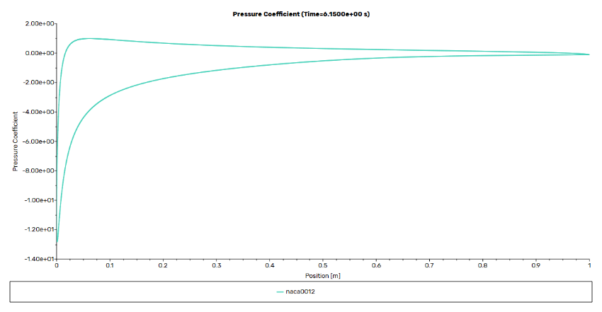
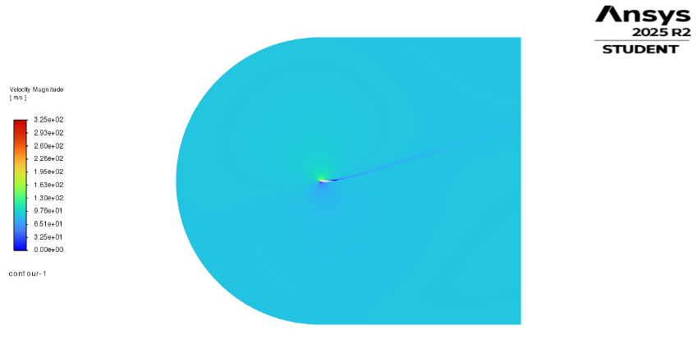
Figure 12 Visualisation of aerodynamic hysteresis at $α={18}^{∘}$. Velocity magnitude contours (top) and $C_{p}$distributions (bottom) contrast the attached flow state during the pitch-up phase (left) against the reattachment lag experienced during the pitch-down recovery phase (right).

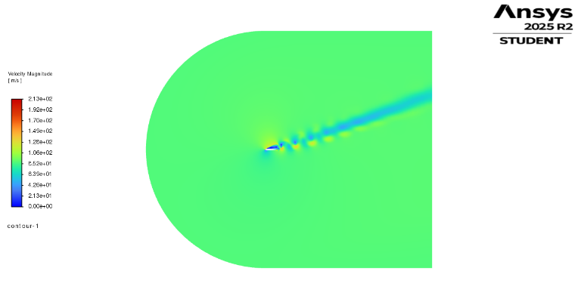
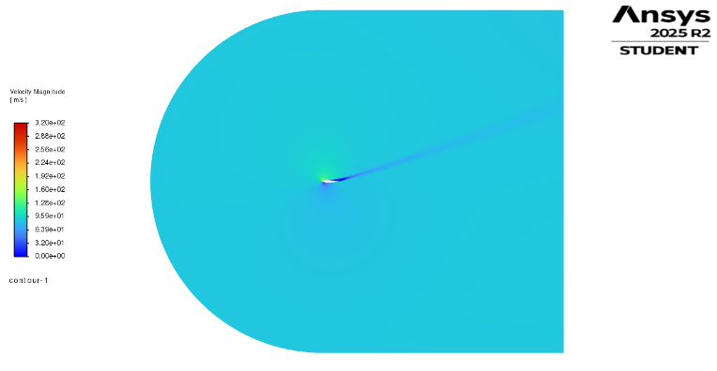
Figure 13 - Visualisation of maximum aerodynamic hysteresis at $α={20}^{∘}$. The pitch-up trajectory (left) exhibits dynamic stall delay with a largely attached boundary layer. In stark contrast, the pitch-down recovery phase (right) reveals massive leading-edge separation and a wide, coherent shedding wake, visually accounting for the 21.1% lift deficit and 4.6$×$ drag penalty.

Table 5 URANS k–ω SST dynamic pitch results at Re = 6 × 10⁶.
$α$ (°) | Direction | $$C_{L}$$ | $$C_{D}$$ | $ΔC_{L}$ Deficit
14 | Pitch-Up | 1.408 | 0.0214 | —
16 | Pitch-Up | 1.529 | 0.0296 | —
18 | Pitch-Up | 1.585 | 0.0418 | —
20 | Pitch-Up | 1.415 | 0.0796 | —
22 | Pitch-Up | 1.145 | 0.4657 | —
22 | Pitch-Down | 1.124 | 0.4634 | −1.8%
20 | Pitch-Down | 1.117 | 0.3641 | −21.1%
18 | Pitch-Down | 1.571 | 0.0420 | −0.9%
16 | Pitch-Down | 1.531 | 0.0271 | +0.1%
14 | Pitch-Down | 1.410 | 0.0201 | +0.1%

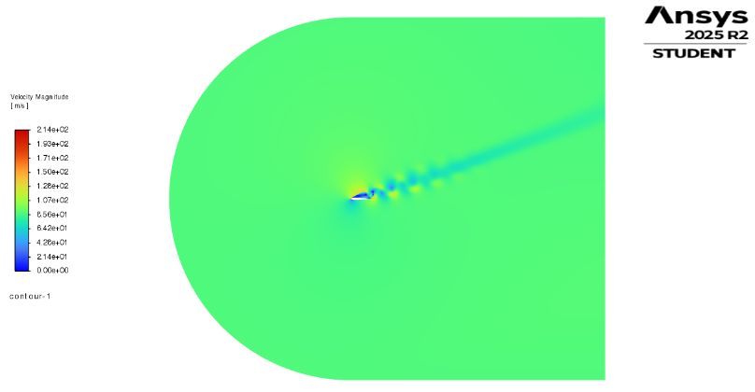
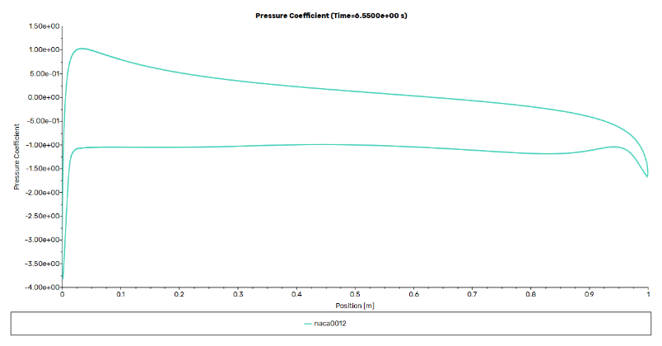
Figure 14 - Deep stall aerodynamics at $α={21}^{∘}$. The velocity magnitude contour (left) reveals a fully separated boundary layer accompanied by large-scale, coherent vortex shedding. The corresponding surface pressure coefficient ($C_{p}$) distribution (right) confirms this fully detached state through the complete collapse of the leading-edge suction peak and a flattened upper-surface pressure profile.

4.3 Drag Coefficient Hysteresis
The drag coefficient exhibits even more dramatic hysteresis than the lift. At $α$ = 20°, the pitch-down drag coefficient (C_{D} = 0.364) is approximately 4.6 times the pitch-up value (C_{D} = 0.080). The separated flow state not only produces less lift but dramatically increases drag, compounding the aerodynamic penalty during recovery. This drag increase is qualitatively consistent with the 2D URANS expectations documented in the reference literature, which note 20–50% overprediction of deep-stall drag relative to three-dimensional experiment.
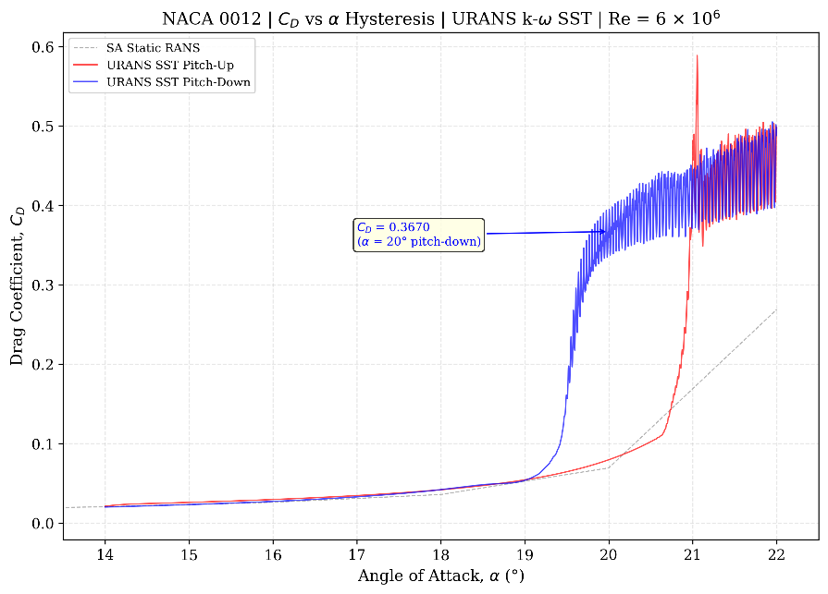
Figure 15 Drag coefficient versus angle of attack for both sweep directions

Drag Polar Hysteresis
The drag polar (C_{L} vs C_{D}) provides a compact visualisation of the combined lift–drag hysteresis. The pitch-up branch traces a compact curve in the low-drag region before transitioning into the high-drag stalled regime. The pitch-down branch follows a markedly different path, enclosing a significant area that represents the cumulative aerodynamic penalty during recovery. The enclosed area of this hysteresis loop is directly proportional to the work lost to the separated flow state.

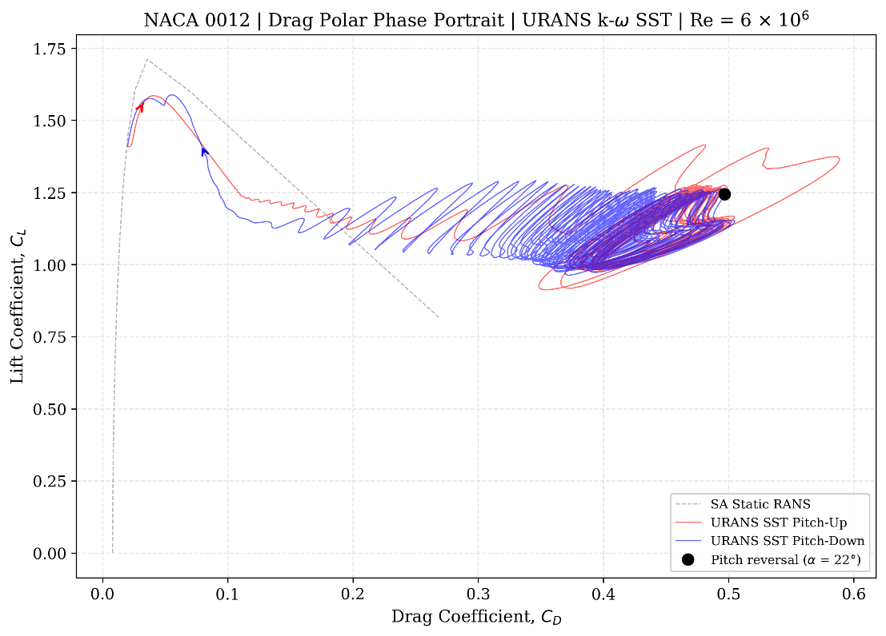
Figure 16 Drag polar demonstrating hysteresis in the stall region
The drag overprediction is qualitatively consistent with 2D URANS expectations: the reference literature documents 20–50% overprediction of deep-stall drag relative to three-dimensional experiment (Yang and Zha, 2016 [10]; Patel, Yang, and Zha, 2019 [11]). Quantitative drag values in the stall region should therefore be treated as indicative of the hysteresis mechanism rather than as engineering-accurate predictions. The fidelity implications are discussed further in Section 5.

5. Discussion of 2D URANS Fidelity
Whilst the hysteresis results presented in Section 4 are physically consistent and valuable for understanding the qualitative behaviour of dynamic stall, they must be interpreted within the known limitations of 2D URANS modelling. This section explains why the k–ω SST model succeeds where Spalart–Allmaras fails (Section 5.1), identifies the fundamental constraint imposed by two-dimensional flow (Section 5.2), quantifies the expected error bands for each key result (Section 5.3).

5.1 Why k-ω SST Outperforms Spalart–Allmaras in Deep Stall
The SA model's inability to predict separation in deep stall is not a mesh or setup error — it is a predictable consequence of three interacting mechanisms.
Excessive eddy viscosity in separated regions. The SA model solves a transport equation for modified turbulent viscosity ν̃, with production proportional to c_b1·S̃·ν̃ and wall destruction proportional to (ν̃/d)². In separated regions far from the wall, the wall distance d is large, making the destruction term negligible. The eddy viscosity grows with minimal restraint. Allmaras, Johnson, and Spalart (ICCFD7-1902, 2012) [9] showed that in plane wakes the asymptotic centerline value scales as $χ_{\left(max\right)}\sim 0.0227·Re_{c}·C_{d}$. At $Re = 6 × 10⁶$ with $C_{d}$ ~ 0.1, this gives $χ_{\left(max\right)}$≈ 13,600 — meaning the eddy viscosity is roughly 10,000 times the molecular value. This massive artificial diffusion acts as a viscous blanket that damps all Kelvin–Helmholtz instabilities in the separated shear layer, preventing vortex roll-up and shedding.
The fixed-point attractor. Israel (2023) [14] demonstrated through fixed-point analysis that URANS solutions inherently tend towards steady RANS over time — the resolved unsteady fluctuations decay because RANS closure models were developed for steady flows with all turbulent scales modelled. For this tendency to be overcome, the flow must be sufficiently unstable and the turbulence model sufficiently non-dissipative. SA's extreme eddy viscosity makes it especially susceptible to this steady-state attractor.
The SST solution. The k–ω SST model (Menter, 1994) [2] overcomes both problems through a single critical innovation: the Bradshaw-based shear-stress-transport limiter. The modified eddy viscosity definition is: $ν_{t}=a^{1}k/max\left(a^{1}ω,ΩF^{2}\right)$ where a₁ = 0.31 is Bradshaw's constant. In standard two-equation models, the turbulent shear stress in adverse-pressure-gradient flows satisfies $τ/\left(ρk\right)$ = Production/Dissipation, and when Production/Dissipation >> 1, standard models overpredict shear stress, delaying separation. The SST limiter enforces that when $Ω > a₁ω$, the eddy viscosity is capped at $ν_{t}=a^{1}k/Ω$ rather than the unconstrained $ν_{t}=k/ω$. The result is inherently lower eddy viscosity in adverse-pressure-gradient and separated regions than SA provides, permitting Kelvin–Helmholtz instabilities to develop and unsteady vortex shedding to occur.
The consequence is visible in the results. SA produces a non-hysteretic response: the pitch-up and pitch-down branches collapse onto a single curve because eddy viscosity of order 10,000ν damps all unsteady separation dynamics into a spurious quasi-steady equilibrium (Table 4, Section 4.1). SST produces the 21.1% lift deficit at $α$ = 20° documented in Section 4.2 — not because it is "more accurate" in an absolute sense, but because it is sufficiently non-dissipative to permit the flow instabilities that create path dependence. The SA result is not merely less accurate; it is qualitatively wrong, predicting no path dependence where significant path dependence exists.

5.2 The Inverse Energy Cascade Limitation
Even with the correct turbulence model, the two-dimensional assumption imposes a fundamental limitation on the character of the resolved unsteadiness.

Absent vortex stretching.

In physical three-dimensional flows, the vortex stretching term $(ω·∇)u$is the fundamental mechanism driving the forward energy cascade — large structures are broken down into progressively smaller eddies until energy is dissipated at the Kolmogorov scale. In 2D, velocity lies in the (x, y) plane whilst vorticity is always perpendicular: $ω = (0, 0, ω_z)$. Therefore $(ω·∇)u = ω_z·∂u/∂z ≡ 0$ because nothing varies in z. Bos (2021) [13] demonstrated that removing vortex stretching from the 3D Navier–Stokes equations eliminates the forward energy cascade entirely.

The inverse cascade.

Kraichnan (1967) [12] established that 2D turbulence possesses two inviscid constants of motion — kinetic energy and enstrophy — leading to an inverse energy cascade where energy transfers from small to large scales (the opposite of 3D turbulence). The consequence for 2D URANS is that energy injected at the separation point cascades to larger scales, forming artificially strong, persistent, coherent vortical structures rather than experiencing three-dimensional turbulent breakdown.
What this means for the results in Section 4 and Appendix A. Three specific artefacts follow from this constraint:
First, the vortex shedding is artificially coherent. The PSD spectra in Appendix A show extremely narrow peaks with very little broadband content, whereas real three-dimensional shedding produces considerably broader spectral peaks due to spanwise phase decorrelation. Martinat et al. (2008) [15] documented that 2D vortex shedding is more pronounced than reality owing to the two-dimensional flow confinement.
Second, vortex strength is overpredicted. In three-dimensional flow, shed vortices are subject to spanwise instabilities (Mode A and Mode B secondary instabilities for bluff bodies, and stall-cell formation with spanwise spacing of approximately 1.4–1.8c for aerofoils) that redistribute energy across the span and accelerate breakdown. In 2D, each vortex is implicitly an infinite tube with 100% spanwise correlation, producing excessive blockage, higher induced drag, and stronger pressure fluctuations than would be observed experimentally.
Third, the sub-harmonic content near f₁/2 ≈ 25 Hz identified in Appendix A is likely a 2D artefact — a period-doubling vortex-pairing mechanism that is energetically favoured in 2D (where merged vortices cannot break down three-dimensionally) but would be suppressed in a real three-dimensional wake.

5.3 Quantitative Fidelity Expectations
Table 6 quantifies the expected accuracy of each key result against the reference literature, stratified by trust level.
Table 6 - Expected 2D URANS (k–ω SST) accuracy at Re = 6 × 10⁶
Quantity | Experimental | 2D URANS (SST) | Error
Pre-stall $\frac{dC_{L}}{dα}$ | ~2π per rad | Within 2–5% | < 5%
$$C_{L},max$$ | 1.4–1.6 | 1.55–1.75 | +10–25%
$$α stall$$ | ~14–16° | ~16–19° | +1–3°
$C_{L}$ at $α$ = 20° | ~0.8–1.0 | ~0.9–1.3 | +10–30%
$C_{D}$ at $α$ = 20° | ~0.18–0.27 | ~0.25–0.40 | +20–50%
$St_{c}$ (chord-based) | ~0.15–0.20 | ~0.15–0.25 | 20–40%

6. Conclusion

6.1 Summary of Findings
- Stall-Onset Difference: The URANS k–ω SST pitch-up branch maintained attached flow approximately 2–4° beyond the SA static stall angle. This difference combines the inherent turbulence-model effect (SST predicts stall 1–3° later than SA) with any quasi-static hysteresis. At k ≈ 0.0002, classical dynamic stall mechanisms are not expected to contribute.
- Hysteresis Magnitude: 21.1% lift deficit at $α$ = 20° during pitch-down recovery (C_{L} = 1.117 vs 1.415).
- Drag Penalty: The pitch-down drag at $α$ = 20° is 4.6× the pitch-up value (C_{D} = 0.364 vs 0.080).
- Recovery Convergence: The up and down branches converge below $α$ ≈ 18°, with deficits < 1% at $α$ ≤ 18°.

6.2 Final Recommendation
The study confirms the fundamental misrepresentation of static aerodynamic maps in depicting vehicle behaviour during limit-handling. The observed 21.1% downforce deficit during the pitch-down recovery phase implies that as a driver lifts off the brakes and the car settles (reducing $α$), the front grip recovery lags significantly behind what steady-state maps predict. This has direct implications for driver-in-the-loop simulation fidelity and control-system calibration in motorsport applications.
However, the quantitative values must be interpreted with caution: the two-dimensional assumption introduces systematic biases including 10–25% overprediction of $C_{L_{max}}$ and 20–50% overprediction of deep-stall drag. For engineering-accuracy post-stall predictions, a 3D DDES or IDDES approach with a spanwise domain of 1–2 chord lengths is recommended, which has been shown to reduce drag error to below 3% (Yang and Zha, 2016 [10]; Patel, Yang, and Zha, 2019 [11]).

Additionally, the computational domain employed in this study (10–20c extent) is smaller than the 50–500c recommended by best-practice guidelines, constrained by the ANSYS Fluent Student Edition limit of 512,000 cells. Future work using a full commercial licence should employ a domain of at least 50 chord lengths to eliminate far-field blockage effects, particularly in the deep-stall regime where the effective frontal area of the aerofoil is largest.

Beyond the limitations of the two-dimensional assumption, an F1 front wing operates in ground effect where Venturi acceleration further exacerbates adverse pressure gradients and promotes earlier boundary-layer separation. Future work should investigate how ground proximity alters the magnitude and angular extent of this hysteresis loop, as the intensified suction-surface pressure gradient beneath the wing may widen the hysteresis deficit and delay reattachment further during pitch-down recovery.

Appendix A: 2D Wake Modelling and FFT Analysis

A.1 Wake Probe Methodology
To characterise the unsteady vortex-shedding structure downstream of the NACA 0012 aerofoil at $α={21}^{∘}$, three point-surface monitors were placed along the projected wake centerline. The transverse offset of each probe follows the relation $y≈(x-x_{TE})⋅tan⁡(α)$ to ensure capture of the deflected vortex street core.These stations (1.5c, 3.0c, and 4.5c) were selected to capture the near-wake formation, intermediate roll-up, and far-wake viscous decay regions, respectively. Velocity and pressure time-histories were recorded at every time step ($Δt=0.0005$s) during the URANS production run.

Table 7 Wake probe coordinates and Power Spectral Density (PSD) peaks.
Probe Name | x [m] | y [m] | x/c Downstream
close-wake-1.5 | 1.500 | 0.38386 | 1.5c
med-wake-1.5 | 3.000 | 0.83467 | 3.0c
far_wake | 4.500 | 1.33905 | 4.5c
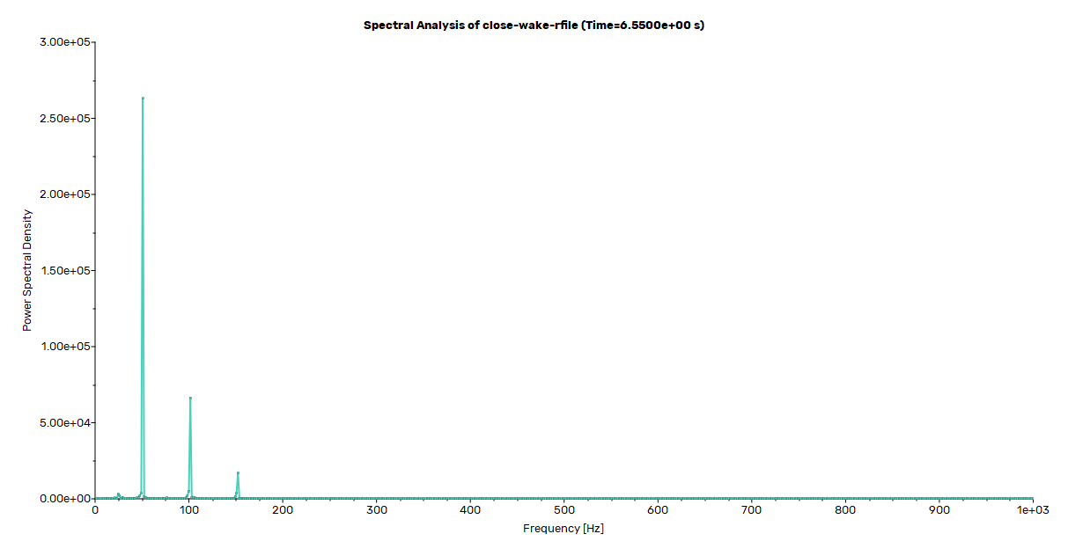
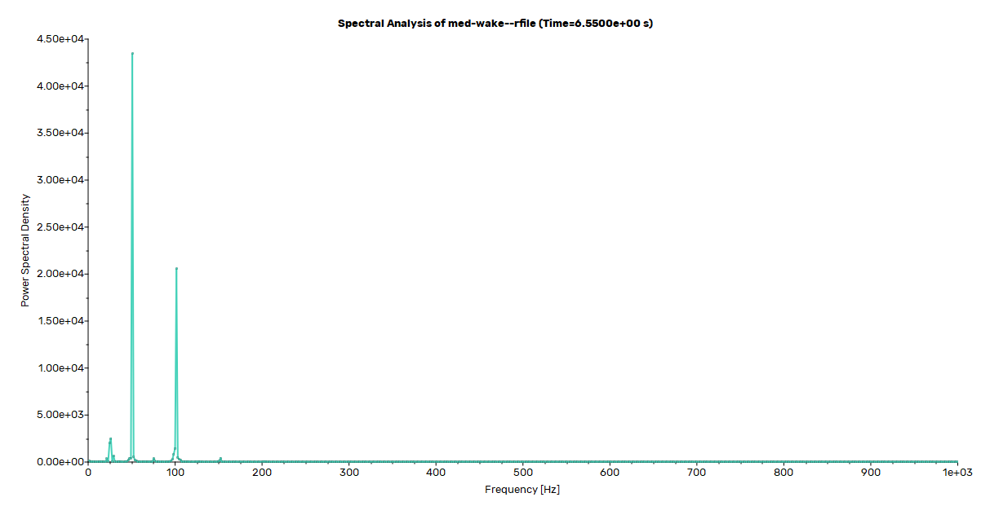
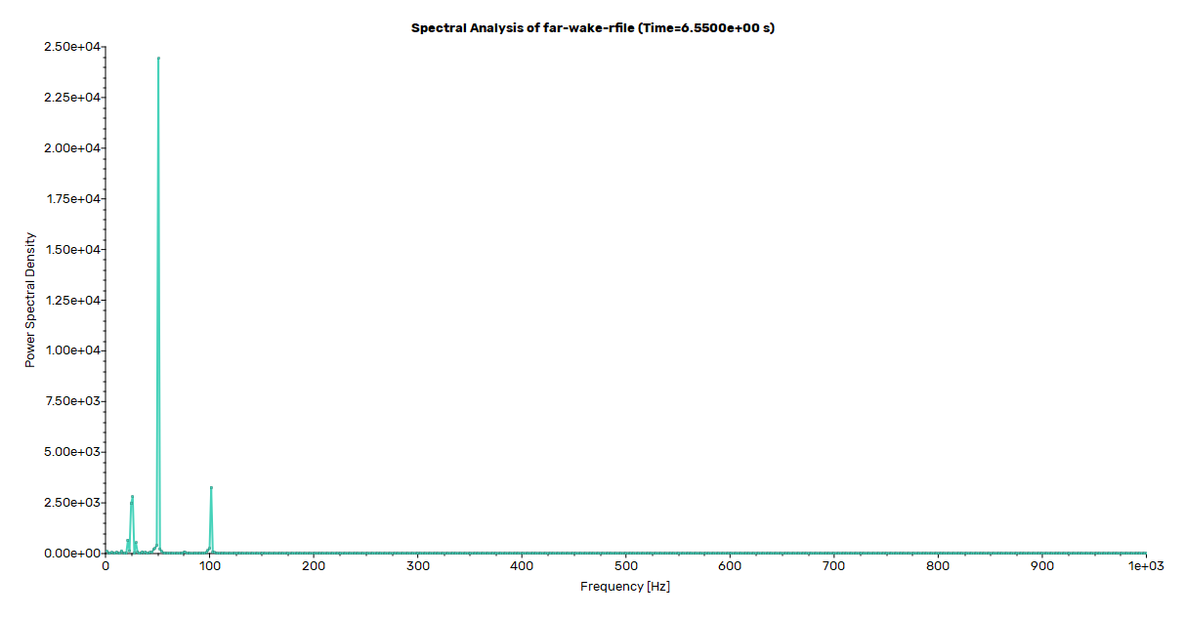
Figure 17 Power Spectral Density of wake velocity fluctuations at the close-wake
Figure 18 Power Spectral Density of wake velocity fluctuations at the med-wake probe
Figure 19 Power Spectral Density of wake velocity fluctuations at the far-wake probe
The transverse offset of each probe follows the relation $y ≈ \left(x - x_{TE}\right)·\tan\left(α\right)$, which places the probe approximately on the centerline of the deflected wake. Minor deviations from this geometric projection arise because the true wake centerline is influenced by the circulation-induced downwash and the asymmetric vortex shedding pattern.

A.2 Spectral Analysis of Wake Velocity Fluctuations
Power Spectral Density (PSD) analysis was performed using a Fast Fourier Transform (FFT) with a Nyquist frequency of 1,000 Hz. All three probes identified an unambiguous dominant shedding frequency of $f_{1}=50.77$ Hz (shedding period $T=19.7$ ms, or $1.74$ convective time units).The PSD spectra exhibit a well-defined harmonic series built upon this fundamental frequency. The second harmonic ($f_{2}≈101.5$ Hz) carries approximately 25% of the fundamental’s energy at the near-wake station, reflecting the non-sinusoidal character of the vortex passage. A sub-harmonic feature centred near 25.4 Hz ($≈f_{1}/2$) emerges in the downstream spectra, indicative of 2D vortex-pairing and wake meandering.

Table 8 Wake probe coordinates and configuration
Probe Station | f₁ [Hz] | PSD Peak | $$St_{c}$$ | $$St_{d}$$
Close wake (1.5c) | 50.77 | 2.64 × 10⁵ | 0.573 | 0.196
Medium wake (3.0c) | 50.77 | 4.35 × 10⁴ | 0.573 | 0.196
Far wake (4.5c) | 50.77 | 2.44 × 10⁴ | 0.573 | 0.196

Table 9 Dominant frequency and Strouhal numbers at each probe station
Component | f [Hz] | Ratio to f₁ | $$St_{c}$$ | $$St_{d}$$ | PSD (1.5c)
Sub-harmonic | ≈25.4 | f₁ / 2 | 0.286 | 0.098 | 3.23 × 10³
Fundamental (f₁) | 50.77 | 1.0 | 0.573 | 0.196 | 2.64 × 10⁵
2nd harmonic (f₂) | 101.54 | 2.0 | 1.145 | 0.392 | 6.63 × 10⁴
3rd harmonic (f₃) | 152.31 | 3.0 | 1.718 | 0.588 | 1.69 × 10⁴

A.3 Strouhal Number Calculation
The Strouhal number is the non-dimensional frequency characterising periodic vortex shedding. For bluff bodies, two scaling conventions are in common use, and the choice of length scale is critical for comparison with the established literature.
Chord-Based Strouhal Number
The chord-based definition uses the full aerofoil chord as the length scale:
$${St}_{c}=\frac{f×L}{U}$$
- $f$ is the peak frequency,
- $L$ is the chord length
- $U$ is the freestream velocity.
The measured peak frequency of $f = 50.77 Hz$ yields a Strouhal number of
$${St}_{c}=\frac{50.77×1}{88.65}= 0.573$$
This chord-based value of ${St}_{c}=0.573$ substantially exceeds the range of $St_{c}≈ 0.15-0.25$ commonly cited in the 2D URANS literature. This discrepancy warrants careful examination, as it could indicate either a genuine physical difference or a methodological artefact.
The primary explanation is the choice of reference length scale. The literature values of $St_{c}≈ 0.15-0.25$ are typically reported at angles of attack where the projected frontal height d = c · sin(α) is a larger fraction of the chord (e.g. α = 45–90° for flat plates, or lower α for thicker aerofoils). At α = 21°, sin(21°) ≈ 0.358, so the geometric conversion $St_{c}=St_{d}/sin\left(α\right)$ amplifies a physically reasonable $St_{d}≈ 0.20$ to a chord-based value of $St_{c}≈ 0.56$. The projected-height Strouhal number of $St_{d} = 0.205$ falls squarely within the universal bluff-body range of 0.15–0.20 established by Roshko (1954) [21], confirming that the fundamental vortex-shedding mechanism is correctly captured.
However, two secondary factors may also contribute to the elevated shedding frequency. First, the computational domain (10–20c extent) is smaller than the recommended 50–500c, and the resulting blockage may locally accelerate the flow, increasing the effective velocity past the aerofoil and thereby raising the shedding frequency. Second, the two-dimensional constraint eliminates spanwise phase decorrelation, which in three-dimensional flows tends to broaden the spectral peak and reduce the apparent dominant frequency. The combination of these effects means that whilst the $St_{d}$-based agreement with bluff-body universality is encouraging, the absolute shedding frequency of 50.77 Hz should be treated as indicative rather than quantitatively precise.
Projected-Height Strouhal Number
The physically meaningful definition for a stalled aerofoil uses the projected frontal height as the reference length, since the aerofoil effectively behaves as a bluff body of characteristic dimension $d = c ·\sin\left(α\right)$:
$$d = 1.0 ×\sin\left(20°\right)= 0.358 m$$
$$St_{d}=\frac{\left(50.77 Hz · 0.342 m\right)}{88.65 m/s}= 0.205$$

This result of $St_{d}$ = 0.205 falls squarely within the universal bluff-body Strouhal range of 0.15–0.20 established by Roshko (1954) [21] for circular cylinders and subsequently confirmed for a wide range of bluff-body geometries. The agreement is excellent and provides strong validation that the 2D URANS simulation with k-ω SST is correctly resolving the fundamental vortex-shedding mechanism at this angle of attack. The aerofoil in deep stall at $α$ = 21° behaves, from a wake dynamics perspective, as a bluff body with an effective frontal height of approximately 0.342 chord lengths.

Table 10 - Strouhal number comparison: this study versus expected bluff-body values
Definition | This Study | Expected Range | Agreement
$$St_{d}= \frac{f · d}{U∞}$$ | 0.205 | 0.15 – 0.20 | Excellent
$$St_{c}= \frac{f · c}{U∞}$$ | 0.573 | 0.15–0.25 (literature) | Above range*

*Note: The chord-based Strouhal number $St_{c}= 0.573$ is not anomalous; it is simply the consequence of using a length scale (c) that is approximately $\frac{1}{\sin\left(21°\right)}≈ 2.79$ times larger than the physically relevant projected height d. The identity $St_{c}=\frac{St_{d}}{\sin\left(α\right)}$ holds exactly.

A.4 Spectral Energy Attenuation with Downstream Distance
The evolution of PSD magnitude across the three probe stations provides insight into the spatial decay of the shedding energy. The fundamental peak ($f_{1}$) decays to 16.5% of its near-wake amplitude by 3.0c, and to 9.2% by 4.5c. Higher harmonics decay even more rapidly due to viscous diffusion acting preferentially on shorter wavelengths, leaving an increasingly sinusoidal signal in the far wake.
Table 11 PSD attenuation of the fundamental and second harmonic with downstream distance
Metric | Close (1.5c) | Medium (3.0c) | Far (4.5c)
PSD at f₁ | 2.64 × 10⁵ | 4.35 × 10⁴ | 2.44 × 10⁴
% of Close-Wake PSD | 100% | 16.5% | 9.2%
PSD at f₂ (2nd harmonic) | 6.63 × 10⁴ | 2.06 × 10⁴ | 3.26 × 10³
% of Close-Wake PSD | 100% | 31.1% | 4.9%

Note on 2D Fidelity: As discussed in Section 5, the artificially narrow spectral peaks, 100% spanwise vortex correlation, and strong period-doubling sub-harmonics are inherent artefacts of the 2D spatial constraint (the inverse energy cascade). While the mean forces and fundamental shedding frequencies ($St_{d}$) are highly accurate, capturing true broadband spectral content and realistic spanwise vortex breakdown would require 3D Scale-Resolving Simulations (DDES/IDDES).

Appendix B: Simulation Automation

B.1 PyFluent Automation Framework
The entire simulation workflow was automated using the ANSYS PyFluent API, enabling reproducible execution, comprehensive logging, and automatic data export. Two primary scripts were developed:

RANS Sweep Script (naca0012_rans_only_with_export.py)
This script performs steady-state RANS simulations across the full angle-of-attack range (0° → 22° → 0°) to establish the static baseline. Features include mesh validation, convergence monitoring with early stopping, checkpointing for failure recovery, and comprehensive data export at each angle.

URANS Hysteresis Script (naca0012_urans_complete.py)
This script executes the dynamic pitch protocol with continuous angle ramping at 2.0°/s. It includes automatic case/data saving at key angles, contour image capture, surface data export, and comprehensive CSV logging of all aerodynamic coefficients at every time step (16,000 data points total).

References
[1] Ladson, C.L., Hill, A.S., and Johnson, W.G., “Pressure Distributions from High Reynolds Number Transonic Tests of an NACA 0012 Aerofoil in the Langley 0.3-Meter Transonic Cryogenic Tunnel,” NASA TM 4074, 1988.
[2] Menter, F.R., “Two-Equation Eddy-Viscosity Turbulence Models for Engineering Applications,” AIAA Journal, Vol. 32, No. 8, 1994, pp. 1598–1605.
[3] Roache, P.J., Verification and Validation in Computational Science and Engineering, Hermosa Publishers, Albuquerque, NM, 1998.
[4] McCroskey, W.J., “A Critical Assessment of Wind Tunnel Results for the NACA 0012 Aerofoil,” NASA TM 100019, 1987.
[5] Leishman, J.G., Principles of Helicopter Aerodynamics, Cambridge University Press, 2nd Edition, 2006, Chapter 8.
[6] ANSYS, Inc., ANSYS Fluent Theory Guide, Release 2025 R2, Canonsburg, PA, 2025.
[7] CFD Land, “Y+ Calculator for First Cell Height,” https://www.cfdland.com/cfd-calculators/, accessed 2026.
[8] Menter, F.R. and Lechner, R., “Best Practice: RANS Turbulence Modelling in Ansys CFD,” Version 1.0, Ansys Germany GmbH, 2021.
[9] Allmaras, S.R., Johnson, F.T., and Spalart, P.R., “Modifications and Clarifications for the Implementation of the Spalart–Allmaras Turbulence Model,” ICCFD7-1902, 7th International Conference on Computational Fluid Dynamics, 2012.
[10] Yang, Y.-C. and Zha, G.-C., “Simulation of Aerofoil Stall Flows Using IDDES with High Order Schemes,” AIAA Paper 2016-3185, 2016.
[11] Patel, P., Yang, Y., and Zha, G., “SAS Study of NACA 0012 Stall Flows,” AIAA Paper 2019-3527, 2019.
[12] Kraichnan, R.H., “Inertial Ranges in Two-Dimensional Turbulence,” Physics of Fluids, Vol. 10, 1967, pp. 1417–1423.
[13] Bos, W.J.T., “Three-Dimensional Turbulence Without Vortex Stretching,” Journal of Fluid Mechanics, Vol. 915, A121, 2021.
[14] Israel, D.M., “The Myth of URANS,” Journal of Turbulence, Vol. 24, No. 8, 2023, pp. 367–392.
[15] Martinat, G., Hoarau, Y., Braza, M., et al., “Turbulence Modelling of the Flow Past a Pitching NACA 0012 Aerofoil,” Journal of Fluids and Structures, Vol. 24, 2008, pp. 1294–1303.
[16] Sereez, M., Abramov, N., and Goman, M., “CFD Simulations and Phenomenological Modelling of Aerodynamic Stall Hysteresis of NACA 0018 Wing,” Aerospace, Vol. 11, No. 5, 354, 2024.
[17] NASA Turbulence Modelling Resource, NACA 0012 Validation: turbmodels.larc.nasa.gov/naca0012_val.html.
[18] Spalart, P.R. and Allmaras, S.R., “A One-Equation Turbulence Model for Aerodynamic Flows,” AIAA Paper 92-0439, 1992.
[19] McCroskey, W.J., "The Phenomenon of Dynamic Stall," NASA TM 81264, 1981.
[20] Langtry, R.B. and Menter, F.R., "Correlation-Based Transition Modeling for Unstructured Parallelized Computational Fluid Dynamics Codes," AIAA Journal, Vol. 47, No. 12, 2009, pp. 2894–2906.
[21] Roshko, A., "On the Development of Turbulent Wakes from Vortex Streets," NACA Report 1191, 1954.
[22] Celik, I.B., Ghia, U., Roache, P.J. and Freitas, C.J., 2008. “Procedure for Estimation and Reporting of Uncertainty Due to Discretization in CFD Applications.” Journal of Fluids Engineering — Transactions of the ASME, Vol. 130, No. 7.

