Name: _____Muhammad Uzair _______ Roll No: 22SW106

Score: ____________Signature of the Lab Tutor: _______________ Date: __10/30/24

**________________________________________________________________________**

**OBJECTIVES**

|  |  |  |  |  |
| --- | --- | --- | --- | --- |
| **#** | **Topic** | **#. Of**  **Lectures** | **CLO** | **Taxonomy level** |
| 4 | To **make** console and telnet connections with network devices (e.g., switch and router) using open-source terminal emulator software. | 3 | 2 | P5 |

**OUTCOME(S)**

|  |  |
| --- | --- |
| a. An ability to apply knowledge of math, science, and engineering | PLO1: Engineering Knowledge: |
| k. an ability to use the techniques, skills, and modern engineering tools necessary for engineering practice. | **PLO5:** Modern Tool Usage |

**RUBRICS:**

|  |  |  |  |  |
| --- | --- | --- | --- | --- |
| **Performance Metric** | **Exceeds expectation (4-5)** | **Meets expectations (2-3)** | **Does not meet expectations (0-1)** | **Score** |
| Knowledge and application  [PLO1] | Applies the appropriate knowledge and concepts to the problem with accuracy and  proficiency; shows precise understanding of these knowledge and concepts. | Applies the relevant knowledge and concept to the problem, possibly in a roundabout way; understands the major points of the knowledge, with possible misunderstanding or failure to recall minor points; | Fails to apply relevant knowledge and concepts to the problem; misunderstands or fails to recall critical points. |  |
| Modern Tool  Usage [PLO5] | Computer and software are extensively used  in the course | Computer and software are somewhat utilized, effort was put into learning new software | Computer and software are  not utilized, no attempt was made at learning new software |  |
|  |  |  | **Total Score** |  |

***EQUIPMENT***

* Catalyst 2950 /1920 Switch
* 2 PC’s with NIC installed
* 2 Straight through UTP cables
* RJ-45 TO DB-9 adapter
* RJ-45 TO RJ 45 rollover cable DISCUSSION & CONFIGRATION:

Navigation between different switch command modes

Cisco switches run on proprietary OS known as Cisco IOS. IOS is a group of commands used for monitoring, configuring and maintaining cisco devices. For security and easy administration, IOS commands are divided in the set of different command modes. Each command mode has its own set of commands. Which commands are available to use, depend upon the mode we are in.

**Navigation between Cisco IOS modes**

|  |  |  |  |  |
| --- | --- | --- | --- | --- |
| Mode | Purpose | Prompt | Command to enter | Command to exit |
| User EXEC | Allow you to connect with remote devices, perform basic tests, temporary change terminal setting and list system information | Router > | Default mode after booting. Login with password, if configured. | Use exit command |
| Privileged  EXEC | Allow you to set operating parameters. It also includes high level testing and list commands like show, copy and debug. | Router # | Use enable command from user exec mode | Use exit command |
| Global  Configuration | Contain commands those affect the entire system | Router(config)# | Use configure terminal command from privileged exec mode | Use exit command |
| Interface  Configuration | Contain commands those modify the operation of an interface | Router(configif)# | Use interface type  number command from global configuration mode | Use exit command to return in global configuration mode |

Sub-Interface Configure or modify the Router(config Use interface type sub Use exit to return

Configuration virtual interface created subif) interface number command in previous mode.

from physical interface from global configuration mode Use end command

or interface configure mode to return in

privileged exec mode.

ROMMON If router automatically enter ROMMON> Enter reload command from Use exit command in this mode, then it privileged exec mode. indicates that it fails to Press CTRL + C key locate a valid IOS image. combination during the first 60 Manual entrance in this seconds of booting process mode Allow you to perform low-level diagnostics.

How to get help on Cisco Switch command mode

Switch provides two types of context sensitive help, word help and command syntax help.

**Word help**

Word help is used to get a list of available commands that begin with a specific letter. For example, if we know that our command begins with letter e, we can hit enter key after typing e? at command prompt. It will list all possible commands that begin with letter e.

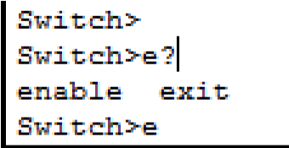

We can list all available commands, if we don't know the initials of our command. For example, to list all available commands at User exec mode, just type? at command prompt and hit enter key.

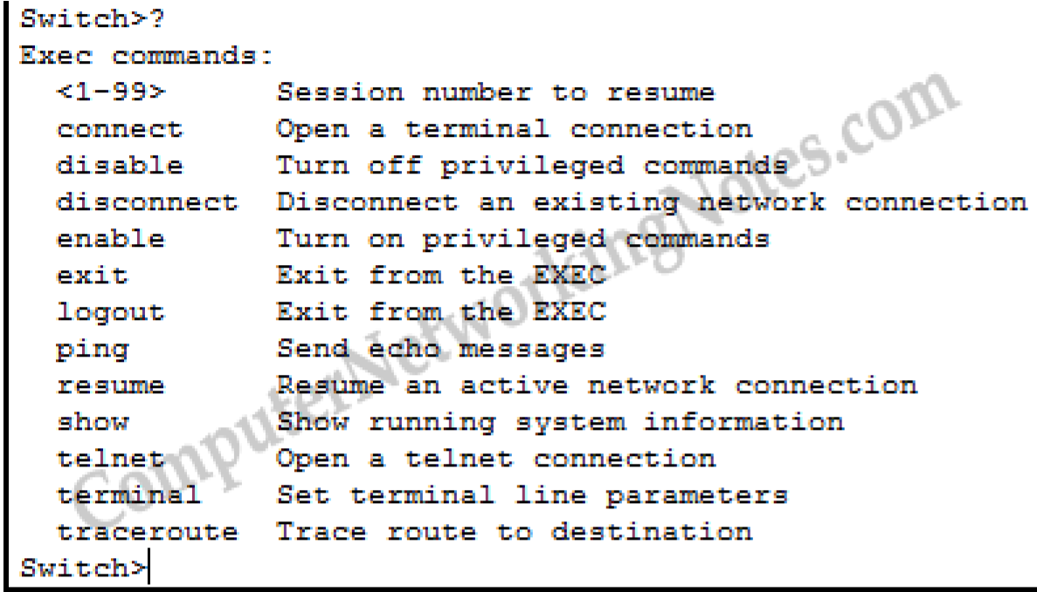

**Command syntax help**

Command syntax help can be used to get the list of keyword, commands, or parameters that are available starting with the keywords that we had already entered. Enter? (Question mark) after hitting Space key and prompt will return with the list of available command options. For example, to know the parameters required by show ip command type show ip? and prompt will return with all associate parameters. If prompt returns with <CR> only as an option, that means switch does not need any additional parameters to complete the command. You can execute the command in current condition.

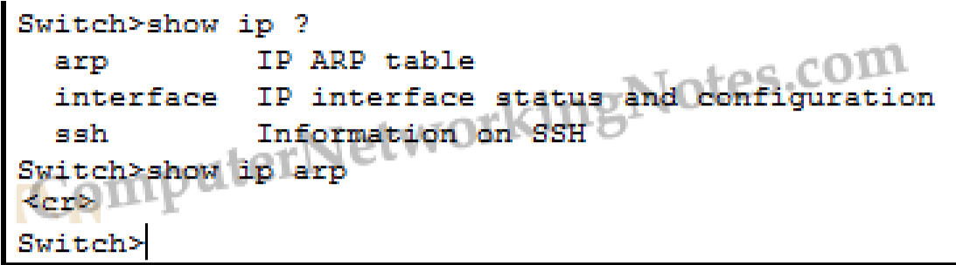

***Lab equipment requirements***

To perform this lab, you need 1 Cisco Catalyst 2950 Switch and at least 1 PC. However, most of the commands will work on other switch models as well. We are going to use two different PCs but they can be one and the same physical PC. You will need to connect them as depicted in the following the network diagram:

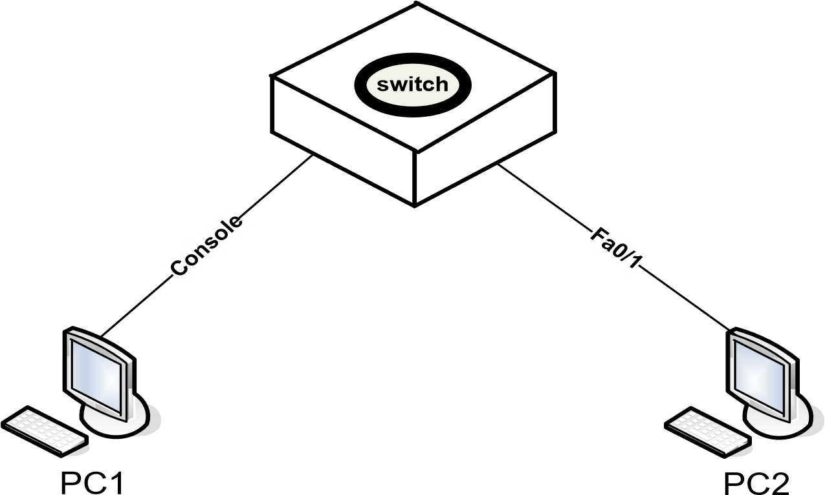

**Fig: Network Diagrm**

*Connect the console cable to the to the console port on the switch and the other end to the serial port of PC1. Connect PC2 to first Fast Ethernet port (i.e. FA0/1) using an UTP/STP cable. PC1 must have a terminal client (i.e. Windows HyperTerminal) installed, and PC2 must be able to setup a telnet connection.*

***Configuring the Switch***

Before you start with the configuration of the switch, clear the switch configuration by using the **erase startup-config command** or the erase nvram: command in Privileged EXEC mode, and then use the reload command to reboot the switch. After the switch rebooted, the following message will be displayed:

% Please answer 'yes' or 'no'.

Would you like to enter the initial configuration dialog? [yes/no]

Type no and press ENTER.

Press ENTER when the message Press RETURN to get started appears.

Type enable at the **Switch>** command prompt.

**Switch>enable**

1. What prompt does *enable* command display and what does it mean?

ANS: **Prompt:** Router#

**Meaning:** This prompt signifies that you have entered the Privileged EXEC mode, allowing access to high-level commands, such as configuring settings or testing device performance.

_____________________________________________________________________

***STEP 1: Change the switch's host name to SWR-2024***

Enter configuration mode using the following command:

**Switch#configure terminal**

1. Enter **configure terminal** at the privilege mode prompt.

Switch#**configure terminal**

1. Which prompt switch will display after typing above command?

ANS: Switch(config)#

____________________________________________

1. What does this prompt mean?

ANS: This prompt shows that you have entered Global Configuration mode, which allows you to change system-wide settings on the switch.

_______________________________________________________________________

Change the host name of the switch to **"SWR-2024"** using the following command:

**Switch(config)#hostname SWR-2024**

1. Which prompt this Switch will display?

ANS: SWR-2024(config)#

_____________________

1. What does this prompt mean?

ANS: This prompt shows the hostname has been changed to "SWR-2024," and the device is in Global Configuration mode.

_______________________________________________________________________ c. Why this change in the prompt is required?

ANS: Changing the hostname provides easy identification of the switch, which is helpful for network administrators managing multiple devices.

_______________________________________________________________________

***STEP 2: Configure passwords***

First set the enable password to cisco using the following command: **SWR-2024(config)#enable password cisco**

Next, set the enable secret to cisco123 using the following command: **SWR-2024(config)#enable secret cisco123**

Next, set the password for all telnet lines to 'cisco456' using the following commands:

**SWR-2024 (config)#line vty 0 15**

**SWR-2024 (config-line)#password cisco456**

**SWR-2024 (config-line)#login**

Although the enable secret is encrypted, other passwords stored in the switch's configuration are still in clear text like enable password. You can see this by returning to Privileged EXEC mode and running the show running config:

**SWR-2024 (config)#end (or press CTRL-Z) SWR-2024#show running-config**

Notice the enable secret is replaced by a hashed version, for example: **enable secret 5 $1$iUjJ$cDZ03KKGh7mHfX2RSbDq**

When you log on with the enable *secret*, the switch calculates the hash value again and compares it with the hash value stored in the configuration. If they match, you typed in the correct secret and will enter Privileged EXEC mode. You can configure a password by using the enable password command instead, but in contrary to the enable secret, the enable password is not encrypted by default. If an enable password *and* an enable secret are configured, you will need to enter the enable secret to logon. In other words, there’s no need to configure an enable password if you configured an enable secret.

Near the end of the configuration, you will notice the vty password you just configured, and that it is stored in plain text format. To ensure this password, as well as others such as the console password are also encrypted, use the service password-encryption command in Global configuration mode:

**SWR-2024#configure terminal**

**SWR-2024(config)#service password-encryption**

If you would run the show running-config command in Privileged EXEC mode again, you will notice the vty password is now also encrypted. For example: **1511021F07257F717E**

You can also set a password on the aux or console connection, for example to set the password to cisco789:

**SWR-2024 (config)#line con 0**

**SWR-2024 (config-line) #password cisco789**

**SWR-2024 (config-line) #login**

1. At Privileged EXEC mode type **‘show running-config’** and follow the details.
2. Is there an encrypted password?

ANS: Yes, the enable secret password is encrypted and appears hashed in the configuration.

______________________________________________

c. Are there any other passwords?

ANS: Yes, other passwords, such as the enable password and line vty (Telnet) password, are also configured.

_______________________________________________

d. Are any of the other passwords encrypted?

ANS: Only the enable secret is encrypted by default. The enable password and line vty passwords are not encrypted unless service password-encryption is enabled in Global Configuration mode.

_______________________________________

***STEP 3: Configure Banner on switch***

The banner or MOTD (message of the day) is to display a temporary notice to users, such as issues with system availability. However, because the message displays when a user connects to the device prior to login, most network administrators are now using it to display legal notices regarding access to the switch, such as unauthorized access to this device is prohibited and violators will be prosecuted to the full extent of the law and other such cheery endearments.

Use the following commands to set the banner or motd on switch which alerts unauthorized users not to access the switch.

**SWR-2024(config)#banner motd #this device is for authorized person only if you**

**Haven’t been provided with the permission to access this device Exit at once#**

Notice that each of the banner lines ends with a # symbol; this is a delimiter to identify the end of the message. You can specify any character you want, but the character you choose is the one you will use to end the banner message. Here is what these messages look like when you connect to the switch:

***STEP 4: show mac-address-table***

*Switch stores MAC address of devices those are attached with its interfaces in CAM table. We can use show mac-address-table command to list all learned devices.*

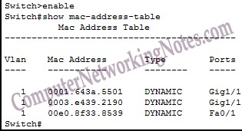

1. How switches use this table to forward data?

ANS: Switches use the MAC address table to map MAC addresses to their corresponding switch ports, allowing them to forward data directly to the correct device instead of broadcasting it to all ports.

______________________________________________

1. In mac table under type column what does dynamic refers to?

ANS : "Dynamic" means the MAC addresses were learned by the switch automatically when devices communicated over the network. This type of entry is temporary and may be removed if the switch does not detect activity from the MAC address.

______________________________________________

How to clear mac address table

Switch stores MAC addresses in MAC address table. Gradually it could be full. Once it full, switch automatically starts removing old entries. You can also clear these tables manually from privileged exec mode. To delete all entries use following command

|  |
| --- |
| **switch#clear mac address-table** |
|  |

To delete only dynamic entries use

|  |
| --- |
| **switch#clear mac address-table dynamic** |
| How to add static MAC address in CAM table |

For security purp ose sometime we have to add mac address in CAM table manually. To add static MAC address in CAM table use following command

|  |
| --- |
| **Switch(config)#mac address-table static aaaa.aaaa.aaaa vlan 1 interface fastethernet 0/1** |
| In above command we entered an entry for static MAC address aaaa.aaaa.aaaa assigned |

to FastEnternet 0/1 with default VLAN1. STEP 5: How to set duplex mode

*Switch automatically adjust duplex mode depending upon remote device. We could change this mode with any of other supported mode. For example, to force switch to use full duplex mode use*

|  |
| --- |
| **Switch(config)# #interface fastethernet 0/1 Switch(config-if)#duplex full** |
|  |

To use half duplex use

|  |
| --- |
| **Switch(config)# #interface fastethernet 0/1 Switch(config-if)#duplex half** |
| STEP 5: Display interface status |

show interface command displays information about interfaces. Without argument it would list all interfaces. To get information about specific interface we need to pass its interface number as an argument. For example, to view details about FastEthernet 0/1, use show interface fastethernet 0/1. First line from output below provides information about the status of interface. FastEthernet0/1 is up, line protocol is up (connected), The first up indicates the status of the physical layer, and the second up indicates to the status of the data link layer.

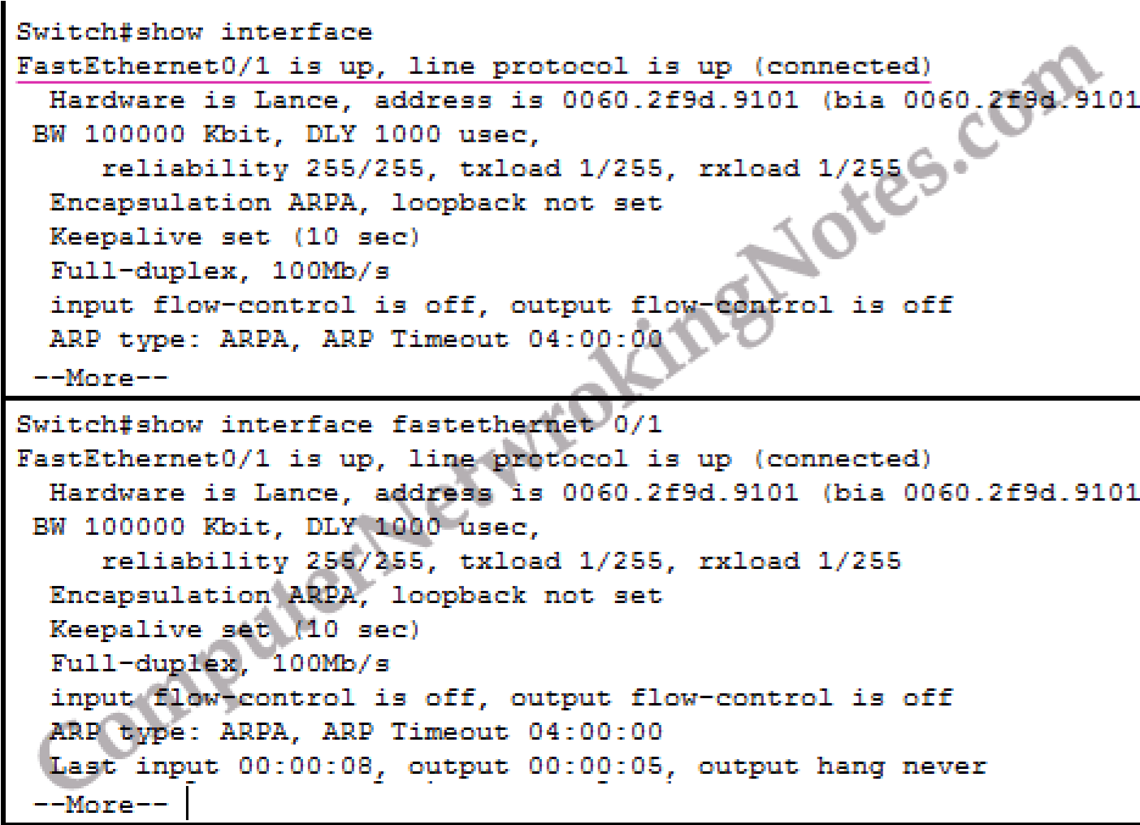

a. What will be status of line protocol if at data link layer we use two different protocols?

ANS: The status of the line protocol would be "up and down," indicating a data link layer issue, likely caused by incompatible protocols.

______________________________________________

Possible interface status

* up and up :- Interface is operational.
* up and down :- Its data link layer problem.
* down and down :- Its physical layer problem.
* Administratively down Interface is disabled with shutdown command.

Possible values for physical layer status

* Up :- Switch is sensing physical layer signal.
* Down :- Switch is not sensing physical layer signal. Possible reasons could be cable is not connected, wrong cable type is used and remote end device is turned off.
* Administratively down :- Interface is disabled by using shutdown command.

Possible values for data link layer status

* Up :- The data link layer is operational.
* Down :- The data link layer is not operational. Possible reasons could be a disabled physical layer, missed keep alives on a serial link, no clocking or an incorrect encapsulation type.

**show ip interface brief** is a extremely useful command to get quick overview of all interfaces on switch. It lists their status including IP address and protocol.

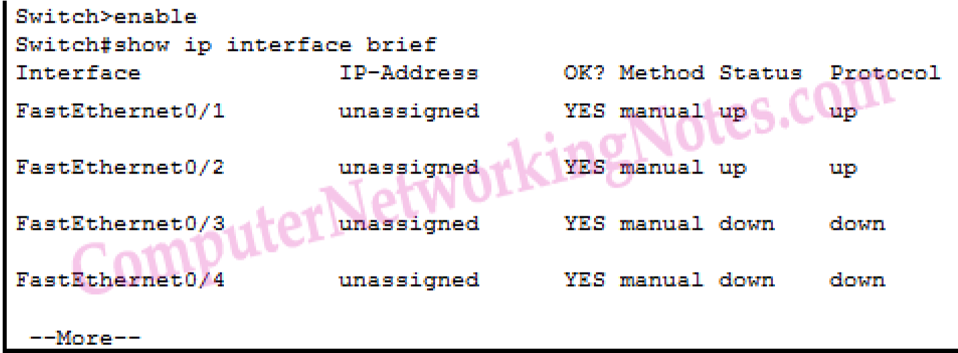

***STEP 5: Saving the configuration***

Saving the configuration on a modern Cisco Catalyst switch running IOS software works the same as on Cisco routers. This means you have to copy the running configuration (in RAM) to the startup configuration (in NVRAM) by using the following command in Privileged EXEC mode:

**SWR-2024#copy running-config startup-config**

If you run the show startup-config command, you should get the same output as the show running-config command. The dir nvram: command should show the startup-config file with a size greater than zero. The configuration is also stored in the config.text file in flash, which content you can see by using the show flash command.STEP 6: Display switch hardware and firmware information

The show version command allows you to display information about the switch’s hardware and IOS. The first half shows information about the IOS in flash, the boot loader on ROM, the uptime, what caused the switched to reboot, and the IOS edition it runs. The second half shows information about the hardware, including the interfaces, the memory and serial numbers.

**SWR-2024#show version**

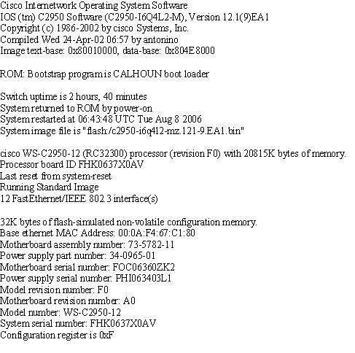

1. Enter the **show version** command. The Switch will return information about the IOS that is running in RAM.
2. Write the name of the IOS version?

ANS: 12.1(22)EA4

1. What is the name of the system image (IOS) file?

ANS: c2950-i6q4l2-mz.121-22.EA1.bin

______________________________________________________________________

d. Where was the switch IOS image booted from?

ANS: The IOS is generally booted from flash memory.

____________________________________________

e. How many Ethernet interfaces does this switch have?

ANS: 24 Fast Ethernet ports

_________________________

Lab Exercise:

1. Submit a lab with performing a simple task connect a pc with switch using console

connection and configure telnet connection. Using Telnet configure switch with all basic

configuration we learnt in this Lab.

