Name: ______________Muhammad Uzair______________ Roll No: __22SW106 _

Score: ____________Signature of the Lab Tutor: _______________ Date: _10/30/2024

**________________________________________________________________________**

**OBJECTIVES**

|  |  |  |  |  |
| --- | --- | --- | --- | --- |
| **#** | **Topic** | **#. Of**  **Lectures** | **CLO** | **Taxonomy level** |
| 1 | To **understand** different connectors and transmission media and **apply** the knowledge to **make** straight through and cross over cables. | 3 | 1,2 | C3, P5 |

**OUTCOME(S)**

|  |  |
| --- | --- |
| a. An ability to apply knowledge of math, science, and engineering | **PLO1**: Engineering Knowledge: |

**RUBRICS:**

|  |  |  |  |  |
| --- | --- | --- | --- | --- |
| **Performance Metric** | **Exceeds expectation (4-5)** | **Meets expectations (2-3)** | **Does not meet expectations (0-1)** | **Score** |
| Knowledge and  application  [PLO1] | Applies the appropriate knowledge and concepts to the problem with accuracy and  proficiency; shows precise understanding of these knowledge and concepts. | Applies the relevant knowledge and concept to the problem, possibly in a roundabout way; understands the major points of the knowledge, with possible misunderstanding or failure to recall minor points; | Fails to apply relevant knowledge and concepts to  the problem; misunderstands or fails to recall critical points. |  |
|  |  |  | **Total Score** |  |

**PERFORMANCE OBJECTIVE**

**Upon successful completion this experiment, the student will be able to:**

1. **Familiar with the different connectors & transmission media**
2. **Making of RJ- 45 connector (wiring standard)**

**EQUIPMENTS**

* RJ 45 connectors
* Twisted pair wire (UTP)
* Crimping tools
* LAN Cable Tester

**DISCUSSION**

**TRANSMISSION MEDIA**

**Twisted-pair cabling**

Most networks are connected with twisted-pair cabling. The cable that runs from your telephone to the wall is probably twisted-pair. Different types and categories of twistedpair cable exist, but they all have two things common:

* The wires come in pairs
* The pairs of wires are twisted around each other.

The twisting of wires reduces crosstalk, the bleeding of a signal from one wire to another, which can corrupt signals and cause network error.

Transmitting cables have a naturally created magnetic field around them. When two wires are placed in close proximity, their electronically created magnetic fields cancel each other out. This cancellation insulates the signal from the effects of signal bleeding. When the wires are twisted around one another, the magnetic cancellation is further enhanced. The twisting of the wires not only protects the signal inside from the internal crosstalk, but also guards against other external forms of signal interference.

**UTP**

**Unshielded twisted- pair (UTP)** cabling is used for a variety of electronic communications. UTP cable supports data transmissions of 4, 10, 16, and 100 Mbps. The maximum segment length for UTP is 100 meters.

**Advantages**

* It is thin, flexible cable that is easy to string between walls
* Most modern buildings come with CAT 5 UTP already wired into the wall outlets or at least run between the floors.
* Because UTP is small, it does not quickly fill up wiring ducts
* UTP costs less per foot than nay other type of LAN cable

**Disadvantages**

* It is more susceptible to interference than most other types of cabling. The pair twisting does help, but is does not make the cable impervious to electrical noise.
* It is limited to segments of 100 meters.

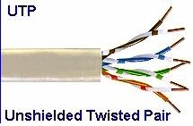

**STP**

**Shielded twisted-pair (STP)** cabling is similar to UTP in that the wire pairs are twisted around each other inside the cable. However, STP also shielding around the cable to further protect it from external interference. The shielding of the individual pairs of wires further reduces the chance of crosstalk. Of course, shielding the individual wire pairs increases the overall diameter and weight of the cable the maximum segment length of STP cable is 100 meter.

The **advantages** of STP over UTP are:

* It has greater protection from interference and crosstalk due to shielding. The **disadvantages** of STP include:
* STP has a higher cost per foot
* The STP shield must be grounded at both ends; if grounded improperly, it can cause serious interference.
* Heavier and less flexible, STP is more difficult to install ▪ Because of its thickness, STP may not fit down cable ducts.

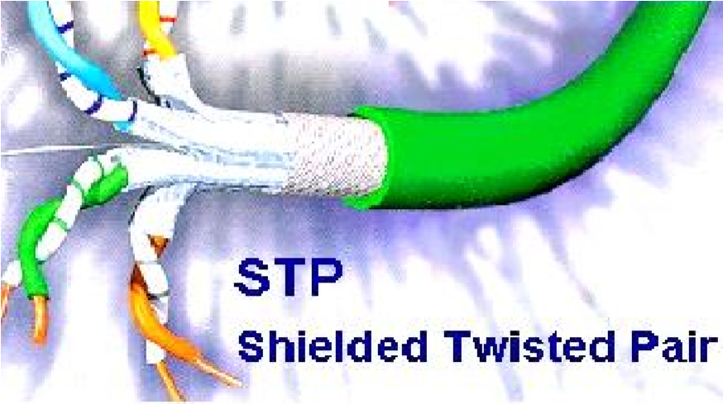

**COAXIAL CABLING**

Coaxial cable consists of a solid core (often made of copper) or wire strand conductor that is surrounded by insulation. Just outside of the insulation is a shield, which is a foil or copper braid that protects the inner conductor. A protective jacket (external coasting) surrounds the outside of the cable.

Coaxial cable supports data-transmission rates of 10 Mbps. The two most commonly used types of coaxial cable are **Thicknet** and **Thinnet.** Thicknet is a thicker then Thinnet. Thicknet can be up to 500 meters long whereas Thinnet segments are limited to 185 meters. Figure show coaxial cable.

The **advantages** of using coaxial cabling on the LAN include the following:

* The segment lengths are longer than UTP or STP ▪ Shielding is built in.
* Hubs between stations are not required.

**Disadvantages**

* It is not easy to run as UTP because it is not as flexible or thin.
* It is more expensive than UTP.
* It requires more room in wiring ducts than UTP.

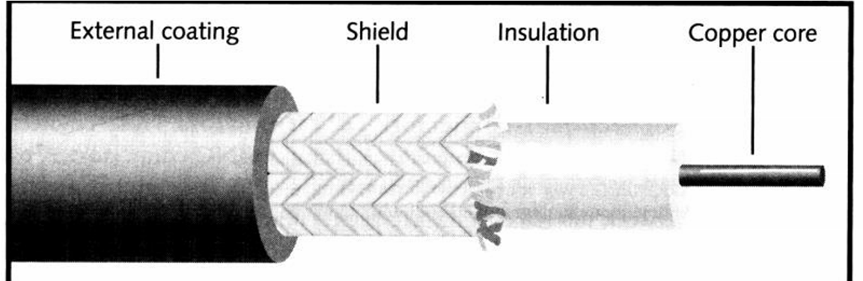

**FIBER OPTIC CABLE**

**Fiber optic cable** carries light pulses rather than electrical signals along its fibers. This cable is made of glass or plastic fibers, rather than copper wire like most other network cabling. The core of the cable is usually glass. Surrounding the glass is a layer of cladding made of glass or plastic. It traps the light in the core. The cladding is usually wrapped either an insulating layer. This fiber is then surrounded with Kevlar, which the strong substance used in bulletproof vests. Finally, a protective outer sheath made of either PVC or Teflon (plenum grade) is added.

The light pulses carrying the signals in fiber optic cable originating from a light emitting diode (LED) (multimode cable) or Laser (single- mode cable).

Multimode cable can supports transmission up to 100 Mbps, over segments up to 2 km. Single-mode cable can transmit up to 2 Gbps with the segments that span up to 62 miles. Fiber optic cable is the media choice for connections between LANs, between buildings, across MANs (metropolitan area network), and where there is excessive interference or security issue.

**Advantages**

* It can transmit over long distances, farther than any other network media▪ It is not susceptible to electromagnetic interference.
* It is immune from cross talk
* It supports extremely high transmission rates
* The cable has a small diameter and can be use in narrow wiring ducts▪ It is not susceptible to eavesdropping.

**Disadvantages**

* It is more expensive than other types of networking media
* It is more difficult and expensive to install than other types of network media. The ends of each cable must be polished perfectly flat and scratch free before they are inserted into the connection device.
* Because it is fragile, fiber optic cable must be installed carefully and protected after installation

**CONNECTORS**

**RJ-45 connectors**

RJ-45 plugs are similar to those you'll see on the end of your telephone cable except they have eight versus four or six contacts on the end of the plug and they are about twice as big. Make sure they are rated for CAT 5 wiring. (RJ means "Registered Jack"), as shown in the fig:

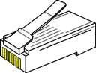

**Thinnet connectors**

The most common connectors for RG-58 cabling on Thinnet networks are **barrel connectors, T-connectors,** and **terminators.** These connectors are known as British Naval Connectors, or simply BNC connectors. A barrel connector connects two sections of coaxial cabling. A T –connector fits on the end of the network interface card (NIC) and connects a station to two sections of RG-58 cabling. Terminators are placed on each end of a Thinnet network segment to absorb signals as they reach the end of the wire. This absorption keeps the signals from reflecting and preventing other station from transmitting. Fig

**Thicknet connectors**

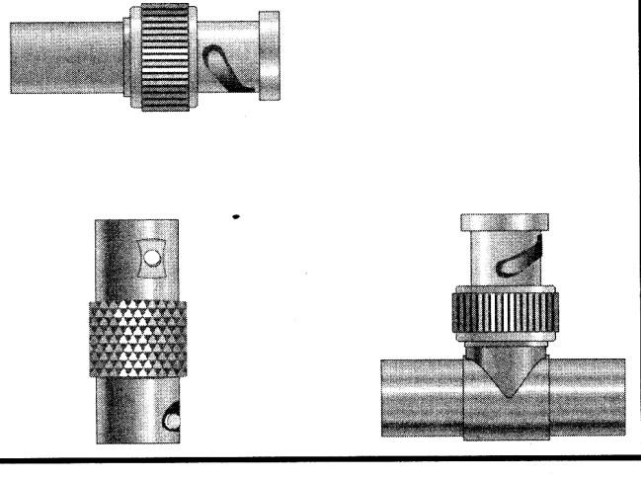

Although a Thicknet also uses coaxial cabling, the connectors can be different. Thicknet cable can be attached directly to computers using larger BNC- style connectors that are similar to the Thinnet connectors, but Thicknet is extremely difficult to manipulate and usually is connected indirectly.

In this direct method, a small device called a vampire tap pierces the Thicknet cable to mark a connection with the core. The tap is then attached to a transceiver external to the NIC. A drop cable, no more the n 50 feet long, connects the transceiver to an **attachment unit interface (AUI) port** on the NIC. Unlike a BNC attachment or RJ-45 attachment, the AUI attachment on the NIC is not a transceiver.

**Fiber optic connector**

Optical fiber connectors mostly used are “ST” (a) and the “SC” (b) and they must be able to support at least 200 cycles for extraction/insertion without introducing attenuation over 1 dB, as shown in the fig: 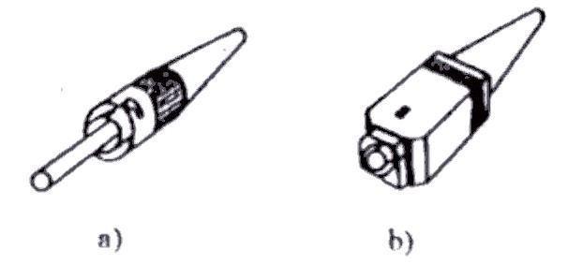

**Making of RJ-45**

CAT 5 cable has four twisted pairs of wire for a total of eight individually insulated wires. Each pair is color coded with one wire having a solid color (blue, orange, green, or brown) twisted around a second wire with a white background and a stripe of the same color. The solid colors may have a white stripe in some cables. Cable colors are commonly described using the background color followed by the color of the stripe; e.g., white-orange is a cable with a white background and an orange stripe. Following are the steps for making of an RJ-45 cable

1. The total length of wire segments between a PC and a hub or between two PC's cannot exceed 100 Meters (328 feet)
2. Strip one end of the cable with the stripper or a knife. If you are using the stripper, place the cable in the groove on the blade (left) side of the stripper and align the end of the cable with the right side of the stripper. This will strip about 1/2" of the jacket off the cable. If you are using a knife carefully slit the cable for about an inch and removes the jacket.
3. Spread and arrange the pairs roughly in the order of the desired cable end.
4. Untwist the pairs and arrange the wires in the order of the desired cable end. Flatten the end between your thumb and forefinger. Trim the ends of the wires so they are even with one another**.** It is very important that the outstripped (untwisted) end be slightly less than 1/2" long.If it is longer than 1/2" it will be out-of-spec and susceptible to crosstalk. If it less than slightly less than 1/2" it will not be properly clinched when RJ-45 plug is crimped on. Flatten again. There should be little or no space between the wires.
5. Hold the RJ-45 plug with the clip facing down or away from you. Push the wire firmly into the plug. Looking through the bottom of the plug, the wire on the far left side will have a white background. The wires should alternate light and dark from left to right. The furthest right wire is brown. The wires should all end evenly at the front of the plug. The jacket should end just about where you see it in the diagram.

 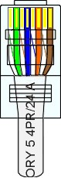

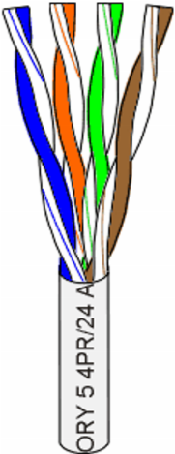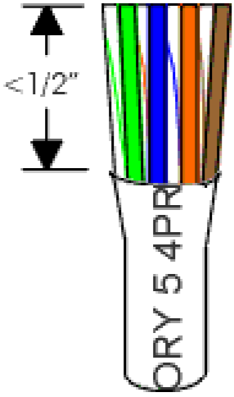

**ALL ABOUT CRIMPING**

1. Hold the wire near the RJ-45 plug with the clip down and firmly push it into the left side of the front of the crimper (it will only go in one way). Hold the wire in place squeeze the crimper handles quite firmly. This is what will happen:

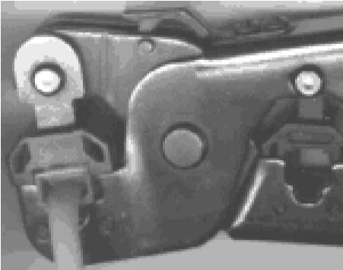 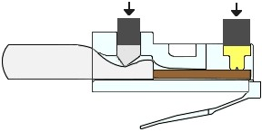

(Crimp it once.) The crimper pushes two plungers down on the RJ-45 plug. One forces what amounts to a cleverly designed plastic plug/wedge onto the cable jacket and very firmly clinches it. The other seats the "pins," each with two teeth at its end, through the insulation and into the conductors of their respective wires.

1. Prepare the other end of the cable so it has the desired end and crimp.
2. . If both ends of the cable are within reach, hold them next to each other and with RJ45 clips facing away. Look through the bottom of the plugs. If the plugs are wired correctly, and they are identical, it is **a straight-thru cable**. If they are wired correctly and they are different, it is **a crossover cable**.
3. . If you have an operational network, test the cable. Copy some large files.
4. If the cable doesn't work, inspect the ends again and make sure you have the right cable and that it is plugged into the correct units for the type of cable. Try powercycling (cold booting) the involved computers.
5. . If you have many straight-thru cables and a crossover cable in your system, you should consider labeling the crossover cable or using a different colored cable for the

crossover cable so you don't mix them up.

12.

Following shows the two configur

ation one for the straight through and other cross

over cable

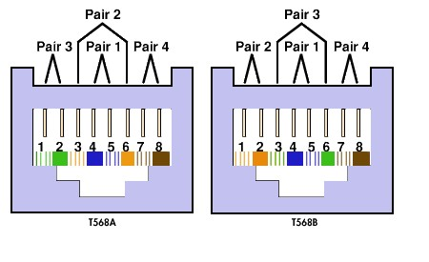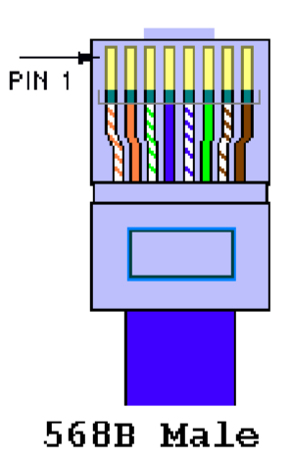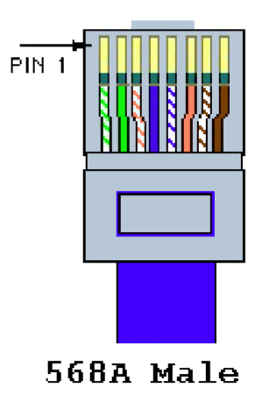

________________________________________________________________________

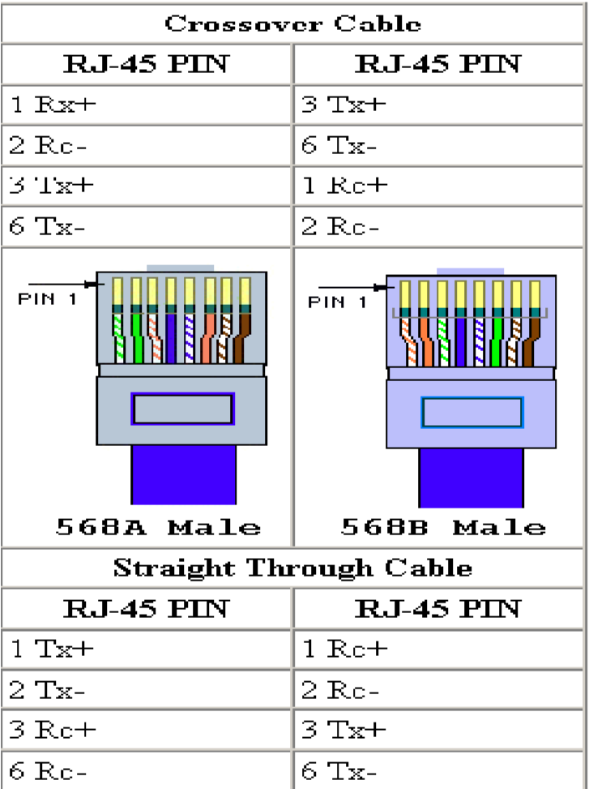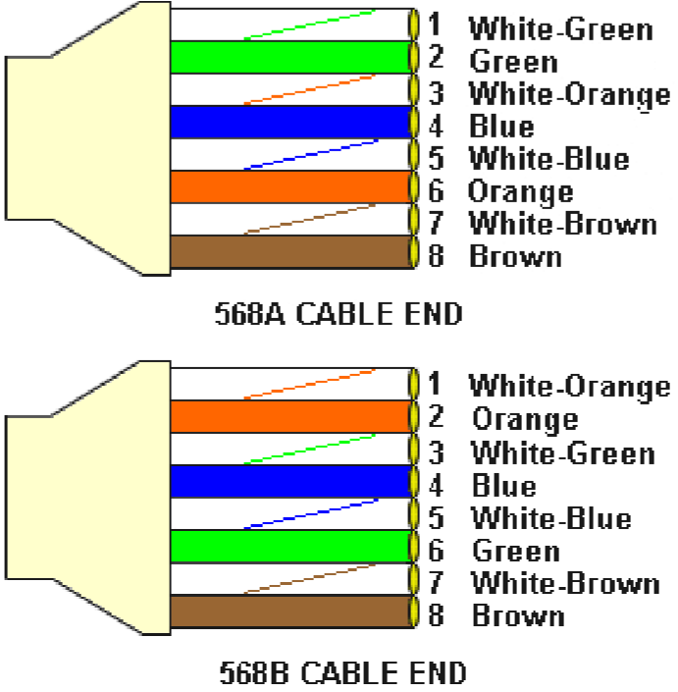

________________________________________________________________________

**LAB ASSIGNMENT**

Make your own straight-through and crossover cable and submit it along with your lab handout.

**REVIEW QUESTIONS:-**

1.**What do you mean by straight-through and crossover cable?**

· A straight-through cable is a type of Ethernet cable where the wire order at both ends of the cable is identical, making it suitable for connecting different devices (e.g., a computer to a switch). A crossover cable has a different wire order at each end, allowing it to connect similar devices directly (e.g., a computer to another computer).

2 **What is the advantage of STP over UTP? Also, compare it with coaxial cable.**

**Advantage of STP over UTP:** STP (Shielded Twisted Pair) has shielding around the cable, which offers greater protection from interference and crosstalk compared to UTP (Unshielded Twisted Pair).

**Comparison with Coaxial Cable:** Coaxial cable provides built-in shielding and supports longer segment lengths than both UTP and STP. However, coaxial cable is less flexible, more expensive, and takes up more space in wiring ducts compared to UTP and STP.

3 **Why is Optical Fiber cable widely used for backbone networks?**

Optical Fiber cable is widely used for backbone networks because it supports extremely high transmission rates, can cover long distances, is immune to electromagnetic interference, and has protection from crosstalk. Additionally, it has a small diameter and is secure against eavesdropping.

4 **What do you mean by Thinnet and Thicknet?**

**Thinnet:** Thinnet is a type of coaxial cable with a maximum segment length of 185 meters, often used in shorter network connections.

**Thicknet:** Thicknet is a thicker coaxial cable than Thinnet, with a maximum segment length of 500 meters, commonly used in backbone connections for networks where longer distances are required.