|  |  |
| --- | --- |
| **Roll no** | **22SW106** |
| **Section** | III |

Task-1:

Using Team Viewer, install a software on a remote device.

To install software on a remote device using TeamViewer, follow these steps:

**Open TeamViewer**: Make sure you and the remote user have TeamViewer installed and running.

**Connect to the Remote Device**:

* 1. Enter the remote device’s TeamViewer ID and password to establish a connection.
  2. The remote device will need to approve access if unattended access isn't already set up.

**Control the Remote Device**:

* 1. Once connected, you’ll see the remote device's screen on your own. You can control the mouse and keyboard as if you were in front of it.

**Download the Software**:

* 1. Open a browser on the remote device and download the installation file for the software you want to install. You can also transfer files directly if you have the installer on your device.

**Install the Software**:

* 1. Locate the downloaded file, open it, and follow the installation instructions as you would on your own computer.

**Complete the Installation and Confirm**:

* 1. Finish the installation process, and ensure the software is working as expected on the remote device.

**End the TeamViewer Session**:

* 1. Once installation is complete, close the TeamViewer session by ending the remote control connection.

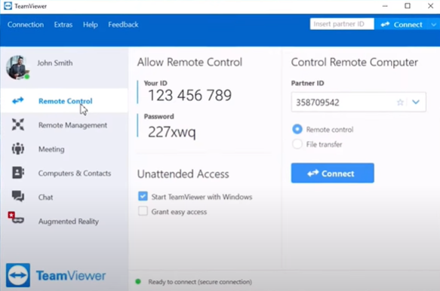

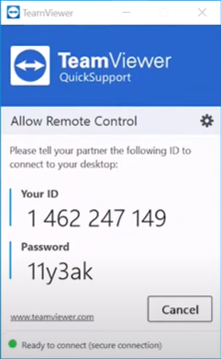

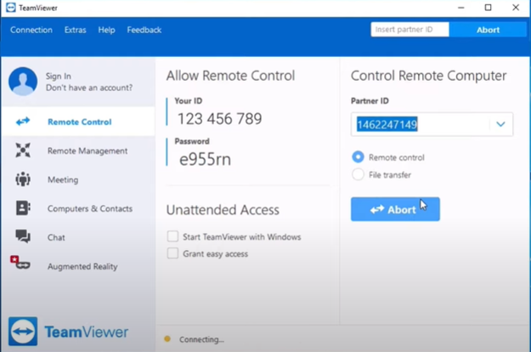

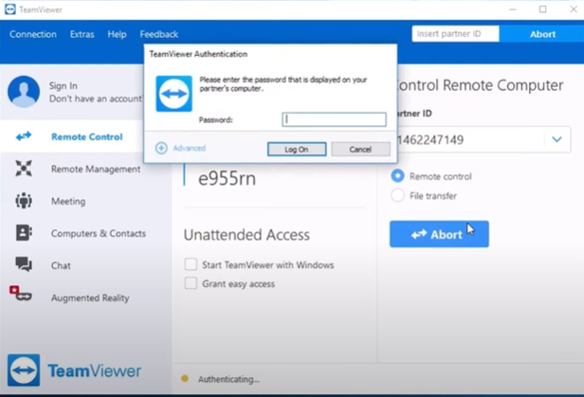

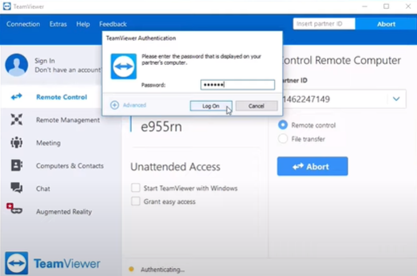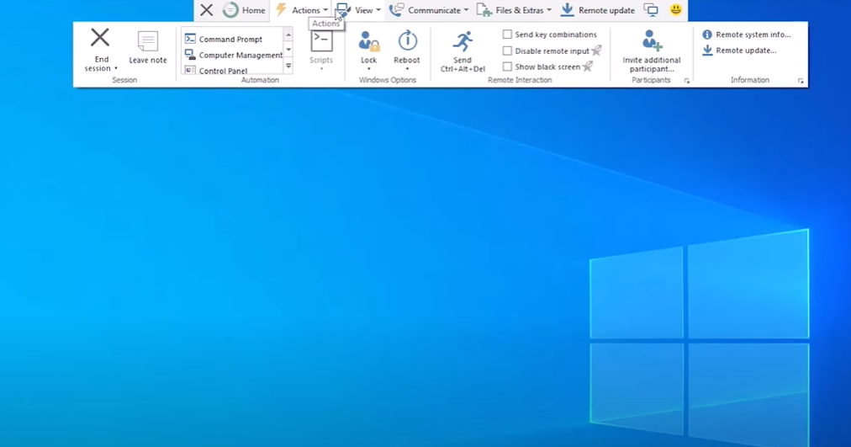

Task-2:

* Using Team Viewer, transfer files between two different devices.

**Open TeamViewer on Both Devices**:

* 1. Ensure both devices have TeamViewer installed, and both are connected to the internet.

**Connect to the Remote Device**:

* 1. Enter the TeamViewer ID of the remote device and connect using the provided password.
  2. Alternatively, you can use the “File Transfer” option in TeamViewer to directly enter file transfer mode without full screen-sharing.

**Access the File Transfer Window**:

* 1. If you’re in the main TeamViewer window, select the “File Transfer” option instead of “Remote Control.”
  2. This will open a split-screen view showing the file directories of both devices.

**Navigate to the Files**:

* 1. In the file transfer window, navigate through the folders on both the local and remote device to locate the files you want to transfer.

**Transfer the Files**:

* 1. Select the files or folders you wish to transfer and click the “Send” or “Receive” button depending on the direction of the transfer.

**Monitor the Transfer Progress**:

* 1. TeamViewer will display a progress bar. Once the transfer is complete, you’ll see a confirmation.

**Close the File Transfer Window**:

* 1. When you’re done, you can close the file transfer window or the TeamViewer session.

This method allows for efficient file transfers without needing to take full control of the remote screen, making it convenient for sharing data between devices.