MEHRAN UNIVERSITY

OF ENGINEERING & TECHNOLOGY

JAMSHORO, PAKISTAN

Subject: Operating System

(Tasks Solution)

|  |  |
| --- | --- |
| **Roll No:** | **22SW106** |
| **Section:** | **III** |

Task 1: Demonstrate all the commands mentioned in the handouts. Use switches where possible. (Define their working with the switch and add screenshots)

1. **cd Command:**

To navigate to a specific directory:

To go up one directory level:

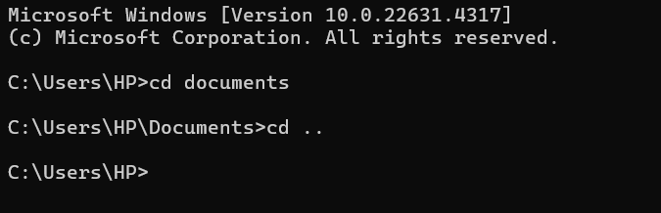

**Switch:**

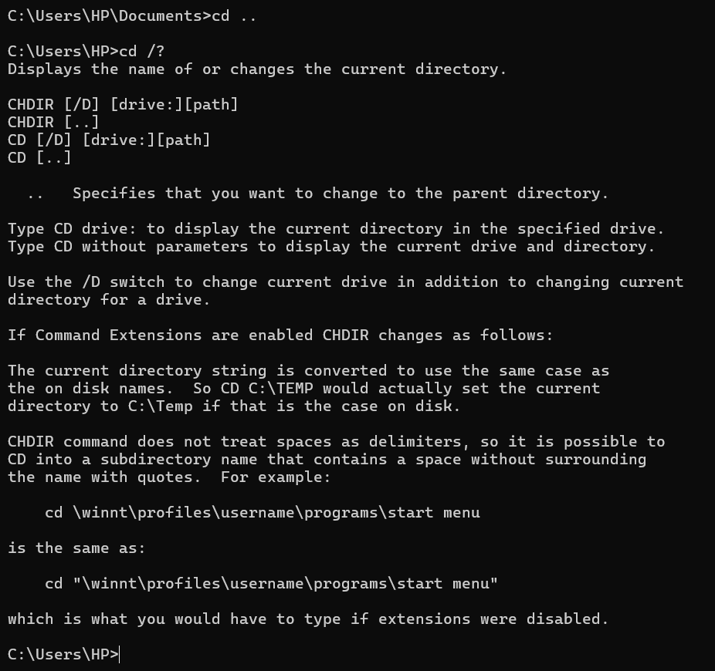

1. **help Command:**

To display all available commands and their descriptions:

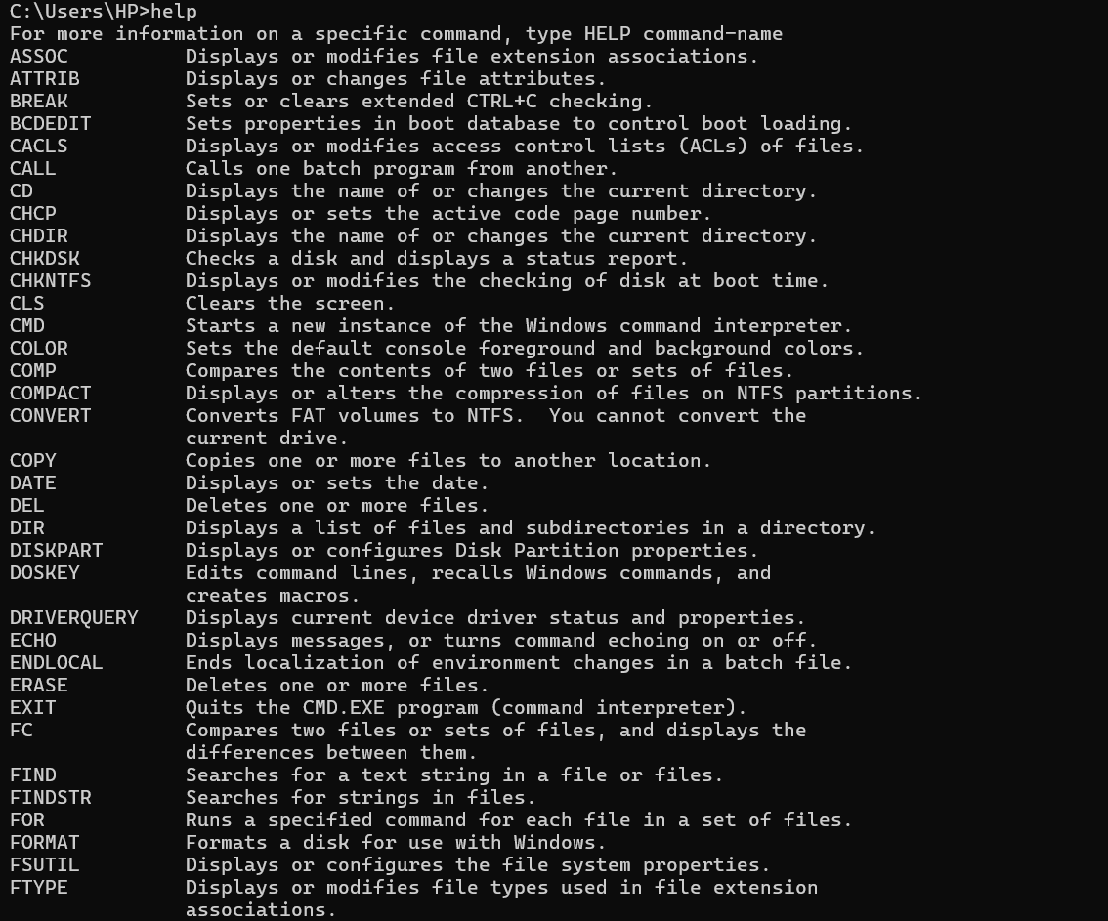

**Switch:**

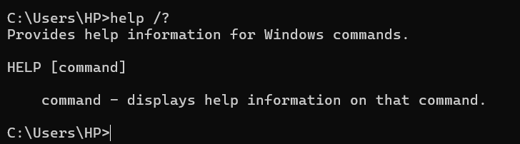

1. **dir Command with Switches**:

To list directory contents in columns:

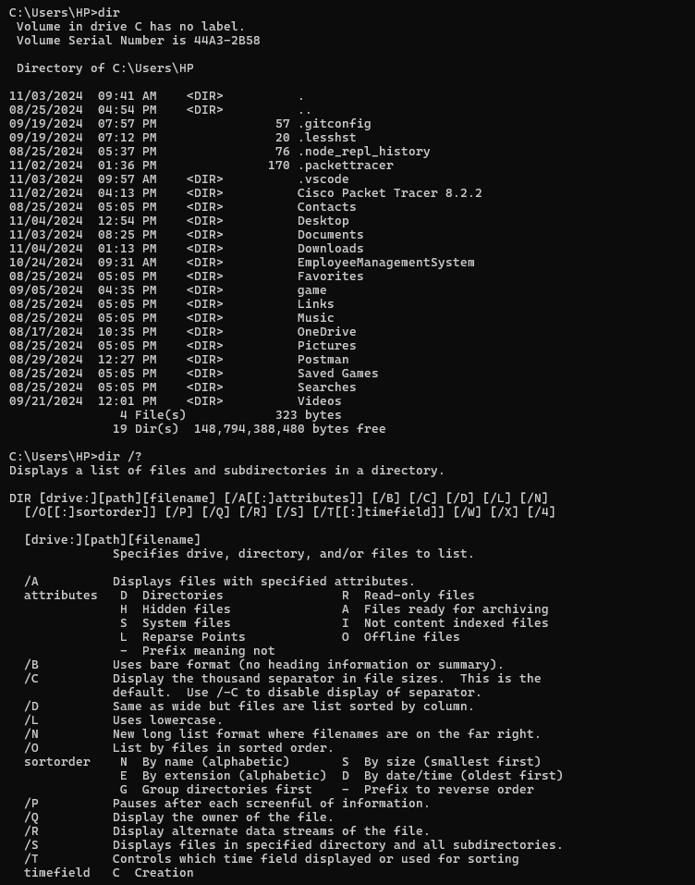

4.echo **Command with switch:**

**To display a message:**

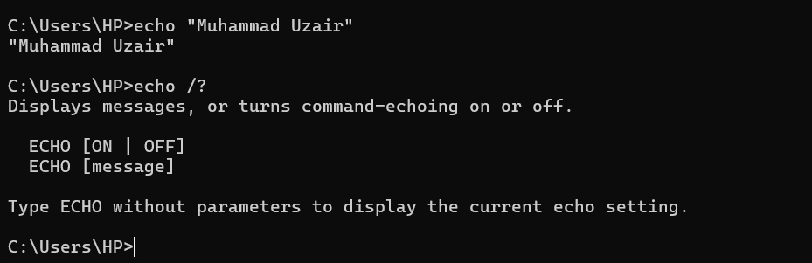

5.ping **Command with Switch:**

**To ping Google's server and check connectivity:**

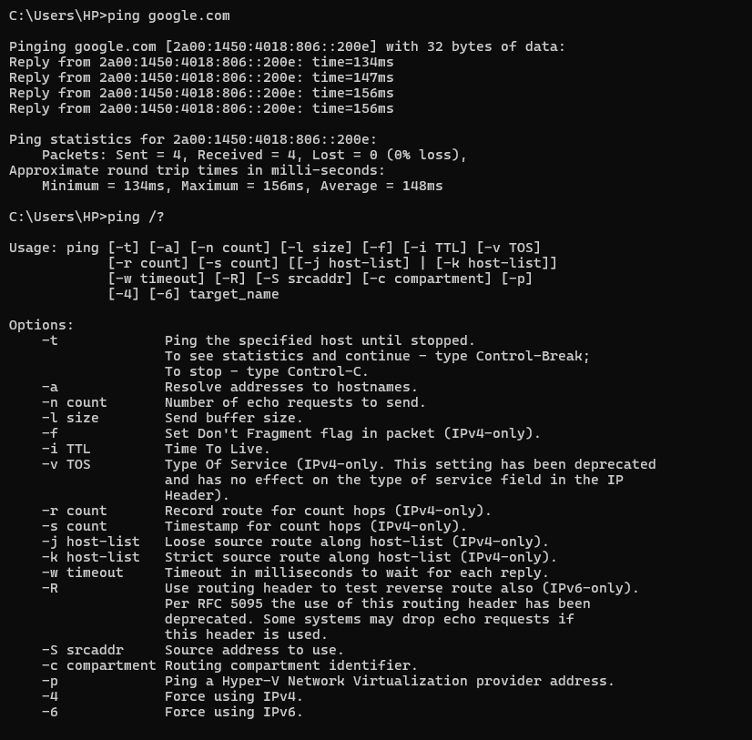6.ipconfig **Command:**

* **To display the IP configuration details:**

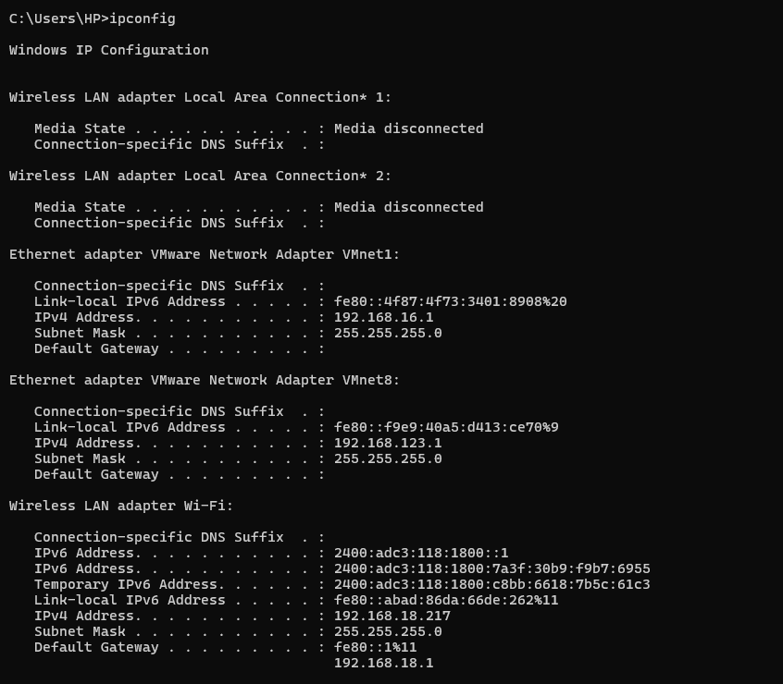

**Switch:**

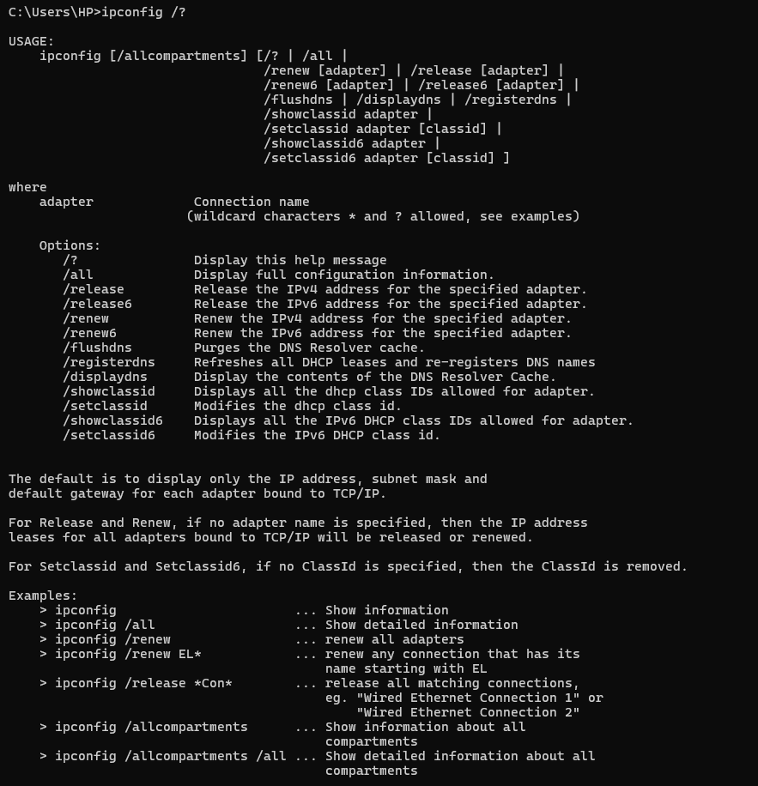

7.driverquery **Command:**

**To list all installed drivers:**

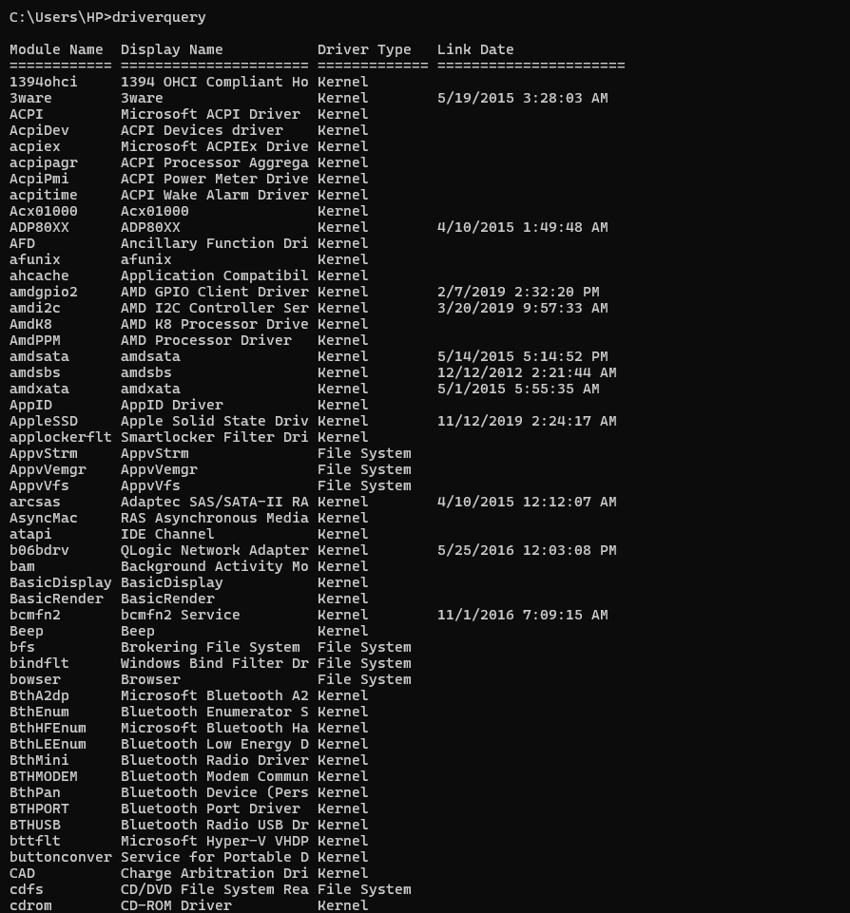

**Switch:**

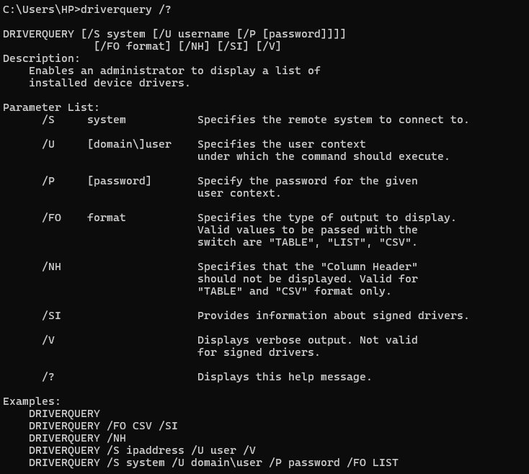

7.tasklist **Command:**

* **To display the list of running tasks:**

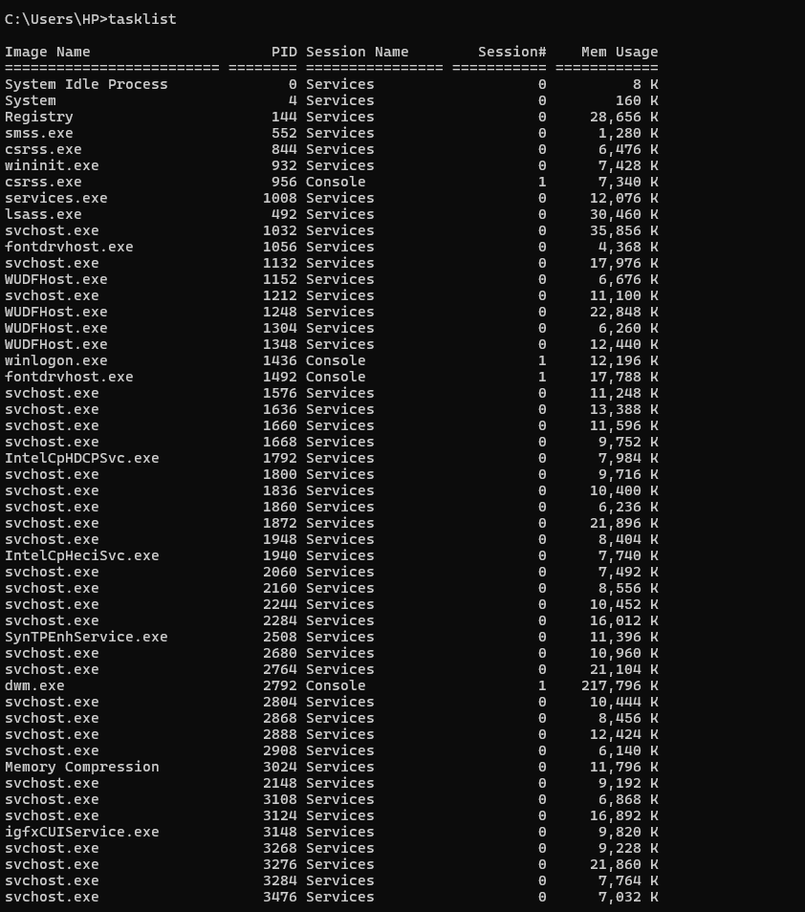

**Switch:**

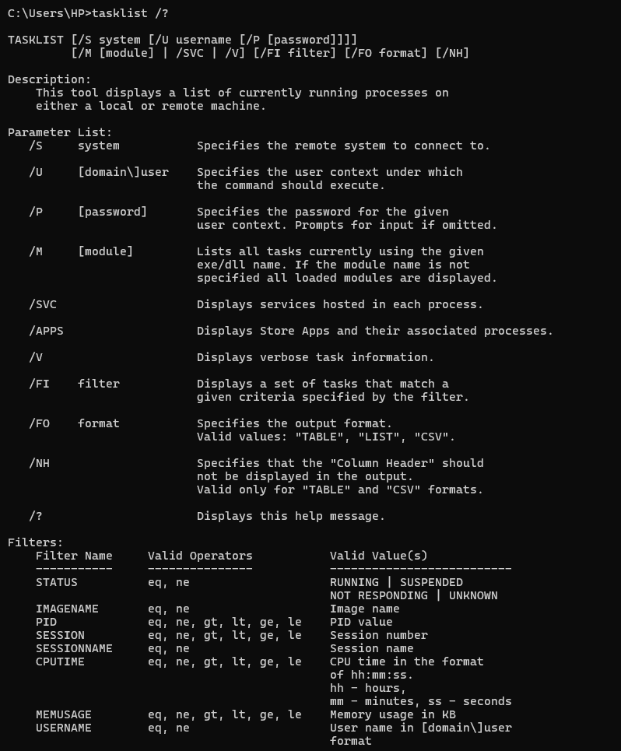

8.systeminfo **Command:**

**To display system information**

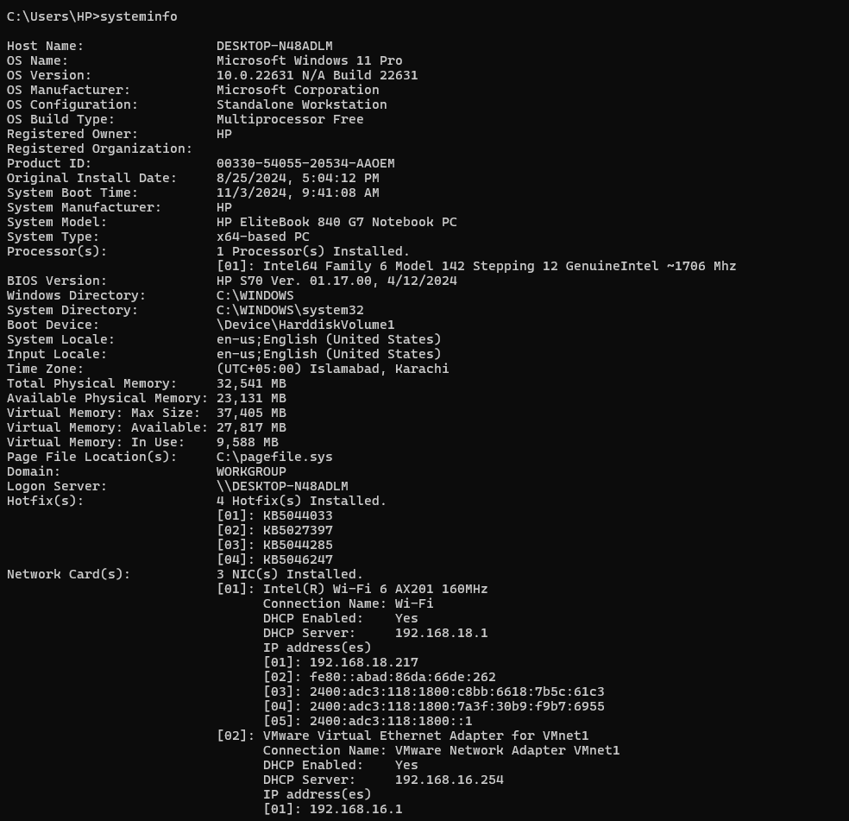

Switch:

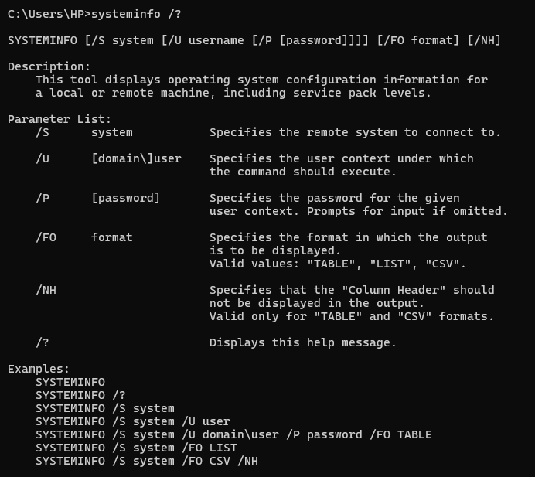

Task 2: Create a Folder with Your Roll Number

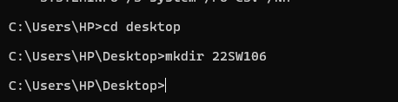

**Task 3:** Create a Text File

* **Navigate to the folder with your roll number**

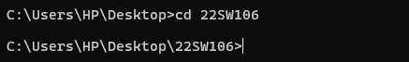

Create a text file yourname.txt with specified content:

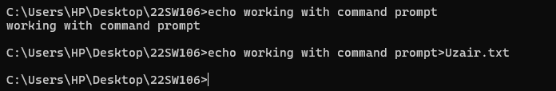

Task 4: Rename the Text File to Uppercase

**To rename** yourname.txt **to uppercase**

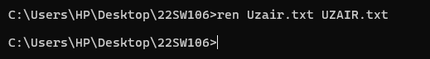

Task 5: Make a Subfolder and Move the File

**Create a subfolder named**  “oslab” and Move the file UZAIR.txt into the oslab folder:

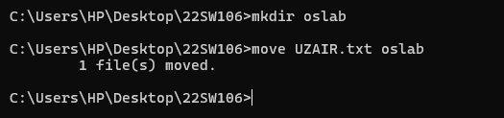

Task 6: Create a Backup of the File

**Create a backup of** YOURNAME.TXT **in the** osclab **folder:**

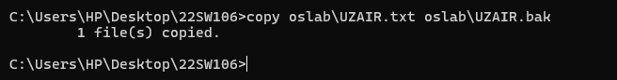

Task 7: Show Directories

* **Display the directories in the folder with your roll number**

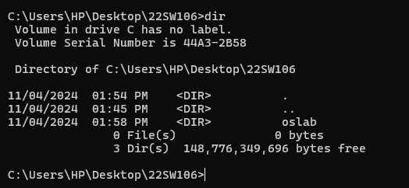

Task 8: Type help in the command prompt and show the working of any 10 commands in that list. (make sure the commands have not been used in this lab)

* **Help**

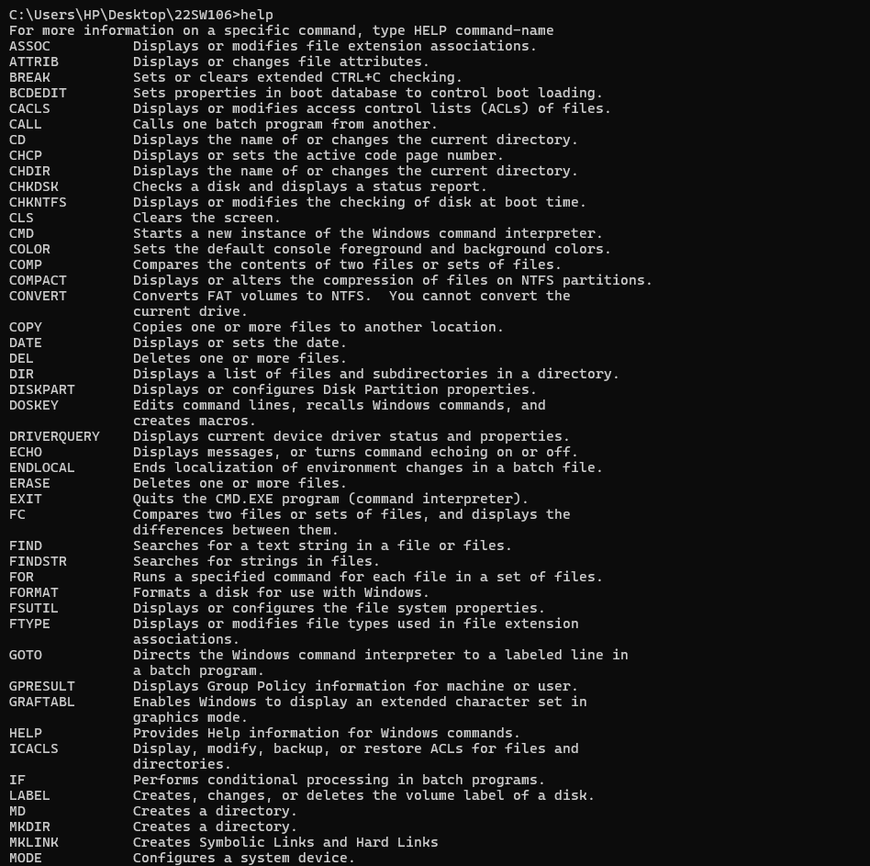

* **assoc**

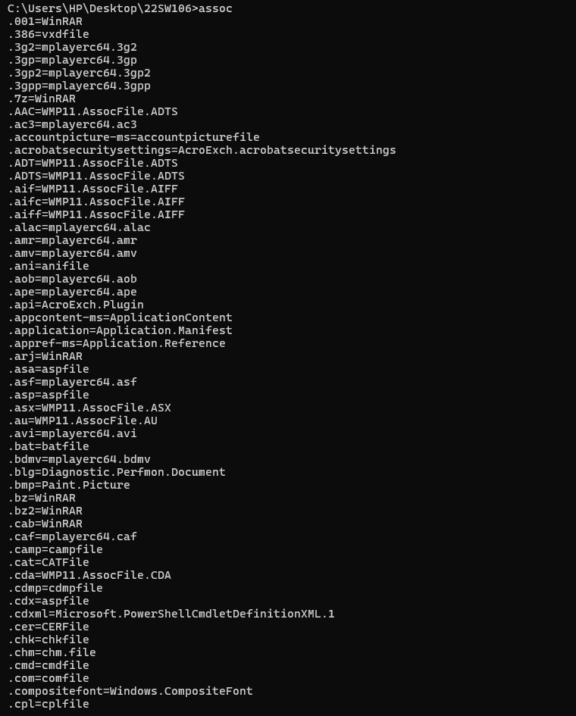

* **fc file1.txt file2.txt**



* **cls 🡪** “clear the console”



* **time**

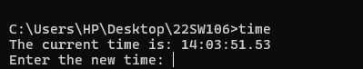

* **date**

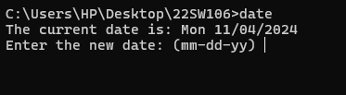

* **color 0A**

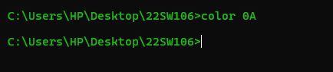

* **tree**

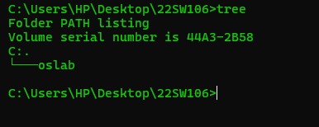

* **pause**



* **ver**

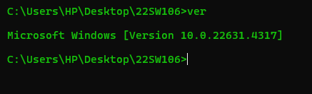

**find "example" yourfile.txt**