1.

This first page is designed for view purpose, only HOME tab can be accessible. The notification bar will let them know that either event is going to be started or not.

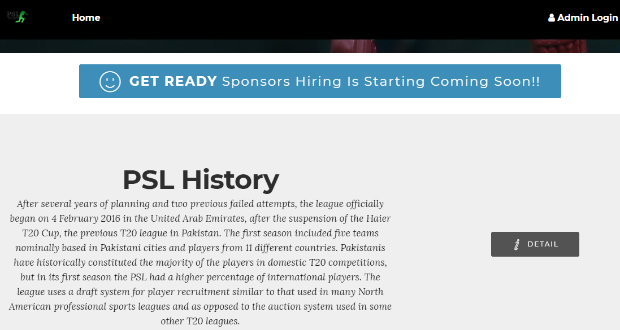

2.

This page will be accessible only by ADMINS. They have some special privileges:

1. They can allow any user who applied to become a sponsor; they will allow that user to become sponsor and can bid on players.
2. A “SPONSOR” Tab will be provided in admin page to access those functionalities by clicking on that tab.

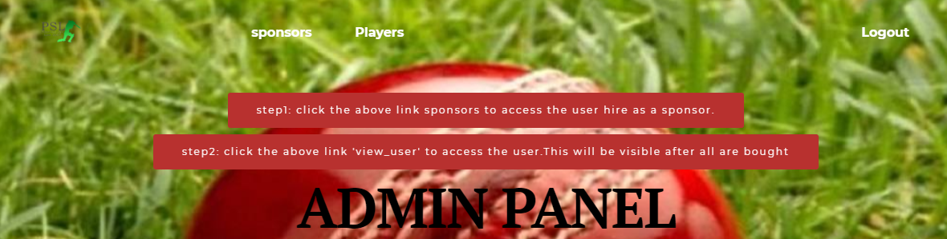

3.

The process goes on when USER wants to become SPONSOR. For that purpose they have to fill a simple interactive form, they just need to provide their

1. Name
2. E-Mail
3. Password
4. Team Name
5. Sponsor’s Qualification

In these textboxes “PLACEHOLDER” is also provided to guide users what they have to fill in these textboxes and also shows the constraint if any mistake occur. This provides the interaction between users and website.



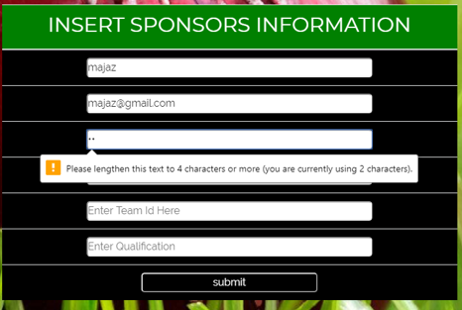



4.

A button “DONE SPONSORS” will be visible when Admin is done with adding 4 Sponsors. This will communicate with admin that at exactly 4 Sponsors are needed to make an event.

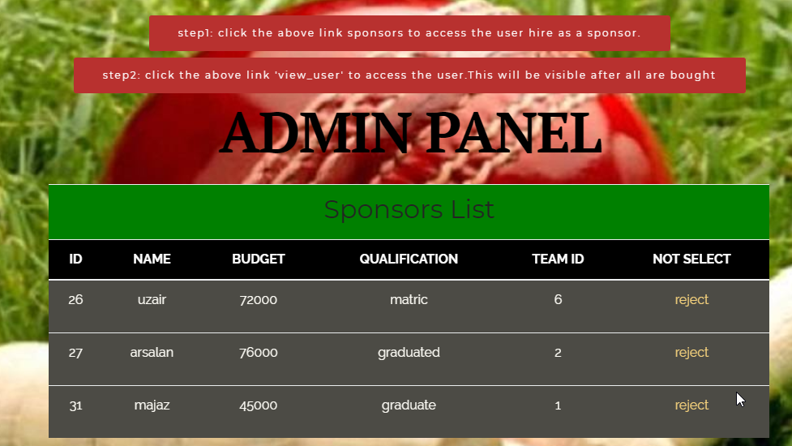

5.

After selecting Sponsors, this page will be automatically directed showing the notification “**Step 1 Completed**”. This notification is made to interact with Admin that he is following the correct procedure.

Also a list of selected sponsors will be visible to admin with “Done Sponsors” button and making sponsors tab invisible in order to avoid any confusion.

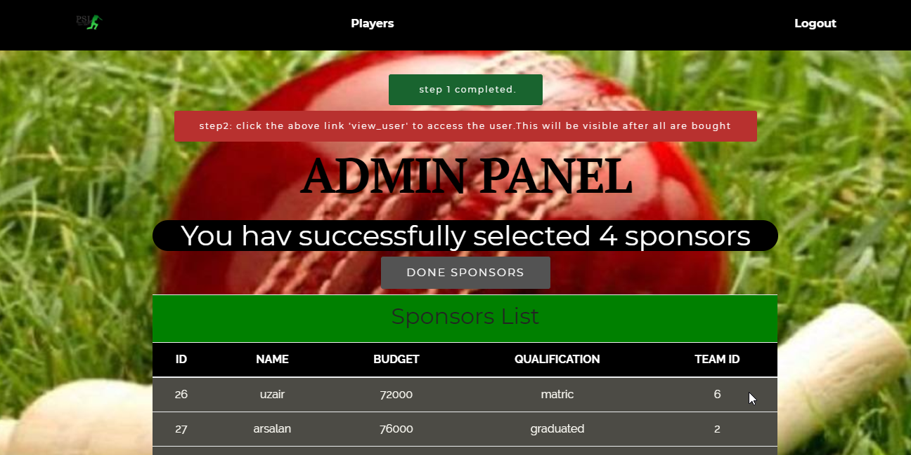

6.

After clicking on DONE SPONSOR, all the users who were selected as sponsors will get notified. Font Size will be increased to get attention of all users. Then all those can be login as a sponsor by clicking on their respective names.



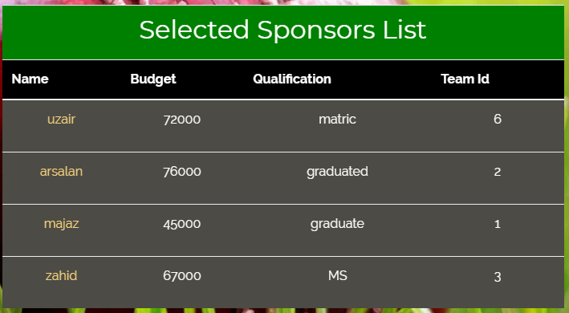

7.

After LOGIN AS SPONSOR, they will now have access to buy players and coaches. Admin can view each and every activity of sponsors and STEP 2 COMPLETED notification won’t appear until or unless they are done with bidding.

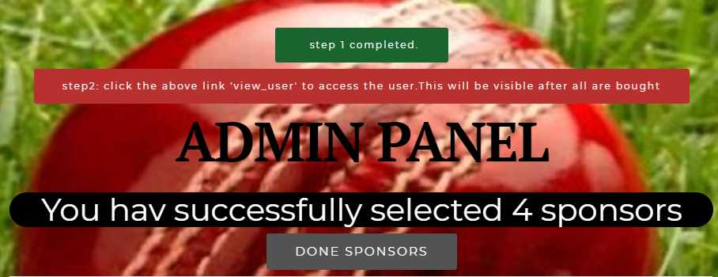

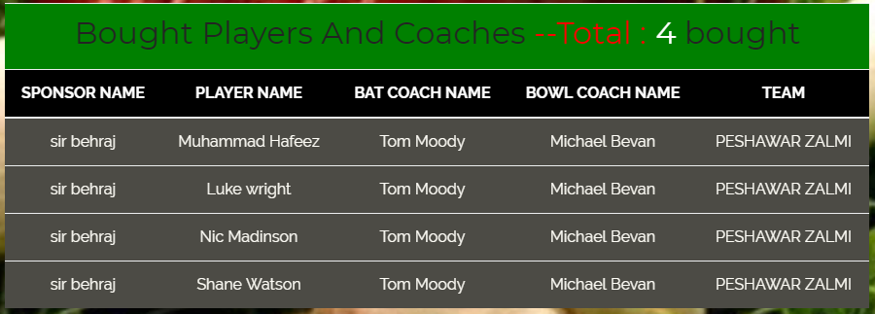

8.

After logging in as sponsor, a list of available players will be visible and that actor will have option to:

1. Buy players
2. Buy Batting Coach
3. Buy bowling Coach

The budget of that sponsor will also be visible on the top to avoid any misunderstanding regarding total budget.

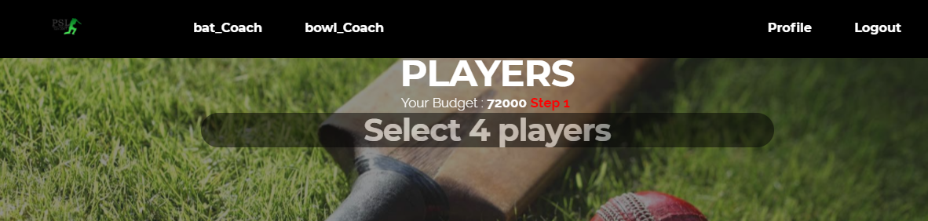

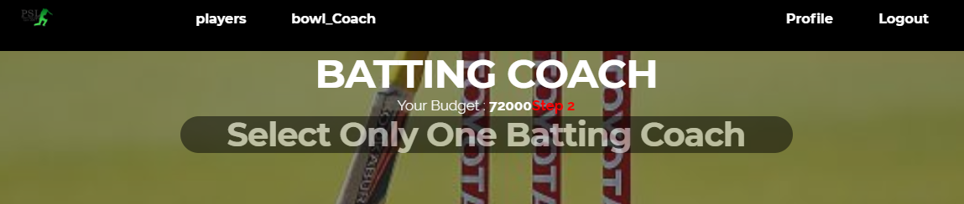

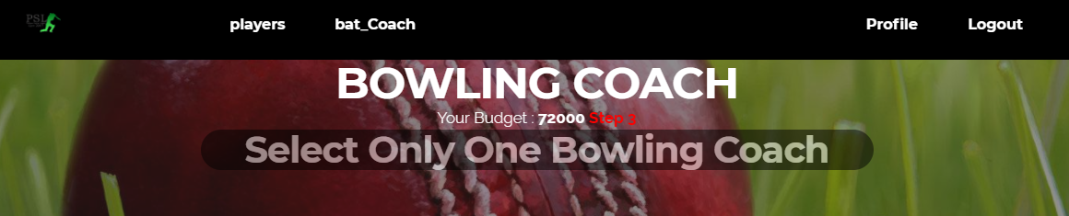

9.

The players can be selected by clicking on select button on that respected player’s row

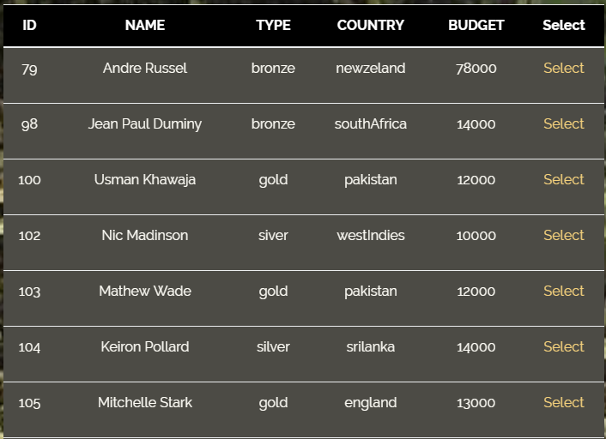

10.

A dialogue box will be shown communicating with sponsor that his requested has been completed.

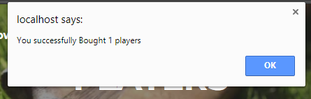

11.

A separate profile page is designed for sponsors so that they can update their budget and profile. This page is only accessible to sponsors once they click on “Profile” Tab.



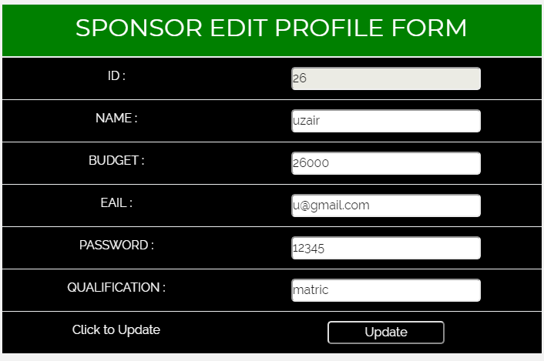

12.

After all sponsors has done, then admin will get updated about this.

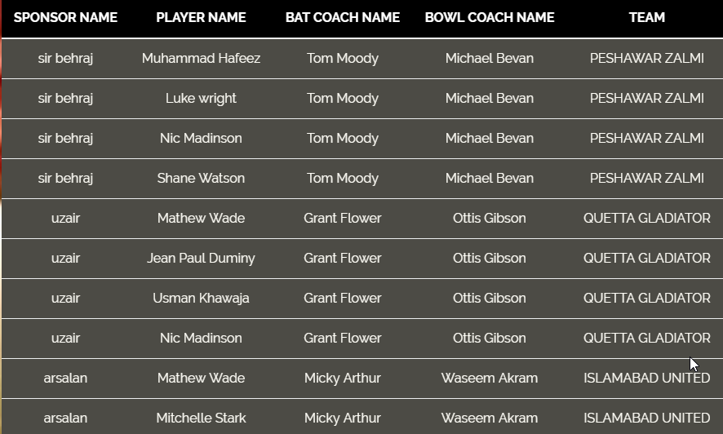

13.

Then “STEP 2 COMPLETED” notification will be shown and “VIEW USERS” link will be visible. By This link all other users can view teams, players, coaches and can search for specific information.



14.

After click on ‘View User’ link. User can go to any page by click on the above link

