PAAF
Polymer Auto-Assembly Framework
Complete User Manual & Methods Guide
PAAF is a desktop application that turns a single polymer monomer into a fully-typed, packed molecular-dynamics (MD) system for LAMMPS or GROMACS. It automates every step between a chemical structure and a ready-to-run simulation: chain building, geometry optimisation, force-field assignment, periodic-box packing, crosslinking reactions, and multi-component blends. This guide explains every page and every option, then documents the scientific methods behind them.
Version | 0.1.0
Launch | python run_paaf.py (from the PAAF folder, conda env active)
Interface | PyQt5 desktop GUI — dark sidebar, page in the centre, log console at the bottom
Pipeline (6 steps) | Builder → Chain → Optimize → Force field → Box → Export
Independent tools | Reactions · System builder · Blend
MD engines | LAMMPS and GROMACS
Force fields | 22 (OPLS-AA, OPLS 2005, PCFF, COMPASS, CVFF, GAFF, CHARMM36, GROMOS 54A7, TraPPE, DREIDING, MARTINI, …)
Polymer library | 124 curated + database polymers with Tg and density

Contents
1 How PAAF Works — the big picture
Part I · User Manual
2 Builder — define your monomer (Step 1)
3 Chain — polymerise into a chain (Step 2)
4 Optimize — relax the chain (Step 3)
5 Force field — parameters & MD engine (Step 4)
6 Box — pack the periodic cell (Step 5)
7 Export — generate topology files (Step 6)
8 Reactions — crosslinking
9 System builder — cells, surfaces, layers
10 Blend — multi-component packing
Part II · Methods & Architecture
A–G Loading · Chain assembly · Optimisation · Typing · Packing · Blends · Stack

1 How PAAF Works — the big picture
You give PAAF a monomer — as a structure file, a SMILES string, or a pick from the library — and it walks through six pipeline steps, each a page in the sidebar, producing a complete MD system at the end. The sidebar's top six entries are the linear pipeline (with Back / Next buttons); the bottom three are independent tools that operate on systems the pipeline produced.
The pipeline, end to end:
- Builder — define the monomer(s). Upload a file, compose a SMILES, or pick from the 124-polymer library. Everything lands in a shared Monomers table used by every later step.
- Chain — polymerise the monomer into N repeat units. Choose homopolymer or copolymer, the sequence, and how many units.
- Optimize — relax the assembled chain's geometry with an OpenBabel force field so bond lengths are physical before typing.
- Force field — choose the MD force field; PAAF assigns atom types. For DL_FIELD force fields you also pick the MD output engine here.
- Box — pack N chains into a periodic cell of a chosen shape, size, or target density.
- Export — write the final LAMMPS or GROMACS topology files.
The three independent tools:
- Reactions — learn crosslink/reaction templates from reactant→product pairs and apply them to a packed system.
- System builder — amorphous cells, crystals, surfaces, nanotubes, solvated boxes, and multilayer stacks.
- Blend — pack two or more different polymers into one box with merged topology.
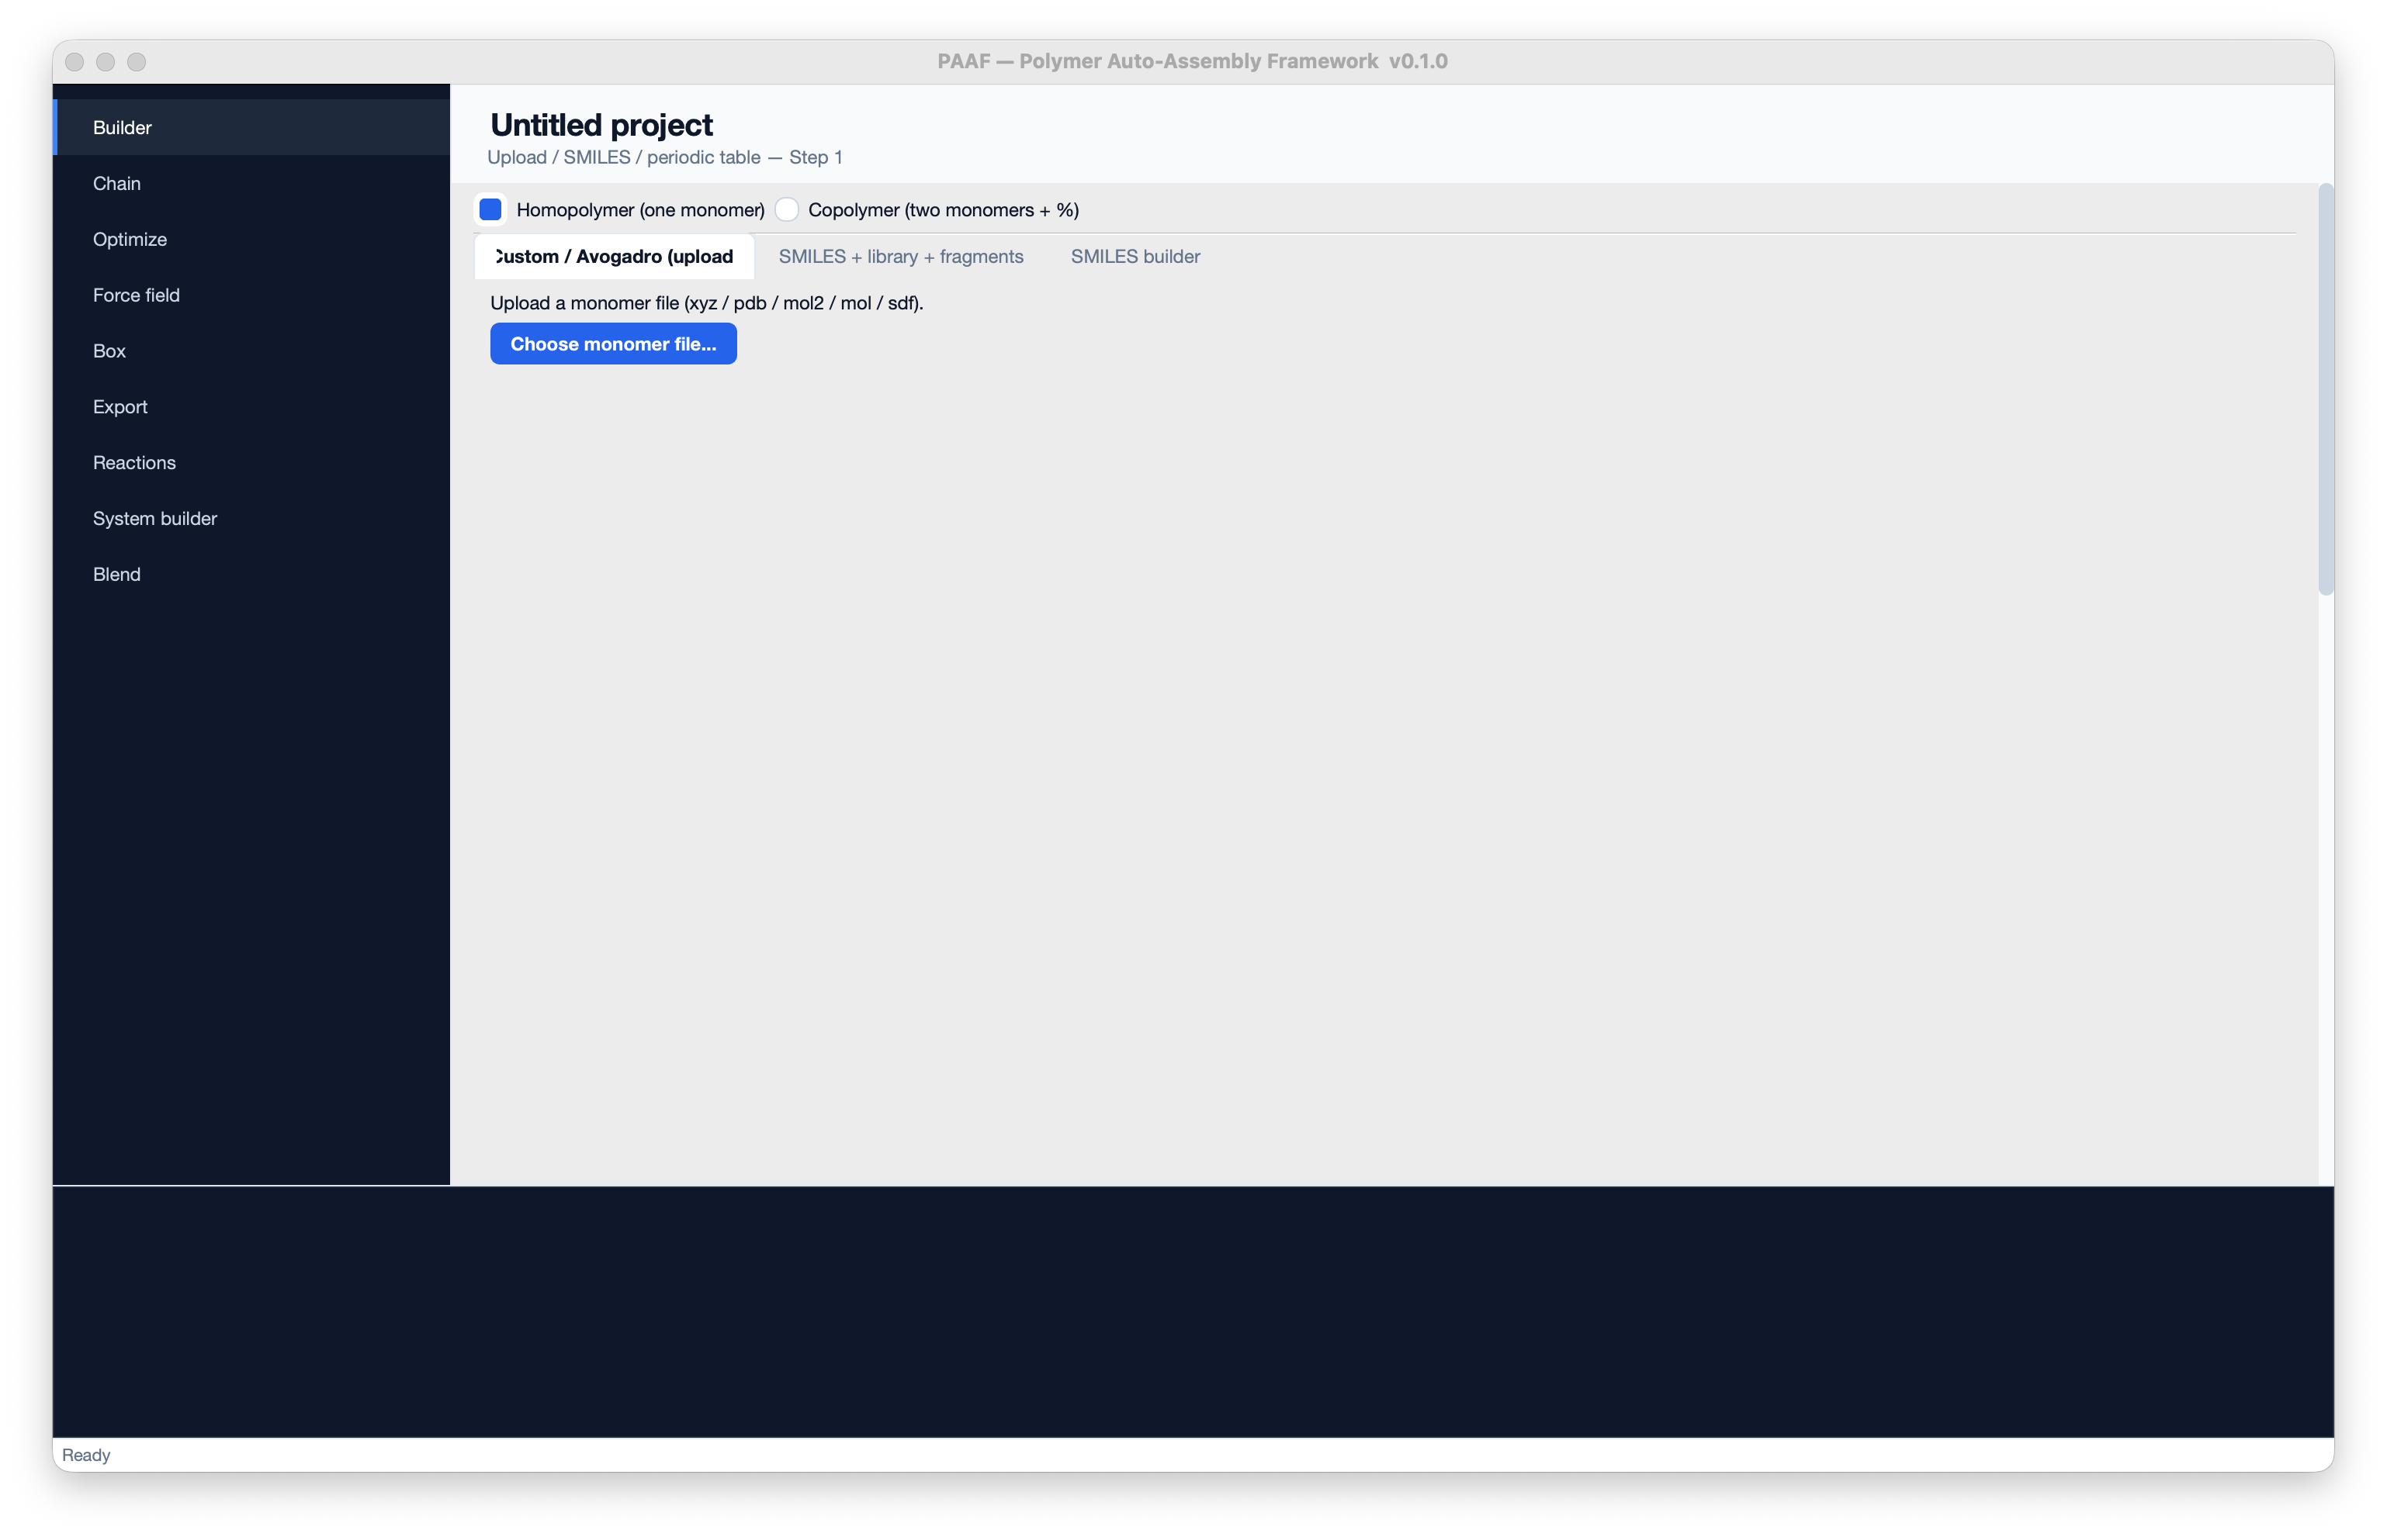
Figure 1 — The PAAF main window: dark sidebar navigation (left), the active page (centre), and the log console (bottom).

Part I · User Manual
Work through the pipeline top to bottom. Each section below explains the purpose of the page, every control on it, and practical tips.

2 Builder — define your monomer (Step 1)
The Builder tells PAAF what your repeat unit is. At the very top you choose Homopolymer (one monomer, repeated) or Copolymer (two monomers combined at a chosen ratio and sequence). Below that are three input tabs, and at the bottom sits the shared Monomers table.

The three input tabs
- Custom / Avogadro (upload) — load a monomer geometry you built in another program (XYZ, PDB, MOL2, MOL, SDF). Tip: cap both ends with hydrogens at the connection points, and export with bonds (MOL2 / PDB-with-CONECT) so PAAF reads connectivity correctly.
- SMILES + library + fragments — search the 124-polymer library (PBS, PET, PE, PS, nylons, natural rubber, …), each row showing Tg, density, and polymerization SMILES. Picking a library polymer records its [*]…[*] SMILES so the Chain step knows exactly which atoms connect.
- SMILES builder — a periodic table plus a SMILES-notation strip (bonds, branches, rings, stereo, brackets, charges, wildcards) for composing a SMILES click by click.

The shared Monomers table
Every monomer you build appears here, and the Chain, Optimize, Force-field, Box and Export pages all read from it. For uploaded files you can double-click the Head / Tail / Head_H / Tail_H columns to specify the exact connection atoms as 1-based indices — this bypasses PAAF's automatic guess and guarantees the polymer bonds where you intend.
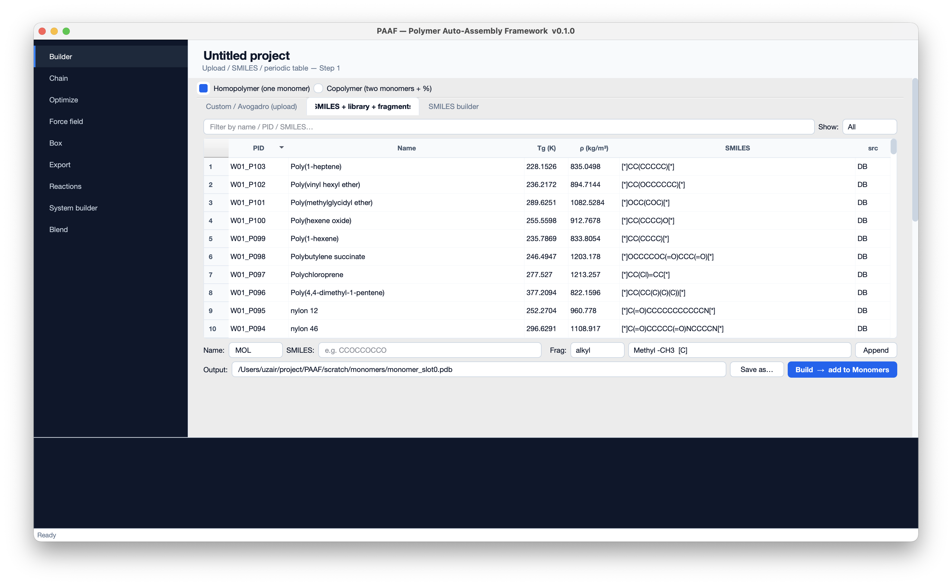
Figure 2 — Builder, SMILES + library tab: the searchable 124-polymer library with Tg, density and polymerization SMILES.
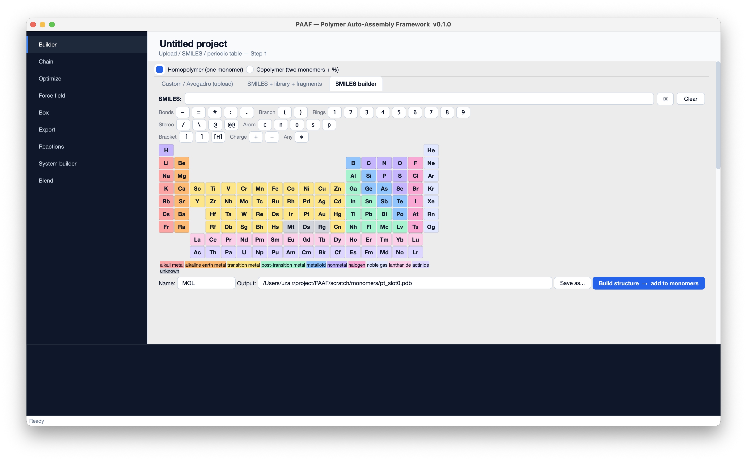
Figure 2b — SMILES builder tab: compose a SMILES from the notation strip and periodic table.

3 Chain — polymerise into a chain (Step 2)
The Chain page assembles the monomer into an N-unit polymer. For a homopolymer it repeats one monomer; for a copolymer it interleaves two according to the sequence mode and composition. The Copolymer helper lets you pick two monomers, set the fraction of B, and it fills the fields above automatically.
Total monomers per chain | Degree of polymerisation N (e.g. 20).
Sequence mode | homopolymer · alternating · block · random. The last three combine two monomers.
Backend | auto (recommended) · mbuild · simple. 'auto' uses the robust mBuild builder when installed.
Fractions (random) | Composition for random copolymers, e.g. 0.7,0.3.
Block sizes (block) | Repeat-unit run lengths for block copolymers, e.g. 5,5.
Random seed | Optional — fixes the random copolymer sequence for reproducibility.
Auto-cap polyester end | For monomers whose tail is a carbonyl carbon (PBS/PET/PLA), the chain end is capped as -C(=O)OH. No effect on polyethylene, polystyrene, etc.
For library monomers that carry a polymerization SMILES, PAAF uses a graph-isomorphism chain builder: it builds a clean 3D compound directly from the SMILES, locates the two connection atoms, and joins repeat units through them — giving straight, correctly-bonded backbones instead of the geometry artefacts a naïve builder can introduce.
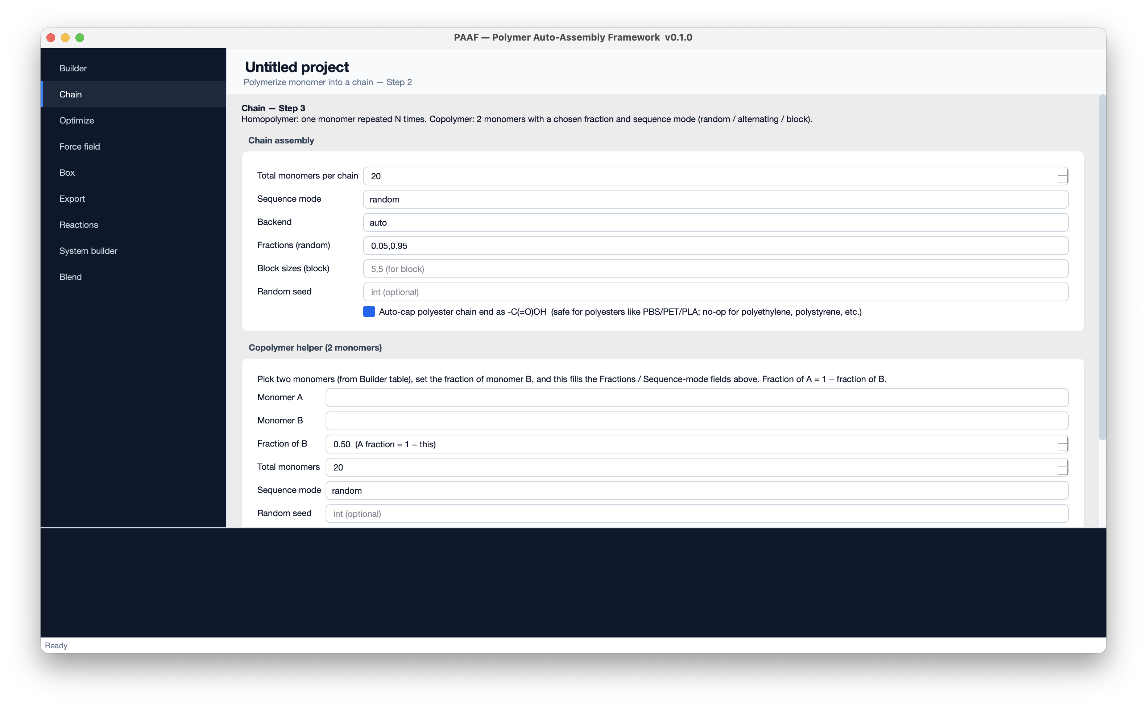
Figure 3 — Chain assembly settings, with the Copolymer helper below.

4 Optimize — relax the chain (Step 3)
Once assembled, the full chain is geometry-minimised with an OpenBabel force field so bond lengths and angles are physically sensible before atom typing. This matters: DL_FIELD and moltemplate perceive bonds by distance, so a stretched or clashing chain could be mis-typed. You can turn optimisation off, but it is recommended for any chain longer than a few units.
Optimize monomers + chain | Master on/off switch for this step.
Force field | MMFF94 · MMFF94s · UFF · Ghemical · GAFF. Falls back MMFF94 → UFF → Ghemical if the chosen FF can't set up.
Max steps | Conjugate-gradient iteration cap (e.g. 10,000). Larger = tighter but slower.
Convergence tol | Energy tolerance in scientific notation, e.g. 1.0e-6.
Algorithm | Conjugate gradients (recommended) or steepest descent.
Log initial + final energy | Prints the energy before/after so you can see how much the geometry relaxed.
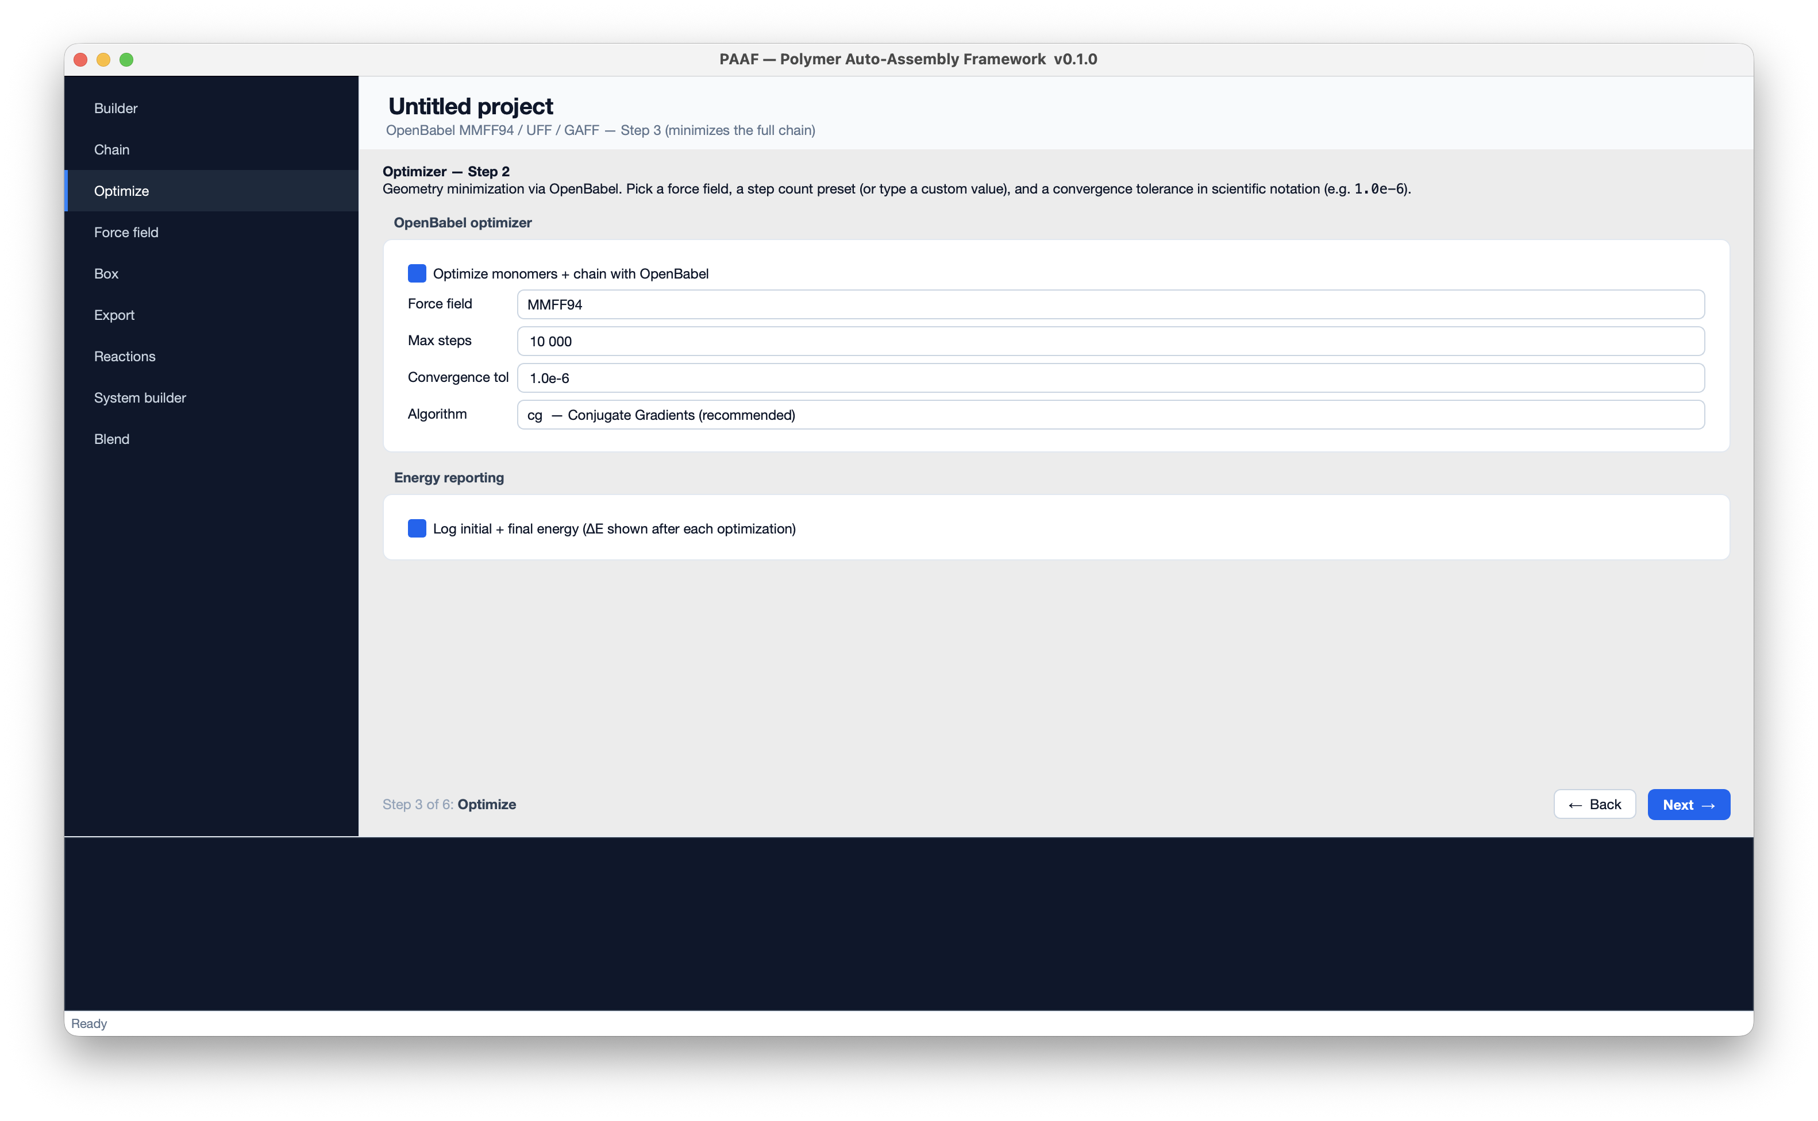
Figure 4 — OpenBabel optimisation controls.

5 Force field — parameters & MD engine (Step 4)
Here you pick the force field that parameterises the system. PAAF ships 22, in two families that differ in how atoms are typed and files are written:
- Moltemplate-native (OPLS-AA 2024/2008, L-OPLS-AA, TraPPE-UA, OPLS-UA, GAFF/GAFF2, DREIDING, COMPASS-published, SDK, MARTINI, Dry-MARTINI) — written as .lt files and compiled by moltemplate.sh into LAMMPS data/settings.
- DL_FIELD-based (OPLS 2005, PCFF, COMPASS, CVFF, CHARMM36, GROMOS 54A7, AMBER GAFF, TraPPE-EH, OPLS-UA) — typed by the dl_field program, which auto-assigns atom types and can emit LAMMPS or GROMACS directly.
The default is OPLS 2005 (DL_FIELD). When a DL_FIELD force field is selected, three things appear: an MD output format chooser (lammps / gromacs / both) written straight into the control file; a DL_FIELD lib dir field pointing to your dl_f_4.13/lib directory (remembered once set); and an editable polymer.control preview you can tweak before generation.
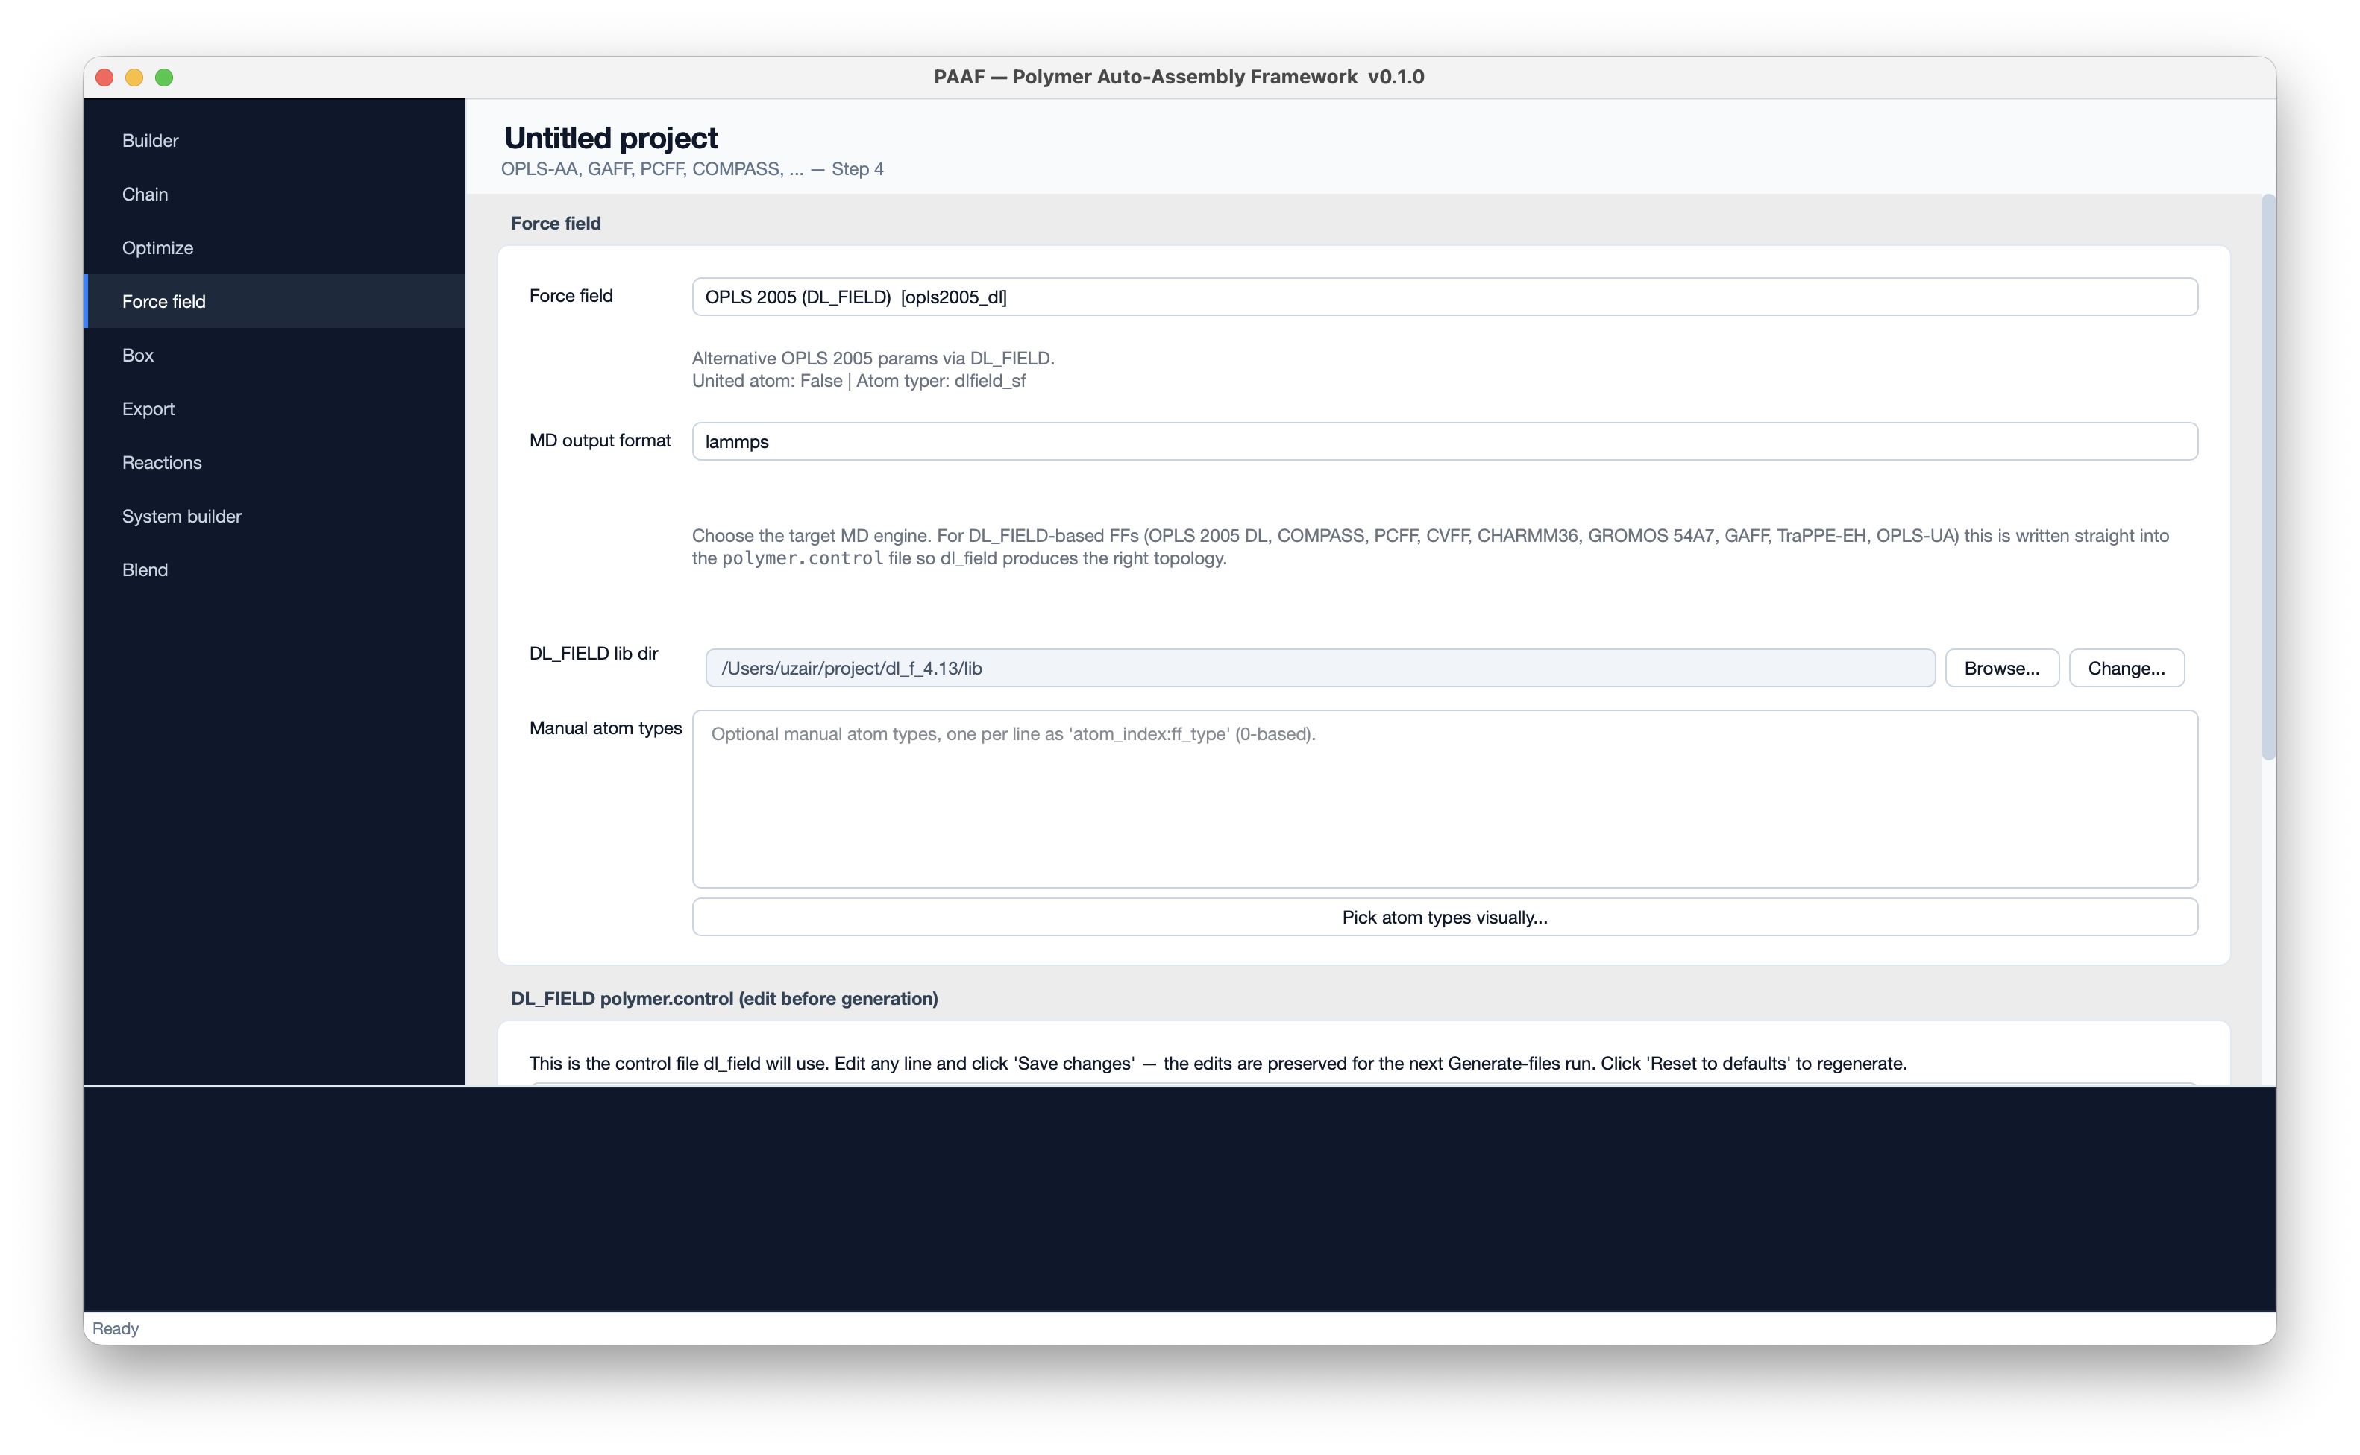
Figure 5 — Force-field page with OPLS 2005 (DL_FIELD) selected, the MD-output-format chooser, and the DL_FIELD library path.
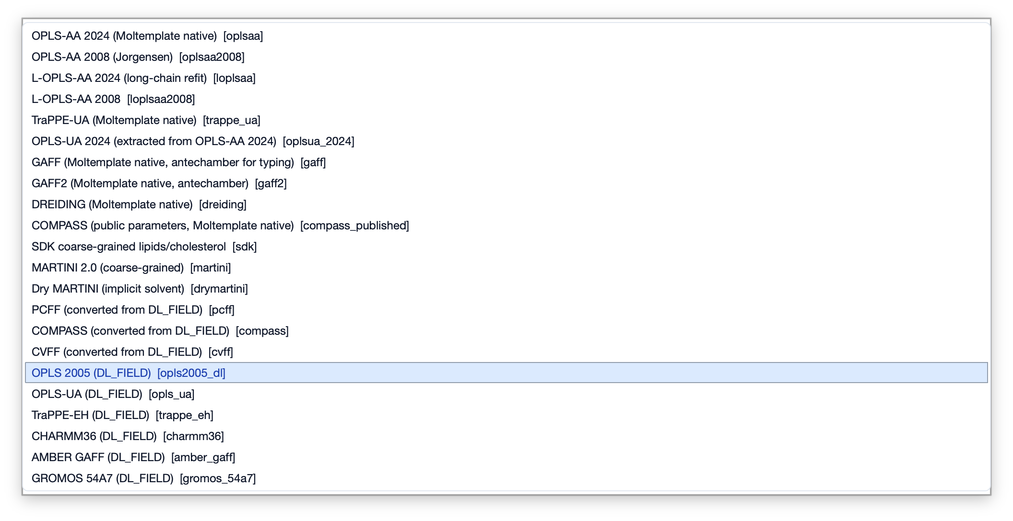
Figure 5b — The 22 built-in force fields, spanning Moltemplate-native and DL_FIELD families.

Manual atom typing (optional)
For fine control, Pick atom types visually… opens a manual atom-typing dialog. The left panel lists every atom with its detected chemical group and neighbours; the right panel is the searchable force-field atom-type library (id, element, key, partial charge, description). Click an atom, click a type, and assign — or press Auto-type all to seed from the SMARTS typer and fine-tune. Assignments can be saved and reloaded as profiles.
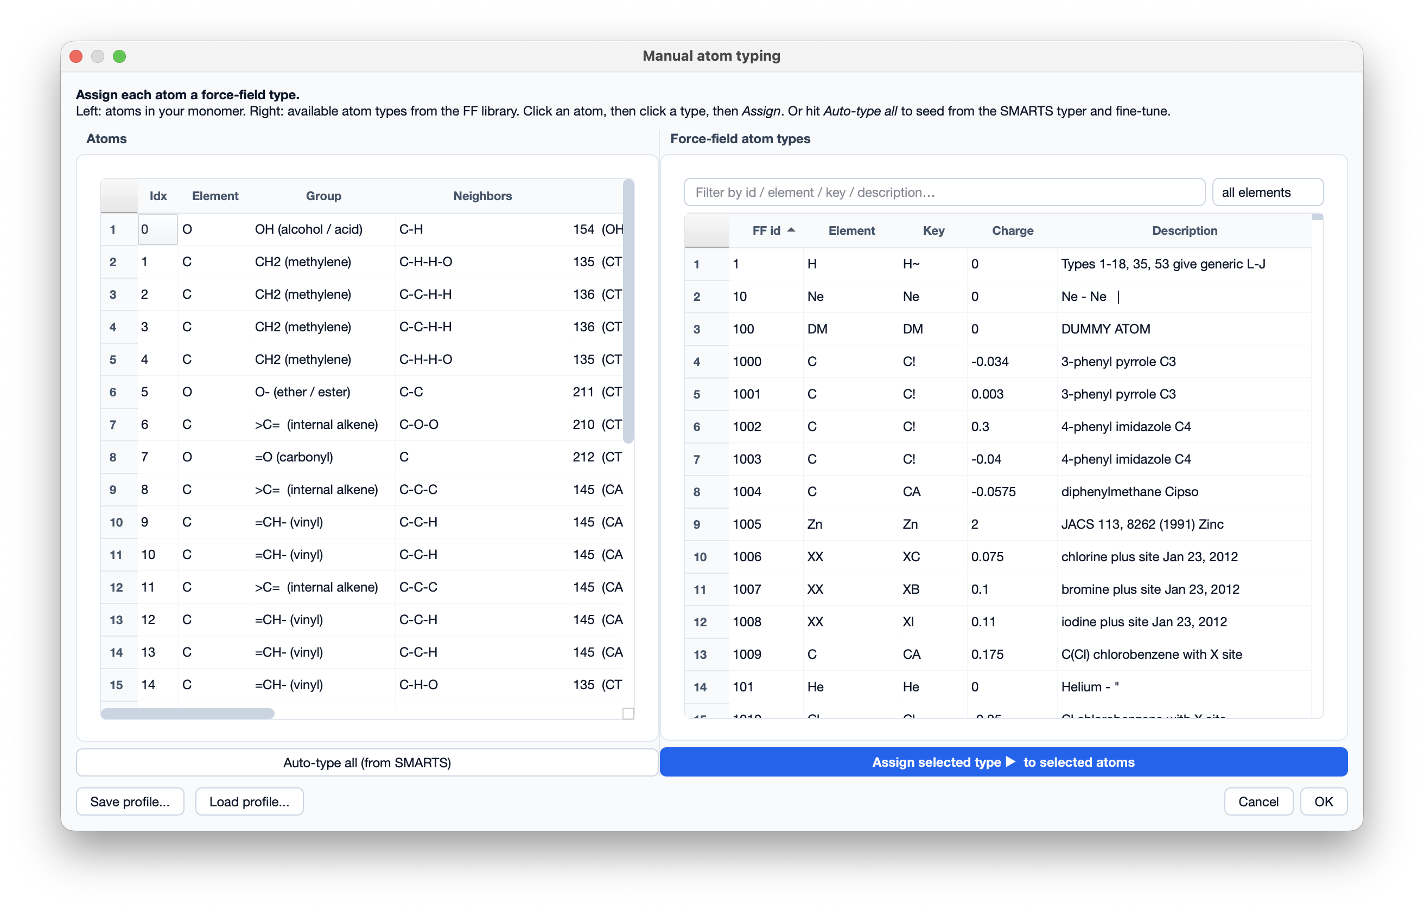
Figure 5c — Manual atom-typing dialog: per-atom force-field type assignment against a searchable type library.

6 Box — pack the periodic cell (Step 5)
The Box page packs multiple chains into a periodic simulation cell. You set how many chains, the cell shape and size (or a target density that derives the edge lengths), and the packing engine. For LAMMPS, packing uses packmol; for GROMACS it uses gmx insert-molecules.
Number of chains | How many chain copies to pack into the box.
Box shape | cubic · orthorhombic · triclinic. Cubic mirrors edge a into b and c.
Cell edge lengths | a, b, c in Ångström.
Target density | Optionally derive edge lengths from a density in g/cm³, preserving the shape's aspect ratio.
Packmol binary | Path to packmol (auto-detected; editable).
Packmol seed | -1 = fresh random layout every run; any positive integer fixes the layout for exact reproducibility.
Packmol tolerance | Minimum inter-molecule atom distance in Å (2.0 is safe; 1.5 packs tighter).
GROMACS packing | When the engine is GROMACS: choose Explicit chain count or Target atom count (inserts atom_limit ÷ atoms-per-chain copies), with optional pre-minimisation and a try-count. Falls back to a pure-Python packer if gmx is not installed.
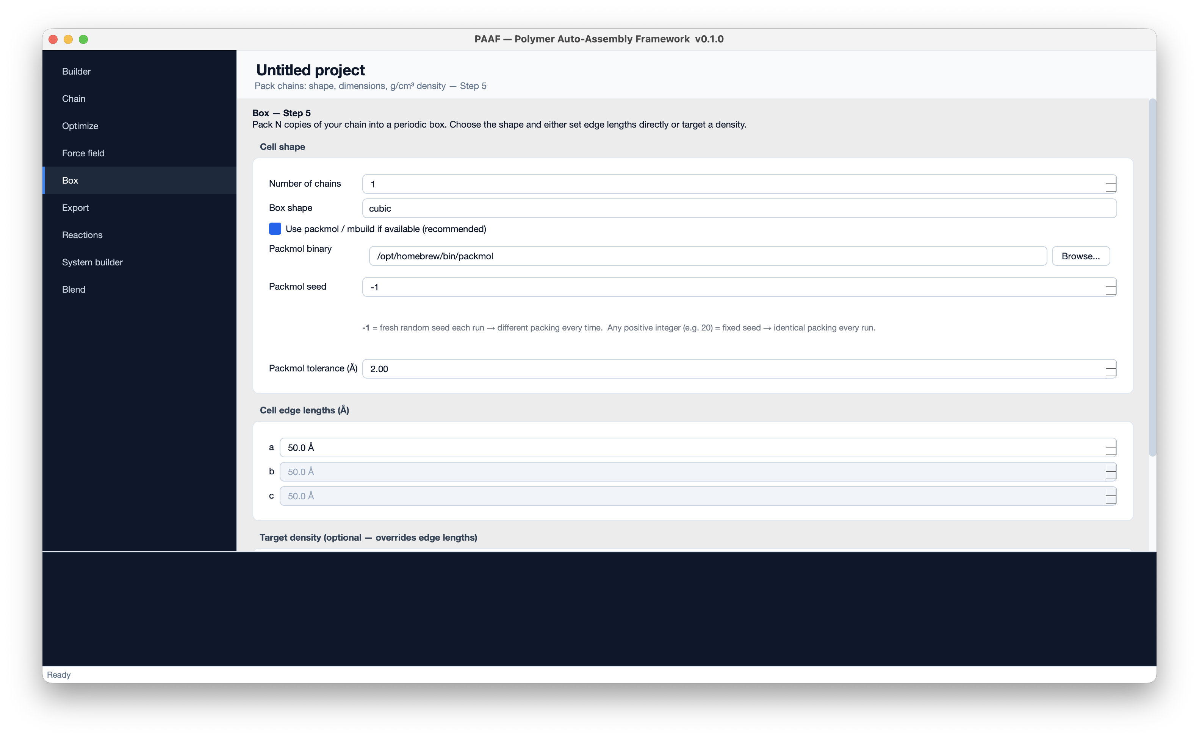
Figure 6 — Box page: cell shape, packmol / gmx options, dimensions, and density.

7 Export — generate topology files (Step 6)
The final step writes the MD files. Set the project name and output directory, confirm the MD engine output (lammps / gromacs / both) and the topology builder (auto / moltemplate.sh / dl_field), optionally give a GROMACS #include .itp path, then click Generate files. MD execution is off by default — PAAF writes topology, not trajectories.
What gets produced:
- Moltemplate-native force fields → <project>.lt, system.lt, system.data, system.in.settings, system.in.init via moltemplate.sh.
- DL_FIELD force fields → LAMMPS lammps.data + lammps.in, or GROMACS system.gro + system.top + *.mdp, via dl_field.
- Multi-chain packed boxes → packed_box.data (LAMMPS) or packed_box.gro (GROMACS).
PAAF deliberately writes no ensemble / thermostat / damping settings — set those in your own LAMMPS input or MDP when you run the simulation. You can also Save / Load the entire configuration so a run is exactly reproducible.
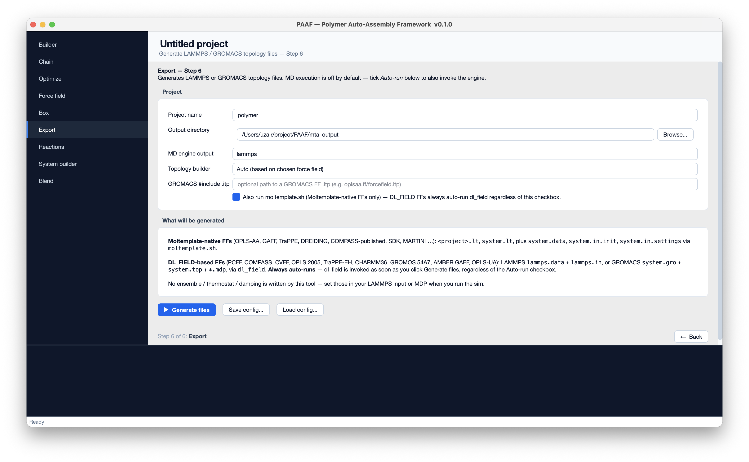
Figure 7 — Export page and the generated-file summary.

8 Reactions — crosslinking (independent tool)
The Reactions tool learns reaction templates from example structures. Add one row per reaction and upload its reactant and product structures; PAAF compares them by graph mapping to derive which bonds form or break, and stores the result as a reusable reaction library (JSON). Optionally it applies the learned templates to a packed system to build a crosslinked network — useful for thermosets, epoxies and vulcanised rubbers. A reactive-pair cutoff and a maximum-events cap control how aggressively crosslinks form.
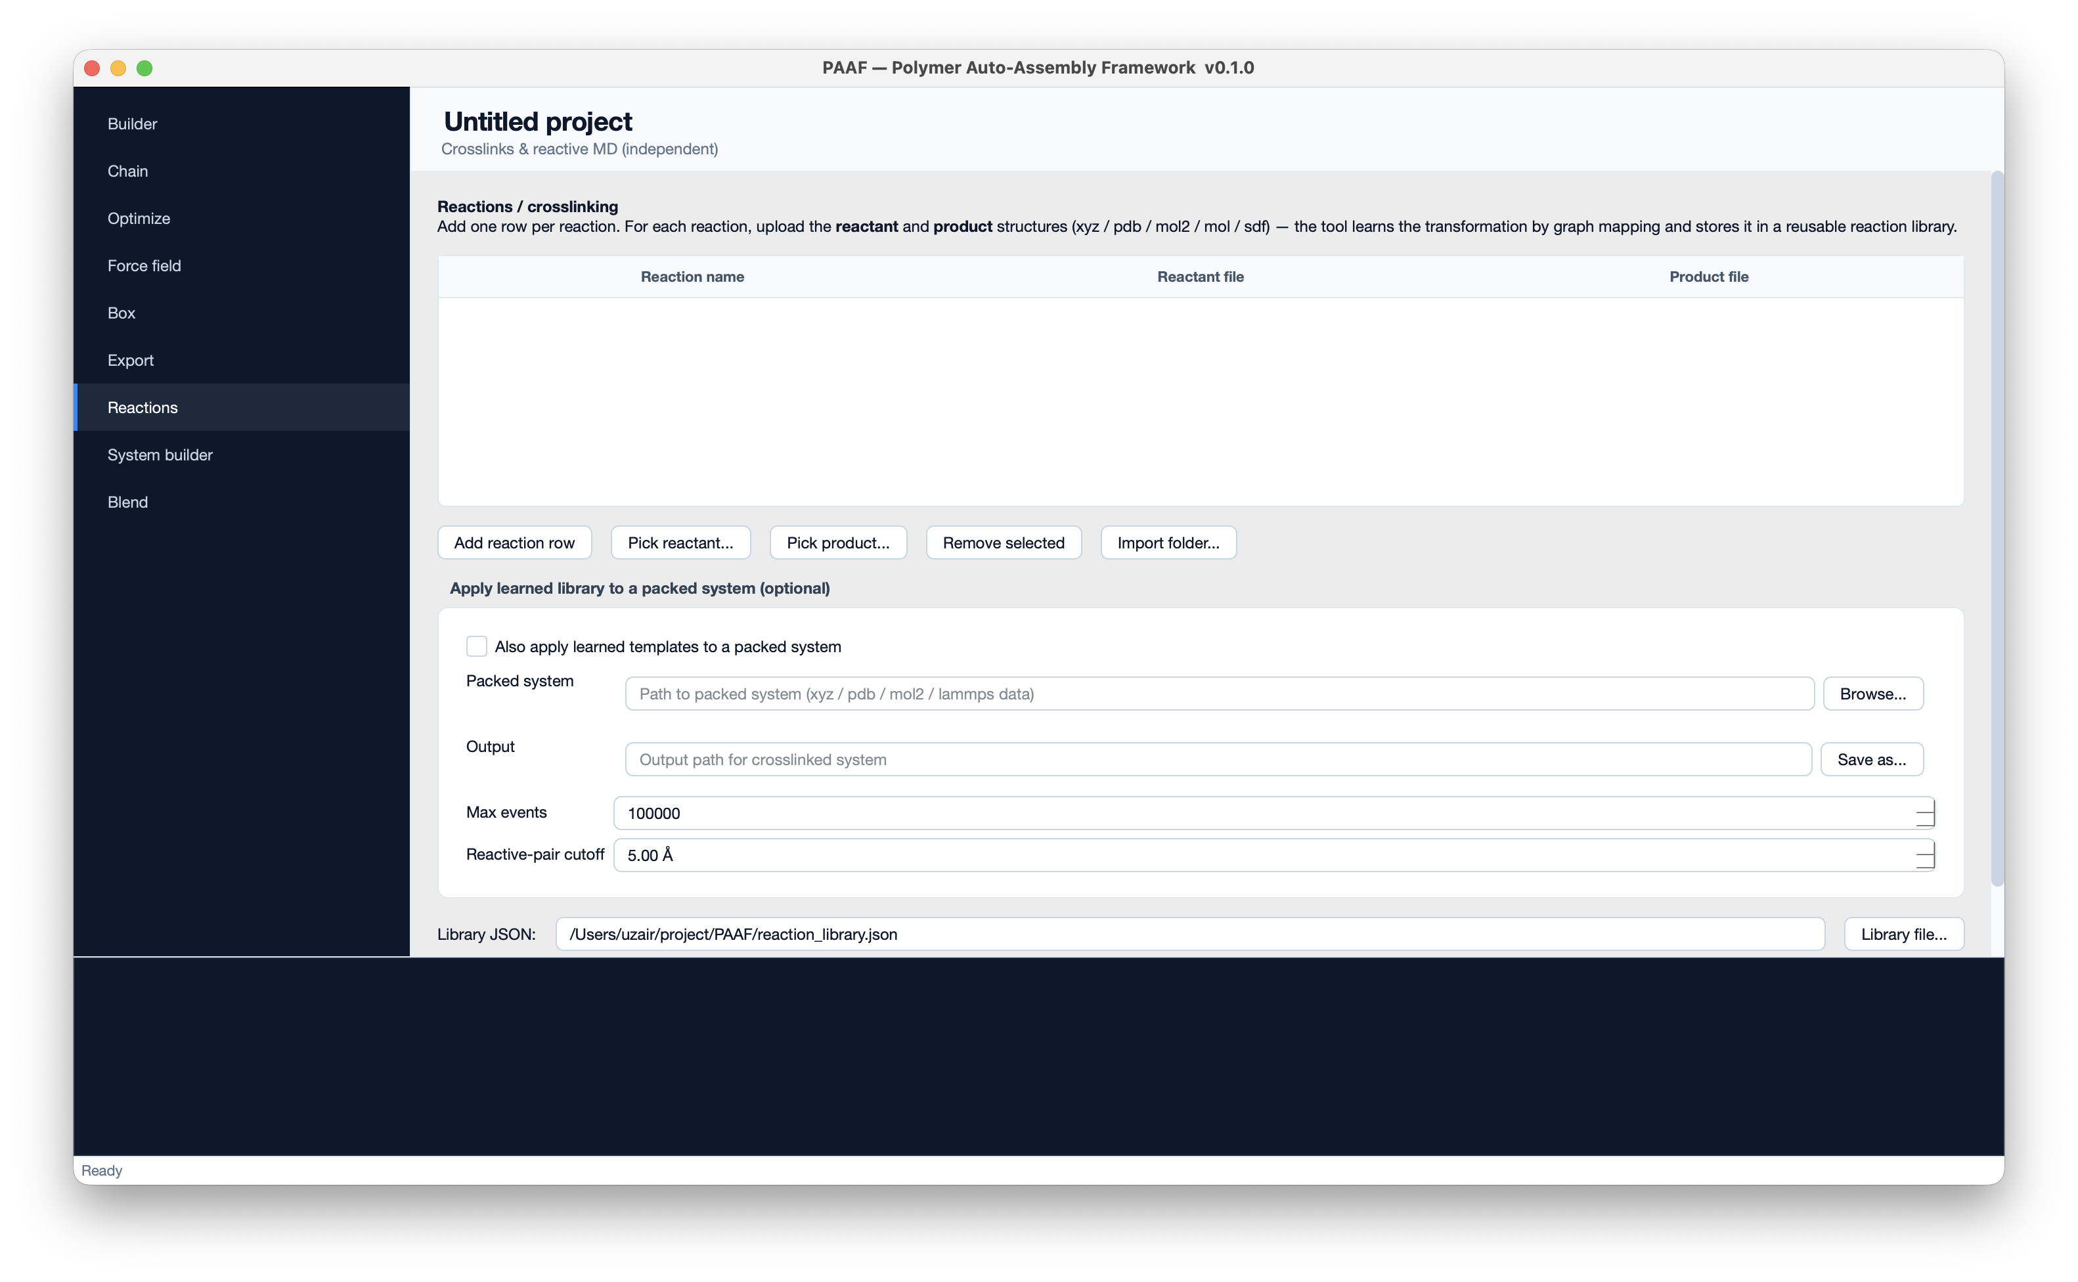
Figure 8 — Reactions / crosslinking tool.

9 System builder — cells, surfaces, layers (independent tool)
A Materials-Studio-style construction toolkit for starting configurations beyond a single packed polymer box. Pick a mode, add the species / parameters, and Build:
- Amorphous cell — pack one or more species to a target density.
- Crystal — build a super-cell from a unit cell / lattice.
- Surface — cleave a crystal along a Miller plane.
- Nanotube — build carbon (or other) nanotubes.
- Solvate — surround a solute with solvent molecules.
- Layers — stack multiple slabs into a multilayer / trilayer system.
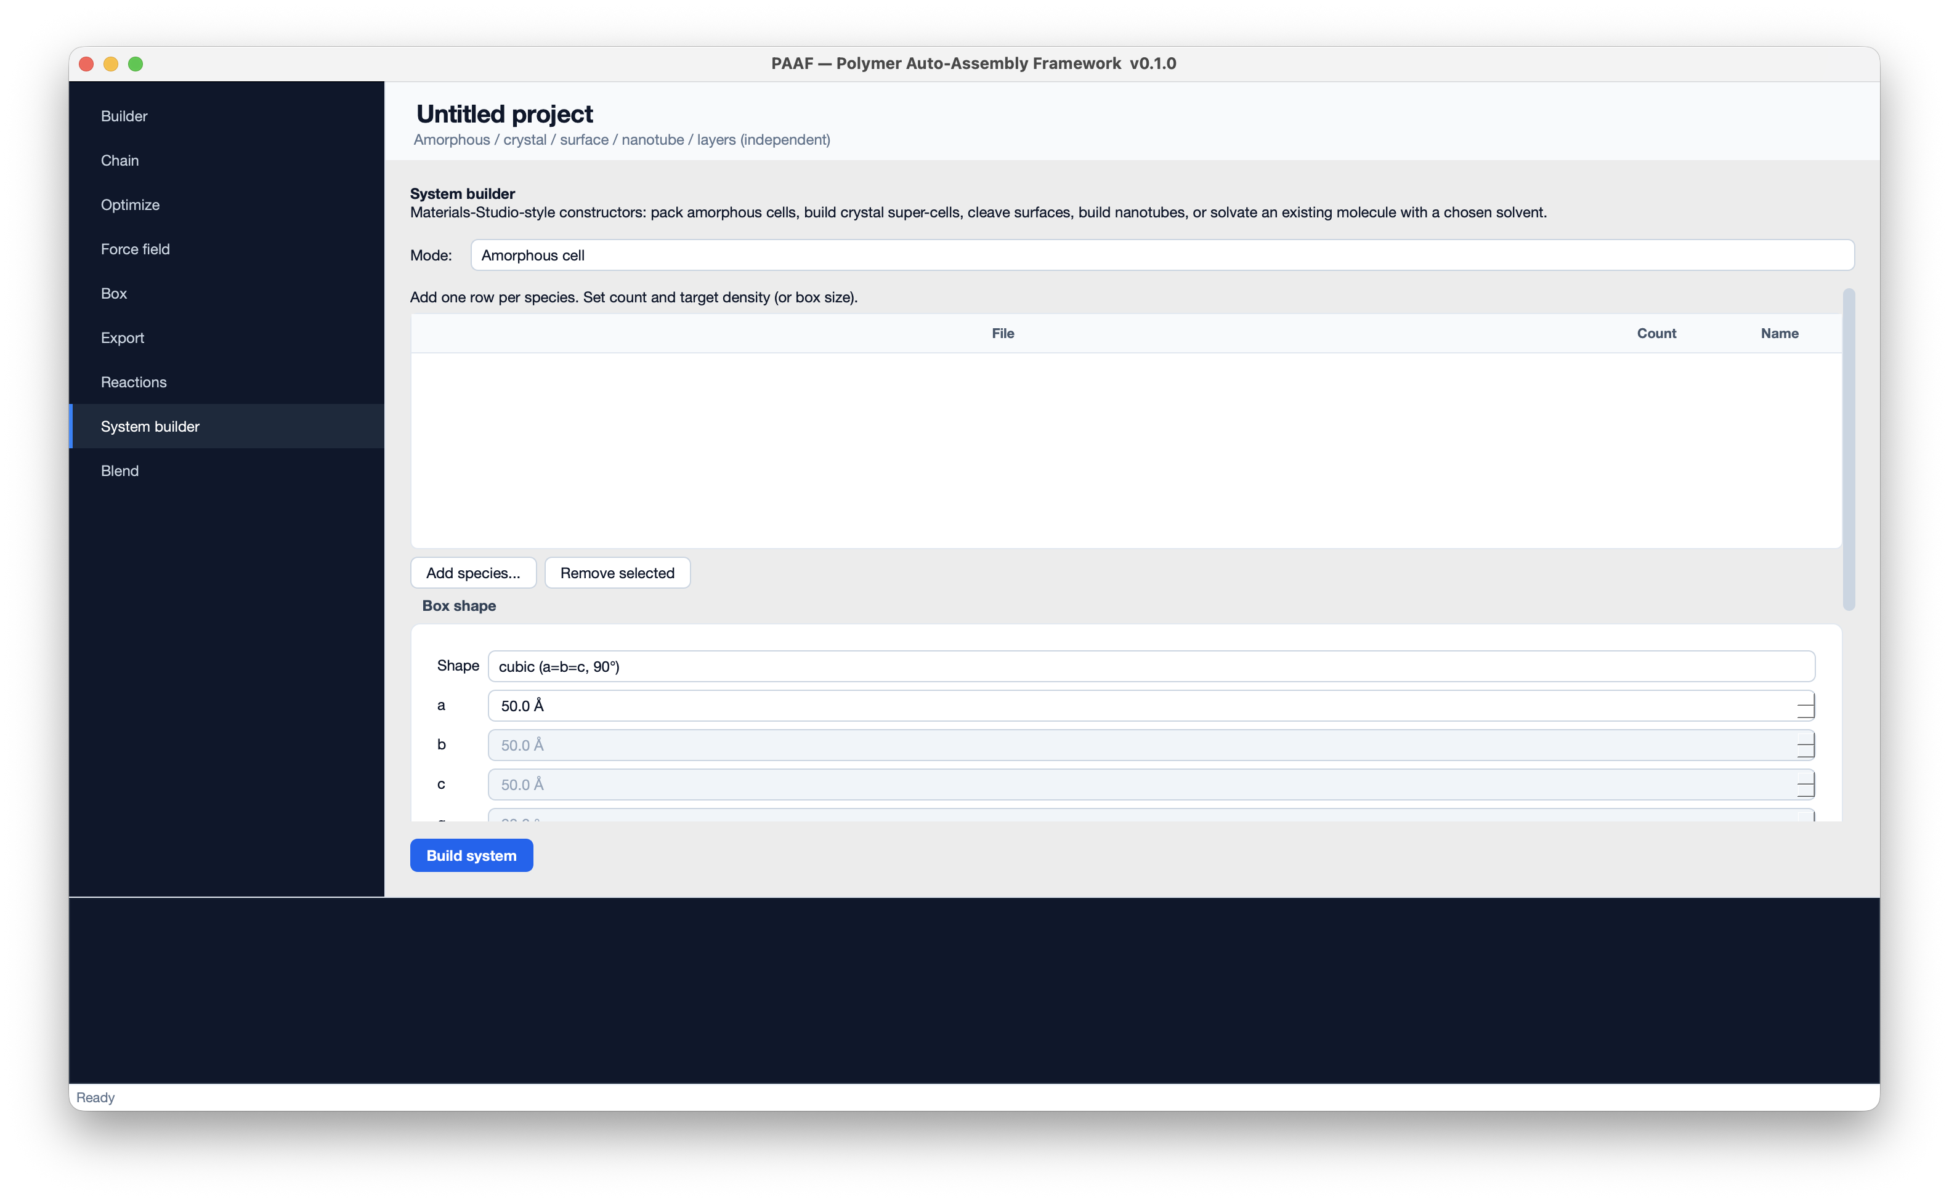
Figure 9 — System builder, Amorphous-cell mode.

10 Blend — multi-component packing (independent tool)
The Blend tool packs two or more different polymers into one box. Each component is a pre-built single-chain LAMMPS data file (typically the dlf_output1/lammps1.data a previous PAAF run produced) plus a copy count. PAAF offsets every atom / bond / angle / dihedral / improper type ID per component so they never collide, merges all the coefficient sections, packs every copy of every species with packmol, and writes a single consolidated packed_blend.data plus a matching packed_blend.in with offset pair_coeff commands. The Import from PAAF run… button auto-populates components from an existing output directory.
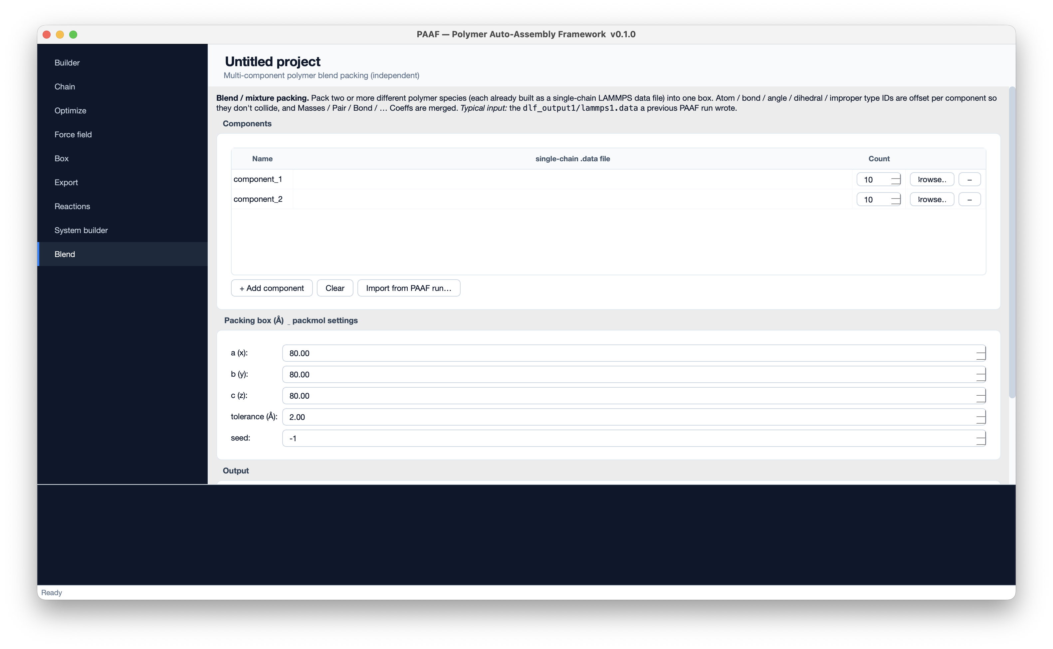
Figure 10 — Blend / mixture packing: components and packmol settings.

Part II · Methods & Architecture
This appendix documents the scientific methods and software behind each stage, for readers who need to cite or reproduce PAAF's workflow — for example a thesis appendix or a publication supplement.

A. Monomer loading & connection-point detection
Structures are parsed with OpenBabel into an internal container (atoms + bonds). For library polymers the polymerization SMILES with [*] wildcards is preserved in a sidecar file; PAAF reads the wildcard neighbours to identify the head and tail connection atoms by element, avoiding fragile geometry-based guessing. Uploaded files without wildcards use an antiparallel-vector heuristic, or the head/tail indices you enter in the Monomers table.

B. Chain assembly (mBuild + graph isomorphism)
The preferred builder constructs a clean 3D compound directly from SMILES via mbuild.load(smiles=True), then uses RDKit + NetworkX graph isomorphism to map the wildcard connection atoms onto the compound. It selects the head/tail hydrogen pair whose bond vectors are most antiparallel (straightest chain) and assembles N units with mbuild's Polymer recipe. Polyester ends are capped as carboxylic acids. Building from SMILES avoids a PDB round-trip that can stretch backbone bonds and break downstream atom typing.

C. Geometry optimisation (OpenBabel)
Both the monomer and the assembled chain are minimised with an OpenBabel force field (default MMFF94, conjugate gradients), with an automatic MMFF94 → UFF → Ghemical fallback so exotic monomers still relax.

D. Force-field assignment & topology
Two typing routes are supported. Moltemplate-native force fields are written as .lt files and compiled by moltemplate.sh into LAMMPS data/settings. DL_FIELD force fields are typed by the dl_field program using DL_F Notation, which auto-assigns atom types against its library and emits LAMMPS or GROMACS topology directly. For OPLS-AA specifically, PAAF's SMARTS-based typer emits valid numeric OPLS atom-type IDs; a manual typing dialog is available for overrides.

E. Box packing
For LAMMPS, PAAF replicates the single-chain data file into an N-chain system using packmol (with a random seed for varied layouts) and non-hybrid type-ID offsetting; a numpy grid packer is the fallback if packmol is unavailable. For GROMACS, PAAF uses gmx insert-molecules — optionally pre-minimising the single chain, then inserting either an explicit count or a target-atom-derived count of copies, and updating the topology's molecule count. A pure-Python random-rotation packer is the fallback when gmx is not installed.

F. Blends
Multi-component systems merge several single-chain data files with per-component cumulative type-ID offsets across atom, bond, angle, dihedral and improper types; all coefficient sections are concatenated with the same offsets; and packmol packs every copy of every species into a shared box. A merged LAMMPS input file carries the offset pair_coeff commands.

G. Software stack & reproducibility
Every GUI run serialises to the same Config object the headless pipeline uses, so a GUI-built system and a scripted one are identical; random seeds (copolymer sequence, packmol layout) are configurable for exact reproduction.
GUI | PyQt5
Chemistry | OpenBabel · RDKit
Chain assembly | mBuild · NetworkX
Typing / topology | moltemplate.sh · DL_FIELD 4.13
Packing | packmol · GROMACS (gmx insert-molecules)
MD engines | LAMMPS · GROMACS

