

Lab 05

Logic Diagram



November 14, 2019

Farah Al-Falahi

Contents

List of Figure 1

Requirement 02 2

Requirement 03 3

# List of Figure

Figure 1: Hierarchy Chart 1

Figure 2: Flowchart 2

# Requirement 02

`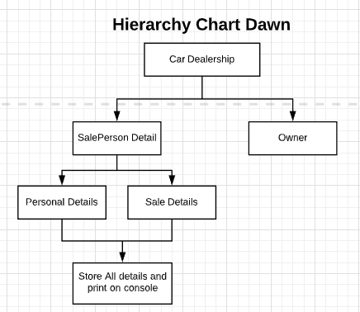

Figure 1: Hierarchy Chart

# Requirement 03

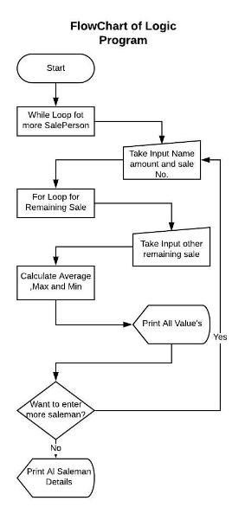

Figure 2: Flowchart