**Student Name: Student Id:20181332812**

**Lab Instructions:**Please show your work to the instructor present in the lab before submitting.

**Submission Due**: End of laboratory class, submit the file on Moodle at least 10 minutes before the end of laboratory class.

**Total Marks** = 10 marks

Marks will be given only to students who attend and participate during 2-hour laboratory class. Submission on Moodle is mandatory as an evidence of participation.

**Learning Outcomes:**

|  |  |
| --- | --- |
| LO4 | Plan and Analyze Big Data |

**Marking Criteria:**

|  |  |  |
| --- | --- | --- |
| **Task Details** | **Submission Requirements** | **Marks** |
| **Task 1:** Write code to perform the following tasks. Use Python programming language and NumPy library to solve them. | Same **Word file** containing the transcript of the answer.  Also submit **Source Code/Script** files along with. | 6 |
| **Task 2:** Implement a function “**int sqrt(int x)**” in Python to compute and return the square root of x. | Same **Word file** containing the transcript of the answer.  Also submit **Source Code/Script** file along with. | 4 |

**Lab 3 – Using NumPy Library to work with Matrix/Array Data & Functions in Python**

**Lab Task 1:** Write code to perform the following tasks. Use Python programming language and NumPy library to solve them. Provide code and output screenshot for each of the task in appropriate sections under them.

## **Task 0**

* import numpy

**Code:**

#Task 0

import numpy as np

**Output:**

## **Task 1**

* print version of numpy

​ **Code:**



**Output:**



## **Task 2**

* create 1d vector of zeros of size 10

**Code:**

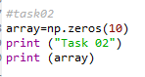

**Output:**



​

## **Task 3**

* create 1d vector filled with ones of size 10

**Code:**

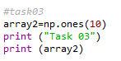

**Output:**



## **Task 4**

* create 1d vector filled with ones of size 10,

**Code:**

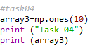

**Output:**



## **Task 5**

* Create 1d vector filled with numbers from 10 to 49

**Code:**

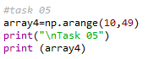

**Output:**

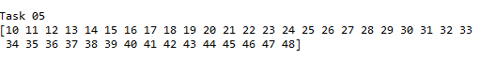

​

## **Task 6**

* create any 1d vector, then reverse it, such that last element will be on the first position

**Hint:** use np.flipud() function.

**Code:**

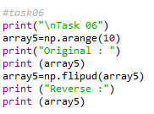

**Output:**

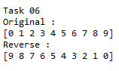

​

## **Task 7**

* create 2d 3x3 array / matrix, filled with numbers from 0 to 8

**Hint:** use np.arange and np.reshape() functions to perform this task.

**Code:**

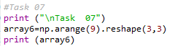

**Output:**

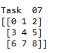

​

## **Task 8**

* create 3x3 matrix filled with ones

**Hint:** use np.mat() to cast/convert your array to matrix.

**Code:**

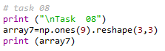

**Output:**

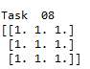

​

## **Task 9**

* create 3x3 matrix filled with random numbers

**Code:**

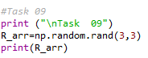

**Output:**

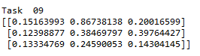

## **Task 10**

* create 3x3x3 array filled with random numbers

**Code:**

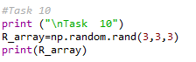

**Output:**

​ 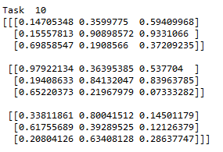

## **Task 11**

* create 10x10 matrix filled with random numbers and find minimal and maximal elements

**Hint:** use np.min() and np.max() to find minimum and maximum numbers in your matrix.

**Code:**

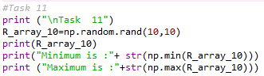

**Output:**

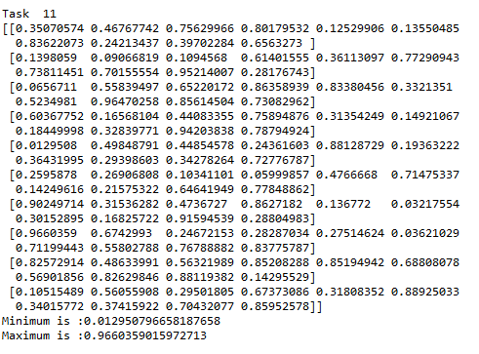

​

## **Task 12**

* create a random 1d vector of size 30 and find average of them

**Hint:** Use np.mean() to find average of your array

**Code:**

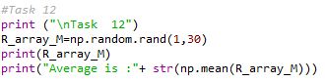

**Output:**

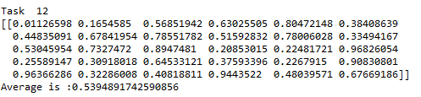

​

## **Task 13**

* create 5x5 matrix, which has ones on a "frame" and zeros inside

**Hint:** Use row & column slicing to perform this task.

**Code:**

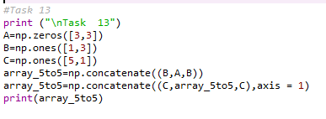

**Output:**

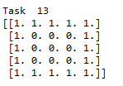

**Lab Task 2:**

# Implement a function “**int sqrt(int x)**” in Python to compute and return the square root of x, where x is guaranteed to be a non-negative integer.

Since the return type is an integer, the decimal digits are truncated and only the integer part of the result is returned.

## **Example 1:**

* Input: 4
* Output: 2

## **Example 2:**

* Input: 8
* Output: 2
* Explanation: The square root of 8 is 2.82842..., and since the decimal part is truncated, 2 is returned.

**Hints:**

1. In order to **cast** any value to integer you can use “**int()**” command. For example, x=2.12 is a **float**, so if you want to convert it to **int** you can use **x = int(x)**.
2. If you want to take input from user you can use [**input()**](https://www.geeksforgeeks.org/taking-input-in-python/)function.
3. Remember, square root of any value in math means its exponent is “1/2” like x1/2, where x is any number.

**Code:**

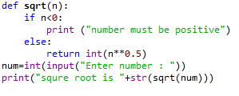

**Output:**







**Submission Instructions:**

1. Submit your answers in this word file by renaming it in the format **“BI&BD_SEN4210_Lab{#}_29_03_2020_Student ID”** and uploading on **Moodle** in the appropriate submission link.
2. Along with this word file, submit source/script (.py) files for all the python scripts of lab tasks.

**Please conform to the naming convention of the file.**

**References:**

**[1]** Open Machine Learning Course. Web Access:<https://mlcourse.ai/>

**END OF LABORATORY**