# Problem

## A)

### Code

#a.

def any_lowercase1(s):

for c in s:

if c.islower():

return True

else:

return False

### Explanation

It works fine and give true answer in only case if our first character is lower. If we pass name which is combination of lower and upper then it checks only one character and give result.

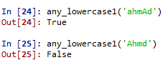

## B)

### Code

#b.

def any_lowercase2(s):

for c in s:

if 'c'.islower():

return 'True'

else:

return 'False'

### Explanation

It gives always true because we check the ‘c‘ itself every time and ‘c’ is pass as lower it return True. This is also wrong function for the actual determining string is lower or not.

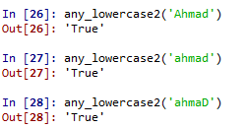

## C)

### Code

#c.

def any_lowercase3(s):

for c in s:

flag = c.islower()

return flag

### Explanation

This is also wrong function we can check the output combination.

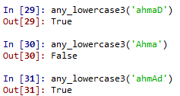

## D)

### Code

#d.

def any_lowercase4(s):

flag = False

for c in s:

flag = flag or c.islower()

return flag

### Explanation

This is also wrong function because we use bit wise or operation. Once True come it means it give always True.

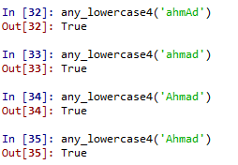

## E)

### Code

#e.

def any_lowercase5(s):

for c in s:

if not c.islower():

return False

return True

### Explanation

This is also work for the first character from the string..

