# A

## Code

def ﬁnd_doubleletter(word):

n=len(word)

for i in range(n-1):

if (word[i] == word[i + 1]):

return True

return False

## Output

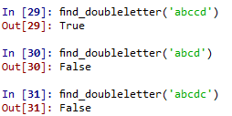

# B

## Code

#b

def uniqueCharacters(str):

for i in range(len(str)):

for j in range(i + 1,len(str)):

if(str[i] == str[j]):

return False;

return True;

def count_word():

count=0

file= open("word.txt","r")

for i in file:

if(ﬁnd_doubleletter(file.readline())):

count=count+1

elif(~uniqueCharacters(file.readline())):

count=count+1

else:

count=count

return count

print ('File have',str(count_word()),' word which contains double letter')

## Output

