Spring 2020 CSC 113 Intro. To Programming with Matlab

Quiz Chapter 10 Matrix Algebra 04/30/2020 Name:________________________

1. Explain what MATLAB’s dot() function does (2 points)

Answer

C = dot (A, B) returns the scalar product of the vectors A and B.A and B must be vectors of the same length. When A and B are both column vectors, dot (A, B) is the same as A'*B.

Dot (A, B), for N-D arrays A and B, returns the scalar product along the first non-singleton dimension of A and B. A and B must have the same size.

Dot (A, B, DIM) returns the scalar product of A and B in the dimension DIM

1. Write MATLAB code to solve the following system of linear equations: (6 points)  
    𝑥+3𝑧=8  
    𝑥+2𝑦+𝑧=7  
    3𝑥−4𝑦+5𝑧=0

Code

clc

clear

A = [1,0,3;1,2,1;3,-4,5];

B = [8;7;0];

C = inv(A)*B;

x=C(1)

y=C(2)

z=C(3)

Output

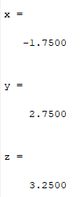

1. Write a MATLAB function “hasInverse” that determines if a given matrix has an inverse or not. The input parameter should be a matrix and it should output the logical result, 1 for true, or 0 for false. (Hint: A matrix must be square and have a non-zero determinant to be inverted: 12 points)

**Code**

function z=hasInverse(X)

% Q03

[r,c]=size(X);

if(r-c==0)

if(det(X)==0)

z=0;

else

z=1;

end

else

z=0;

end

end

**Output**

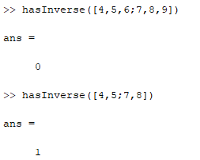

**Extra Credit**: (5 points)

1. Write a MATLAB function called “AproxDiff” that:
   * Accepts two vectors as input
   * Approximates the Numerical differential of the first vector with respect to the second (you may assume they are the same length)
   * Returns a vector containing the approximate differential.
2. Demonstrate calling your function with the following data and storing the results in a variable:

first vector: 40, 35, 27, 23, 12  
Second vector: 1, 2, 3, 4, 5

1. **Code of function**

function AproxDiff (a, b)

%extra credit part a

dff_a=diff(a);

dff_b=diff(b);

output = dff_a./dff_b;

disp('output is: ');

disp(output);

end

1. **Code**

clc

clear

%part b of the extra credit

first_vector=[40,35,27,23,12]

second_vector=[1:5]

AproxDiff (first_vector,second_vector)

**Output**

