Please double-check these answers and solve the one with no answer

1. Write a MATLAB function called “AproxDiff” that:
   * Accepts two vectors as input
   * Approximates the Numerical differential of the first vector with respect to the second (you may assume they are the same length)
   * Returns a vector containing the approximate differential.
2. Demonstrate calling your function with the following data and storing the results in a variable:

first vector: 40, 35, 27, 23, 12  
Second vector: 1, 2, 3, 4, 5

**(a)**function AproxDiff (first, second)

d = diff(first)./diff(second);

disp('output is: ');

disp(d);

end

(b)

First=[40,35,27,23,12];

Second=[1,2,3,4,5];

AproxDiff (First, Second)

output is:   
 -5 -8 -4 -11

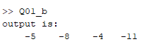

2. Write a MATLAB function “hasInverse” that determines if a given matrix has an inverse or not. The input parameter should be a matrix and it should output the logical result, 1 for true, or 0 for false. (Hint: A matrix must be square and have a non-zero determinant to be inverted:

function output=hasInverse(A)

% A maust be matrix

[r,c]=size(A);

if(r==c)

if(det(A)==0)

output=0;

else

output=1;

end

else

output=0;

end

end

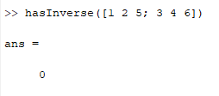

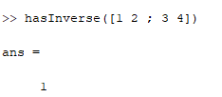

1. Explain what MATLAB’s dot() function does.

%Dot () function is used for vectors multiplication and sum them.

%For example:

A = [1,2,3];

B = [4,5,6];

C = dot(A,B)

% C = 32

1. Write MATLAB code to solve the following system of linear equations:   
    𝑥+3𝑧=8, 𝑥+2𝑦+𝑧=7, 3𝑥−4𝑦+5𝑧=0

A = [1,0,3;1,2,1;3,-4,5];

B = [8;7;0];

C = inv(A)*B

% or

C = A\B