**DIGITAL SIGNAL PROCESSING**

**CMPE 476**

**HW 3**

**Solve All Questions.**

**Q1**. Let x(n) be a complex values sequence with real part *xR(n)* and the imaginary part *xI(n)*. Prove the following z-transform two relations:



Must you use only *MATLAB* in your proof, and for *x(n),* use two random sequences for real and the imaginary parts.

Code

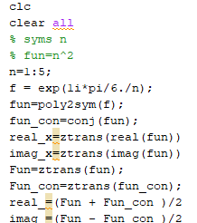

Output

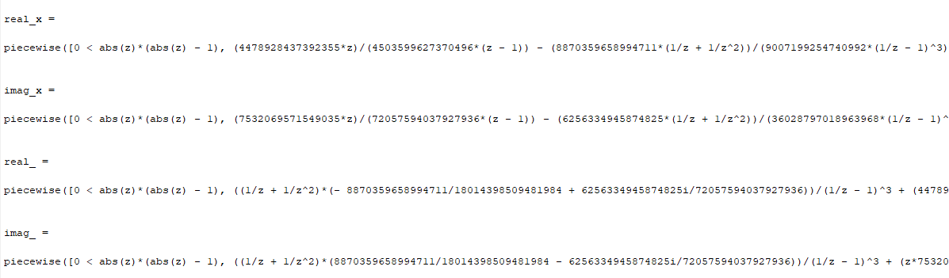

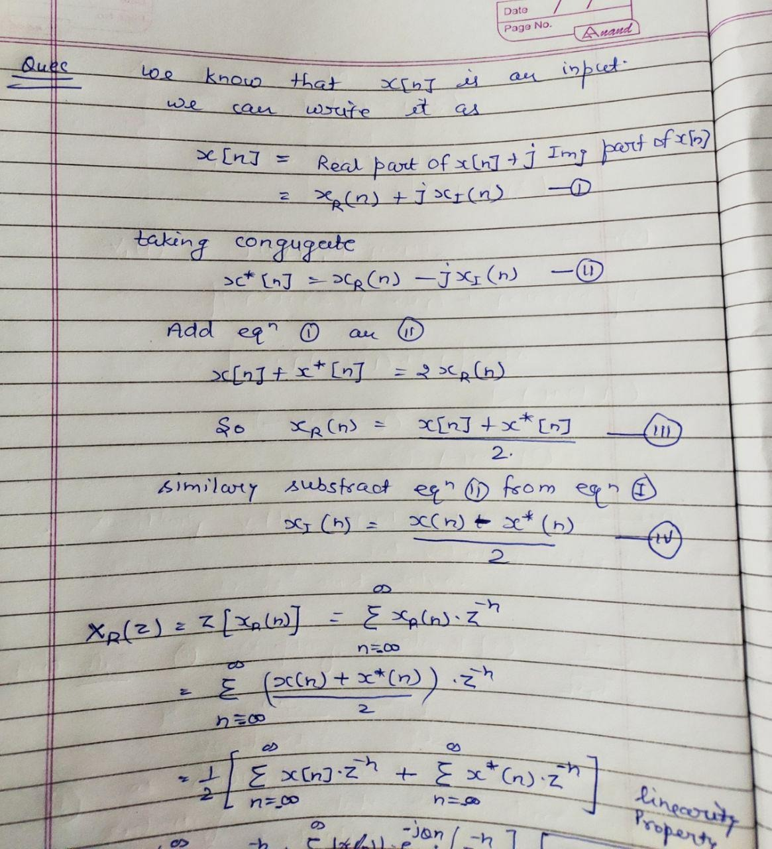

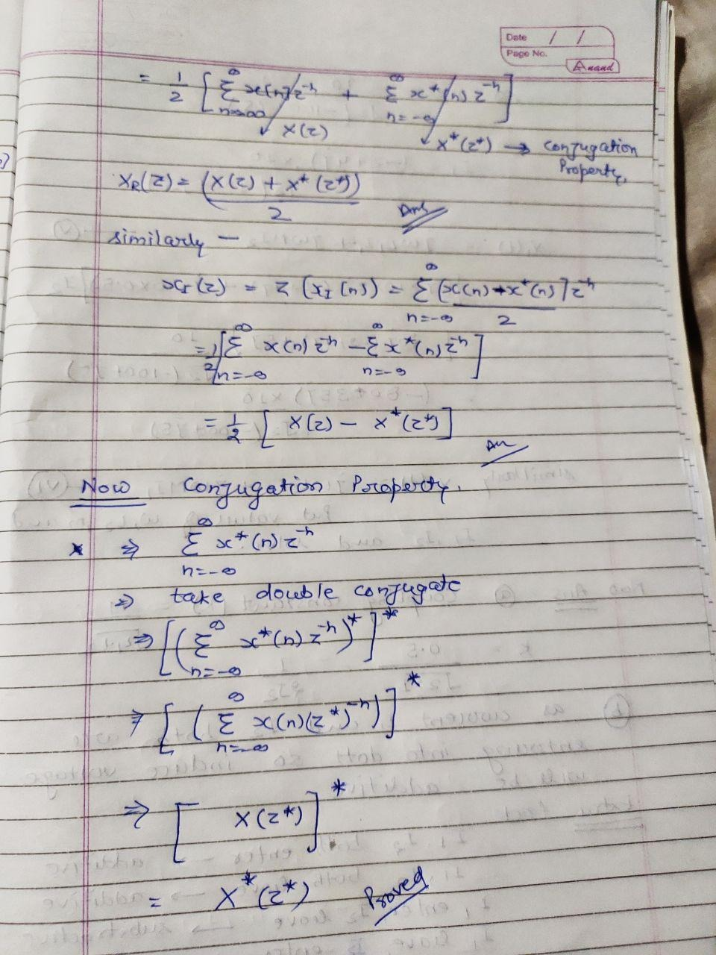

**Q2.** The z-transform of *x(n)* is *X(z) = 1/(1 - 0.5z−1), |z| ≥ 0.5*. Determine the z-transforms of the following sequences and indicate their region of convergence:

*x2(n) = (1+n) x(n)*

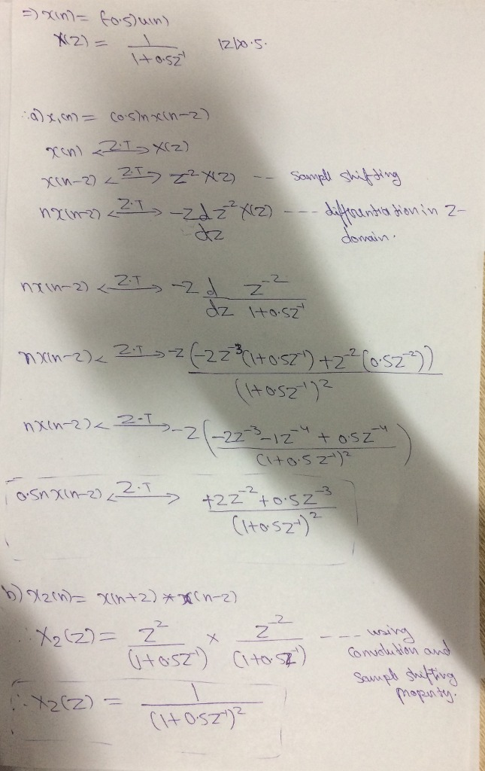

**Q3.** Determine the following inverse z-transforms using the partial fraction expansion method.

*X1(z) = z-1 / [1 – 0.25z-1 – 0.15z-2]*

1. Get *x(n)* analytically

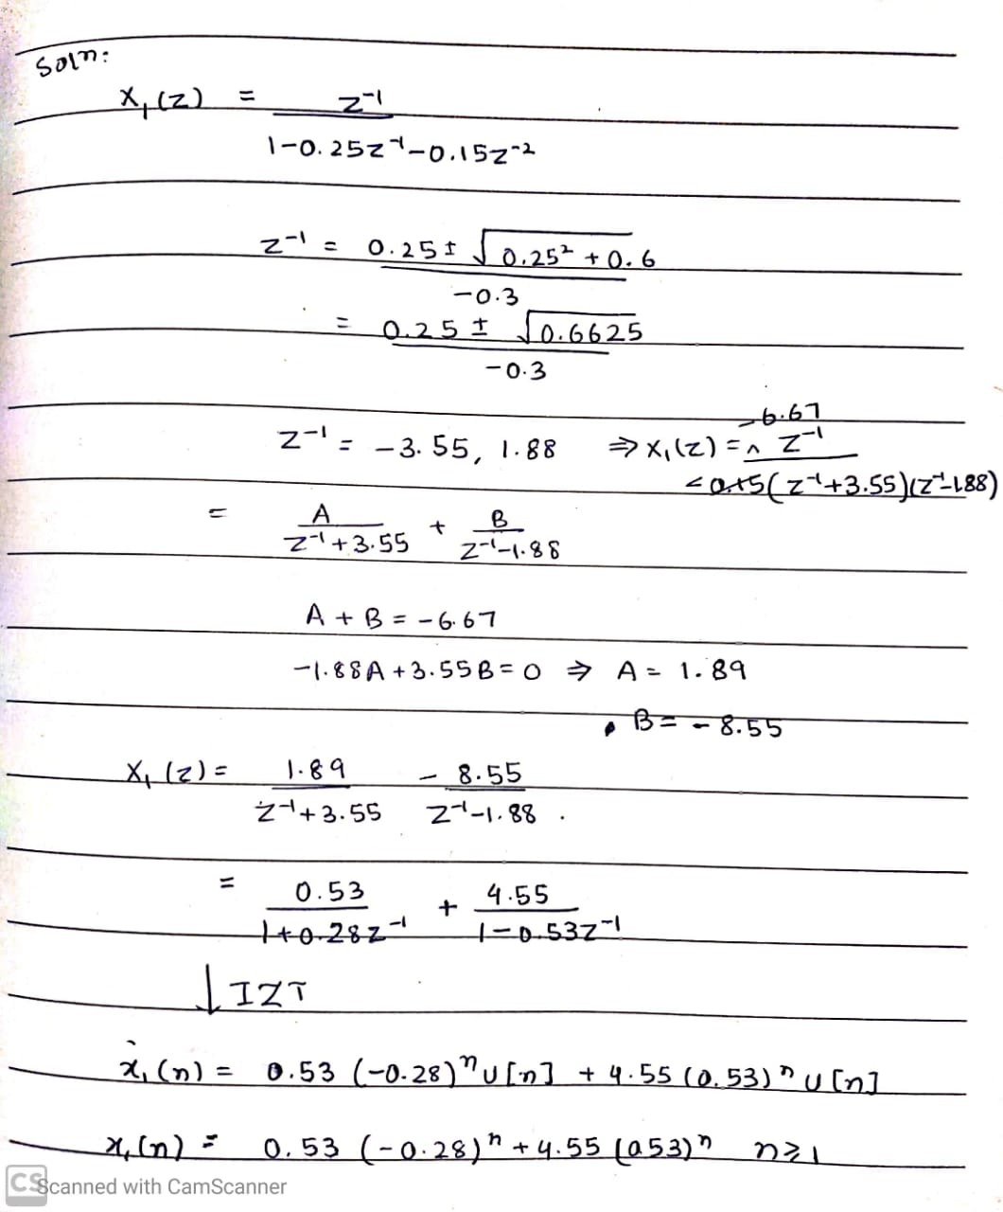

1. Proof that using *MATLAB*

Code

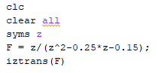

Output



**Q4**. Solve the following difference equation for y(n) using the one-sided z-transform approach.

*y(n) = 0.5 y(n-2) + x(n) – x(n-1), n ≥ 0; y(-1) = Y(-2) = 1*

*x(n) = (0.5)n u(n)*

Generate the first 20 samples of y(n) using *MATLAB* and compare them with your answer

Code

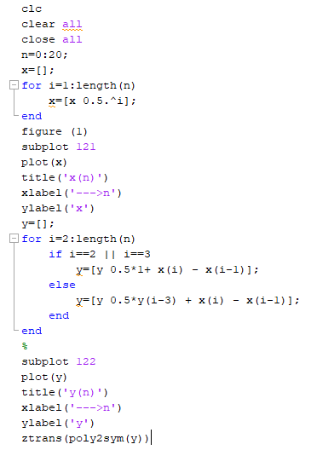

Output

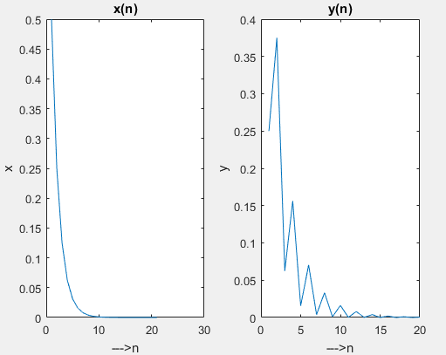

 

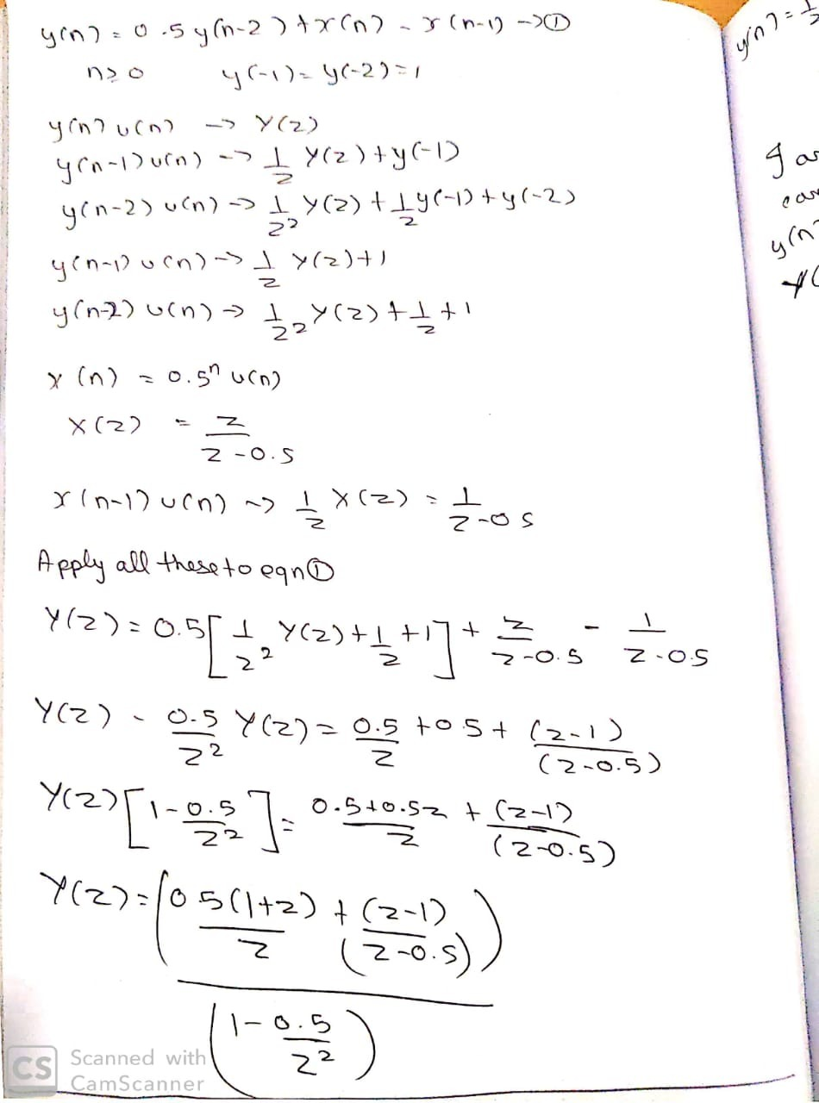

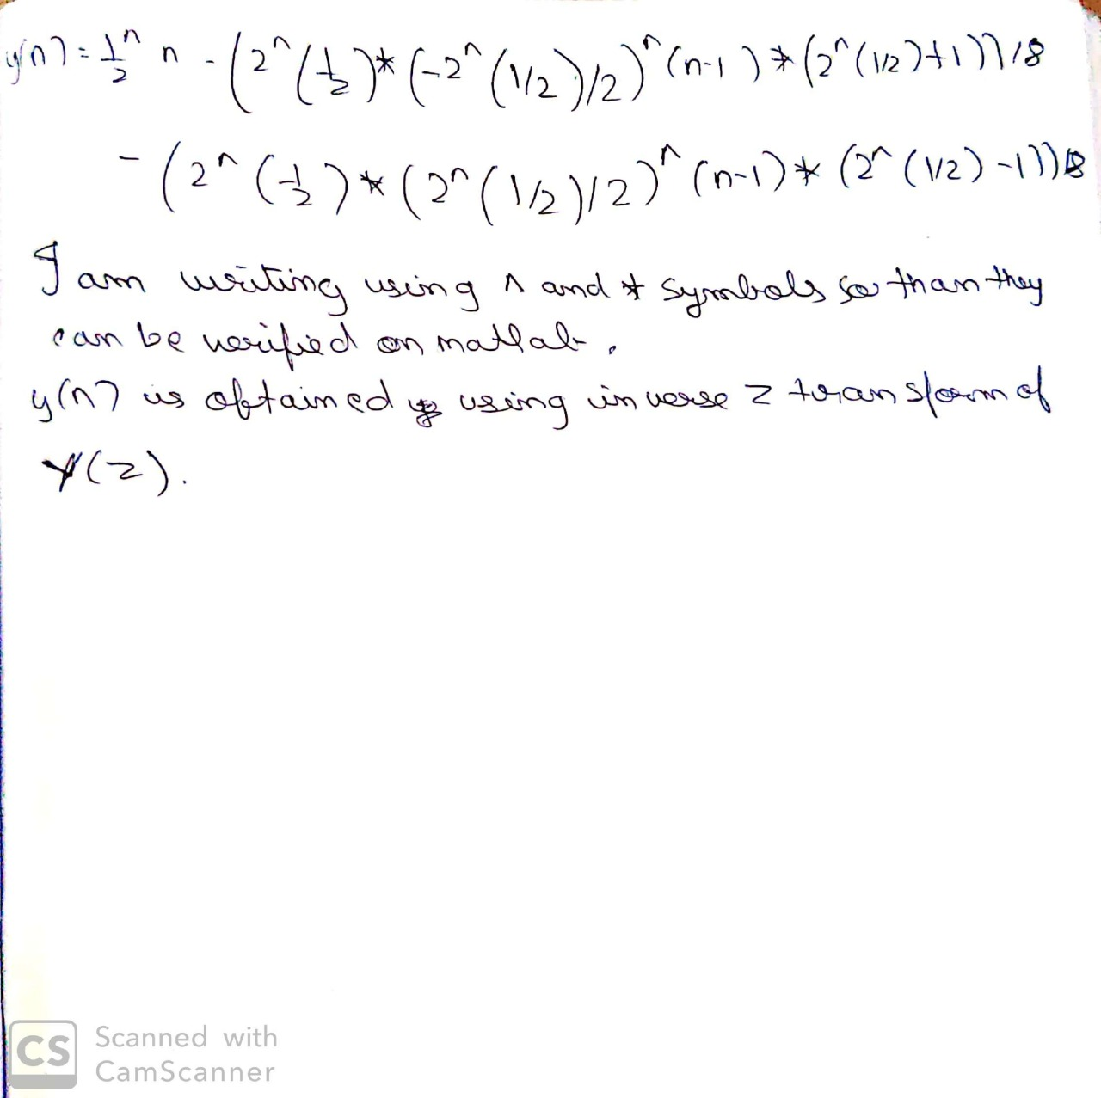

**Q5**. For the linear, causal, and time-invariant systems described by the following difference equation:

*y(n) = 2x(n) + 0.9y(n − 1)*

determine (i) the impulse response representation, (ii) the system function representation, (iii) the pole-zero plot, and (iv) the output y(n) if the input is

*x(n) = u(n-1).*

