# Part 1

## Pseudocode

|  |
| --- |
| isPrime(num)  p = True  for pf ranges from 2 to num-1 do  begin block  if num divisible by pf then set p = False  end block  if p = True display num is prime  else num is not prime |

## Flowchart

|  |
| --- |
|  |

## Screenshots

|  |
| --- |
|  |

## Top 200 primes

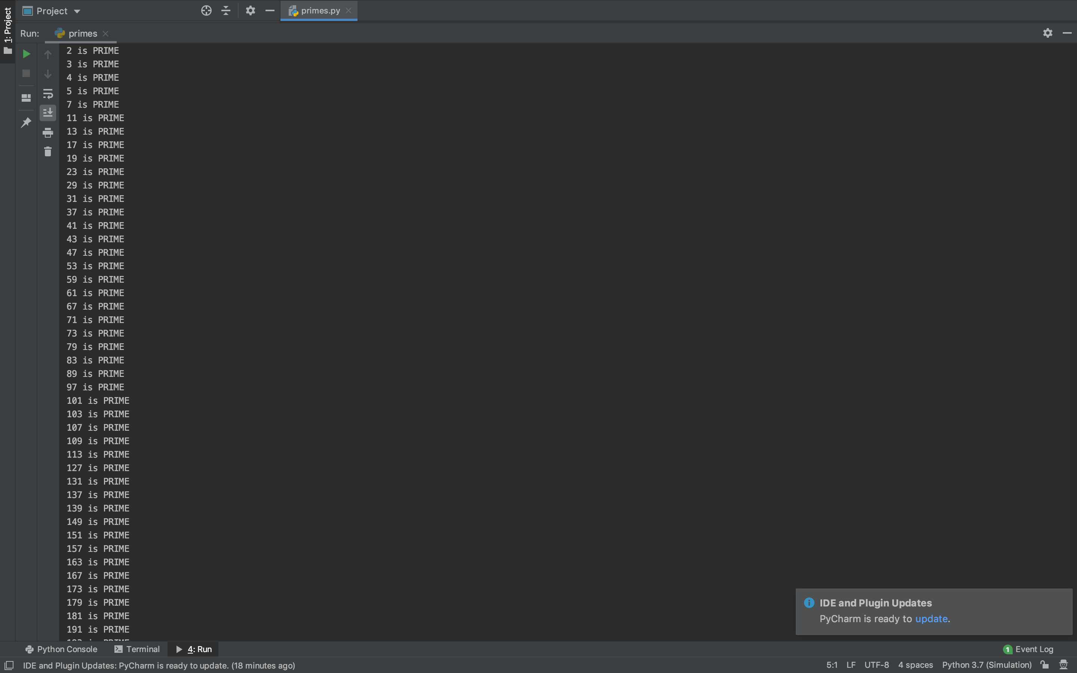

## Code

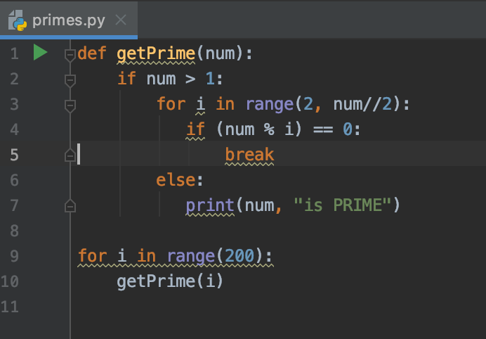

# Part 2

